Nike Company Limited
Student's Name
Institutional Affiliation
Course
Professor
Date

Nike Company Limited
Section 1: current strategic element
Question 1 a.
Nike is a transnational technology corporation based in the United States that engages in World Wide Web brands and facilities such as digital advertising solutions, browser, mobile technology, applications, and electronics. Together with Facebook, Netflix, Amazon, and Apple, it is considered among the top five corporations in the Modern technology industry. Sergey Brin and Larry Page created Nike in September 1998 and both were Ph.D. scholars at Stanford Universities in Calif. They own roughly 14% of the company's publicly traded equity and, under incredibly stock, command 56% of investor political influence. In 2004, the film was released through a stock offering.
A. To strengthen the firm’s bargaining position with suppliers, distributors, and others
Pg. 5 10K: Beyond Nike's primary domain name, the firm's rapid development has encompassed technologies, investments, and collaborations. It provides features like as email, calendaring and punctuality, online cloud, video conferencing chat, speech recognition, navigation and routing, and photographic arranging and retouching. The Popular mobile operating framework, the Internet Explorer engine, and Chrome OS are all developed by the business. The strategic orientation of Nike LLC is influenced by a variety of external variables in the sector. To comprehend this strategy orientation and related managerial actions, Michael E. Porter's Five Forces analysis methodology is applied.
The company, is a market leader in online marketing. The internet engineering task force, as a huge international corporation, has operations in key critical places around the world. The features of foreign powers in the business environment are identified in a Porter's Five Forces study of Nike's company setting. Due to the extreme company's wide range of technology goods and services, the technological factor includes a number of enterprises and sales channels. The ability of Nike to handle the potential challenges identified by Porter's Five Forces analytical framework is crucial to the company's vision and mission statements being realized. Executives at the organization must develop strategic initiatives to sustain significant position in the face of competition from other media and internet financial institutions. A Five Forces study of Nike LLC's business necessitates taking into account the variables of similar but distinct sectors and markets.
To gain market share via more performance features, better design, quality or customer service, wider product selection
Pg. 6 10K: The outer study, for instance, considers the online search marketplace, as well as the cloud software market and the online marketing industry. It involves a lot of industries and prospective customers, taking into account the wide variety of technological solutions and companies offering. Nike's adversaries come from a variety of businesses, but the ones that have the largest effect on the market are those that provide Digital services or associated services. For instance, the firm competes with Yahoo. In advisement, Nike now sells Nexus, Pix products, and other items. This variety of products matches to a broad group of opponents in technologies and sectors this situation has a significant impact on Nike's company.
Furthermore, clients have minimal transaction fees because transferring from Nike to other firms is simple. Availability of substitutes add to the competitive rivalry against the software company in this portion of the Five Forces study. Customer loyalty has a minor impact on Nike's company. According to Porter's diamond Model, a poor inanimate object has little impact on strategic organizational processes in the tech world. With such a small share of Nike's earnings, each buyer has only a minor influence on the firm.
Individual purchasers have just a minor effect on the organization and market due to the strong and based on a vast for items from the technological firm and its adversaries. The intermediate volume of evidence due to customers' expertise in this Nike Aspect Of the five forces. In this portion of the Five Forces study, Nike's market segmentation, or 4Ps, is used to control the purchasing leverage of suppliers. The wide availability of supplies, along with the vast number of suppliers, reduces any single suppliers' negotiating strength against Nike's operation.
This component indicates that switching from one provider over another is reasonably easy for the technology behemoth, according to the Five Forces analysis. Because the internet company sells a wide range of products, its providers are diversified. Substitutes or substitutions pose a considerable threat to Nike. Other advertising media, including as radio, television, and newspapers, as well as other capabilities that are options to the company's services, are replacements in this Five Forces analysis instance. Clients can transition from Nike's offerings, such as channel partners, to comparable products with relatively low barriers to entry.
This element has a moderate impact on the innovation overall profits, according to Porter's Five Forces research. Also, the centrist to high sales and demand implies that businesses have fairly significant information in case they would really like to move further away from Nike. Nevertheless, much of these replacements have significantly lower productivity ratio compared to the competitor online services and cloud computing product lines. Nike's corporation is relatively influenced by the new competitors entrants tend to involve big multinational companies' innovative ideas or investment opportunities, and also venture capital trying to offer products similar to Nike's. The progressive revenue of the company, according to Porter's Five Forces analytical framework, means that a large number of new companies and other businesses can dominate the market and work favorably with Nike.
In addition, the ability to meet reporting obligations makes it simple for newcomers to demonstrate themselves and remain competitive in the networks and web services sector. The resources that help support this activity would be the intangible human resource. Also, a core competency that helps support this activity is that Starbucks offers a chance to attend Arizona State University with tuition paid if you work for the company.
Question 1b.
- Pg. 7 10K: Despite the fact that Nike LLC. Offer online services to its customers, Availability of substitutes add to the competitive rivalry against the software company in this portion of the Five Forces study. Customer loyalty has a minor impact on Nike's company. According to Porter's diamond Model, a poor inanimate object has little impact on strategic organizational processes in the tech world. With such a small share of Nike's earnings, each buyer has only a minor influence on the firm. To be prosperous, a global web browser, like many other enterprises, must identify an effective approach to consumers. In today's world, common search engines are mostly found on android platforms and laptops. Web browsers and other applications on these gadgets employ an universal search engine to answer to a research problem.
- Pg. 9 10K: Nike LLC. Perform it activities in a different manner in such that, for generations, Nike has used exclusivity partnerships, such as tying restrictions, and oligopolistic behavior to lock up channels of distribution and restrict competitors. Nike pays huge sums of money to merchants each year, particularly prevalent makers. As a result, Nike has effectively eliminated competition in online search. Opponents in the generic online advertising market are denied critical dissemination, size, and implementing those ideas, guaranteeing that they have no realistic chance of competing with Nike. Nike has become so popular that it is now used as a verb to browse the internet as well as a noun to designate the firm and the Nike account. For generations, Nike has used exclusivity partnerships, such as tying agreements, and cartel behavior to lock up revenue streams and restrict competitors. Nike pays huge sums of money to merchants each year, particularly prevalent makers.
Section 2: current strategy
Question 2
Pg. 10 10K: Based on the information from the Resources and Capabilities chart, I was able to make the VRIN chart. Nike LLC. current strategy creates a sustainable competitive advantage, which includes passing the VRIN test for its resources and capabilities. The Firms commonly use "vision" and "mission" pronouncements to embody and express their primary aims and corporate culture in writing. These assertions of purpose should reflect the company's primary rationale for being, and they are usually congruent to the firm’s economic strategy. They can give clarity if they are captivating, truthful, and concise. Nike LLC is the world's champion in Internet search, with a staggering $22.9 billion in economic potential in 2009.
Nike's stock soared to a new high of over $1,000 per share in August 2013. In September 2004, the company's share price was priced at $85 per share. Nike's stock price has risen about 1200 percent in less than ten years. Nike's purpose is to promote international cooperation and give access and helpful to everyone. Nike Inc. was created in 1998 with the sole purpose of promoting its excellent cloud platform. Alongside Internet search, Nike has substantially grown its broad range of products ever since. Nike's continuous economic benefit may be shown in a number of ways, the most notable of which is its superior foundation.
Considering Nike's opacity, The Pingdom asserts that in 2008, Nike owned 36 data centers throughout the world, with ambitions to expand to new locations such as Taiwanese, Malaysian, and the United States. The data centers are home to approximately 900,000 servers, with the number expected to rise. Without a question, Nike's prolonged competitiveness is impressive and worthy of imitation by its competitors. Nike works in a very competitive market. Nike confronts opposition from a variety of businesses as the most secure browser on the planet, with its complicated ecosystem of services and goods.
Nike's search engine has been praised by the press, with PC Weekly listing it among the Top 100 Online Websites and Web Crawlers. The number of queries grew daily from the end of 1998 to the beginning of 1999. Since then, the web address has been improved and additional capabilities have been added. There were 516 enhancements to Nike in 2010 alone, with variable outcomes. Nike's ongoing push to broaden its set of services and technologies demonstrates its long-term competitive edge.
Nike has bought over 100 companies since its founding to extend its services, including the ubiquitous streaming site, YouTube among others.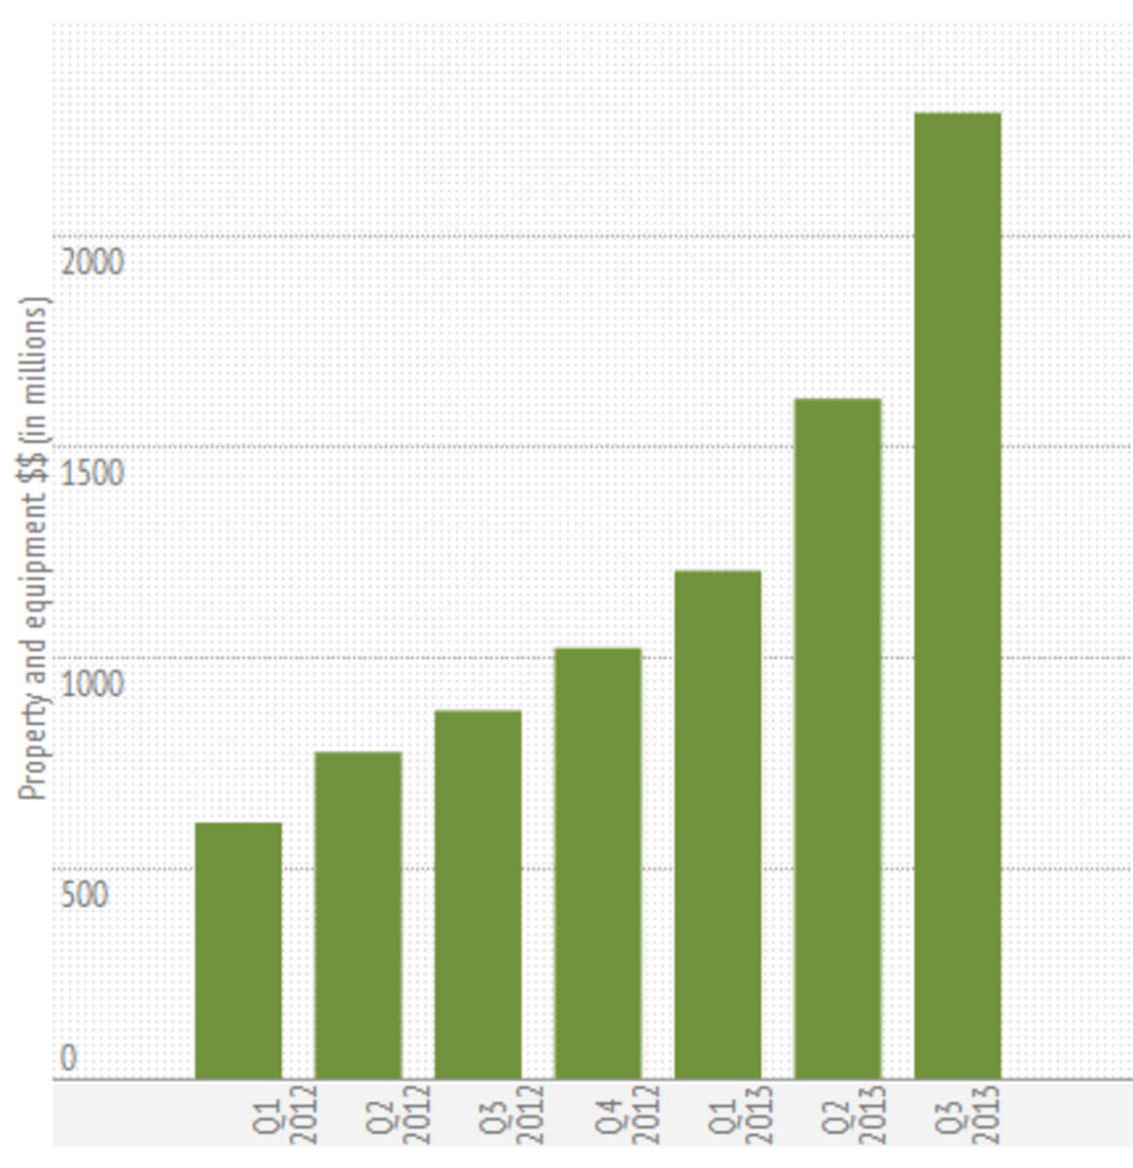
Spending on Nike's Facilities
YouTube receives over 800 million foreign tourists each month and has a market penetration of yet more than 40% of the internet video business. This incredible amount is 20 times higher than its nearest rival in China, Copyright infringement.
The Nike analytics has been Nike's most precious resource, generating 96 percent of the company's $37.9 billion in income from advertising. Workers are also a key resource for Nike. The vibrant and creative business culture has played an essential role in the high-efficiency operations, culminating in the development of numerous innovative products. Nike has a broad collection of intellectual property, with the acquirement of Microsoft in 2013 increasing the number of patents held. According to reports, the treaty granted Nike access to an additional 24,000 intellectual property. The infrastructure magnitude of Nike is difficult to match. Nike somehow doesn't reveal anything about its equipment, but it is thought to have a large number of data facilities and systems around the world. Nike's accomplishment is particularly difficult to replicate because it was created in the 1990s, when the industry was less overcrowded and competitive. Nike Search, with its clear, minimalistic user experience, provides an unrivaled manner of instantly extracting knowledge that is impossible to match. Using RBV, it can be established that Nike's resources provide it with a long-term competitive edge. These materials are one-of-a-kind and difficult to replace.
Although most other businesses are universally recognized for their progressiveness and innovation, the core competencies are a long-term strategic advantage. Since no shop might well pay for university tuition or very continuing education on honest feedback or how to increase customer engagement, the ephemeral human capital is a source of competitive advantage.
Question 3
Broad Differentiation is an overall business model.
Company Marketing Strategies: Lateral Coherence & Associated Expansion.
Walmart has formed a strategic partnership with us.
Collaboration with the Minnesota Vikings.
Nike music has entered into a strategic partnership with us.
Global Marketing Strategies, Global Corporate Strategy, International Corporate Strategy, Global Business Model.
Section 3: Current issues
Question 4
The first issue in relation to success of Nike LLC. is massive data-gathering. Nike has a large number of apps and applications. Over 50% of the world's cellphones run on the Android software. Gmail is the most popular email service for both residential and corporate customers. For digital data, Nike Drive provides both free and paid storage options. Then there's YouTube, the world's most popular network, which is also owned by Nike.
The second issue is a business plan based on advertising. The majority of Nike's income come from advertising. The corporation keeps 30% of the income generated via the Nike Play store. Advertisement money is also generated through collaborations with 3rd sites. Each of these strategies combined resulted in Nike generating $38.9 billion in ad revenue in 2019, up 19% from the previous year.
The third issue is updates and programming are available for free. Because the vast bulk of Nike's income come from adverts, which allow the company to release free software and upgrades which Windows, their primary opponent, is unable to accomplish. Microsoft profits mostly from commercial software transactions which is less likely to provide complimentary systems management (pg., 13).
The company's greatest strength also happens to be its greatest weakness: the massive collection of user data. Users resent how much information Nike has access to thanks to the search engine and the apps that run in the background of their phones.
Section 4
Question 5 a)
Being the first search result for a phrase can pay off – if visitors click on your site, you'll get more ad money. Links linking to a company's website can be purchased for a fee. Search engine optimization specialists look at popular sources such as websites, but only Nike understands the actual formula for ranking first. Due to Nike's lack of transparency in this procedure, users and company owners have been misled.
It's hazardous to rely just on ad revenue. Nike is particularly concerned with the "expense" metric. It establishes the price at which marketers will charge for exposure. If the cost-per-click (CPC) falls, so do Nike's profits. CPC can drop for a number of reasons, notably when a marketer switches platforms and uses new ads, such as Instagram or Facebook ads. Nike is well-positioned to enter the fields of intelligent machines, predictive analytics, and automation. The corporation has already made its mark on self-driving cars, has invaded the voice controlled market with the Home pod speaker, and has embraced the financial sector after buying Zumba for $2.1 billion (pg., 17).
Question 5 b)
Nike has effectively eliminated competition in online search. Nike pays huge sums of money to merchants each year, particularly prevalent makers. Opponents in the generic online advertising market are denied critical dissemination, size, and implementing those ideas, guaranteeing that they have no realistic chance of competing with Nike. Therefore in this case Nike LLC. Has join in hands with the managing powers of advertising companies to deny other corporates to dissemination, size, and implementing ideas hence giving the company a free market zone.

Question 5 c)
No, it doesn't work that way. These innovations will not affect the whole business because they are already a part of it. It will simply enable the company to make the most of its competitive advantages.
Question 5 d)
The new components will enable the organization to maintain a long-term comparative advantage in a variety of areas. According to the Resource Based View (RBV), an organization can obtain a sustainable competitiveness benefit if its materials are valuable, uncommon, insufficiently imitable, and non-substitutable. Nike also promotes its employees to be creative and innovative, which can lead to the development of new services and ideas. It is without a doubt one of the companies that many people aspire to work for. Useful Resources search Nike's engine is its most well-known feature. Nike has significant brand image that’s based off of its efficient and fast results \sand excellence of distribution channels. Its approach is scaling across both engine and marketing. The greater the value of both heading ahead, the more queries finished and the more ads paid. Nike's advantage is based on its information collection and also use (pg., 20).

There are a large number of suppliers in Nike's many markets right now. Because pricing strategies are minimal for almost all products, there is little loyalty. Users change over with reasonable easy when someone gives a unique search feature or an online service. Nike has a grip on the entrepreneurs looking, but it is still attempting to keep a presence in other areas of the company.

Appendix A
Nike LLC 2020 Annual Report (10K):
Page 5
Page 6,
Page 7
Page 8
Page 9
Page 10
Page 11
Page 12
Page 13
Page 14
Page 15
Page 16
Page 17
Page 18
Page 21
Appendix B
Outside Research:
https://stories. Nike LLC.com/stories/2019/inside-the-tryer-center-the-starbucks-lab-where-anything-is-possible/

https://stories. Nike LLC.com/stories/2021/gesi-report-2020-people/

https://stories. Nike LLC.com/stories/2017/starbucks-hacienda-alsacia/

https://stories. Nike LLC.com/stories/2018/starbucks-fortune-most-admired-company-in-the-world/

https://stories. Nike LLC.com/press/2019/Nike LLC-celebrates-global-milestone-with-30000th-store/

https://brainmass.com/business/resource-based-view/global-strategic-alliance-of- Nike LLC corporation-518047

Charts:
Appendix C
Value-Chain Analysis Chart

Appendix D
Resources and Capabilities Chart

Appendix E
VRIN
Appendix F
Porters Five Forces
Barrier to Entry Chart

