Professor
Institution
Date

1. Briefly describe (in sentence form) the various parts of the spinal cord and summarize the functions of these general areas.
A spinal cord is a part of the central nervous system that sends information between the periphery and the brain. A spinal cord is made up of white outer layer and gray centered matter. Usually, the spinal cord consists of four segments: thoracic, cervical, coccygeal, and lumbar. The primary function of all these spinal cord segments is to support our bodies. It enables us to stand upright, twist, bend, and as well as protect the spinal cord from damage.
2. How would superficial damage to the left anterior spinal cord likely impact the physiological function of the affected individual?
In case the left anterior spinal cord is damaged, it might cause permanent changes in the individual's sensation because of its connection to the brain.
3. Compare and contrast tonic and phasic receptors, use an example of each to support your answer
Tonic receptors are well known to be slow in adapting to the inducement or stimulus; however, when the response and get activated, they occur for a more extended time. 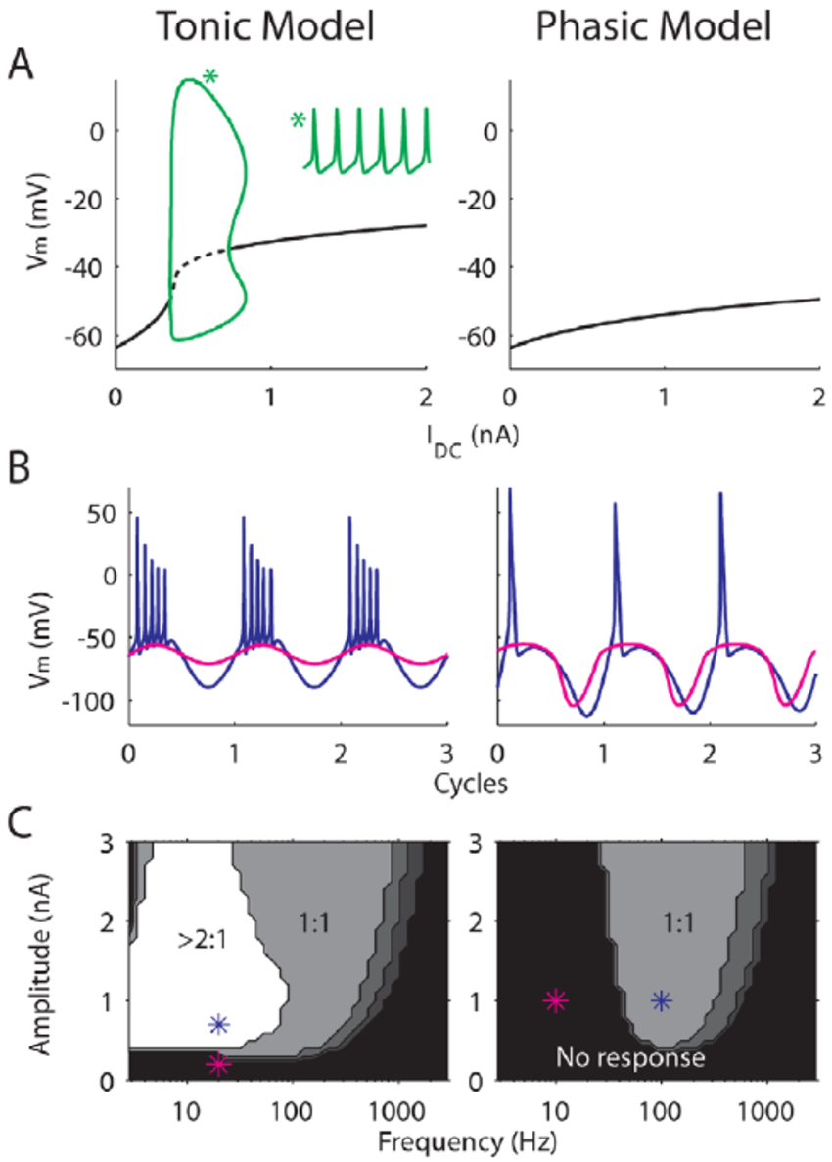In dissimilarity, physic receptors adapt faster to the stimulus, but they are enabled for a shorter period. Additionally, Tonic muscles are known to be slow-twitch while, on the other hand, phasing is faster twitch muscles.

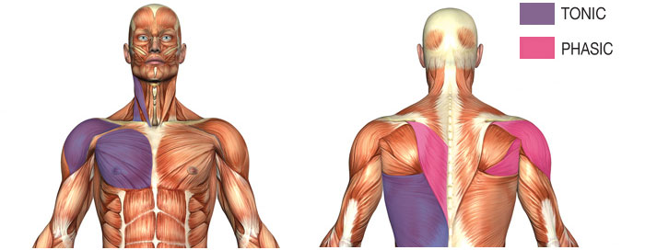
4. Propose a mechanism for Painorphin (a new synthetic opiate). It has been found to have analgesic properties, and the receptors it binds to have been localized to the dorsal horn of the gray matter of the spinal cord on axon terminals of pseudounipolar neurons.
For painorphin, I will propose narcotic ibuprofen narcotic acetaminophen combination
5. In your OWN words, describe the steps involved in phototransduction in rod cells start with a photon of light and end with an action potential in the optic nerve
The outer layer of the cell membrane of a rod possesses an electric charge, and activation of rhodopsin by the light results in a reduction in cyclic GMP. This increases electric charge hence producing an electric current alongside the cell.
6. Explain what YOU would expect to happen if a drug that blocked the cation channel in the photoreceptive cells was applied to the left eye.
Synapses will initiate bipolar cells after the application of a drug on the left eye. In this case, light receptors will release one neurotransmitter, 21 glutamates, to react to the drug applied. There is two response, in this case, glutamate hyperpolarization and glutamate depolarization.
7. Using the patellar reflex as an example, explain the concept of spinal reflexes and why we have them.
Spinal reflexes are referred to as actions that are not caused by the mindful movement. These movements are initiated by spinal cord cells. Spinal reflexes start from the spine and run over the entire brain.
Spinal reflexes are essential as they help our bodies to react and respond to harmful stimuli without even checking with the brain to see if the movement is ok. Also, spinal reflexes possess signals that need immediate responsiveness, such as being burned by fire.
8. Legend: (+) excitatory synapse (-) inhibitory synapse, Blue Cell (sensory), Green Cells (interneurons) Red / (Orang) Cells (motor neurons) red neuron - motor neuron to knee extensors, orange neuron-motor neuron to knee flexors. Is the above diagram an accurate representation of a potential set of circuitry that would to an effective reflex (Yes / (No))? Explain Why or Why Not (use the picture in the file
Based on a given set of the reflex circuit, the reflex will not be effective- because the ordering is incorrect. For the reflex to be effective it should be as follows; stimulus, sensory neuron, intermediary neuron, motor neuron then impulse is sent to the muscle or gland
10. If nicotinic, cholinergic receptor agonist was dripped on the heart, how would you expect the heart to respond? Would heart rate and / (or) contractility rease/decrease/ or show no change ? Explain your answer.
Nicotine will increase the heartbeat rate, myocardial contractility, as well as blood pressure. The nicotine- cardiovascular impacts are a result of the stimulation of sympathetic neurotransmission. Nicotine rouses catecholamine production by an activating nicotine acetylcholine receptors

