REFLECTION
Name of the student:
Name of the University:
Author Note:

This reflection aims to reveal the learning, perception and engagement in a group scenario. In order to analyze all the incidents and events during the team project I will be utilizing Gibbs reflective cycle as it has five segments to describe and analyze the situation in a more efficient way (Wain, 2017). The firm that I have been working for is a UK based accounting firm namely Ernst & Young LLP which operates globally therefore, we have a cross cultural teams working in a similar project. In my team there are two other team members excluding me and we all are responsible to complete a project successfully. In this group project we have come across several issues in performance and time management.
Event 1.
Description:
As I have pointed out that my team has been a cross cultural one therefore the leadership influence was very much necessity (Koeslag-Kreunen et al. 2018). On the every first day, I found that both of my team members are trying to convince that they must be the leader of the team as they have in depth knowledge about the project and experience (Husebø, O'Regan & Nestel, 2015). In such case, I also have the experience and knowledge to complete the task hence I also claimed that the team leader must be taking responsibility of all the situation and take the risks sufficiently hence I must be the leader in its team. The other team members were not satisfied with the idea and conflicts grew up.
Feelings:
At that point of time I was feeling dishearten as this was my dream project in this company and I had developed myself accordingly. Now this conflict may create scope for personal ego and the professional causes will be secondary. However I tried to establish our points but the problem regarding leadership within the team remain content. Hence we agreed not to work under one another but distribute the task according to our capacity and share knowledge as much as possible so that the leadership issues do not affect the performance.
Evaluation:
The main problem was that all the three members has started to demonstrate the leadership skills. As I have found in the week 5 learning that we must be choosing the team leaders according to the capability. As the conflict resulted, we did not have any team leader who is more knowledgeable and guide us to achieve the goals (Pianpeng & Koraneekij, 2016). This situation was risky as the other teams were not facing such issues and respecting the claims of these leaders within the team (Koeslag-Kreunen et al., 2018). In our case, we were not being able to select a leader in the team therefore nobody was taking responsibilities or organizing the detailed plan to be followed. This led us to face a lot of pressure in the time management and other teams for other projects gained competitive advantage. These were pulling me down and it was difficult for me to work and I lost motivation.
Analysis:
According to the Parkinson’s Law, the more the people get time expansion, the more they waste it. Hence, time management in a team is essential because team tasks have certain deadlines (Khorasani & Almasifard, 2017). This prove efficiency of the team members and help to earn reputation before the clients. However, I realized that this type of situation cannot be prevailing anyway therefore we might be choosing someone to choose as the team leader officially. We consulted among one another and followed research driven learning for solving this issue for now as mentioned in Chen and Flowerdew, (2018). The participation in the meetings and arranging the whole process became problematic. The problem was solved as I arranged a meeting with other team members and motivated them to take initiatives so that the personal conflicts do not hamper the project goal achievements. This idea was shared to the other team members which both of them agreed upon.
Conclusion:
In order to solve this problem of executing leadership motivation and guidance we finally elected a team leader who has effective analytical and communication skill. As week 5 learing has mentioned that we needed to follow Belbin profiles to choose the leader and start the project work immediately (Adean et al.). We could have applied this at the first place. This enabled us to have some systematic approach to identify the resources we already had and other too acquire for meeting the goals.
Action:
From this project I have understood the importance of having leadership skill in a team project. In the team I will establish my ability to become a successful team leader and convince others for my credibility and responsible nature.
Event 2.
Description:
Another incident that took place in the project process was related to the agreed tasks to be delivered. In our team, three of us were responsible to complete certain activities so that we can distribute the tasks properly. This is effective as no one member needs to take stress for the entire tasks (Ardian, Hariyati & Afifah, 2019). For this reason the team leader developed a detailed plan and schedule associated with it. This helped us to take time for the extensive research, analysis and reach the conclusion so that we can make the activities needed for completing these tasks. In this regard it is important to state that the tasks were connected with each other therefore we need to complete our task so that the other team member can complete the next level without any issue. They were important for us to achieve the goals for the weekly manner and complete all the activities within set time. However, we could not achieve the target as the completion of these tasks were not done properly within the scheduled time.
Feelings:
In such situation I face the tremendous pressure as take the work stress. This is one the most problematic issues that I need to overcome. This time I found that I needed to put pressure upon the other team members so that they can complete their tasks faster and send those to me to complete those (Solodova, Kalmykova & Polupan, 2018). In such case I came across the issues of procrastination and carelessness within my team. The team members were continuously wasting time in in completing their own tasks and as I have found in the Gantt chart, the lowest score is the task completed as agreed. We had the agreement that we would be completing our task and submit our responsibilities within the set time but in such cases I found that the other team members were sending me incomplete tasks to me and showing various explanations which are mainly vague. This again created scope for conflict and I could not complete my task within time.
Evaluation;
In evaluating this incident it can be stated that we had developed proper strategies to achieve the goal but these were conditioned under complete participation of all the team members in taking responsibility properly. In such case I found that despite all the team members had agreed upon to submit their responsibilities properly, even the team leader also failed to submit the tasks within deadline (Ciasullo et al., 2017). We did not stayed in the task and I was taking more responsibility from behind. This had hampered my on performance individually and we suffered collectively also as a team. The leadership rule says building a team and communicating are not the only aspects of successful team management but the team leaders along with the other team members must be very responsible to their own tasks also. In case the team members are in capable to complete a task within time and in proper way this means that they may need certain resources all information in that his they must be moving such information to the other team members so that new strategies can be developed on urgent basis. In this project no team member had conveyed such information to me so that I can develop new plan for myself.
Analysis:
Under such circumstances I could only contact the project manager and begged time for us. This also give us that we cannot work transparently e and never share our weaknesses to the other team members which may reveal our incapability (Liu, 2021). Moreover I also realised that I should be more critical in the monitoring process of my other team members because I had knowledge that this type of incidents will be taking place therefore I needed to be more authentic to the project manager so that the team members Procrastination do not affect my performance. From this situation I learnt that the inability of the team members can hamper my growth and performance. This is the reason why I should be choosing the right members depending upon all the criteria in future so that I do not feel the same again. This will reduce demotivating factors within the team and we will complete the tasks more successfully.
Conclusion:
Completing tasks within a team is the most important and primary criteria for the project in the company. Along with this we can add leadership skills or communication system or the team bonding skills. The action there were mainly related to the capability of the team members in understanding the criteria related to the task completion and all the resources associated with it. In case we need any type of resources we must be conveying them as early as possible. This can reduce the problem of the other persons within the team to complete the tasks.
From the above analysis I can conclude that I was not very much motivated with the team performance as I asked for time and other resources to complete the tasks. Along with this, the problems of communication, organizational behavior and many issues had affected my performance however, this particular team project was very much important for my growth as I faced several issues and learnt a lot from them. I explored that I possessed certain leadership capabilities to guide and inspire people.
Actions:
From the next time I would be increasing my learning and knowledge sharing capabilities so that my team earns credibility in meeting the requirements and achieve the targets. To devoid procrastination, I must be following the schedule or plan I develop and learn new tactic to complete the tasks properly. These will never be repeated in my future projects.

References:
Adeani, I. S., Febriani, R. B., Syafryadin, S., Mangana, A. V., Kurniawan, E., Ananda, J., & Maryam, S. Using GIBBS reflective cycle in making reflections of literary analysis. Indonesian EFL Journal (IEFLJ), 6(2), 139-148.
Ardian, P., Hariyati, R. T. S., & Afifah, E. (2019). Correlation between implementation case reflection discussion based on the Graham Gibbs Cycle and nurses’ critical thinking skills. Enfermeria clinica, 29, 588-593.
Chen, M., & Flowerdew, J. (2018). A critical review of research and practice in data-driven learning (DDL) in the academic writing classroom. International Journal of Corpus Linguistics, 23(3), 335-369.
Ciasullo, M. V., Cosimato, S., Gaeta, M., & Palumbo, R. (2017). Comparing two approaches to team building: a performance measurement evaluation. Team Performance Management: An International Journal.
Husebø, S. E., O'Regan, S., & Nestel, D. (2015). Reflective practice and its role in simulation. Clinical Simulation in Nursing, 11(8), 368-375.
Khorasani, S. T., & Almasifard, M. (2017). Evolution of management theory within 20 century: A systemic overview of paradigm shifts in management. International Review of Management and Marketing, 7(3).
Koeslag-Kreunen, M., Van den Bossche, P., Hoven, M., Van der Klink, M., & Gijselaers, W. (2018). When leadership powers team learning: A meta-analysis. Small group research, 49(4), 475-513.
Liu, D. (2021). Academic oriented team building and management in critical care medicine. Zhonghua wei Zhong Bing ji jiu yi xue, 33(1), 1-4.
Pianpeng, T., & Koraneekij, P. (2016). Development of a Model of Reflection Using Video Based on Gibbs's Cycle in Electronic Portfolio to Enhance Level of Reflective Thinking of Teacher Students. International Journal of Social Science and Humanity, 6(1), 26.
Solodova, E. P., Kalmykova, D. A., & Polupan, K. L. (2018). Team Building as a Modern Method for Human Resource Management. Vestnik of Samara University. Economics and Management, 9(4).
Wain, A. (2017). Learning through reflection. British Journal of Midwifery, 25(10), 662-666.
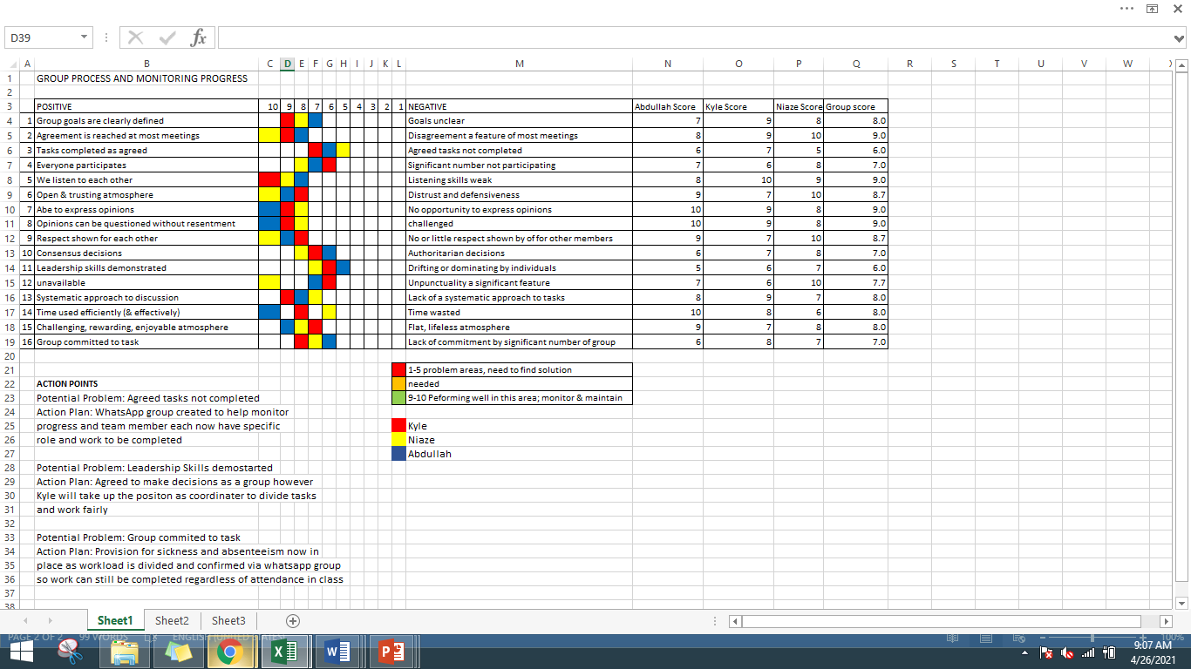
Appendix:

