Normalization
[Name]
[Institution affiliation]
[Course]
[Date]

NORMALISATION- IT DATABASE
Introduction
Normalization can be described as a series of designed phases in removing the repeating groups and the functional dependencies that are not required (Zazula, 2011). However, normalization results in arranging groups of some types of entity that are in normal forms, i.e., the first normal form (1NF), the second normal form (2NF), and the third normal form (3NF). The types of entity in 3NF mostly facilitate a good design for a database. Nevertheless, a normalization is perceived to be a bottom-up approach since the starting point is mainly a group of types of the attribute. Since the technique is used step-by-step, there emerge different sets of attribute forms, whereby every group reflects a type of entity. Therefore, below is a summary concerning normalizing database tables that will be used by IT staff in the upcoming training session in our college.
Desca Community College Class list
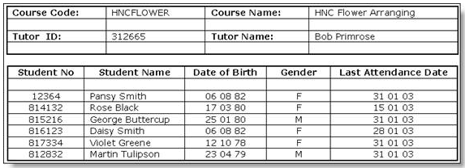
The above table represents a record of all the courses the college provides- each course has one document. Students can pursue various courses, while the teachers can be in charge of multiple courses. Data is repeated more than one time i.e., student no, student name, date of birth, gender, and the last attendance date. Therefore, this is a complex entity because different amounts of students will take different courses (Zazula, 2011). As a result, the system is converted in phases known as the Normal Forms:
- Un-Normalized Form (UNF)
- First Normal Form (1NF)
- Second Normal Form (2NF)
- Third Normal Form (3NF)
However, as earlier mentioned, the simple version of the system that can be integrated into the database is the 3NF version.
Un-Normalized Form (UNF)
In this step, the following is performed:
- Listing the entity’s attributes
- Identifying the unique course code (main key)
- Identifying the set of attributes that are repeating
- Identifying the key from the group repeating.
The process is carried out in a specific document with keys denoted by ( as illustrated below:
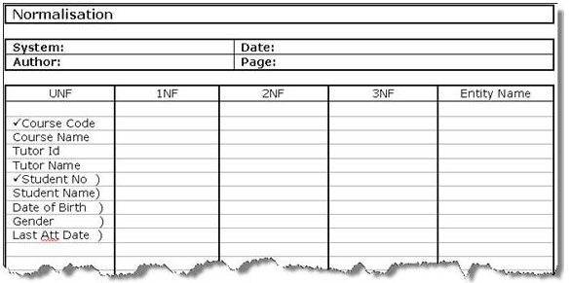
Converting to First Normal Form (1NF)
In this process, we remove all the repeated set of attributes in forming a new entity, and then adding to the original key as shown below:
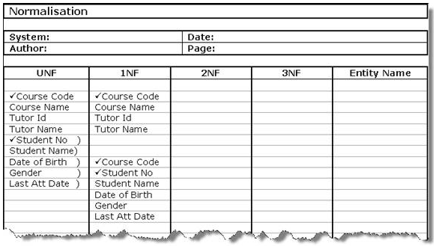
As a result, we have two linked entities by the key of the course code. This implies that every student in the class is reflected in an entry second table; hence, there are no issues with the different students’ numbers (Zazula, 2011).
Converting to Second Normal Form (2NF)
So far, the issue of the inability for storing the document in the database tables has been solved, though there emerged a new issue (Welzer-Družovec, Rozman, & Györkös, 2008). By looking at the table in the 1NF, one will notice that the details of the students are stored. Therefore, if the student is registered on a different course, then a similar information would again be stored in that table, but the student’s details have to be only stored once in the database. Such a condition is evident since various non-key attributes in the table are partly reflected on the table’s key and not the entire key. Therefore, the following should be done:
- Examining the tables with a composite key
- For every non-key attribute, we define whether its key is the 1st part, or the 2nd part, or, if not, then the answer becomes both the parts
- Removing the partial key, including its dependents to obtain a new table.
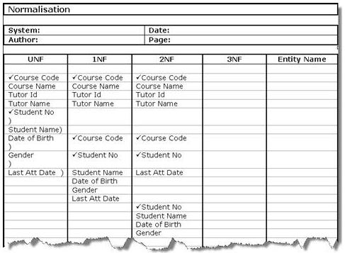
As a result, three tables are in the database, whereby the initial table is already the 2NF since it only involves a single-part key.
Converting to Third Normal Form (3NF)
Occasionally across an entity, there is a key as well as a dependent relation between a set of the non-key attributes. Therefore, it is obvious in the 2NF table that such a relationship exists between the Tutor Id and the Tutor Name. Therefore, in 3NF, they have been removed to obtain a new table (Welzer-Družovec, Rozman, & Györkös, 2008). Failure to conduct the 3NF conversion, then the course details of the tutor would have been repeated every time such a course of a tutor were stored. Therefore, the following have been done:
- Identifying any potential dependencies between the non-key attributes in every table
- Removing them to forming a new table
- Promoting one of the attributes to become the new table’s key that has become the link to a foreign key in the initial table represented by *).
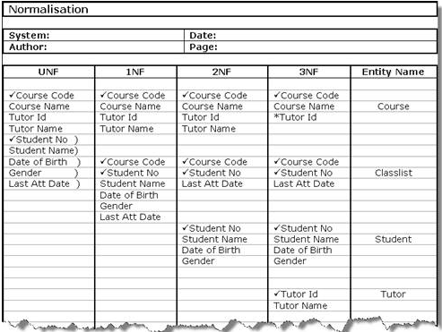
As a result, the database is now complete.
Conclusion
As a fact, the framework for formal thinking concerning database design integrity is a normalization process from a relational theory perspective. Normalization facilitates practical sound prescriptions in evaluating if a dataset for a constant data is the best based on integrity or correctness. Such prescriptions are reflected by the three normal forms (INF, 2NF, and 3NF). Also, rules directly address the integrity, i.e., which states of the database are allowed, and which are not, depending on the business rules.

References
Spruit, M., & de, B. T. (January 01, 2016). Business Intelligence as a Service.
Welzer-Družovec, T., Rozman, I., & Györkös, J. (January 01, 2008). The normalization of relational database. Informatica, 12, 12-15.
Zazula, D. (January 01, 2011). An approach to the distributed database construction. Proceedings, 1065-1068.

