Health information technology management policy.

Abstract.
The purpose of this paper is to sensitize the role of Health Information Management policy in the aspect of technologically driven. The paper will give us ideas on Information Management and Technology in the field of health sector (clement j., 2017).

Introduction.
A research done in the United States of America, Indiana State, it had the nation’s largest Health Information Exchange. The state has one hundred and seventeen hospitals which represents thirty eight health systems. It has a data of ninety two percent of the Indian population, meaning that more than seventeen thousand practices with over forty nine thousand providers. The state of Indiana has over fifteen million patients and a total of twelve point eight clinical data elements in the area. The board compositions in the Indiana health centres include the hospital CEOs, Healthcare Association, Academia, state and the community. The Indiana state has created a spirit of cooperation with the Regenstrief Institute with an effort to accelerate the delivery of Health Information Exchange. This partnership is stated in Article 501 cap 3 under supporting organizations. This partnership was certified by HITA which strongly beliefs that information security should be a core pillar of the broad adoption of health information system and exchanges.
Out of 125 hospitals in Indian, 118 hospitals has data on the 92% of the total population in Indiana. The Regeinstrief through grant needed a supporting entity so they created the IHIS which operates the nation’s largest health information exchange providing a secure, robust and state-wide health information. The system shows that with a total of 117 hospitals it has a total of 12 billion health related data elements.
The scattering of Indiana Health Information Exchange.
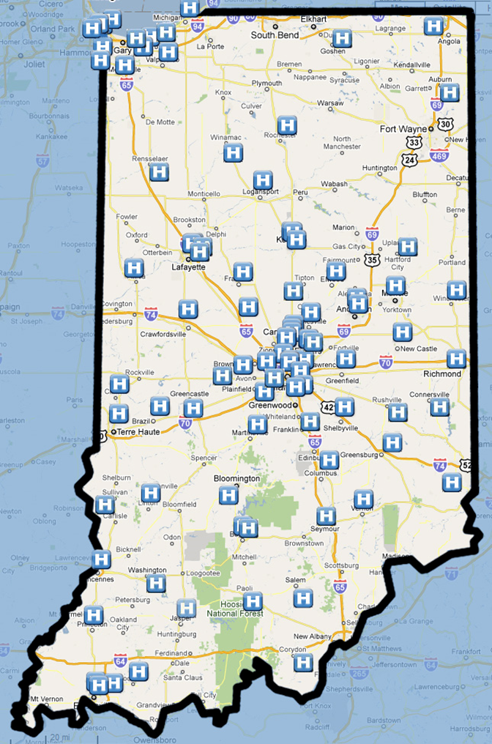
Scattering in the Hospitals.
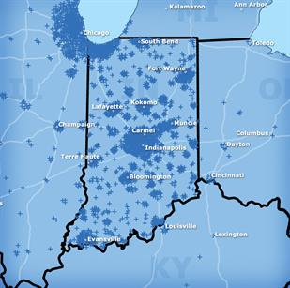
Scattering in physicians practices.
The above scattering shows how the Indiana Health Information Exchange has led to scattering of the patience health records making it even easier to be treated everywhere.
The Indiana Network for Patient Care.
The INPC was the initial data repository at the founding of Indiana Health Information Exchange and it remains the primary source of the clinical data in the system. In the recent analysis done, the number of people with an encounter in the Indiana Network for Patient care has increased. This is because the there has been an increase in the use of IHIE which feeds the data to Indiana Network for Patients.
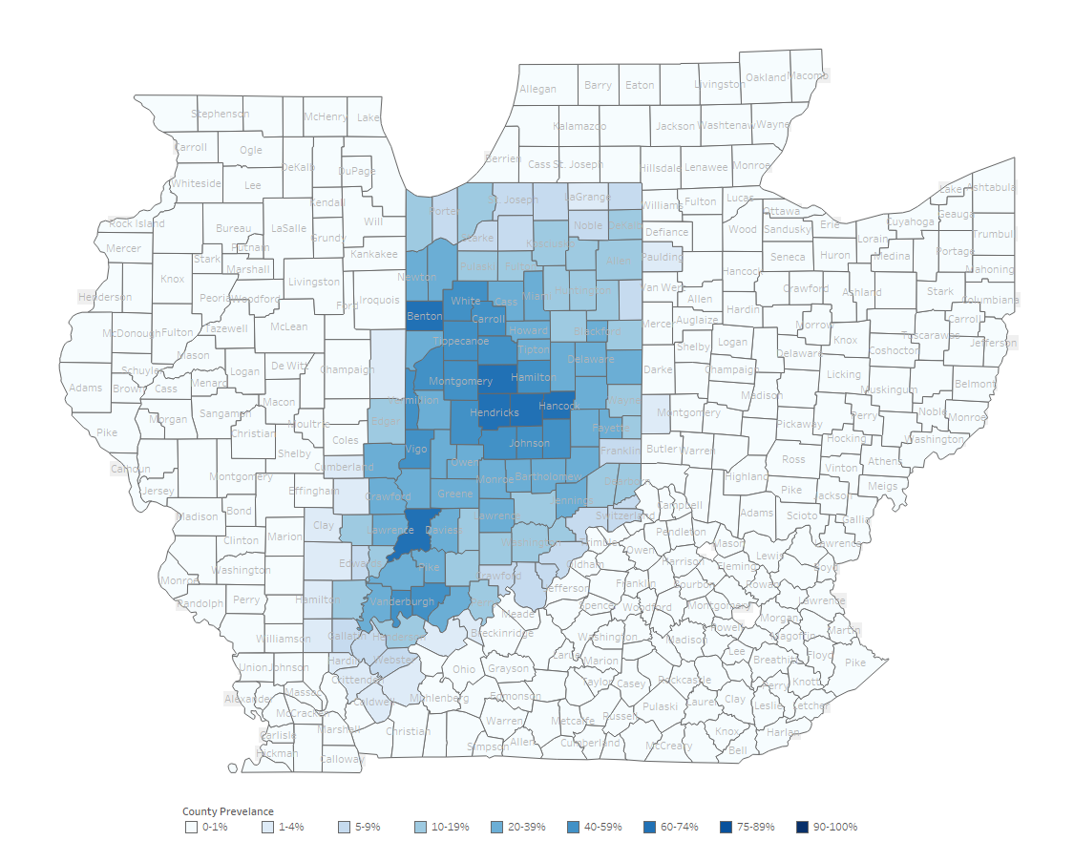
The percentage of the Indiana population with an encounter in INPC in 2010.
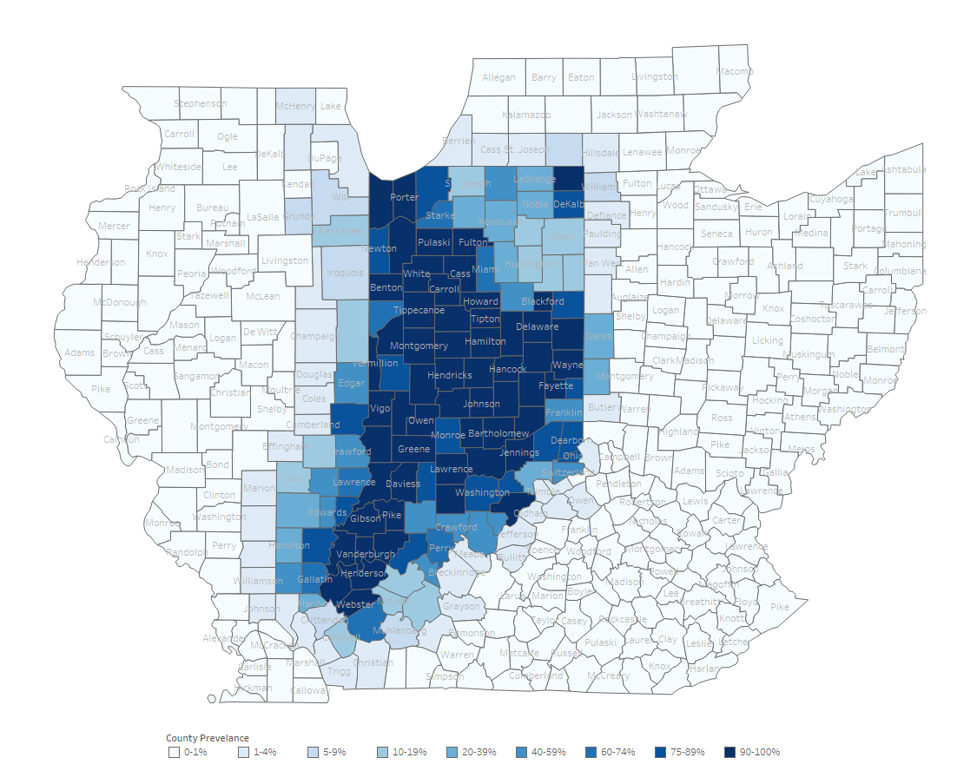The percentage of the Indiana population with an encounter in INPC in 2018.
The footprint of Health Information is fast growing as we add additional services to the community. The major goal of the IHIE is to get data to all folks who touch patient care from birth to death. Today mostly hospitals, insurance providers and physician officers are focused on growing LTC, EMS and employer clinics.
To enable data flowing, public health and government healthcare have adopted the IHIE for proper mapping of the patient’s data.

How HIE Produces value.
The IHIE is a data steward for central resposirity of data through the Indiana Network for Patient Care. IHIE receives data feeds from each of its participating institutions. As data flows in, mapping is done to allow data to be compared and trended with data from another participating continuum. Once mapped, the data is triggered for other continuums to access. IHIE delivers the longitudinal view of that patient records across the entire continuum of care. The information is only accessed by secure VPN so covered from security standpoint. The VPN is governed by INPC committee made up of charter of hospitals. This ensures the security of the patient’s data.

Patience Centred Data Home.
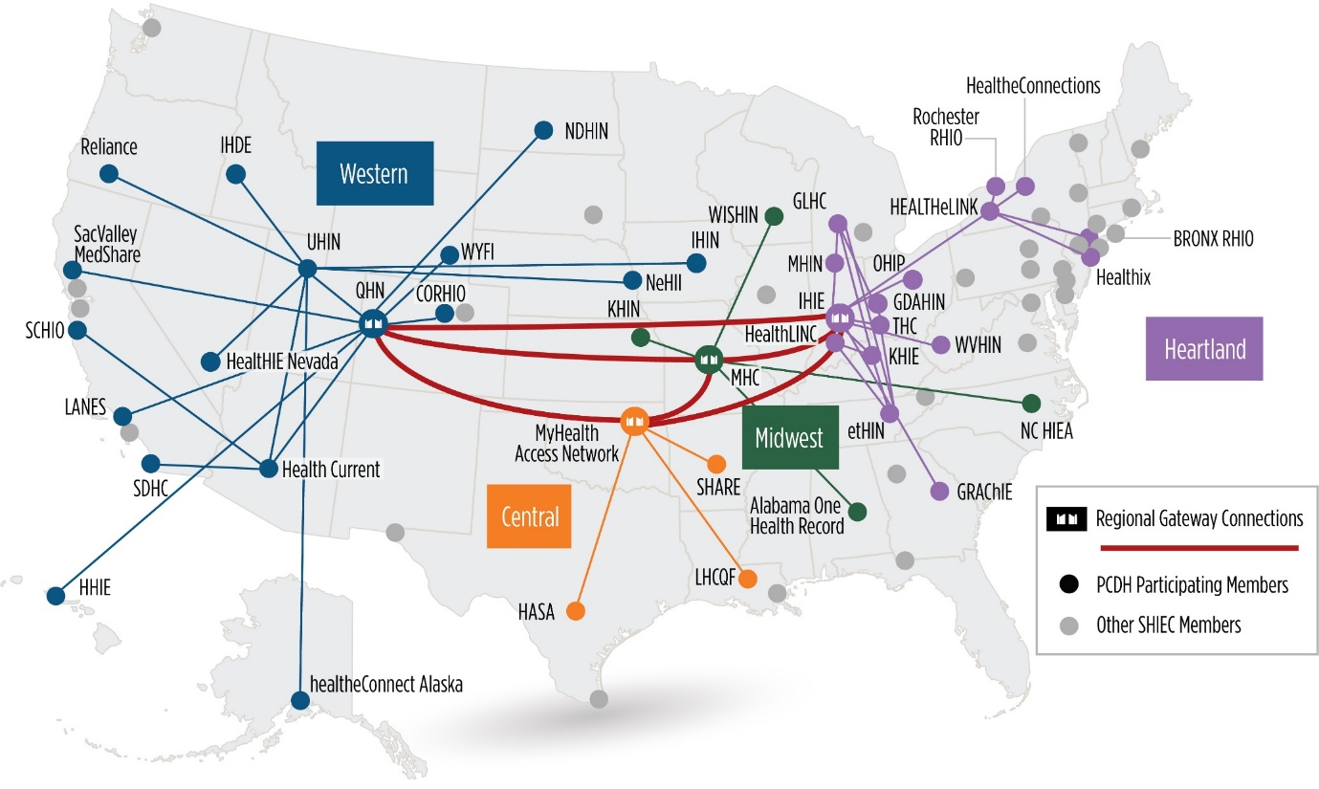
This is over five million data transactions through the PCDH. The PCDH aims to place the patient at the centre of care by making important health data available whenever and wherever care occurs. PCDH, has a collaboration with the Health Information Exchange services which has spearheaded the exchange of health information through the continuums associated with the HIE. PCDH national collaborative, using patient zip codes, we route ADT’s to 26 Health Information Exchange across four regions. IHI is the post office for the geographical region.
This is important because there is better outcomes/process improvement, less duplication, more saved lives like for this case: Saint Francis MD saw a patient for severe stomach pains and was able to read a report from the INPC and knew immediately it was a bleeding aneurysm.

Indiana Health Information Exchange products and services.
- One care- access patient data quickly and securely. Trends the lab data to understand the full story of the patient. Search clinical results data by keyword. Customizes your electronic delivery machines.
CareWeb; a secure, web based application that displays patient information from the Indian Network for Patient Care, IHIE robust clinical data repository. It provides access to critical clinical information when and where it is needed.
Docs4Docs; an electronic results delivery service that offers a single source for clinical information such as lab results, radiology reports, hospital admission reports and more. Results can be viewed through a web based portal or delivered directly into HER system.
- PopCare- this is a track where patient care is delivered. Discrete data within EHRs are accessed. Support quality metric efforts. Manage patient’s transition of care.
ADT alerts; supports the patient/primary provider relationship, address appropriate usage of healthcare resources and ultimately reduce healthcare costs for any managed care organization.
Care; customized form of careweb access to real time and historical INPC community data for a specific segment of the population.
Clinical value; a customized report to assist your organization in care management for specific population and quality metric efforts.

In summary, we are dedicated to improving health care through exchanging important information when it needed most to make better clinical decisions and reduce risk and the cost of healthcare.
Delivering CVR to 55% of the population (minus children and young adults). That’s over half the population in Indiana.
Three services were provided under pop care; ADT alerts when patient is presenting somewhere.

Conclusion.
One among the key questions was how secure was the patients data. The patient data is only available when triggered by events such as user registration in an ED or inpatient environment and it is completely disabled.
The HIE is important as it enables patient data to be accessed everywhere for care (seitz, 2018).

References
clement j., J. M. O. M. B., 2017. Indiana Network for patient care. A working local health information infrastructure, 24(5).
seitz, D., 2018. Indiana Health Information Exchange. Indiana Health Exchange, p. 3.

