Impact of Neoliberalism
Student’s Name
Institution Affiliation

Impact of Neoliberalism
Introduction
Neoliberalism is a socio-economic theory that explores social good is best maximized in unregulated market behaviors (Bacevic 2019). Among Western countries such as the U.S, Neoliberalism is a dominant socio-economic paradigm that has resulted in an extensive impact on all aspects of life. For instance, there has been extensive research on the rapid and fundamental changes that occur in most American colleagues and universities, faculty, and students with much influence on governance, finances, and faculty (Hamilton, Mary and Lyn 2021). These changes are evident in areas such as real dollar state allocation, which are adjustments made based on inflation to higher education, private sources of funding, and prioritization on the revenue generation to aid in applied research. Aside from the institutions, there have been shifts made among students where the students are now conceptualized as customers to different programs offered by the institutions for the exchange of money. Extension of the free-market logic has been criticized by identifying education as a commodity where students receive it in exchange for much is entirely not correct, but rather education is a creative and complex process that requires additional non-monetary costs to attain.
Academic capitalism
Research conducted by Jessop (2017) explores much of the impact of neoliberalism studies has focused on K-12 education. There is little discussion currently ongoing on Neoliberalism's impact on higher education. Nonetheless, there is a growing interest in academic capitalism, which manifests Neoliberalism in different universities and colleges. Academic capitalism entails the involvements of different colleges and universities in different market-like behaviors, which have been on the rise in the last twenty years (Jessop 2017). For instance, there have been attempts made with the transformation of the colleges and universities' basic functions of both teaching and research operations. Different universities have developed a contractual relationship with various universities and colleges in technology transfers where developed knowledge of a project while at the university is directly soled tot eh business. Moreover, colleges and universities are making an entry into the market by developing spin-off which is based on academic research. In these centers, the developed expertise plus its research is patent and licensed and sold to the market similar to consultancy. In both instances, the institutions' education functions have successfully been transformed into commodities that are easily sold to the open market, resulting in assessment, competition, measurements, and much emphasis on the money.
As earlier identified, the shift of primary reasons for education has resulted in substantial changes in students’ motivation and goals to attain their higher education degrees. Education is no longer considered a social good that has intrinsic value but has been designed to be a commodity where students can purchase for their own gain in their respective fields. Furthermore, Neoliberalism recognizes education as extrinsically good, which allows the students to increase their human capital to attain better jobs with better salaries and wealth (Jessop 2017). Unfortunately, with a preference to place much importance on education as an extrinsic goal, it results to lower psychological well-being, which has adverse effects on the students with symptoms such as narcissistic, depression, and anxiousness.
Globalization
The global education system has resulted in different goals for various countries. Some of the aims and importance of global education includes; developing ways of thinking for students to be globalized, develop skills of multi-sided thinking, provide an opportunity for people to work together, help people to criticize events based on a global perspective, and enable students in different schools to attain skills in new cultures. Neoliberalism's impact on higher education in a globalized system illustrates on the education system shifts both on communication system changes, the way education is delivered and roles played by teachers and students.

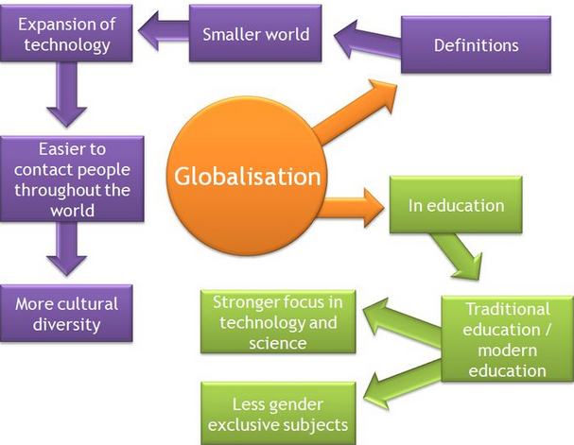
Figure 1 (Steemit 2021)
As illustrated in the image above, on effects of globalization on education have resulted in increased developments in communication and technology, resulting in foreseen changes within the school systems resulting in changes in roles in teachers and students (Steemit 2021). In addition, there has been a shift in society with the education systems seizing from industrialization to an information-based community.
Globalization has resulted in communication developments that are identified to shape the students resulting in ‘global students’ which are also referred to as intelligent people with both skills and knowledge to be competitive in the information-based society (Pipia 2017). Evidently, Neoliberalism has impacted the education system, with students who have studied numerous abroad courses being regarded as more qualified in their respective careers in comparison to the students who have not attained abroad qualifications. The notion of ‘global students’ being regarded as superior over students who have attended local colleges has shifted the employment landscape in numerous counties, with more students now preferring to take secondary papers online from a recognized abroad institution (Pipia 2017). These colleges and universities offering the courses to 'global students' have increased in their profit margins. They do not need to consider the students who take online lessons as part of their physical students; thus, there is no need to increase physical lecture rooms or physical books. This has allowed most of the colleges with online platforms to double their student’s enrolment per year, thus getting more profits.
Moreover, there has been a shift in the mode of delivery. Previously, students were required to attend physical classes for their lessons, but there has been a shift into more online-based lessons for the students. This is an illustration of giving room for electronic literacy with more education materials provided and more programs given for students across the globe. Also, students are being examined based on computer-managed learning systems and tutorial exercises (Pipia 2017). Preference to shift the mode of learning from in-person to more online-based has had both advantages and disadvantages. An advantage with the preferred online platform allows more students to study different abroad courses from their homes. All required is a computer and internet. But there has been a major disadvantage with those who do not have access to the internet or computer being blocked to achieve these online resources. Thus, despite the increase of online scholarships offered by many Ivy League colleges, the students who do not have access to either a computer or internet access are not capable of seizing the opportunity.
Education system's ultimatum
The education system's ultimatum explores unless a student is willing to abide by some set rules, then it will be impossible for them to be considered successful in their respective careers. Ivy League schools have been at the forefront to put demands on the students who wish to make it to join the schools (Iliasu, Jinadu and Kiran 2017). For instance, most ivy league schools have a pass mark, a requirement for all the students who wish to join the schools. Also, for the students who wish to join via scholarships, they have been accorded a respective mark where they have to ensure they attain at all times. Failure to reach the marks, the students will lose their scholarships despite the method they used to get the scholarship. For instance, students who get scholarships for education based on their athletic capabilities are not only required to excel in those sports that enabled them to attain the scholarship, but there is an average grade score set for the students (Iliasu et al. 2017). Therefore, the education system's ultimatum ensures the students are treated as capital gains in the schools they have selected for their studies instead of general interest in educating the community. For instance, once the students join the schools, they are eager, as identified above, to secure the careers that will aid them to get the much-needed opportunity to join their respective dream jobs instead of acquiring general knowledge on how to address different concerns in their neighborhood.
Trickle Down effects
Trickle-down effects in the economy are described as a belief if the high-income earners have an increment in wealth, then the rest of the people in the same community who either directly or indirectly depend on them will benefit (Akinci 2018). This is illustrated with the wealth being filtered through all the sections in the society, as illustrated in the image below.
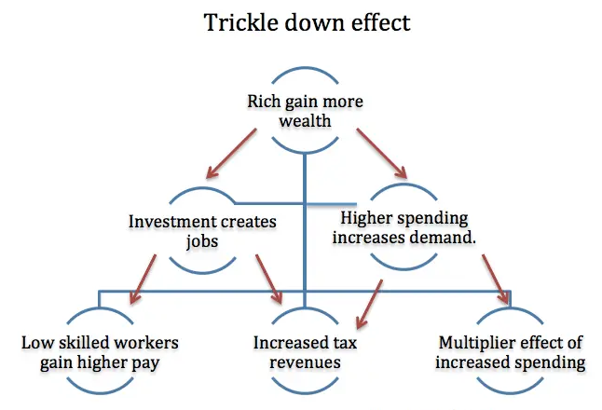
Figure 2: (Pettinger 2021)
Trickle-down effects of changes in education are evident in numerous ways. Some affluent schools, including Harvard, Stanford, and Cambridge, have been in high demand over the years (Pettinger 2021). But for the longest time, these affluent schools preferred to take a smaller number of students with the intent to retain the school's prestige. But in recent times, there has been an increase in the number of students who are taken per year (Partelow et al. 2017). For instance, in most of the Harvard schools, a class has about 42 students, which makes it difficult for the students to hold any meaningful class discussions with ease.
There have been funding cuts that have affected students who depend on students’ loans to make through school (Partelow et al. 2017). With the students now required to pay high tuition, it has shifted the students' narrative to pick their passion as the preferred study program and pick to study based on how marketable their degree will be once they complete schools. Unfortunately, students’ loans have increased in their interest rates over the years, and with limited job posts, it has resulted in students taking longer time to clear their loans hence further dragging the education funding programs.
Overachiever students have been worried if the education they are acquiring now will aid them for future careers (Partelow et al. 2017). This is evident with the fast passed technology shifts, which are requiring students to ensure they handle more than one degree at a time for them to be considered credible for future careers. For instance, accounting students have been required in multiple companies to have a secondary degree in software management (Pettinger 2021). This is preferred with the progressive use of IT in most accounting programs in numerous companies.
On an annual basis, students have been scoring high on their ACT scores to ensure they get into some of the best colleges and universities of choice, but the number has been lower for students in disadvantaged communities due to the prevailing hard economic challenges. Most parents and guardians have emphasized the need for the students to do very well in schools as education is considered the element that will ensure they get out of poverty faster (Partelow et al. 2017). Nonetheless, this has paused grave pressure among students to ensure they perform excellently in their students resulting from increasing substance abuse among college students with preferred use of drugs to enable them to absorb more content. Also, students who have mental issues due to stress have been on the rise, with pressure from the parents on the importance for the students to excel in their careers.
Modernization
Education has directly contributed to modernization, especially in western countries. For instance, human resource is created ad developed by education systems. The kind of employees who are hired in most of the companies is dependent on their qualifications in their fields (Bowman, Mary and Arnold, 2019). Thus, human recourses have the capability to ensure skilled personnel occupies and operate in industrial, economic, technical, and social fields. Based on a country's ability to have high-powered human resources, it is possible to contribute to its national wealth based on its productive and creative efforts. Thus, Neoliberalism has been applied across industries to ensure preferred education allows the employees to acquire the needed skills, knowledge, and attitudes which further accelerate the pace of modernization in a respective country. Furthermore, Neoliberalism's impact on education has challenged traditional thinking by changing how things are done, attitudes, habits, and values (Bowman et al. 2019). This further attributed to broadening the mental horizon in both employees' experimentation and innovation. The current education system has allowed individuals to be broad-minded and allowed most to stimulate their thinking and ensure they accept new ways of doing things.
Neoliberalism's impact on education has developed a powerful force of modernization to allow the development of national outlook and international understanding. For instance, global students can learn of the different latest developments in technology, social, economic, cultural, and scientific domain of respective persons. Thus, it is easier for students to ensure they attain both emotional and national integration, which is identified as the primary base for uniting the person for the development of their cultural, national-social, and political aspects in their respective communities.
Education plays an integral role in fostering a democratic and secular outlook ad vision for the students. Secular attitudes help students to develop the needed respect for all religions across the nations. Neoliberalism has played a fundamental role for the students to acquire education for the sake but ensure that once the needed education qualification has been attained, the students can travel globally to use their education (Bowman et al. 2019). Democratic attitudes are essential to enable individuals to live in the community and be successful in their ventures without feeling any form of disadvantage. For instance, Neoliberalism impacts education by allowing all students in the community to be treated as equal. All students have an equal chance to convert their education to a form of capital. This is essential as it promoted the need to have the students regard their education as an avenue to attain their desired careers in the future.

Conclusion
In summary, the study has explored how Neoliberalism has impacted the education system both directly and indirectly. Globalization has promoted the development of global students who are considered more advanced based on the number of globally recognized certificates they have for their respective careers in comparison to the students who only have local certificates. Education has directly impacted modernization with different students’ preference to consider respective careers they excel in with ease and have acquired the much needed human resources in respective careers. Trickle-down effects have impacted the college students in regards to the loans being cut off, increase in the number of students per class, and preference for Ivy League schools to pick only a particular number of students with respective marks. Academic capitalism has promoted the students to only pick on programs and courses they regard to be marketable. They can easily get the desired jobs with ease to attain desired salaries instead of having a general interest in education.

References
Akinci, Merter. 2018. "Inequality and economic growth: Trickle‐down effect revisited." Development Policy Review 36: O1-O24.
Bacevic, Jana. 2019. "Knowing neoliberalism." Social Epistemology 33(4): 380-392.
Bowman, Mary Jean, and C. Arnold Anderson. 2019. Human capital and economic modernization in historical perspective." In Fourth International Conference of Economic History, Bloomington 1968/Quatrième Conférence Internationale d’Histoire Économique, pp. 247-272. De Gruyter Mouton.
Hamilton, Mary, and Lyn Tett, eds. 2021. Resisting neoliberalism in education: Local, national and transnational perspectives. Policy Press.
Iliasu, Jinadu, and Kiran Kaur. 2017. "Shut Down the University! -The ultimatum for quality undergraduates." Qualitative and Quantitative Methods in Libraries 3(4): 987-1000.
Jessop, Bob. 2017. "Varieties of academic capitalism and entrepreneurial universities." Higher Education 73(6): 853-870.
Partelow, Lisette, Meg Benner, Michael Dannenberg, and Charles Barone. 2017. "Trickle-Down Cuts to Education." Center for American Progress.
Pettinger, Tejvan. 2021. Trickledown economics - Economics Help. Retrieved 15 April 2021, from https://www.economicshelp.org/blog/174/economics/trickle-down-economics/
Pipia, Ekaterine. 2017. "The impact of globalization and internationalization on education in Georgia." European Journal of Education Studies 3(5).
Steemit. 2021. Globalization and its impact on education. Retrieved 15 April 2021, from https://steemit.com/education/@imbsnt/globalization-and-its-impact-on-education

