Nepal: A Poverty-Reduction Strategy
Student’s Name
Institution

Nepal: A Poverty-Reduction Strategy
Introduction
Nepal is a landlocked Asian country, located on the slopes of the southern Himalayan mountain ranges. The country is bordered eastwards, westwards and southwards by India and surrounded by China to the north. With the capital city at Kathmandu, the country’s extent covers a stretch of approximately eight-hundred kilometers from the east to west, and another stretch of ninety to one-hundred and fifty miles from the north to the south (Rose, Proud, Zuberi, & Karan, 2018).
Historically, Nepal had been cut off from the exposure to the outside world by the hereditary rule of the prime ministers, which greatly enhanced the policy of isolation. However, this autonomous rule came to an end in the year 1950 following a palace revolt that saw the regaining of the crown’s authority in the year 1951 (Rose et al., 2018). The country’s journey to diversity gained a full-fledge in the year 1991 when it adopted a multiparty parliamentary system for its electoral processes. Nevertheless, this declaration was followed by a period of political instability, which was characterized by “violence and turbulent negotiation with a strong Maoist insurgency.” After a decade of continual volatility, the country re-stabilized in the year 2008 after the monarchy was broken up and Nepal was declared as a free democratic republic (Rose et al., 2018).
The country’s political instability, among many other factors, have been listed as the major contributors to its retarded economic growth and the subsequent high levels of poverty. This paper outlines some of these challenges, establishing the most common causes of poverty and highlights the possible recommendations to rid the country of a long-standing plague- poverty.
Brief Description of the Country’s Economy and the Poverty Profile
Nepal’s efforts to maintain its own independence are heightened by the fact that it is sandwiched between two economic giants: India and China, which forces it to struggle in maintaining its foreign policy. However, Nepal remains of a great geopolitical importance since it acts as a link between China and the rich Gangetic Plain, marking the southern boundary of the Chinese sphere, towards the north of the Himalayas mountains in Asia (Rose et al., 2018). Thus, this implies that if the country grows stronger, it could easily cut off China from gaining access to this highly treasured location, depriving its economic growth.
For a very long period, Nepal has remained geographically separated from other regions, together with its self-imposed isolation. These factors have greatly contributed to the country’s slow economic growth, thus, attributing to the high poverty levels (“Why is Nepal a Poor Country?,” 2018). As a result, Nepal is among the poorest countries in the world. Through various means, many countries such as the United States, China, Germany, Canada, among others, have been providing economic aid to the economically unstable Nepal to boost its stability. Additionally, the country’s strategic location between China and India has been of great importance in facilitating its acquisition of economic aid from the two regions (Rose et al., 2018).
Currently, it is estimated that nearly 38% of the Nepalese population falls under the poverty line (“Why is Nepal a Poor Country?,” 2018). This implies that such a country’s big population do not have a sufficient income to sustain their basic needs. Although there have been efforts to minimize the poverty levels, the rates still remain high. The high rates of poverty in the country have resulted to other economic threats such as overpopulation and illiteracy, which further enhance the poverty cycle. Despite the presence of isolated cases of extremely rich personalities, the country remains as poor due to poverty among the majority of its citizens (“Why is Nepal a Poor Country?,” 2018).
The deterioration in the country’s economy has had various other outcomes that impact directly to its citizens’ well-being. For instance, majority of the country’s youths evade to the neighboring states to seek for employment (“Why is Nepal a Poor Country?,” 2018). Since this is the population that is essential in building the country’s economy, there still remains a challenge in the efforts to reclaim the country’s economic stability. The education system is also poorly developed, compelling learners to seek education from other countries such as the United States and Canada (“Why is Nepal a Poor Country?,” 2018). As a result, the country’s economic growth remains compromised. However, it is essential to establish some of the contributing factors to this state in order to come up with strategic recommendations that can help to ouster the country from its economic synergy.
Causes of Poverty in Nepal
Nepal, hailing from the southern parts of Asia, is among the poorest countries in the region and rated as the twelfth poorest country worldwide with an average GDP of close to US$260. Although the country has strived and managed a continuous positive growth in the recent years, its economic scale is still below the expected measure and poverty still razes across the country. Among the factors that have been rated as the top causes of poverty in Nepal are the social, political and cultural transitions that the country has progressively experienced. The country hosts one of the world’s most ancient cultures, with an approximate population of twenty-nine million people (Nikku & Azman, 2014).
Among the leading causes of poverty in Nepal is the country’s prolonged political instability. Despite the absence of foreign interference with its political matters, the country has, for a long time, remained without any established political structures in place. Although there have been some significant changes in the political system, the current instability is still a considerable threat to the country’s economic growth. For instance, the country started to display some kind of reformation following a transition from the Panchayat system to a more streamlined democratic one (“Why is Nepal a Poor Country?,” 2018). Later on, the invasion with the Maoist insurgency further crippled the country both politically and economically after a series of endless wars (“Why is Nepal a Poor Country?,” 2018). Majority of the Nepalese locals also lost their lives during this era. As the country was recovering from a violent insurgency era, there was an introduction of the monarchical system, which caused further disorientation and sunk the country into an economic crisis. The turnout of the political events in Nepal have, therefore, been among the major contributors to the country’s current poor state. However, the country has of late been transformed into a federal republic, which offers a significant hope of it becoming politically and economically stable again (“Why is Nepal a Poor Country?,” 2018).
Secondly, just like many developing countries, Nepal’s economic underdevelopment has been greatly contributed to by the excruciatingly high levels of corruption. The country ranks third in terms of corruption among the south Asian countries (“Why is Nepal a Poor Country?,” 2018). Bureaucratic corruption has been reported in almost every sector in the country, with bribes being given for any service in public offices. Additionally, other forms of corruption, including nepotism, have been reported a rampant in the country’s operational sectors as public officers adamantly squander public resources. Utterly falsified data on expenditures provided during the audits present an unrealistic state of the nation while the country continues to anguish in the depths of bizarre poverty (Rose et al., 2018)
Thirdly, it is evident that Nepal has significantly high amounts of natural and water resources. However, the country lacks adequate industrial developments to harness the natural resources for its economic development. In the long run, most of its natural resources end up being exported to the neighboring highly-industrialized India. In return, the country imports manufactured items from China at higher costs since it lacks even the basic manufacturing unit. The inability to control and utilize its own resources has been among the contributors to poverty among the majority of the Nepalese locals.
Nepal’s geographical presentation in terms of relief has also been among the contributors to the country’s retarded economic growth. The country is characterized by some of the most rugged and sloppy landscapes worldwide, with steep mountains covering up to seventy-five percent of the total land (Rose et al., 2018). The country is generally divided into four physical locations: Tarai, the flat and agriculturally fertile land bordering India; Churia, which is covered with forests and foothills; the land neighboring the Great Himalayas and the Great Himalaya Range. Since most of the land is under forests and sloping mountains, only a smaller arable location is left at Tarai for meaningful farming. Farming is described as the main economic activity in Nepal, but the practice is grossly outdated and greatly hindered by the rough landscape (Rose et al., 2018).
Due to nature of the country’s terrain, Nepal has severally encountered severe natural disasters that have significantly taken its economy aback. For instance, a massive earthquake hit the country in 2015, leading to thousands of deaths together with destruction of an unmeasurable amount of property (“Why is Nepal a Poor Country?,” 2018). Severally, the country has also experienced destructive landslides that often block or damage roads, destroy property and cause casualties and deaths. Flood-prone areas such as the Terai region are also a threat to the country’s economy as a result of frequent property destruction (“Why is Nepal a Poor Country?,” 2018). These natural calamities often hinder the development of any major economic resource in the country’s most prone areas. Huge amounts of money are as well utilized in the preparation for calamities and the rehabilitation of the destroyed amenities, depriving the country the ability to foster its economic plans. Additionally, some of the resourceful people are killed in the disasters, thus, leaving the country in its poor state.
In general, Nepal’s poverty level can be summarized into various factors such as high illiteracy levels, poor states of health and sanitation, underproduction of food grain, high malnutrition levels among children, low accessibility to basic services and well as insufficiencies from the tough traditions that run the social lives of the Nepalese majorities (Shah, 2015).
Possible Remedies for the Nepalese Poverty Disaster and the Government Policies
Since an end was put to the violent insurgency and the monarchical systems in Nepal, much has been going on, both at national and local levels, to alleviate poverty and return normalcy in Nepal. As noted by Shah (2015), people realized that the fight to reduce poverty levels is their own, and that “people can correct their economic situation–get richer–if they tried harder not to remain poor.” Therefore, it is not a matter of being lucky or unlucky, but the reason behind the differences in extremely rich countries like Singapore and the highly poor states such as Nepal is the variations in their public service delivery efficiencies and the differences in the institutional qualities (Shah, 2015). Therefore, the best solution is neither to formulate new policies nor construct new institutions, but to streamline the existing ones and make them more functional (Shah, 2015).
The Poverty Reduction Strategy Paper (PRSP) developed by IMF advisory to the Nepalese government indicate various strategies that would direct the government towards the long-term reduction of the poverty levels. The Tenth Plan outlined in the country’s Poverty Reduction Strategy (PRS) highlighted various important features, which included the recognition of the role played by the local bodied and the non-governmental organizations in the development of the national economy; the use of modern planning tools as well as logical frameworks in the evaluation of the institutional duties; clear definition of the priorities in P1, P2 and P3 projects in poverty alleviation and the extensive investment in monitoring and evaluation programs to assess the progress of the poverty alleviation strategies and programs (Fund, 2005).
Currently, the governmental PRSP is supported by various pillars, which are directed towards the commitment to ensure the levels of poverty are greatly reduced in Nepal. First the PRSP is supported by the “high broad-based and sustained economic growth” pillar, which solicit resources to facilitate the economic growth programs (Fund, 2005). The second pillar is targeted at the improvement in the accessibility and high quality infrastructure, social and economic services especially in the rural settings to help boost their economic sustainability (Fund, 2005). Thirdly, the PRSP is supported by the pillar of appropriate governance that facilitates delivery of the services, the “efficiency, transparency and accountability” in dealing with the country’s poverty alleviation programs (Fund, 2005).
To facilitate the healing process from the pangs of poverty that the country faces, the Nepalese government should be able to implement the other strategies suggested in the bid to attain the Millennium Development Goals (MDGs). These strategies aim at creating a sustainable macroeconomic stability by facilitating the structural and policy reforms, especially in the areas that have a direct influence on the country’s economic performance. In the first place, the government should promote a fast track in the non-agricultural growth aiming at the creation of an ample environment that can support both local and foreign investment. This is possible through the compliance with the economic policies as well as promoting the agricultural performance, which is essential in raising the income, provision of employment opportunities and boosting food security, especially in the rural areas (Fund, 2005).
Secondly, the government should focus on the improvement of the availability and the accessibility to the quality infrastructure, together with both social and economic services. Since the rural areas are the ones greatly hit by high poverty levels, the government should be committed to ensuring the provision good roads, reliable electrification and the improvement in the communication services that would guarantee a sustainable economic growth and service delivery in these areas (Fund, 2005). Thirdly, there should be a recognition that there are socially marginalized communities in the country, such as the Dalits, Janjatis, Muslims as well as women in general, who require special attention regarding to economic development strategies (Nikku & Azman, 2014). Attention should also be paid to the highly vulnerable groups such as children, widows, internal refugees among others, by facilitating their accessibility to essential services like education, healthcare as well as other economic opportunities that would empower them and contribute towards fostering the national economic growth.
Studies have also shown that women involvement in the self-help organizations would as well facilitate the growth of the country’s economy. This follows an observation of continuous disparities in the employment rates between women and men, which is evident that women demonstrated lower rates of employment as compared to men (Atteraya, Gnawali, & Palley, 2016). Creation of self-help groups and motivating women to join would help in the creation of employment opportunities and facilitate the reduction of the unemployment rates among the Nepalese women (Atteraya, Gnawali, & Palley, 2016). Higher economic growth rate has also been associated with gender-based groups (Atteraya et al., 2016). Therefore, it is recommendable that the government, together with the existing NGOs to take this initiative of creating women-affiliated self-help groups to facilitate the process of poverty alleviation.
Additionally, studies have demonstrated that the remittances given to the country by its citizens working in other countries were also essential in growing the country’s economy. This comes after it was demonstrated that remittances collected from the expatriates was growing at the rate of 30% annually, and it as well from less than 3% in the year 1995 to nearly 15% towards the close of 2003, a higher generation than any other source of income like tourism, exports among others (Lokshin, Bontch-Osmolovski, & Glinskaya, 2010). Over one million of Nepalese prime-age citizens work in other countries outside of Nepal, most of which are males. However, there have not been specific policies regarding the collection and utilization if the remittances collected from the expatriates. Formulation of policies, encouraging such numbers and facilitating the rates at which remittances are paid and utilized would help grow the country’s economy with a bigger margin (Lokshin, Bontch-Osmolovski, & Glinskaya, 2010).
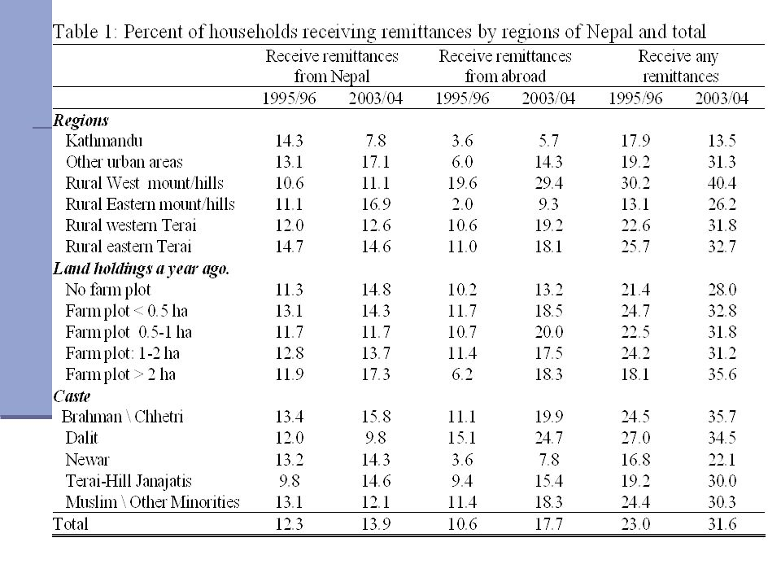Source: http://slideplayer.com/slide/7003127/
In conclusion, Nepal’s ranking third among the poorest countries in South Asia follows a series of political wars among other social and economic difficulties. However, since the violent insurgency and monarchical eras were put to end and the country declared a free republic, there have been great efforts to revive the country from poverty and help it grow economically. Basing on the current status of the country, it is recommended that that the government take an initiative of sealing the loopholes and implementing the existing policies rather than developing new policies. Together with the aid coming from the neighboring states, the commitment by the government to alleviate poverty will finally bear fruits.

References
Atteraya, M. S., Gnawali, S., & Palley, E. (2016). Women’s participation in self-help groups as a pathway to women’s empowerment: A case of Nepal. International Journal of Social Welfare, 25(4), 321–330. https://doi.org/10.1111/ijsw.12212
Fund, I. M. (2005). Nepal: Poverty Reduction Strategy Paper Progress Report. International Monetary Fund.
Lokshin, M., Bontch-Osmolovski, M., & Glinskaya, E. (2010). Work-Related Migration and Poverty Reduction in Nepal. Review of Development Economics, 14(2), 323–332. https://doi.org/10.1111/j.1467-9361.2010.00555.x
Nikku, B. R., & Azman, A. (2014). Politics, Policy and Poverty in Nepal. Horizon Research Publishing, 2(2), 1–9. Retrieved from https://www.google.com/url?sa=t&rct=j&q=&esrc=s&source=web&cd=4&ved=0ahUKEwjCtLabuaXaAhWkAsAKHQbPBLgQFghJMAM&url=http%3A%2F%2Fwww.hrpub.org%2Fdownload%2F20140405%2FIJRH1-19290002.pdf&usg=AOvVaw0Zb3NE0HuxJlrbBfbj7Bzo
Rose, L., Proud, R. R., Zuberi, M., & Karan, P. (2018). Nepal | Culture, History, & People. Retrieved April 6, 2018, from https://www.britannica.com/place/Nepal
Shah, S. (2015). Nepal’S Enduring Poverty: Non-Economic Barriers to Economic Growth. AuthorHouse.
Why is Nepal a Poor Country? Top 10 Causes of Poverty. (2018, January 3). Retrieved April 6, 2018, from https://www.merokalam.com/why-nepal-poor-country/

