Network Design Proposal
Network Design Proposal

Prepared for:
University of Maryland University College

Prepared by:
Student Name

I. Network Design

A. Network Topology

Technical Requirements

In this section, the physical topology demonstrates the direction of the physical design implementation and illustrates the major points of the network upgrade, which includes the devices, locations, and cable installation.
In the 2 server rooms of the building, the mainframe and the servers are in place. The mainframe connects to the servers. The managed switches from the different floors then connect to the mainframe.
The physical design has the following features:
- The building is equipped with Category 6e cabling and wall plates in the offices, classrooms, labs, and so on.
- Within the building, managed switches are used. Managed switches give more control over LAN traffic and offer advanced features to control that traffic. It provides the ability to configure, manage, and monitor LAN and this gives greater control over how data travels over the network and who has access to it. In addition, managed switches use protocols such as the Simple Network Management Protocol, or what we call SNMP, for monitoring the devices on the network. SNMP is a protocol that facilitates the exchange of management information between network devices. SNMP queries can determine the health of the network or the status of a particular device. By displaying this data in an easily understood format, IT managers located at a central site can monitor the performance of the network and quickly detect and repair network problems without having to physically interact with the switch.
- A separate router is used in the other floor. The sole purpose of this router is to manage the VLAN of the School in order to prevent the students from accessing the critical information of the such as administrative information.
- The ISP stands for Internet Service Provider. These are companies that provide access to the Internet.
- The firewall is a device designed to permit or deny network transmissions based upon a set of rules and is frequently used to protect networks from unauthorized access while permitting legitimate communications to pass.
Proposed Topology

A star topology is a topology for a Local Area Network (LAN) in which all nodes are individually connected to a central connection point, like a hub or a switch. A star takes more cable than e.g. a bus, but the benefit is that if a cable fails, only one node will be brought down.
In this configuration, every node connects to a central network device, like a hub, switch, or computer. The central network device acts as a server and the peripheral devices act as clients. Depending on the type of network card used in each computer of the star topology, a coaxial cable or an RJ-45 network cable is used to connect computers together.
Advantages of star topology
- Centralized management of the network, through the use of the central computer, hub, or switch.
- Easy to add another computer to the network.
- If one computer on the network fails, the rest of the network continues to function normally.
Disadvantages of star topology
- May have a higher cost to implement, especially when using a switch or router as the central network device.
- The central network device determines the performance and number of nodes the network can handle.
- If the central computer, hub, or switch fails, the entire network goes down and all computers are disconnected from the network.
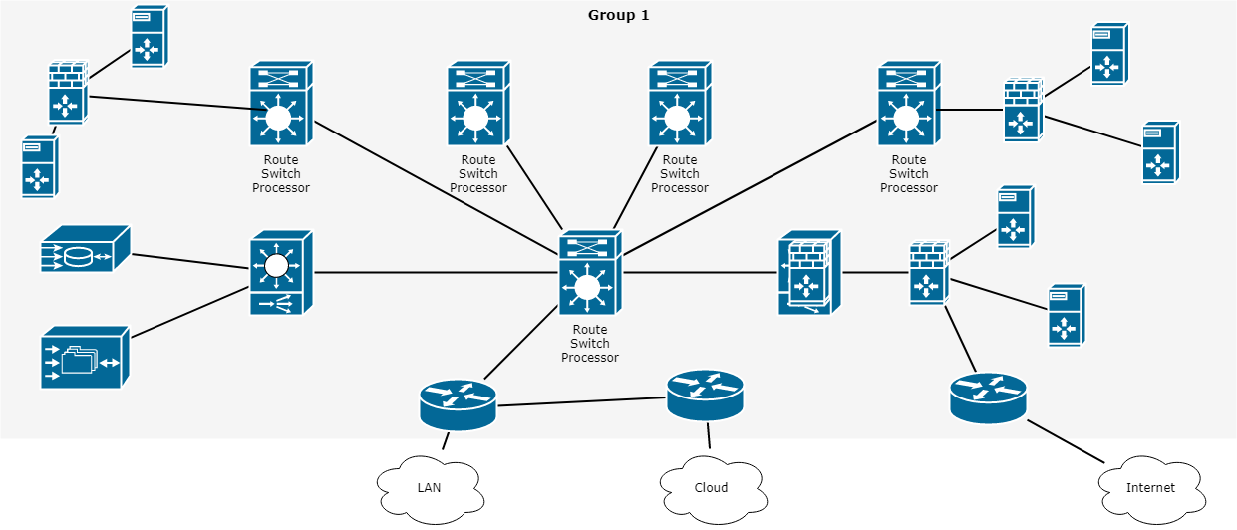

Justification

This section should be used to justify your proposed solution based on the requirement(s). That is, you are explaining why you proposed the solution in the aforementioned paragraph, based on the technical requirement you made explicit in aforementioned paragraph.

Example (Note: The paragraph that follows is an example. It is expected that students will use this as a reference only. Remember to include references and cite your work according to IEEE-style format.)

Secure Network Contractors believes that a ring topology is the best solution based on the requirements described by the University of Maryland University College (UMUC). Specifically, the requirement that data flows in one direction, reducing the chance of packet collisions. The ring topology reduce the need for network servers because they are not needed to control network connectivity between each workstation. Etc. (students should continue to explain their proposal).

B. Cables and Connectors

Note: (Students should consider the needs for both a wired and wireless implementation as your proposal should include both.)

Technical Requirements

Cat 6 cables or to give them their full name category 6 cable is the current preferred cable type for LAN network and telephone wiring where twisted pair cabling is required. Cat 6 cables consist of an unshielded cable comprising four twisted pairs, typically of 24 gauge wire. The terminating connector is an RJ-45 jack. In view of this these Cat5 network cables are often referred to as RJ45 network cables or RJ45 patch cables. Certified Cat-6 cables will have the wording "Cat-6" written on the side. As they conform to EIA/TIA 568A-5, this is written on the outer sheath. It is always best to use the appropriate network cables when setting up a network as faulty or not to standard cables can cause problems that may be difficult to identify and trace.

Cat 6 network cable is now the standard form of twisted pair cable and supersedes Cat 3. The Cat 6 cables can be used for data speeds up to 125 Mbps, thereby enabling them to support 100Base-T which has a maximum data speed of 100 Mbps whereas the Cat-3 cable was designed to be compatible with 10Base-T. The Cat6 cable is able to support working up to lengths of 100 metres at the full data rate.

Where it is necessary to operate at higher speeds, as in the case of Gigabit Ethernet, an enhanced version of Cat 6 cable known as Cat 6e is often recommended, although Cat 6 is specified to operate with Gigabit Ethernet, 1000Base-T. Alternatively Cat 6e can be used with 100Base-T to enable greater lengths (up to 350 metres) to be achieved.
Proposed Cables and Connectors

Unshielded Twisted Pair (UTP) - This is the most popular form of cables in the network and the cheapest form that you can go with. The UTP has four pairs of wires and all inside plastic sheathing. The biggest reason that we call it Twisted Pair is to protect the wires from interference from themselves. Each wire is only protected with a thin plastic sheath.

Justification

This section should be used to justify your proposed solution based on the technical requirements and assumptions., The justification should explain why you chose what you did and how it meets the UMUC’s goals for training and presentation to students

C. Networking and Internetworking Hardware

Technical Requirements

In this section, you will assess UMUC’s technical requirements related to networking and internetworking hardware. You will need to make assumptions where appropriate. When making assumptions, list each and make sure to justify the solution in the Justification section.

Proposed Networking and Internetworking Devices

Network Hub: Network Hub is a networking device which is used to connect multiple network hosts. A network hub is also used to do data transfer. The data is transferred in terms of packets on a computer network. So, when a host sends a data packet to a network hub, the hub copies the data packet to all of its ports connected to. Like this, all the ports know about the data and the port for whom the packet is intended, claims the packet.
Network Switch: Like a hub, a switch also works at the layer of LAN (Local Area Network) but you can say that a switch is more intelligent than a hub. While hub just does the work of data forwarding, a switch does 'filter and forwarding' which is a more intelligent way of dealing with the data packets.
Justification

This section should be used to justify your proposed solution based on the technical requirements and assumptions.

D. Wide Area Network (WAN) Design

Technical Requirements

In this section, you will assess UMUC’s technical requirements related to the Wide Area Network (WAN) design. You will need to make assumptions where appropriate. When making assumptions, list each and make sure to justify the solution in the Justification section.

Proposed Wide Area Network (WAN) Design

This section should be used to provide the details of your proposed Internet Service Provider (ISP) solution. Be sure to cover what options are available through leased lines, metro Ethernet, and dedicated connections are based on the technical requirements and assumptions. Students should connect to the ISP with two different technologies. Student should be specific when discussing the models, types, and costs.

Justification

This section should be used to justify your proposed solution based on the technical requirements and assumptions.

E. Computer Systems Hardware

Technical Requirements

In this section, you will assess UMUC’s technical requirements related to the computer systems hardware for both classroom end points and servers as well as what would be needed for dedicated IT use. You will need to make assumptions where appropriate. When making assumptions, list each and make sure to justify the solution in the Justification section.

Proposed Computer Systems Hardware

This section should be used to provide the details of your proposed solution, based on the technical requirements and assumptions. Student should be specific when discussing the models, types, and costs.

Justification

This section should be used to justify your proposed solution based on the technical requirements and assumptions.

II. Network Addressing and Security

A. Subnetting

Overview

Subnetting is a process of breaking a large network into small networks known as subnets. Subnetting happens when we extend the default boundary of the subnet mask. Basically, we borrow host bits to create networks (i.e., subnets).

We have been assigned the network address 192.168.22.0. Based on the chart below, we know this is a Class C address. This is determined by observing the first octet of the IP address, which is 192. This octet falls in between 192 and 223.

Class | Octet Decimal Range
A | 1 - 126
B | 128 - 191
C | 192 - 223

Each class has a predefined default subnet mask that tells us the octets, which are already part of the network portion, as well as how many bits we have available to work with.

Class | Subnet Mask | Format
A | 255.0.0.0 | Network.Host.Host.Host
B | 255.255.0.0 | Network.Network.Host.Host
C | 255.255.255.0 | Network.Network.Network.Host

CIDR (Classless Inter Domain Routing)

CIDR is a slash notation of the subnet mask. CIDR tells us the number of on bits in a network address.

- Class A has default subnet mask 255.0.0.0. that means first octet of the subnet mask has all on bits. In slash notation, it would be written as /8, means address has 8 bits on.

- Class B has default subnet mask 255.255.0.0. that means first two octets of the subnet mask have all on bits. In slash notation, it would be written as /16, means address has 16 bits on.

- Class C has default subnet mask 255.255.255.0. that means first three octets of the subnet mask have all on bits. In slash notation, it would be written as /24, means address has 24 bits on.

Technical Requirements

UMUC has not decided how they will use all of the physical space within the newly leased building, but the diagrams below convey the proposed end state. However, they have decided to use some of the space in the short term. In doing so, we will proceed with the proposed plan. Initially, the building will house 5 classrooms, 1 student computer lab, 1 library, and 1 office.

- In the below building diagrams, we will use Office 5 (Admissions) on the first floor. Each office will have 1 computer for staff use, with the exception of the admissions office, which will have 5 computers. Based on the subnetting performed above, we may be able to add more devices in the future.

- The classrooms are labeled Classroom #1, Classroom #2, and Classroom #4 on the first floor and Classroom #1 and Classroom #5 on the second floor; each classroom will have a closet. Each classroom will have 25 devices: 23 student computers, 1 instructor computer, and 1 server in the closet, for instructional use.

- Students should consider high traffic areas for Wi-Fi, such as the sitting areas and not the classrooms. The Wi-Fi network should be segregated from the wired network and implemented on a separate Class C network. What will the network address, range, and broadcast address for this separate Class C wireless address be?

- In addition, there will be a student computer lab that will provide computer access to students to do their homework. The student computer lab is located on the second floor. There will be 24 computers in this lab and 1 server in the closet.

- To allow students access to library resources, the library will also have 10 computers for the general public to use and 5 computers for library staff.

- There will be two server rooms, one on the first floor and one on the second floor.

To be clear, the diagram below conveys the proposed end state.

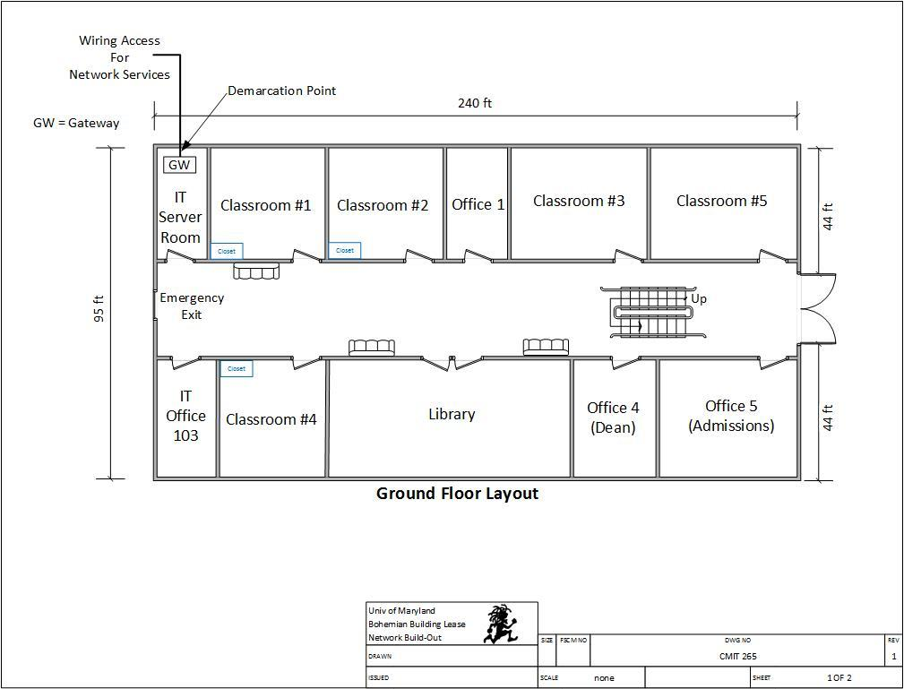

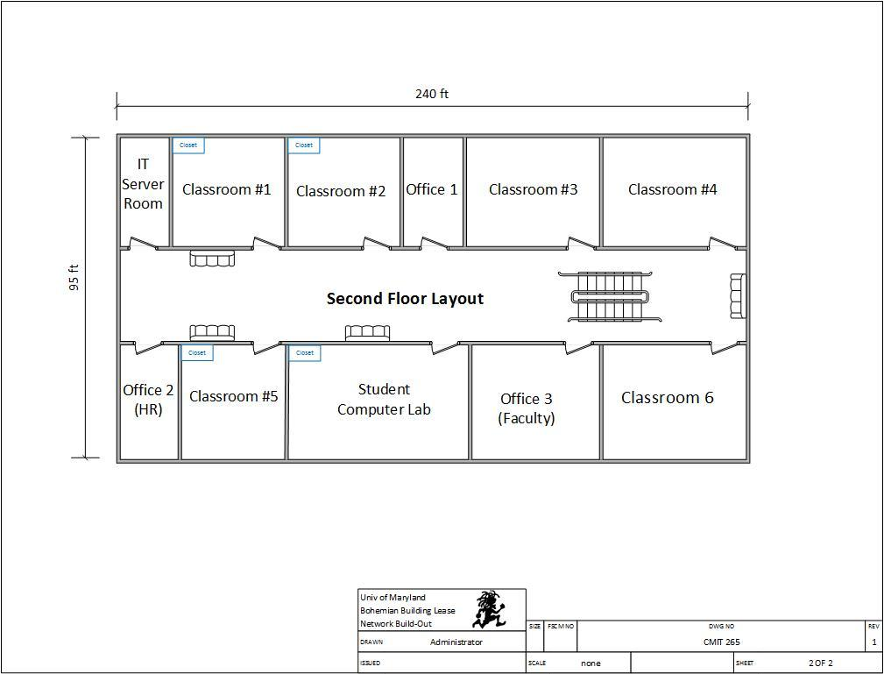

Given the aforementioned scenario, we are going to use the 192.168.3.0 network and create a total of 8 subnets, with 25 possible hosts on each subnet. The chart below describes structures the scenario to include each subnet and required hosts.

Subnet Description | Required Hosts
Classroom 1 (First Floor) | 25 Computers
Classroom 2 (First Floor) | 25 Computers
Classroom 4 (First Floor) | 25 Computers
Classroom 1 (Second Floor) | 25 Computers
Classroom 5 (Second Floor) | 25 Computers
Office 5 – Admissions (Second Floor) | 25 Computers
Student Computer Lab | 25 Computers
Library | 15 Computers
Note: Using the How to Subnet a Network Video provided in CMIT 265 LEO - Content - UMUC Network Design Proposal, complete the following chart.

Proposed Subnet
Subnet | Network Address | Host Address Range | Broadcast Address
Subnet Mask: 255.255.255. ___
Classroom 1 (First Floor) | 192.168.22.0 | 192.168.22.1 - 192.168.22.30 | 192.168.22.31
Classroom 2 (First Floor) | 192.168.22. _ | 192.168.22. _ - 192.168.22. _ | 192.168.22. _
Classroom 4 (First Floor) | 192.168.22. _ | 192.168.22. _ - 192.168.22. _ | 192.168.22. _
Classroom 1 (Second Floor) | 192.168.22.96 | 192.168.22.97 - 192.168.22.126 | 192.168.22.127
Classroom 5 (Second Floor) | 192.168.22.128 | 192.168.22.129 - 192.168.22.158 | 192.168.22.159
Office 5 – Admissions (Second Floor) | 192.168.22. _ | 192.168.22. _ - 192.168.22. _ | 192.168.22. _
Student Computer Lab | 192.168.22. _ | 192.168.22. _ - 192.168.22. _ | 192.168.22. _
Library | 192.168.22. _ | 192.168.22. _ - 192.168.22. _ | 192.168.22. _
Wi-Fi Network | 192.__. __.__ | 192._._. _ - 192._._. _ | 192._._. _
B. Firewall Implementation

Technical Requirements

In this section, you will assess UMUC’s technical requirements related to the firewall implementation. You will need to make assumptions where appropriate. When making assumptions, list each and make sure to justify the solution in the Justification section.

Proposed Firewall Implementation

This section should be used to provide the details of your proposed solution, based on the technical requirements and assumptions. Be sure to review different types of firewalls available, what the firewall will be doing, and the benefits and drawbacks of some models are. Student should be specific when discussing the models, types, and costs.

Justification

This section should be used to justify your proposed solution based on the technical requirements and assumptions.

C. Intrusion Detection System / Intrusion Protection System

Technical Requirements

In this section, you will assess UMUC’s technical requirements related to the intrusion detection system (IDS) and Intrusion Prevention System (IPS). You will need to make assumptions where appropriate. When making assumptions, list each and make sure to justify the solution in the Justification section.

Proposed Intrusion Detection System / Intrusion Protection System

This section should be used to provide the details of your proposed solution, based on the technical requirements and assumptions. Describe how IDS and IPS operates and how will or won’t IDS and or IPS be used in your solution? Student should be specific when discussing the models, types, and costs.

Justification

This section should be used to justify your proposed solution based on the technical requirements and assumptions.

D. DMZ Implementation

Technical Requirements

In this section, you will assess UMUC’s technical requirements related to the DMZ implementation. You will need to make assumptions where appropriate. When making assumptions, list each and make sure to justify the solution in the Justification section.

Proposed DMZ Implementation

This section should be used to provide the details of your proposed solution, based on the technical requirements and assumptions. What uses would UMUC need for a DMZ? What equipment should be placed into the DMZ? Student should be specific when discussing the models, types, and costs.

Justification

This section should be used to justify your proposed solution based on the technical requirements and assumptions.

E. Physical Security Measures

Technical Requirements

In this section, you will assess UMUC’s technical requirements related to the physical security measures. You will need to make assumptions where appropriate. When making assumptions, list each and make sure to justify the solution in the Justification section.

Proposed Physical Security Measures

This section should be used to provide the details of your proposed solution, based on the technical requirements and assumptions. Be practical, as the classrooms and library are open for students to use. Be sure to address physical access of the computers in the classroom, remember law 3 of the 10 immutable laws of information security. Student should be specific when discussing the models, types, and costs.

Justification

This section should be used to justify your proposed solution based on the technical requirements and assumptions.

F. Additional Network Security Measures

Technical Requirements

In this section, you will assess UMUC’s technical requirements related to the additional security measures. You will need to make assumptions where appropriate. When making assumptions, list each and make sure to justify the solution in the Justification section.

Proposed Network Security Measures

This section should be used to provide the details of your proposed solution, based on the technical requirements and assumptions. You should consider the carbon units utilizing the computers, what additional measures are needed when dealing with people? Student should be specific when discussing policy, training, and awareness.

Justification

This section should be used to justify your proposed solution based on the technical requirements and assumptions.

III. Network Customization and Optimization

A. Network and Cloud Based Storage

Technical Requirements

In this section, you will assess UMUC’s technical requirements related to the network and cloud based storage. You will need to make assumptions where appropriate. When making assumptions, list each and make sure to justify the solution in the Justification section.

Proposed Network and Cloud Based Storage

This section should be used to provide the details of your proposed solution, based on the technical requirements and assumptions. Student should be specific when discussing the models, types, and costs.

Justification

This section should be used to justify your proposed solution based on the technical requirements and assumptions. Is it worthwhile to consider outsourcing some or all of the classrooms? Have all the costs been considered?

B. Data Protection and Backup

Technical Requirements

In this section, you will assess UMUC’s technical requirements related to the data protection and backup. You will need to make assumptions where appropriate. When making assumptions, list each and make sure to justify the solution in the Justification section.

Proposed Data Protection and Backup

This section should be used to provide the details of your proposed solution, based on the technical requirements and assumptions. Consider disaster recovery and options available for conducting classes, but also day to day operations of the offices. Student should be specific when discussing the models, types, and costs.

Justification

This section should be used to justify your proposed solution based on the technical requirements and assumptions.
C. Network Monitoring

Technical Requirements

In this section, you will assess UMUC’s technical requirements related to network monitoring. You will need to make assumptions where appropriate. When making assumptions, list each and make sure to justify the solution in the Justification section.

Proposed Network Monitoring

This section should be used to provide the details of your proposed solution, based on the technical requirements and assumptions. What monitoring systems are available and of them which would be the most advantageous for the UMUC to implement? Student should be specific when discussing the models, types, and costs.

Justification

This section should be used to justify your proposed solution based on the technical requirements and assumptions.

D. Log Storage and Management

Technical Requirements

In this section, you will assess UMUC’s technical requirements related to the log storage and management. You will need to make assumptions where appropriate. When making assumptions, list each and make sure to justify the solution in the Justification section.

Proposed Log Storage and Management

This section should be used to provide the details of your proposed solution, based on the technical requirements and assumptions. What aggregating and analysis solutions are there and which one is best to choose from for UMUC? Student should be specific when discussing the models, types, and costs.

Justification

This section should be used to justify your proposed solution based on the technical requirements and assumptions.

E. Troubleshooting Methodology

Technical Requirements

In this section, you will assess UMUC’s technical requirements related to the troubleshooting methodology. You will need to make assumptions where appropriate. When making assumptions, list each and make sure to justify the solution in the Justification section.

Proposed Troubleshooting Methodology

This section should be used to provide the details of your proposed solution, based on the technical requirements and assumptions. Present the isolation method for equipment and how you could find one bad end point or a cable that is bad between classroom 1 and the IT server closet. Student should be specific when discussing the methods, test equipment, and results.

Justification

This section should be used to justify your proposed solution based on the technical requirements and assumptions.

