Network Design Proposal
Network Design Proposal

Prepared for:
University of Maryland University College

Prepared by:
Student Name

I. Network Design

A. Network Topology

Technical Requirements

In this space, the network topology exhibits the course of the physical arrange usage and represents the $64000 functions of the system design, which includes the gadgets, areas, and link institution.
In the two server rooms of the structure, the centralized server and therefore the servers are founded. The centralized pc interfaces with the servers. The oversaw changes from the distinctive floors at that time keep company with the centralized server.
The physical style has the subsequent features:
• The building is outfitted with class 6e cabling and divider plates within the workplaces, study halls, labs, etc.
• There are Cat half-dozen cabling and divider plates fitted within the lecture rooms,library and therefore the workplaces”[1]
• at intervals the structure, oversaw switches are used. Overseen switches provide a lot of power over local area network traffic and offer propelled highlights to manage that traffic. It offers the capability to rearrange, oversee, and screen local area network and this offers a lot of distinguished power over however data goes over the system and UN agency approaches it. Also, oversaw switches use conventions, as an example, the straightforward Network Management Protocol, or what we have a tendency to decision SNMP, for checking the gadgets on the system. SNMP may be a convention that encourages the commerce of the executives information between system gadgets. SNMP queries will decide the soundness of the system or the standing of a selected widget. By showing this data in associate degree effectively gotten arrangement, IT administrators set at a focal web site will screen the execution of the system and speedily acknowledge and fix organize problems while not having to physically collaborate with the switch.
• A separate switch is used within the different floor. thusle|the only|the only real} reason for this switch is to handle the VLAN of the varsity so on keep the understudies from progressing to the essential information of the, as an example, authoritative information.
• The ISP represents net Service supplier. These are organizations that provide access to the net.
• The firewall may be a widget supposed to permit or deny organize transmissions addicted to plenty of tenets and is each currently and once more accustomed protect systems from unapproved get to whereas permitting real correspondences to pass.
Proposed Topology

A star topology is a topology for a Local Area Network (LAN) in which all hubs are independently associated with a focal association point, similar to a center or a switch. A star takes more link than for example a transport, however the advantage is that if a link flops, just a single hub will be cut down”[5].
In this setup, each hub interfaces with a focal system gadget, similar to a center, switch, or PC. The focal system gadget goes about as a server and the fringe gadgets go about as customers. Contingent upon the sort of system card utilized in every PC of the star topology, a coaxial link or a RJ-45 organize link is utilized to interface PCs together.
Advantages of star topology
- Centralized the board of the system, using the focal PC, center, or switch.
- Easy to add another PC to the system.
- If one PC on the system falls flat, the remainder of the system keeps on working regularly.
Disadvantages of star topology
- May have a greater expense to actualize, particularly when utilizing a switch or switch as the focal system gadget.
- The focal system gadget decides the execution and number of hubs the system can deal with.
- If the focal PC, center point, or switch fizzles, the whole system goes down and all PCs are separated from the system”[7].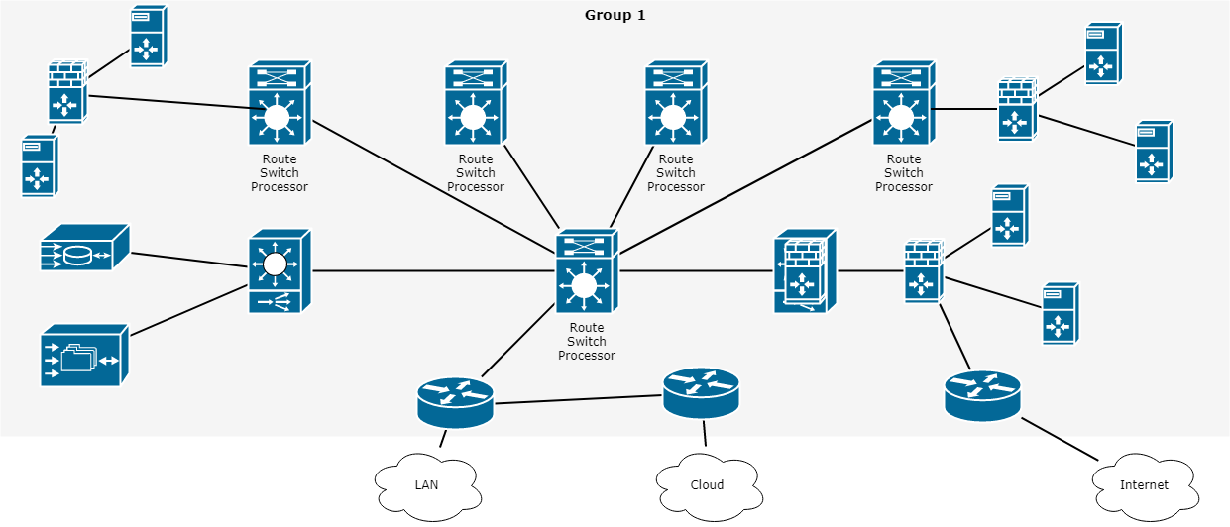

Justification

Star topology is a network topology where every individual bit of a system is connected to a focal hub (frequently called a center point or switch). The connection of these system pieces to the focal segment is outwardly spoken to in a structure like a star. All traffic radiates from the center of the star”[5]. The focal site is responsible for every one of the hubs joined to it. The focal center point is typically a quick, independent PC and is in charge of steering all traffic to different hubs. The primary preferences of a star arrange is that one failing hub does not influence the remainder of the system. In any case, this kind of system can be inclined to bottleneck and disappointment issues at the focal site.

B. Cables and Connectors

Technical Requirements

Cat 6 links or to give them their full name class 6 link is the current favored link type for LAN system and phone wiring where curved pair cabling is required. Cat 6 links comprise of an unshielded link containing four contorted sets, regularly of 24 check wire. The ending connector is a RJ-45 jack. In perspective on this these Cat5 organize links are regularly alluded to as RJ45 arrange links or RJ45 fix links. Ensured Cat-6 links will have the wording "Cat 6" composed as an afterthought. As they adjust to EIA/TIA 568A-5, this is composed on the external sheath. It is in every case best to utilize the suitable system links when setting up a system as flawed or not to standard links can cause issues that might be hard to recognize and follow.
Cat 6 arrange link is currently the standard type of wound pair link and overrides Cat 3. The Cat 6 links can be utilized for information accelerates to 125 Mbps, in this way empowering them to help 100Base-T which has a most extreme information speed of 100 Mbps while the Cat-3 link was intended to be good with 10Base-T. The Cat6 link can bolster working up to lengths of 100 meters at the full information rate.
Where it is important to work at higher rates, as on account of Gigabit Ethernet, an upgraded rendition of Cat 6 link known as Cat 6e is frequently suggested, in spite of the fact that Cat 6 is determined to work with Gigabit Ethernet, 1000Base-T. On the other hand Cat 6e can be utilized with 100Base-T to empower more noteworthy lengths (up to 350 meters) to be accomplished”[11].
Proposed Cables and Connectors

Unshielded Twisted Pair (UTP) - This is the most mainstream type of links in the system and the least expensive structure that you can run with. The UTP has four sets of wires and all inside plastic sheathing. The main motivation that we call it Twisted Pair is to shield the wires from obstruction from themselves. Each wire is just ensured with a dainty plastic sheath”[3].
There are seven unique sorts of UTP classifications and, contingent upon what you need to accomplish, you would require the fitting kind of link. UTP-CAT6e is the most prevalent UTP link which came to supplant the old coaxial link that was not ready to stay aware of the steady developing requirement for quicker and progressively dependable systems.

Justification

The attributes of UTP are exceptionally great and make it simple to work with, introduce, grow and investigate and we are going to take a gander at the diverse wiring plans accessible for UTP, how to make a straight through UTP link, rules for safe activity and a ton of other cool stuff. ”[3]
C. Networking and Internetworking Hardware

Technical Requirements

An internetworking gadget is a generally utilized term for any equipment inside systems that interface diverse system assets. Key gadgets that involve a system are switches, scaffolds, repeaters and portals. All gadgets have independently introduced extension highlights, per arrange prerequisites and situations.
Proposed Networking and Internetworking Devices
Network Hub: Network Hub is a systems administration gadget which is utilized to interface different system has. A system center point is likewise used to do information exchange. The information is moved as far as bundles on a PC arrange. Along these lines, when a host sends an information parcel to a system center point, the center duplicates the information bundle to the majority of its ports associated with. Like this, every one of the ports think about the information and the port for whom the bundle is planned, claims the parcel. ”[6]

Network Switch: Like a center point, a switch likewise works at the layer of LAN (Local Area Network) yet you can say that a switch is more insightful than a center. While center point simply takes every necessary step of information sending, a switch does 'channel and sending' which is an increasingly insightful method for managing the information parcels.

Modem: A Modem is to some degree all the more intriguing system gadget in our day by day life. So, in the event that you have seen around, you get a web association through a wire (there are distinctive sorts of wires) to your home. This wire is utilized to convey our web information outside to the web world.

Network Router: A switch is a system gadget which is in charge of directing traffic starting with one then onto the next system. These two systems could be a privately-owned business system to an open system. You can think about a switch as a traffic police who guides diverse system traffic to various bearings”[6].

Bridge: If a switch associates two unique sorts of systems, at that point a scaffold interfaces two subnetworks as a piece of a similar system. You can consider two distinct labs or two unique floors associated by an extension.

Repeater: A repeater is an electronic gadget that enhances the flag it gets. In different terms, you can consider repeater a gadget which gets a flag and retransmits it at a more elevated amount or higher power with the goal that the flag can cover longer separations”[6].

Justification
Switches are very keen system gadgets that are basically utilized for huge systems and give the best information way to viable correspondence. Switches have memory chips which store extensive amounts of system addresses.
Extensions are utilized to interface two substantial systems by giving distinctive system administrations.
Repeaters are utilized for flag and information recovery and are basically in charge of information enhancement.
Passages are internetworking gadgets used to change over arrangements and are the foundation of any system design.

D. Wide Area Network (WAN) Design

Technical Requirements

In this section, you'll assess UMUC’s technical needs associated with the Wide space Network (WAN) style. you'll must build assumptions wherever applicable. once creating assumptions, list every and confirm to justify the answer within the Justification section.

Proposed Wide Area Network (WAN) Design

A Wide Area Network (WAN) is a PC organize covering numerous separation regions, which may spread over the whole world. WANs regularly interface different littler systems, for example, neighborhood (LANs) or metro region systems (MANs). The world's most mainstream WAN is the Internet. A few sections of the Internet are likewise WANs in themselves. The key contrast among WAN and LAN advances is versatility. C WAN must most likely develop as expected to cover different urban communities, even nations and mainlands”[9].

A lot of switches and switches are interconnected to shape a Wide Area Network. The switches can be associated in various topologies, for example, full work and half work. A wide territory system might be exclusive or leased from a specialist organization, yet the term generally implies the consideration of open (shared client) systems.
Both parcel exchanging and circuit exchanging innovations are utilized in the WAN. Bundle changing enables clients to share normal bearer assets with the goal that the transporter can make increasingly effective utilization of its framework. In a parcel exchanging setup, systems have associations into the bearer's system, and numerous clients share the transporter's system. The transporter would then be able to make virtual circuits between clients' destinations by which parcels of information are conveyed from one to the next through the system.
Circuit Switching enables information associations with be built up when required and after that ended when correspondence is finished. This works like a typical phone line works for voice correspondence. Incorporated Services Digital Network (ISDN) is a genuine case of circuit exchanging. At the point when a switch has information for a remote site, the exchanged circuit is started with the circuit number of the remote system.

Justification

This section ought to be accustomed justify your planned answer supported the technical needs and assumptions.

E. Computer Systems Hardware

Technical Requirements

In this section, you may assess UMUC’s technical needs associated with the pc systems hardware for each room finish points and servers likewise as what would be required for dedicated IT use. you may have to create assumptions wherever acceptable. once creating assumptions, list every and confirm to justify the answer within the Justification section.

Proposed Computer Systems Hardware

Gadgets and media are the physical elements, or instrumentation, of the system. instrumentation contains the components of the system stage that normally are clear, for instance, a PC, PC, switch, switch, remote passage, or the cabling wont to associate the gadgets. Incidentally, some system components might not be obvious. On account of remote media, as an example, messages are transmitted through the air utilizing indiscernible radio return or infrared waves.

System components are utilised to present administrations and procedures. These administrations and procedures are the correspondence programs, known as programming, that keep running on the organized gadgets. A system administration offers knowledge thanks to a solicitation. Administrations incorporate an outsized variety of the regular system applications people utilize daily, almost like email facilitating administrations and internet facilitating administrations. Procedures provide the utility that coordinates and moves the messages through the system. Procedures are additional delicate to United States of America nevertheless are basic to the activity of systems.
Justification

This section ought to be accustomed justify your projected answer supported the technical needs and assumptions.

II. Network Addressing and Security

A. Subnetting

Overview

Subnetting could also be a way of breaking AN oversize network into little networks observed as subnets. Subnetting happens once we have a tendency to extend the default boundary of the subnet mask. Basically, we have a tendency to tend to borrow host bits to form networks (i.e., subnets).
We have been allotted the network address 192.168.22.0. supported the chart below, we have a tendency to all grasp this could be a class C address. this could be determined by perceptive the first octet of the science address, that's 192. This octet falls in between 192 and 223.
Class | Octet Decimal Range
A | 1 - 126
B | 128 - 191
C | 192 - 223

Each category contains a predefined default subnet mask that tells United States of America the octets, that are already a part of the network portion, furthermore as what number bits we've offered to figure with.
Class | Subnet Mask | Format
A | 255.0.0.0 | Network.Host.Host.Host
B | 255.255.0.0 | Network.Network.Host.Host
C | 255.255.255.0 | Network.Network.Network.Host

CIDR (Classless Inter Domain Routing)

● CIDR might be a slash notation of the subnet mask. CIDR tells U.S.A. the amount of on bits throughout a network address.
● class A has default subnet mask 255.0.0.0. which suggests initial octet of the subnet mask has all on bits. In slash notation, it would be written as /8, implies that address has eight bits on.
● class B has default subnet mask 255.255.0.0. which suggests initial two octets of the subnet mask have all on bits. In slash notation, it would be written as /16, implies that address has sixteen bits on.
● category C has default subnet mask 255.255.255.0. which means initial 3 octets of the subnet mask have all on bits. In slash notation, it might be written as /24, means that address has twenty four bits on.

Technical Requirements

UMUC has not determined but they'll use all of the physical space within the contemporary hired building, but the diagrams below convey the planned end state. However, they have determined to use variety of the realm at intervals the short term. In doing so, we'll proceed with the planned prepare. Initially, the building will house five school rooms, one student pc laboratory, 1 library, and one workplace.

● among the below building diagrams, we have a tendency to are visiting use geographic point 5 (Admissions) on the first floor. each geographic point will have one portable computer for staff use, with the exception of the admissions geographic point, that is in a position to own 5 computers. supported the subnetting performed on top of, we have a tendency to tend to is {additionally} able to add additional devices among the longer term.
● the lecture areas are tagged room #1, room #2, and area #4 on the first floor and room #1 and room #5 on the second floor; each room will have a closet. each area will have twenty 5 devices: twenty 3 student computers, one professional portable computer, and one server among the closet, for academic use.
● Students should take into consideration high traffic areas for Wi-Fi, just like the sitting areas and not the lecture rooms. The Wi-Fi network should be white from the wired network and enforced on a separate class C network. what's visiting the network address, range, and broadcast address for this separate class C wireless address be?
● in addition, there'll be a student portable computer laboratory which is able to provide computer access to students to undertake and do their school assignment. the scholar portable computer laboratory is found on the second floor. there'll be twenty four computers throughout this laboratory and one server among the closet. to allow students access to library resources, the library can have 10 computers for the ultimate public to use and 5 computers for library staff.
there'll be two server rooms, one on the first floor and one on the second floor.
To be clear, the diagram below conveys the proposed end state.

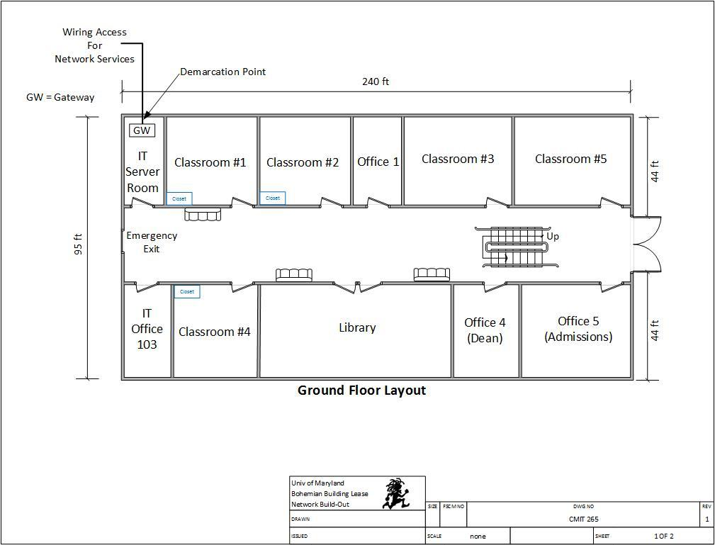

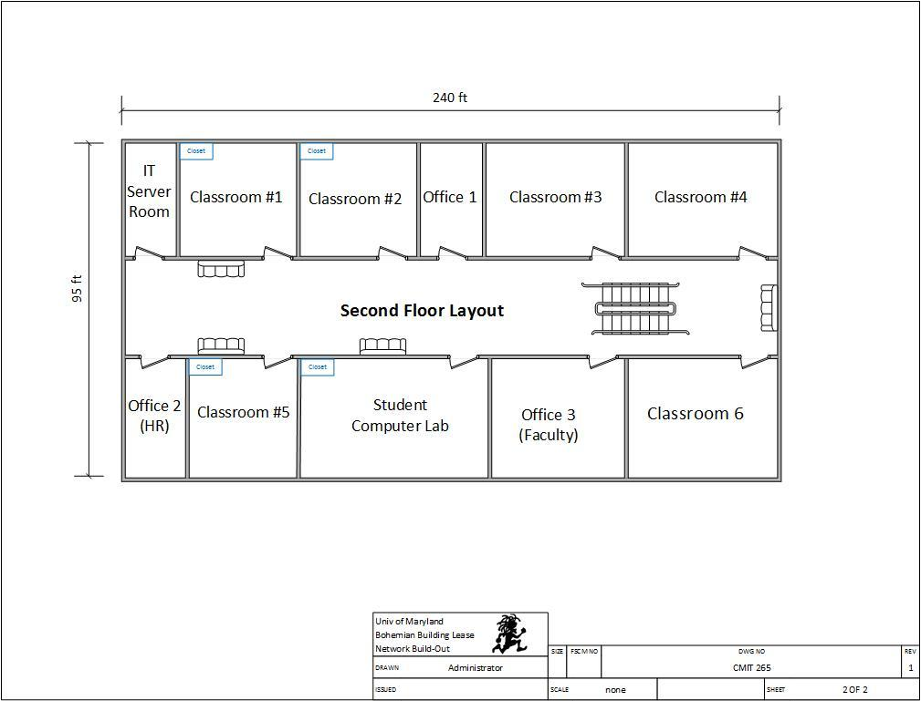

Given the identical scenario, we've got a bent to are visiting use the 192.168.3.0 network and build an entire of eight subnets, with twenty-five potential hosts on each subnet. The chart below describes structures true to include each subnet and required hosts.
Subnet Description | Required Hosts
Classroom 1 (First Floor) | 25 Computers
Classroom 2 (First Floor) | 25 Computers
Classroom 4 (First Floor) | 25 Computers
Classroom 1 (Second Floor) | 25 Computers
Classroom 5 (Second Floor) | 25 Computers
Office 5 – Admissions (Second Floor) | 25 Computers
Student Computer Lab | 25 Computers
Library | 15 Computers
Note: Using the How to Subnet a Network Video provided in CMIT 265 LEO - Content - UMUC Network Design Proposal, complete the following chart.

Proposed Subnet
Subnet | Network Address | Host Address Range | Broadcast Address
Subnet Mask: 255.255.255. ___
Classroom 1 (First Floor) | 192.168.22.0 | 192.168.22.1 - 192.168.22.30 | 192.168.22.31
Classroom 2 (First Floor) | 192.168.22.32 | 192.168.22.33 - 192.168.22.62 | 192.168.22.63
Classroom 4 (First Floor) | 192.168.22.64 | 192.168.22.65 - 192.168.22.94 | 192.168.22.95
Classroom 1 (Second Floor) | 192.168.22.96 | 192.168.22.97 - 192.168.22.126 | 192.168.22.127
Classroom 5 (Second Floor) | 192.168.22.128 | 192.168.22.129 - 192.168.22.158 | 192.168.22.159
Office 5 – Admissions (Second Floor) | 192.168.22.160 | 192.168.22.161 - 192.168.22.190 | 192.168.22.191
Student Computer Lab | 192.168.22.192 | 192.168.22.193 - 192.168.22.222 | 192.168.22.223
Library | 192.168.22.224 | 192.168.22.225- 192.168.22.254 | 192.168.22.255
Wi-Fi Network | 192.168.22.0 | 192.168.22.1 – 192.168.22.254 | 192.168.22.255
B. Firewall Implementation

Technical Requirements

In this section, you'll assess UMUC’s technical needs associated with the firewall implementation. you'll must build assumptions wherever acceptable. once creating assumptions, list every and confirm to justify the answer within the Justification section”[12].
Proposed Firewall Implementation

Packet filtering firewall: On the net, bundle separation is that the approach toward passing or interference parcels at a system interface addicted to supply and goal locations, ports, or conventions. The procedure is employed associated with bundle devastation and Network Address Translation (NAT). Bundle separation is often a part of a firewall program for shielding a locality organize from undesirable interruption”[10].

In a product firewall, parcel separation is finished by a program known as a bundle channel. The parcel channel appearance at the header of each bundle addicted to a specific arrangement of pointers, and on it premise, chooses to stay it from passing (called DROP) or alter it to pass (called ACCEPT).

Justification

This section ought to be accustomed justify your projected resolution supported the technical necessities and assumptions.

C. Intrusion Detection System / Intrusion Protection System

Technical Requirements

In this section, you'll assess UMUC’s technical necessities associated with the intrusion detection system (IDS) and Intrusion bar System (IPS). you'll have to create assumptions wherever acceptable. once creating assumptions, list every and ensure to justify the answer within the Justification section.

Proposed Intrusion Detection System / Intrusion Protection System

An IDS screens organize traffic searching down suspicious movement and notable dangers, causation up cautions once it finds such things. A semipermanent company digital security staple, interruption identification as a capability stays basic within the advanced venture, however maybe not as associate freelance arrangement.

Interruption recognition programming frameworks will be broken into 2 general classifications: have primarily based and organize based; those two classifications address wherever sensors for the IDS are place (on a host/endpoint or on a system).

Interruption identification is associate inactive innovation; it acknowledges and recognizes a problem however go in the stream of system traffic, Novak said. "As documented, the planning is to get and alarm on imperative traffic. associate alarm educates the IDS examiner that some intriguing traffic has been watched. Be that because it could, it's someday presently the grounds that the traffic isn't blocked or ceased in any capability from achieving its goal. ”[8]

Contrast that with firewalls that shut notable malware and interruption compensative action framework (IPS) innovation, that because the name portrays, to boot squares vindictive traffic.

Despite the actual fact that associate IDS doesn't stop malware, cybersecurity specialists aforementioned the innovation still incorporates a spot within the leading edge venture.

"The quality of what it will continues to be primarily important," aforementioned Eric Hanselman, boss investigator with 451 analysis. "The IDS piece itself is thus far pertinent in light-weight of the actual fact that at its center it's characteristic a functioning assault.”

Justification

The ASA 5506H-X provides a Next Generation Intrusion Protection system and advanced malware protection to detect and prevent any attacks attempting to enter the network, along with “advanced malware protection” [11]. The 5506H-X also provides the following features to ensure full network protection next to the building’s firewall:

Provides a “Stateful inspection throughput with multi-protocols up to 300 Mbps” [11]. Provides an “Application Control and an IPS/NGIPS for maximum protection” [11].
Hard Drive capacity up to 50 GB.

Capable of handling an unlimited number of hosts/nodes Can hold up to 275 Cloud security users.

Takes up to “5000 new connections per second” [11].

D. DMZ Implementation

Technical Requirements

It has become progressively tough to stay the protection of the infrastructure and users active from any threats. Most users are going to be transportation their own devices to access all resources and after all accessing them from their homes via the net. Network security for users each in and out of the field should be maintained so as for analysis, lectures, and private data for all students/staff from any unauthorized users anyplace on the net.

All PII and mission essential data for UMUC should be unbroken at intervals UMUC’s non-public servers and not enable any public users to access these servers. solely licensed users at intervals the non-public network are only allowed to access all private data. All users making an attempt to attach to UMUC’s web sources from home should be able to have access to those public servers solely and not the mission essential information.

Proposed Network Security Hardware

A device that's capable to make De-Militarized zones or DMZs should be needed to guard all users each within and outdoors of the UMUC building once making an attempt to utilize all public sources and personal sources. DMZs are essentially firewalls that are enforced with completely different security levels for authorization to different network sources. the identical device projected for AN Intrusion Protection System are used for making a demilitarized zone for the recently chartered building for UMUC:

- ASA 5506H-X with Firepower Services

Cost: $1,240.00 1 for each server room

Total 2: $2,480.00

Justification

Alongside providing associate degree Intrusion protection system, the 5506H-X with strength services conjointly is a firewall device to produce the most effective protection doable at any level. totally different modes of firewall protection should be enforced so as for users to be able to at minimum access all net sources either in and out of the fresh chartered building and keeping them out of the personal servers. Users that are admin level and have priority into accessing the Mission important drives would force firewalls with most protection settings to stay the personal servers secure. The 5506H-X model provides all totally different firewall levels and also the following options for increased security:

Capable of handling an unlimited number of hosts/nodes Can hold up to 275 Cloud security users.

Takes up to “5000 new connections per second” [11].

Takes stateful inspection throughput speeds up to 750mbps

Provides “High Availability support with active and standby modes” [11].

E. Physical Security Measures

Technical Requirements

UMUC should not solely give most internal security for all of its network resources however ought to conjointly provide physical security for all of its infrastructure and network hardware. Any sort of network hardware is at risk of being tampered by unauthorized personnel in any of the server rooms and lecture rooms. The fresh hired UMUC building should be totally enforced with physical security so as to stay unauthorized personnel from accessing and change of state with instrumentation of any kind.

Proposed Physical Security Measures

#1: Lock up the server room: so, even before you lock down the servers, truth be told, before you even flip them on out of the blue, you must guarantee that there are nice bolts on the server area access. Obviously, the simplest lock on the earth will an entire ton of nothing within the event that it isn't used, therefore you likewise want methods necessitating that those entryways be fast whenever the area is empty, and therefore the arrangements ought to started United Nations agency has the key or keycode to induce in.

The server area is that the core of your physical system, and someone with physical access to the servers, switches, switches, links and totally different gadgets therein area will do large hurt.

#2: founded surveillance: protection the door to the server area could be a smart opening, however somebody may break in, or somebody United Nations agency has licensed access may misuse that authority. you wish the simplest way to understand United Nations agency goes in and out and once. A log book for language in and out is that the most elemental thanks to accomplish this, however it's lots of drawbacks. an individual with malicious intent is probably going to simply bypass it.

A video police investigation camera, placed during a location that produces it troublesome to tamper with or disable (or even to find) however offers an honest read of persons coming into and deed ought to supplement the log book or electronic access system. police investigation cams will monitor unendingly, or they'll use motion detection technology to record only if somebody is moving concerning. they'll even be founded to send e-mail or cellular phone notification if motion is detected once it shouldn't be (such as once hours).

#3: confirm the foremost vulnerable devices are therein fast room: confine mind, it's not merely the servers you wish to fret over. A software engineer will connect a digital computer to a middle purpose and use someone programming to catch data traversing the system. make sure that but several of your system gadgets as might be expected beneath the circumstances are therein fast area, or on the off probability that they ought to be in associate alternate region, during a secured room elsewhere within the structure.

#4: Use rack mount servers: Rack mount servers not solely take up less server area real estate; they're conjointly easier to secure. though smaller and arguably lighter than (some) tower systems, they'll simply be fast into closed racks that, once loaded with many servers, will then be fast to the ground, creating the whole package nearly not possible to maneuver, abundant less to steal.

#5: Don't forget the workstations: Programmers will utilize any unbound laptop that's related to the system to induce to or erase knowledge that is essential to your business. Workstations at abandoned work areas or in void workplaces, (for example, those used by representatives United Nations agency are within the inside of some recreation or have left the organization and not however been supplanted) or at areas effectively hospitable pariahs, as an example, the front secretary's work space, are particularly uneffective.

Separate or probably expel PCs that aren't being used similarly as lock the entryways of void workplaces, together with people who are shortly empty whereas a employee is at lunch or out done in. Prepare PCs that has to keep in open zones, a number of the day out of perspective on staff, with savvy card or biometric perusers therefore it's more and more difficult for unapproved individuals to sign up.

#6: Keep intruders from gap the case: each servers and workstations ought to be shielded from thieves United Nations agency will open the case and grab the disc drive. It's abundant easier to form off with a tough disk in your pocket than to hold a full tower off the premises. several computers include case locks to forestall gap the case while not a key.

You can get protection kits from a spread of sources for terribly low value, like the one at Innovative Security merchandise.

#7: defend the portables: Laptops and hand-held computers cause special physical security risks. A stealer will simply steal the whole laptop, together with any knowledge keep on its disk similarly as network logon passwords that will be saved. If staff use laptops at their desks, they ought to take them with them once they leave or secure them to a permanent fixture with a cable lock, like the one at laptop Guardian.

Handhelds may be fast during a drawer or safe or simply slipped into a pocket and carried on your person after you leave the realm. Motion sensing alarms like the one at SecurityKit.com are out there to provide you with a warning if your transportable is rapt.

For portables that contain sensitive data, full disk cryptography, biometric readers, and computer code that "phones home" if the taken laptop computer connects to the web will supplement physical precautions.

#8: shut down the backups: Backing up important knowledge is a necessary part in disaster recovery, however don't forget that the data on those backup tapes, disks, or discs may be taken and employed by somebody outside the corporate. several IT directors keep the backups next to the server within the server area. they ought to be fast {in a|during a|in an exceedingly|in a terribly} drawer or safe at the very least. Ideally, a group of backups ought to be unbroken off web site, and you need to make sure to make sure that they're secured therein offsite location.

Don't overlook the very fact that some staff might keep a copy their work on floppy disks, USB keys, or external exhausting disks. If this apply is allowed or inspired, make certain to possess policies requiring that the backups be fast up in the least times.

#9: Disable the drives: If you don't would like staff repetition company data to removable media, you'll be ready to disable or remove floppy drives, USB ports, and different suggests that of connecting external drives. simply disconnecting the cables won't deter technically savvy employees. Some organizations go up to currently on fill ports with glue or different substances to permanently stop their use, tho' there are computer code mechanisms that need it. Disk locks, just like the one at SecurityKit.com, is inserted into floppy drives on those computers that even have them to stay out different diskettes.

#10: defend your printers: you may not take into account printers sitting a security risk, but many of today's printers store document contents in their own on-board reminiscences. If a hacker steals the printer and accesses that memory, he or she is additionally able to produce copies of recently written documents. Printers, like servers and workstations that store important knowledge, must be settled in secure locations and mounted down so nobody can walk off with them.

Justification

Remember that network security starts at the physical level. All the firewalls within the world won't stop associate degree entrant United Nations agency is in a position to achieve physical access to your network and computers, so lock up further as lock down.

F. Additional Network Security Measures

Technical Requirements

UMUC strives to extend security for college kids, staff, computers, and also the network infrastructure altogether. Physical door locks, scanners, firewalls, intrusion protection systems, and server locks won’t be enough to stay all information and network sources secure. The freshly chartered UMUC building should follow with pc security procedures the field has implemented. nobody within the building ought to be permissible to require out computers or instrumentation while not correct consent and following a checkout procedure. No students or academics ought to be stealing credentials from any of their peers. nobody within the building ought to be permissible to open up sites that don't seem to be permitted for access inside college grounds, or it could lead on to exposure of malware inside the complete network. further personal ought to be employed aboard a system to be able to monitor all rooms to create certain nobody enters to steal or tamper with the pc instrumentation.

Proposed Network Security Hardware

To increase security for the newly leased building and ensuring the safety of all staff, students, and equipment, the following security measures must be implemented:

A hardware checkout procedure ought to be implemented for the entire field to allow students, IT personnel, and employees to get rid of any instrumentality once required. Staff, students, and IT support should sign a consent kind with admin to require out any computer-based instrumentality out of the building and out of the field. The document should even have the user write a reason why the instrumentality must be withdrawn of the field. This additionally includes IT personnel requiring to get rid of instrumentality to form repairs once required. If this consent is broken, enforcement officers should be contacted ought to any instrumentality be taken with none consent. No Exceptions.

A monthly seminar ought to be incorporated all told courses so as to show and unfold awareness of social engineering and the way to find and avoid any social engineering attacks like shoulder water sport, container diving, causation legitimate emails requesting sure requests for info which will be confidential, and more. The seminars ought to run regarding 1-2 hours and everyone should have full participation and counts as credit to pass the course. Seminars for social engineering ought to be control throughout the primary week of every course, as it’s the suitable time for student and employees to completely become at home with the entire course and info, before starting major assignments and study.

A new net user agreement kind kind of like the DoDEA 6600 form ought to be enforced and state that websites are applicable and which websites are inappropriate once victimization the school’s web sources. Students and employees should absolutely scan and conform to the terms and conditions before they’re allowable to use any pc and make a college account. If anyone disagrees to the current consent, that user shouldn't be allowed to use the school’s resources and creation of a replacement account won't be allowable.

A security contract ought to be created with a non-public security company like Academi to supply up to 2 security guards to observe over the new building and make sure that nobody steals any instrumentality or walk into unauthorized areas while not permission. Security guards ought to work throughout traditional operational hours all the means till closure of the field and therefore the new building.

  - Cost for security contract: $250 million a year.

An A1 16 HD CCTV camera IP security system should be implemented in all rooms

including server rooms and monitored from the administrative office to make sure all equipment is kept and remained intact.
  - Cost for camera system: $1,224.

Justification

Safety and security for all faculty infrastructure is high priority once it involves making certain all users safe usage of all network resources. New security policies like hardware checkout agreements, net usage agreements, and social engineering seminars meet the wants in terms of keeping all users tuned in to the way to operate the instrumentality and network safely, together with protective confidential information each on and off of the network. while not awareness, all information and network resources would stay compromised and therefore the network for the freshly chartered building are going to be a failure. everybody should have full consent and instruction of the way to secure their information so as to work and keep the network running swimmingly and freed from any threat.

Security guards is another major resource that ought to be enforced to enforce all security laws, together with keeping all laptop and network instrumentality secure. Such major contracts just like the United States military contractor Academi provides security agents with thorough background checks and security clearances to make sure that the employed guards don't tamper or take any instrumentality while not licensed consent. Security guards are trained to non-violently handle anyone United Nations agency doesn’t follow any consent with the computer/internet policies and victimization force techniques once necessary.

Alongside hired security personnel, A1 CCTV security cameras provide the following features to help security guards with more visibility of each room within the new building:

This system provides clear imagery, along with “facial level detail at up to 300 feet away

in complete darkness making it ideal for monitoring open fields and parking lots” [15]. Provides infrared imagery for nighttime operations up to 100 ft.

Provides high tech digital video recording systems(DVRs) to record “up to 30 days of

material when required” [15].

Provides fish-eye camera lens to “view at 360* angles with no areas lacking coverage”

[15].
These cameras can be connected to the internet and can remotely be used from a smart

phone, PC, notebook computer, and tablet to access and view the entire school security system.

III. Network Customization and Optimization

A. Network and Cloud Based Storage

Technical Requirements

Storage for varsity information, assignments, lesson plans, and mission crucial documents is needed in most faculties and businesses. The new hired building in UMUC ought to even have a type of storage for necessary faculty files. Also, special cloud-based storage system ought to even be needed for college students, staff, and directors to access their files anyplace they're either on or off field. while UMUC utilizes LEO to assist save your files and assignments, there should be a less complicated means that of on-line storage as critical simply victimization LEO, as this on-line tool is tough even to newer users.
Proposed Network and Cloud Based Storage

Businesses and customers are plenty of and additional enthusiastic about cloud-based storage solutions rather than in-house, on-premise native storage hardware. Your files are hold on among the cloud, that may be a simplified browse of what's basically somebody else's infrastructure (data center, server, hard drive, property etc.)
Ever since Amazon popularized storage on-line with S3 (Simple Storage Service), Google knowledge shows that interest for "Cloud Storage" alone has inflated by 40x over the past decade. most therefore individuals less often talk of with it as "online storage". Given the multitude of cloud storage suppliers out there, one should with wisdom select a supplier World Health Organization can supply the utmost quantity of cheap storage and data live, whereas still keeping your knowledge safe. I propose IDrive as a results of it's presently the simplest cloud storage.
Justification

For the proposed network-based storage option, the Supermicro Enterprise Storage Server provides the following functionality for storage:

Operates with a “Dual socket R3 (LGA 2011) CPU core which can support Intel® Xeon®

processor E5-2600 v4/v3 family” [16].

Provides up to 45 Hot-swap 3.5″ SAS3/SATA3 drive bays, 2 rear Hot-swap 2.5″ SATA

drive bays, and 6 NVMe bays for mass storage” [16].
Includes a Supermicro Super I/O Module (SIOM) “to support flexible networking options”

[16].

Provides Server Remote management.

Customizable for usage of “Web Server, Mail Servers, Storage and Security Appliances,

Network Infrastructure, Enterprise Software, Video Processing, Big Data, Hyperconverged Appliances, Internet of Things (IoT), In-Memory Analytics, Machine Learning (ML), Artificial Intelligence (AI) and general Data Center Virtualization & Private Cloud or Hyperscale Infrastructure Applications” [16].

Provides “Broadcom 3108 SAS3 HW RAID array as a backup in case the main storage drive fails in order to save data” [16].

For the cloud-based storage choice, Google Drives ought to be the foremost appropriate choice because it provides “up to ten TB of storage for all users” [17]. for many users globally, Google is turning into a lot of common for network and web usage. a lot of users use Google Chrome and Google Docs as against different choices like Microsoft Edge or web soul. compared to different cloud storage firms like OneDrive could charge cheaper costs, however users are
more in tune with Google Services and exploitation Google Drive can suit users as using Google merchandise quite Microsoft products for each on and off field operations
B. Data Protection and Backup

Technical Requirements

With network and cloud-based storage choices enforced for the fresh chartered building of UMUC, the network storage controller and cloud-based net service are thought of the one purpose of failure, during which will cause all knowledge inside the network to be lost fully. All UMUC primarily based hardware/software needs any sort of backing up knowledge mechanically ought to the network-based and cloud-based storage controllers fail, and if any natural disaster strikes during which will for good harm the specified storage systems and mission-critical files. instrumentality should even be able to run on a backup power supply within the case of an influence outage of any kind so as to avoid wasting knowledge from corruption throughout a power outage. Backups should even be set to run each single night mechanically for all knowledge inside a backup system to stay all data once a failure happens on the most system.

Proposed Data Protection and Backup

Data protection is that the strategy of safeguarding vital info from corruption, compromise or loss. The importance of information protection will increase as a results of the quantity of data created and hold on continues to grow at new rates. there's also very little or no tolerance for quantity which might manufacture it out of the question to access vital info.
Storage technologies which might be accustomed defend info embody a disk or tape backup that copies selected information to a disk-based storage array or a cartridge device therefore it'll be safely hold on. Mirroring are accustomed end up associate actual copy of an internet electronic computer or files therefore they're available from quite one place. Storage snapshots will mechanically generate a gaggle of tips that may info hold on on tape or disk, sanctionative quicker info recovery, whereas continuous information protection (CDP) backs up all the data in degree enterprise whenever a modification is made.

Cloud backup is turning into lots of prevailing. Organizations often move their backup information to public clouds or clouds maintained by backup vendors. These backups can replace on-site disk and tape libraries, or they're going to operate more protected copies of data.

Backup has traditionally been the key to associate economical information protection strategy. information was periodically copied, typically nightly, to a tape drive or tape library where it would sit until one issue went wrong with the primary information storage. That's once the backup information would be accessed and accustomed restore lost or broken information.

Backups aren't from now on a whole operate. Instead, they're being combined with various information protection functions to avoid wasting space for storing and lower costs.

Backup and archiving, as associate example, are treated as two separate functions. Backup's purpose was to revive information once a failure, whereas degree archive provided a searchable copy of data. However, that semiconductor unit to redundant information sets. Today, there are product that duplicate, archive and index information during a} very single pass. This approach saves organizations time and cuts down on the quantity of data in long storage.

Justification

A key house on information} management aspect is data lifecycle management, that's that the tactic of automating the movement of significant data to on-line and offline storage, and knowledge lifecycle management, a comprehensive strategy for valuing, cataloging and protecting knowledge assets from application and user errors, malware and virus attacks, machine failure, or facility outages and disruptions. lots of recently, data management has return to include finding ways in which within which to unlock business value from otherwise dormant copies of information for news, test/dev enablement, analytics and various functions.
C. Network Monitoring

Technical Requirements

In UMUC, the network will bear intermittent performance and presumably fail at any given time by surprise. A network failure or slow performance with very little to no warning are often unfavorable for all users particularly throughout peak hours of study. IT personnel should have a technique of watching the network systems daily and fixing any issues right away as they show up. A special tool to assist monitor the network in terms of statistics, traffic, and any potential failures which may show up ought to be enforced to assist IT personnel totally keep the complete network system under control and safe from any hurt.

Proposed Network Monitoring

Businesses rely upon networks for all operations. Hence, network observance is improbably crucial for any business. Today, networks span globally, having multiple links established between geographically separated data centers, public and private clouds. This creates multifold challenges in network management. Network admins need to be extra proactive and agile in observance network performance. However, this will be easier same than done.
Introducing OpManager, associate degree easy-to-use, and low cost network observance answer. It monitors network devices like routers, switches, firewalls, load balancers, wireless LAN controllers, servers, VMs, printers, storage devices, ANd everything that has associate degree information science and is connected to the network. OpManager continuously monitors the network ANd provides associate degree in-depth visibility and management over it. simply just in case of a fault, you'll merely drill all the means right down to the muse cause and eliminate it before operations are affected.
Justification

Most IT outlets use multiple network observance tools to watch and manage network operations. However, just in case of any fault, they need to sift through multiple tools, GUI, graphs, and reports to travel the underside the difficulty. OpManager, the integrated network observance answer, offers insights into numerous problematic areas of the network. It permits you to simply drill right down to the basis cause and fix it quickly.
D. Log Storage and Management

Technical Requirements

With network observance enforced, there should be separate storage break free the most network-based storage to stay the storage-based code clean from extra muddle. A separate system ought to be enforced to store and maintain all network observance logs and for all different essential files for UMUC’s network to be maintained among the most storage system.

Proposed Logging Solution

A third network-based storage system should be utilized in storing all data statistics within the network:

Amazon Simple Storage device S3 o Cost: $0.039 per GB
o Allows you to use “50 TB in the first month” [21].

Justification

The Amazon S3 device is favorable in terms of a backup storage for system logs as it’s designed to “store and retrieve any quantity of information from anyplace from websites and mobile apps, company applications, and knowledge from IoT sensors or devices” [22]. It not solely stores only app knowledge however permits users to manage data flexibly and allows them to “run analytics of your data whereas the S3 is at rest” [22]. in contrast to all of our alternative projected storage devices used for managing knowledge for college kids and workers, the S3 provides storage for many completely different applications and is appropriate enough to carry log files which will be over one hundred GB long and permit our IT personnel to simply manage and monitor knowledge logs related to watching tasks.

E. Troubleshooting Methodology

Technical Requirements

With all the new network-based infrastructure and IT personnel gift to keep up and monitor the system at intervals the freshly hired UMUC building, IT personnel should be ready to grasp what to try to to once responding to sure things. In most alternative businesses, troubleshooting procedures for IT personnel are set in situ to permit IT personnel to resolve any technical connected issue expeditiously and keep infrastructure running and operational. UMUC conjointly would need that freshly employed IT personnel are ready to effectively troubleshoot and solve any issues concerning problems with all IT instrumentality at intervals the newly hired building. UMUC conjointly needs that IT personnel have the right troubleshooting tools to assist them troubleshoot any problems encountered with the instrumentality.

Proposed Computer Systems Hardware

The following resources should be considered to incorporate to allow for proper troubleshooting methods within the newly leased building in UMUC:

The proper IT personnel that should be hired must have at least 6 months of experience

and must have in possession the CompTIA Network + certificate.
The CompTIA recommended troubleshooting procedures should be implemented to

allow all IT personnel to follow when troubleshooting problems within the IT infrastructure. Hard copies of the procedures will be kept in the IT office in the main building of UMUC.
Wiring schematics, a network subnetting sheet, and instructions for all networking

hardware by manufacture should be implemented and kept with the IT personnel at all times.

The following troubleshooting tools must be implemented to help IT personnel with

simple troubleshooting with hardware and network cables:

- Triplett Low Voltage Pro 30 Cable Tester Cost: $345.00
- Intellinet Net Toner Probe Kit with LEDs Cost: $115.00
- Klein Tools Digital Multimeter - Auto-Ranging - 600V Cost: $65.00
- Superlooper Gigabit Loopback Jack and Plug Cost: $44.00
- Fluke Networks AIRCHECK Wi-Fi Tester Cost: $1,995.00
- Eclipse Tools Network Tool Bundle Cost: $26.00

Justification

Hiring personnel with a minimum of vi months of expertise and possess the CompTIA Network + can alleviate any major network problems as opposed towards hiring those that have very little to no experience once operating with network, which can cause additional issues with the network and cause ruinous failures at intervals the network.

As given by CompTIA for certifying people with A+ and Network + certificates, the subsequent six troubleshooting steps should be written and have IT members follow during this methodology for effective troubleshooting:

- “Identify the Problem” [23]

- “Establish a theory of probable cause” [23]
- “Test the theory to determine cause” [23]

- “Establish a plan of action to resolve the problem and implement the solution” [23]
- “Verify full system functionality and if applicable implement preventative measures” [23]

- “Document findings, actions, and outcomes” [23]

With these straightforward half-dozen steps set as correct steering, IT personnel in time ought to be ready to resolve any issues confronted inside the network and build note of a way to resolve bound problems. All documentation for easy resolution sets done by IT personnel ought to even be traced and announce within the UMUC facilitate table website to permit users to troubleshoot any simple issues like loose network cables or resetting wireless settings on a personal device.

Alongside the troubleshooting methodologies place in situ, developing and implementing wiring schematics, subnetting sheets, wi-fi access purpose placement sheets, and every one directions for networking hardware won't scarcely aid in serving to to troubleshoot problems, however to produce situational awareness to assist IT personnel become totally accustomed to the system. those that are particularly new rents with previous expertise can greatly profit in obtaining them totally accustomed to the network system and infrastructure within the 1st few days of hire.

IT personnel don't seem to be visiting be ready to troubleshoot effectively while not these tools in situ to resolve hardware connected problems. software system tools like observance systems and firewall settings won't be enough to resolve issues if a network goes down utterly. Such circumstances attribute to a hardware or cable connected issue and should be dealt consequently. the subsequent devices are effective in resolution issues with network property, wi-fi property, and power connected issues with the hardware:

A cable tester is needed to check cables if an indication are often carried from one finish to the opposite and guarantee all wires are at intervals the right positions, together with any miswiring conditions. The Triplett port thirty tester is possible because it contains “multiple ports and thirteen application settings for testing numerous cables for any breaks or misconfigured wires” [24].

A toner probe is needed to assist IT personnel find signals and find the acceptable cables connected from one finish into a wiring closet. this is often best appropriate ought to any cables be incorrectly tagged or placed into incorrect ports. The Intelligent web Toner Probe kit provides a “probe &amp; signal generator in one package and is ready to trace wires at intervals bundles and groups” [25]. It’s conjointly able to be wont to “test telecommunication, datacom, and A/V networks” [25].

For troubleshooting hardware connected problems like if a server won't operate, its doable that there's a failing power provide and a multimeter tool ought to be enforced to test for correct voltage input/output from the facility supply to see if the power supply has run its course. The Klein Tools Digital Multimeter is ready to “measure up to 6000 volts of AC/DC voltage, ten amps of AC/DC electrical phenomenon, and 40M of resistance currents” [26]. This device is additionally capable of measure temperature, capacitance, frequencies, and testing diodes for power continuity and is employable at intervals tiny industries.

A loopback plug ought to be needed to check if a tool will each send and receive an indication and could be a nice indicator to see if a faulty network card could also be put in at intervals a particular system. The Superlooper Gigabit Loopback jack and plug is best notable for not solely testing signals at intervals devices, however to conjointly “check for any breaks or shorts at intervals wiring as critical simply checking the network card” [27].

A wi-fi tester ought to be used for checking and troubleshooting any signal outages and magnetic force interference with channels for wireless access points at intervals the building. With the Fluke Networks AIRCHECK tester, technicians will “quickly verify and troubleshoot 802.11 a/b/g/n networks” [28].

IT technicians is also needed to form, cut open, and punch down network cables inside a server closet. employing a wire crimper, technicians are ready to attach connectors at the top of wiring cables. employing a cable stripper will facilitate technicians cut open wires for maintenance functions in fixing miswiring and substitution any faulty wires inside a cable. A punch-down tool is needed to put in patch cables inside a patch panel within a wiring closet. The Eclipse Network tool Bundle is possible because it provides a “wire denudation tool, a standard plug crimping tool, and a sway punch-down tool bushed one” [29]. The cable stripper is “designed for flat stranded phone wire 2P, 4P, 6P, 8P,10P, etc; intercom/alarm wire/2-cord speaker wire from 18-22 AWG gamma hydroxybutyrate and SPT-1 electrical wires” [29]. The crimper during this set is supposed “for 4/6/8P standard connectors” [29]. The enclosed impact punch-down tool includes a 100/88 blade with cutting practicality at one finish to assist with cable adjustment once hook into a patch panel.

With the proper tools and troubleshooting methodologies set in situ for the new IT personnel to be employed to keep up the network infrastructure among the new hired building at the University of Maryland University school in Adelphi, there ought to be very little to no issues for the technicians to become absolutely aware of the system and maintain a powerful network for all our students, staff, and colleagues partaking into numerous studies. It’s vital to cater to all or any our users and present a powerful network setting for the new building on our field to grant all users stable and swish semesters of on-line study within the a few years to come back

References:

[1]“Chapter 5: Topology,” in An Educator’s Guide to School Networks. Usf.edu. College of Education, University of South Florida, 2013. [Online]. Available at: https://fcit.usf.edu/network/chap5/chap5.htm [Accessed 5 Aug. 2018].
[2]Gordon, W. “What's the Difference Between These Ethernet Cables, and Will They Make My Network Faster?” Lifehacker.com, 9 Apr. 2013. [Online] Available at: https://lifehacker.com/5994163/whats-the-difference-between-these-ethernet-cables-and-will-they-make-my-network-faster [Accessed 5 Aug. 2018].

- “Cisco 350X Series Stackable Managed Switches Data Sheet.” Cisco.com, 2018. [Online] Available at: https://www.cisco.com/c/en/us/products/collateral/switches/350x-series-stackable-managed-switches/datasheet-c78-735986.html [Accessed 5 Aug. 2018].

- “Cisco 2911 Integrated Services Router”. Cisco.com, 2018. [Online] Available at: https://www.cisco.com/c/en/us/products/routers/2911-integrated-services-router-isr/index.html [Accessed 5 Aug. 2018].

- “Cisco WAP371 Wireless-AC/N Dual Radio Access Point with Single Point Setup”. Cisco.com, 2018. [Online] Available at: https://www.cisco.com/c/en/us/products/collateral/wireless/small-business-300-series-wireless-access-points/datasheet-c78-732143.pdf [Accessed 5 Aug. 2018].

- “Precision Tower 3000 Series Workstation Desktop | Dell United States”. Dell.com, 2018. [Online]. Available at: https://www.dell.com/en-us/work/shop/desktop-and-all-in-one-pcs/precision-tower-3000-series-3420-3620/spd/precision-t3x20-series-workstation [Accessed 5 Aug. 2018].

- “PowerEdge R540 2-socket Rack Server | Dell United States”. Dell.com, 2018. [Online]. Available at: https://www.dell.com/en-us/work/shop/cty/pdp/spd/poweredge-R540?ref=PD_OC [Accessed 5 Aug. 2018].

[8]“Mellanox ConnectX-4 VPI MCX455A-ECAT - Network adapter - PCIe 3.0 x16 - InfiniBand,

100 Gigabit Ethernet | Dell United States.” Dell.com, 2018. [Online]. Available at: https://www.dell.com/en-us/work/shop/accessories/apd/a8175873? cid=298721&st=&gclid=CjwKCAjwwJrbBRAoEiwAGA1B_Tb-vRafS7p02LEMQuhwoIrfKHtV3pJYd24uVtLcLxgM_rhs53hUkxoClKQQAvD_BwE&lid=5704670 &VEN1=se974OLmV,101952148149,901q5c14135,c,,A8175873&VEN2=,&dgc=st&dgseg=so&a cd=12309152537501410&VEN3=237404350720702914 [Accessed 5 Aug. 2018].

- “Hardwired Computer Network Cost.” Fixr.com, 2018. [Online]. Available at: https://www.fixr.com/costs/hardwired-computer-network [Accessed 5 Aug. 2018].

- “Cisco Firepower 2100 Series.” Cisco.com. [Online]. Available at: https://www.cisco.com/c/en/us/products/security/firepower-2100-series/index.html [Accessed 11 Aug. 2018].

- “ASA 5506H-X with FirePOWER Services.” Cisco.com. [Online]. Available at: https://apps.cisco.com/ccw/cpc/guest/content/ucsProductDetails/prod_ASA5506H-FPWR-BUN [Accessed 11 Aug. 2018].

- “Barska Biometric Door Lock Reversible Handle – Black.” Foundry35.com. [Online]. Available at: https://www.foundry35.com/products/barska-biometric-door-lock-reversible-handle-black? utm_medium=cpc&utm_source=googlepla&variant=7522070145&gclid=CjwKCAjwkrrbBRB9Eiw AhlN8_GgFM1JafiG4GyD56ZP1lD_1Vl0cv52T1WSmylgkQKoywylJylffiRoC8AEQAvD_BwE [Accessed 11 Aug. 2018].

- “OmniMount RE18 Enclosed Equipment Rack (Black).” B&H-Photo-Video-Pro-Audio.com. [Online]. Available at: https://www.bhphotovideo.com/c/product/979298-REG/omnimount_1004777_1_re18_enclosed_equipment.html? ap=y&gclid=CjwKCAjwkrrbBRB9EiwAhlN8_KeGoEno54n1uOvkjMucfvlM3JlJ57QMADT20dZbn hs5EaOBcq8UUhoCID8QAvD_BwE&smp=y [Accessed 11 Aug. 2018].

- “Digital Electronic Keyless Keypad Security Entry Door Lock.” CostWay.com. [Online]. Available at: https://www.costway.com/digital-electronic-keyless-keypad-security-entry-door-lock.html? fee=4&fep=6950&utm_source=google&utm_medium=googleshopping&utm_campaign=googles hopping&gclid=CjwKCAjwkrrbBRB9EiwAhlN8_JHbGP3_T25buLRq4sb2q7c-XS6wyt-NjbeZ4dClgr3pKc4_8Ei8NhoCEPQQAvD_BwE [Accessed 11 Aug. 2018].

- “School Security Camera Systems.” A1SecurityCameras.com. [Online]. Available at: https://www.a1securitycameras.com/school-security-camera-systems/ [Accessed 11 Aug. 2018].

- “Supermicro 6048R-E1CR45H 4U 2S Xeon E5-2600 3TB 45×3.5SAS/SATA 2×2.5Rear

HWRAID SIOM FlexNW R1600W Virtualization Cloud IoT Enterprise Storage Server.” Dihuni.com. [Online]. Available at: https://www.dihuni.com/shop/servers/servers-by-manufacturer/supermicro-servers/supermicro-6048r-e1cr45h-4u-2s-xeon-e5-2600-3tb-45x3-5sassata-2x2-5rear-hwraid-siom-flexnw-r1600w-virtualization-cloud-iot-enterprise-storage-server/ [Accessed 12 Aug. 2018].

- “Pricing Guide.” Google.com. [Online]. Available at: https://www.google.com/drive/pricing/ [Accessed 12 Aug. 2018].

- “My Cloud Expert Series EX4100.” WDC.com. [Online]. Available at: https://www.wdc.com/products/network-attached-storage/my-cloud-ex4100.html [Accessed 12 Aug. 2018].

- “APC Smart-UPS SRT 10000VA RM 208V.” APC.com. [Online]. Available at: http://www.apc.com/shop/us/en/products/APC-Smart-UPS-SRT-10000VA-RM-208V/P-SRT10KRMXLT [Accessed 12 Aug. 2018].
.

