Network Design Proposal Template
Network Design Proposal

Prepared for:
University of Maryland University College

Prepared by:
Student Name

I. Network Design

A. Network Topology

Technical Requirements

In this section, you will assess UMUC’s technical requirements. Use the information provided in the scenario to analyze the need for network topology, cables and connectors, networking and internetworking devices, wide area networking design, and computer systems. If you need more information, feel free to ask your instructor or make some assumptions. If you make assumptions, be sure to list them. This section should be used to describe the technical requirements of the task at hand. That is, you will be making explicit the requirements as you understand them, which will lead to the next section (your proposed solution).

Example (Note: The paragraph that follows is an example. It is expected that students will use this as a reference only. Remember to include references and cite your work according to IEEE-style format.)

Secure Network Contractors believes that students and faculty health, well­being, and morale have a significant impact on the learning experience and productivity of the academic institution. Secure Network Contractors understands the following technical requirements. The university has invested in a new building that will bestow an academic ambience while providing students and faculty a world class research and learning environment. The university has hundreds of Faculty that teach and perform research within the new academic building. Faculty should be able to seamlessly transition between the newly leased building, and other buildings on the UMUC campus. Students will be required to have a similar experience as classes take place in multiple buildings across campus each day. Faculty and students will be required to print regardless of location, and therefore needs shared printing resources. All computers should be able to communicate, but the human resources department should operate on a separate network due to the sensitive and personally identifiable information they handle. We understand that the newly leased building will need to wirelessly communicate with other buildings on campus, and we will address this in the Wide Area Network (WAN) section that follows. Etc. (students should continue to explain the technical requirements).
Proposed Topology

Select one or more topologies to use for this design (i.e., star, bus, mesh, ring, and please note that the star topology is the most commonly used). This section should be used to provide the details of your proposed solution. Be specific and include the model, manufacturer, features, and cost of devices where appropriate. Students should include a visual representation of the topology selected. Topologies can be created using Microsoft Visio, or you can create a free account at draw.io (https://www.draw.io) and create diagrams. Be sure to review the types of topologies and highlight the benefits and drawbacks for each.
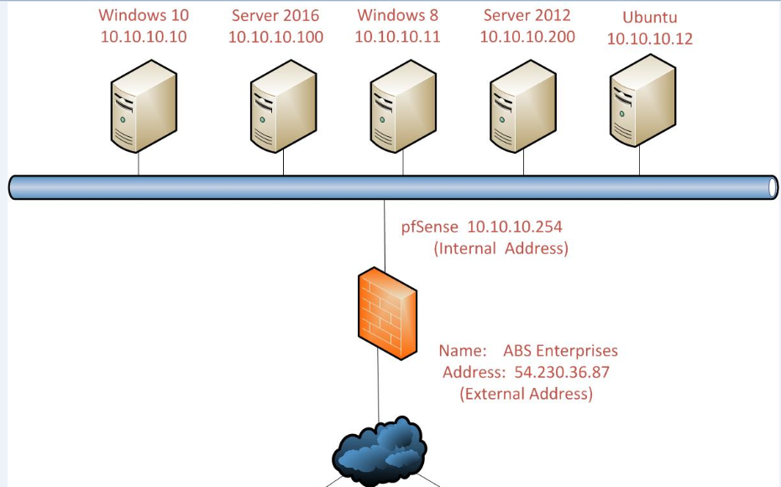

Example (Note: The paragraph that follows is an example. It is expected that students will use this as a reference only. Furthermore, you must include a chart comparing and contrasting the different options available to meet the requirement. An example is provided below and should be used as a reference only. Remember to include references and cite your work according to IEEE-style format.)

Secure Network Contractors believes that from a comparison of all the types available a ring topology is the best solution based on the requirements described by the University of Maryland University College (UMUC). We believe a ring topology satisfies the requirements of forming a single, continuous pathway for data to be transmitted through each node. A ring network topology in where each node connects to exactly two other nodes. A node on a network can be considered a computer, laptop, printer, or mobile device. Each node has a unique network address, which is referred to as the Media Access Control (MAC) address. The MAC address provides… Etc. (students should continue to explain their proposal).

The following business case analysis show the three potential hardware solutions to the requirement provided. The visual presents the ability for the reader to understand the variables considered during the analysis of the three potential hardware solutions.

[The requirements are on the top row. The green in the table shows options that meet requirements, red does not, and blue exceeds requirements. As you can see in the above table, not all requirements can be met. You will need to explain in your Justification why the selection you made gives the school the best available option for the cost. The options that meet or exceed the requirements may cost too much. Your job is to decide what the best option is and present it to management. So, based on the requirements, which phone would you select for meeting those requirements at the least cost?]

Justification

This section should be used to justify your proposed solution based on the requirement(s). That is, you are explaining why you proposed the solution in the aforementioned paragraph, based on the technical requirement you made explicit in aforementioned paragraph.

Example (Note: The paragraph that follows is an example. It is expected that students will use this as a reference only. Remember to include references and cite your work according to IEEE-style format.)

Secure Network Contractors believes that a ring topology is the best solution based on the requirements described by the University of Maryland University College (UMUC). Specifically, the requirement that data flows in one direction, reducing the chance of packet collisions. The ring topology reduce the need for network servers because they are not needed to control network connectivity between each workstation. Etc. (students should continue to explain their proposal).

B. Cables and Connectors

Note: (Students should consider the needs for both a wired and wireless implementation as your proposal should include both.)

Technical Requirements

In this section, you will assess UMUC’s technical requirements related to cables and connectors. You will need to make assumptions where appropriate. When making assumptions, list each and make sure to justify the solution in the Justification section.

Proposed Cables and Connectors

This section should be used to provide the details of your proposed solution, based on the technical requirements and assumptions. Student should be specific when discussing the models, types, and costs.

Justification

This section should be used to justify your proposed solution based on the technical requirements and assumptions., The justification should explain why you chose what you did and how it meets the UMUC’s goals for training and presentation to students

C. Networking and Internetworking Hardware

Technical Requirements

In this section, you will assess UMUC’s technical requirements related to networking and internetworking hardware. You will need to make assumptions where appropriate. When making assumptions, list each and make sure to justify the solution in the Justification section.

Proposed Networking and Internetworking Devices

This section should be used to provide the details of your proposed LAN solution, based on the technical requirements and assumptions. Student should be specific when discussing the models, types, and costs.

Justification

This section should be used to justify your proposed solution based on the technical requirements and assumptions.

D. Wide Area Network (WAN) Design

Technical Requirements

In this section, you will assess UMUC’s technical requirements related to the Wide Area Network (WAN) design. You will need to make assumptions where appropriate. When making assumptions, list each and make sure to justify the solution in the Justification section.

Proposed Wide Area Network (WAN) Design

This section should be used to provide the details of your proposed Internet Service Provider (ISP) solution. Be sure to cover what options are available through leased lines, metro Ethernet, and dedicated connections are based on the technical requirements and assumptions. Students should connect to the ISP with two different technologies. Student should be specific when discussing the models, types, and costs.

Justification

This section should be used to justify your proposed solution based on the technical requirements and assumptions.

E. Computer Systems Hardware

Technical Requirements

In this section, you will assess UMUC’s technical requirements related to the computer systems hardware for both classroom end points and servers as well as what would be needed for dedicated IT use. You will need to make assumptions where appropriate. When making assumptions, list each and make sure to justify the solution in the Justification section.

Proposed Computer Systems Hardware

This section should be used to provide the details of your proposed solution, based on the technical requirements and assumptions. Student should be specific when discussing the models, types, and costs.

Justification

This section should be used to justify your proposed solution based on the technical requirements and assumptions.

II. Network Addressing and Security

A. Subnetting

Overview

Subnetting is a process of breaking a large network into small networks known as subnets. Subnetting happens when we extend the default boundary of the subnet mask. Basically, we borrow host bits to create networks (i.e., subnets).

We have been assigned the network address 192.168.22.0. Based on the chart below, we know this is a Class C address. This is determined by observing the first octet of the IP address, which is 192. This octet falls in between 192 and 223.

Class | Octet Decimal Range
A | 1 - 126
B | 128 - 191
C | 192 - 223

Each class has a predefined default subnet mask that tells us the octets, which are already part of the network portion, as well as how many bits we have available to work with.

Class | Subnet Mask | Format
A | 255.0.0.0 | Network.Host.Host.Host
B | 255.255.0.0 | Network.Network.Host.Host
C | 255.255.255.0 | Network.Network.Network.Host

CIDR (Classless Inter Domain Routing)

CIDR is a slash notation of the subnet mask. CIDR tells us the number of on bits in a network address.

- Class A has default subnet mask 255.0.0.0. that means first octet of the subnet mask has all on bits. In slash notation, it would be written as /8, means address has 8 bits on.

- Class B has default subnet mask 255.255.0.0. that means first two octets of the subnet mask have all on bits. In slash notation, it would be written as /16, means address has 16 bits on.

- Class C has default subnet mask 255.255.255.0. that means first three octets of the subnet mask have all on bits. In slash notation, it would be written as /24, means address has 24 bits on.

Technical Requirements

UMUC has not decided how they will use all of the physical space within the newly leased building, but the diagrams below convey the proposed end state. However, they have decided to use some of the space in the short term. In doing so, we will proceed with the proposed plan. Initially, the building will house 5 classrooms, 1 student computer lab, 1 library, and 1 office.

- In the below building diagrams, we will use Office 5 (Admissions) on the first floor. Each office will have 1 computer for staff use, with the exception of the admissions office, which will have 5 computers. Based on the subnetting performed above, we may be able to add more devices in the future.

- The classrooms are labeled Classroom #1, Classroom #2, and Classroom #4 on the first floor and Classroom #1 and Classroom #5 on the second floor; each classroom will have a closet. Each classroom will have 25 devices: 23 student computers, 1 instructor computer, and 1 server in the closet, for instructional use.

- Students should consider high traffic areas for Wi-Fi, such as the sitting areas and not the classrooms. The Wi-Fi network should be segregated from the wired network and implemented on a separate Class C network. What will the network address, range, and broadcast address for this separate Class C wireless address be?

- In addition, there will be a student computer lab that will provide computer access to students to do their homework. The student computer lab is located on the second floor. There will be 24 computers in this lab and 1 server in the closet.

- To allow students access to library resources, the library will also have 10 computers for the general public to use and 5 computers for library staff.

- There will be two server rooms, one on the first floor and one on the second floor.

To be clear, the diagram below conveys the proposed end state.

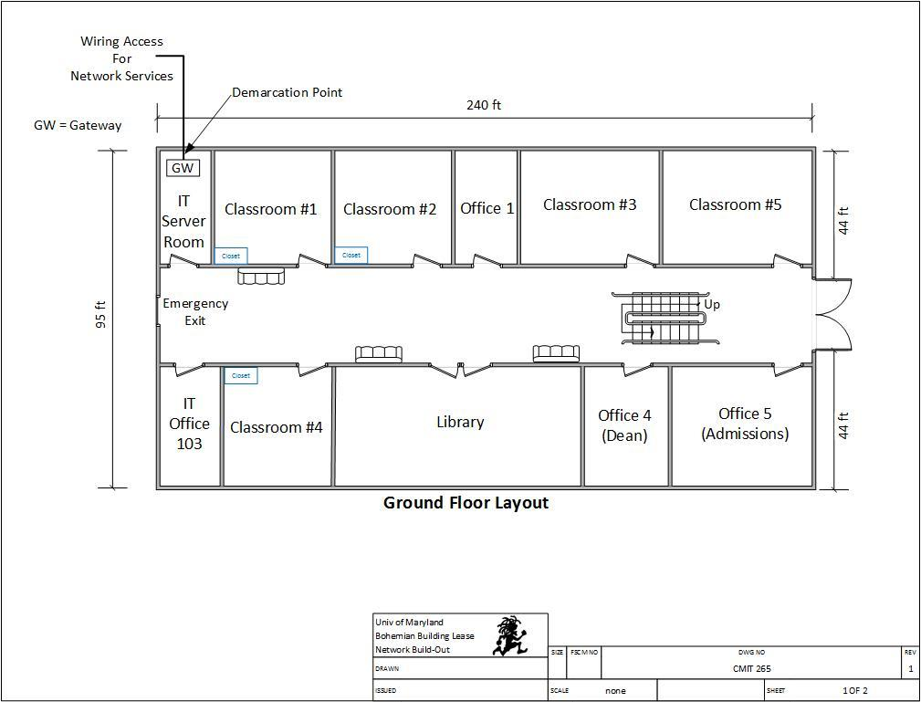

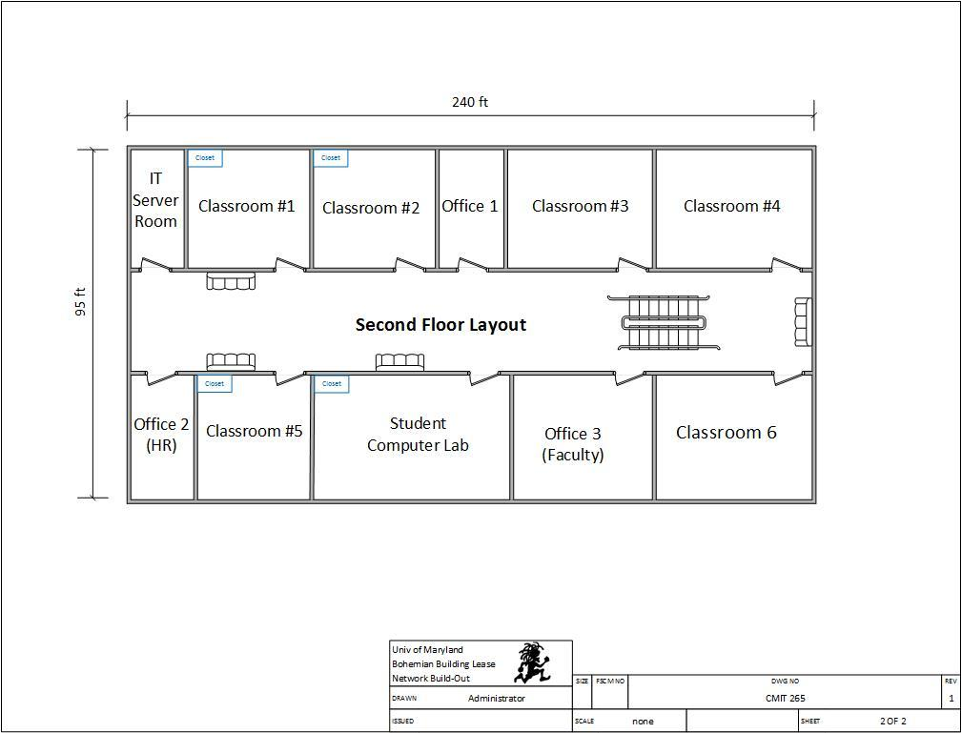

Given the aforementioned scenario, we are going to use the 192.168.3.0 network and create a total of 8 subnets, with 25 possible hosts on each subnet. The chart below describes structures the scenario to include each subnet and required hosts.

Subnet Description | Required Hosts
Classroom 1 (First Floor) | 25 Computers
Classroom 2 (First Floor) | 25 Computers
Classroom 4 (First Floor) | 25 Computers
Classroom 1 (Second Floor) | 25 Computers
Classroom 5 (Second Floor) | 25 Computers
Office 5 – Admissions (Second Floor) | 25 Computers
Student Computer Lab | 25 Computers
Library | 15 Computers
Note: Using the How to Subnet a Network Video provided in CMIT 265 LEO - Content - UMUC Network Design Proposal, complete the following chart.

Proposed Subnet
Subnet | Network Address | Host Address Range | Broadcast Address
Subnet Mask: 255.255.255. ___
Classroom 1 (First Floor) | 192.168.22.0 | 192.168.22.1 - 192.168.22.30 | 192.168.22.31
Classroom 2 (First Floor) | 192.168.22. _ | 192.168.22. _ - 192.168.22. _ | 192.168.22. _
Classroom 4 (First Floor) | 192.168.22. _ | 192.168.22. _ - 192.168.22. _ | 192.168.22. _
Classroom 1 (Second Floor) | 192.168.22.96 | 192.168.22.97 - 192.168.22.126 | 192.168.22.127
Classroom 5 (Second Floor) | 192.168.22.128 | 192.168.22.129 - 192.168.22.158 | 192.168.22.159
Office 5 – Admissions (Second Floor) | 192.168.22. _ | 192.168.22. _ - 192.168.22. _ | 192.168.22. _
Student Computer Lab | 192.168.22. _ | 192.168.22. _ - 192.168.22. _ | 192.168.22. _
Library | 192.168.22. _ | 192.168.22. _ - 192.168.22. _ | 192.168.22. _
Wi-Fi Network | 192.__. __.__ | 192._._. _ - 192._._. _ | 192._._. _
B. Firewall Implementation

Technical Requirements

In this section, you will assess UMUC’s technical requirements related to the firewall implementation. You will need to make assumptions where appropriate. When making assumptions, list each and make sure to justify the solution in the Justification section.

Proposed Firewall Implementation

This section should be used to provide the details of your proposed solution, based on the technical requirements and assumptions. Be sure to review different types of firewalls available, what the firewall will be doing, and the benefits and drawbacks of some models are. Student should be specific when discussing the models, types, and costs.

Justification

This section should be used to justify your proposed solution based on the technical requirements and assumptions.

C. Intrusion Detection System / Intrusion Protection System

Technical Requirements

In this section, you will assess UMUC’s technical requirements related to the intrusion detection system (IDS) and Intrusion Prevention System (IPS). You will need to make assumptions where appropriate. When making assumptions, list each and make sure to justify the solution in the Justification section.

Proposed Intrusion Detection System / Intrusion Protection System

This section should be used to provide the details of your proposed solution, based on the technical requirements and assumptions. Describe how IDS and IPS operates and how will or won’t IDS and or IPS be used in your solution? Student should be specific when discussing the models, types, and costs.

Justification

This section should be used to justify your proposed solution based on the technical requirements and assumptions.

D. DMZ Implementation

Technical Requirements

In this section, you will assess UMUC’s technical requirements related to the DMZ implementation. You will need to make assumptions where appropriate. When making assumptions, list each and make sure to justify the solution in the Justification section.

Proposed DMZ Implementation

This section should be used to provide the details of your proposed solution, based on the technical requirements and assumptions. What uses would UMUC need for a DMZ? What equipment should be placed into the DMZ? Student should be specific when discussing the models, types, and costs.

Justification

This section should be used to justify your proposed solution based on the technical requirements and assumptions.

E. Physical Security Measures

Technical Requirements

In this section, you will assess UMUC’s technical requirements related to the physical security measures. You will need to make assumptions where appropriate. When making assumptions, list each and make sure to justify the solution in the Justification section.

Proposed Physical Security Measures

This section should be used to provide the details of your proposed solution, based on the technical requirements and assumptions. Be practical, as the classrooms and library are open for students to use. Be sure to address physical access of the computers in the classroom, remember law 3 of the 10 immutable laws of information security. Student should be specific when discussing the models, types, and costs.

Justification

This section should be used to justify your proposed solution based on the technical requirements and assumptions.

F. Additional Network Security Measures

Technical Requirements

In this section, you will assess UMUC’s technical requirements related to the additional security measures. You will need to make assumptions where appropriate. When making assumptions, list each and make sure to justify the solution in the Justification section.

Proposed Network Security Measures

This section should be used to provide the details of your proposed solution, based on the technical requirements and assumptions. You should consider the carbon units utilizing the computers, what additional measures are needed when dealing with people? Student should be specific when discussing policy, training, and awareness.

Justification

This section should be used to justify your proposed solution based on the technical requirements and assumptions.

III. Network Customization and Optimization

A. Network and Cloud Based Storage

Technical Requirements

In this section, you will assess UMUC’s technical requirements related to the network and cloud based storage. You will need to make assumptions where appropriate. When making assumptions, list each and make sure to justify the solution in the Justification section.

Proposed Network and Cloud Based Storage

This section should be used to provide the details of your proposed solution, based on the technical requirements and assumptions. Student should be specific when discussing the models, types, and costs.

Justification

This section should be used to justify your proposed solution based on the technical requirements and assumptions. Is it worthwhile to consider outsourcing some or all of the classrooms? Have all the costs been considered?

B. Data Protection and Backup

Technical Requirements

In this section, you will assess UMUC’s technical requirements related to the data protection and backup. You will need to make assumptions where appropriate. When making assumptions, list each and make sure to justify the solution in the Justification section.

Proposed Data Protection and Backup

This section should be used to provide the details of your proposed solution, based on the technical requirements and assumptions. Consider disaster recovery and options available for conducting classes, but also day to day operations of the offices. Student should be specific when discussing the models, types, and costs.

Justification

This section should be used to justify your proposed solution based on the technical requirements and assumptions.
C. Network Monitoring

Technical Requirements

In this section, you will assess UMUC’s technical requirements related to network monitoring. You will need to make assumptions where appropriate. When making assumptions, list each and make sure to justify the solution in the Justification section.

Proposed Network Monitoring

This section should be used to provide the details of your proposed solution, based on the technical requirements and assumptions. What monitoring systems are available and of them which would be the most advantageous for the UMUC to implement? Student should be specific when discussing the models, types, and costs.

Justification

This section should be used to justify your proposed solution based on the technical requirements and assumptions.

D. Log Storage and Management

Technical Requirements

In this section, you will assess UMUC’s technical requirements related to the log storage and management. You will need to make assumptions where appropriate. When making assumptions, list each and make sure to justify the solution in the Justification section.

Proposed Log Storage and Management

This section should be used to provide the details of your proposed solution, based on the technical requirements and assumptions. What aggregating and analysis solutions are there and which one is best to choose from for UMUC? Student should be specific when discussing the models, types, and costs.

Justification

This section should be used to justify your proposed solution based on the technical requirements and assumptions.

E. Troubleshooting Methodology

Technical Requirements

In this section, you will assess UMUC’s technical requirements related to the troubleshooting methodology. You will need to make assumptions where appropriate. When making assumptions, list each and make sure to justify the solution in the Justification section.

Proposed Troubleshooting Methodology

This section should be used to provide the details of your proposed solution, based on the technical requirements and assumptions. Present the isolation method for equipment and how you could find one bad end point or a cable that is bad between classroom 1 and the IT server closet. Student should be specific when discussing the methods, test equipment, and results.

Justification

This section should be used to justify your proposed solution based on the technical requirements and assumptions.

