
Start (Requirement Gathering)
Start: Thu 3/7/19 ID: 1
Finish: Wed 5/8/19 Dur: 45 days
Comp: 0%
Initial, Operation, & Coonfiguration
Start: Thu 3/7/19 ID: 2
Finish: Thu 3/28/19Dur: 16 days
Comp: 0%
Selection & Design
Start: Fri 3/29/19 ID: 6
Finish: Thu 4/4/19 Dur: 5 days
Comp: 0%
Implementation
Start: Thu 4/18/19 ID: 10
Finish: Thu 4/25/19Dur: 6 days
Comp: 0%
Page 1

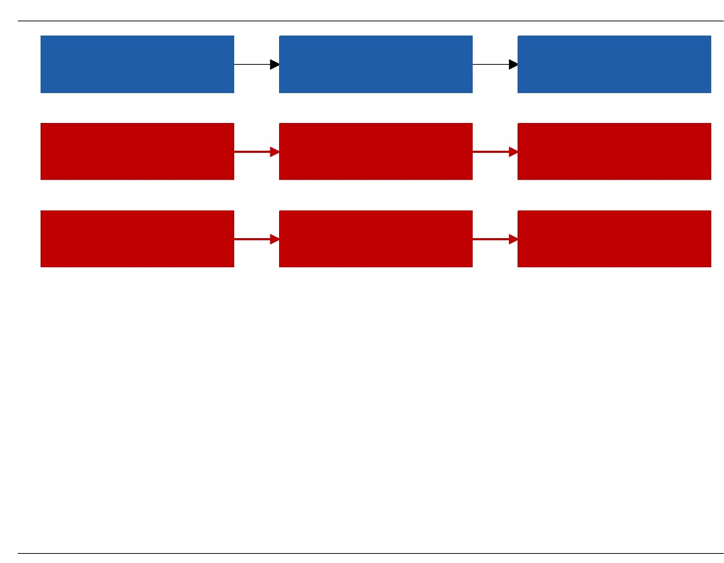
Set-up Router
Start: Thu 3/7/19 ID: 3
Finish: Wed 3/13/19Dur: 5 days
Res:
Training & Training Manual
Start: Thu 3/14/19 ID: 4
Finish: Fri 3/22/19 Dur: 7 days
Res:
End (Network Capabilities & Business Opportu
Start: Mon 3/25/19ID: 5
Finish: Thu 3/28/19Dur: 4 days
Res:
Set up Network
Start: Fri 3/29/19 ID: 7
Finish: Thu 4/4/19 Dur: 5 days
Res:
Set-up User
Start: Fri 4/5/19 ID: 8
Finish: Thu 4/11/19Dur: 5 days
Res:
End (Network Capabilties & Business Opportu
Start: Fri 4/12/19 ID: 9
Finish: Wed 4/17/19Dur: 4 days
Res:
Establish Security system & Bsck up plan
Start: Thu 4/18/19 ID: 11
Finish: Wed 4/24/19Dur: 5 days
Res:
Set -up User
Start: Thu 4/25/19 ID: 12
Finish: Thu 5/2/19 Dur: 6 days
Res:
End (Network Capabilties & Business Opportu
Start: Fri 5/3/19 ID: 13
Finish: Wed 5/8/19 Dur: 4 days
Res:
Page 2


Page 3

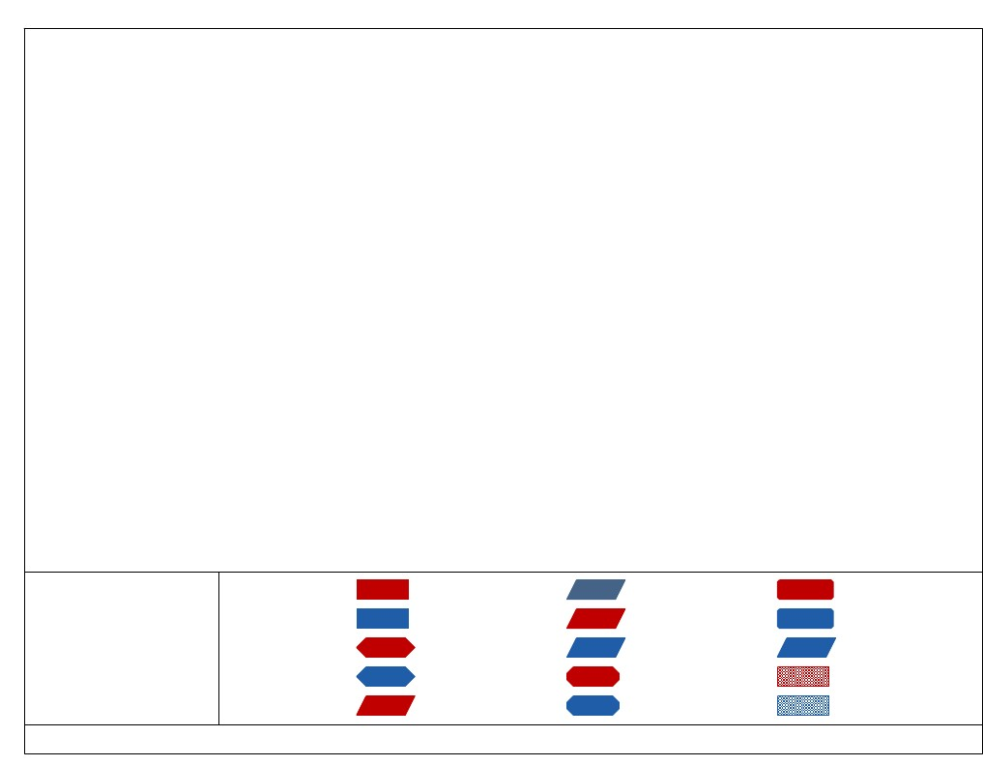
Critical
Noncritical
Project: Network diagram
Date: Thu 3/7/19
Critical Milestone
Milestone
Critical Summary
Summary
Critical Inserted
Inserted
Critical Marked
Marked
Page 4
Critical External
External
Project Summary
Highlighted Critical
Highlighted Noncritical

