The Nibelungen Myth
Prof. Joerg Esleben, ALG1100

Monuments
- On the following pages, look at the monuments related to the Nibelungen myth from around Germany and Austria.
- What are some recurring characters and images in these monuments?
- What commonaliGes and differences do you noGce about the styles of these monuments?
Relief from the Nibelungen GroJo, on the banks of the Rhein in Bonn, created around 1880
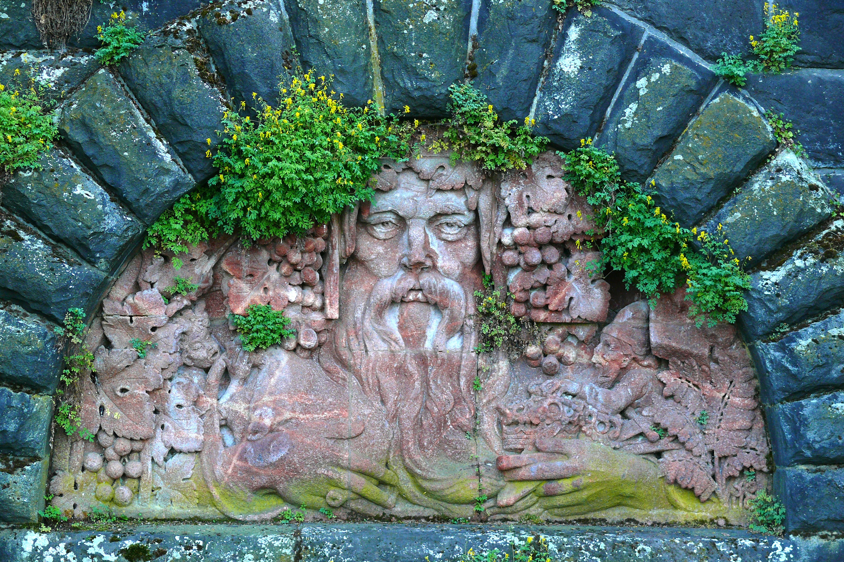
Image by: Hawobo; source: hJps://commons.wikimedia.org/wiki/File:V ater_Rhein_Bonn.JPG

Statue of Siegfried, Bürgerpark,
Bremen, sculpted by ConstanGn
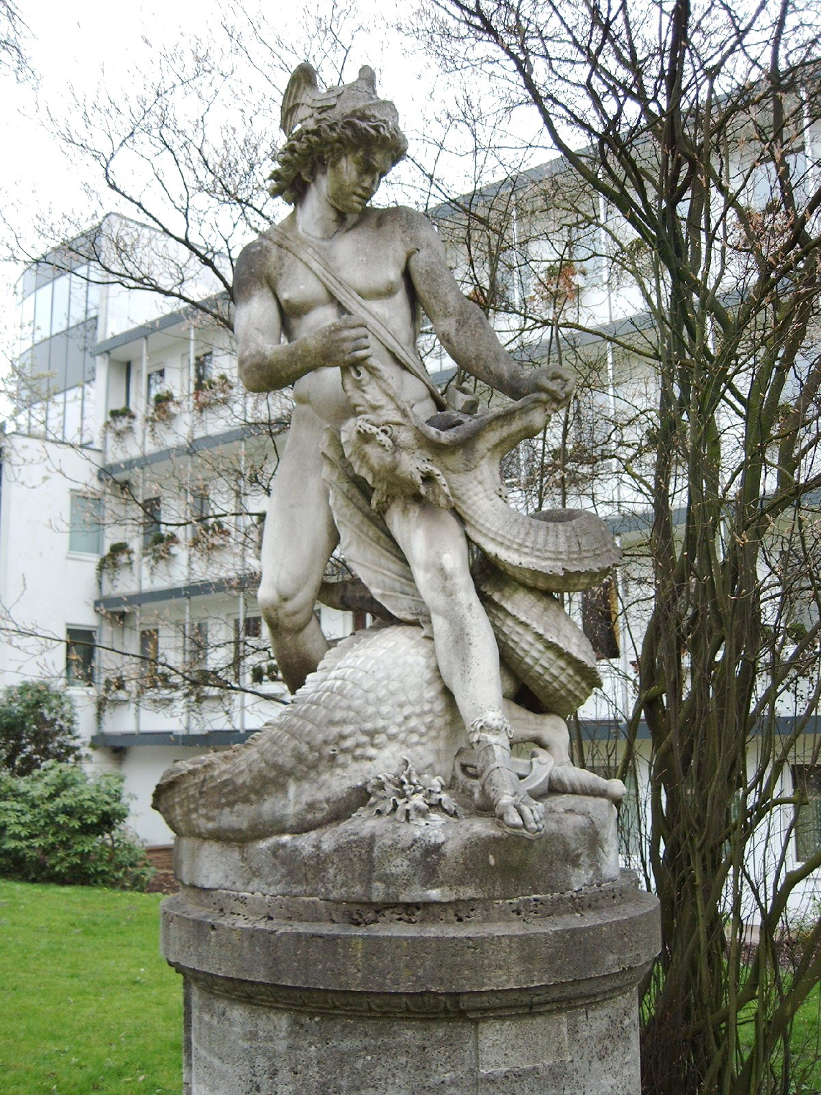
Dausch, 1890
Image by: Rami Tarawneh
source: hJps://commons.wikimedia.org/wiki/File:B
%C3%BCrgerPark_Bremen_21-­‐04-­‐2006_0044.jpg

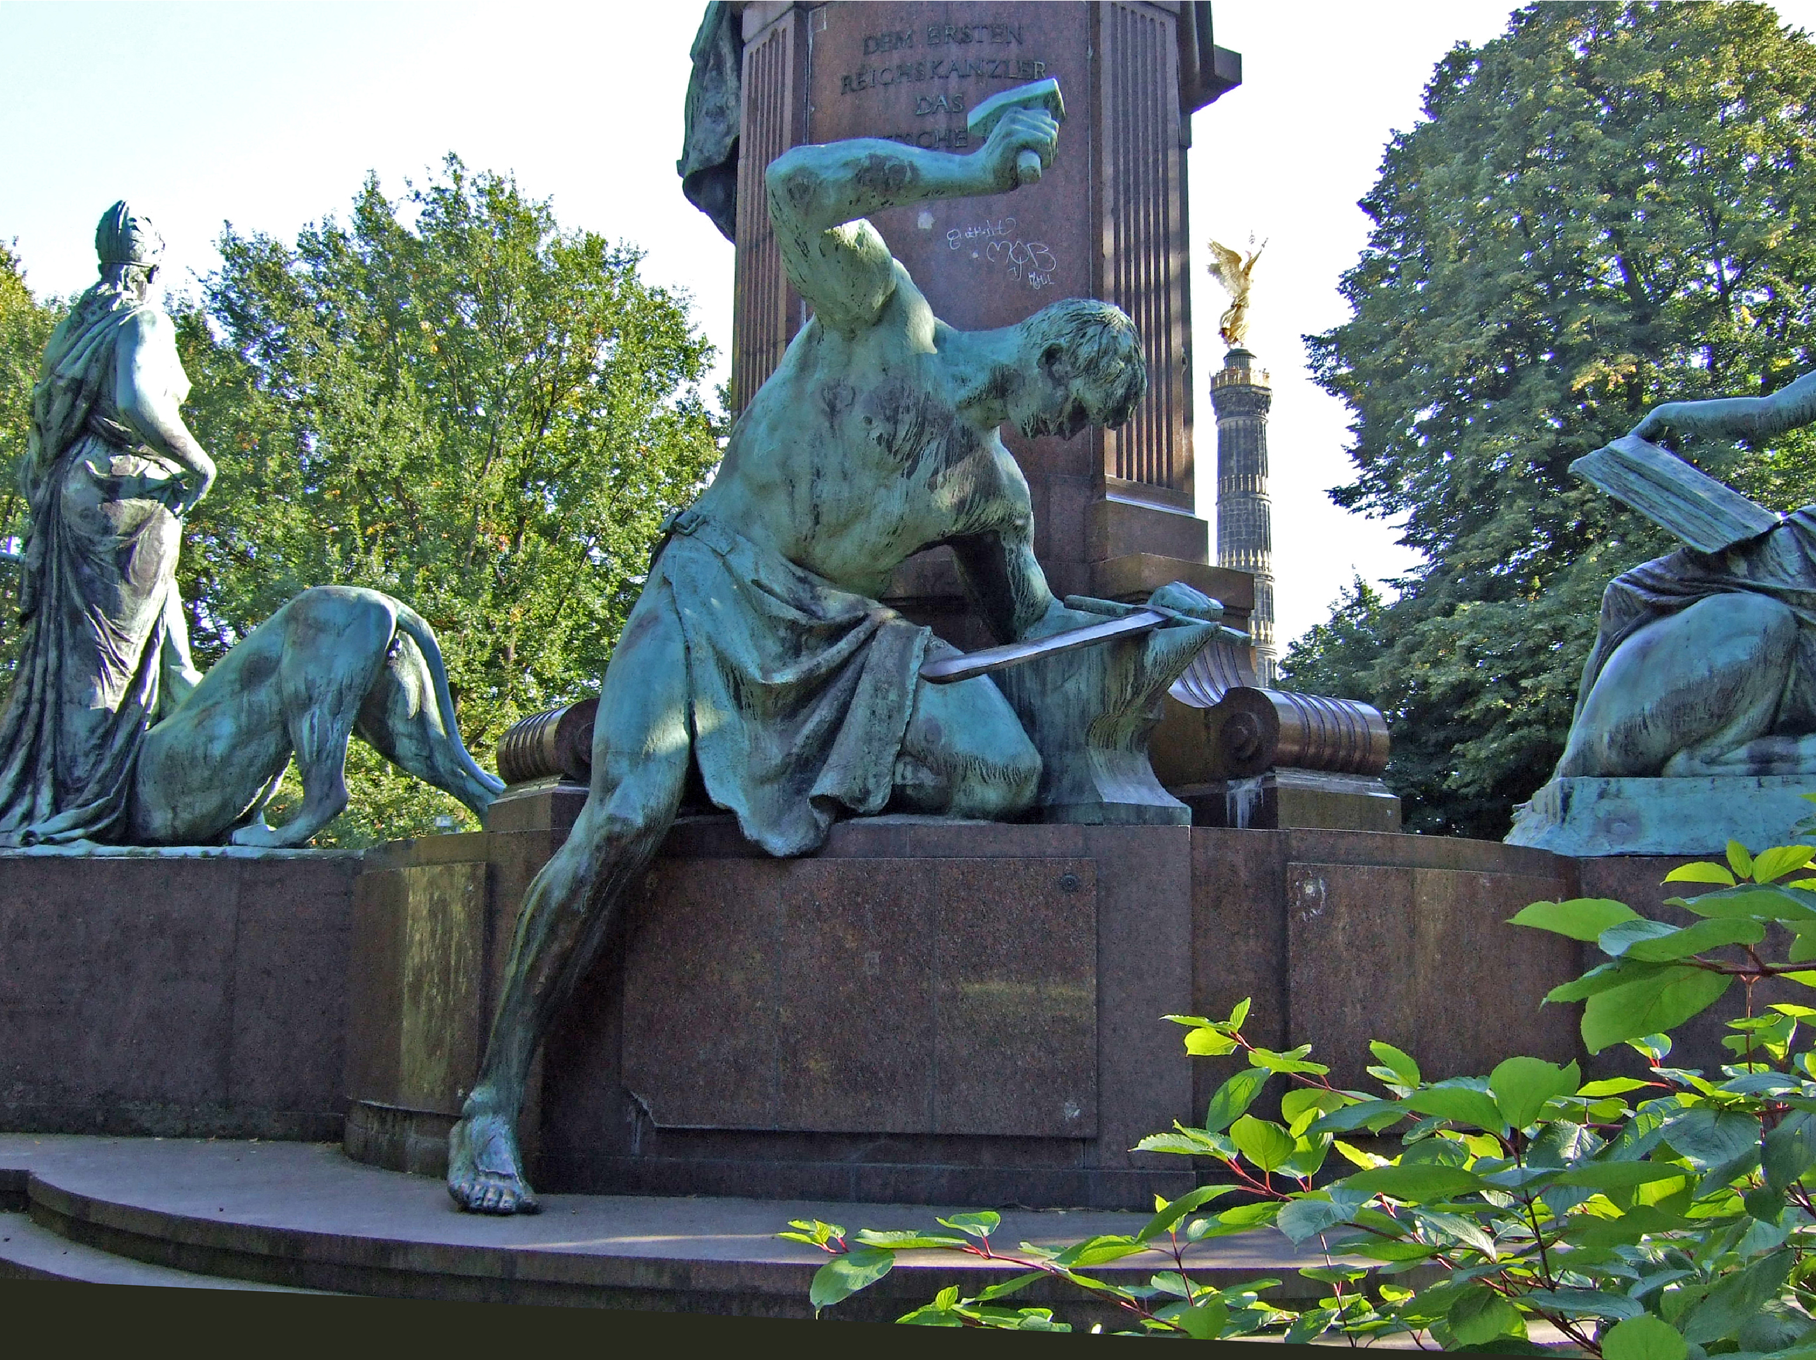
Siegfried forging the imperial sword,
Bismarck Monument, Berlin,
sculpted by Reinhold Begas,
unveiled in 1901
Image by : James Steakley; source: hJps://commons.wikimedia.org/wiki/
File:Siegfried,_das_Reichsschwert_schmiedend_1.JPG
For enGre monument see:
hJps://upload.wikimedia.org/wikipedia/
commons/5/51/Berlin_-­‐_Bismarck-­‐
NaGonaldenkmal1.jpg

Hagen Monument, Worms,
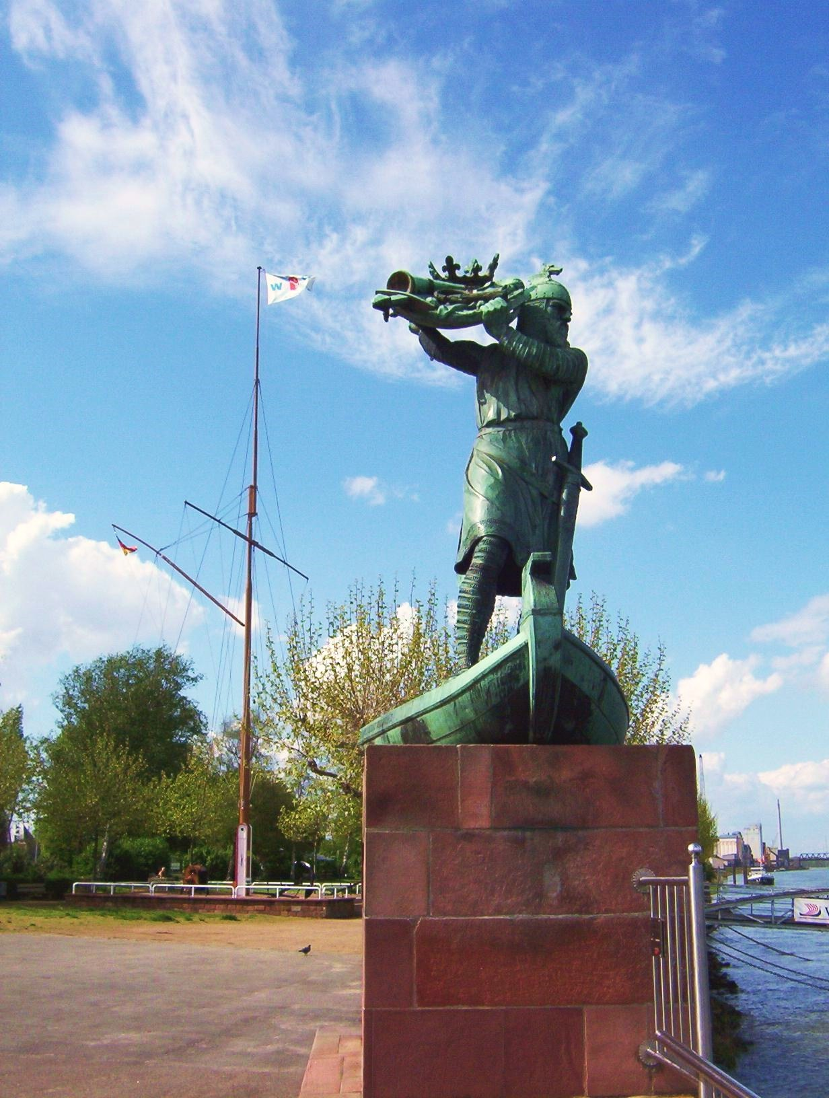
Germany, designed by Johannes Hirt, unveiled in 1905, moved to the bank of the Rhein in 1932
Image by: Dirk Schmidt
Source: hJps://commons.wikimedia.org/wiki/
File:Worms_hagendenkmal_wv_d_schmidt_04_2005.jpg

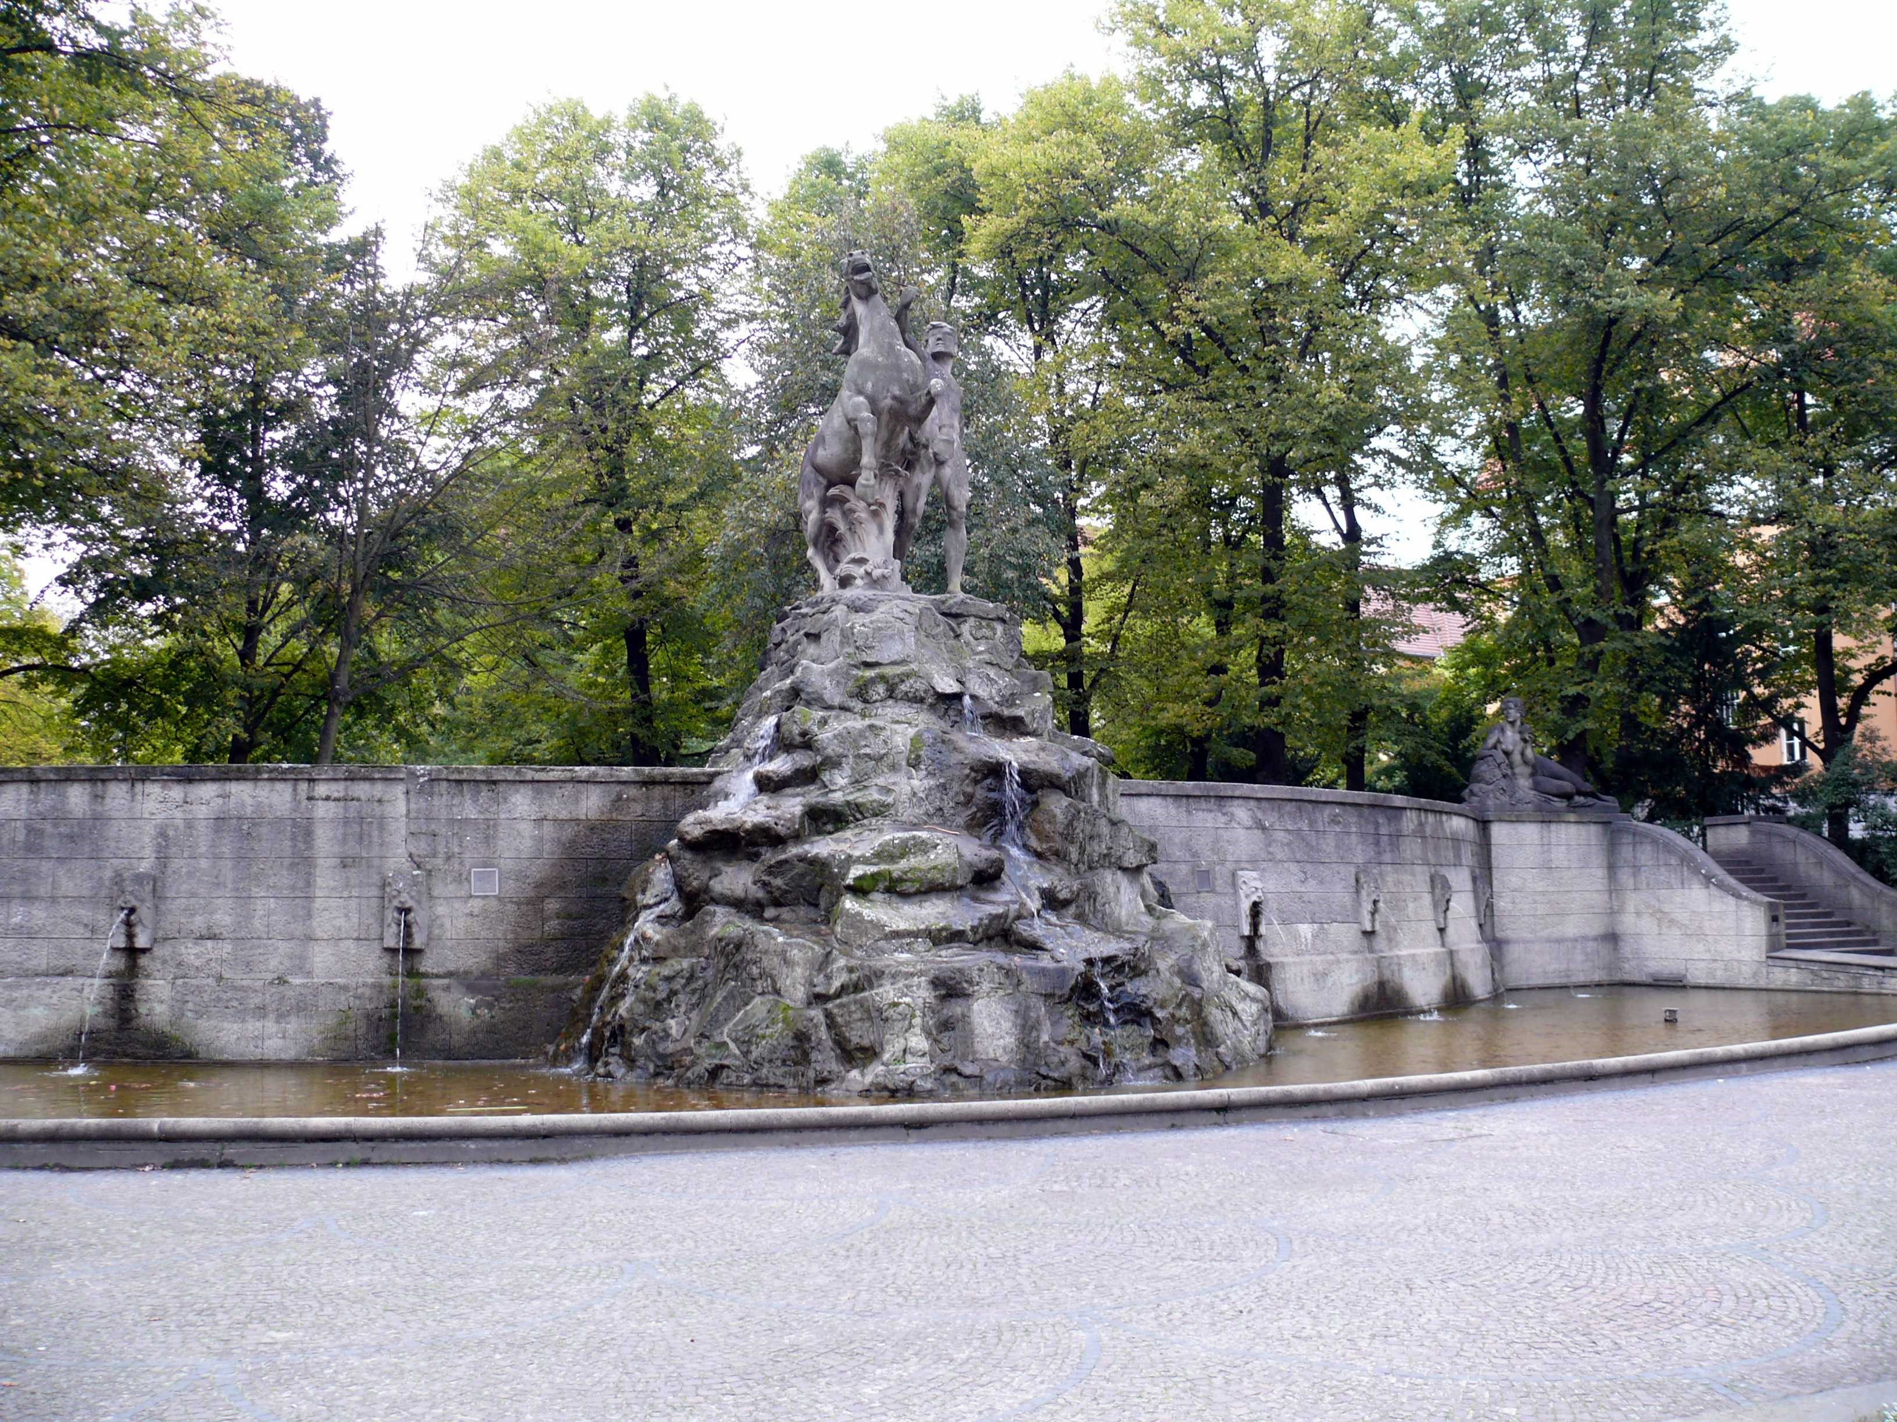
Siegfried Fountain, Berlin-­‐Wilmersdorf, designed by Emil Cauer d. J. , 1911
Image by: Peter Kuley
source: hJps://commons.wikimedia.org/wiki/
File:WilmersdorfR%C3%BCdesheimerPlatz6.jpg
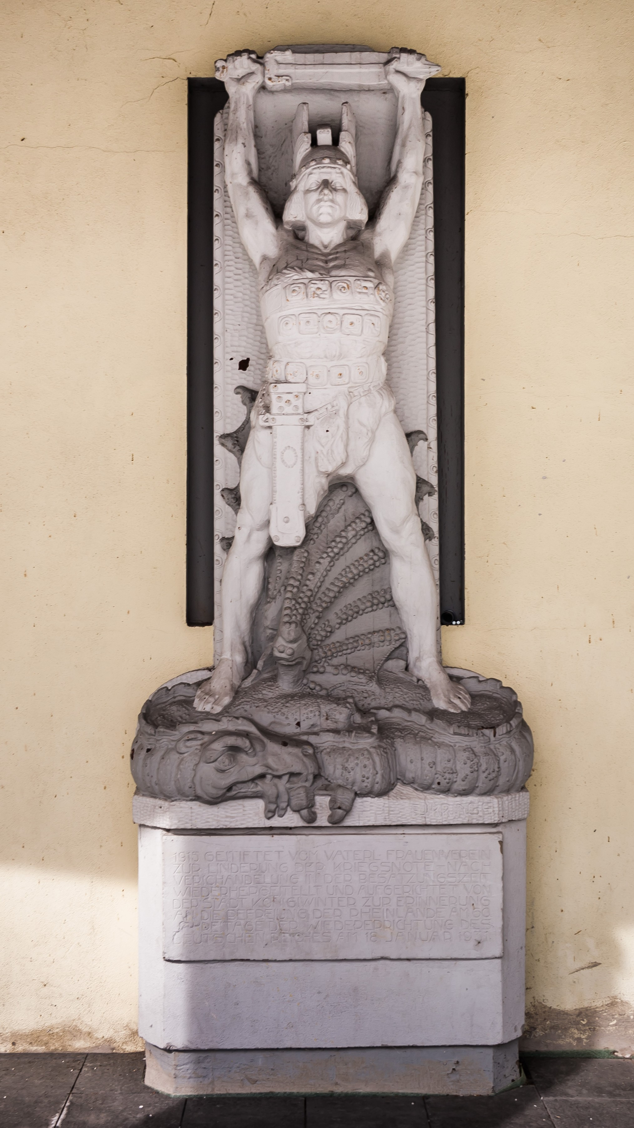
Siegfried Monument, Königswinter, Germany, sculpted by Franz Josef Krings, 1915
Image by: Eckhard Henkel
source: hJps://commons.wikimedia.org/wiki/File:2013-­‐03-­‐16_Drachenfelsstra
%C3%9Fe_5-­‐7,_K%C3%B6nigswinter_IMG_4161.jpg

Siegfried Fountain, Worms, sculpted by Adolf von
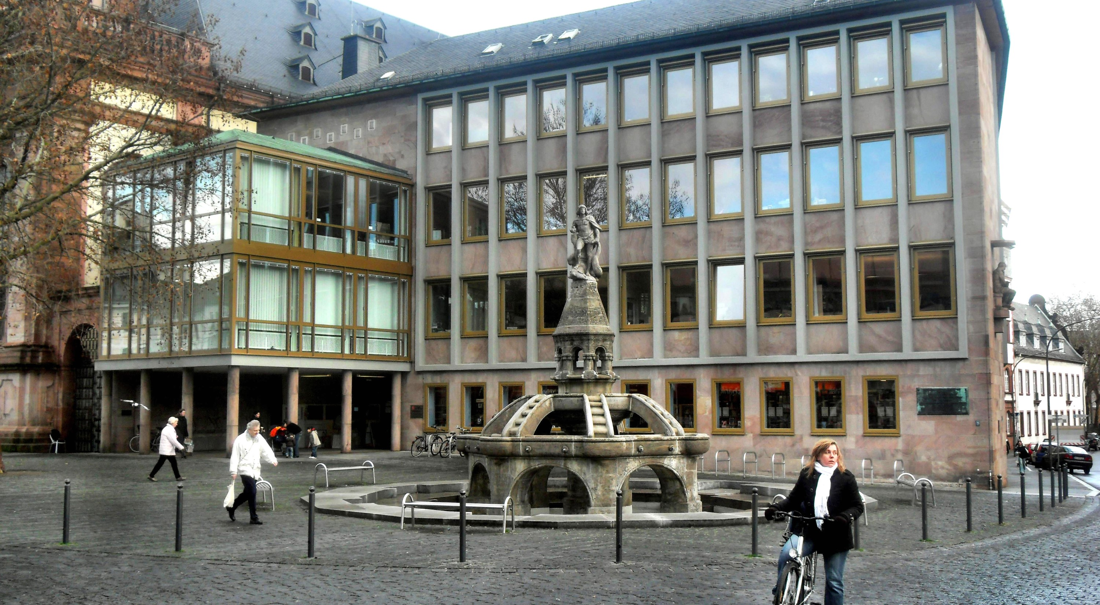
Hildebrand, 1913
Photo credit and source: Jivee Blau, hJps://commons.wikimedia.org/wiki/File:Worms-­‐_Stadtbibliothek-­‐_von_Marktplatz_aus_10.12.2009.jpg
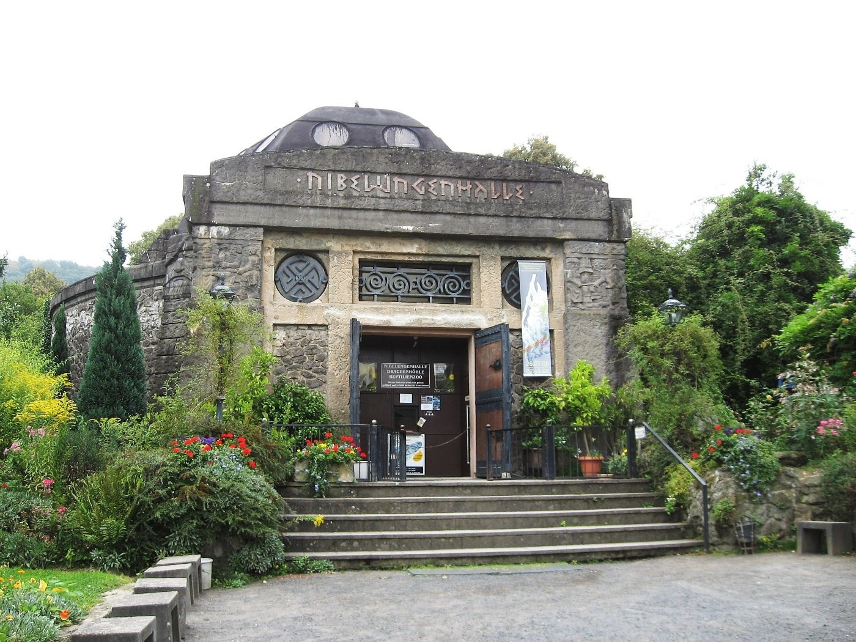
Nibelungen Hall at the Drachenfels mountain, Siebengebirge, Germany, opened 1913
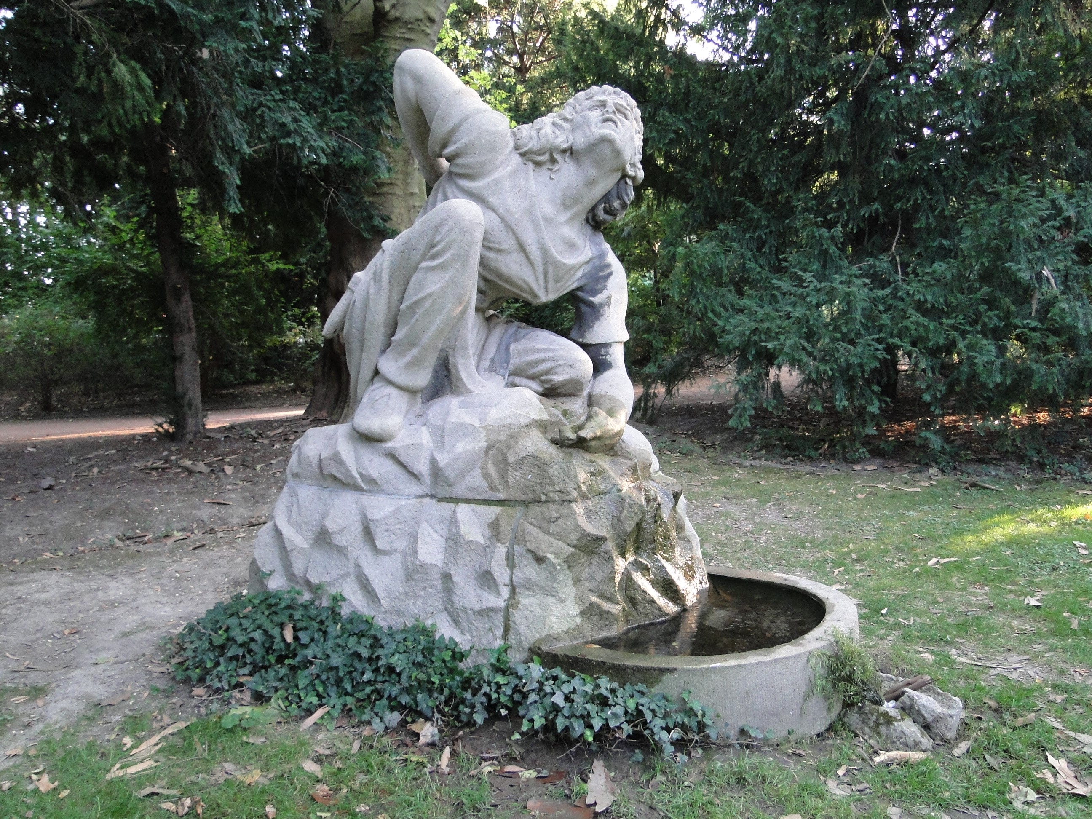
Siegfried Fountain, Lenné Park,
Dresden, Germany, sculpted by
Franz Weschke, 1936
Image by: Paulae
Source: hJps://commons.wikimedia.org/wiki/
File:Siegfriedbrunnen_Dresden.JPG
Statue depicGng
Siegfried, St. AugusGn,
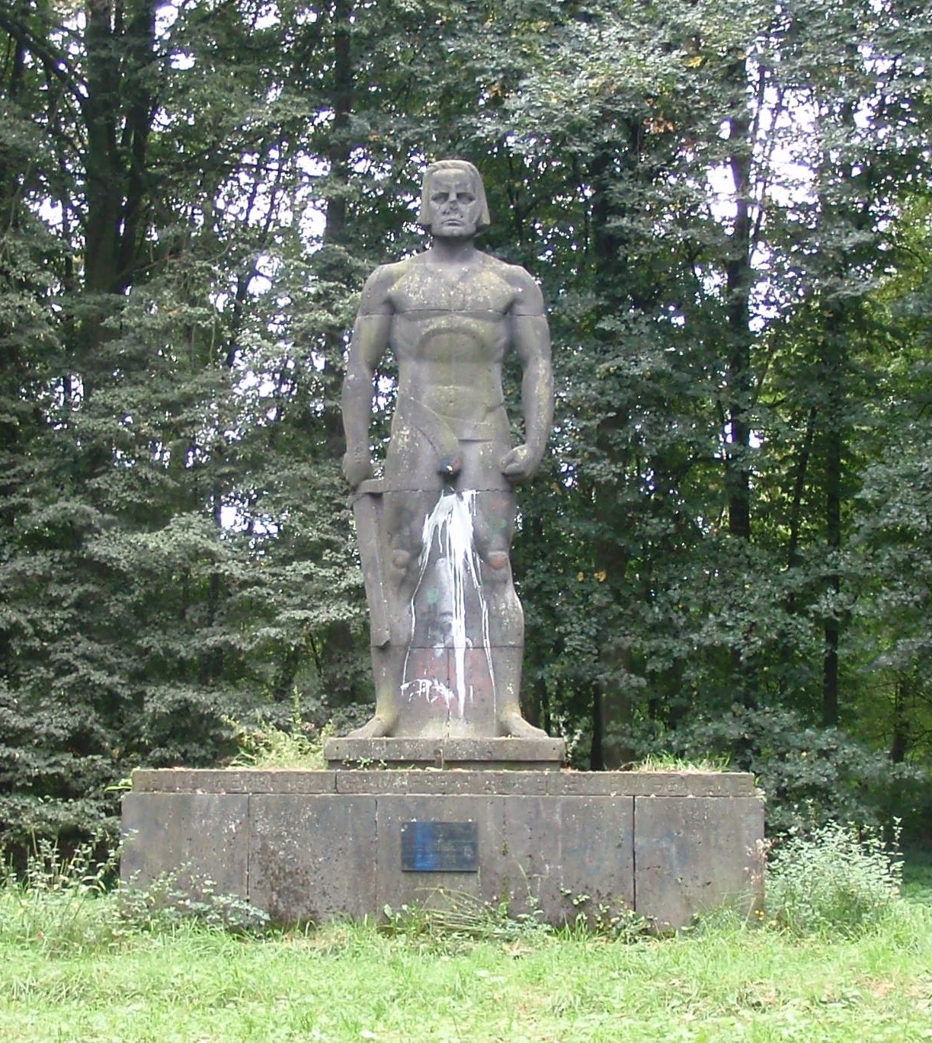
Germany, erected 1938
Image by: Stefan Knauf;
source: hJps://commons.wikimedia.org/wiki/ File:Sankt_AugusGner_Siegfried_Statue_P9060
647.JPG

Plaque on the Siegfried statue in St. AugusGn
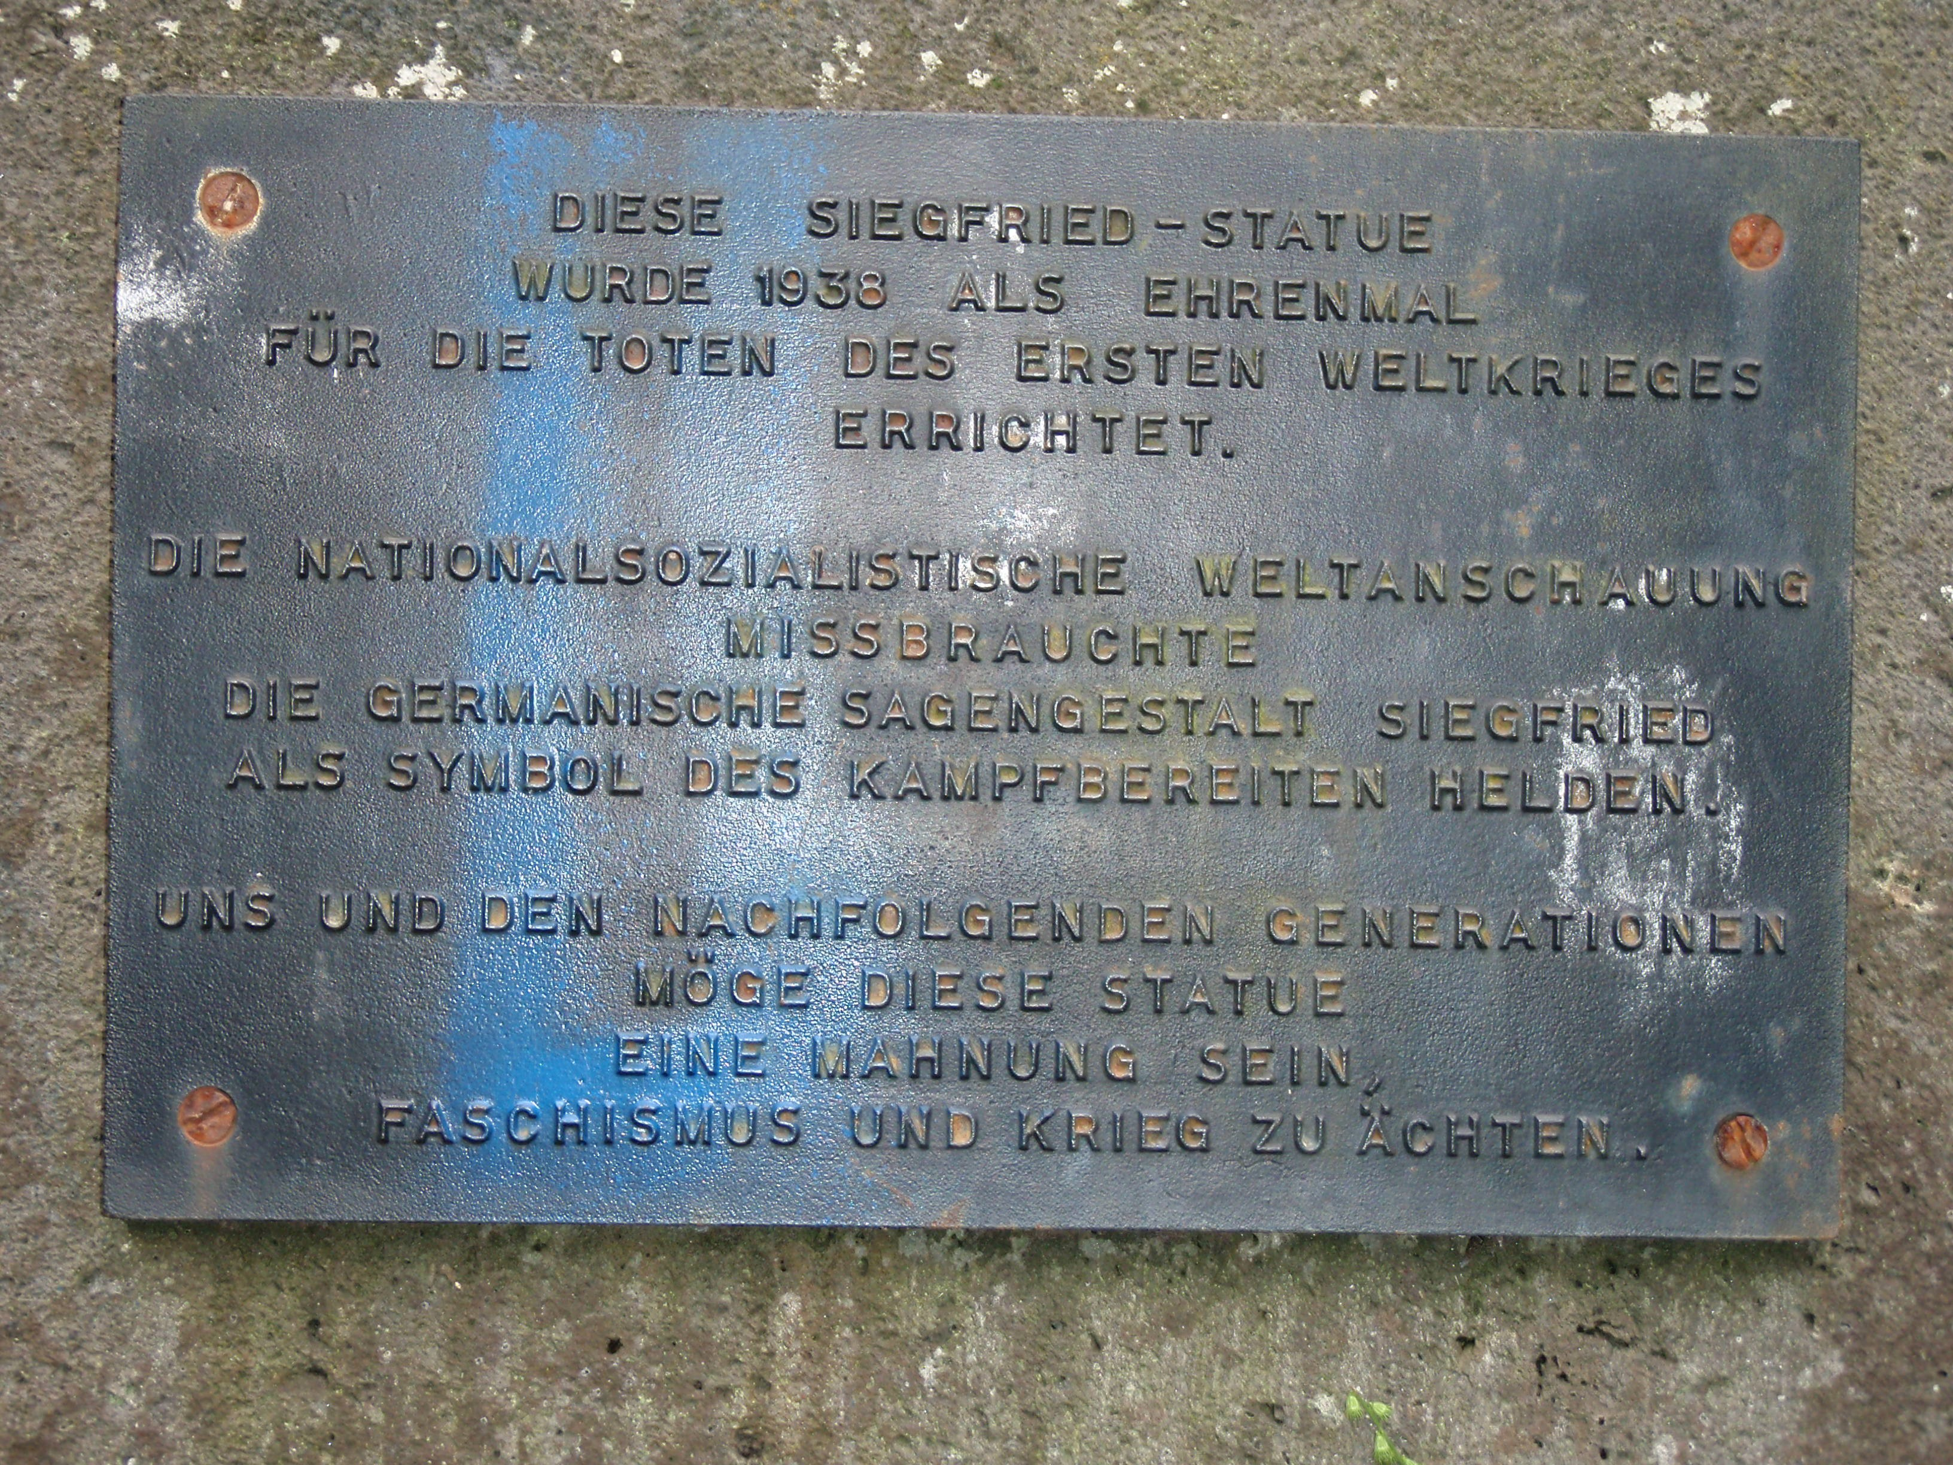
TranslaGon:

This statue of Siegfried was erected in 1938 as monument for the dead of the First
World War.
The NaGonal Socialist ideology abused the Germanic legendary figure Siegfried as symbol of a hero ready for baJle.
May this statue be an admoniGon to us and the following generaGons to ostracize fascism and war.
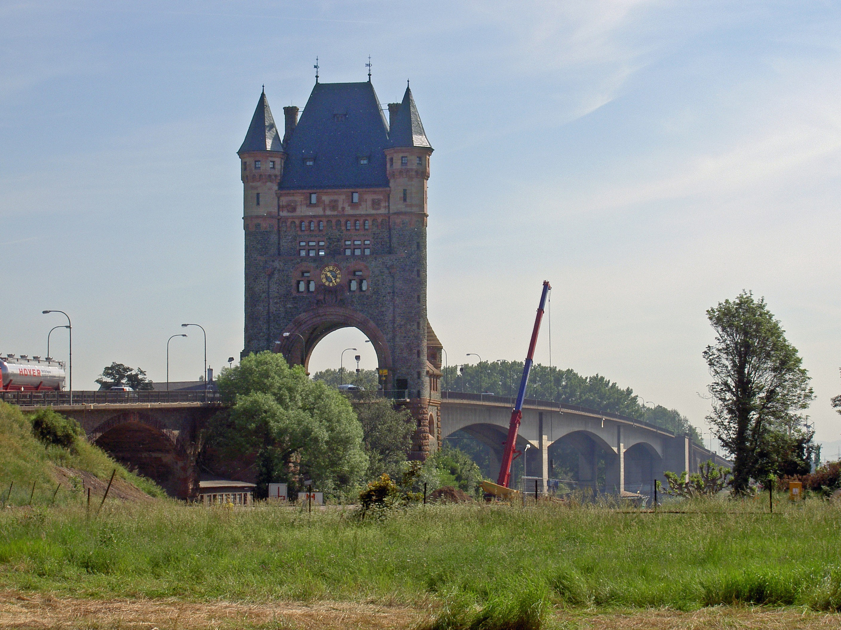
Nibelungen Bridge, Worms, Germany, originally built 1900, re-­‐built 1951-­‐53
Image by: Heidas; source: hJps://commons.wikimedia.org/wiki/File:Worms_Nibelungenbr%C3%BCcke_Br%C3%BCckenturm_2005-­‐05-­‐27a.jpg

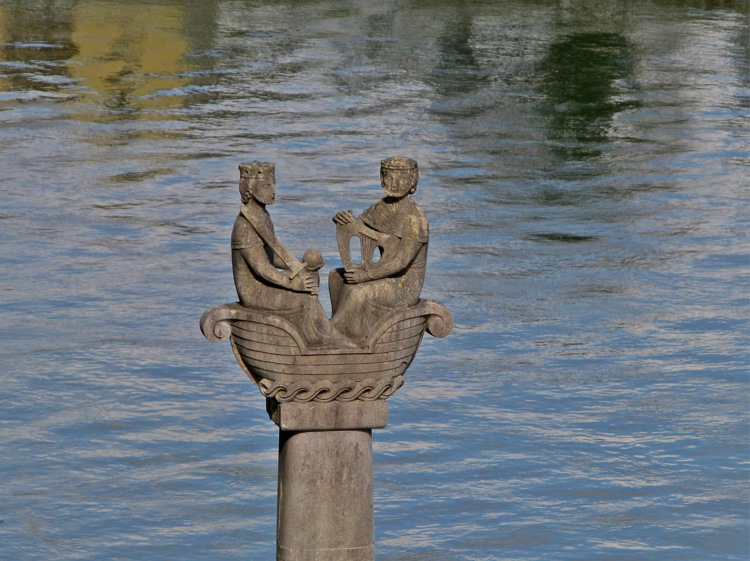
Nibelungen Ship, in front of the Danube in Linz, Austria,
sculpted by Peter Dimmel, 1957
Image by: Eboli; source: hJps://commons.wikimedia.org/wiki/File:Nibelungen_auf_der_Donau.JPG
Image by: Dede2; source: hJps://commons.wikimedia.org/wiki/File:Nibelungen_Donau%C3%BCberquerungsdenkmal_Gro%C3%9Fmehring_LkrEichst
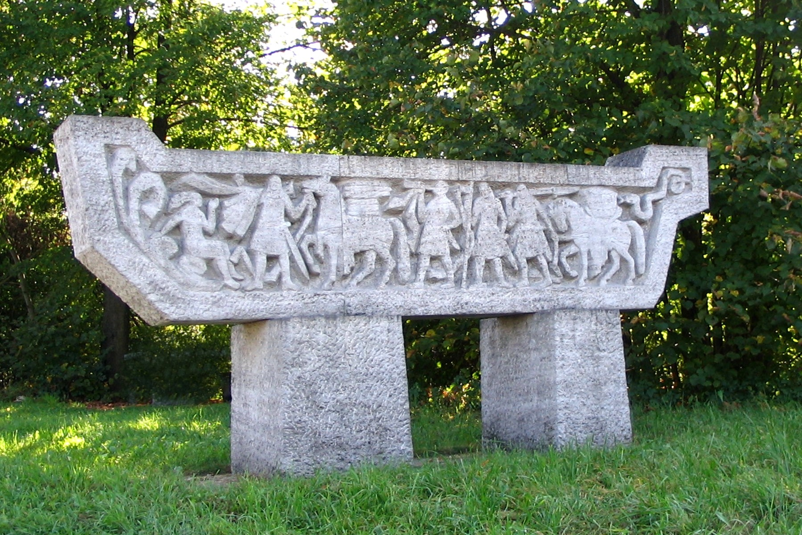
%C3%A4J_Oberbayern.JPG
Monument depicGng the Nibelungen crossing the Danube, Großmehring, Upper Bavaria, 1980

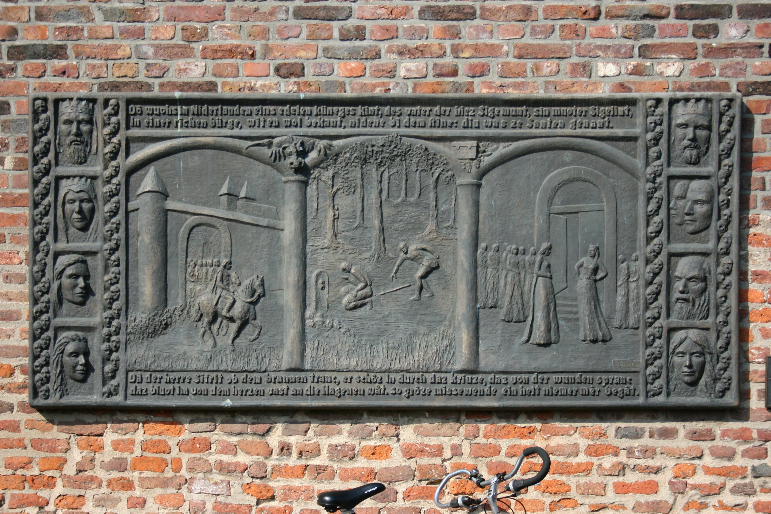
Siegfried in Xanten, relief, Xanten, Germany,sculpted by Erika Rutert, 2000
Image by: Frank Vincentz; source: hJps://commons.wikimedia.org/wiki/File:Xanten_-­‐_Nordwall_-­‐_Siegfried_01_ies.jpg
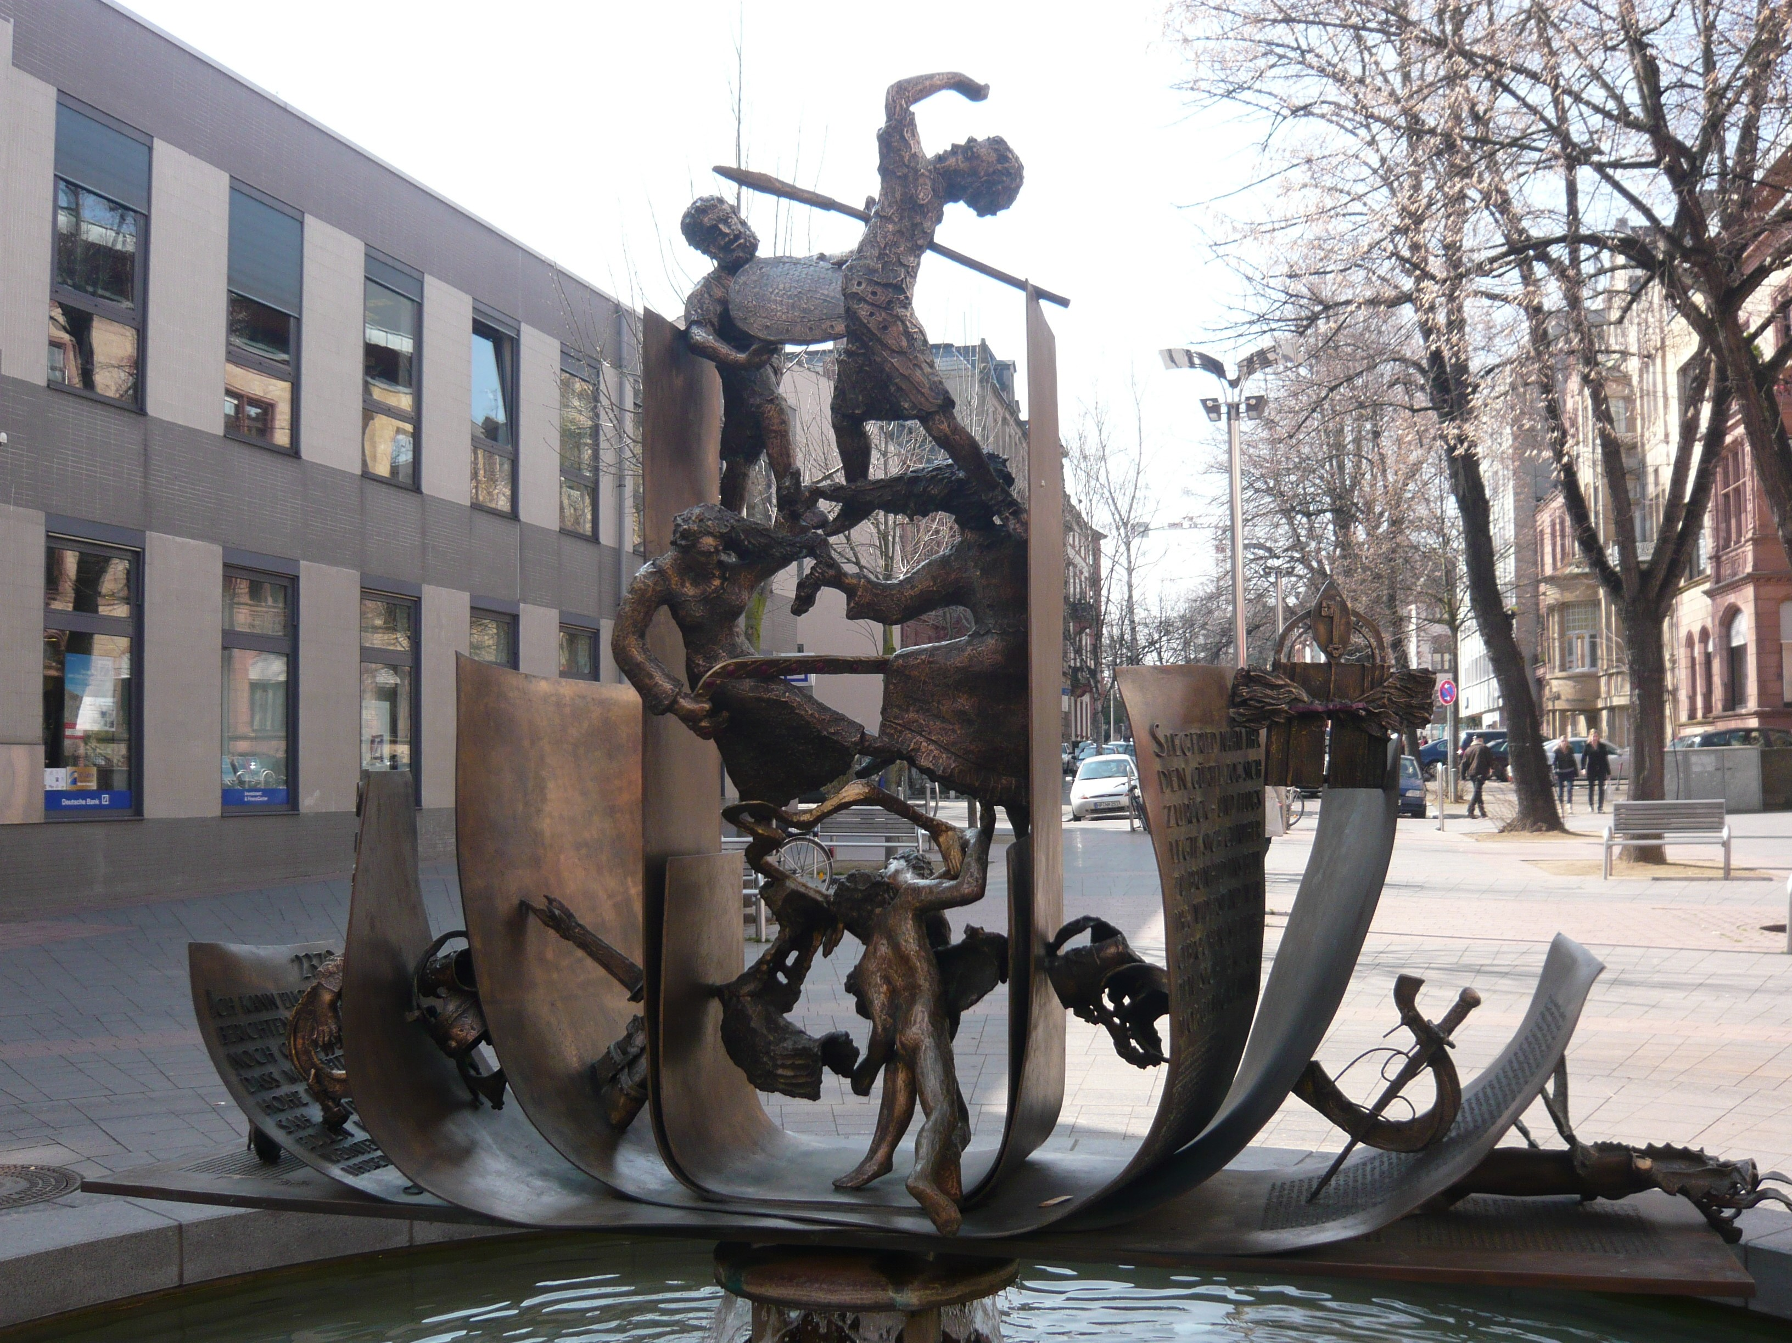
Nibelungen Fountain, Worms, sculpted by
Gustav Nonnenmacher, 2003
Image by: Dimitar Denev
Source: hJps://www.flickr.com/photos/mitko/3531527729/

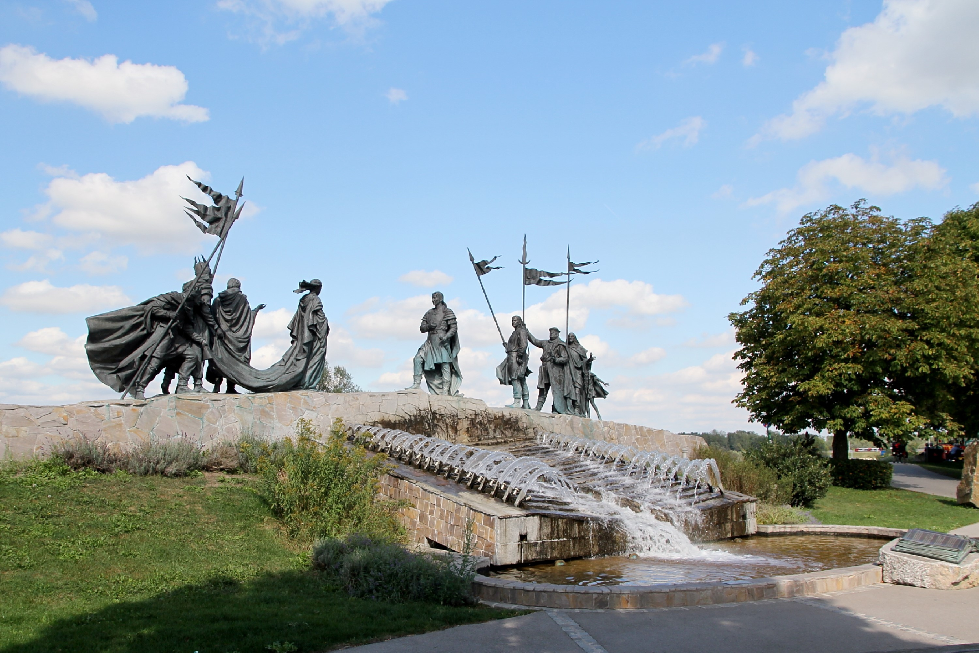
Nibelungen Fountain, Tulln, Austria, created by Michail Nogin and Hans Muhr, 2005
Image by: Bwag; source: hJps://commons.wikimedia.org/wiki/File:Tulln_-­‐_Nibelungenbrunnen.JPG

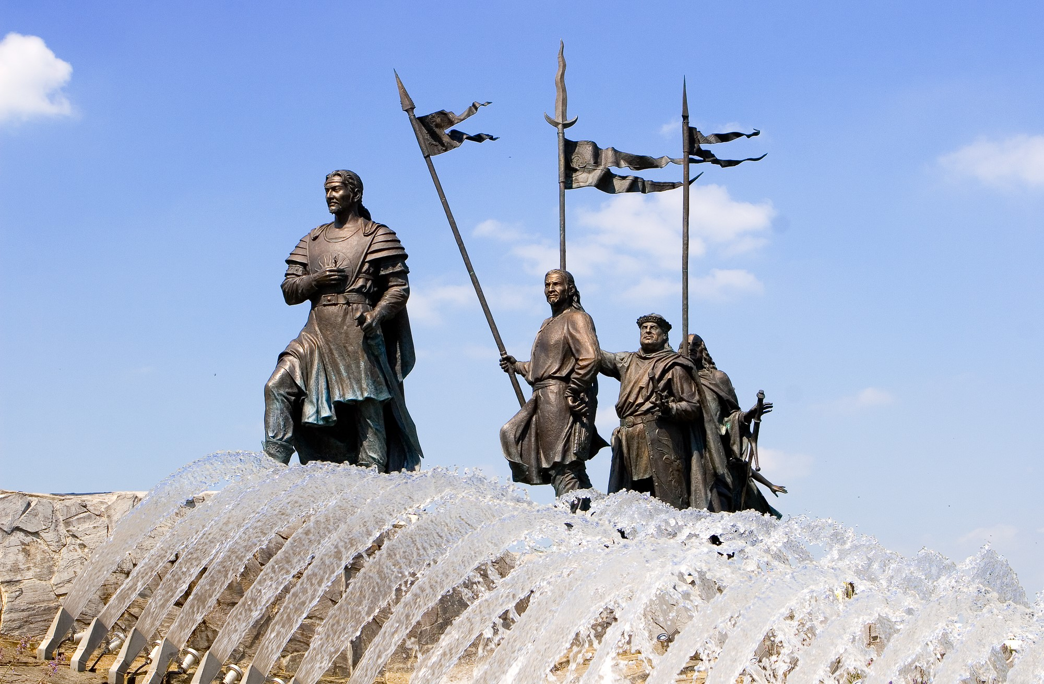
Detail of the Nibelungen Fountain, Tulln, Austria
Image by: Hannes SallmuJer; source: hJps://commons.wikimedia.org/wiki/File:Wiki_nibelungen.jpg

2007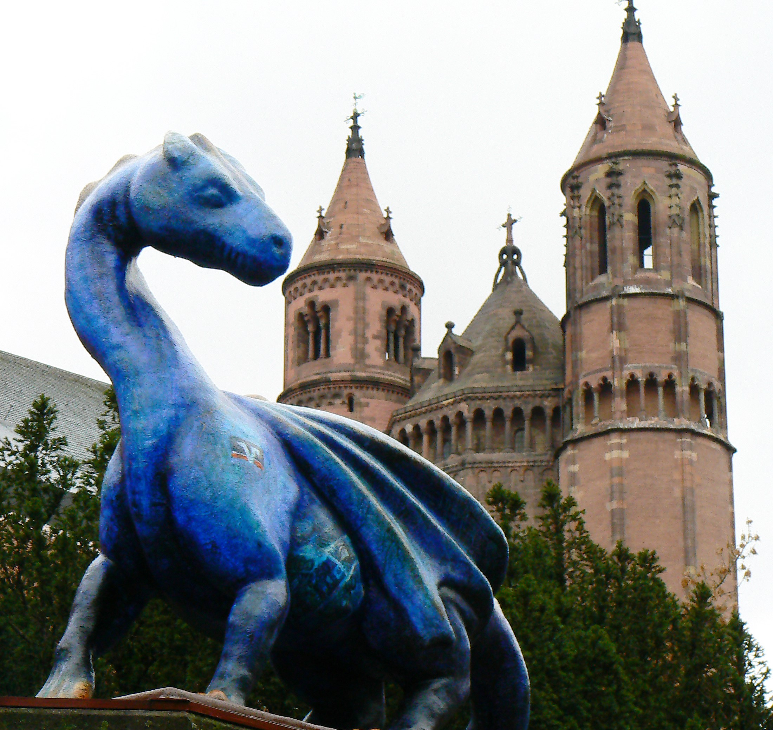
The dragon Fafnir in front of the Worms cathedral,
Photo credit and source: Dierk Schaefer, hJps://www.flickr.com/photos/dierkschaefer/3355643929
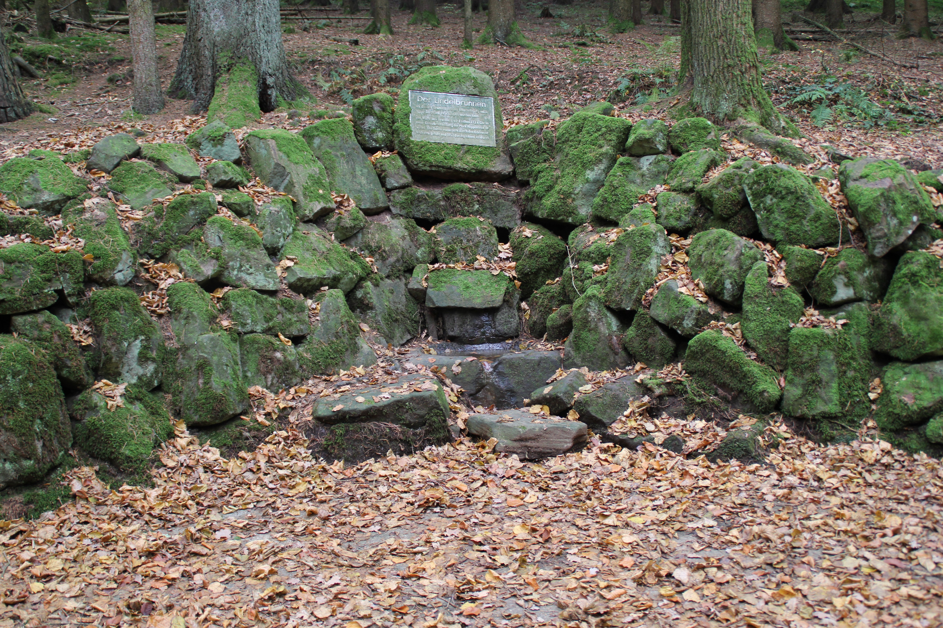
The Lindel Source near Mossautal in the Odenwald region, newly set in 1884 and restored in
1953 Image source: hJps://commons.wikimedia.org/wiki/File:Lindelbrunnen.jpg
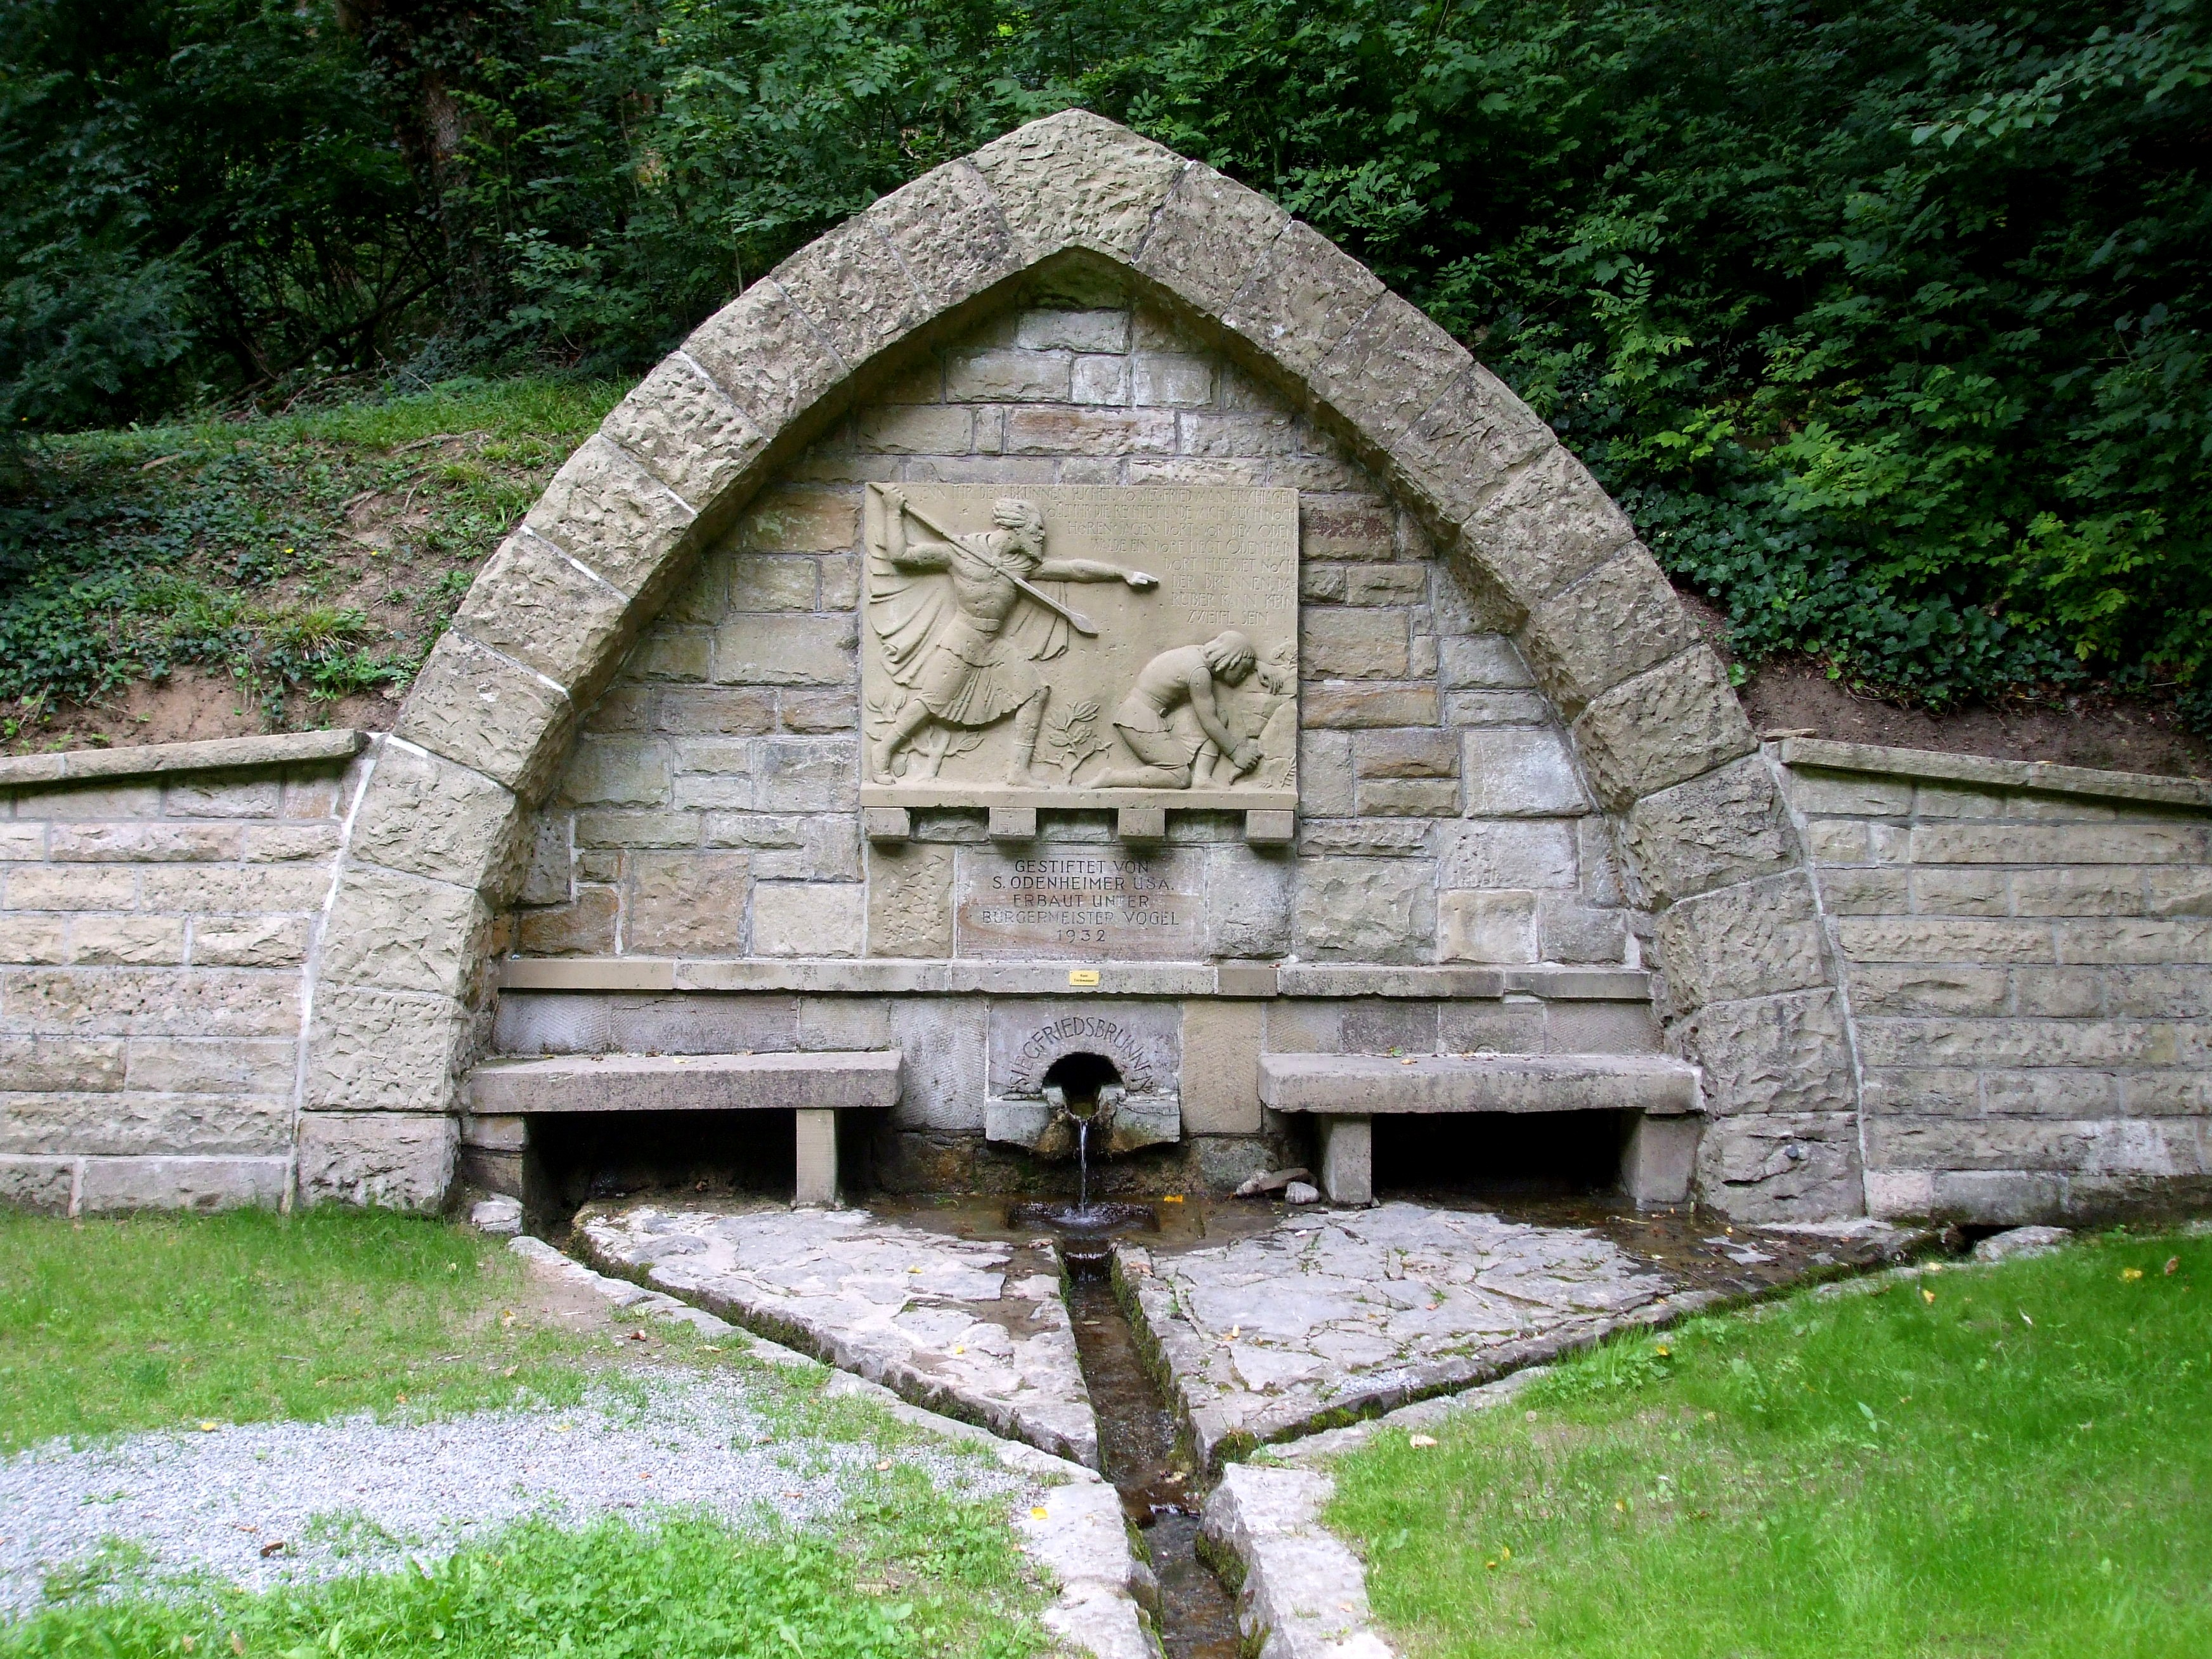
Siegfried’s Source, Odenheim
Built in 1932, endowed by
S. Odenheimer, a Jewish
emigrant living in the USA
Image by: StromBer
source: hJps://commons.wikimedia.org/
wiki/File:SiegfriedsbrunnenOdenheim.JPG
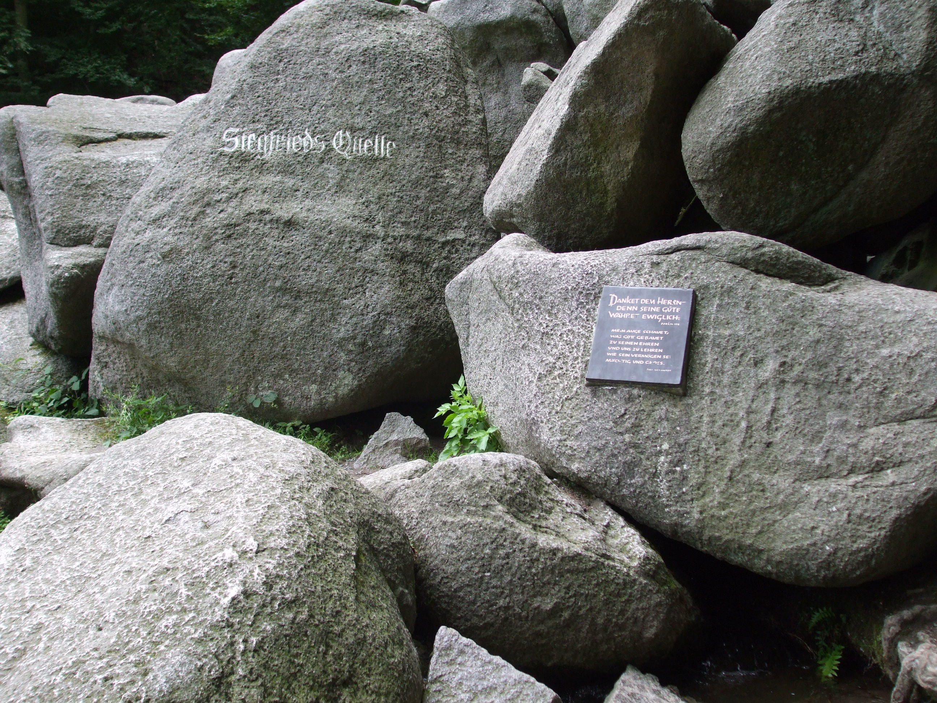
Siegfried’s Source, Lautertal,
Odenwald, Germany
Image by: StromBer
Source: hJps://
commons.wikimedia.org/wiki/
File:SiegfriedsquelleFelsenmeerLaut
ertal.JPG

