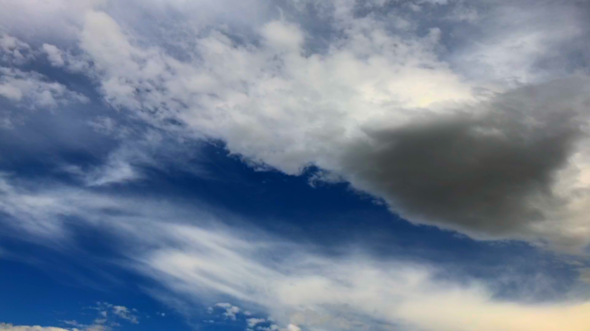

Christopher Nielsen
Clouds 1 Report
CINE 4200--01
Cirrus and Cirrocumulus
06 October, 2021
2:06 p.m. MST at Kittredge Field Boulder, CO.

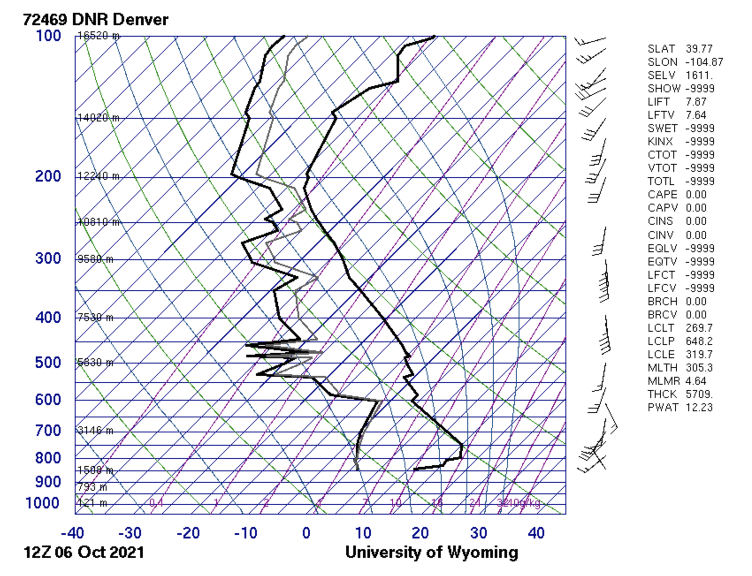
The goal for this project was to capture a dynamic photograph depicting the flow of clouds. My intent was to find a mixture of clouds, especially altostratus, that would show the movement of the wind as well. I attempted to photograph a composition that had a balance of cloud and sky to create a visually stimulating contrast.
Recorded on the 6th of October, 2021, at the University’s Kittredge Field in Boulder Colorado at 2:06 p.m. at the elevation of 5,370ft. Facing approximately East South East the camera was angled at approximately 45 degrees from the horizon. It was 70 degrees fahrenheit with a humidity of 28% and air pressure of 30 inHg. There was a visibility of 10mi and an air quality of 70 with a 10% chance of rain.
The clouds depicted are a mixture of Cirrus and Cirrocumulus. The CAPE value was 0.00 so the atmosphere was stable and there were no thunderstorms that day. There were no ground level winds recorded, however according to the Skew-T diagram, there were winds aloft coming from the South South West. The first cloud formation starts at around 5,000m and goes up to about 6,000m which coincides with the altitude that Cirrus and Cirrocumulas form at. The wisps of the cloud in the bottom left of the frame are also indicative of a Cirrus formation. There was no rain or snow before or after recording the video. Cirrus clouds need conditions of about -40C which is exactly what the Skew-T diagram indicates and does not produce precipitation which is also consistent with the day’s weather. These conditions are consistent with how cirrus clouds form; the air was dry enough and cold enough aloft to cause the air to undergo deposition into ice crystals.
This photograph was taken from a video recorded on an iPhone 8 using the FiLMiC Pro application. The camera has a field of view of 120 degrees and an aperture of f/1.8 and a focal length of 28mm. The distance of the subject from the lens is approximately 5,500m away. The shutter speed was set to 1/288 and the ISO was 31. In post processing Davinci Resolve was used to screengrab the still image used from the source video file, and to color grade the final image. In the color grading process, the saturation of the image was cranked up to 100%, the gain and lift wheels were then used to adjust the high and low ends to normalize the color levels. The still was saved as a PNG file taken from the MOV file.
The image reveals the way in which Cirrus clouds are pulled along to create the wisping variety of shapes by the wind. This image also reveals the relative closeness of altitude that Cirrus and Cirrocumulus clouds form at. What I dislike about this photo is the narrow field that it was captured in. I will try to use a wide angle lens next time. I believe that this image does a good job of showing the fluid physics of the clouds. I think that I fulfilled my intent for this project. I think that another direction that this project could take is to record for much longer and generate time lapse videos of the flow of clouds.

Before Color Grading | After Color Grading
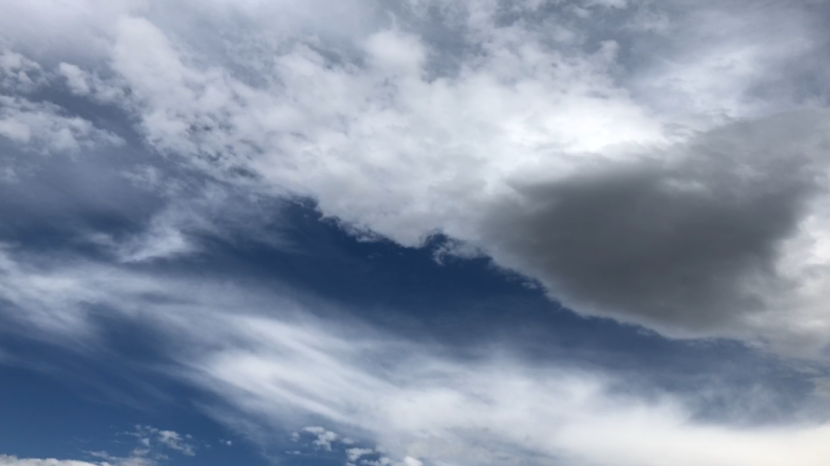

Resources:

Skew-T Diagram:
“Atmospheric Soundings.” Atmospheric Soundings, http://weather.uwyo.edu/upperair/sounding.html.

