Case Analysis: Nike Problems
Name
Professor
Course
Date
Case Analysis: Nike Problems
Introduction
Nike was established in 1964 as Blue Ribbon Sports by University of Oregon track competitor Philip Knight and his mentor Bill Bowerman, and formally progressed toward becoming Nike, Inc. in 1978. The organization takes its name from Nike, the Greek goddess of triumph, and embraced the outstanding logo, called the "Swoosh", first utilized by Nike in 1971. Nike delivers an extensive variety of games types of gear. Their first items were track running shoes, for an extensive variety of games including track and field, tennis, baseball, among others.
NIKE, Inc., based near Beaverton, Oregon, is the world's leading designer, advertiser and wholesaler of true athletic footwear, clothing, gear and extras for a wide assortment of games and wellness exercises. Completely claimed NIKE, Inc. backup brands incorporate Converse, which plans, advertises and circulates athletic way of life footwear, attire and embellishments; and Hurley, which outlines, showcases and appropriates surf and youth way of life footwear, clothing and frill (Nike, 2018).
The organization supports some prominent professional competitors, for example, Cristiano Ronaldo, Rafael Nadal, Lebron James, and Rory Mcllroy to utilize their items and advance and promote their innovation and outline. Over that, Nike likewise fabricates and gives packs (garbs) for an extensive variety of games groups like Barcelona, Manchester United, Arsenal and numerous U.S. schools too (Statista, 2018).
Throughout the years, the sporting products industry has seen numerous mergers and acquisitions. Enter players in the business incorporate Reebok, Adidas, Puma and obviously Nike, with the last creating a worldwide income near 31 billion U.S. dollars in 2015. A portion of these organizations are getting together with form originators to create new dress styles and broaden their product offerings. Accordingly, utilization will keep on being driven by a pattern toward less formal dress in the working environment and request from particular socioeconomics, for example, adolescents and children of post war America.
Footwear has dependably been an enormous piece of Nike, more than 60% of the income produced from the North American district originates from footwear. As detailed by the market following organization NPD Group, in the initial eight months of 2017, Nike kept on commanding the footwear advertise in North America with 37% piece of the overall industry, down from 39% a year ago finished a similar eight months. While Adidas takes the second spot from Jordan mark, controlling 11.3% of the market, up from 6.6%. Jordan mark controls 9.5%, up from 9.4%. In spite of the way that Jordan mark is a piece of Nike, it is thought about independently in this report.
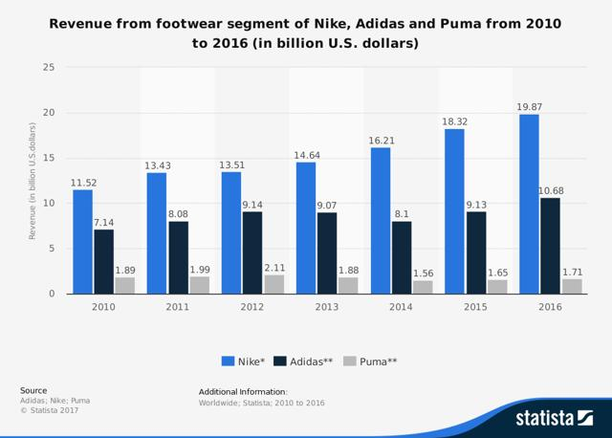
The footwear advertise has been becoming hugely finished the previous couple of years. Nike's income from the footwear fragment has been developing at multi year-over-year rate of almost 10%. A portion of the key drivers are the request from millennial and the vital business approach of restricted supply by organizations, for example, Nike (Jordan Brand) and Adidas.
Social Nike has confidence in the great energy of the human potential in this way by utilizing their size and achieve, they can be an impetus for long haul change that enables bolster for nearby networks tending to the fundamental requirements for wellbeing, security and essentialness; particularly where they live, work and play (Nike Responsibility, Community, 2011).
Budgetary Analysis
Second from last quarter pay articulation survey demonstrates that Revenues for NIKE, Inc. expanded 7 per cent to $9.0 billion, up 3 per cent on a cash nonpartisan premise. Incomes for the NIKE Brand were $8.5 billion, up 4 per cent on a money impartial premise, driven by Greater China, EMEA and APLA, incorporating twofold digit development in NIKE Direct and development in Sportswear and NIKE Basketball (Nike, 2018).
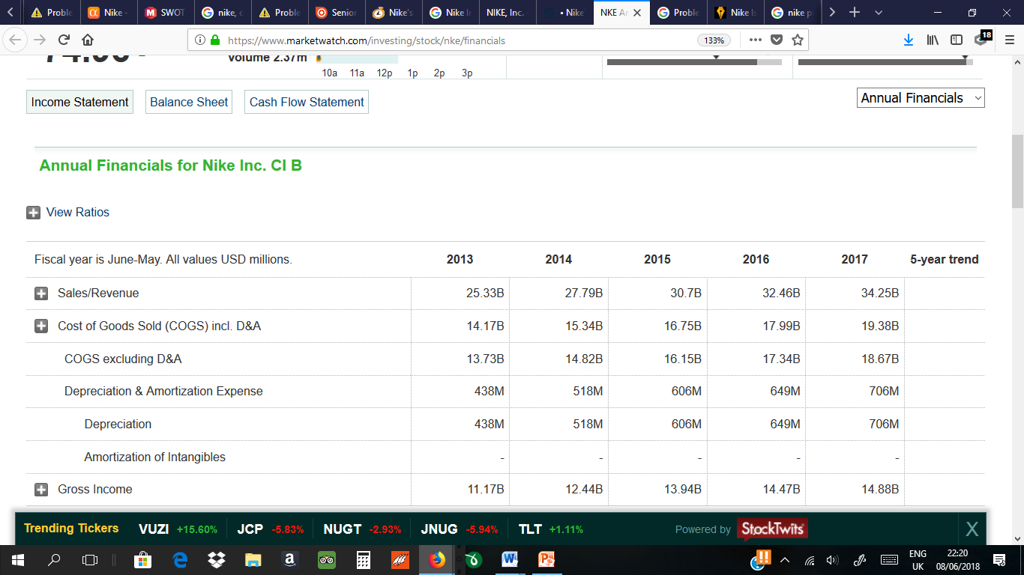 (Source: Marketwatch)
Incomes for Converse were $483 million, down 8 per cent on a cash unbiased premise, as worldwide and advanced development were more than counterbalance by decreases in North America. Net edge declined 70 premise focuses to 43.8 for every penny due basically to ominous changes in remote cash trade rates, which were in part balance by bring down item costs.
Offering and authoritative cost expanded 11 per cent to $2.8 billion. Request creation cost was $862 million, up 15 per cent, essentially determined by higher spend in sports advertising, mark minutes and new advancement dispatches. Working overhead cost expanded 9 per cent to $1.9 billion, to a great extent because of higher regulatory expenses and proceeded with interests in worldwide advanced abilities and the NikePlus participation program (Nike, 2018).
Wage before pay charges diminished 12 per cent to $1.2 billion as strong income development was more than balance by bring down gross edge, higher offering and authoritative cost and lower other pay.
The compelling expense rate was 179.5 per cent, driven by the Tax Act, which affected similarity. Amid the quarter, because of order of the Tax Act on December 22, 2017, the Company recorded extra pay charge cost of $2.0 billion fundamentally identified with the progress impose on our gathered outside income and the measurement of conceded assess resources and liabilities. This sum was recorded as a temporary gauge and is liable to change as the Company finishes its examination amid the estimation time frame, which ought not stretch out past multi year from the establishment date (Nike, 2018).
Net misfortune was $921 million and weakened net misfortune per share was $0.57, driven by the order of the Tax Act.
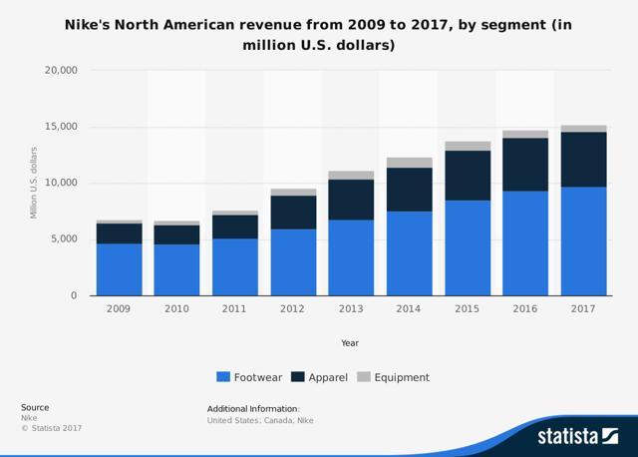Source: Statista.
The above course of events portrays Nike's North America's income from 2009 to 2017. In 2017, Nike's worldwide income added up to around 34.35 billion U.S. dollars (Statista, 2018).
Optional Market Analysis
Nike's (NKE) as of late discharged their outcomes for Q1 of 2017. Income development is level and footwear deals from the North America area dropped by 3% amid the quarter. There is a general shortcoming originating from the US retail industry and declining development in the footwear advertise. In this article, we will initially talk about how the footwear showcase has changed and influenced Nike. At that point we will talk about the brand estimation of Nike and we will finish up with a DCF valuation of Nike (Alpha, 2017).
Nike Problems and Solutions
Appropriation of new Material
As per Vogel (2012), Nike has confronted some test when they are putting their endeavors in consolidate the manageability inside the Nike's items and improve a reclassified future yet it has driven them to finding better approaches to run and work the business all the more adequately, effectively and furthermore innovatively. Execution hazard in selection of utilizing new material It's very test for Nike when there is a significant number of execution and stylish hazard looked by Nike in utilizing the natural material friendly(EPM, for example, the manufactured calfskin.
A potential hazard do exist which the engineered cowhide could minimize the physical properties, for example, the material toughness and this is truly undermining Nike's strict quality models and execution. An items creation chief from Nike additionally says that the standpoint of the EPM engineered calfskins looks not alluring. He says that "Cowhides look boardy and dry, and the materials aren't exceptionally intriguing" Nowadays, the ascending of information costs that required for the development and furthermore the innovation has turned out to be increasingly elevated.
Battling Apparel Industry
Nike has for quite some time been seen as safe to the battles of the clothing business, however the as yet sickly and buyers generally would prefer not to burn through cash on attire.
Stores that offer Nike stock have been floundering, as well, for example, Sports Authority, which petitioned for liquidation not long ago. Furthermore, Macy's offers Nike, and however the Nike segment stays one of Macy's Herald Square's just flawless segments, Macy's is as yet attempting to direct people to its stores. For example, certain models of Nike's Jordan image were offering at slower rates than they had truly (Halzack, 2018).
There is so gigantic offer of Nike athletic shoes in 2003. The one splendid spot in a generally discouraging year was the ladies' section. In ladies' casual tennis footwear was the most present day class, driven by both the retro mold pattern and development in the casual way of life section. As footwear suppliers concentrated on worldwide request to raise wage, it was trusted that a proceeded with frail would prop up worldwide deals.
The non-athletic shoe fragment had encountered a noteworthy move far from dress to casual shoes, splendid the more casual dress condition of the working environment. Lower-estimated rivalry in this fragment would make abroad sourcing, powerful showcasing, and working efficiencies keys to benefits in the close term.
The world's greatest sportswear producer anticipates that North American deals will decay again this quarter, following a 3 per cent dunk in the area last quarter. Nike's Converse business additionally will drop in the present time frame. The droop has constrained Nike to depend all the more vigorously on abroad development, particularly in China. Universal deals - alongside a forceful cost-cutting arrangement (Townsend, 2017).
Morgan Stanley report predicts that attire and footwear deals will grow 1-3% throughout the following three months, yet the report demonstrated that year-over-year development on a 3-month normal for apparel and adornment stores were down - 5%. The donning products, side interest, book, and music store class was up 4.9%.
Crowded Women's Athleisure
There are the real contenders — like Lululemon and Under Armor — and afterward there are more specialty brands, similar to the ultra-luxury Sweaty Betty and Bandier, and Outdoor Voices, presented above, which prides itself on marking that spotlights on fun, instead of being aggressive and the best. At the end of the day, its the counter Nike, and that could be speaking to young ladies who looked for another option to Nike's "Just do it" mindset.
In spite of the fact that in sheer size none of these brands — even the quickly developing Under Amour — have nothing on Nike, The Journal focuses to a NPD ponder that says there are more than 700 athleisure choices for ladies to wear nowadays. Put these smaller brands together, and you could have a really suitable risk to Nike's piece of the overall industry (Mallory, 2016).
Product Development and Process Change
Nike needs to set their long haul vision which is to deliver and configuration out waste, take out unsafe synthetic substances and non-sustainable power source utilization through their creative outline, science, and furthermore innovation with the goal that they can plan the items in new materials and new ways to deal with the items. Absence of time for executing Nowadays, the to a great degree quick pace and changing of item advancement in light of shopper patterns has giving an effects to item creation workers as they just has adequate time to actualize and furthermore plan another items.
They have to know the issue that combination is vital to address the procedure changes. Reclassify of the announcing structure, outline and sourcing process and furthermore the formation of the material may assist them with bettering accomplish an one of a kind items with bring down ecological impact in a brief span. The expanding of cost Nike is confronting another test which is the moderately mind-boggling expense for building up the greener footwear. With the expanding cost of the oil, including the EPM manufactured calfskin has adding all the more mind-boggling expense to Nike.
Declining Demand for Premium Sneakers
While Nike was genuinely well enhance crosswise over value focuses, the organization's presentation territory shoes, which represented 15%-20% of worldwide income, had been a solid supporter of benefits and had made the "buzz" to move bring down estimated models. Declining interest for these superior tennis shoes was exacerbated by developing joblessness rates, a degeneration economy, dubious geopolitical occasions, falling shopper certainty, and rivalry from other high schooler and youthful grown-up unquestionable requirements, for example, PDAs, PDAs and other new thingamabobs whimsical customer tastes and inclinations and the spat with Foot bureau were factors also.
Work Issues and Working Conditions
For Nike, work and human rights proceed as a best need and corporate stress. The organization's three principle product offerings and issues - footwear, clothing and gear - are made in roughly 600 contract industrial facilities that utilize in excess of 800,000 laborers in 46 nations around the globe. Almost 60 per cent of the work drive is in North Asia, 31 per cent in South Asia. One noteworthy trouble is that agreement clothing manufacturing plants for the most part deliver for various brands, making it a hard to look after benchmarks.
Working conditions and wages, and additionally charges of bothering and mishandle, had been a wellspring of warmed open deliberation amongst Nike and an expansive exhibit of specific vested parties and writers for 10 years. Commentators blamed Nike for desert nations as they grew better pay and work rights for nations, for example, China with bring down wages and little control of business hones.
In a few cases identifying with physical or verbal mishandle and tyke work, Nike chose that business hones were troublesome, and the organization reacted with what the global affiliation concurred were not kidding and sensible remediation designs. The organization's contention that huge numbers of the charges depended on old and off base data and did not reflect current tasks had done little to fulfil activists. In spite of the fact that Nike had actualized a progression of social and natural activities and Nike's biggest rivals had sought after relatively indistinguishable assembling methodology, Nike kept on being the focal point of activists contradicting producing rehearses in creating nations.
Weaknesses
The pay of the business is still intensely subordinate upon its offer of the footwear showcase. This may abandon it defenceless if for any reason its piece of the overall industry dissolves. Correspondingly, the retail division is extremely value touchy. In any case, the majority of its pay is gotten from offering into retailers. Retailers tend to offer a fundamentally the same as experience to the customer. So edges have a tendency to get crushed as retailers endeavour to pass a portion of the low value rivalry weight onto Nike (Bhasin, 2018).
Solutions
A potential arrangement, Nike reports, is teaming up with different brands on production line reviews and, possibly more imperatively, working with contenders on creating solutions for work issues and in addition institutionalized codes. And afterward there are changes that can be made by Nike alone. Requesting that production lines fabricate excessively numerous styles is one of the most noteworthy supporters of processing plant extra time in attire. It has a chance to diminish this weight by lessening the quantity of clothing styles and banding together with the manufacturing plants to enhance efficiencies through lean generation strategies.
Besides, Product improvement offers Nike numerous openings. The brand is savagely safeguarded by its proprietors whom really trust that Nike isn't a form mark anyway shoppers that wear Nike item don't generally get it to take an interest in sport. In youth culture particularly, Nike is a design mark. This makes its own particular openings
Thirdly, there is likewise the chance to create items, for example, sport wear, shades and gems. Such high esteem things complete have a tendency to have related with them, high benefit (Bhasin, 2018).
Finally, the business could likewise be produced universally, expanding upon its solid worldwide brand acknowledgment. There are likewise worldwide promoting occasions that can be used to help the brand, for example, the World Cup (soccer) and The Olympics.

References
Bhasin, H. (2018). SWOT Analysis of Nike. Marketing91. Retrieved from: https://www.marketing91.com/swot-nike/
Halzack, S. (2018). Nike Has a Growing Product Problem. Bloomberg. Retrieved from: https://www.bloomberg.com/gadfly/articles/2017-09-27/nike-earnings-show-it-has-a-product-problem
Mallory, S. (2016). Nike is facing 3 major challenges to its business. Business Insider. Retrieved from: http://www.businessinsider.com/nike-is-facing-3-major-challenges-2016-6?IR=T
Marketwatch. (2018). Nike Inc. Cl B. Marketwatch. Retrieved from: https://www.marketwatch.com/investing/stock/nke/financials
Nike. (2018). NIKE, Inc. Reports Fiscal 2018 Third Quarter Results. Nike Inc. Retrieved from: https://investors.nike.com/investors/news-events-and-reports/investor-news/investor-news-details/2018/NIKE-Inc-Reports-Fiscal-2018-Third-Quarter-Results/default.aspx
Statista, (2018). Nike's revenue worldwide from 2005 to 2017 (in million U.S. dollars). Statista Portal. Retrieved from: https://www.statista.com/statistics/241683/nikes-sales-worldwide-since-2004/
Townsend, M. (2017). Nike Declines After Athletic Giant Gives Bleak U.S. Outlook. Bloomberg. Retrieved from: https://www.bloomberg.com/news/articles/2017-09-26/nike-s-anemic-u-s-growth-forces-company-to-rely-more-on-asia

