Nutrition Self-Assessment
Name
Instructor
Course
Date

Nutrition Self-Assessment
One of the instruments that have been very helpful to me in overcoming some of my fears and enabling me to face reality about my body weight is nutrition self-assessment. I can't recall the last time I weighed myself, but this a decision I made after I noticed unusual weight gain in the previous months. Currently, my calculated BMI is 29.9 and according to Dudek (2013), this puts me in class 1 group of obesity. From Hamwi method, 130lbs is my ideal body weight giving a percentage weight of 138% which expose me to a risk of obesity. In a day, 1636-2045 are the estimated required calories for everyone. 130g is my RDA for carbohydrates and 65g for my protein. On a daily basis, my total calories for AMDR of protein are in the range of 51-179g, 230-332g for AMDR carbohydrates and 45-80g for AMDR for fats.
Food Diary
The three-day food diary entails information on nutrition, situation, physical and emotion information. The following is the screenshot for App used in checking the calories:
MyFitnessPal
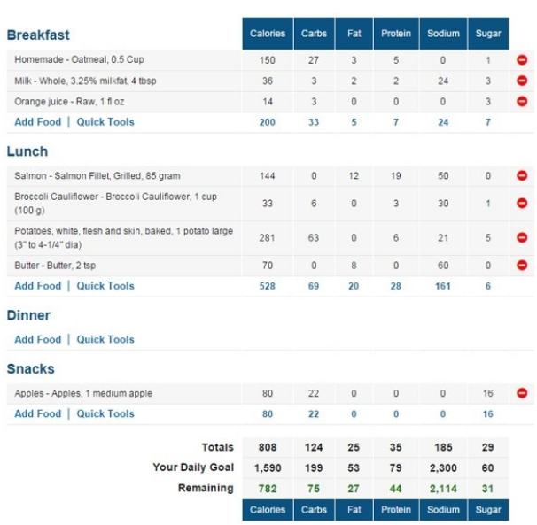
Analysis
From my food journal, I have realized that I am not eating enough as required in maintaining my body weight. According to Dudek (2013), 1636-2045 is the amount of calories that I require daily so as to maintain my current weight. From the food journal, the average amount of calories that I consume is 1400 calories with a shortfall of all required macronutrient. For instance, on the second day, I consumed a total of 106g of carbohydrates, 18g of fats and 48g of protein. Dudek (2013) asserts that the minimum AMDR for carbohydrates should be 230g, 45g for fats and 51g for proteins so as to maintain weight. However, am near to meeting the required daily allowance (RDA) for carbohydrates and proteins since the required RDA for carbohydrates and protein is 130g and 65g respectively. During the food diary experience, the nutrients were hard to keep track since getting the precise amount of nutrients in a certain food was hard to get. However, I managed to get some percentages but they were strictly based on a 2000-calorie diet.
Strengths and Weakness
During the analysis, one of the strengths I found was on doing a good job of finding good quality sources on carbohydrates. From my realization, I consumed lots of grains and hardly went for white bread. Also, I realized that on a daily basis, I drink the appropriate amount of water. According to Dudek (2013), the recommended amount of water needed by the body is at least 2-3 liters daily. On my side, I take at least 3-4 arrowhead bottles in a day which gives almost 1.5 liters a day which is a conscious effort even though this may not end up to the 3 liters. I have an erratic eating habit which makes one of the major weaknesses. This is because there are days when I take the inappropriate amount of food and there are moments when I don't eat enough food. During the analysis, I also realized that am not really aware of what I eat since I don't eat while considering my health, but I eat at convenience. As a result, I don't get an adequate nutrition that is required for healthy living. To solve this, I can consider splitting the meals so as to ensure I eat enough foods full of nutrition and not eat to be convenient.
Medical Condition
Thankfully, as for now, my nutrition is not being affected by any medical condition. However, my father is at this time being diagnosed with type II diabetes, hypertension, and hyperlipidemia while my mother has hypertension only. Due to family history, I always monitor my blood pressure which currently is 118spb. Even though I am at normal limits of diabetes and hyperlipidemia, I always get tested and have lipid panels performed. Since birth, I have not been admitted to hospital or flagged with any critical medical condition.
Drug Interactions
I am not under any medication or supplement or even vitamins. Contrary to taking pills and other forms of supplements, I have learned the natural way of acquiring the required vitamins and nutrients from food.
Culture
I am exposed to various cultures that impact the way I eat and what I eat. One way is through my tradition from Filipino where food must be very rich in saturated fats, sodium and with lots of cholesterol. Due diagnosis of hypertension, my family is aware of the implication of such foods. Hence, we usually use less salt while cooking and substitute the red meats with white meat like fish. Also, we avoid frying foods and we try to stay away from delicious pork belly (Lechon Kawali) which everyone loves. Additionally, our white rice we always substitute it with brown rice and quinoa.
Braces culture is another way that has affected me as it has made me eliminate some of the things that I used to eat. For instance, gums are used as appetite deterrent when one is hungry, but on my side, I cannot use any gum. Also, I cannot be able to consume any foods that are hard and cannot take carbonated beverages such as sodas as they wear away the glue that was attaching my teeth brace.
Diet Plan
In order to decrease my BMI, I plan on taking 1500 calories daily and combine it with exercise. In regards to minimizing my intake of sodium to less than 2300mgdaily, I will follow the American dietary guidelines which will involve “consuming 10% of calories from saturated fats and reducing cholesterol to 300mg daily” (Yaktine & Murphy, 2013). Also, I will limit red meats and try to consume lots of carbohydrates from whole grain. I will institute a daily exercise regimen that will involve a 30-minute physical exercise since it will help in promoting my healthy living.
First Goal, Implementation, and Obstacles
My major goal is that with every meal I will involve a fruit or any kind of vegetable. In implementing this, I will replace it with sandwiches and ensure I have the fruits and vegetables placed on my table. Also, I plan on packing the fruits in a small container and take it as a snack during the day. However, this is likely to cause an obstacle as fruits are always perishable hence making it hard for me especially if I don't have a proper refrigeration. Also, cutting the fruits into pieces for packing is likely to consume my night time due to my full-time school and job task.
Second Goal, Implementation, and Obstacles
On a daily basis, I will perform a 30 minutes of physical exercise. To implement this, I will ensure I set my time that every evening is when I perform the exercises for at least five days. Also, instead of using a car, I will be walking to school and even place of work. Instead of using an elevator, I will be using the stairs. Instead of walking, I will be jogging to my place of destination. Time is my major obstacle due to tight schedule from both school and job even finding time in between my daytime, will be difficult for me. That's why I can only implement it by using other alternative methods such as walking, jogging as I walk and using the stairs.
Third Goal, Implementation and Obstacles
With red meat, I will ensure I take it once a week and not consume lots of it. So far, my intake of red meat is in three meals a week which I must ensure I reduce it. To implement this, I can substitute the red meat with white meats like chicken or fish. Also, proteins like tofu and nuts can work out well for me. My love for red meat is my big obstacle as I find it easy to cook than the white meats.
Reflections
Carrying out this exercise has acted as an eye opener for my unhealthy eating habits. I have become more aware of what to eat and what not to eat and made me realize that exercises are important in my diet. I realized that I should not eat out of convenience but out of health. In order to live a healthier lifestyle, am now aware of how I can substitute my meals that can make me risk my health. To limit my calories and the saturated fats, fruits and vegetables will help me overcome this. I have learned that I need to take my time while eating and not take it while being distracted like while walking. This is because while walking can make me consume more foods than expected which as a result can make me become overweight unknowingly. I need to focus and take my time while eating and even avoid stress. It is now clear to me that I can channel the unhealthy habits with more productive habits like having physical exercise on a daily basis. As a result, I am now motivated and inspired in implementing what I have realized since my health depends on my initiatives.

References
Dudek, S. G., & Dudek, S. G. (2013). Nutrition essentials for nursing practice. Lippincott Williams & Wilkins.
Yaktine, A. L., & Murphy, S. P. (2013). Aligning nutrition assistance programs with the Dietary Guidelines for Americans. Nutrition reviews, 71(9), 622-630.

