OL-36 Series and Parallel Circuit Using PhET Simulation Tool

Objective
- Learn to build up series circuit and a parallel circuit with three resisters.
- Use PhET interactive simulation tool (Circuit Construction Kit AC Prototype) to build the circuits and Verify Ohm’s Law

Theory
The relations for two resisters in series and parallel circuits are the following:
Series Circuit Parallel Circuit
𝑅total = 𝑅₁ + 𝑅₂ (1) 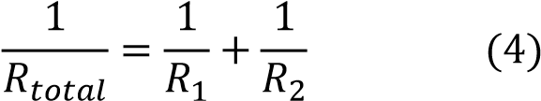
𝐼total = 𝐼1 = 𝐼2 (2) 𝐼total= 𝐼𝐼1 + 𝐼𝐼2 (5)
∆𝑉 = ∆𝑉1 + ∆𝑉2 (3) ∆𝑉 = ∆𝑉1 = ∆𝑉2 (6)

𝑅𝑅
1

∆
𝑉𝑉

𝑅𝑅
2



𝑅𝑅
2

𝑅𝑅
1

∆
𝑉𝑉

Figure 1 Two resister in series Figure 2 Two resister in parallel

The relation between the current passing through a resister with resistance and the voltage (electric potential difference) across the resister is called Ohm’s Law
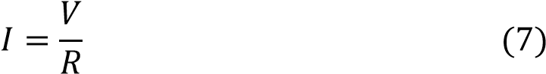

Equipment
PhET interactive simulation tool (Circuit Construction Kit: DC - Virtual Lab) https://phet.colorado.edu/en/simulation/circuit-construction-kit-dc-virtual-lab

Procedures and the building photos.

Build the circuit as shown in Figure 1 by using PhET Simulation Tool

- Click the above http link, you will see


- Click , you will see
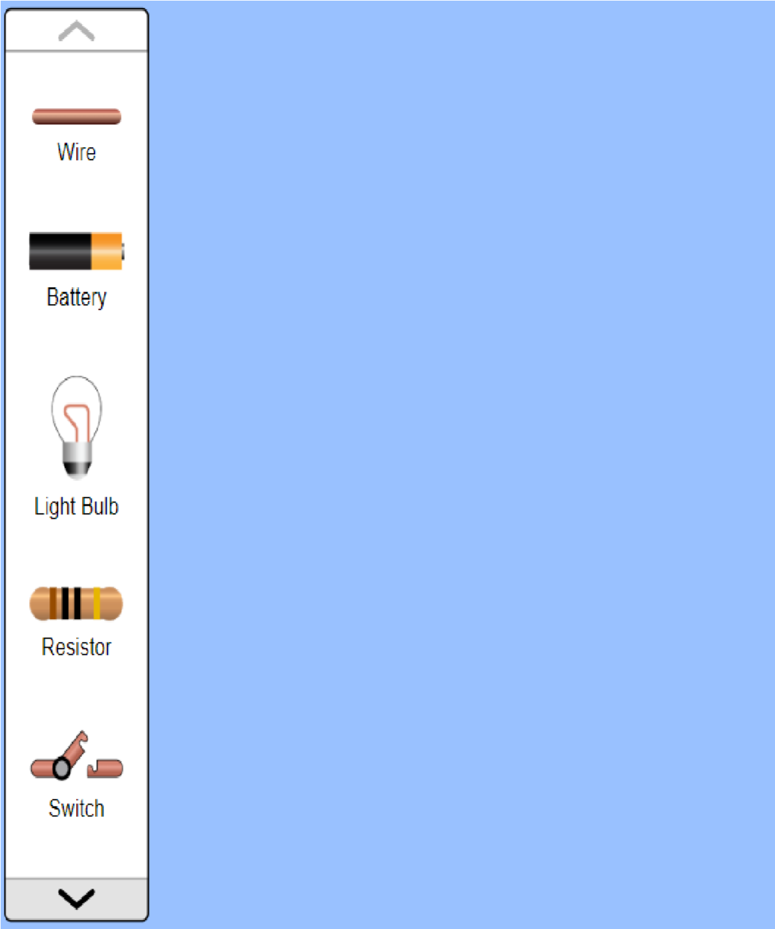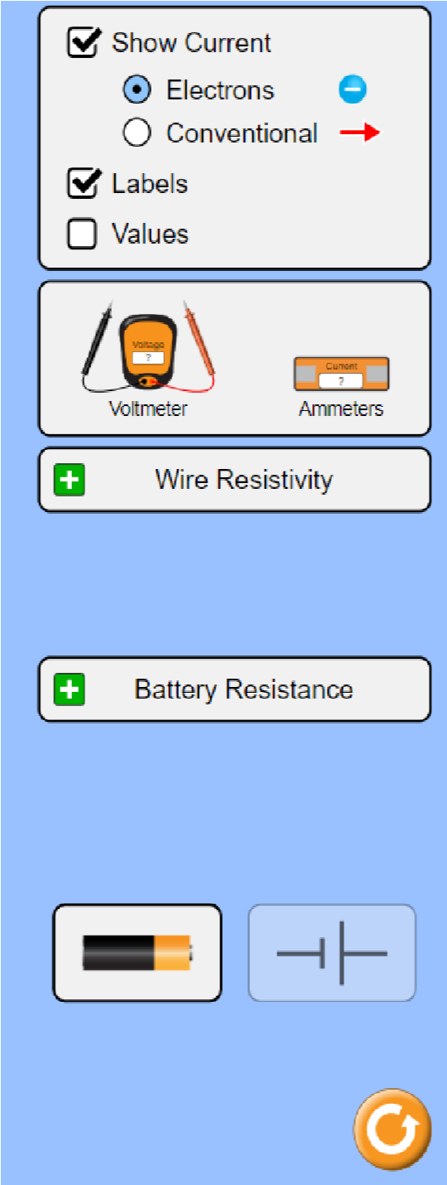

- Now you build your circuit by using “wire”, “Battery” and “Resistor”

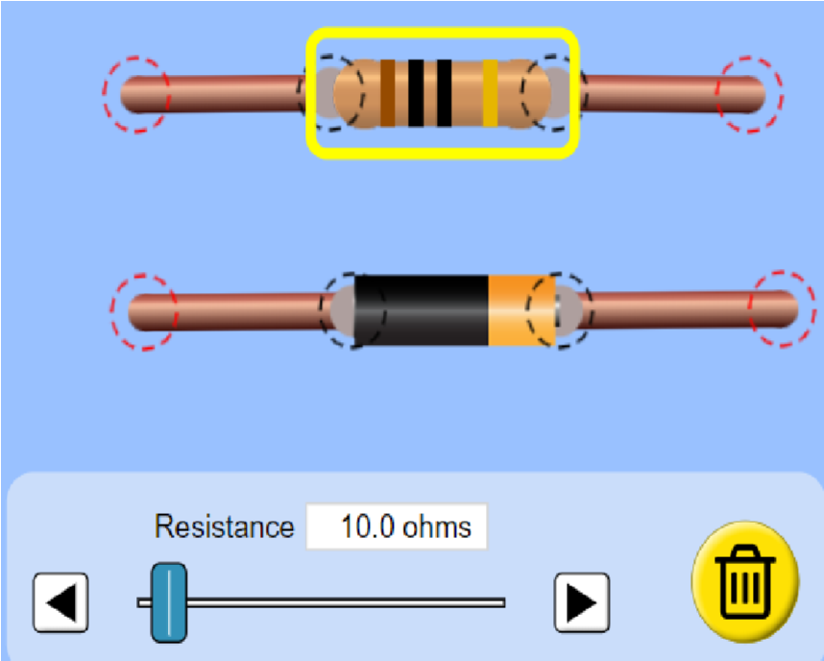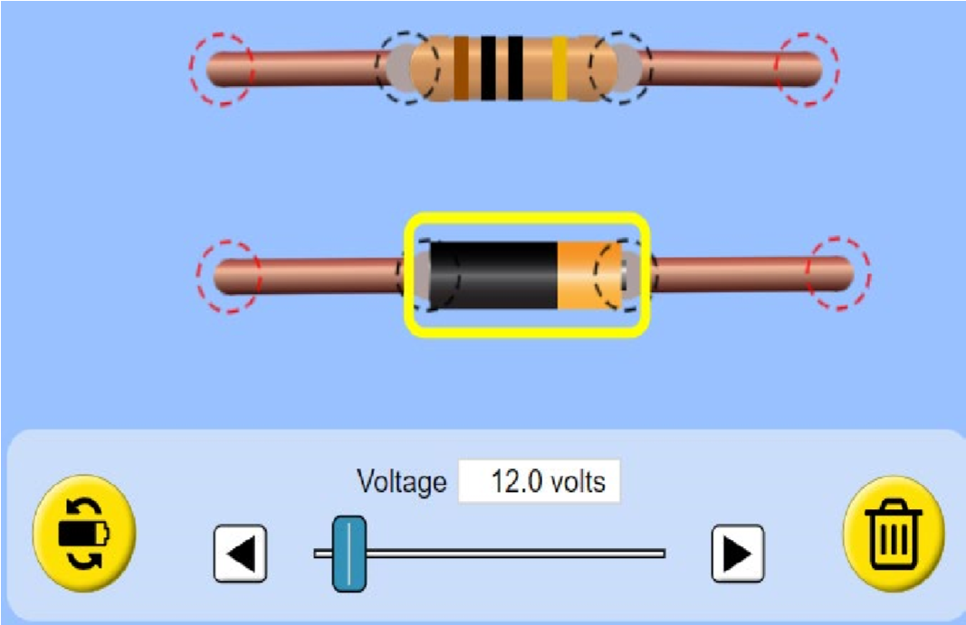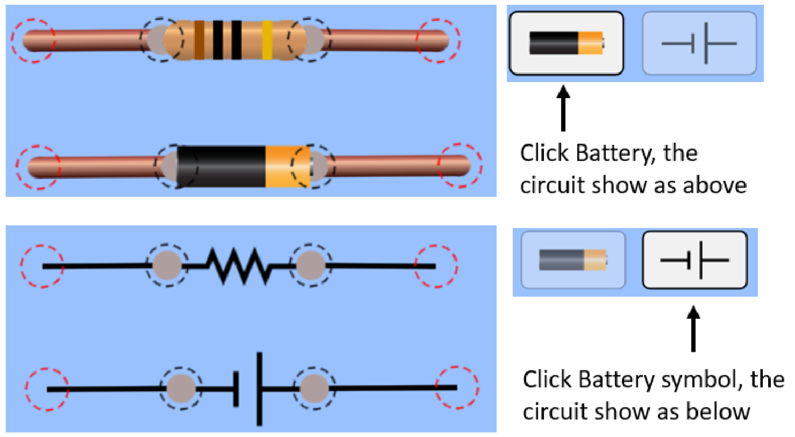

4.

You can tap the circuit elements to change it value by adjust

- You can also toggle between the battery and the battery symbol as shown above.
- Use the circuit board, build the series circuit by using three resisters as shown in the following figure 3: set up 𝑅𝑅₁ = 20 𝛺𝛺, 𝑅𝑅₂ = 50.0 𝛺𝛺, 𝑅𝑅₂ = 80.0 𝛺𝛺, ∆𝑉𝑉 = 5.0 𝑉𝑉
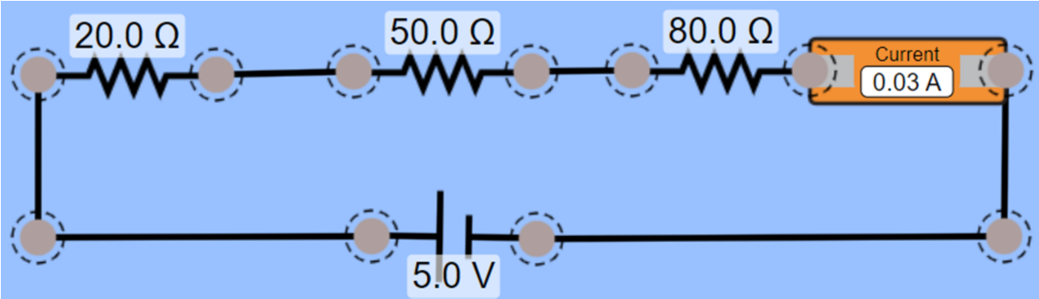
Figure 3

- Measure the voltage across each resister, the voltage across over the two 𝑅𝑅₁ and 𝑅𝑅₂ (resister𝑅𝑅₁₂) and the voltage across over all the resisters (𝑅𝑅_{𝑡𝑡𝑡𝑡𝑡𝑡𝑡𝑡𝑡𝑡}). Record the values on the table 1.

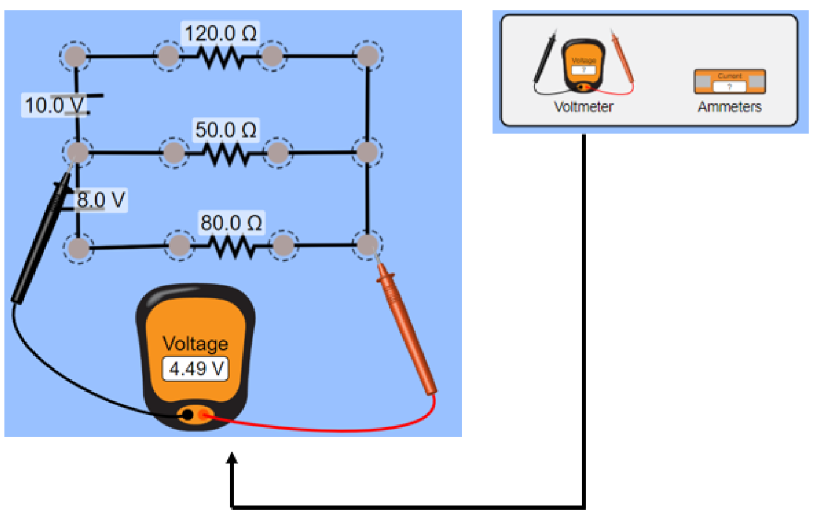

Figure 4

B

A

- How to measure voltage using the voltmeter in the circuit board tool.
  - Simply drag the voltmeter to the necessary location as shown in the figure 4. You can use multiple voltmeters as needed.
  - Voltage measurements look at the potential difference between two points. Figure 4 shows the voltage between A and B.
  - When making the measurement, if the displayed voltage of the voltmeter is positive, it tells that the red color lead is connected to higher electric potential point.
  - If the displayed voltage of the voltmeter is negative, it tells that the red color lead is connected to lower electric potential point.
  - The circuit in figure 4 is an example show you how to measure voltage. It is not the same circuit that you will build.
- Using Ohm’s law calculate the currents for each resister and put the values on table 1.
- Using circuit board tool Ammeters measure the current passing through each resister and record the values on the table 1.
- How to measure current using ammeters in the circuit board tool.
  - Simply drag the ammeter to the necessary location as shown in the figure 5. You can use multiple ammeters as needed.
  - Measuring the current of a resistor requires the ammeter to be connected in series with the resistor (the figure below shows you how to do this).
  - Checking and unchecking the “show current” and “conventional” checkboxes on the upperright corner of the circuit board tool will show or hide the current direction.
  - The circuit in figure 5 is an example show you how to measure voltage. It is not the same circuit that you will build.

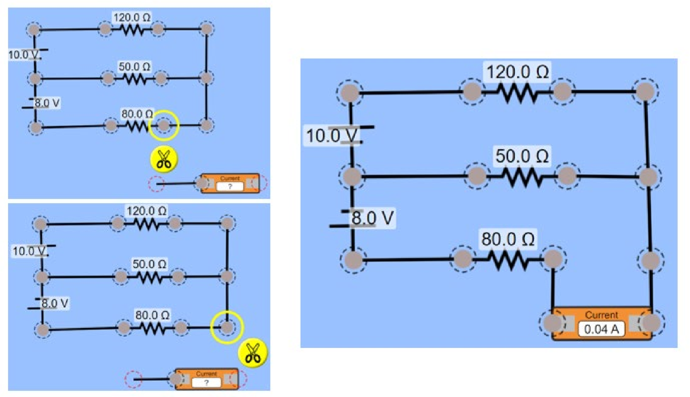

Figure 5

- Compare the current in table 1, and find the percentage difference.
- Use the circuit board, build the parallel circuit by using three resisters as shown in the following figure 6.

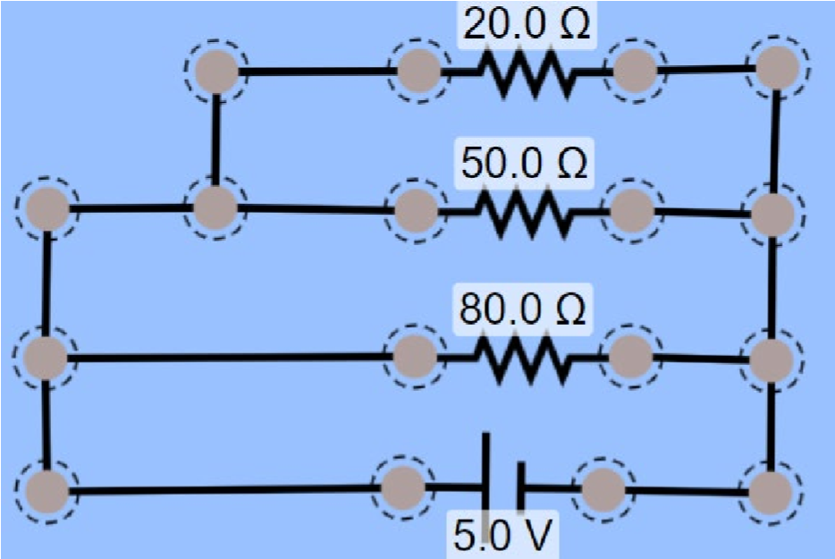
Figure 6

- Repeat procedures from 7 to 12, record the data in table 1, and find the percentage difference.

Data Table 1

Resistance: :___________ 𝑅𝑅₂:____________ 𝑅𝑅₃:____________

 |  | Series |  |  |  | Parallel
 | Measured Voltage | 𝐼total  (Ohm law) | Measured Current | % difference | Measured Voltage | 𝐼total  (Ohm law) | Measured Current | % difference
𝑅₁ | 5.0 | 14.3 | 0.04 | 0.13 | 5.0 | 12.4 | 0.030 | 1.14
𝑅₂ | 5.0 | 12.2 | 0.04 | 1.27 | 5.0 | 13.9 | 0.029 | 1.23
𝑅₃ | 8.0 | 11.5 | 0.04 | 1.18 | 5.0 | 13.0 | 0.034 | 0.97
𝑅₁₂ | 10.0 | 10.7 | 0.04 | 1.29 | 5.0 | 14.8 | 0.026 | 1.34
𝑅𝑡otal | 10.0 | 11.7 | 0.04 | 1.09 | 5.0 | 12.34 | 0.032 | 1.92

Conclusion

For the case of series arrangement, the voltage remains constant for the various resistors leading to the voltage difference seen. As for the parallel arrangement, the current remains a constant across all the resistors leading to the difference in percentage and voltage as seen. This greatly supports the Ohm’s law.

Your Lab Report Should Include the Following

- Lab theory
- Your build circuit photo
- Procedures
- Your circuit setup photo which shows voltage 𝑉𝑉₁₂ [across the two 𝑅𝑅₁ and 𝑅𝑅₂ (resister𝑅𝑅₁₂)] measurement; and circuit setup photo which shows current 𝐼𝐼₁₂ [pass through the two resistor 𝑅𝑅₁ and 𝑅𝑅₂ (resister𝑅𝑅₁₂)] measurement.
- Data Table 1
- Conclusion

