Lab Report
% 1 Screenshot for folders created for the new FAT32 drive E.
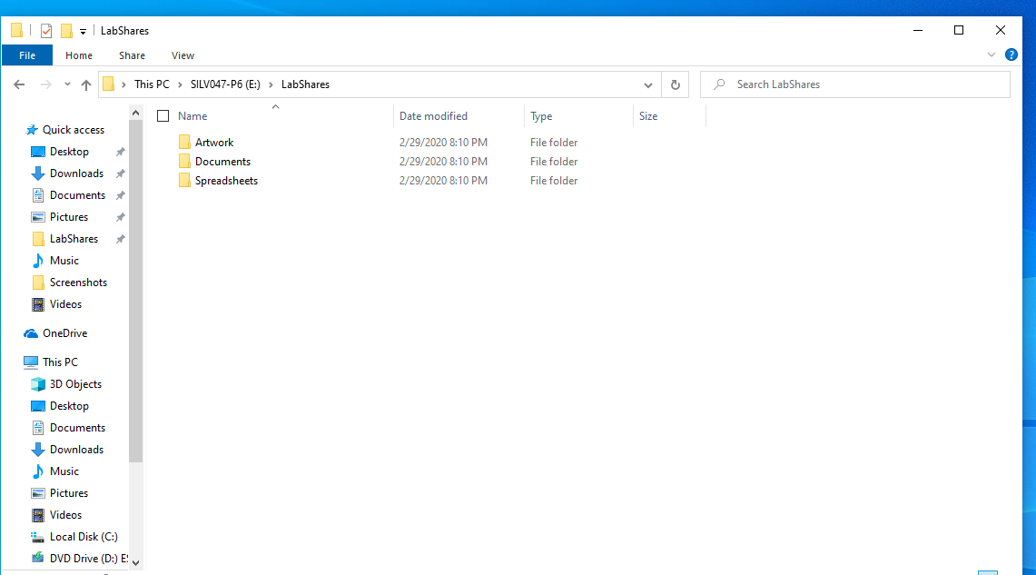

#2 The network path for LabShares is \\DESKTOP-ISNJH\Shared
%3 Screenshot for Permission of LabShares Folder.
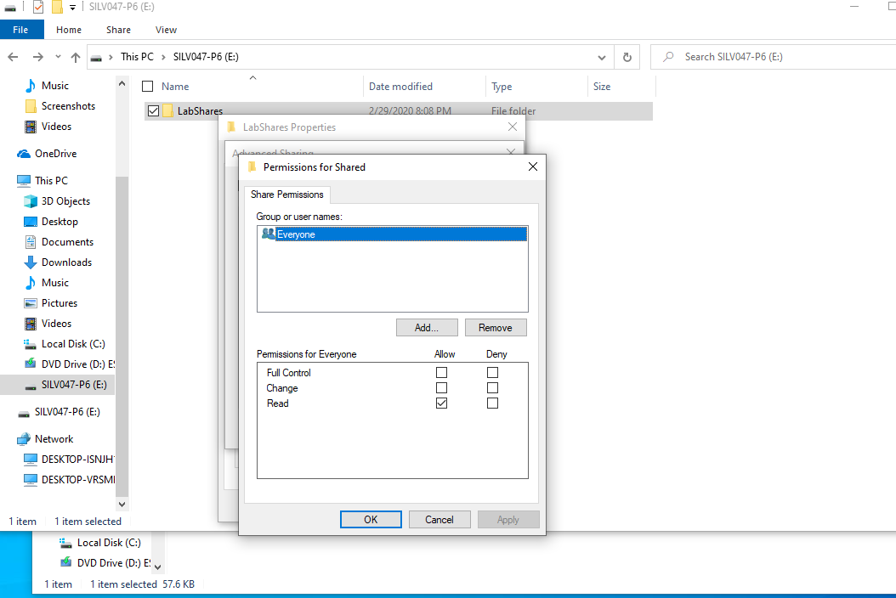
%4 Screenshot for Richard permission set up
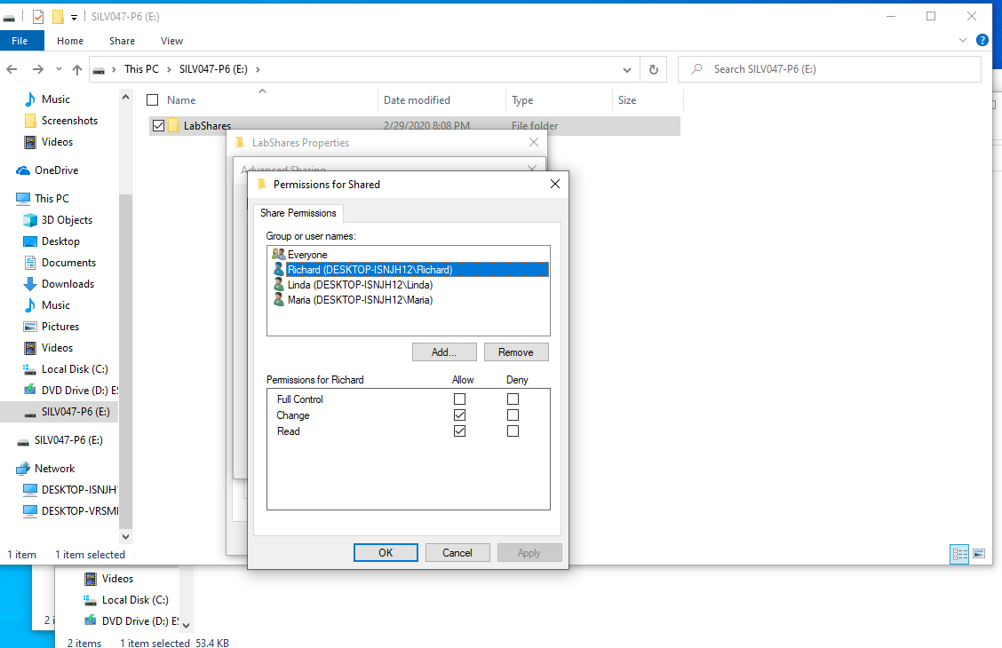
%5 Screenshot for Linda Permission Set up.
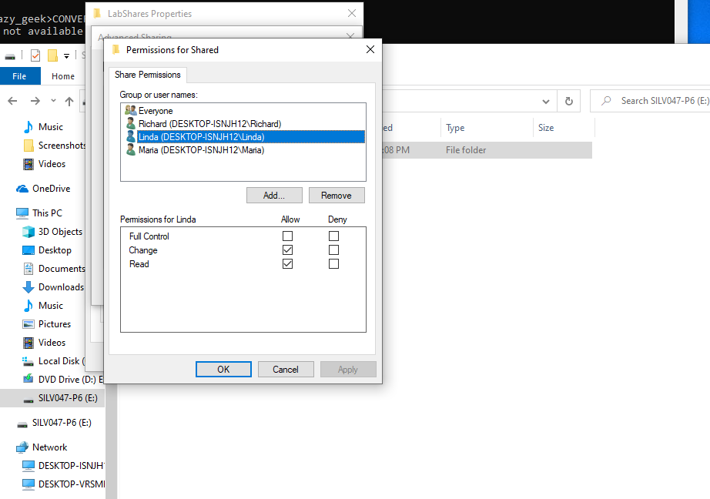
%6 Screenshot for Maria permission set up.
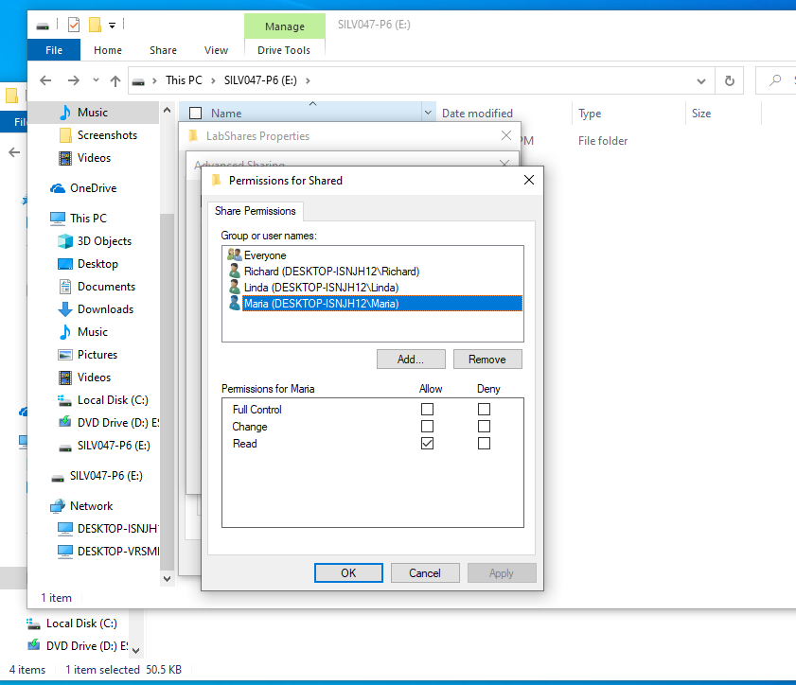

Log in each user Richard, Linda and Maria, create and read in various subfolders
#7 Richard and Linda accounts can create Documents
#8 Richard and Linda accounts can modify Documents.
#9 Richard, Linda and Maria user accounts can read Documents.

After Altering permissions as instructed.
#13 Maria account can create Documents and folders. Linda account cannot access to the LabShares folder completely.
#14 Maria account can Modify documents.
#15 Maria and Richard accounts can Read Documents
%16 Screenshot for Parent folder and each of subfolders permission modification.
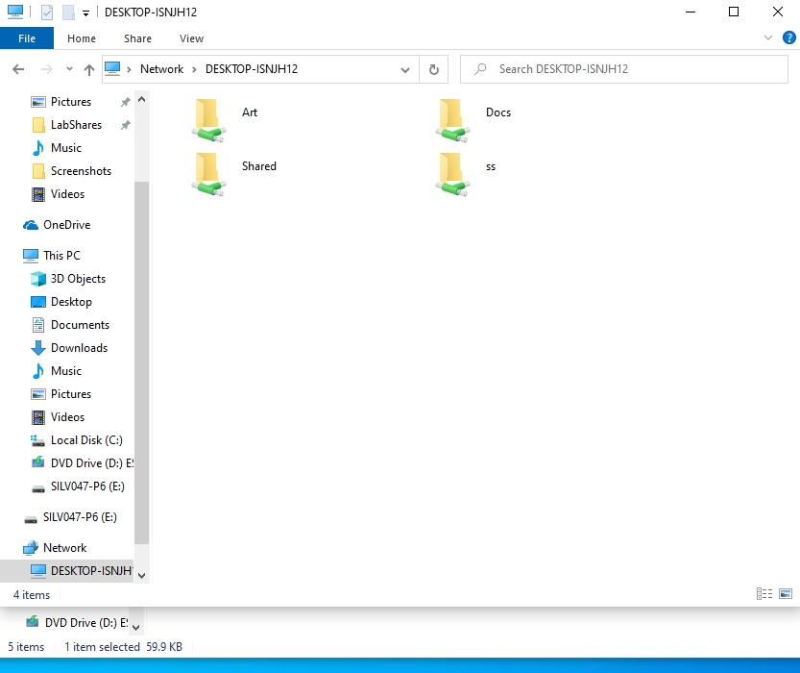

#17
 |  | Richard  Is able to | Linda  Is able to | Maria Is able to
Folder Name | Share Name | Richard  Is able to | Linda  Is able to | Maria Is able to
LabShares | Shared | R, C, M | R, C, M | R, C, M
Documents | Docs | R | R, C, M | R, C, M
Spreadsheets | SS | R, C, M | R, C, M
Artwork | Art |  | R | R, C, M

No permissions are not the same no matter which type of share you gain because each and every has its own set of permissions for very user. Some shares restrict users to only viewing them, some shares have permission to change and view them while some shares are completely blocked from the users. Therefore, the permissions depend on the permissions allowed for a given user in a share.
#18. If the permission is assigned in Allow mode, the Change permission is the same permission features and functions. Read permission allow user to read only. However, in the Deny mode, no matter what permission is, the user cannot access to the directory or file, therefore, the user cannot do anything even though the user has been assigned the particular permission.

%19 Screenshot to Add Richard to Executives Group.
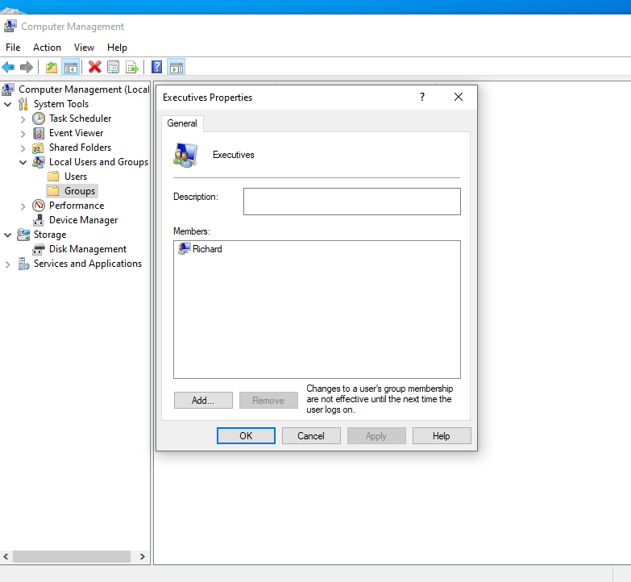
%20 Screenshot to add Linda to Temp.
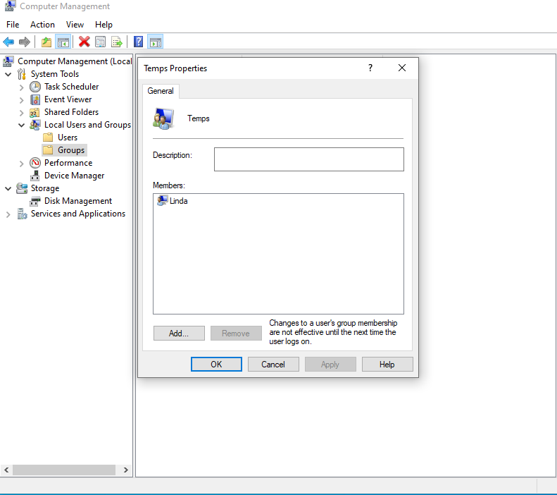

%21 Screenshot for assigning Executives to Docs Share to allow Change.
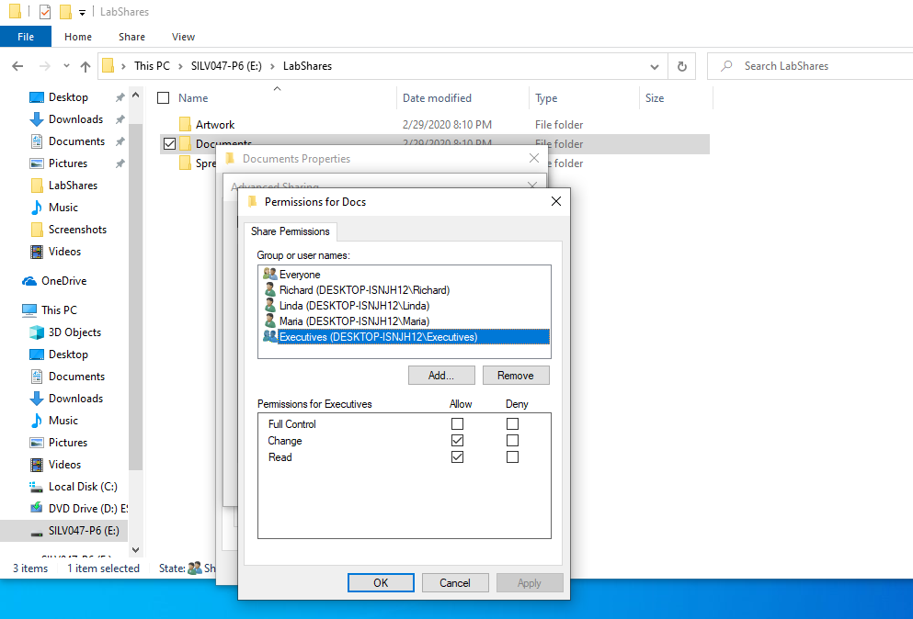

%22 Screenshot for assigning Temps to SS share with deny Change.
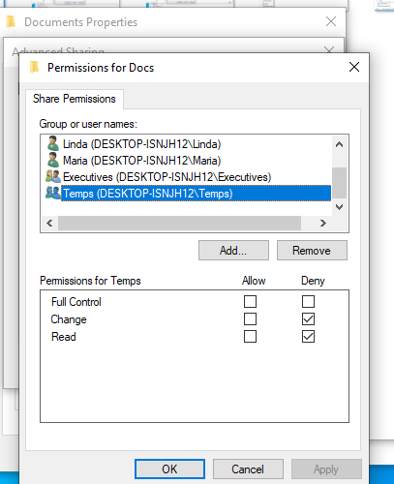

#23 For Richard after making the changes to Docs share.
#24This is because the account is part of Executive group which has the permission to Change the Docs share, Richard is now able to Read documents, create documents and Modify documents within the Docs share as opposed to before when he was only able to Read the Docs share.
#25 Linda cannot read the SS Share.
#26This is because the account is added to the account to Temp groups and modifying its permissions to deny Read, the account cannot therefore have Read access to SS share as it had before adding it within the Temp group.

%27a Screenshot for Mapping Shared – Drive V:
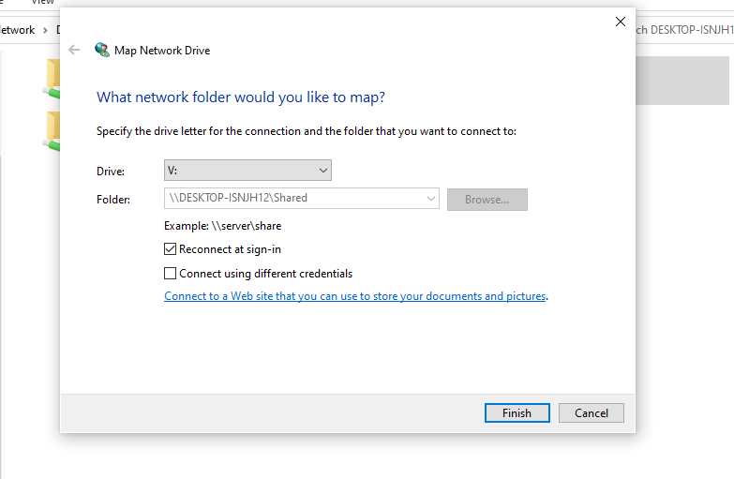
%27b Screenshot for Mapping network drive for Art -Drive W.
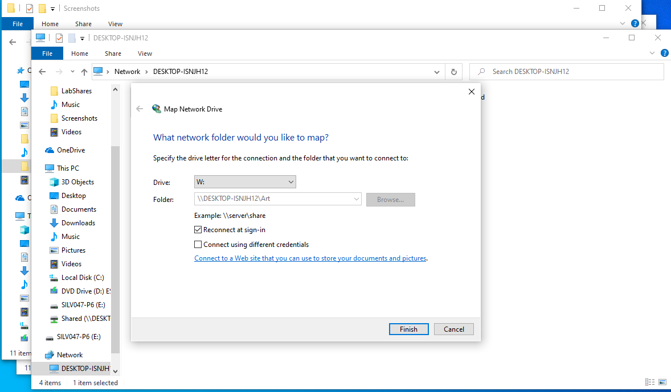

%27c Screenshot for Mapping network drives for Docs-Drive X:
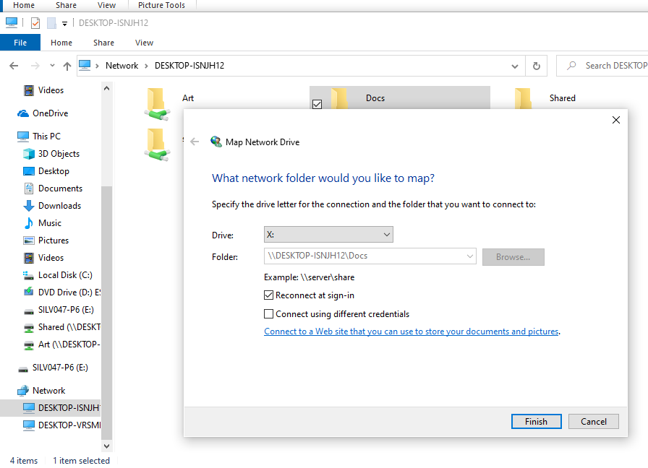

%27d Screenshot for Mapping network drives for SS Share-Drive Y:
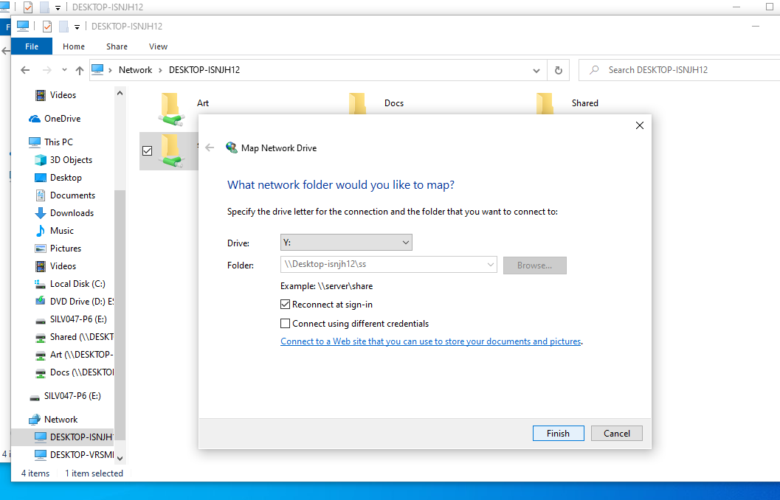

#28 Even after mapping the shares to drives and accessing them using drive letters rather than network shares, the permissions have remained the same therefore nothing has changed.

%29a Screenshot for Labshares user’s removal.
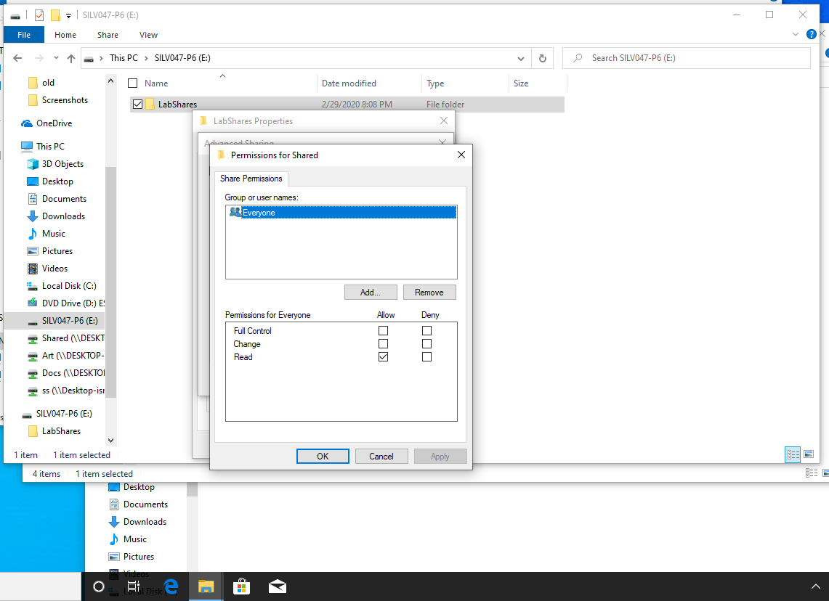

%29b Screenshot for Art Share user’s removal.
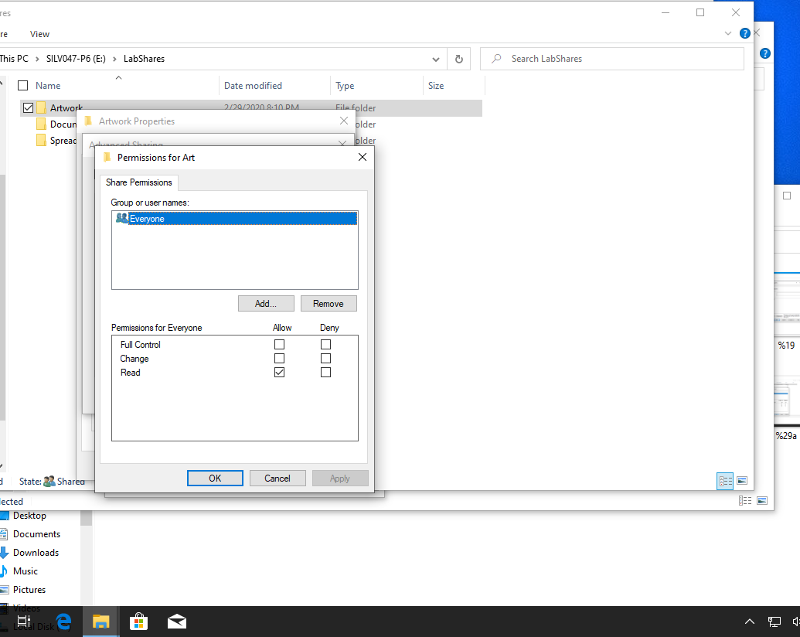

%29c Screenshot for Documents user’s removal
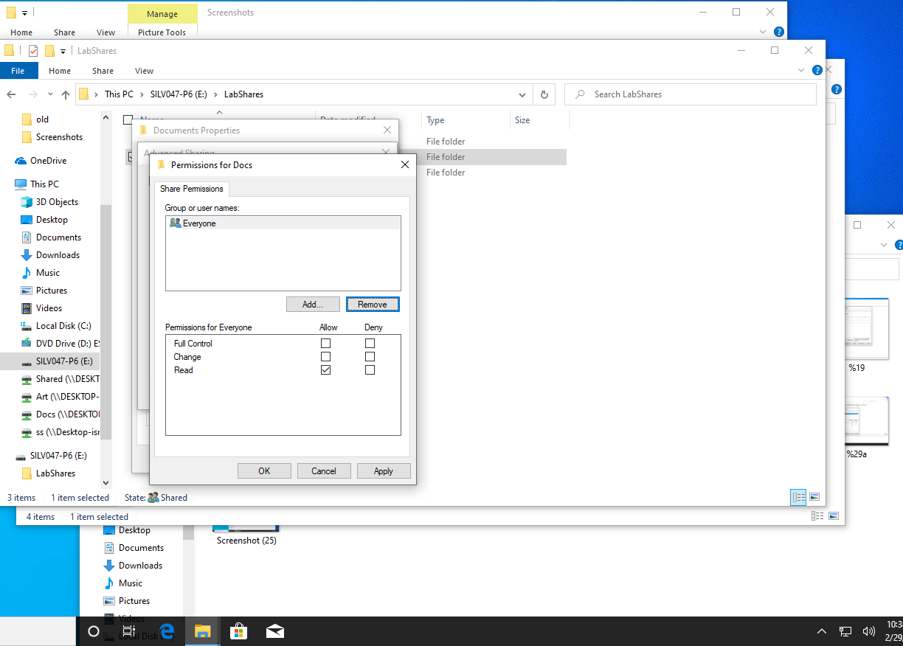

%29d Screenshot for Spreadsheets user assignment removal
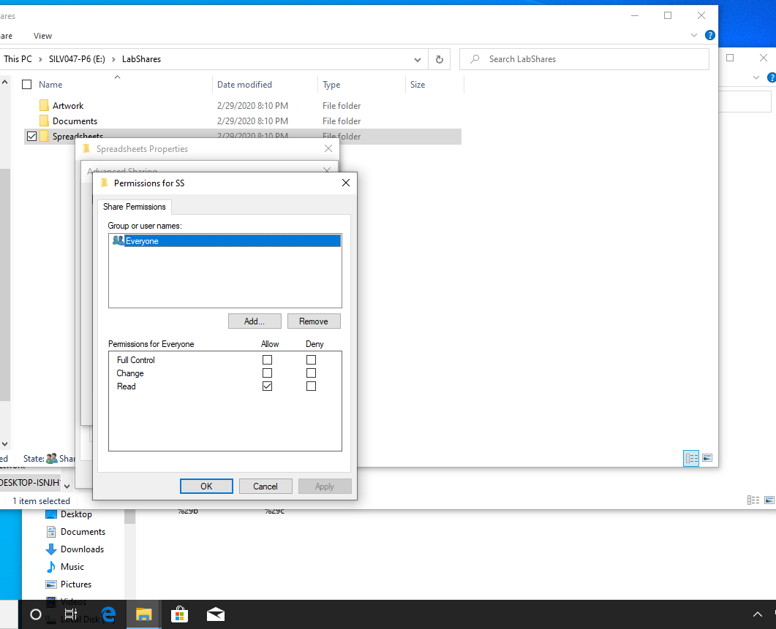
%30 Screenshot for NTFS Security Tab.
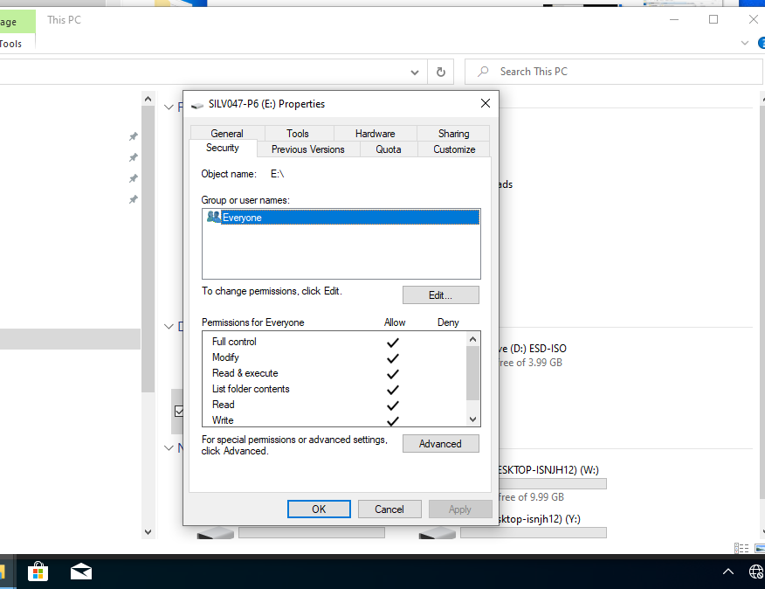

%31 Screenshot for Security assignment.
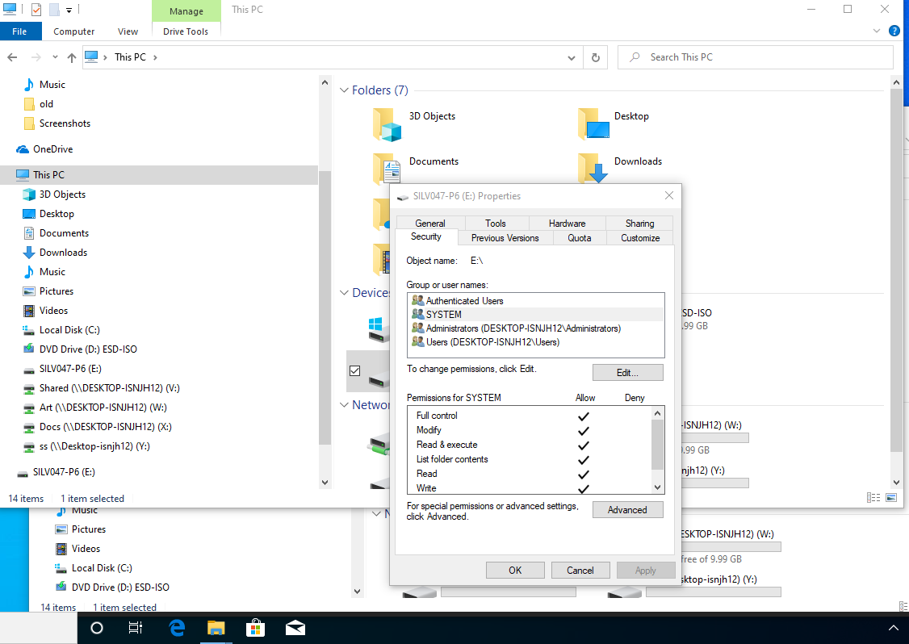

#32. Shared share Folder settings
Assigned Object | User or Group (U/G) | Permissions | Inherited (Y/N)
SYSTEM |  | Full Control | N
Administrator |  | Full Control | N
Authenticated User |  | Modify | N
Users |  | Read and Execute | N

#33 Art share Folder settings.
Assigned Object | User or Group (U/G) | Permissions | Inherited (Y/N)
SYSTEM |  | Full Control | N
Administrator |  | Full Control | N
Authenticated User |  | Modify | N
Users |  | Read and Execute | N

#34. Maria, Richard and Linda’s effective NTFS permissions Table.
Artwork | Richard | Linda | Maria
Full Control | N | N | N
Traverse folder / execute file | Y | Y | Y
List folder/ read data | Y | Y | Y
Read attributes | Y | Y | Y
Read extended attributes | Y | Y | Y
Create files / write data | Y | N | Y
Create folders / append data | Y | N | Y
Write attributes | Y | N | Y
Write extended attributes | Y | N | Y
Delete subfolders and files | N | N | N
Delete | Y | N | Y
Read permissions | Y | Y | Y
Change permissions | N | N | N
Take ownership | N | N | N

#35. Maria Account holder can access, create and modify files within the Art share.

#36. NTFS share permissions are granted to an account user at Windows logon and they affect both local and network users. There since Maria has Read, Write and Create permissions on Artwork folder the account user can perform those operations whenever the sign in.
#37 Richard Account holder can access, create and modify files within the Art share.
#38 When logged in Richard local account the user has effective permission to create, Modify and Read the Art share.

#39. When logged in as Maria she is able to create new documents read but cannot modify the existing documents to delete them. This is because the account has the capability to only extend attributes as per its effective permissions.
When logged in as Richard she is able to create new documents read but cannot modify the existing documents to delete them. This is because the account has the capability to only extend attributes as per its effective permissions.
Maria is not able to write to existing and new files. This is because the account is currently users under everyone are only given permissions to read and view share files and cannot make modifications to any of the share files or create new ones.

#40. Not it’s not necessary to deny Linda access of the share files in order to have write across a network but rather to add a user account with the Access permission type in order to read and write across a network.
#41. Yes, after making the necessary changes as described above my solution worked as I expected.

#42. To make all the users to have access to change files and folders across the network access, I would create a new user group add all the users to it and give access permission for the group with capability to change various shares across a network access. This will give all the users in that group access to change files and folders across the network access. This procedure all makes it very easy to manage permissions for shares in a network access.

