Organization on USA Gymnastics
Name
University
Date

Executive Summary
USA gymnastics is federation that is tasked with the responsibility of training world champions and Olympics participants. However, the corporation is governed by a board of directors headed by the president. Also, the leadership of the organization is supported by the program staff to the with different national sub-committee and the regional committee members. The organization activities are monitored from top to bottom with a representative at each level of the organization. The board of directors holds the executive powers with the role of ensuring that the strategic plan of the organization is achieved. Also, the board of directors provides that the members are compliant to the safety rules and regulation of the organization. It is through the board of directors that the central decision affecting the organization are made.

Organization on USA Gymnastics
Introduction
Sport is a global event that allows participants to showcase and perfect their talents and skills. Sport is a competition that is carried out at a global level of world championships and the Olympics. In the United States, the sports are governed by the USA gymnastics, which to obtain a chance to participate in sport fairly with preparing and training world championship and Olympic games participants. USA gymnastics federation allows the participants to obtain an opportunity to participate in sport reasonably and therefore. The federation is governed by a board of directors that oversees the operation of the organization. USA gymnastics consists of 15 board of directors, eight of which are independent, three are athlete directors, three are national membership directors and one advisory council representative (USA Gymnastics, 2019).
Formal, Legal And Structural Elements Of Governance
The USA gymnastics is an official organization that is governed by formal agreements and contracts that have been signed by various stakeholders. The organization has rule and policies for the various programs that it manages that enables the proper operation of the organization (USA Gymnastics,2019). Also, the ethical code of conduct in the organization allows the organization to operate within the formal guidelines of the organization. The moral code of conduct is dived into two sections that of moral obligation and that of resolution of ethical issues (USA Gymnastics, 2019). The moral responsibility of the organization includes the creation of a safe environment for all participants, commitment to integrity, communication, concern for welfare for other, participation, and inclusion among others. Also, the availability of conflict of interest policy in the organization contributes to the formality of the organization. In addition to this, the organization has a formal audited financial statement that outlines its commercial operations.
Legally, the governance at USA gymnastics is bind by the constitution of the organization that outlines the various laws to be followed by the organization. The legal governance of the USA gymnastics are contained in article 4, which describes the directors and their role in the organization, article 5 outlines the board members and their roles (USA Gymnastics, 2018). Section 6 of the bylaws describe the committees and their role. An official 7 states the election of various officers to hold the organization and oversee various activities (USA Gymnastics, 2018). Therefore, the legal governance of the USA gymnastics allows the organization to execute its mandate within its jurisdictions successfully.
Strategic Capability Of Board Members
The board of directors are tasked with the responsibility of approving and reviewing the corporation's strategic plan, operating plans, budgets, and corporate performance (USA Gymnastics, 2018). Once the annual strategic plan of the organization has been rolled out, it is the role of the board of directors to scrutinize the strategic plan, point out any errors and make the necessary adjustment to ensure than the strategic plans are achievable and aligns with the organization mission. Once the board of directors completes the reviewing process, the strategic plan is then approved by each member who signs the strategy which will then be subject to implementation by the organization. The strategic plan allows the organization to monitor its progress over time, including the achievement of the set goals.
Relationship Between Paid Stuff And Voluntary Board Member
The board members of USA gymnastics consists of both the paid and the voluntary members who share a shared vision for the organization. Both board members play a critical role in contributing their skill, intelligence, knowledge, and experience to ensure than the core mandate of the organization is achieved (USA Gymnastics, 2018). Despite the voluntary board members not receiving any compensation for their commitment, they have proved to be critical in helping the organization thrive well. Both the paid and the voluntary board member have the same task of ensuring that the organization operates in the required manner. The contribution that is made by both the settled and the voluntary board members are often incorporated into the action plans of the organization which creates equality among the board members while creating a unified environment for the organization.
Role Of Governance In Designing Strategic Directions Of The Organization
The board of governance set the strategic directions by outlining the policies that govern the organization. Whenever there are issues that are facing the organization, it is the responsibility of the board of directors to outline the plans that will allow the organization to solve the problems while pointing the organization in the right direction (USA Gymnastics, 2018). Policies are the guidelines that enable the organization to follow a specific procedure leading to the desired outcomes of the organization. The anticipated outcomes and goals of the organization are set by the board of directors, which gives the organization a clear path to follow to achieve its mission.
Role Of Governance In Monitoring Compliance And Performance Of The Organization
The performance of the organization is achieved through the efforts that are instilled by the board of directors. For example, the performance of the organization is achieved by ensuring that each member of the organization understands the business and governance affair of the organization (USA Gymnastics, 2018). Also, the board of directors provides that any pertinent issues that are facing and likely to impact on the performance of the organization are solved within the required timeframe. Also, the board of directors monitors the compliance of the organization by ensuring that the safe sport program is followed. Safety ate the sport is achieved by following the set rules and standards of the organization.
Role Of Governance In Generating Wisdom On Behalf Of Stakeholders
The board of directors is composed of members who have vast experience in diverse issues that are relevant to sports and therefore forming a critical part of the required wisdom in the management of the organization. The board of directors tends to give their insights on various issues that are facing the organization, drawing knowledge from the experience while integrating it with the anticipated the future events of the organization based on the current trends (USA Gymnastics, 2018). The knowledge and experience posed by the board of directors is an asset to the organization as it can resolve any issues before it impacts negatively on the organization.
Governance Structure Map
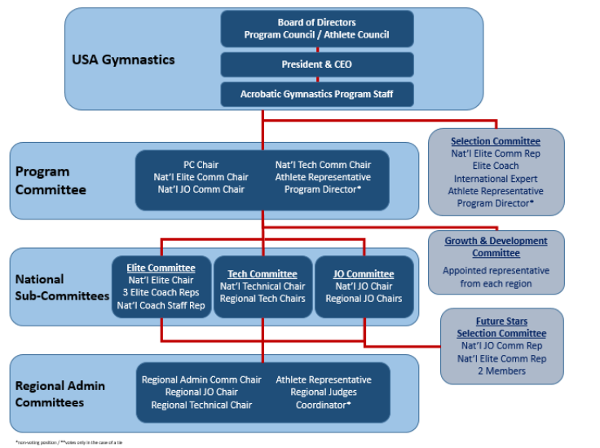
In conclusion, the USA gymnastics play a critical role in ensuring that the athletes and other sports participants are successful in their competitions. The corporation has an effective governance and leadership team that is dedicated to providing that the core mission and goals of the organization are achieved. Through the board of directors, the organization can set up an achievable strategic plan of the organization. Also, the board of directors ensures that the organization is compliant with the set rules and standards. The board of director has been effective in ensuring the success of the corporation.

References
USA Gymnastics. (2019). Acro rules and policies. Retrieved on 23 September 2019 from https://usagym.org/PDFs/Acro/Rules/2019_rules_policies.pdf
USA Gymnastics. (2019). Board of directors. Retrieved on 23 September 2019 from https://usagym.org/pages/aboutus/pages/board_of_directors.html
USA Gymnastics. (2018). Bylaws. Retrieved on 23 September 2019 from https://usagym.org/PDFs/About%20USA%20Gymnastics/Governance/usag-bylaws.pdf

