Organizational Effectiveness of FEMA
Student’s Name
Institution

Organizational Effectiveness of FEMA
FEMA (Federal Emergency Management Agency) has been pivotal in the process of mitigating the consequences of natural disasters in the United States. It has accorded support to the citizens of America on how to improve their preparedness, protection against, respond to, recover from as well as mitigate disasters (Myers, & White, 2019). Some of the notable disasters include the Great Flood of 1993, Hurricane Katrina in 2005 and Hurricane Harvey in 2017. FEMA’s organizational effectiveness is, as explained by the below competing value approach.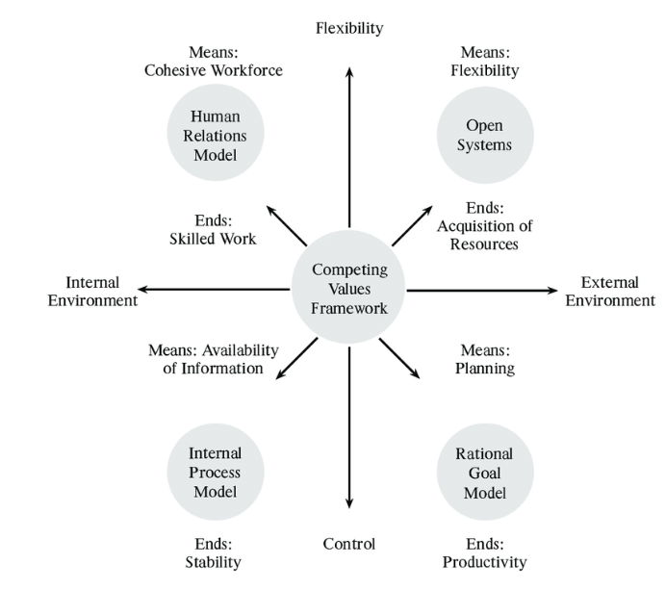
The Great Flood of 1993
Human relations model
FEMA had an astronomical impact in ensuring that recovery missions of retrieving properties and moving of people to safer places was properly orchestrated during the Great Flood of 1993 (Shah et al., 2018). The body had adept and well-skilled personnel such as first responders who performed substantial work in helping the locals of Illinois vacate the flooded regions.
Open systems
During the Great Flood of 1993, FEMA helped in the provision of diverse resources like food, evacuation centers, and clothing. The supplies were crucial to the residents of Illinois, whose properties had been lost and destroyed by the flooding Mississippi and Missouri rivers as well as their tributaries. Damages to properties were estimated to be toting up to $15 billion. The lesson learned was to build flood-resistant architectural designs that resist the impacts of floods.
Internal process model
FEMA played an instrumental role in disseminating information through mass media such as televisions, public addresses, notices, and posters to warn people of impending floods likely to take place in different states (Myers, & White, 2019). This helped in ensuring people were evacuated from their homes in time and taken to safer regions.
Rational goal model
The Great Flood of 1993 caused unimaginably high losses to property. It registered property damage worth $15 billion. This denoted that FEMA did not adequately plan in the protection of properties like buildings, cars, and farm crops.
Hurricane Katrina 2005
Human relations model
FEMA established Incident Management Assistance Teams that provided a federal decision to all the people who suffered Hurricane Katrina 2005. The teams helped in the provision of helpful awareness information that people in the area to use during a disaster attack. Appropriate working teams made sure all people were informed about disaster to create understanding of its occurrences and prevention process (Davis & Robbin, 2015).
Open systems
The flexibility of FEMA was to ensure adequate support gets provided to all people through the development of active coordination structures (Davis & Robbin, 2015). The government would encourage helping in expediting FEMA's goals in the best way possible. FEMA used a proper communication process to inform people of the impending danger of Hurricane Katrina 2005. The lesson learned is that the federal response should integrate volunteers and non-governmental organizations contributing to the emergency response.
Internal process model
FEMA made it sure that it conveniently conveyed information to people concerning the likelihood of occurrence of Hurricane Katrina of 2005. It disseminated the impending hazard to the locals of New Orleans and coastal Louisiana. FEMA had been involved in channeling media communications to people on the dangers posed by gushing winds of Hurricane Katrina that were strong and would lead to damage to properties as well as deaths.
Rational goal model
FEMA had a significant contribution in the planning of how to mitigate the adverse effects of Hurricane Katrina on people. For instance, it enhanced public awareness about the impending occurrence of the hazard through mass media. Additionally, FEMA developed early warning systems that would help in detecting a looming Hurricane Katrina and notify the public and then mitigation measures could be undertaken thereafter.
Hurricane Harvey 2017
Human Resource Model
FEMA was effective in helping the survivors of the Hurricane Harvey 2017 in several ways. Firstly, it made sure 6 million meals and water to get distributed to all the survivors of the hurricane attack. The creation of a cohesive workforce has made FEMA provide an approximate of $186 million to the Public Assistance Funding to help in cleaning and removal of debris. A team of specialists got mobilized to assist in helping injured people and the removal of waste in Texas. The workforce created by FEMA helped in attending to disaster survivors in the service companies (Brasier & Thompson, 2018).
Open systems
FEMA has got a flexible system that allows the use of Mobile Emergency Response Support personnel to get involved in the process of communication. People living in Texas got information concerning Hurricane Harvey 2017 to help in reducing its impact. Evacuation would get done without any form of difficulty received. Flexibility in creating modern technologies to assist in rescuing people from Hurricane Harvey 2017 disaster was necessary.
Rational Goal Model
Proper planning of emergency measures that got done by FEMA was instrumental in making more lives got saved, and properties are protected and efficient public health promoted. Protective emergency measures planned by FEMA are significant in combating catastrophes through the development of protective measures (Brasier & Thompson, 2018).
Internal Process Model
FEMA has created proper methodologies that can get used by families in Texas to understand the periods when Hurricane Texas 2017 occurs. Readily available information has got uploaded within the internet to assist people in survival. The lesson learned is that FEMA plays a significant role in helping people understand the effects of Hurricane Harvey 2017. The information enables assistance to get created effectively to people.

References
Brasier, R., & Thompson, J. (2018). FEMA to Play Long-Term Role in Recovery from Harvey.
Davis, G. L., & Robbin, A. (2015). Network disaster response effectiveness: the case of ICTs and Hurricane Katrina. Journal of Homeland Security and Emergency Management, 12(3), 437-467.
Myers, M. F., & White, G. F. (2019). Reprint:" The Challenge of the Mississippi Flood". Environment: Science and Policy for Sustainable Development, 61(5), 22-36.
Shah, M. A. R., Rahman, A., & Chowdhury, S. H. (2018). Challenges for achieving sustainable flood risk management. Journal of Flood Risk Management, 11, S352-S358.

