Impact of Overpopulation on the Environment
Title page
Abstract
Table of contents

Introduction and Background
Overpopulation refer to the undesirable condition where the number of human beings exceeds the Earth’s carrying capacity. The condition is influenced by factors that include the reduced mortality rates, better medical facilities, depletion of precious resources among other causes. Other factors that contribute to this phenomenon include the increased birth rates, decreased death rates and immigration issues where people are seeking employment in other regions. It is crucial to note a region previously considered as sparsely population might become densely population due to migration of people or when it is unable to sustain the human life. In the modern world it is currently witnessed in developing countries such as India and China.
The growing advances in technology in each year impacts humanity in numerous ways. Medical interventions are one such avenue that seeks to save as well as create a better medical treatment to all the members on the given population. An increase in the lifespan as well as growth of the population. The birth rates and the death rates often balance each other hence maintaining a sustainable population growth rate. There has been a constant population increases reported since the time of Bubonic plague around 1400s. However, in 21st century there were global civil wars, world wars, natural calamities as well as artificial calamities all have resulted to the death among people but only accounts for insignificant figures hence less impact on Earth’s overpopulation.
Developing nations usually face the problem of overpopulation compared to the developed countries. However, the challenges of overpopulation affect most of the Earth as of now. There is need to understand what causes it.

Purpose of study
Literature review
At the beginning of the human civilization presented avenues where the
Research Questions
- What are the problems associated with overpopulation in the united states?
- Is overpopulation a problem only in the areas that are densely populated?

Hypothesis
- High population density especially in the urban centers does not translate to overpopulation.
- Overpopulation is triggered by numerous factors that presents scenario where the resources are constraint in the regions.
Description of The Proposed Study

Research Design
Method of studying the problem
Methods of data collection
Explain the variables or themes to be studied
Measuring the various variable or concept
Subject of the study
Discuss the problems you might encounter
Limitations of the study
Ethical consideration
Facilities and special resources
Collaborative arrangements
Significance of the proposed research

Study description
The world population consists if of over 7.3 billion as at statistics reported in 2015 and is expected to attain a growth of 9 -12 billion before the year 2050. This illustrates that the world would be in great danger of overpopulation by 2050. It is expected to contributed to the ecological changes as well as impose the burden on the biodiversity. The least developed countries population growth is 2.3 percent per annum while the developing nations its growth is 1.2 percent as per 2000 United Nations statistics.
Increases in human population size have caused an increased risk of synergies among impacts with resultant accelerated environmental degradation (Harte, 2007). This increase in population size has fastened the agricultural activities and technological development up to the extent, which is catastrophic to environmental health. The negative effect of an agriculture or technological society on the abiotic and biotic components of the environment can be expressed in the simplest terms.
An exponential growth of human population over the last few centuries has caused encroachment in the wild habitats and their consequent destruction, posing a potential threat to biodiversity components. Growth rate of world population was approximately 2% per annum from 1960-2000, which indicted potential population doubling every 35 years thus could cause ecological unsustainability. Improved agriculture practices, modern medical facilities and illiteracy in rural regions caused demographic transition with more natality rate and decline in mortality rate. From 1980–81 until 1999–2000, agriculture showed a growth rate of 3.2% per annum, which exceeds the population growth rate of 2.0% annually over the period, while annual growth rate of per capita income was 3.1% between 1980 and 1991 and 4.3% since there forms of 1991 (Lal, 2006). According to the Inter Academy Panel Statement on Population Growth, several environmental concerns such as, elevated level of greenhouse gases, threat to biodiversity, climate change and environmental pollution are arisen as a result of rapid population growth (Coleman, 2011; Edet et al., 2014). This chapter reviews the impacts of overpopulation on environment, indicates future perspectives and provides some recommendation to combat the adverse impact of overpopulation.
Effect of Overpopulation
Overpopulation has severe environmental implications. Although it has contributed in the nation’s economy at global level, but has caused some adverse impacts on environment, which need to be addressed as illustrated in figure 1.

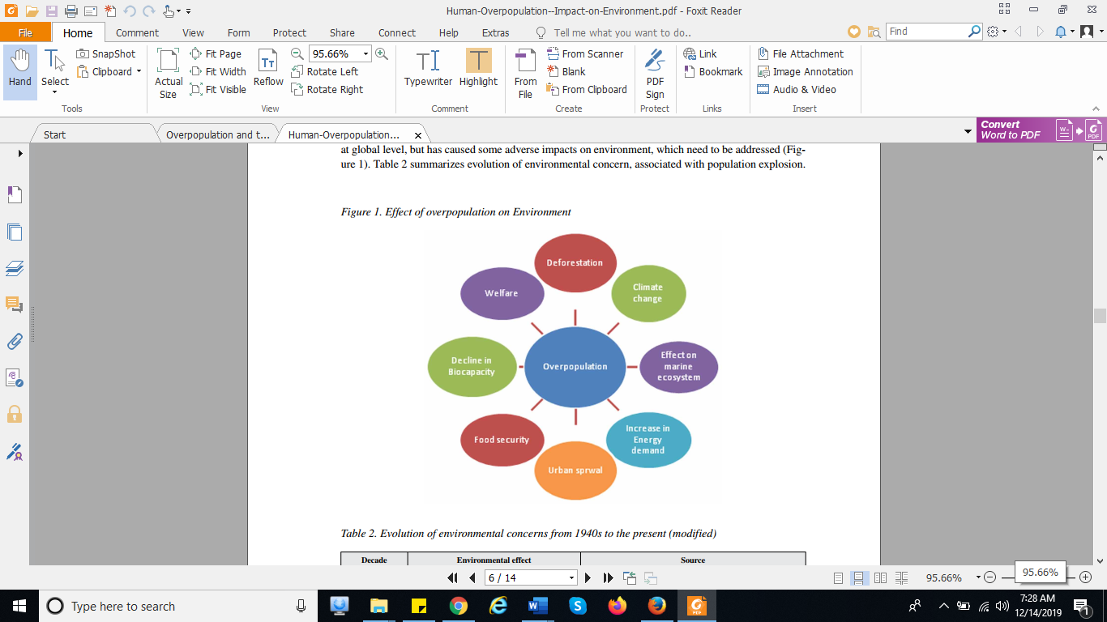
Figure: Effect of overpopulation
Overpopulation has severe environmental implications. Although it has contributed in the nation’s economy
at global level, but has caused some adverse impacts on environment, which need to be addressed (Figure 1).
Deforestation
Increasing urbanization has triggered deforestation at a very fast pace, in order to fulfill infrastructure demand of increasing population. Lands with high canopy covers are being subjected to deforestation and people are continuing to migrate from rural areas to urban areas. According to World Migration Report (2015), net migration from rural to urban area during 1981–1991 was 11 million which has risen during 2001-2011 to 19 million, in India. Population growth caused an exponential increase in the alternation of the land utilization patterns to supplements economic needs in the form of agricultural products, fuel wood, timber etc. However, to control conversion of forest area to agricultural, industrial and residential area, Forest (Conservation) Act was enacted in the year 1980 in India as a result of which conversion of forest area to other land use practices was reduced with the annual diversion rate of 16,000 hectare (Economic Survey of India, 1998-99; Nagdeve, 2002).
Welfare
Overpopulation has severely affected the quality of life in recent years. Quality of life (QOL) of individuals is an approach used to determine their satisfaction in: Life, Financial status, Education, Social life, Family life, Health and Employment.
According to Quality-of-Life Index, 2005, Ireland ranks first in the quality of life, with comparatively low population in comparison with countries such as China and India which ranks 60 and 73, respectively. Increasing population has imposed a burden on existing recourses to fulfill the basic needs of such huge population, which resulted in elevated poverty percentage. According to Planning Commission, India, below poverty line population living in the rural area showed a sharp increase from 27.09% in 1999 to 41.79% in the year 2005. This increase is subsequently accelerating lack of education in a mass of poor population. It tends to increase fertility rate in illiterate and poor population, which is not much aware about degrading environmental quality due to increasing population. Table 3 represents general fertility rate of women by their education level in different states of India. Kerala showed lowest i.e. 1.3% of illiterate women, while Bihar represents highest illiteracy i.e. 51.1% of illiterate women. General fertility rate was found to be lower for literate women as compare to illiterate women in all states of India. However, states showed lower value of general fertility rate for illiterate population than the literate population which was ascribed to the fact that sample size in illiterate category was quite small as theses states have significantly high literacy level (Census of India, 2011). In addition, government of developing countries like India is not able to manage medical facilities to such huge amount of population.
Climate Change
Recent reports on climate change indicated more frequency and catastrophe in the weather extremes, leading to costly damage of infrastructure and loss of human life (Intergovernmental Panel on Climate Change, 2007). Increased use of fossil fuels since the mid-19th century in overpopulated regions around the globe caused release of over 1100Gt CO2 into the atmosphere (IPCC, 2001). Furthermore, overpopulation accelerated agricultural practices, leading to enhanced emission of greenhouse gases. For example, methane is produced from rice agriculture practices and livestock. For emission of greenhouse gases, agriculture sources in 2014 accounted for 24% of 2010 global emission (IPCC, 2014). Population reduction in high-income countries might act as a possible solution. Any reduction in population growth in high-income countries, even starting from zero or negative rates, will have much more impact on reducing climate change than the same size reduction in low-income countries, because of the much higher per capita consumption and emission of greenhouse gases in the high-income countries (Rosnick, 2014). In addition, switch to alternative energy options (solar energy, tidal energy, wind energy etc). General fertility rate by level of education of women in India and bigger States, 2011 improved agricultural practices could help in combating the problem of climate change resulting from increased population.
Decline in Biocapacity
Increasing global population has accelerated resource consumption, which subsequently increased pressure on existing natural resources to unprecedented levels. Biocapacity is the area available as productive land and available water to produce resources or absorb carbon dioxide waste, given current management practices (Ecological Footprint Atlas, 2010). Biocapacity seems to decline sharply with increased pressure on ecological resources, as existing resources could not support consumption need of such a wide world population. Biocapacity per head decreased from 3.2 global hectares (gha) in 1961 to 1.8 gha per capita in 2008, even though total global biocapacity increased over this time (WWF Living Planet Report, 2012). The Ecological footprint denotes the land area required to meet the consumption and waste absorption needs of a population (Wackernagel & Rees, 1995). It can be used to track the availability and consumption of ecological resources and thus can aid in sustainable utilization of resources. According to Ecological Footprint accounts, demand for renewable resources has increased from 7.6 billion global hectares in 1961 to 18.1 billion global hectares in 2010. Similarly, global bioproductive area showed an increase from 9.9 billion global hectares in 1961 to 12 billion global hectares in 2010, indicating its unsustainable status (Global Footprint Network, 2015).
Urban Sprawl
Urban sprawl is one of the several consequences of rapid population growth. Sprawl is a large scale development process of real estate, producing low density, scattered, discontinuous car-dependent construction, usually on the periphery of the declining older suburbs and shrinking city centers (Hayden, 2004). Urban global population will grow to 4.9 billion by 2030, while, the global rural population is predicted to decline by approximately 28 million during 2005 to 2030 (Bhatta, 2010). In the United States, urban growth is expected to utilize about 19 million acres of farmland, environmentally sensitive and other lands during 2000–2025 (Burchell et al., 2005). Urban sprawl can be caused either by increased natality rate or by increased immigration. Better living facilities and need employment of employment are the major factors, which caused migration of population from rural area to urban area. Governmental organizations cannot deliver all basic services and quality life to huge urban population and thus, resulting massive sprawl may cause severe environmental degradation.
Food Security
Overpopulation has worsened the local and global food security by synergistic impacts of climate change. Emission from agriculture sources elevated from 4.7 billion tonnes to over 5.3 billion tonnes of carbon dioxide equivalents (CO2 eq) during 2001-2011 (Food and Agriculture Organization, 2014). Climate change resulting from the enhanced emission of greenhouse gases has posed a severe threat on food security by affecting agricultural crop production and biodiversity. Food security is linked with food availability, accessibility and utilization. Increasing urbanization has limited the growth of agricultural sectors by encouraging industrial development in rural regions. Current food production is becoming limited along with the hasty growth in human population number, field of agriculture depends on availability of natural resources like water, land and energy. For instance, 1kcal of food production requires about 10kcal of fossil energy, which is present in limited amount and thus restrict the progress in agriculture production (Pimentel, 2011). Currently, agricultural land suitable for irrigation is 50% of the world’s land. This land area is continuously being shrinking due to soil erosion, nutrient depletion, soil acidification and soil salination (Horizon, 2009).
Increase in Energy Demand
Growing global population has caused rapid inflation in energy requirement and consumption. According to Energy Information Administration (2001), use of energy, mostly for fossil fuels has boosted by nearly 85 percent globally during past 30 years, while for Asia, it is more than 300%. Sustainability for energy resources can be assured by the increased use of renewable resources, utilizing energy conserving devices for household purposes and development of advanced technologies for generating energy from biological sources.
Effect on Marine Ecosystem
Overpopulation in coastlines has mainly resulted from migration activities and caused severe environmental degradation. Mangroves, fisheries and beaches used commercially for tourism purposes are among the coastal resources, which are severely damaged by consumption practices (Naylor et al., 2002). Coral reefs are being rapidly degraded both due to direct impact of climate change and by human induced marine pollution, overfishing etc. Out of the 19,210 km2 of coral reefs in South Asia, 45% of have been destroyed, while 10%, 25% and 20% are critically threatened, threatened and at low risk, respectively (Tun et al., 2004). In Mesoamerican Barrier Reef, coral cover is declining at an average rate of about 11% since 2004, with more than 50% cover loss for some reefs (Wilkinson, 2008). International agreements for conserving marine biodiversity have however caused a significant increase in several biodiversity rich marine regions but increasing population is still a hurdle for their successful implementations.
ISSUES, CONTROVERSIES, PROBLEMS
Several efforts are being taken to ensure reduction of adverse impacts of overpopulation on environment but these are associated with serious issues. For example, developing countries are being funded under clean development mechanism to increase plantation practices, but simultaneous deforestation, has checked the advantages emerging out of the strategy. Huge population in rural regions is still dependent on fossil fuels for energy needs. Although renewable energy programmes are being initiated in rural regions by various governmental organizations but the success of these programmes always remains on question. No maintainers are provided for the solar panels after their installment. As a result, most of such renewable energy devices remain in non-working condition. Several schemes are being hurled by government of India to provide employment in the rural areas so that the massive urban sprawl can be checked. Government of India inducted a scheme for self-employment in 1980-81 namely, Integrated Rural Development Programme (IRDP), which was further remodeled as the Swarnjayanti Gram Swarozgar Yojana (SGSY). In 1989, Jawahar Rozgar Yojana (JRY) was initiated by amalgamating National Rural
Employment Programme (NREP) and Rural Landless Employment Guarantee Programme (RLEGP).
The main goal of the scheme was generating more employment opportunities for people living in rural areas, advancing rural infrastructure and quality of life (Planning Commission, Government of India). However, it turns out to be a very time-consuming process for procuring actual financial gain by rural people due to red tapism involved in governmental procedures especially in developing nations. In addition, to ensure food security, use of enormous quantity of chemical fertilizers further worsened the environmental health by reducing soil fertility.
Conclusion

References and appendices
Appendices
Bibliography

