[ART B
The purpose of this assignment is to explain core concepts related to stocks and to analyze the ethical implications of decisions and promote ethical standards within organizations.
Read the Chapter 7 Mini Case on pages 339-341 in Financial Management: Theory and Practice. Using complete sentences and academic vocabulary, please answer questions a through d.
Using the mini case information, write a 250-500 word report presenting potential ethical issues that may arise from expanding into other related fields. In your discussion, proactively strategize about possible expansion by explaining opportunities to promote ethical standards within your organization.

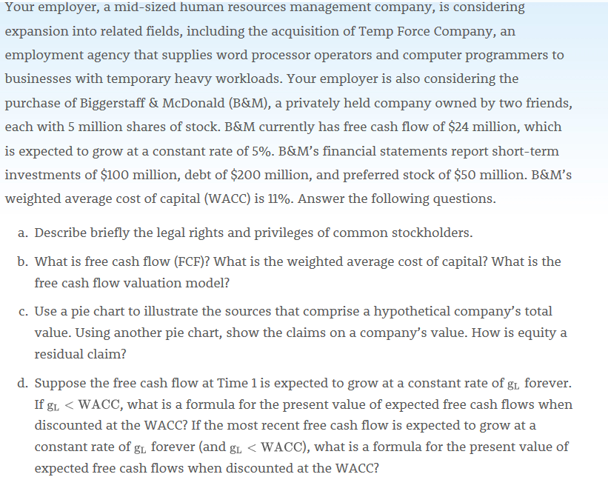
- Common shareholders have been bestowed with several legal rights and privileges which they enjoy. These rights and privileges include electing of the firm’s director and authority to purchase additional shares. Traditionary, common share holders have more privileges compared to their counterparts. They can be elected or participate in electing firm’s directors.
- Free cash flow (FCF) is the cash flow available for distribution to all of a company’s investors. FCF is generated by a company’s operations.
The weighted average cost of capital (WACC) is the overall rate of return required by all of the company’s investors. The PV of their expected future free cash flows, discounted at the WACC, is the value of operations. This is the essence of the FCF valuation model.
Nonoperating assets are marketable securities and ownership of non-controlling interest in another company. The value of nonoperating assets usually is very close to figure that is reported on balance sheets.
- Total corporate value is sum of value of operations and value of nonoperating assets. Some company’s also have growth options, but assume they are negligible for this company. Debtholders have first claim. Preferred stockholders have the next claim. Any remaining value belongs to stockholders.

Equity residual claim = 29%

- Formula for the present value of expected free cash
$V_{op}=\frac{{FCF}_{1}}{WACC- g_{L}}$
Present value of expected free cash flows when discounted at the WACC

$V_{op}=\frac{{FCF}_{0}(1+g_{L})}{WACC- g_{L}}$

