Lecturer: Nele Vande Walle & Kasper Vermote

OPO: Marketing Communication Strategy

Exercise media planning: 1BBMA/1BBMB/1BBMC

PE2: Exercises media planning

Instructions

- Prepare these exercises individually & upload your results (Word doc or Excel) on Toledo before the indicated deadline of your class group. Important: show each step of your calculation, not only the answer!

Exercises

Note: the mentioned total readers or reach of each title are always based on 12+

Exercise 1:

Title: Elle Belgique+Elle Belgium
- Reach total readers with 1 insert: 343.600
- Reach women social class 1 with 1 insert: 52.100

Universum 12+ Belgium:
- Women social class 1: 575.900
- Universe 12+: 9.885.400

Calculate for Elle Belgique+Elle Belgium:

- Coverage on women social class 1
Coverage = 52.100/575.90 x 100= 9.05%
- Selectivity index on women social class 1
Selectivity index = 575.9/9,885.4 x 100 =5.8%
- Based on the selectivity index, how do you evaluate this medium?
The selectivity index is below 100; therefore, the target group is under-represented.

Exercise 2:

Title: Elle Belgique+Elle Belgium
- Reach total readers with 1 insert*: 343.600
- Reach women with 1 insert: 268.600

Title: Flair (NL+Flair):
- Reach total readers with 1 insert: 679.400
- Reach women with 1 insert: 504.900

Universum 12+ Belgium:
- Women: 5.048.000
- Universe 12+: 9.885.400

Suppose an advertiser plans 1 insertion in Elle Belgique/Elle België and 1 insertion (advertisement) in Flair (NL&FR)

Calculate the following media objectives:

- Gross Reach women

Reach: Total no of people or houslod exposed to an ad schedule during a given period (usually 4 weeks); expressed as a percentage of the total potentially exposed
Elle Belgique
Reach total readers in 1 insert-343600
Reach total women in 1 insert-268600
268600/343600=0.78= 78.17%

Reach total readers in 1 insert =6,79,400
Reach total women in 1 insert=5,04,900
Gross reach women= 5,04,900/6,79,400=0.743=74.31%

- Gross Coverage on women

Gross coverage/ Average Frequency:-
Frequency- no of exposures to the same message each HH supposedly receives
Average Frequency- total exposures for all HH/no of people reached
Elle belgique NL + Flair
No of insert 1 1
reach total women in 1 insert 2,68,600 5,09,400
Average frequency (2,68,600*1)+(5,09,400*1)/(3,43,600+6,79,400)/2=5,11,500
2,68,600+5,09,400=778000/5,11,500=1.52

- Selectivity index on women for Flair (NL&FR)
Selectivity index = 679.4/9885.4 x 100 =6.9%
- What is net reach on 12+ if the duplication would be 193.500

Universe- the total group of persons in a specific geographic area that shares a common characteristic
Net reach a count of persons with at least 1 in-person
Net reach= No of persons reached/No of persons in universe*100
Assumed the no of women reached is 1,93,500
Net reach =193500/9885400*100=1.957%

- What is the OTS
OTS means the opportunity to see indicates how often, on average, a person has come in contact with a particular advertising medium. OTS is used to measure the success of an advertising campaign
OTS= Elle belgique= Gross reach/ Net reach
=78.17/1.95=39.94
NL+Flair=74.31/1.95=15.89

- Exercise 3:

Title: Data News NL+FR
- Reach total readers with 1 insert: 87.800
- Reach men 25-34 years with 1 insert: 20.300

The price for 1/1 quadri page in Data News NL/FR is 8.900 €.

Calculate
- what will be the general CPM and CPM-TM for men between 25 and 34 years.

CPM = (Total Impressions/ 1000) *CPM
= (87.800/1000) *8.900
= 0.78142
CPM-TM = (20.300/1000) *8.900
= 0.18067

- Exercise 4

Explain:
- How is this GRP calculated and why is important to know?
Gross rating is calculated as the product of the percentage of the audience reached an ad and the Frequency.
Gross rating point is used in media to measure the audience size that a particular media reaches.

- What is reach% 3+ and affinity according to you?
According to me, reach% 3+ means the effective reach of the audience; it is also the percentage of the audience reached who were exposed to the message 3 times.
Affinity explains how the media audience matches specific people; when the affinity is high, there is clear interest between the media and the target audience.

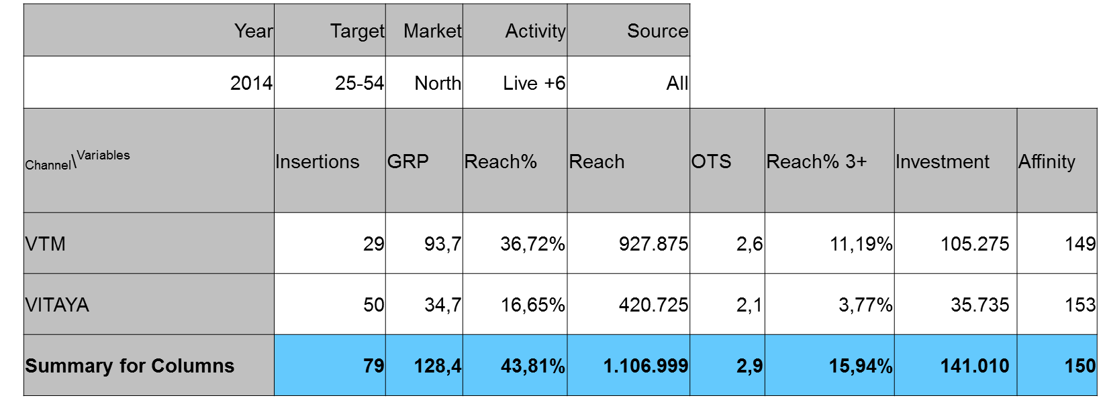

- Exercise 5:

The coverage on women with 1 insert is the following for each magazine:

3,6% coverage on women Marie-Claire (NL/FR)
17,9% coverage on women Libelle+Femmes
10,0% coverage on women Flair (NL/FR)

Suppose: Dove obtains a net coverage of 23,4% on women after
- 3 advertisements in Marie-Claire (NL&FR)
- 3 advertisements in Libelle+Femmes
- 3 advertisements in Flair (NL&FR).

Calculate the OTS and GRP on target group women?
OTS 3,6% coverage on women Marie-Claire (NL/FR) = 23.4$/3.6% = 6.5
OTS 17,9% coverage on women Libelle+Femmes =23.4%/17.9% = 1.3
OTS 10,0% coverage on women Flair (NL/FR) = 23.4%/10.0% = 2.3

GRP = Reach x frequency

3 advertisements in Marie-Claire (NL&FR)= 6.5 x 3=19.5
3 advertisements in Libelle+Femmes = 1.3 x3 = 3.9
3 advertisements in Flair (NL&FR). =2.3 x3 =6.9

