Lecturer: Nele Vande Walle & Kasper Vermote

OPO: Marketing Communication Strategy

Exercise media planning: 1BBMA/1BBMB/1BBMC

PE2: Exercises media planning

Instructions

- Prepare these exercises individually & upload your results (Word doc or Excel) on Toledo before the indicated deadline of your class group. Important: show each step of your calculation, not only the answer!

Exercises

Note: the mentioned total readers or reach of each title are always based on 12+

Exercise 1:

Title: Elle Belgique+Elle Belgium
- Reach total readers with 1 insert: 343.600
- Reach women social class 1 with 1 insert: 52.100

Universum 12+ Belgium:
- Women social class 1: 575.900
- Universe 12+: 9.885.400

Calculate for Elle Belgique+Elle Belgium:

- Coverage on women social class 1
- Selectivity index on women social class 1
- Based on the selectivity index, how do you evaluate this medium?

Exercise 2:

Title: Elle Belgique+Elle Belgium
- Reach total readers with 1 insert*: 343.600
- Reach women with 1 insert: 268.600

Title: Flair (NL+Flair):
- Reach total readers with 1 insert: 679.400
- Reach women with 1 insert: 504.900

Universum 12+ Belgium:
- Women: 5.048.000
- Universe 12+: 9.885.400

Suppose an advertiser plans 1 insertion in Elle Belgique/Elle België and 1 insertion (advertisement) in Flair (NL&FR)

Calculate the following media objectives:

- Gross Reach women
- Gross Coverage on women
- Selectivity index on women for Flair (NL&FR)
- What is net reach on 12+ if the duplication would be 193.500
- What is the OTS

- Exercise 3:

Title: Data News NL+FR
- Reach total readers with 1 insert: 87.800
- Reach men 25-34 years with 1 insert: 20.300

The price for 1/1 quadri page in Data News NL/FR is 8.900 €.

Calculate
- what will be the general CPM and CPM-TM for men between 25 and 34 years.

- Exercise 4

Explain:
- How is this GRP calculated and why is important to know.
- What is reach% 3+ and affinity according to you?

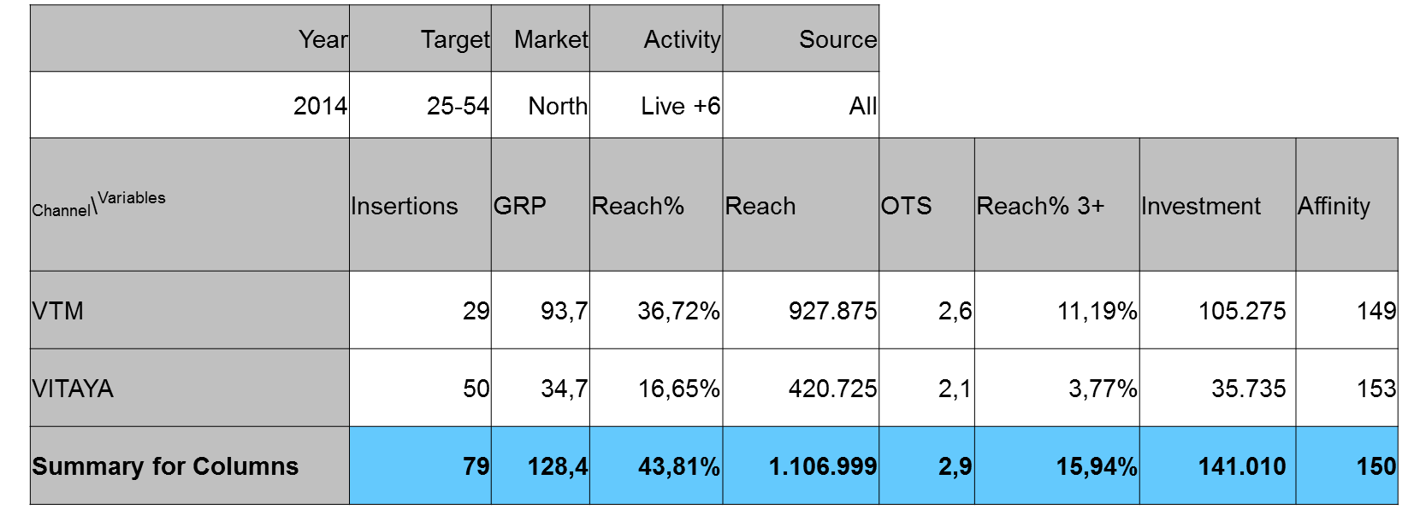

- Exercise 5:

The coverage on women with 1 insert is the following for each magazine:

3,6% coverage on women Marie-Claire (NL/FR)
17,9% coverage on women Libelle+Femmes
10,0% coverage on women Flair (NL/FR)

Suppose: Dove obtains a net coverage of 23,4% on women after
- 3 advertisements in Marie-Claire (NL&FR)
- 3 advertisements in Libelle+Femmes
- 3 advertisements in Flair (NL&FR).

Calculate the OTS and GRP on target group women?

