Unit 5 ~ Learning Guide Name: ______________________________

Instructions

Using a pencil, complete the following notes as you work through the related lessons. Show ALL work as is explained in the lessons. You are required to have this package completed BEFORE you write your unit test. Do your best and ask questions if you don’t understand anything!

Electrostatics
- Neutrons have no charge, while protons are positively charged, and electrons are negatively charged.

- Within an atom, the electrons can move significantly, while the neutrons and protons can’t.

- Electrons are attracted to positive charges.

- Electrons are repelled by negative charges.

- An object has no net charge (i.e. is neutral) if the number of electrons and protons are equal.

- When an object is negatively charged, it's due to excessive electrons.

- When an object is positively charged, it's due to missing electrons.

- Electrons are (repelled by / attracted to) the positive pole on a battery (circle one).

- Electrons are (repelled by / attracted to) the negative pole on a battery (circle one).

- An electroscope can detect a charge, but can’t determine if it’s positive or negative.

- An electrical charge can build up when a bunch of electrons is built-up on an object (negative charge) OR if the object loses a bunch of protons (positive charge).

- If a built-up charge isn’t moving, we call it static electricity (due to the lack of any movement).

- When a charge is discharged to the Earth, whether through a water pipe or wire or the ground itself, we call it grounding/earthing.

- When you are charged, your hair stands up because like charges repel so each hair is trying to get away from other hairs and your head.

- Charging involving rubbing is called “charging by friction”, charging by contact is called “charging by conduction”, and charging without any touch is called “charging by induction.

- Consider the following items. Each positive represents billions of protons, while each negative represents billions of electrons.
Rod-A | Rod-B | Balloon-A | Balloon-B | Balloon-C
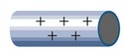 |  | 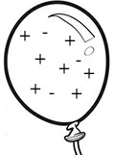 | 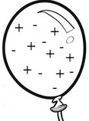 | 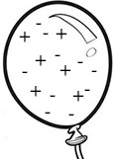
positive | Negative | Positive | neutral | Negative
Electrons < protons | electrons > protons | electrons < protons | electrons = protons | electrons > protons

- Complete the bottom two rows of the table above. (positive, negative, or neutral in the first row) and (<, >, or =) in the second.

- If Rod-A Touches Balloon-B, describe (in pictures or steps) what would happen?
When the tow rods get into contact the charge distribution changes. All the positive charges on rod A moves on the right side of the rod while all the negative charges on rod B moves to the left side of the rod due to an attraction effect.
- If Balloon-C is brought close to Balloon-B, describe (in pictures or steps) what would happen?
All positive charges on Balloon B will be attracted to the negative charges of balloon C and they will move to the right side of the balloon while the negative charges of balloon B move to the left side but still neutral. Negative charges of balloon C moves to the left side of the balloon due to an attraction by positive charges of balloon B.
- If Rod-B Touches Balloon-A, describe (in pictures or steps) what would happen?
All the positive charges of the balloon will be attracted to the negative charge of the rod and move to one side of the balloon. The negative charges will be repelled and move to the other side of the balloon, further from the rod.
- Describe how you could use Rod-A, along with two Balloon-B’s to make two charged balloons.
When rod A is in contact with balloon B, the negative charges move from the balloon to the rod and the balloon becomes positively charged.

- Find a wire leading to a grounding rod or grid near your home. Don't open any electrical devices or panels, as they are typically visible without this. If you can't find one, ask for help. Describe its location below.

- Describe how a Van de Graph generator works. Show as a labeled diagram, describing it's charging process.
The Van de Graaf generator makes use of a moving belt to accumulate electric charges to create high electric potential.
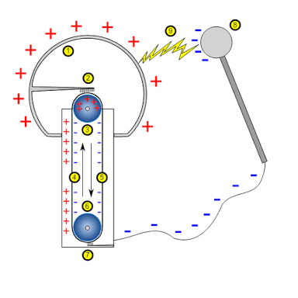
- Before a lightning strike, describe where and how the charges build up.
Lightning happens when there is a movement of clouds in the atmosphere. This creates large quantities of static charges due to friction. The friction between clouds and air induce opposite charges between the atmosphere and the earth which produces a high potential difference. the air becomes a charged conductor and the huge charges strongly attract and neutralize each other causing thunder and lightning.
- Many electronic devices produce a static charge because of the electricity they use. With this in mind, explain why the screen of your TV tends to be much dustier than most other pieces of furniture in your home.
The television screen is positively charged due to electric charges. When dust particles pass nearby, they are attracted by the positive screen.

Coulomb’s Law:

- What is the smallest unit of charge (in Coulombs)? Where does it exist (in positive and negative) form?
The smallest unit of charge is an electron measured in Micro Coulomb equivalent to
1.6 X 10⁻¹⁹ C and exists in a negative form since the charge of an electron is negative.
- Explain how Coulomb's law provides a quantitative understanding of the forces involved in charging balloons that were discussed earlier.
According to coulombs law, the force exerted by a charged particle on another is directed along a line connecting them. They move away from each other if the two particles have the same charge type and move towards each other if the particles have different charge types. The coulomb law, therefore, helps determine the amount of force of attraction or repulsion.
- We know that two positive charges repel each other. Determine the force between two charges which are both +1C and separated by 1m.
If two oppositely charged particles are at a distance of 1m apart, then the force between them is;
$F=k\frac{q_{1}q_{2}}{r2}$ where k=Coulombs constant and k=8.99x10⁹ Nm²/C²
$$F=8.99×{10}^{9}×\frac{1×1}{1^{2}}$$
=8.99 X 10⁹ N

- Why do we normally measure charge in μC instead of Coulombs?
The unit Micro Coulomb is often used because the charge of an atom is so small that cannot be quantified and measure using the coulomb. Besides, the forces within an atom are very large is Coulombs are used as basic units of measurement.

- Determine the force between two charges (2.5 μC and -4.3 μC) which are separated by 4 cm.
$F=k\frac{q_{1}q_{2}}{r2}$
$$F=8.99×{10}^{9}×\frac{2.5 ×{10}^{-6}×-4.3×{10}^{-6}}{4^{2}×100}$$
=60.4 N (Attraction)
- Compare the general magnitude of the force of gravity and the electrostatic force. Consider the constants in each equation to explain the difference (use the equation for the universal force of gravity). Why do we often think of gravity as being bigger?
The electrostatic force is given by $F=k\frac{q_{1}q_{2}}{r2}$where k=8.99X10⁹Nm²/C² while the force of gravity is given by $F=G\frac{m_{1}m_{2}}{r2}$ where G=6.67 X 10⁻¹¹ Nkg²/m² (Universal gravitational Constant). This electrostatic force within an atom is bigger than the gravitational force. Most people think gravity bigger because the size of the earth is billions of trillions of times bigger than that of an atom.
- Find the force of attraction between objects of 4.0 μC and -5.0 μC when they are 0.20 m apart. How does this change when the distance is doubled?
$F=k\frac{q_{1}q_{2}}{r2}$
$$F=8.99×{10}^{9}×\frac{4.0 ×{10}^{-6}×-5.0×{10}^{-6}}{{0.20}^{2}}$$
=4.495 N (Attraction
When the distance is doubled, then
$$F=8.99×{10}^{9}×\frac{4.0 ×{10}^{-6}×-5.0×{10}^{-6}}{{0.40}^{2}}$$
=1.12375 N (Attraction
Implying that the force of attraction if quartered i.e. $\frac{1.12375}{4.495}=\frac{1}{4}$
- A small sphere of mass 0.050 kg is seen to accelerate away from a charge of 16 μC at a rate of 1150 m/s² when placed 10 cm apart.
  - What is the charge on the small sphere?

$F=k\frac{q_{1}q_{2}}{r2}$

$$0.05 X 10=8.99×{10}^{9}×\frac{16 ×{10}^{-6}× q_{2}}{{0.1}^{2}}$$
= 3.476 X 10⁻⁶ C

  - Describe the motion of the small sphere as it moves away from the 16 μC charges. In particular, discuss how the sphere accelerates as they separate. Whenever possible, back up your reasoning with an equation.

Since q₁>q₂ and have the same charge type, then the smaller particle will be pulled away faster.

- Use Coulomb's Law to help explain why charged objects are attracted to neutral objects.

A neutral object has both negative and positive charges in equal numbers. Therefore, a charged object will always attract the opposite charges from the neutral object or repel the same charge type from the same neutral object.

- Demonstrate (show work) with Coulomb’s Law what happens to the magnitude of the force between two charges Q₁and Q₂ separated by a distance R if:
Since $F=k\frac{Q_{1}Q_{2}}{R2}$, then,

  - one of the charges is doubled?
Then the force is doubled.
That is $F=k\frac{{2Q}_{1}Q_{2}}{R2}=2F$

  - both charges are doubled?
Then the force becomes 4times the original
That is $F=k\frac{{2Q}_{1}{ X 2Q}_{2}}{r2}=4F$

  - the separation distance is doubled?
Then the force is quartered.
That is $F=k\frac{Q_{1}Q_{2}}{{(2R)}^{2}}$ = $\frac{F}{4}$

  - the separation distance is tripled?
Then the force is a ninth of the original.
That is $F=k\frac{Q_{1}Q_{2}}{{(2R)}^{2}}$ = $\frac{F}{9}$

  - both charges are doubled and separation distance is doubled?
There is no change in the force
That is $F=k\frac{{2Q}_{1}{ X 2Q}_{2}}{{(2R)}^{2}}=\frac{4}{4}F=F$

  - both charges are doubled and separation distance is halved?
The force becomes 16 times of the original
That is $F=k\frac{{2Q}_{1}{ X 2Q}_{2}}{{(0.5R)}^{2}}=\frac{4}{0,25}F=16F$

- Two small spheres are located 0.50 m apart. Both have the same charge on them. If the repulsive force is 5.0 N, what charge is on the spheres, in µC?
$F=k\frac{q_{1}q_{2}}{r2}$

$$0.5=8.99×{10}^{9}×\frac{Q_{1}×Q_{2}}{{0.5}^{2}}$$
Since Q₁=Q₂=Q, then, $$0.5=8.99×{10}^{9}×\frac{Q^{2}}{{0.5}^{2}}$$
Q² = 0.0139 X 10⁹C
Q = 11.79µC
- Let’s compare this electrical force to the force of gravity. Imagine you could place 1g of electrons 1.0 m away from another 1g of electrons. Calculate:
  - the electrical force of repulsion between the two charge collections.

$F=k\frac{Q_{1}Q_{2}}{R^{2}}$ where K=8.99 X 10⁹NC²/m², Q₁=Q₂= 1.6 X 10⁻¹⁹C, and R=1m

Then,
$F=8.99×{10}^{9}×\frac{{(1.6 X {10}^{-19})}^{2}}{1^{2}}$
= 2.3 X 10 ⁻²⁹ N
  - the gravitational force of attraction between them.

$F=G\frac{m_{1}m_{2}}{r2}$ where G=6.67 X 10⁻¹¹ Nkg²/m², m₁=1g, m₂=1g, and r=1m

Then,
$F=6.67×{10}^{-11}×\frac{0.001×0.001}{1^{2}}$
=6.67 X 10⁻¹⁷ N

  - the ratio of the electrical force to the gravitational force.

$Ratio=\frac{elactrical force}{gravitational force}=\frac{2.3 X {10}^{29}}{6.67 X {10}^{-17}}=3.45X{10}^{45}:1$

  - Discuss whether you think gravity would play a major part in holding atoms together. Refer to your results above.
Gravity would not play a major role in holding atoms together since it is $\frac{1}{3.45 X{10}^{45}}$ of the force of attractions in an atom.
- One electron has a mass of 9.1 x 10-31 kg. How many coulombs of charge would there be in 1 kg of electrons? How much force would this charge exert on another 1 kg of electrons 1.0 km away? (This is strictly an imaginary situation.)
9.1 X 10⁻³¹ is the mass of an electron and the charge of an electron is equivalent to
1.6 X 10⁻¹⁹C. therefore, 1kg of electrons will have;
$$\frac{1.6×{10}^{-19}}{9.1×{10}^{-31}}=1.758 ×{10}^{11}C$$

$$F=8.99×{10}^{9}×\frac{1.759 ×{10}^{11}×1.758×{10}^{11}}{{1000}^{2}}$$
= 2.778 X 10²⁶ N

Coulombs Law in 2D

- Electric Force is a vector. Three charged objects are located at the 'corners' of an equilateral triangle with sides 1.0 m long. Two of the objects carry a charge of 5.0 µC each. The third object carries a charge of –5.0 µC. Assume all three objects are very small.
  - Draw the three charges below. Draw the forces acting on the –5.0 µC charge.
-5µC

1m
1m

5µC
5µC
1m

  - ing your diagram above draw the vector diagram showing how you would arrive at the direction of the Net Force acting on the –5.0 µC charge. Determine the angles inside your vector diagram and label them directly onto the sketch.
Initial psn of -5µC

0.866m 1m

Final psn of -5µC 5µC particle
0.5m
  - What is the resultant force acting on the –5.0 µC object?
$F=k\frac{Q_{1}Q_{2}}{R^{2}}$
= $8.99×{10}^{9}×\frac{-5 ×{10}^{-6}×-5×{10}^{-6}}{{0.866}^{2}}$
= 0.299 N (Vertically downwards)

- A 4.0 μC charge is 20 cm from a 6.0 μC charge. At 90° to this, a -9.0 μC charge is fixed 25 cm above the 6.0 μC charge. What force is experienced by the 6.0 μC charge?
-9.0μC 4.0μC

25cm 20cm

6.0μC
- Consider two small spheres, each of mass m and positive charge q, hanging from light threads of lengths l.
  - On the diagram draw and label all forces on sphere I. Label the distance, r, that you would use to determine the magnitude of the electric force acting between both spheres.
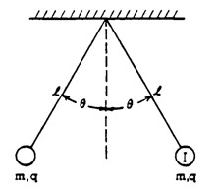

Tension on the sphere

g g

Electric Fields
- E = kQ/R² is the equation for the electric field surrounding point charges.
  - What is the relationship between E and the distance away from the charge, R? Explain with an example.
The electric field, E is inversely proportional to the square of the distance, R. therefore, when R increases, the electric field surrounding the charges decreases and vice versa
  - Sketch electric field lines around each charge and pass one through the three points, then draw a vector showing the resulting force at each point (ie. F_{a}, F_{b}, and F_{c}).

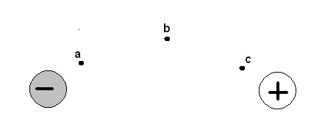

- Calculate the electric field strength 1.2 m away from a 7.5 μC charge.
$E=k\frac{Q}{R^{2}}$
=$8.99×{10}^{9}×\frac{7.5 ×{10}^{-6}}{{1.2}^{2}}$
= 4.682 X 10⁴ N/C
- A charge experiences a force of -2.0x10⁻² N in an electric field of strength 45000 N/C. Calculate the size of the charge. Is it created by a surplus or shortage of electrons? How many electrons involved?
E=$\frac{F}{Q}$
Q=$\frac{-2.0×{10}^{-2}}{4.5×{10}^{4}} =-0.444×{10}^{-6}=-0.4µC$
$No. of electrons=\frac{4.444×{10}^{-7}}{1.6×{10}^{-19}}=2.778×{10}^{12} electrons$
- Find the electric field at point P in the diagram below.
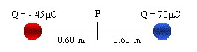
The electric field at P is due to the attraction between Q1 and Q2, given by
$$E=k\frac{Q}{R^{2}}$$
$E_{Q1}$=$8.99×{10}^{9}×\frac{-45 ×{10}^{-6}}{{1.2}^{2}}=$2.809 X 10⁶ N/C
$E_{Q2}$=$8.99×{10}^{9}×\frac{75 ×{10}^{-6}}{{1.2}^{2}}=$4.370 X 10⁶ N/C

- An electron carries a charge of 1.6 x 10⁻¹⁹ C. If a force of 3.2 x 10⁻¹⁷ N causes the electron to move upward, what is the magnitude and direction of the electric field
E=$\frac{F}{Q}$
= $\frac{3.2×{10}^{-17}}{1.6×{10}^{-19}}=200N/C Downwards$

- Calculate the electric field strength at point P in the diagram below.
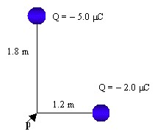
$$E=k\frac{Q}{R^{2}}$$
$E_{Q1}$=$8.99×{10}^{9}×\frac{-5.0 ×{10}^{-6}}{{1.8}^{2}}=$1.387 X 10⁴ N/C
$E_{Q2}$=$8.99×{10}^{9}×\frac{-2.0 ×{10}^{-6}}{{1.2}^{2}}=$1.2 X 10⁴ N/C

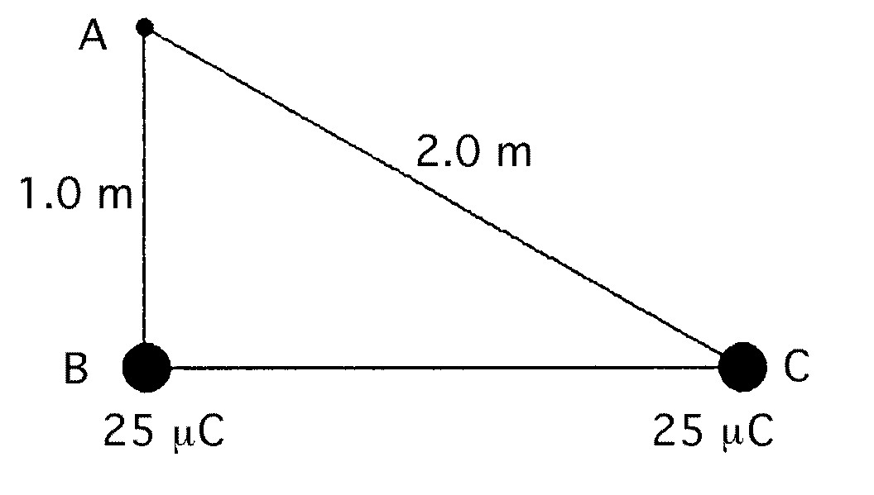
- Consider the diagram.
30º

  - Sketch the electric field vectors from each charge at location A. Be sure to sketch them roughly to scale. Show the direction of the Net Electric Field. Lightly sketch in the field lines onto the diagram above. e

  - Determine the angles of the vectors above and label them on the diagram above.
$\sin^{-1}({\frac{1}{2})}=30°$

  - What is the resultant electric field strength E at point A? Give both the magnitude and the direction.
$E_{Q1}$=$8.99×{10}^{9}×\frac{25 ×{10}^{-6}}{{(1.732Cos60)}^{2}}=$2.99 X 10⁵ N/C

  - If an electron placed at location A what would be its acceleration? Give both magnitude and direction.
$E_{Q1}$=$8.99×{10}^{9}×\frac{25 ×{10}^{-6}}{{(1Cos30)}^{2}}=$1.685 X 10⁵ N/C

  - Discuss the similarities and differences between Electric Force as opposed to Electric Field.
An electric force is then exerted between two charged particles while an electric field is an electric force on a unit charge. There must be an electric field for the occurrence of the electric force.

- Sketch two oppositely charged parallel plates. Draw in the electric field lines being sure to adhere to the rules regarding their direction and relative strength. Discuss how the field between the plates near the positive plate compares to the field near the negative plate.
For the parallel plates below, the electric field lines are uniform and parallel to one another. The net electric field is therefore null.
E

e

- For the above set of plates why can’t we use the formula E=kQ/r² to determine the value of the electric field between the plates? What formula should we use?
The above formula applies only for point charges. In the diagram, the plates provide surfaces at different potentials, therefore the most appropriate formula to be used is E=V/d
Electric Potential Energy

- Recall that electric/gravitational fields and forces are vector quantities (with direction). Potential Energy, though, is a scalar quantity.
  - Compare the formula to determine the gravitational potential energy between two planets with the formula to determine the electrical potential energy between two charges.
The gravitational potential energy is given by E=mgh, while that for electrical potential energy is $U=k\frac{Q_{1}Q_{2}}{R}$.
  - Potential energy is negative if the mass/charge moves in the same direction as the gravitational/electrical Force (decreasing the stored energy).

  - Potential energy is positive if the mass/charge moves in the opposite direction as the gravitational/electrical force increasing the stored energy).

  - Gravitational potential energy is always increased as two masses move away from each other and decreased as they move closer.

  - Electrical potential energy is increased if two oppositely charged objects move away from each other.

  - Electrical potential energy is decreased if two similarly charged objects move away from each other.

  - Electrical potential energy is decreased if two oppositely charged objects move towards each other.

  - Electrical potential energy is increased if two similarly charged objects move towards each other.

- Find the potential energy of two protons which are 10⁻¹⁰ m apart.
The potential energy of between two charges is given by
$$V=k\frac{q^{2}}{r} where k=8.99X{10}^{9}$$
$$q is the point charge$$
$$r is the distance between the charges$$
Therefore, V=$8.99X{10}^{9 }×\frac{({1.6X{10}^{-19})}^{2}}{{10}^{-10}}$
= 2.30 X 10⁻¹⁸J

- A 50 μC charged sphere of mass 0.050 kg is stationary and 2.0 m away from a -30 μC charged sphere. The 50 μC charged sphere was released and allowed to approach the other. When it is 1.2 m away, what is the speed of this sphere?
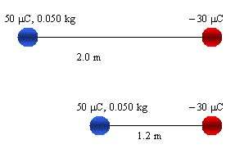
Potential Energy between the 50µC sphere and the -30µC sphere at 1.2m apart is
$$V=k\frac{Qq}{r}$$
Therefore, V=$8.99X{10}^{9 }×\frac{50×{10}^{-6}×-30×{10}^{-6}}{1.2}$
= 11.24 J
This potential energy at 0.8m equals the kinetic energy of the particle at this point. Therefore,
KE=$\frac{1}{2}mv^{2}=11.24$
v² = $\frac{11.24X2}{0.05}$
v = 21.2m/s
- How much work is needed to bring a + 5.0 µC point charge from infinity to a point 2.0 m away from a + 25 µC charge?
$$V=k\frac{Qq}{r}$$
Therefore, V=$8.99X{10}^{9 }×\frac{5.0×{10}^{-6}×25×{10}^{-6}}{2.0}$

= 0.56 J

- How much potential energy would an electron in a hydrogen atom lose if it fell toward the nucleus from a distance of 7.5 x 10⁻¹¹ m to a distance of 5.0 x 10⁻¹¹ m?
∆$V=k\frac{q^{2}}{∆r}$
∆r = (7.5 – 5.0) X 10⁻¹¹m
=2.5 X 10⁻¹¹m
Therefore, ∆V = $8.99×{10}^{9}×\frac{{(1.6X{10}^{-19})}^{2}}{2.5X{10}^{-11}}$
= 9.21 X 10⁻¹⁸ J
- A 50 μC charged sphere of mass 0.050 kg is 2.0 m away from a -30 μC charged sphere. The 50 μC charged sphere is moved to a point 1.2 m away. What is the change in the energy of this sphere?

∆$V=k\frac{q^{2}}{∆r}$
∆r = (2.0 – 1.2) m
= 0.8 m
Therefore, ∆V = $8.99×{10}^{9}×\frac{{(50X{10}^{-6})}^{2}}{0.8}$
= 28.09 J

Voltage
- When working with electricity, we often use the term potential interchangeably with voltage. This is NOT the same thing as potential energy (though pretty close). Describe the difference between potential (or voltage) and potential energy.
An electrical potential(V) is defined as the work done in moving a unit charge from one point to another in an electric field without a change in the speed of the charged particle. It is given by $V=k\frac{Q}{r}$. Potential energy(U) on the other hand is defined as is the energy possessed by a particle in a given position relative to other particles. Also, it is the energy stored in a charged particle to its zero position. The potential energy is given by $U=k\frac{Qq}{r}$

- An electron-volt, eV, is a unit of measure. What quantity does the electron volt measure? What is the conversion between eV and the standard unit for this quantity?
The unit electron-volt measures the electrical potential energy of charged particles.
$$1eV=1.602×{10}^{-19}J$$

- An electron is accelerated by a voltage of 2500 V between plates a and b, as shown. What is the electron's change in energy when reaching plate b if it starts from rest? What is the electron's speed when reaching plate b?
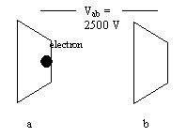

- A proton moving at 3.0 x 10⁴ m/s is accelerated by a potential difference of 200V, what is its final velocity?
$KE=PE$
Therefore, $\frac{1}{2}mv^{2}=PE$
$\frac{1}{2}×1.67×{10}^{-27}×v^{2}=200×1.6×{10}^{-19}$
V² = 383.2 X 10⁸
V = 1.9 X 10⁵ m/s

- A proton is moving at a speed of 2x10⁶ m/s towards a series of charged parallel plates as shown below. What is the final velocity of the proton upon striking the -40000V plate on the right?
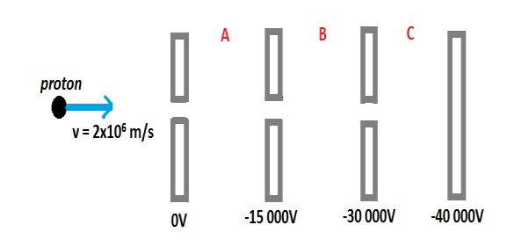
$\frac{1}{2}mv^{2}=PE$
$\frac{1}{2}×1.67×{10}^{-27}×v^{2}=40000×1.6×{10}^{-19}$
V² = 76646.7 X 10⁸
V = 2.769 X 10⁶ m/s

- A proton is moving at a speed of 2x10⁶ m/s towards a series of charged parallel plates as shown below. In what section (A, B, or C) will the proton stop?
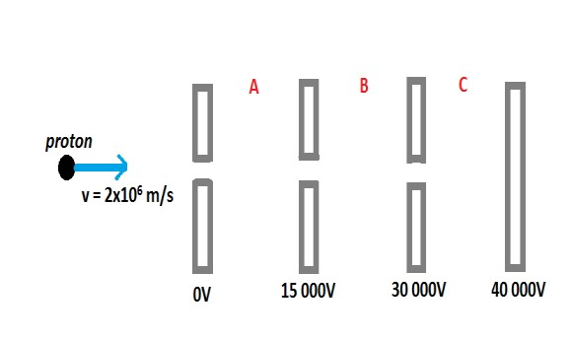
The proton will stop at point B. This is because its potential energy will be
$\frac{1}{2}×1.67×{10}^{-27}×{(2×{10}^{6})}^{2}=\frac{3.34×{10}^{-15}}{1.6×{10}^{-19}}=2087V$

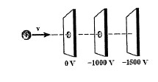
- A proton is traveling at a speed of 4 x 10⁵ m/s moves into a series of charged parallel plates as shown below.
  - What is the impact speed on the third plate?
As the particle approaches the charged plates, its velocity increase hence increasing the energy. An increase in energy increases the force of impact on the third plate

  - The same proton is fired again at the same speed towards a very large nucleus (parallel plates removed) and comes to rest 0.15 nm away from the atom. What is the charge of the atom? What might this nucleus be? (use the periodic table)
$$KE=PE$$
Therefore, $\frac{1}{2}mv^{2}= k\frac{Qq}{r}$
$\frac{1}{2}×1.67×{10}^{-27}×{(4×{10}^{5})}^{2}= 8.99×{10}^{9}×\frac{{(QX{10}^{-6})}^{2}}{0.15X{10}^{-9}}$
Q² = 2.229 X 10⁻²⁴
Q = 1.49 X 10⁻¹² C

  - Why can you not use high-school kinematics to get the answer above for this situation?
This is because force varies with change in distance.

CRTs
- In a television set, electrons are first accelerated from rest through a potential difference in an electron gun. They then pass through deflecting plates before striking the screen.
    - Determine the potential difference through which the electrons must be accelerated in the electron gun to have a speed of 6.0 x 10⁷ m/s when they enter the deflecting plates.
PE=KE=$\frac{1}{2}mv^{2}$
= $\frac{1}{2}×9.1×{10}^{-31}×({6.0×{10}^{7})}^{2}$
=1.63 X 10⁻¹⁵ J
Potential Difference = $\frac{1.63×{10}^{-15}}{1.6×{10}^{-19}}=10,187.5V$

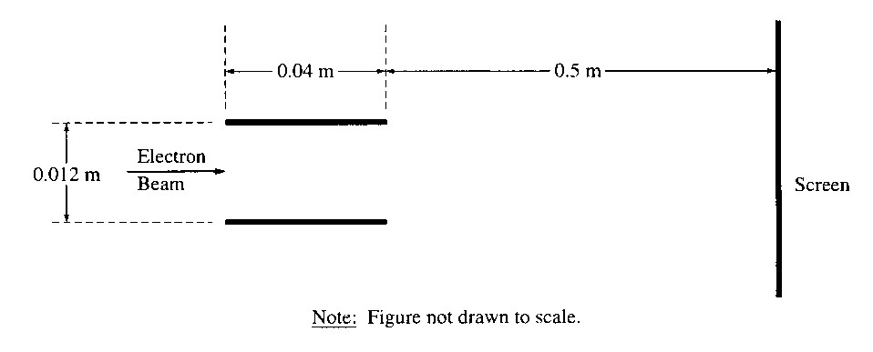
The pair of horizontal plates shown are used to deflect electrons up or down in the television set by placing a potential difference across them. The plates have a length of 0.04 m and separation of 0.012 m, and the right edge of the plates is 0.50 m from the screen. A potential difference of 200 V is applied across the plates, and the electrons are deflected toward the top of the screen. Assume that the electrons enter horizontally midway between the plates with a speed of 6.0 x 107 m/s and that fringing effects at the edges of the plates and gravity are negligible.

    - Which plate in the pair must be at the higher potential (positive) for the electrons to be deflected upward? Justify your answer.
The top plate

    - Considering only an electron's motion as it moves through the space between the plates, compute the time required for the electron to move through the plates.

$$distance=speed Xtime$$
Therefore, $time=\frac{0.04}{6.0×{10}^{7}}=6.667×{10}^{-10}s$

    - What is the force on the electron’s while between the plates?
Work Done in moving the electrons between the plates equals kinetic energy of the electrons
KE=$\frac{1}{2}mv^{2}$
= $\frac{1}{2}×9.1×{10}^{-31}×({6.0×{10}^{7})}^{2}$
=1.63 X 10⁻¹⁵ J
But KE=F x d
Therefore, F=$\frac{1.63×{10}^{-15}}{0.5}$= 2.67x10⁻¹⁵ N
    - What is the vertical displacement of the electron while it is between the plates?

Therefore, d= $\frac{2.67×{10}^{-15}}{200×1.6×{10}^{-19}}=83.4$m

    - Determine the force of gravity on the electron and compare it with the electrical force. Is it being a reasonable assumption to neglect gravity in this question?
Pass

    - Compare the path of the electron between the plates with a Type 1 projectile.
    - What adjustment could be made to increase the overall deflection of the electron?
To increase the deflection, increase the voltage across the plates

    - What adjustment could be made to cause the electron to deflect downwards?
To change the direction of electron deflection, change the terminal polarities of the plates

- A simple Cathode Ray tube is depicted below. Describe the function of each labeled part (i.e. how it affects the electron's motion).

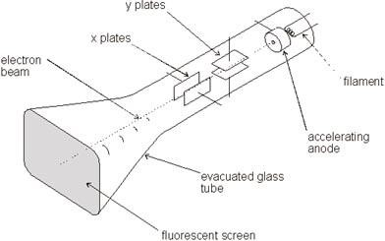
Part: | Function:
filament | Production of electrons through thermionic emission
Accelerating anode (V_{a} applied here) | Direct and accelerate the electrons to the screen through the X and Y plates
Y plates (V_{dy}) | Vertical deflection of electrons on the screen
X Plates (V_{dx}) | Horizontal deflection of electrons on the screen
Fluorescent screen | Detection of electrons as fluorescent images

- For the simple CRT depicted below, describe how each suggested change in Va or Vd would affect the final deflection position of the electron beam.
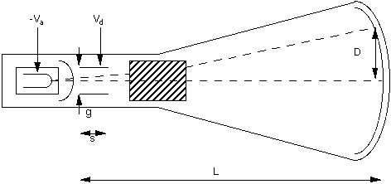
Change in Voltage | Effect on deflection, D
V_{d} is halved | The deflection also halves
V_{a} is tripled | The deflection becomes a third of the original
V_{d} is increased by 1.5x and its polarity is reversed | Deflection increases 1.5times and moves on the opposite side to the original (downwards)
V_{a} is quadrupled, V_{d} is doubled | The deflection becomes half of the original

- In a CRT, the deflection on the screen is 2.4 cm when the accelerating voltage is 480 V and the deflecting voltage is 36 V. What deflection will you see in the screen if the accelerating voltage is 960 V and the deflecting voltage is 18 V?
If an accelerating voltage of 480V causes a deflection of 2.4cm, the 1V will cause a deflection of 2.4/480 = 0.005cm. this implies that the screen voltage of 18V causes a deflection of 0.005cm, then a screen voltage of 1V will cause a deflection of 0.005/36 = 0.00013888cm. hence, a screen voltage of 18V will cause a deflection of 0.000138888 X 18 = 0.0025cm, and the accelerating voltage of 960V will cause a corresponding deflection of 0.0025 X 960 = 2.4 cm

