PHY 1001 Unit III Assignment Electric and Magnetic Fields
Name: __________________________________
1) Electric charges come in two forms: positive and negative. What combinations of charges will?
A) Attract each other? Opposite charges attract each other while like charges repel each other. A positive and a negative charge will attract each other.
B) Repel each other? A positive charge and a positive charge will repel each other; two negative charges will also repel each other.
Sources: ____________________________ College Physics (OpenStax) Edition I, 201

2) What is the unit of electric charge in the MKS system? Coulomb (C)
Sources: ____________________________ College Physics (OpenStax) Edition I, 201

3) What is the smallest unit of free electric charge found in Nature? Are there any objects with smaller charge? If so what are they and what is/are their charges?
Smallest charge is quanta of charge e = 1.6 × 10⁻¹⁹ C. Electron and proton have this value of charge. Electron have -e proton have +e. There are no objects with a smaller charge.
Sources: ____________________________ https://ocw.mit.edu/high-school/physics/exam-prep/electrostatics/charge-coulombs-law/8_02_spring_2007_chap2coulomb_law.pdf

4) Sketch an atom showing the basic constituent parts and the electric charges of those parts.
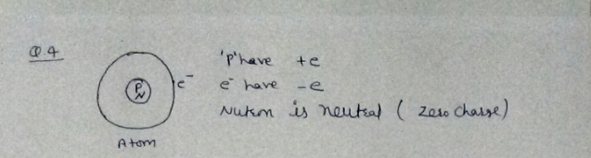
Sources: ____________________________ College Physics (OpenStax) Edition I, 201

5) State Coulomb’s Law. Label the different variables in the equation and give the value of the constant(s) in MKS units.
Coulombs law: The magnitude of electric force between two point charges is directly proportional to the product of the charges and inversely proportional to the square of the distance between them
=k where k is a proportionality constant,
Its units in SI system is N.m/C2 the SI unit of force is Newton (N) The SI unit of charge is Coloumb(C) The SI unit of distance is meter (m)
Sources: ____________________________ College Physics (OpenStax) Edition I, 201

6) how far apart are two electrons that exert a force of 1.0 Newtons on each other? Show work.
Using formula F = k*q1*q2 / r^2
r = Square Root (k*q1*q2 / F).
Force is 1 Newton.
Therefore, it becomes Square Root (k*q1*q2).
K is the Coulomb constant, (8.99 x 10^9 N*m^2/C^2)
The charge on an electron = -1.60 x 10^-19 C
r = Square Root ((8.99 x 10^9 N*m^2/C^2) x (-1.60 x 10^-19 C) x (-1.60 x 10^-19 C))
= 1.5 x 10^-14 m
Sources: ____________________________ College Physics (OpenStax) Edition I, 201

7) Relation between electric force and electric field is given by:
F = q*E
q = point Charge
E = electric field
Therefore, the relationship between electric force and electric field is inversely proportional i.e.: if one increases the other decreases and vice versa
Sources: ____________________________ College Physics (OpenStax) Edition I, 201
8) What is the formula for the magnitude of the electric field due to a point charge?
E = k*q/r^2
q = point charge
r = distance from point charge, where electric field is measured.
K= constant
Sources: ____________________________ College Physics (OpenStax) Edition I, 201
9) Sketch the electric field vectors around a
A) Positive point charge?
B) Negative point charge?
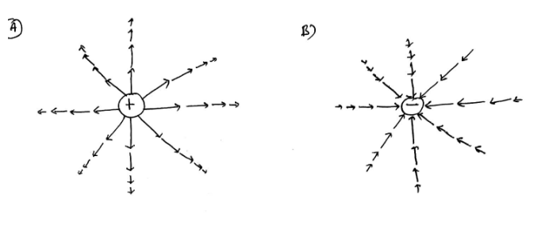Sources: ____________________________ College Physics (OpenStax) Edition I, 201
10) Sketch the electric field lines around a
A) Positive point charge? B) Negative point charge?
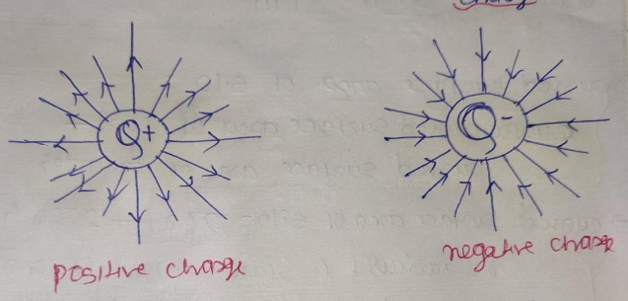
Sources: ____________________________ College Physics (OpenStax) Edition I, 201
11) When examining the electric field lines how can you determine the electric fields
A) Direction? The direction of the field lines is denoted by making arrows on the field lines
B) Magnitude? Magnitude is determined by the density of field lines in a region.
Sources: ____________________________ College Physics (OpenStax) Edition I, 201

12) What is the relationship between electric potential (voltage) and electric potential energy?
What is the equation that relates these two physical quantities?
U=Vq from this equation we can conclude that the relationship between electrical potential and electrical potential energy is directly proportional i.e. when one increases the other decreases and vice versa
What is the MKS unit of electric potential? Joules
Sources: ____________________________ College Physics (OpenStax) Edition I, 201

13) What is the equation that relates electric potential (voltage) to electric field?
$E=-dV/dr$
Where: E=electric field
V=electric potential (Voltage)
Sources: ____________________________ College Physics (OpenStax) Edition I, 201

14) What is the electric potential between two points 5.0 centimeters apart if the electric field between those points is a constant 250 Newtons/meter? Show work.
V=E x L
E=250N/M
L=5cm= 5 x 10^-2m
V=250 x 5 x 10^-2m
V=12.50 V
Sources: ____________________________ College Physics (OpenStax) Edition I, 201
15) What are the equipotential curves (or surfaces) in an electric field? Sketch an example of the electric field lines and the equipotential curves in the same picture. Label the field lines and equipotential curves in your sketch.
Equipotential curves are points that join points with the same potential energy.
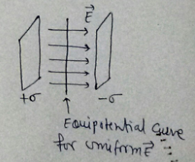
Sources: ____________________________ College Physics (OpenStax) Edition I, 201

16) Under what condition does a charged particle experience a force in a magnetic field?
When a charge is moving and direction of velocity is not parallel or antiparallel to magnetic field.
Sources: ____________________________ College Physics (OpenStax) Edition I, 201

17) What are the units of magnetic field in the MKS system? Tesla
Sources: _________________________________________ College Physics (OpenStax) Edition I, 201

18) Describe how to determine the direction of the magnetic force on a moving charged particle. What is the direction of the magnetic force on a positively charged particle moving to the right if the magnetic field is pointed towards the top of this page?
F=q (v x B)
In the given case, particle moving to the right that is and field is top of the page the force is perpendicular to both the velocity v of the charge q and the magnetic field B. That is force is along z axis.
Using right hand palm rule, point the thumb of the right hand in the direction of B, and a perpendicular to the palm points in the direction of F.
In this case the force is towards you.
Sources: ____________________________ College Physics (OpenStax) Edition I, 201

19) What is the formula that gives the magnitude of the magnetic force on a moving charged particle?
The magnitude of a magnetic force on moving charged particle which will be given by –F=q (v X B)
F = q (v x B)
F = q v B sin Ɵ
Where, Ɵ = angle b/w the velocity & the direction of a field = 90⁰
Then, we get
F = q v B

Sources: ____________________________ College Physics (OpenStax) Edition I, 201

20) What minimum magnetic field is necessary to exert a 15 Newton force on a charge equal to a mole of electrons moving at 25 meters/second through the field? Show work.
96485 Coulomb's = 1 Faraday & 1 Faraday = 1 mole of electrons
1 mole of electrons = 96485 Coulomb's
The minimum magnetic field=B = F / q v
Where, F = force exerted on a charge = 15 N
v = speed of an electron through the field = 25 m/s
Then, we get
B = (15 N) / [(96485 C) (25 m/s)]
B = [(15 N) / (2412125 C.m/s)]
B = 3.61 x 10⁷ T

Sources: ____________________________ College Physics (OpenStax) Edition I, 201

21) Sketch the magnetic field lines around a bar magnet. Label the North and South magnetic poles. If there is a magnetic field inside the bar magnet show those lines as well.
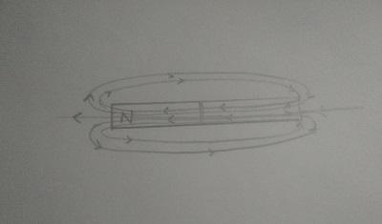
Sources: ____________________________ College Physics (OpenStax) Edition I, 201

22) Electric field lines generated by charges begin at positive charges and end at negative charges. Where do magnetic field lines start and end (include the interior of a magnet if you frame your answer in the context of magnetic materials)?
Answer is framed using a magnetic material. Therefore, image is same as that for question 21
On the outside, these are magnetic field lines which emanate from the north pole of the bar magnet and goes to the south pole of the bar magnet. Inside the magnet, the magnetic field lines go from the South Pole to the North Pole.
N stands for the north pole of the bar magnet,
S stands for the south pole of the bar magnet.
Sources: ____________________________ College Physics (OpenStax) Edition I, 201

