Pre Lab Assignment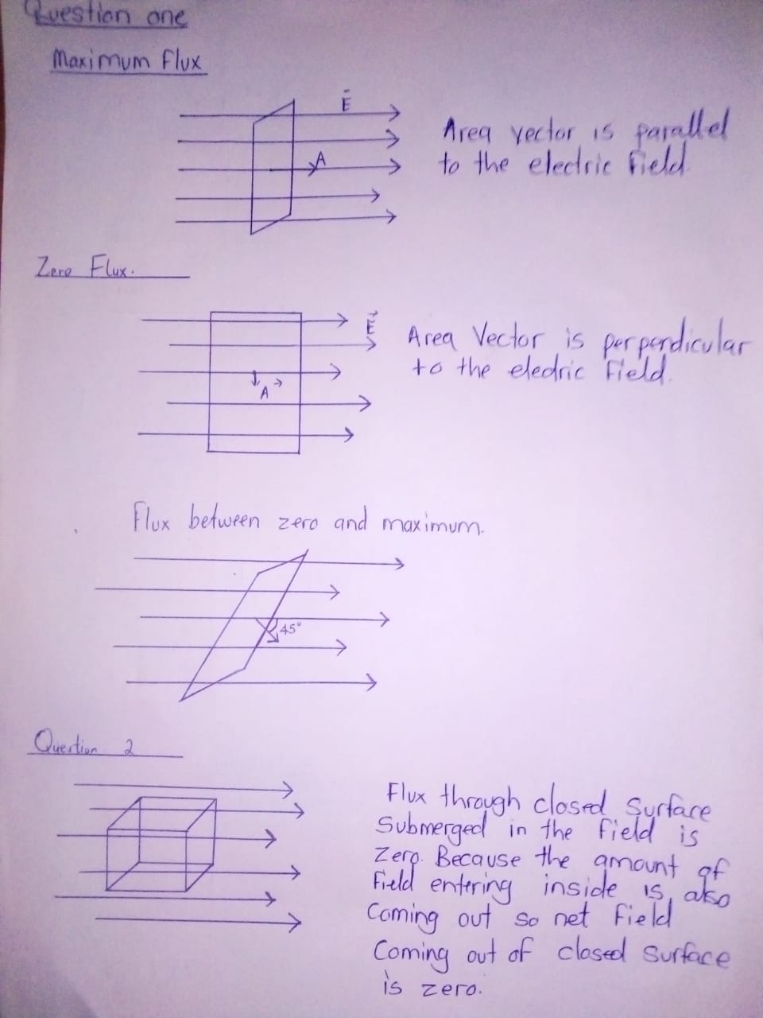
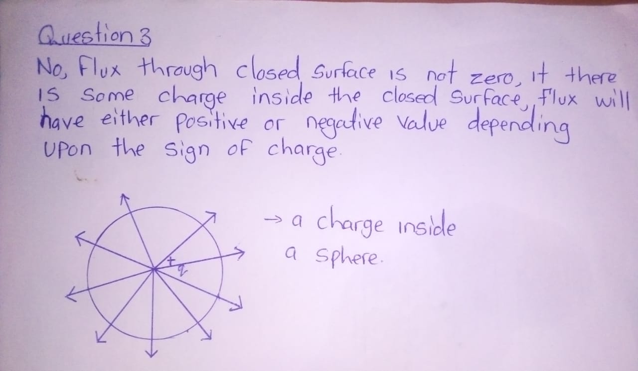

4) All electric fields will not pass through the surface A so Φe = ˜ E~· dA~ = Q E0
Will not pass through A hence flux will be given by: Φe = Φ ˜ E~· dA~ = Q E0
5) Area of square A1=a²
Area of circle A2 =πa² /4
.a =side = diameter
Therefore A2 is less than A1 and so the flux through the square is larger than that through the circle.
6) All the electric field lines passing through the sphere are the same with those passing through the cube; therefore the flux through the sphere is the same as that through the cube.
7) Electric flux is the measure of electric field lines perpendicular to the surface. The number of electric fields through disc 1 is the same as the number of electric fields through the hemisphere therefore flux passing through the disc is the same with the flux passing through the hemisphere.

End of Pre Lab Assignment
8) Assuming the given point charge ''Q'' at the center of an imaginary Gaussian sphere of Radius ''r''.
The Gaussian sphere passes through the point at which the electric field needs to be calculated.
Now, based on Spherical symmetry, the electric field due to the point charge will fall symmetrically and normal to every point on the surface of the Gaussian sphere.
Applying Gauss's Law for the surface:
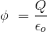
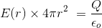
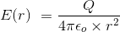
9) Cube won't be a suitable Gaussian surface for calculating electric field due to a point charge. The electric field due to a point charge is spherically symmetric. So choosing a spherically symmetric Gaussian surface would be the best in this particular case.

10) All the shapes other than that of the chocolate could be used as a Gaussian surface. The Gaussian surface should be symmetrical about the charged portion considered
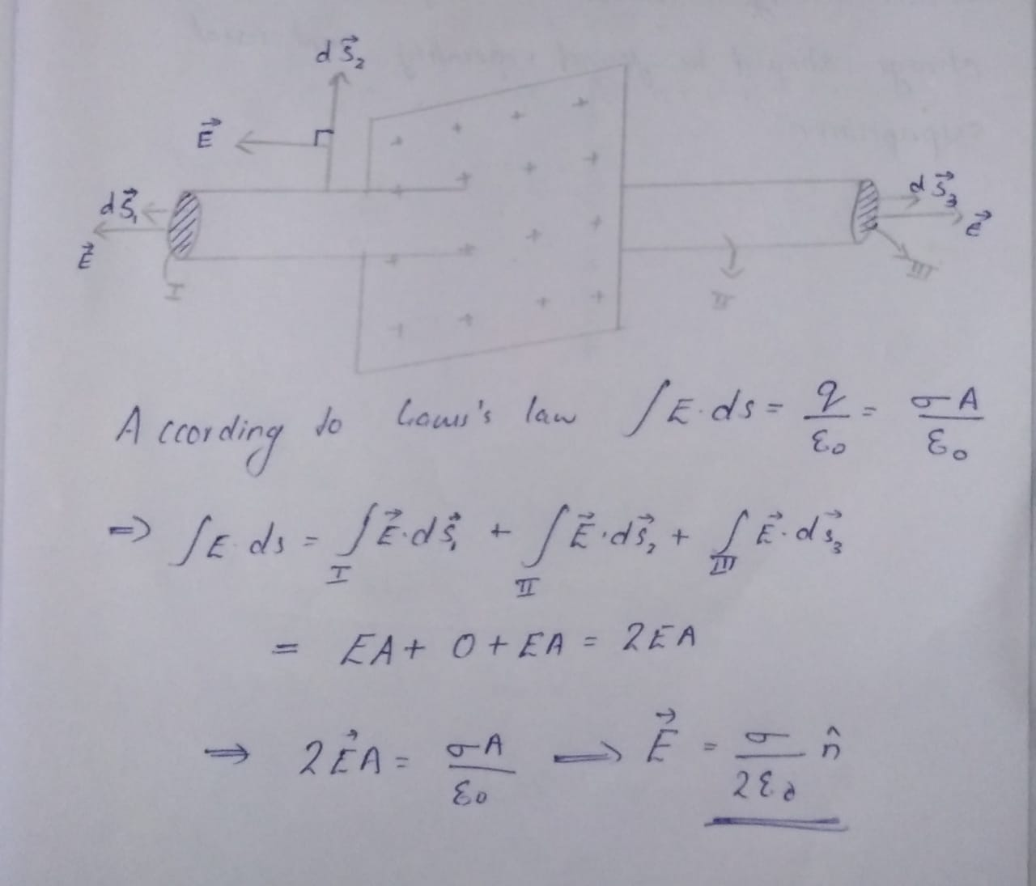
11) Since we use gauss law to calculate electric field when we have symmetry in system. We enclose the charge in a surface which is known as Gaussian surface. And then the electric field at and outside the surface depends on the total charge inside the surface. Since total charge of a dipole is zero. Means flux through the Gaussian surface will be zero. So there is nothing left to solve further. I.e. we can't use gauss law directly to find the electric field of a dipole.
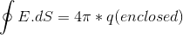
And for dipole q (enclosed) = 0
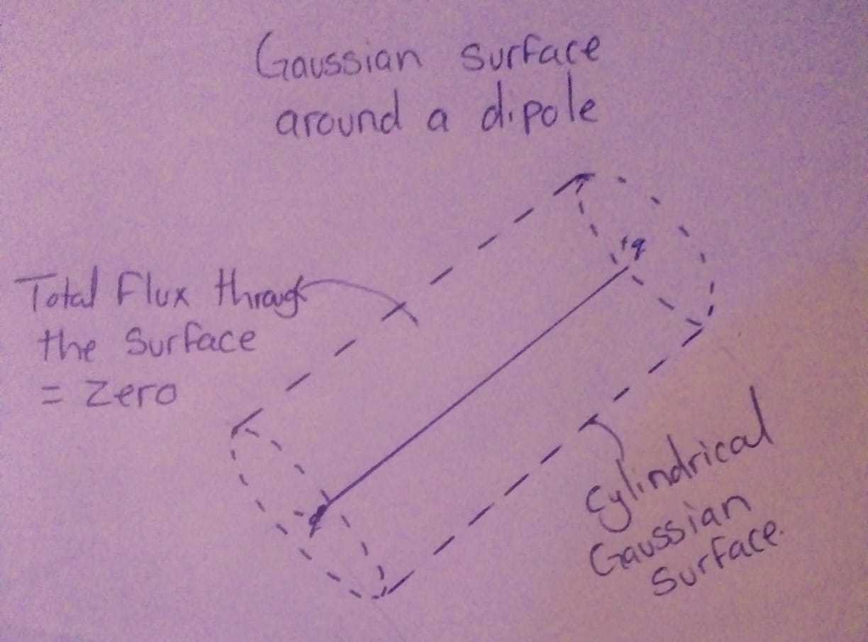
12) a) volume charge density P=Q/V
$P=\frac{Q}{4/3πR^3}$ = $3Q/4πR^3$ = P∝1/R^3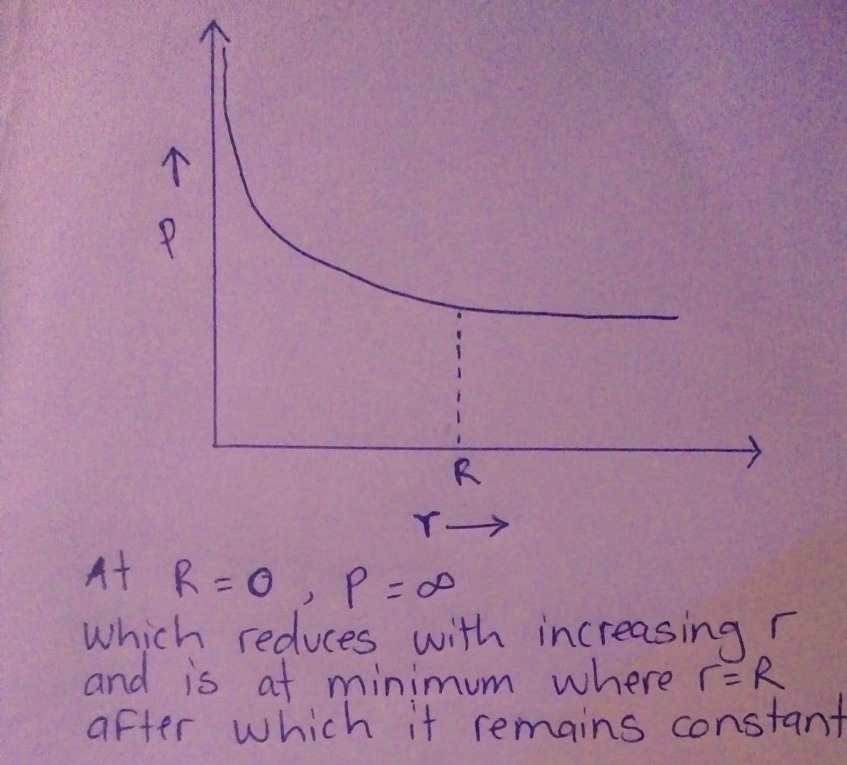
b) At r<R, q = P x $4/3πR^3$
Therefore r³ = Qr³ / R³
c) For r>R, q=Q (Constant)
13) 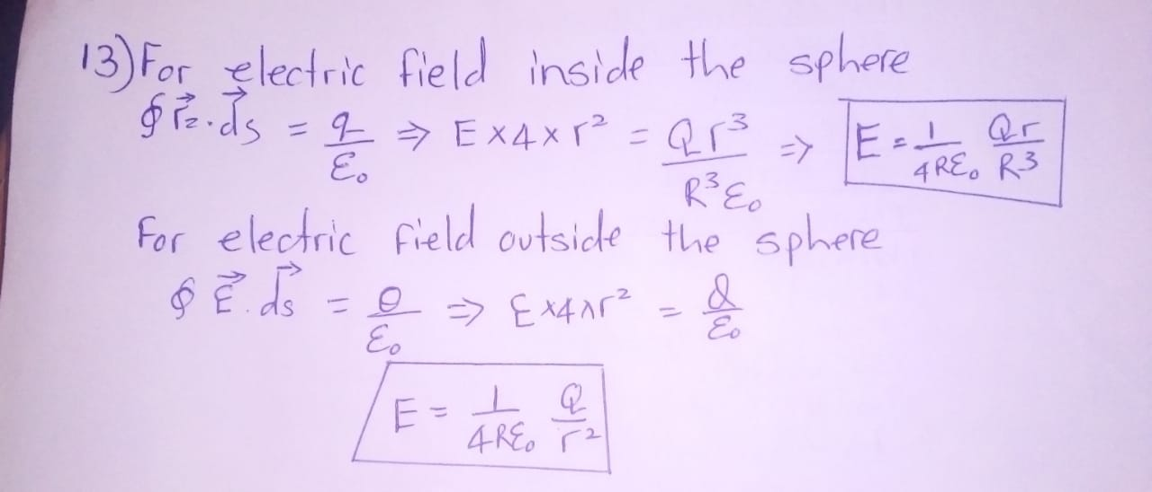
14)
