Partial Least Squares (PLS) in Hospitality and Tourism Research
Special Issue Call for Papers from the Journal of Hospitality and Tourism Technology
Guest editors
Dr. Faizan Ali, Assistant Professor, University of South Florida Sarasota Manatee
Dr. S. Mostafa Rasoolimanesh, Associate Researcher, Universiti Sains Malaysia
Title
Globalization of Workforce: PLS approach to higher-order value construct in a study abroad context

Manuel Rivera, Ph.D.*
University of Central Florida
Rosen College of Hospitality Management
9907 Universal Blvd. Orlando FL 32819
Manuel.Rivera@ucf.edu

Kevin Murphy, Ph.D.
University of Central Florida
Rosen College of Hospitality Management
9907 Universal Blvd. Orlando FL 32819
Kevin.Murphy@ucf.edu

Jalayer Khalilzadeh, M.S.
University of Central Florida
Rosen College of Hospitality Management
9907 Universal Blvd. Orlando FL 32819
Jalayer.Khalilzadeh@ucf.edu

*Corresponding Author

INTRODUCTION
For decades, higher education institutions have adopted experiential learning techniques to enhance their educational programs. In particular, experiential learning opportunities (ELO) (e.g. internships, externships, study abroad) in the hospitality field have been considered a crucial component of hospitality education. This is second only to professional courses with regards to curriculum development (Powers, 1976). The ELO has long been recognized as a well thought out, very important and rewarding “field experience” (Koppel, 1976). Educators in the hospitality and tourism domain regard the experiential learning opportunity as one that allows the learners to be directly involved in the realities of their field of study. This is mainly because experiential learning is a ubiquitous learning opportunity that extends past the creation of knowledge and more towards an interpenetrating experience (Rogers, 1983).
Although experiential learning opportunities have existed for several years, the exactness of their definition underscores their complexities and varieties. As offered by Zopiatis (2004), one of the most thorough definitions that capture the essence of hospitality ELO is that of internships. He defined hospitality internships as a supervised, professional work/learning experience that is paid or unpaid, is within an approved hospitality agency, and is typically supervised by a hospitality professional in conjunction with a faculty member, and for which students can earn academic credit (Zopiatis, 2004, p11). Such conceptualization of hospitality internships is grounded in the experiential learning theory (Kolb et al, 2001), connoting that during the experiential learning process students will learn the specifics of the subject matter and will do so while discovering their own strengths and weaknesses. Students involved in such learning experiences are typically motivated by a desire to fulfill an actualizing tendency that allows them to be in real contact with life problems in order to learn, grow, and master their desire to create. Such holistic experiences allow the learners to combine logic, intuition, intellect, and feelings, and to create meaningful ideas and relevance between their own thoughts and the learned subject matter (Rogers,1983). As a result, knowledge is initiated by a thorough transformation of experience (Kolb et al, 2001).
In the case of hospitality education, although ELO could be embraced during academic courses (King & Zhang, 2017), more explicit attention has been given in the literature to the “outside the classroom activity” that provides value to students (Shortt, 1994, Zopiatis, 2007). Hospitality academia and administrators continue to underline how crucial it is to gain insight into the student experience of the hospitality ELO; yet its popularity and significance have not seized to decrease (Yiu & Law 2012). Several scholars have demanded more attention to further explore alternative ELO models that offer a better understanding of the students’ experiences and overall satisfaction (Beggs et al., 2008; Breakey et al., 2009; Ruhanen et al., 2013). This is mainly due to the need to understand the value of such experiences. Zopiatis and Constanti (2007), for example, highlight that the value of ELO accrues to students, the university, and the hospitality industry. That is, during these experiences, the student benefits from the opportunity, the university can demonstrate the talent of its students, and the industry gets to preview and make prospective choices of potential future employees (Zopiatis & Constanti, 2012). All three stakeholders either give or get something from the internship process. The students especially bear responsibility throughout the internship process. They not only commit their time, money, and efforts, but also have high hopes of a transformational educational experience leading to potential job prospects. Thus, the extent of the students’ sacrifices may be an explanation for the decrease.
A better understanding of the value of the ELO and the strategic benefits from this three- prong relationship deserves further consideration. Thus, the current study departs from traditional literature about the hospitality ELO by assessing the value of an ELO experience under the lens of the service marketing literature. Moreover, the study contends that, as an experiential learning experience, the hospitality ELO can be considered as an “intangible action directed at people’s minds” (Lovelock, 1983). Therefore, in this study we argue that the success of the ELO should be measured from a value perspective that is intrinsic to the student and captures the tradeoff of what is given and what is received. Although the traditional hospitality literature tends to focus on the learning aspects of the ELO, Ng and Forbes (2009) argue that integrating research about educational experiences with the service marketing literature provides a valuable framework within which to harbor considerations of the three-prong relationship. Thus, by applying a marketing framework, its orientation can assist universities in managing their offering while elucidating the uniqueness of the educational experience. More specifically, experiential learning opportunities can benefit from understanding student choices, the value acquired, and student satisfaction with their experience, which then results in a competitive advantage for the institution. When discussing the many benefits accrued from the hospitality ELO Zopiatis & Constanti (2012) review the unique benefits for students, universities, and the host organizations. Indeed, managing a successful hospitality ELO program requires understanding the potential benefits accrued by the student, the educational institution, and the hospitality enterprise (Zopiatis, 2004).
This study conceives the ELO experience as an educational service in which the experience encompasses services that combine tangible and intangible actions that require students to move from the classroom to a practical setting. From this point of view, students enter an ongoing relationship with their school and the ELO setting in which a customized experience is expected to add value to the student and give them a competitive position. For such reasons, the value dimensions of an ELO experience and the satisfaction it could generate are regarded as inherent to each student. This in turn may actually increase students’ satisfaction with their ELO experience. Various scholars have suggested that an educational experience has hedonic components, which within the acquisition of knowledge the students find pleasure, adventure, and emotion (Laukenman et al, 2003; Ng, 2005; Ng & Forbes, 2009; Taylor, 2001).
The main objective of this study, therefore, is to suggest and empirically investigate the students’ experiential learning experience by considering perceived value, satisfaction, and internationalization intentions in the context of the hospitality internship. The study incorporates the concept of perceived value of the ELO experience based on the interrelationships with satisfaction and internationalization intentions for students in a hospitality program from China and Korea. More specifically, the study examines the mediating role of internship satisfaction within the impact of perceived value and internationalization intentions. Understanding the proposed model sheds light onto the direct value created for the student, the indirect value for the academic institution, and the ELO hosting organization by means of internationalization intentions.

LITERATURE REVIEW

Hospitality ELO Experience from Values to Value
The seminal work of Holbrook (1994) is a good starting point from which to understand the concept of value and how it can be applied in the context of the hospitality ELO. Despite the numerous contributions to the hospitality literature regarding experiential learning opportunities (i.e., internships, externships, practicum, study abroad), it is evident that the concept of value and the notion of values are often used interchangeably without clearly differentiating them. In the literature, values have been defined as a preference judgment (Holbrook, 1994), as a consumption valuation (Lai, 1995), or as a reflection of personal values (Huber et al, 2001). Although personal values are seen as a manner of conduct that is generally preferable to an opposite or converse manner of conduct, values are also seen as standard rules, criteria, norms, ideals, or goals (Holbrook, 1999). This is traditionally the case of the hospitality ELO.
Numerous hospitality scholars have explored different values derived from an ELO. For example, hospitality internship programs train students to gain a greater understanding of tasks and practices performed by industry professionals, and to apply learned theories from academic classes to a real world situation (Pauze et al., 1989; Zopiatis, 2007; Dickerson & Kline, 2008; Woo Ko et al, 2007). The students also experience realistic perceptions of problem solving skills that managers value when recruiting hospitality graduates (Lam & Ching, 2007; Raybould & Wilkins, 2005). This provides students with decision-making skills from actual business settings that increase their professional competencies (Marlin-Bennett, 2002). Similarlty, Gryski, Johnson, and O’Toole (1987) recognized the benefits from the socialization, the development of interpersonal skills, awareness to ethical concerns, and a sense of efficacy. During the hospitality ELO, students improve their self-confidence and can determine whether their career choice is compatible with their interests and personality (Herrick, 1987). Others have outlined the benefits of enhanced employment and professional growth opportunities, the ability to network within the industry by creating personal contacts, exposure to management activities, and the development of skills relevant to their particular career choice (Petrillose and Montgomery, 1997; Gabris and Mitchell, 1989; Downey and De Veau, 1988).
The perspective of values is also evident in the use of Tourism Education Futures Initiative to implement a specific set of learning outcomes in undergraduate programs (Sheldon, Fesenmaier, & Tribe, 2009). This view reinforces the position that the values of the hospitality ELO experience have been traditionally measured by considering the skills, competencies, career, and personal development that students obtain based on the desired personal values that are appreciated by the institution (Yiu & Law, 2012). Barber (2011) favors values-based principles (ethics, stewardship, knowledge, professionalism, and mutuality) in hospitality education over a myriad of other experiences (i.e., social life and faculty) that a student may encounter. Therefore, the view of Yiu and Law (2012) might be pondered as distant memories that might not have a lifelong impact on the student’s life. Although understanding the values from ELO is considered important, such experience has also been regarded as a life experience that is important, worthy, or useful in pursuing a hospitality career.
The current study argues that understanding the hospitality ELO experience should consider moving from values to value. The latter fully captures the relative worth, utility, or importance that an experience has on the students’ education. From this perspective, value is equivalent to the overall assessment that an individual makes, founded on perceptions of what is given in exchange for what is received (Zeithaml, 1988). Such representation of value denotes a trade-off between the most desirable components of what is given versus what is received. In a similar note, Woodruff (1997) argued that the consequences of value perceptions also conceive the value desired and received, as well as the connection with the individuals’ goals and objectives.
The characterizations of value can be different in the literature, either in consumption or education, yet similarities emerge that drawing comparisons among benefits and sacrifices assess perceived value. This type of conceptualization of value in an educational context is not new and has been interpreted by various authors as the overall student’s evaluation of the utility of the educational experience based upon the participants’ perceptions between what they are given and what is received (LeBlanc & Nguyen, 1999; Ledden et al., 2007). This rightly applies to an ELO experience in hospitality due to its particular complexion as previously described by Zopiatis (2004). That is, ‘a supervised, professional work/learning experience that is paid or unpaid is within an approved hospitality agency, and is typically supervised by a hospitality professional in conjunction with a faculty member, and for which students can earn academic credit’ (Zopiatis, 2004, p11).
From this point of view, the ELO experience is seen as a critical educational component that breaks away from the traditional education models in which the action or process of educating or being educated is shared by two thespians: the educator and the student. The former imparts knowledge and the latter acquires the knowledge, skills, and the power of reasoning for a profession. When it comes to the hospitality internships there is a casting change and the role of the educator is relinquished to a very astute and experienced actor - the industry practitioner. During the internship experience, the student leaves the comfort of an academic environment and ventures into the real world by taking on real responsibilities - an opportunity that represents the core benefits of the internship experience. In such a case, assessing the educational experiences is only possible by understanding the synergies, responsibilities, and studentship between all the stakeholders involved in the educational experience. This three-prong relationship includes the students, the university, and the industry (Tse, 2010; Yiu & Law, 2012) and is a crucial factor for the success of an internship experience (Zopiatis & Constanti, 2012).
The perceived value of education and the perceived value of an ELO embody many similarities that make it worthwhile to determine what hospitality students get from and give to their experience. Although tripartite benefits of the internship are apparent, the student’s educational experience should come first (Patterson, 1997; Yiu & Law, 2012). Leblanc and Nguyen (1999) posited that, in an education context, the five value concepts (functional, social, emotional, conditional, and epistemic) proposed by Sheth et al. (1991) could be identified.
The first value dimension, functional value, represents the perceived utility of an alternative and is derived from its characteristics. In the context of a hospitality ELO experience, functional value can be related to the students expectations that their field of study will gain them career employment (Bell & Schmidt, 1996; Walo, 2001; Pauze et al., 1989), help them achieve career goals (Jenkins, 2001; Raybould & Wilkins, 2005), assist in earning a better salary (Taylor, 1988), open the door for advancement (Inui et al., 2006), or make them more marketable (Lam & Ching, 2007; McMahon & Quinn, 1995, Petrillose & Montgomery, 1998).
The second value dimension, the social value, represents the benefits from inter-personal/group interactions, which in an educational context can relate to friendships and networking opportunities. Totterdell et al. (1998) underscore the importance of social value as an interpersonal coping resource and it involves access and talking to someone that is supportive and understanding. For example, it provides students an opportunity to “recharge their emotional batteries” when dealing with customers (Grandey, Dickter, & Sin, 2004) or reflect on the service delivery as a coping strategy (Song & Chathoth, 2010). The type of social support can include social resources or social networks that students use when in need of advice, help, assistance, approval, and protection (Wang, Cai, Yang, & Qu, 2015). In addition, the social support received is expected to play an important part in driving satisfaction with the hospitality ELO (Chen, Ku, Shyr, Chen & Chou, 2009).
Thirdly, the emotional value is one that is formed by the benefits received from an affective state or sense of achievement. It relates to the perceived utility acquired from the capacity of experiential opportunities to arouse feelings or affective states (Sheth et al., 1991, p. 161). The authors explain that emotional value is measured based on a profile of feelings or affective state (Stafford, 1994). In the educational context, emotional value is manifested through a student’s sense of gladness and self-achievement in taking a course, or in the student’s like or dislike of a class (Leblanc & Nguyen, 1999; Stafford, 1994).
Fourth, conditional value arises from benefits derived in a specific situational context. According to Unni (2005), the perception of value in an educational setting also encompasses a conditional value. That is, value in education can also be seen in terms of the benefits derived from specific situational contexts, for example, the value perceived by the students in terms of educational support and materials.
Fifth, epistemic value arises from benefits derived from curiosity, novelty in learning, and a desire for knowledge. Epistemic value is often considered a transient dimension and is often omitted as a contributor to perceived value (Sweeny et al., 1999). This is not the case of experiential learning opportunities. That is, they are highly regarded by students as they provide opportunities that offer learning during a short-term period whereupon students gain relevant practical experience related to their field of study (Kiser & Partlow, 1999; Ko, 2008; Wang, Chiang, & Lee, 2014; Wang, Cai, Yang, & Qu, 2015; Zopiatis, 2007). Moreover, the usefulness of ELO is in the opportunity to apply and contextualize all the theoretical concepts from the classroom (Ruhanen, Robinson, & Breakey, 2013). Epistemic value has a place in the hospitality ELO because although student expectations are formed before arriving to college, their perception of value depends on the actual college experience, and therefore is not consistent over a given time frame (Darlaston‐Jones et al., 2003).
The educational value of ELO can be enhanced through academic assignments as well as the onsite or online repertoire of teaching methods and learning situations afforded by instructors. The epistemic value is in reference to benefits arising from the college or hosting institution’s ability to enhance the knowledge, skills, and abilities of students. Thus, the faculty and supervisors are critical in assuring the effectiveness and quality of the teaching and learning experience. The elements regarding the fundamental instruction and administrative services impact the effectiveness and quality of the school.
Lastly, the image of the institution also represents benefits derived from the actual status of the institution in terms of reputation and image projected. The image component represents the students' belief that the image projected by their university and educational program is directly linked to the value of their degree. Various scholars have found that a resemblance exists among these five value perceptions in that they are related to the component of value in terms of image (LeBlanc and Nguyen, 1999; Lapierre, 2000; Nguyen and LeBlanc, 2001). In other words, institutional image represents the benefits derived from their institution reputation, which adds to the above dimensions.

The “Give” Component
In addition to what a student gets from an educational experience, Ledden et al (2007) posit that a “give” component also exists. For example, they argue that the concept of “give” comprises both monetary and non-monetary considerations. These reflect the sacrifices students make in terms of course fees, transportation, time, energy, and effort, to name a few.
Sacrifice is conceptualized as a broader construct that includes non-monetary costs such as time, effort, and risk associated with a particular purchase or service. Examining non-monetary costs is important in the educational context, as students make many sacrifices while completing their studies. The time away from family, loved ones, and friends is a concern that weighs heavily on students’ minds - particularly if they make the decision to go abroad. Moreover, students must weigh what they give, in terms of sacrifice, against the rewards and benefits received from their international experience.

Satisfaction with the hospitality ELO Experience
Lam and Ching (2007) underscore the importance of measuring the degree of internship satisfaction, as it serves as an indicator of the overall experience. In general, the experience at an internship can be seen in terms of job satisfaction, which is defined as an evaluative judgment based on the job performed (Weiss, 2002). According to Dawson, Abbott and Shoemaker (2011), internship satisfaction becomes critical because it helps students understand how their performance, personalities, and backgrounds fit before they commit to a career in the hospitality industry. Chang and Tse (2015) have also found that internship experience is one of the most important factors in explaining students’ overall satisfaction with their educational experiences.
Yiu and Law (2012) conducted a review of the hospitality internship literature and found that previous researchers had not been able to yield consistent findings regarding students’ satisfaction with their internship experience. The lack of consistency in those studies could be attributed to significant discrepancies regarding students’ expectations and actual performance (Cho 2006). The hospitality internship literature implies that the internship experience should be assured to offer a valuable learning experience; however, the link between satisfaction and value is not yet clear. For example, previous studies show mixed results with regards to the students’ overall satisfaction and how it’s influenced by the opportunity to get technical skills (Busby et al. ,1997), develop problem solving abilities (Emenheiser et al. 1997; Walo, 2001), or the ability to get a job. We therefore suggest that in an educational setting, students get to evaluate their experiences based on what students receive versus what students sacrifice.
In the literature, perceived value is considered an antecedent of satisfaction and is defined as: the total assessment of the utility of an experience is formulated on perceptions of what is received and what is given (Zeithaml, 1988). In the context of an internship experience, work values are deemed to precede and influence job satisfaction. For example, Croes and Hara (2014) indicate that although paid internships can have a major contribution to local companies and economies, unpaid internships could also have an effect in individuals’ career opportunities, effect their mobility, and create more inequality in society. Therefore, simultaneously investigating the effect of perceived value and sacrifice as predictors of internship satisfaction provides an opportunity to test if students’ overall satisfaction reflects an experience to be value-laden or if it has value for the sacrifice they bear. Moreover, satisfaction among interns provides a better developmental experience for the student and in turn leads to other important outcomes for the university and sponsoring organization.
The review of the literature provided above recognizes that a gap in the hospitality education literature exists, thus presenting an opportunity to assess the value of an internship experience in hospitality by considering what the students get and what they give. Downey and Deveau (1988) observed that internships should not be designed as a source of free or discounted labor for hospitality businesses. Participants should be remunerated for their externship not only for newly learned skills, but also for financial compensation. This makes the work experience for the students more genuine.

Internationalization Behavior
The demand for managers who are sophisticated and interested in an international business assignment continues to rise (Hauser, 2004; Hauser & Johnson, 2013). More businesses need experienced leaders and managers for managerial assignments in key markets in different countries for a period of time (short- or long-term). Currently, companies are in constant need of qualified personnel to provide key support and understand different policy elements. In the context of hospitality and tourism business, international assignments are typically used to transfer highly or specifically skilled employees to a work location for a temporary time period to accomplish a specific goal. This type of assignment can be short-term, or can extend to longer periods of time depending on the project needs.
Adler (1986) found that students perceived international assignments as offering more job satisfaction, whereas domestic assignments were seen as offering more organizational recognition and a more satisfying personal life. One of the primary reasons university students accept international jobs is because of the cross-cultural experience such jobs provide. Therefore, understanding the impact that an externship experience can have on the intentions to obtain an international assignment is worthy of consideration.
In conclusion, the perceived value of education and the perceived value of an externship experience embody many similarities that make it worthwhile to determine what hospitality students get from and give to the externship experience. After the completion of an international externship experience, the students demonstrate some interest in career opportunities in an international location. In order of importance, that interest is reflected as follows. Wanting an international job at some time in their career received very high ratings and students seem to seriously consider it as an option. Overall, the students show some interest in job positions that include traveling to foreign countries. As for their first job being in a foreign country, this was the lowest rated preference among all students, especially when compared to the previous preferences. Based on their nationality, the E.U. students reveal more interest and serious commitment in pursuing an international career than Asian students. In addition, the E.U. students also give more consideration to the opportunity to work abroad for their first job in comparison to other students. Therefore, gaining insights into students’ perceptions of the internship will help identify what contributes the most to their judgment of the experience. The current study is designed to test three hypotheses. The proposed model for the internship experience is presented in Figure 1.

EMPIRICAL MODEL AND HYPOTHESES

Hypotheses
This study investigates the relationship between students’ study abroad, perceived value, and perceived sacrifice (monetary and non-monetary) with their overall satisfaction and internationalization intentions. The proposed research model is presented in Figure 1. The proposed research hypotheses are:
- Hypothesis 1: Students’ perceived value (get and give components) of the study abroad experience will have a positive impact on the overall satisfaction.
- Hypothesis 2: Students’ perceived value (get and give components) of the study abroad experience will have a positive impact on internationalization intentions.
- Hypothesis 3: Students’ overall satisfaction with the study abroad experience will have a positive impact on the internationalization intentions.
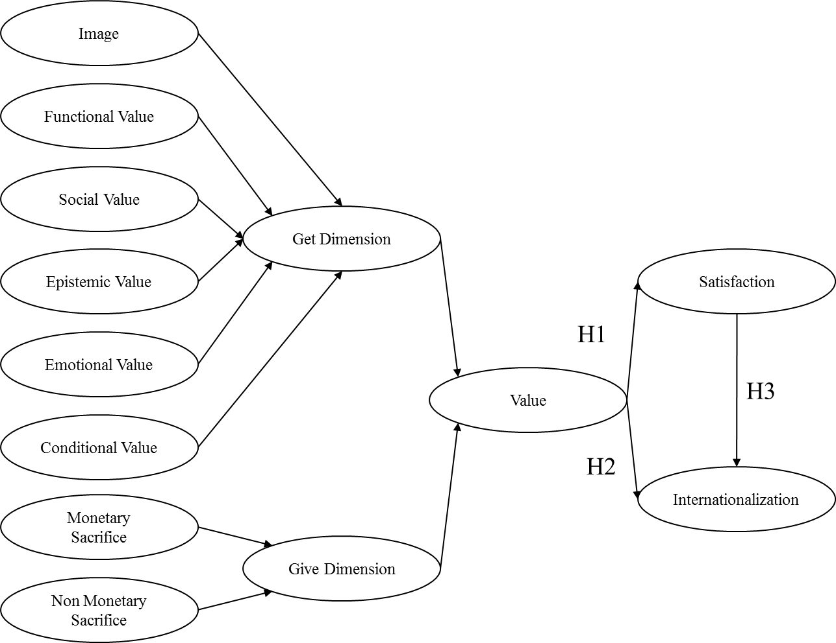
Figure 1 Research Model for Study Abroad Experience
The proposed model is tested using partial least square structural equation modeling (PLS-SEM). The researchers use R software (R Core Team, 2017) with 'plsdepot' (Sanchez, 2012) and ‘plspm’ (Sanchez, Trinchera, & Russolillo, 2015) packages to test the hypotheses. The research model incorporates both reflective and formative measures. This is done to comply with the fundamental propositions of the theory of consumption value. According to Seth, Newman and Gross (1991), the “get” components of value are formative in nature because of their axiomatic propositions. First, the “get” component is a function of multiple values. Second, each value component makes a differential contribution. And third, the value components are independent, thus requiring a formative model rather than reflective. Other constructs such as satisfaction and internationalization intentions are reflective in nature. Therefore, following the recommendations from Hair, Ringle, Hult, & Sarstedt (2016), the model is less restrictive and a normal distribution is not required because a bootstrapping test was used to estimate standard errors.

Reflective Versus Formative Constructs
In reflective measurement theory, the manifest variables/dimensions of a construct are highly correlated with each other because each of them are a reflection of the higher-order construct (Hair, Black, Babin, & Anderson, 2014). From a regression perspective, the higher-order construct is acting as an independent variable that can predict its respective dimensions/manifest variables. Hence, the error terms are on the manifest variables/dimensions instead of the higher-order construct (Diamantopoulos & Siguaw, 2006). High correlations of manifest variables/dimensions make them interchangeable with each other and, as a result, the problematic manifest variables/dimensions can be replaced with the others and still have the same structure that we have theorized (Petter, Straub, & Rai, 2007). Whereas, in formative measurement theory the manifest variables/components of a construct show low correlation with each other because each of them is a standalone aspect of the higher-order construct that together form the construct of interest (Hair et al., 2014).
From a regression perspective, the higher-order construct is acting as a dependent variable that is predicted by its manifest variables/components. Hence, the error term is on the higher-order construct instead of manifest variables/components (Diamantopoulos & Siguaw, 2006). Low correlation of manifest variables/components makes them not interchangeable. Rather, they are different aspects of the higher-order construct and all should be presented in order to have the same structure (Coltman, Devinney, Midgley, & Venaik, 2008; Petter et al., 2007). In case one of the manifest variables/components is dropped due to measurement issues, the higher-order construct should be redefined (Coltman et al., 2008; Hair et al., 2014). Manifest variables in reflective measurement theory are known as items (effect indicators) or scales; whereas, in formative measurement theory they are known as indices or causal indicators (Diamantopoulos & Siguaw, 2006). Figure 2 shows the type and direction of the relationships in reflective and formative measurement theories.
Formally, a reflective construct of η is specified as (For more details see, Diamantopoulos & Siguaw, 2006):
$x_{i}=λ_{i}^{η}+ε_{i}^{}$;
Wherein, η is the latent construct, x₁, x₂, . . ., x_{n} are set of manifest variables, λ_{i} is the effect of η on x_{i}, and ε_{i} is the measurement error of the i^{th} item (i = 1, 2, . . ., n).
Compared to the reflective construct formalization, a formative construct of η is specified as (Diamantopoulos & Siguaw, 2006):
$$η=γ_{1}x_{1}+γ_{2}x_{2}+…+γ_{n}x_{n}+ξ$$
Wherein, η is the latent construct, x₁, x₂, . . ., x_{n} are a set of manifest variables, γ_{i} is the expected effect of x_{i} on η, and ξ is the disturbance term.
It is not always that easy to establish the measurement theory. For example, memorable experiences as defined by Pine and Gilmore (1998), are a combination of four realms: entertainment, education, esthetic, and escapist. Each of these realms can be a reflection of an experience (i.e., experience can be an underlying factor behind these four realms). At the same time, one may argue that these four realms are four independent aspects that together make an experience. However, the current adoption of the Theory of Consumption Values (Sheth et. al, 1999) is approached from a formative measurement theory perspective.
Although reflective measurement theory is predominantly used compared to the formative measurement theory, recently, more scholars are using the formative measurement theory in their studies. Moreover, the selection of formative vs. reflective is dependent on empirical evidence such as independence of the manifest variables. The value of shifting from one measurement theory to the other one within a study, however, should be carefully investigated. The decision of which theory to use should be based on auxiliary theory uses and previous studies. If the selected theory is not supporting the decision to use one measurement over the other one, caution should be taken. That is, if the correct measurement is reflective and the scholar selects a formative measurement, the decision is subject to a type II error. On the other hand, if the correct measurement is formative and the scholar selects a reflective measurement, the decision is subject to a type I error (Diamantopoulos & Siguaw, 2006). Both of the above-mentioned misspecifications are dangerous to an effective research process.
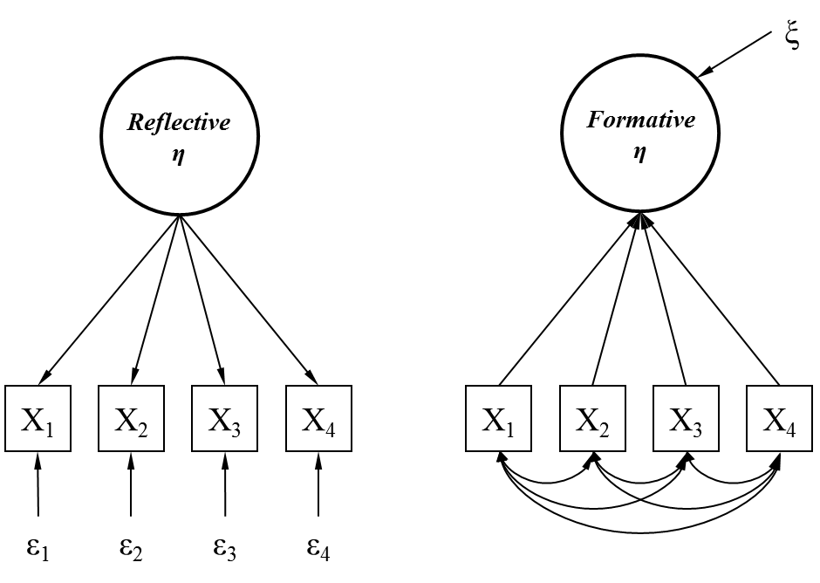
Figure 2 Reflective (left) and Formative (right) Latent Construct Structures (adopted from Petter, Straub, and Rai (2007))

Questionnaire Design
In order to test the proposed hypotheses, the research model presented in Figure 1 was operationalized with the survey instrument as based on previous literature, and gives consideration to eight unique indicators for value and satisfaction. The externship value dimensions were operationalized with 6 unique factors that included: functional value (4 items), social value (3 items), emotional value (4 items), image value (4 items), epistemic value (2 items), and conditional value (2 items) (LeBlanc & Nguyen, 1999; Ledden et al., 2007). The sacrifice dimensions included two distinctive constructs, i.e., monetary sacrifices (3 items) and non-monetary sacrifices (3 items) (Cronin et al., 1997). The externship satisfaction scale was a modified version that was developed by Halstead et al. (1994) and included 4 items that reflect satisfaction with the externship experience. Lastly, internationalization intentions were measured with 4 items. All the constructs used in the study were rated using a 7-point Likert scale, ranging from 1 (Completely Disagree) to 7 (Completely Agree).
In addition, the survey contained questions pertaining to the personal background of the students, such as the location of their externship, the duration of the externship, and certain socio-demographic characteristics, such as gender, age, and type of college degree. After the survey was designed, both industry and academic professionals in the United States and Italy were involved in checking the overall design of the questionnaire, as well as the quality of items used for the purpose of face validity. No issues were found and the researchers proceeded with data collection.

Data Collection
The current study utilized a purposive sampling technique. This technique is considered a non-probability sampling technique that relies on the judgment of the researcher when it comes to selecting the cases (e.g., students) that are to be studied. Contrary to other sampling techniques that can be used under probability sampling, the goal of purposive sampling was not to randomly select students with the intention of making generalizations (i.e., statistical inferences). The main goal was to focus on particular characteristics of the population of interest, that is, students that participate in an externship abroad. Although the sample being studied is not representative of the externship population, this is not considered to be a weakness.
A total of 57 students who had completed an international externship experience were contacted via email and invited to complete an online survey. The online survey gauged the student’s perception of their externship experience, overall satisfaction, internationalization intentions, and demographic information. The online surveys were designed in Qualtrics (qualtrics.com) and the links were administered to students from the China and Korea hospitality programs. A total of 57 students completed the surveys, thus representing a response rate of 38%.

DEMOGRAPHICS

Student Profile: Asia
The students from Asia had an average age of 22.72 years. Three out of four students were females and only 3.5 % indicated they had been married. The vast majority of them were pursuing either a certificate (35.1%) or a baccalaureate degree (31.6%); very few were pursuing an associate degree (8.8%) and one of four students was actually pursuing a graduate degree (24.6%).
Table1 Demographics for students from Asia
Age |  | Gender
Average Age (years) | 22.72 | Male | 24.60%
Standard deviation (SD) | 2.21 | Female | 75.40%
Relationship Status |  | Area Specialization
Single | 96.50% | Hospitality & Tourism | 80.70%
Married | 3.50% | Other | 19.30%
Externship Location |  | Externship Duration
USA | 100.00% | Months | 5.91
Number of Externships |  | Place of Work
First time | 36.80% | Hotel | 26.30%
Two | 31.60% | Restaurant | 26.30%
Three | 19.30% | Theme Parks | 28.10%
Four or more | 12.30% | Other | 19.30%
Academic Standing |  | Degree Program
1st year | 3.50% | Certificate | 35.10%
2nd year | 0.00% | Associate Degree | 8.80%
3rd year | 22.80% | Baccalaureate Degree | 31.60%
4th year | 73.70% | Master’s Degree | 24.60%

The overwhelming majority of the students indicated that their area of specialization was hospitality management (80.7%). The majority of students from Asia worked in hotels (26.3%), restaurants (26.3%), or theme parks (28.1%). More than 90% of the students had an academic standing of at least 3 years. A little over half of the students (56%) were doing their externship for the first time. As for the location of their externship experience, all students did their externship in the United States. The complete profile is presented in Table 1.

Table 2. Measurement statistics of construct scales based on reflective indicators.
Items | Mean | SD | Loading | CR | AVE | Items | Mean | SD | Loading | CR | AVE
IM |  |  |  |  |  | MS
Img1 | 6.07 | 0.83 | 0.86 | 0.872 | 0.797 | Mntry1 | 5.29 | 1.37 | 0.75 | 0.758 | 0.677
Img2 | 5.79 | 1.09 | 0.94 | 0.872 | 0.797 | Mntry2 | 5.14 | 1.37 | 0.88 | 0.758 | 0.677
Img3 | 6.00 | 1.04 | 0.88 | 0.872 | 0.797 | Mntry3 | 5.48 | 1.16 | 0.83 | 0.758 | 0.677
FV |  |  |  |  |  | NMS
Fncl1 | 5.21 | 1.30 | 0.89 | 0.823 | 0.739 | Nomntry1 | 4.45 | 1.53 | 0.68 | 0.655 | 0.585
Fncl2 | 5.48 | 1.18 | 0.87 | 0.823 | 0.739 | Nomntry2 | 5.48 | 1.45 | 0.90 | 0.655 | 0.585
Fncl3 | 5.41 | 1.22 | 0.82 | 0.823 | 0.739 | Nomntry3 | 4.75 | 1.60 | 0.70 | 0.655 | 0.585
SV |  |  |  |  |  | SAT
Scl1 | 6.14 | 0.98 | 0.89 | 0.776 | 0.695 | Sat1 | 6.16 | 0.91 | 0.89 | 0.852 | 0.769
Scl2 | 6.04 | 0.87 | 0.87 | 0.776 | 0.695 | Sat2 | 6.46 | 0.85 | 0.89 | 0.852 | 0.769
Scl3 | 5.89 | 0.95 | 0.74 | 0.776 | 0.695 | Sat3 | 6.27 | 1.17 | 0.85 | 0.852 | 0.769
EPV |  |  |  |  |  | EMV
Epstmc1 | 5.61 | 1.11 | 0.85 | 0.708 | 0.637 | Emtnl1 | 6.25 | 0.86 | 0.85 | 0.799 | 0.625
Epstmc2 | 6.05 | 1.00 | 0.90 | 0.708 | 0.637 | Emtnl2 | 5.93 | 1.22 | 0.81 | 0.799 | 0.625
Epstmc3 | 5.71 | 1.22 | 0.62 | 0.708 | 0.637 | Emtnl3 | 6.18 | 0.83 | 0.82 | 0.799 | 0.625
 |  |  |  |  |  | Emtnl4 | 6.18 | 0.94 | 0.68 | 0.799 | 0.625
INT |  |  |  |  |  | CV
International1 | 6.07 | 1.04 | 0.89 | 0.871 | 0.58 | Cndtnl1 | 5.70 | 0.95 | 0.86 | 0.865 | 0.71
International2 | 5.71 | 1.36 | 0.78 | 0.871 | 0.58 | Cndtnl2 | 5.54 | 1.24 | 0.81 | 0.865 | 0.71
International3 | 5.80 | 1.18 | 0.83 | 0.871 | 0.58 | Cndtnl3 | 5.52 | 1.36 | 0.87 | 0.865 | 0.71
International4 | 5.36 | 1.47 | 0.70 | 0.871 | 0.58 | Cndtnl4 | 5.21 | 1.46 | 0.83 | 0.865 | 0.71
International5 | 4.57 | 1.78 | 0.56 | 0.871 | 0.58
Note: SD: standard deviation; CR: composite reliability; AVE: average variance extracted; IM: Institutional image; FV: functional value; SV: social value; EPV: epistemic value; INT: internationalization; CV: conditional value; MS: monetary sacrifice; NMS: non-monetary sacrifice; SAT: satisfaction; EMV: emotional value

THE EXTERNSHIP VALUE MODEL

Measurement Model
The first step for measuring the proposed model includes presenting the results of the outer model and examining the reliability and validity of the measures utilized in this study. The current study is operationalized by simultaneously considering formative and reflective models. Therefore, assessing the reliability and validity for the formative part of the model is different due to lack of model fit indicators in the PLS estimation. Also, a formative construct unlike the reflective construct is not based on classical test theory. For consistency and meticulousness, we first review the outer model for the reflective constructs and then the inner model for the formative constructs.

Outer Measurement Model (Reflective)
The assessment of a reflective construct encompasses testing the reliability, convergent validity, and discriminant validity of the model (see Hair et al., 2011). All the reliability measures are robust and the composite reliabilities are above .70, except for the non-monetary sacrifice with a .655; however, this is above the .60 cutoff suggested by Fornell and Larcker (1981). In order to evaluate the convergent validity, and following Fornell and Larcker (1981) guidelines, the average variance extracted (AVE) for each construct was also calculated. The results support convergent validity and all constructs AVE’s exceed the threshold of .50 (Table 2).
The discriminant validity was also assessed following Fornell and Larcker (1981) guidelines; the overlap in variance was examined by comparing the AVE of each. Table 3 shows the correlations between constructs, where the diagonal elements are the square root of the AVEs (SQRTAVE). The SQRTAVE of every specific construct is greater than its correlation to all other constructs. This indicates that each construct has more variance with its own indicators than with others, thus demonstrating discriminant validity.
Table 3. Discriminant validity of the constructs e correlations between constructs.
 | Value | Satisfaction | Intentions
Value | 0.000
Satisfaction | 0.703 | 0.878
Intentions | 0.444 | 0.368 | 0.761
Note: The diagonal bold numbers represent square roots of AVEs, The 3rd order construct of Value is formative and hence no square roots of AVE

Inner Measurement Model (Formative)
The formative construct presented in Figure 3 – Give and Get Dimensions – are second-order constructs. The weights of the second-order constructs and their significance were examined (see Table 4) to assess if each first-order construct (Monetary Sacrifice, Non-Monetary Sacrifice, Institutional Image, Functional Value, Social Value, Epistemic Value, Emotional Value, Conditional Value) contributes to form the second-order constructs (Give Dimension and Get Components). All the weights in Table 4 are significant, higher than .10, and consistent with the underlying theoretical background. The only exception is the “give” component, which is not significant.
The last important criterion for assessing validity of the model is to examine multicollinearity. The results in Table 4 show that all tolerance values are more than 0.1.
Table 4. Weights of the first-order constructs on the second-order constructs.
Higher Order Constructs | Lower Order Constructs | Weight | Loading | t-Statistics | Tolerance
Give² | MS¹ | 0.821 | 0.803 | 57*** | 0.999
 | NMS¹ | 0.596 | 0.572 | 43*** | 0.999
Get² | IM¹ | 0.208 | 0.788 | 43*** | 0.468
 | FV¹ | 0.215 | 0.758 | 44*** | 0.529
 | SV¹ | 0.222 | 0.800 | 45*** | 0.476
 | EPV¹ | 0.229 | 0.790 | 49*** | 0.521
 | EMV¹ | 0.216 | 0.736 | 52*** | 0.613
 | CV¹ | 0.212 | 0.736 | 46*** | 0.548
Value³ | Get² | 0.967 | 0.987 | 32*** | 0.985
 | Give² | 0.163 | 0.283 | 0.962 | 0.985
*** Significant at 0.01 level based on 2000 bootstraps; ¹: 1st Order Constructs, ²: 2nd Order Constructs, ³: 3rd Order Construct

Inner Structural Model & Hypotheses Results
Since the model evaluation provides evidence of reliability and validity, the results for the hypotheses can be presented. The inner model coefficients depict the inner model’s quality. The complete results are presented in Figure 3. The first hypothesis tested is: students’ perceived value (get and give components) of the study abroad experience will have a positive impact on the overall satisfaction. The value dimension of the externship experience is significantly associated with the overall satisfaction. The path coefficient is .703 and is significant at the 1% level (Table 5).
Table 5 Coefficients of structural model (Inner Model)
Independent |  | Dependent | Coefficient | t-Statistics
Value | → | Sat | 0.703 | 7.26***
Value | → | Int | 0.366 | 2.13**
Sat | → | Int | 0.111 | 0.645
*** Significant at the 0.01 level, ** 0.05, * 0.1, based on 2000 bootstrap

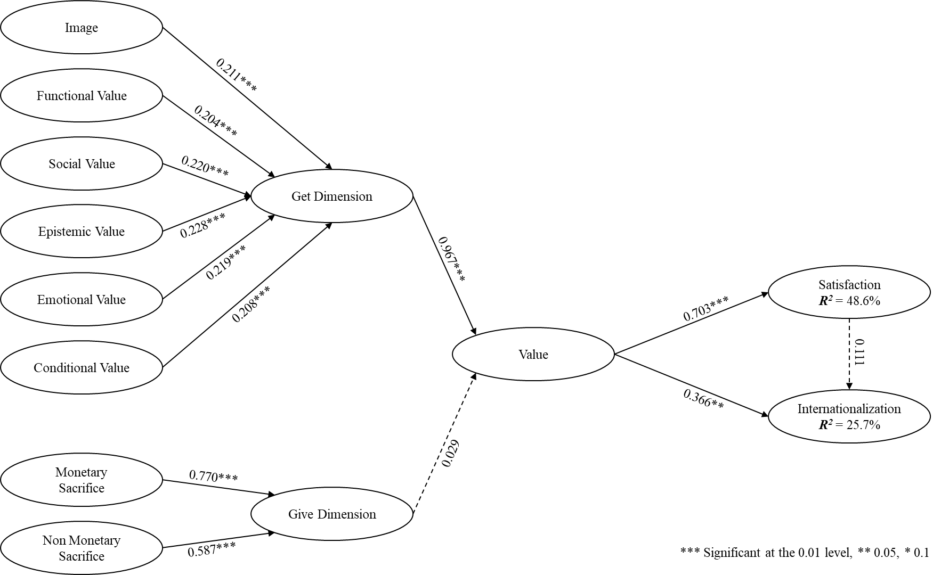
Figure 3 PLS Model Results
The second hypothesis proposed is: the students’ perceived value (get and give components) of the study abroad experience will have a positive impact on internationalization intentions. This hypothesis is also supported, whereupon the path coefficient is .366 and is significant at the 5% level. The results from hypotheses 1 and 2 indicate that the values that students get and give are a suitable and significant predictor of satisfaction and internationalization.
The third hypothesis tested the relationship between the satisfaction and internationalization intentions. Student’s overall satisfaction with the externship will have a positive impact on the internationalization intentions. The results indicate that the coefficient is not significant and the sign is positive (β=0.111, p<.05). All the hypotheses results are presented in Table 6.

Table 6 Hypotheses Results
Research Hypothesis | Results
Hypothesis 1: Students’ perceived value (get and give components) of the study abroad experience will have a positive impact on the overall satisfaction. | Supported
Hypothesis 2: Students’ perceived value (get and give components) of the study abroad experience will have a positive impact on internationalization intentions. | Supported
Hypothesis 3: Students’ overall satisfaction with the externship will have a positive impact on the internationalization intentions. | Rejected

DISCUSSION AND CONCLUSION
This study sheds light on hospitality students’ perceived value, satisfaction, and internationalization intentions when they complete a study abroad internship program. Fifty-seven students completed the surveys from China and Korea. The results of the hypotheses testing indicate that the value students get and give is a suitable and significant predictor of satisfaction and internationalization. However, students’ satisfaction with their study abroad internship does not predict future internationalization intentions.
The value of an externship experience, especially the get and give components, have a significant effect on the students’ internationalization intentions. At the same time, the same dimensions have an effect on overall satisfaction. Interestingly, satisfaction does not influence internationalization intentions. That is, the main effect of the “get” component. This is important because satisfaction is an emotional response that is associated with happiness with the purchase and the consumption experience. In other words, the transitory nature of satisfaction is impacted.
The results of the study demonstrate that the functional value is the lead dimension of study abroad’s value. The students’ responses indicate that the most important functional aspect of the study abroad is that students consider it a good investment in their educational future. Students also perceive that such experience will help their personal development and ability to carry out work, either in their current or future job. This suggests that the study abroad, which students take very seriously, provides a chance for self-awareness. This experience seems to give them more self-assurance by fulfilling a desire and goal that offers a chance to test the industry waters for a proper career fit, or to participate in the industry realities and skill requirements via an international experiential learning experience.
The findings from this study also suggest that the value of the externship experience is also influenced by the image value. Overall, students perceive that the externship experience adds value to their degree, regardless of nationality. In other words, an international experience together with the overall image of the program is considered very important.
In this study, we followed the logic of Seth, Newman and Gross (1991) in measuring the value construct. According to them, value is a third-order multidimensional construct composed of two components - give and get. Give is a second-order formative construct composed of two components of monetary and non-monetary sacrifices. Get is also a second-order formative construct composed of image, functional, social, epistemic, emotional, and conditional values components. All the first-order constructs (i.e., monetary and non-monetary sacrifices, image, functional, social, epistemic, emotional, and conditional values), however, are reflective in nature. As our results show, all first-order constructs met the criteria of classic measurement theory. Reliability, convergent, and discriminant validities, absolute, incremental, and comparative model fits were all within an acceptable range. Since the second-order level is formative, most of the principles of classic measurement theory are not applicable to this level.
According to Freeze and Raschke (2007), the validity of the formative construct can be investigated by checking the strength and significance of the path between construct and its respective indicators. Our results indicate that, in spite of all paths being significant, the coefficients on the give component are stronger compared to the coefficients on the get component. In addition, all the components of the get component are significantly correlated with each other. The highest correlation, however, was between image and conditional value (0.64) and there was no multicollinearity among the get components. The impact of the give component on value was insignificant and weak, which changes the nature of the construct. This issue raises an important question about the formative nature of the value construct as a third- order construct.

From a conceptual point of view, although we followed the literature of formative value measurement theory, it seems that the value is not composed of give and get values in the case of study abroad experience. Rather, it can manifest in forms of give and get values (reflective). From a technical point of view, however, give and get values do not correlate and share enough variance to be treated as reflective measures. In a matter such as this, one modification can be to eliminate the higher-order construct while keeping the components and investigating them separately (Petter et al., 2007), also known as construct decomposition. Our results reveal that the solution of measuring value as a third-order construct is not as stable as measuring it as a separate second-order components (give and get).

FUTURE RESEARCH
The results from this study should not be generalized. The geographic locations and nature of the externship for the students that were surveyed was limited to China and Korea. Possible future studies could consider the effect that the externship value has on students’ overall satisfaction with the manner in which their collegiate education has prepared them for externships, and whether the positive or negative contributions of that preparation would subsequently increase or decrease student loyalty to the collegiate institution.

REFERENCES
Adler, N. J. (1986). Do MBAs want international careers?. International Journal of Intercultural Relations, 10(3), 277-300.
Barber, E. (2011). Case study: Integrating TEFI (Tourism Education Futures Initiative) core values into the undergraduate curriculum. Journal of Teaching in Travel & Tourism, 11(1), 38-75.
Beggs, B., Ross, C. M., & Goodwin, B. (2008). A comparison of student and practitioner perspectives of the travel and tourism internship. Journal of Hospitality, Leisure, Sports and Tourism Education (Pre-2012), 7(1), 31.
Bell, B., & Schmidt, C. (1996). Field practicums: What influence on graduate careers. Practical experiences in professional education: Research monograph, 123-134.
Breakey, N. M., Robinson, R. N., & Beesley, L. G. (2009). Students go a “Waltzing Matilda”—A regional tourism knowledge exchange through innovative internships. Journal of Teaching in Travel & Tourism, 8(2-3), 223-240.
Busby, G., Brunt, P., & Baber, S. (1997). Tourism sandwich placements: an appraisal. Tourism Management, 18(2), 105-110.
Chang, S., & Tse, E. C. Y. (2015). Understanding the initial career decisions of hospitality graduates in Hong Kong: Quantitative and qualitative evidence. Journal of Hospitality & Tourism Research, 39(1), 57-74.
Chen, F. C., Ku, E., Shyr, Y. H., Chen, F. H., & Chou, S. S. (2009). Job demand, emotional awareness, and job satisfaction in internships: The moderating effect of social support. Social Behavior and Personality: an international journal, 37(10), 1429-1440.
Cho, M. (2006). Student perspectives on the quality of hotel management internships. Journal of Teaching in Travel & Tourism, 6(1), 61-76.
Coltman, T., Devinney, T. M., Midgley, D. F., & Venaik, S. (2008). Formative versus reflective measurement models: Two applications of formative measurement. Journal of Business Research, 61(12), 1250-1262.
Croes, R. R., & Hara, T. (2014). Annual Impact of Paid Internship Programs at a Hospitality Management Program–a Case of the largest hospitality management program in North America.
Cronin, J. J., Brady, M. K., Brand, R. R., Hightower Jr, R., & Shemwell, D. J. (1997). A cross-sectional test of the effect and conceptualization of service value. Journal of services Marketing, 11(6), 375-391.
Darlaston-Jones, D., Pike, L., Cohen, L., Young, A., Haunold, S., & Drew, N. (2003). Are they being served? Student expectations of higher education.
Dawson, M., Abbott, J., & Shoemaker, S. (2011). The hospitality culture scale: A measure organizational culture and personal attributes. International Journal of Hospitality Management, 30(2), 290-300.
Diamantopoulos, A., & Siguaw, J. A. (2006). Formative versus reflective indicators in organizational measure development: A comparison and empirical illustration. British Journal of Management, 17(4), 263-282.
Dickerson, J. P., & Kline, S. F. (2008). The early career impact of the co-op commitment in hospitality curricula. Journal of Teaching in Travel & Tourism, 8(1), 3-22.
Downey, J. F., & De Veau, L. T. (1988). Hospitality Internships An Industry View. Cornell Hotel and Restaurant Administration Quarterly, 29(3), 18-20.
Emenheiser, D. A., Clayton, H. R., & Tas, R. F. (1997). Students’ perceptions of the effectiveness of hospitality industry internship experience. In Proceedings of the 1997 Annual CHRIE Conference, USA. p221-222.
Fornell, C., & Larcker, D. F. (1981). Structural equation models with unobservable variables and measurement error: Algebra and statistics. Journal of marketing research, 382-388.
Freeze, R. D., & Raschke, R. L. (2007). An Assessment of Formative and Reflective Constructs in IS Research. In ECIS (pp. 1481-1492).
Gabris, G. T., & Mitchell, K. (1989). Exploring the relationships between intern job performance, quality of education experience, and career placement. Public Administration Quarterly, 484-504.
Grandey, A. A., Dickter, D. N., & Sin, H. P. (2004). The customer is not always right: Customer aggression and emotion regulation of service employees. Journal of Organizational Behavior, 25(3), 397-418.
Gryski, G. S., Johnson, G. W., & O'Toole, L. J. (1987). Undergraduate internships: An empirical review. Public Administration Quarterly, 150-170.
Hair, J. F., Black, W. C., Babin, B. J., & Anderson, R. E. (2014). Multivariate Data Analysis.
Hair Jr, J. F., Hult, G. T. M., Ringle, C., & Sarstedt, M. (2016). A primer on partial least squares structural equation modeling (PLS-SEM). Sage Publications.
Halstead, D., Hartman, D., & Schmidt, S. L. (1994). Multisource effects on the satisfaction formation process. Journal of the Academy of marketing science, 22(2), 114-129.
Hauser, J. A. (2004). 10 “Next practices” in developing expatriate programs. Workspan. In Hein, S. (Ed.), Internationaler Einsatz von Führungskräften (pp. 28-33). Wiesbaden: Gabler (1999).
Hauser, J. & L. Johnson (2013). The changing world of international assignments, London, UK, Crown World Mobility.
Herrick, M. A. (1987). The Effects of Internship Experience and Participant Modeling on the Skill Development and Psychological Adjustment of Rehabilitation Education Interns (Doctoral dissertation, Pennsylvania State University).
Holbrook, M. B. (1994). The nature of customer value: an axiology of services in the consumption
Holbrook, M. B. (Ed.). (1999). Consumer value: a framework for analysis and research. Psychology Press.
Huber, F., Herrmann, A., & Morgan, R. E. (2001). Gaining competitive advantage through customer value oriented management. Journal of consumer marketing, 18(1), 41-53.
Jenkins, A.K. (2001). Making a career of it? Hospitality students’ future perspectives: an Anglo-Dutch study. International Journal of Contemporary Hospitality Management, 13(1), 13-20.
King, B., & Zhang, H. Q. (2017). 14 Experiential tourism and hospitality learning: principles and practice. Handbook of Teaching and Learning in Tourism, 207.
Kiser, J. W., & Partlow, C. G. (1999). Experiential learning in hospitality education: An exploratory study. Journal of Hospitality & Tourism Education, 11(2-3), 70-74.
Ko, W. H. (2008). Training, satisfaction with internship programs, and confidence about future careers among hospitality students: A case study of universities in Taiwan. Journal of Teaching in Travel & Tourism, 7(4), 1-15.
Kolb, D. A., Boyatzis, R. E., & Mainemelis, C. (2001). Experiential learning theory: Previous research and new directions. Perspectives on thinking, learning, and cognitive styles, 1(8), 227-247.
Koppel, J. N. (1976). The field experience in hospitality education. Journal of Hospitality Education, 1(1), 6-19.
Lai, A. W. (1995). Consumer values, product benefits and customer value: a consumption behavior approach. ACR North American Advances.
Lam, T., & Ching, L. (2007). An exploratory study of an internship program: The case of Hong Kong students. International Journal of Hospitality Management, 26(2), 336-351.
Lapierre, J. (2000). Customer-perceived value in industrial contexts. Journal of business & industrial marketing, 15(2/3), 122-145.
Laukenmann, M., Bleicher, M., Fuß, S., Gläser-Zikuda, M., Mayring, P., & von Rhöneck, C. (2003). An investigation of the influence of emotional factors on learning in physics instruction. International Journal of Science Education, 25(4), 489-507.
LeBlanc, G., & Nguyen, N. (1999). Listening to the customer’s voice: examining perceived service value among business college students. International Journal of Educational Management, 13(4), 187-198.
Ledden, L., Kalafatis, S. P., & Samouel, P. (2007). The relationship between personal values and perceived value of education. Journal of Business Research, 60(9), 965-974.
Lovelock, C. H. (1983). Classifying services to gain strategic marketing insights. The Journal of Marketing, 9-20.
Marlin–Bennett, R. (2002). Linking experiential and classroom education: Lessons learned from the American university–Amnesty international USA summer institute on human rights. International Studies Perspectives, 3(4), 384-395.
McMahon, U., & Quinn, U. (1995). Maximizing the hospitality management student work placement experience: a case study. Education+ Training, 37(4), 13-17.
Ng, I. C. L. (2005). Photoessays in the teaching of marketing. Discussion paper, Department of Management, University of Exeter, Exeter, UK.
Ng, I. C., & Forbes, J. (2009). Education as service: The understanding of university experience through the service logic. Journal of Marketing for Higher Education, 19(1), 38-64.
Nguyen, N., & LeBlanc, G. (2001). Image and reputation of higher education institutions in students’ retention decisions. International Journal of Educational Management, 15(6), 303-311.
Patterson, V. (1997). The employers' guide: Successful intern/co-op programs. Journal of Career Planning & Employment, 57(2).
Pauzé, E. F., Johnson, W. A., & Miller, J. L. (1989). Internship strategy for hospitality management programs. Hospitality Education and Research Journal, 13(3), 301-307.
Petter, S., Straub, D., & Rai, A. (2007). Specifying formative constructs in information systems research. MIS quarterly, 623-656.
Petrillose, M. J., & Montgomery, R. (1997). An exploratory study of internship practices in hospitality education and industry's perception of the importance of internships in hospitality curriculum. Journal of Hospitality & Tourism Education, 9(4), 46-51.
Pine, B. J., & Gilmore, J. H. (1998). Welcome to the experience economy. Harvard business review, 76, 97-105.
Powers, T. F. (1976). Food service in 1985. Cornell Hotel and Restaurant Administration Quarterly, 17(1), 40-54.
Raybould, M., & Wilkins, H. (2005). Over qualified and under experienced: Turning graduates into hospitality managers. International journal of contemporary hospitality management, 17(3), 203-216.
Rogers, C. R. (1983). Freedom to learn for the 80s (Columbus, OH, Charles Merrill).
Ruhanen, L., Robinson, R., & Breakey, N. (2013). A tourism immersion internship: Student expectations, experiences and satisfaction. Journal of Hospitality, Leisure, Sport & Tourism Education, 13, 60-69.
Sanchez, G. (2012). plsdepot: Partial least squares (PLS) data analysis methods. R package version 0.1. 17.
Sánchez, G., & Trinchera, L. Russolillo G. plspm: Tools for Partial Least Squares Path Modeling (PLS-PM). R package version 0.4. 7. 2015.
Sheldon, P., Fesenmaier, D. R., & Tribe, J. (2013). The tourism education futures initiative. The Routledge Handbook of Tourism and Hospitality Education, 155.
Sheth, J. N., Newman, B. I., & Gross, B. L. (1991). Why we buy what we buy: A theory of consumption values. Journal of business research, 22(2), 159-170.
Shortt, G. (1994). Education and training for the Indonesian tourism industry. Hospitality & Tourism Educator, 6(2), 79-79.
Song, Z., & Chathoth, P. K. (2010). An interactional approach to organizations’ success in socializing their intern newcomers: The role of general self-efficacy and organizational socialization inventory. Journal of Hospitality & Tourism Research, 34(3), 364-387.
Stafford, T. F. (1994). Consumption values and the choice of marketing electives: Treating students like customers. Journal of Marketing Education, 16(2), 26-33.
Sweeney, J. C., Soutar, G. N., & Johnson, L. W. (1999). The role of perceived risk in the quality-value relationship: a study in a retail environment. Journal of retailing, 75(1), 77-105.
Taylor, M. S. (1988). Effects of college internships on individual participants. Journal of Applied Psychology, 73(3), 393.
Team, R. C. (2017). R: A language and environment for statistical computing [Internet]. Vienna, Austria; 2014.
Totterdell, P., Kellett, S., Teuchmann, K., & Briner, R. B. (1998). Evidence of mood linkage in work groups. Journal of Personality and Social Psychology, 74(6), 1504.
Tse, T. S. (2010). What do hospitality students find important about internships? Journal of Teaching in Travel & Tourism, 10(3), 251-264.
Unni, R. M. (2005). Value perceptions and retention of textbooks among marketing and other business majors. Marketing Education Review, 15(2), 71-79.
Wang, Y. C., Cai, R., Yang, C. E., & Qu, H. (2015). Coping strategy in hospitality internships: A mixed method approach. Journal of Hospitality & Tourism Education, 27(1), 10-19.
Wang, Y. F., Chiang, M. H., & Lee, Y. J. (2014). The relationships amongst the intern anxiety, internship outcomes, and career commitment of hospitality college students. Journal of Hospitality, Leisure, Sport & Tourism Education, 15, 86-93.
Walo, M. (2001). Assessing the contribution of internship in developing Australian tourism and hospitality students’ management competencies. Asia-Pacific Journal of Cooperative Education, 2(1), 12-28.
Weiss, H. M. (2002). Deconstructing job satisfaction: Separating evaluations, beliefs and affective experiences. Human Resource Management Review, 12(2), 173-194.
Woodruff, R. B. (1997). Customer value: the next source for competitive advantage. Journal Of The Academy Of Marketing Science, 25(2), 139-153.
Woo Ko, D., Gil Chun, B., & Murdy, J. J. (2007). The effect of internship on hotel employees in Korea. International Journal of Tourism Sciences, 7(1), 29-42.
Zeithaml, V. A. (1988). Consumer perceptions of price, quality, and value: a means-end model and synthesis of evidence. The Journal of marketing, 2-22.
Zopiatis, A. (2004). An exploratory research investigating the status and future of hospitality internships in Cyprus. unpublished doctorate dissertation (D. Prof), Middlesex University, London.
Zopiatis, A. (2007). Hospitality internships in Cyprus: a genuine academic experience or a continuing frustration? International Journal of Contemporary Hospitality Management, 19(1), 65-77.
Zopiatis, A., & Constanti, P. (2007). “And never the twain shall meet” Investigating the hospitality industry-education relationship in Cyprus. Education+ training, 49(5), 391-407.
Zopiatis, A., & Constanti, P. (2012). Extraversion, openness and conscientiousness: The route to transformational leadership in the hotel industry. Leadership & Organization Development Journal, 33(1), 86-104.
Yiu, M., & Law, R. (2012). A review of hospitality internship: Different perspectives of students, employers, and educators. Journal of teaching in Travel & Tourism, 12(4), 377-402.

