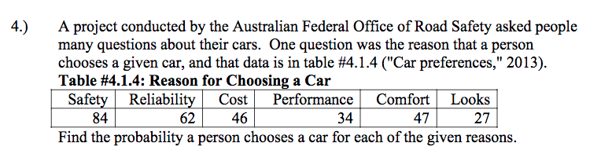

The total reasons for choosing a car is given by
84+62+46+34+47+27 =300
Probabilities for each reason are given by;
Safety =84/300 =0.207
Reliability =62/300 =0.207
Cost =46/300 =0.153
Performance =34/300 = 0.1133
Comfort =47/300 =0.157
Looks = 27/300 = 0.09

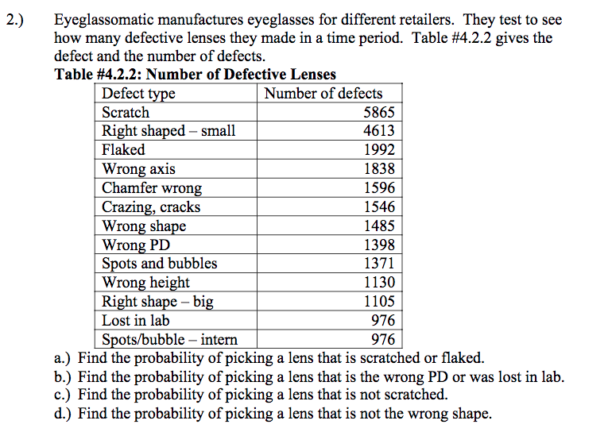
The total number of defects = 5865+4613+1992+1838+1596+1546+1485+1398+1371+1130+1105+976+976 =25891

- Find the probability of picking a lens that is scratched or flaked.
P(scratched) +P(flaked)
5865/25891 +1992/25891 =0.3034
- Find the probability of picking a lens that is the wrong PD or was lost in lab.
1398/25891 +976/25891 = 0.0917
- Find the probability of picking a lens that is not scratched.
1-P(scratched) =1-0.2265 =0.7735

- Find the probability of picking a lens that is not the wrong shape.
1-P (wrong shape) =1-1485/25891
=0.9426

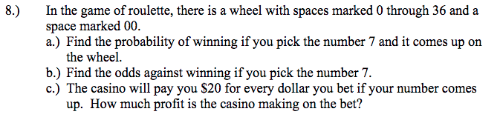
(a)The possible outcomes are 38
the probability of picking number 7 is given by
1/38 =0.0263
(b) odds against =P(event will not happen) divided by P(event will happen)
1-0.0263/0.0263 =37.02 which is approximately 37
The odds against winning are 37
(c) There are 38 slots on the wheel which requires $38. $20 is given to the winner. Therefore the casino will make a profit of 38-20 =18
$18 in profit

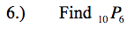
10 permutation 6
$\frac{10!}{\left(10-6\right)!}$ = 151200

n =20 and r =7

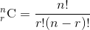
$\frac{20!}{7!\left(20-7\right)!}$ = 77520
This is simply 20 combination 7

2.) Suppose you have an experiment where you flip a coin three times. You then count the number of heads.
a.) State the random variable.
Random variable X = number of heads
Let, H=> heads, T => tails

b.) Write the probability distribution for the number of heads.
TTT, TTH, THT, THH, HTT, HTH, HHT, HHH
Number of heads | 0 | 1 | 2 | 3
Probability | 1/8 | 3/8 | 3/8 | 1/8

c.) Draw a histogram for the number of heads.
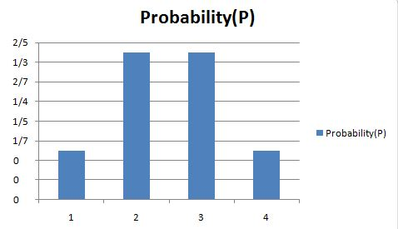
d)Find the mean number of heads.
Mean = E(X)= 0*1/8 + 1*3/8 + 2*3/8 + 3*1/8
= 1.5

- Find the variance for the number of heads.
E(X²) = 0*1/8 + 1²*3/8 + 2²*3/8 + 3²*1/8 = 3
Variance = E(X²) - (E(X))²
= 3 - (1.5)²
= 0.75

- Find the standard deviation for the number of heads.
standard deviation = sqrt(variance) = sqrt (0.75) = 0.866

- Find the probability of having two or more number of heads.
P (2 or more heads) = 3/8 + 1/8 = 0.5
- Is it unusual for to flip two heads?
P (two heads) = 3/8 = 0.375
It is likely that out of 8 times of 3 flips, 3 times we can observe two heads out of three

7. An LG Dishwasher, which costs $800. has a 20% chance of needing to be replaced in the first 2 years of purchase. A two-year extended warrantee costs Sit2A0 on a dishwasher. What is the expected value of the extended warranty assuming it is replaced in the first 2 years?
There is 20% chance of replacement, then value of warranty = 20% * $800 - $112.10 = $160 - $112.10 = $47.10
However, when it is assumed that replacement is done in first two years, then the value of warranty increases to $800 - $112.10 = $687.90
The answer is $687.90 assuming it is definitely replaced in the first 2 years.

8) Suppose a random variable, x, arises from a binomial experiment. If n = 6, and p = 0.30, find the following probabilities using technology.
a.) P (x= 1)
n=6 and p =0.3
P (x = r) = nCr *p^{r} *(1-p) ^{n-r}
r=1
P (x= 1) =6C1(0.30)¹(1-0.30)⁶⁻¹ =6*0.30*(0.7)⁵ =0.3025

b.) P (x =5)
P (x = r) = nCr *p^{r} *(1-p) ^{n-r} =6C5 *(0.30)⁵(1-0.3)⁶⁻⁵
=0.010206

c.) P (x = 3)
P (x = r) = nCr *p^{r} *(1-p) ^{n-r} =6C3 *(0.30)³(1-0.3)⁶⁻³
=0.18522
d.) P (x <=3)
P (x <=3) = P (x = 0) + P (x = 1) + P (x = 2)+ P (x = 3)
6C0 *(0.30)⁰(1-0.3)⁶⁻⁰ + 6C1 *(0.30)¹(1-0.3)⁶⁻¹ + 6C2 *(0.30)²(1-0.3)⁶⁻² + 6C3 *(0.30)³(1-0.3)⁶⁻³
=0.117649+0.302526+0.324135+0.18522 =0.929530

e.) P(x>= 5)
=P (x = 5) + P (x = 6)
6C5 *(0.30)⁵(1-0.3)⁶⁻⁵ + 6C6 *(0.30)⁶(1-0.3)⁶⁻⁶
0.010206+0.000729 =0.010935

f.) P (x<= 4)
=P (x = 0) + P (x = 1) + P (x = 2) + P (x = 3)+ P (x = 4)

6C0 *(0.30)⁰(1-0.3)⁶⁻⁰ + 6C1 *(0.30)¹(1-0.3)⁶⁻¹ + 6C2 *(0.30)²(1-0.3)⁶⁻² + 6C3 *(0.30)³(1-0.3)⁶⁻³+
6C4 *(0.30)⁴(1-0.3)⁶⁻⁴
=0.117649 +0.302526 +0.324135+ 0.18522 +0.059535 =0.989065

9.) The proportion of brown M&M's in a milk chocolate packet is approximately 14% (Madison, 2013). Suppose a package of M&M's typically contains 52 M&M's.
a.) State the random variable.
Random variable = x = number of brown M&M's in a milk cholate packet
b.) Argue that this is a binomial experiment Find the probability that ;
This is a Binomial Experiment because:
n = Total number of trials = 52
p = Probability of success in a single trial = p = 0.14
The trials are independent

c.) Six M&M's are brown.
n = 52, p = 0.14
P (X = x) = nCx * p^{x} * (1 - p) ^{n - x}
P (X = 6) = 52C6 * (0.14)⁶ * (0.86)⁴⁶ = 0.1487
Note 52combination6=20358520
d.) Twenty-five M&M's are brown.
P (X = 25) = 52C25 * (0.14)²⁵ * (0.86)²⁷ = 3.66*10⁻⁹

e.) All of the M&. M’s are brown.
P (X = 52) = 52C52 * (0.14)⁵² * (0.86)⁰ = 0.000001 The probability is almost equal to zero.

f.) Would it be unusual for a package to have only brown M&M's? If this were to happen, what would you think is the reason.
It would be unusual for a package to have only brown M&M's because probability of such as event is almost 0.
If there were to happen, the reason may be: a)We have come across a rare event, which will happen again after a large number of trials OR b) The claim that the proportion of brown M&M's in a milk chocolate packet is approximately 14% is wrong.

10) Approximately 10% of all people are left-handed. Consider a grouping of fifteen people.
a.) State the random variable.
The random variable X is the number of left-handed people in a group of fifteen people.

b.) Write the probability distribution.
P (x = x) = nCr *p^{x} *(1-p) ^{n-x}
=15Cx *0.10^{x} *0.90^{15-x}
P (x = 0) = 15C0 *(0.10)⁰(1-0.9)¹⁵⁻⁰ =0.206
P (x = 1) = 15C1 *(0.10)¹(1-0.9)¹⁵⁻¹ ⁼ 0.343
P (x = 2) = 15C2 *(0.10)²(1-0.9)¹⁵⁻² =0.267
P (x = 3) = 15C3 *(0.10)³(1-0.9)¹⁵⁻³ =0.1285
P (x = 4) = 15C4 *(0.10)⁴(1-0.9)¹⁵⁻⁴=0.0432

c.) Draw a histogram.
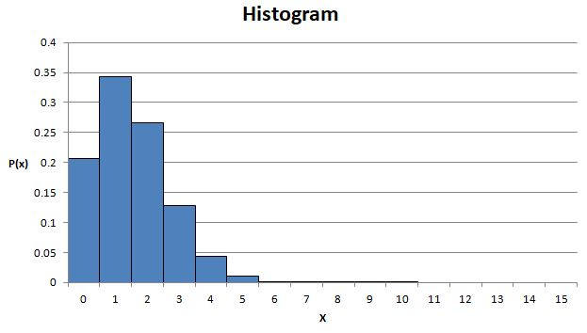

d.) Describe the shape of the histogram.
The shape of the histogram is highly right skewed.
e.) Find the mean.
Mean = n*p
Mean = 0.10*15

f.) Find the variance.
=n *p(1-p) =15*0.1(1-0.1) =1.35

g.) Find the standard deviation
sqrt of 1.35 =1.162

