IFSM 370 Project 4: Network Diagram
Student Name
Institution Affiliation

IFSM 370 Project 4: Network Diagram
Description of the Proposed Technology Solution
Three technology solutions rare necessary for FractalApps business namely LAN, WAN and VPN. All these three will precisely facilitate all networking within the business and ensure smooth flow of business operations. LAN technology will be much essential in interconnecting users within one location.Since the business will having 3 locations, each location will have its LAN connection. Several components will be have to be available in the establishment of LAN technology. The individual computers have to be available which will be connected to the server. Additionally different servers also have to be availableincluding file server, mail server, and print server. Individuals will be able to precisely accessdata from all these servers. WAN network will be able to cover a larger distance hence being able to connect the three office locations. Some of the necessary components include the satellite that will distribute the connection, a router to distribute connection over the three locations, and servers where users will be able to access business data from using their specific computers. Next, the VPN technology will be much helpful to all those who operate outside the office. Client software is the first component that is necessary to ensure that the mobile workers have access to the office servers. Next, the mobile workers require a secure VPN connection and lastly a network Access Server (NAS) where they will be able to access all business data from.

Network Diagrams
LAN DIAGRAM
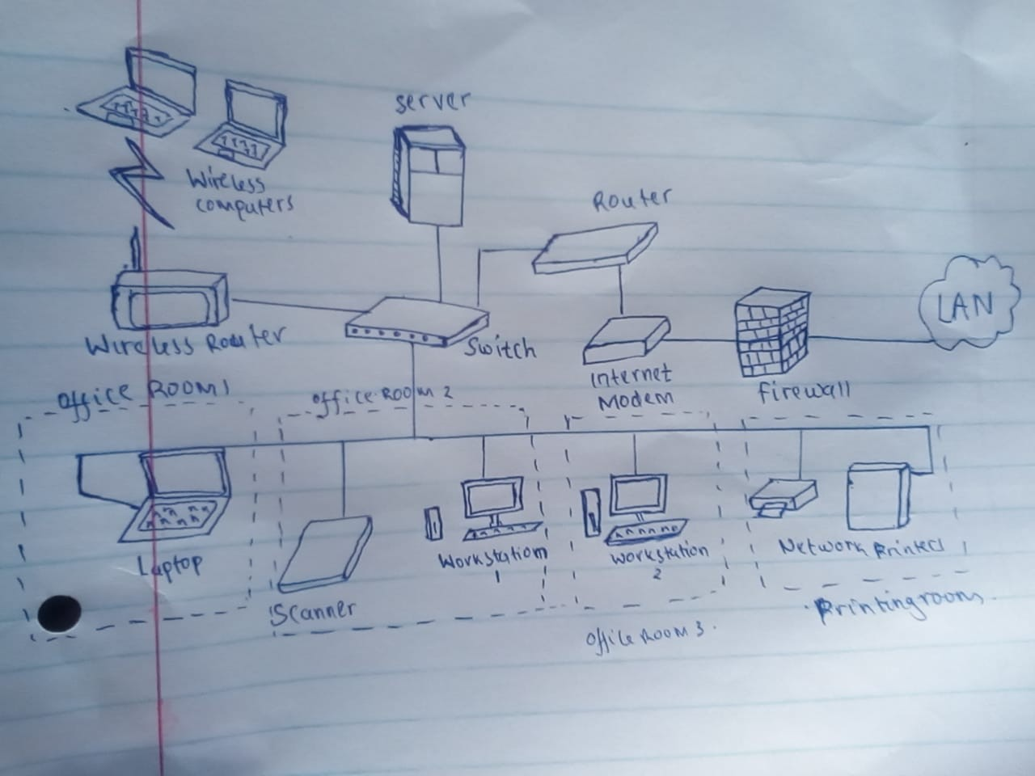

WAN DIAGRAM
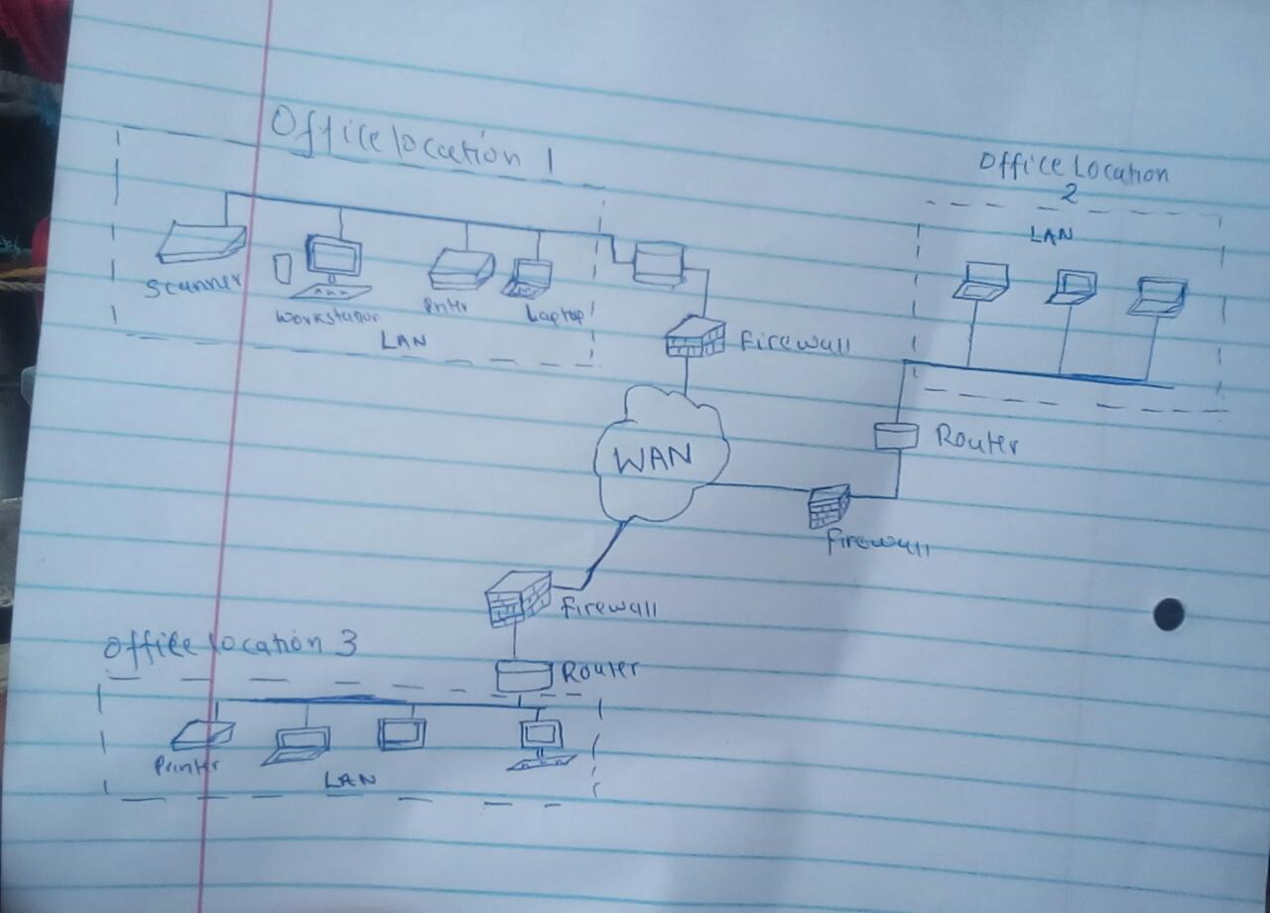

VPN DIAGRAM
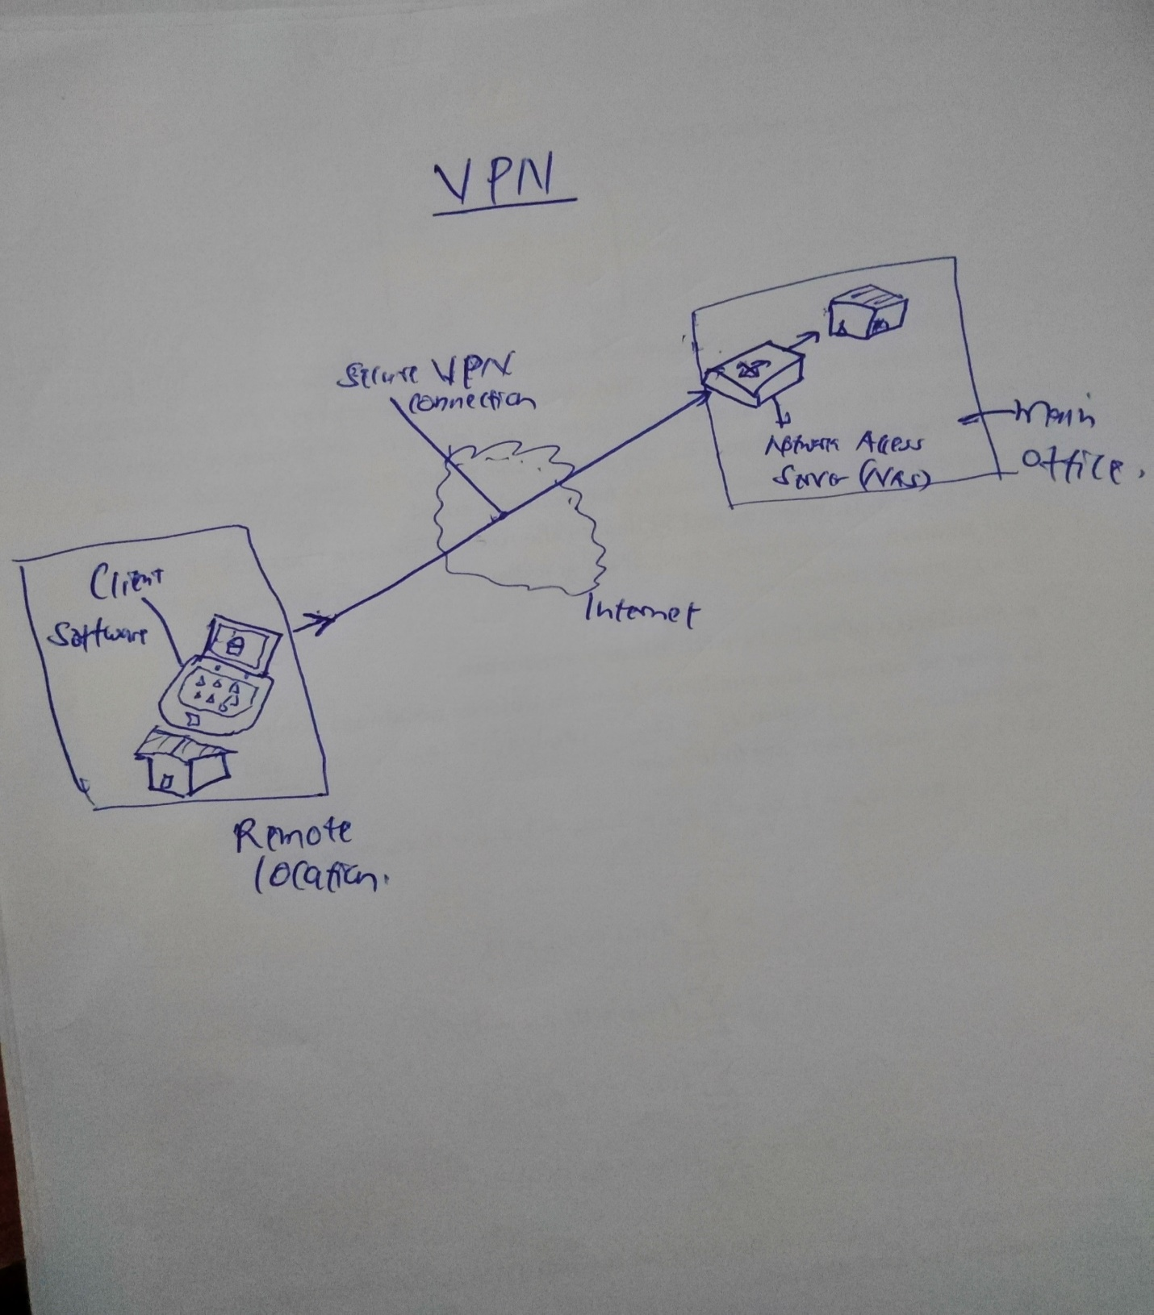

References
Remote Access VPN: Secure Your Access Point with PureVPN. (n.d.). Retrieved from https://www.purevpn.com/blog/secure-remote-access-vpn-solution/
Typical LAN structured cabling system. (n.d.). Retrieved from http://www.l-com.com/content/Article.aspx?Type=N&ID=10003
Wide Area Network Technologies - Design and Implement High-quality WAN Networks. (n.d.). Retrieved from https://www.edrawsoft.com/Wide-Area-Network.php

