
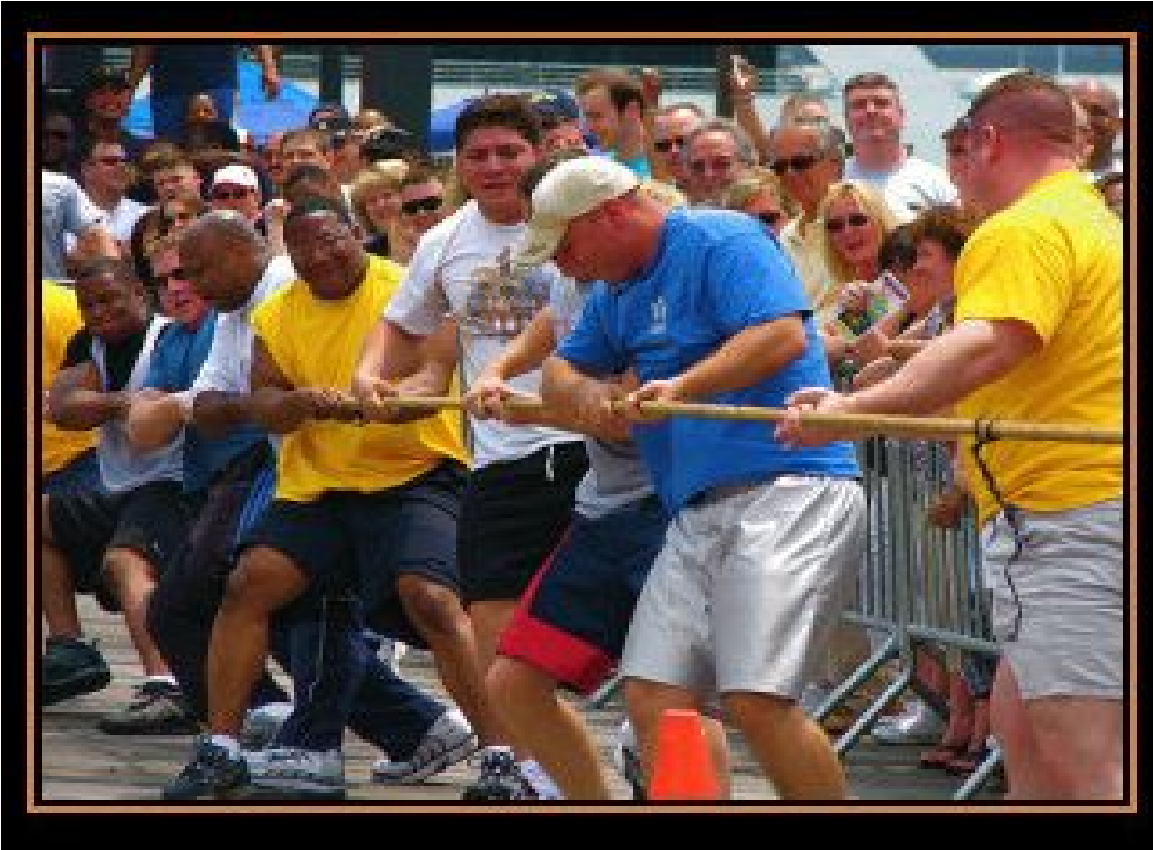
PSYC602 _ S
OCIAL
P
SYCHOLOGY
W
EEK

7
(2020
_
T
HE
L
OCKDOWN
E
DITION
)
P
EOPLE
IN
G
ROUPS
✺
G
ROUP
D
ECISION
-
MAKING
✺
I
NTERGROUP
B
EHAVIOUR
✺
Today’s Lecture Topics
Today, it’s all about GROUPS. The materials we’ll be covering have been extracted out of three of the Vaughan and Hogg (2018) chapters, as noted:



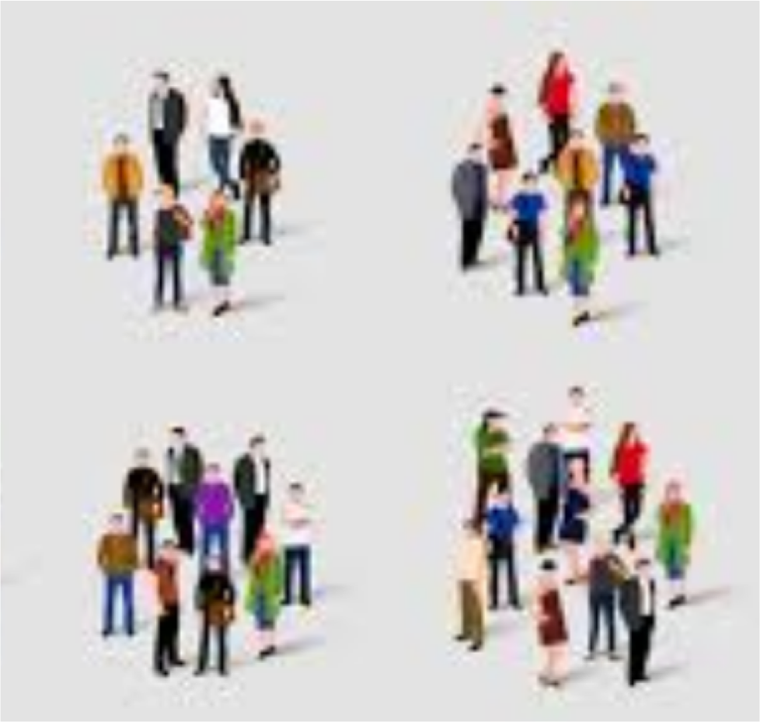
PEOPLE IN GROUPS
(Vaughan & Hogg, Chpt 8)

GROUP DECISION-MAKING
(Vaughan & Hogg, Chpt 9)

INTERGROUP BEHAVIOUR
(Vaughan & Hogg, Chpt 11)
What are groups?
Below are few definitions from Social Psychologists
- Essentially a numerically small face-to-face collection of individuals interacting to perform a shared task or fulfill shared goals (Hogg, 1992).
P
EOPLE
IN
G
ROUPS
- A group exists when two or more people define themselves as members of it and when its existence is recognized by at least one other (Brown, 1988)
- It is not similarity or dissimilarity of individuals that constitutes a group, but interdependence of fate (Lewin, 1948)

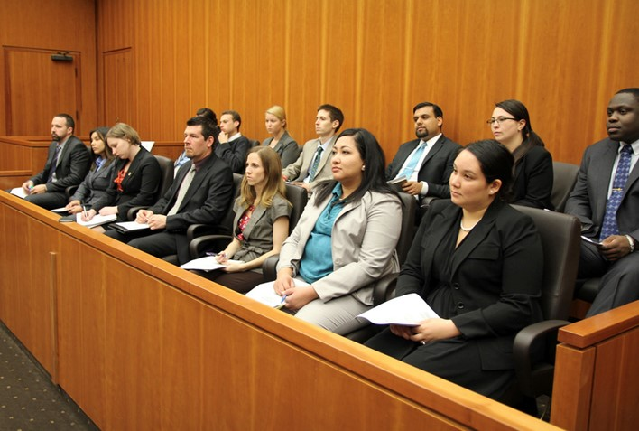
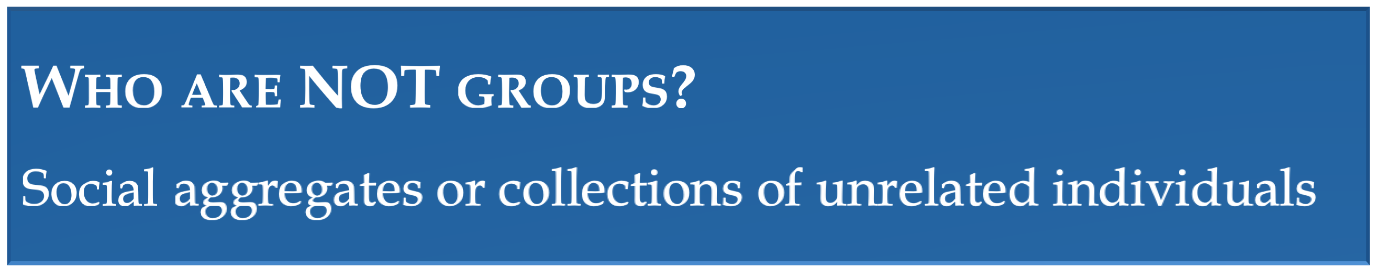
P
EOPLE
IN
G
ROUPS
What are Social Groups?
Two or more people, who share a
common definition and evaluation
of themselves, and behave in
accordance with such a definition.
×
Can determine who we are and how
we live our lives
×
Our group has a large impact on how
we talk, the language we speak, the
accent we have through to how we
think and feel
Why do people join groups?
- Shared goals that require others


- Mutual positive support
P
EOPLE
IN
G
ROUPS
- Pleasure of affiliation and fellowship
- Self-protection and personal safety
- Emotional support in times of stress
- Avoid loneliness and increase a sense of belonging
Are these groups?
- The spectators at a rugby game.
- A man and a woman flirting with each other, having just met each other for the first time in a pub.
- All the students in a psychology class.
- Five people talking to each other on-line in a computer "chat room.”
- Individuals waiting in silence at a bus stop.
P
EOPLE
IN
G
ROUPS
- All women in Christchurch who have blue eyes.
- All people who think of themselves as Germans.
- People who drive Jaguars.
- Six employees wearing sound-proof headphones working on assembly line.
- Five adolescent males who hang out together skateboarding in a park.
Four of the above would NOT be considered a group. Can you pick them out?
Groups vary in terms of:

× SIZE ×
- Large (New Zealander)
- Small (family)

× DURATION ×
- Short (friendships)
- Long (religion, culture)

× CONCENTRATION ×
- Concentrated (study group)
- Dispersed (AUT students)
P
EOPLE
IN
G
ROUPS

STRUCTURE
- High (army)
- Low (fan club)

PURPOSE
× Specific (demonstration) × General (shared house)

POLITICAL STRUCTURE
- Autocratic (police)
- Democratic (student union)

How others affect individual performance
We respond differently in the mere presence of others
- Members of the same species
- Co-actors (doing the same thing but not interacting)



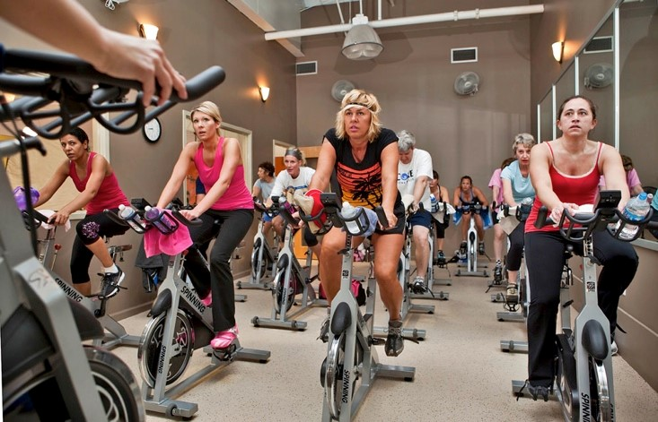
- Can even be passive and unresponsive audience (only physically present)
P
EOPLE
IN
G
ROUPS
The presence of others can improve or worsen performance. This is called social facilitation
- an improvement in the performance of well-learned/easy tasks
- deterioration in the performance of poorly learned/difficult tasks

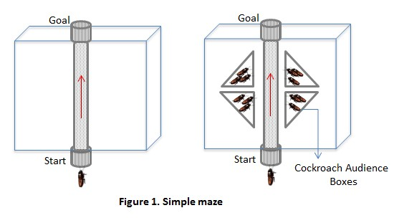
Zajonc et al. (1969) studied the mere presence of others for several species and found:
- Travel time for cockroaches away from a light, with others present, was faster than alone.
P
EOPLE
IN
G
ROUPS
- Replicated with more difficult tasks. Slower in presence of others when task is complex.
The presence of others increases physiological arousal making it easier to do something that is simple but harder to do something complex, or to learn something new (because of evaluation apprehension).
Theories for Social Facilitation effect

AROUSAL (DRIVE THEORY)
Zajonc’s theory that the physical presence of memebers of the same species instinctively causes arousal that motivates performance on habitual behaviour
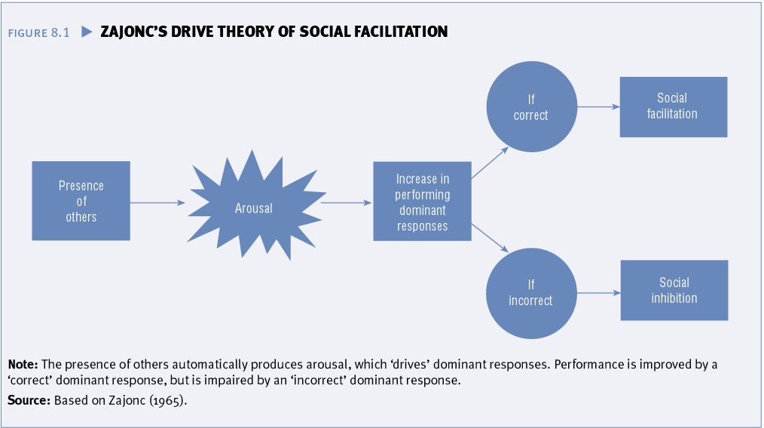
Others can increase motivation or arousal just by being there.
P
EOPLE
IN
G
ROUPS
If we feel that the dominant response is correct, we do better; if incorrect, we do worse (e.g.., always getting the steps right when we practice by ourselves will probably mean we get it right when in front of others)
Theories for Social Facilitation effect

EVALUATION APPREHENSION




The physical presence of others causes drive because we have learned to be apprehensive about being evaluated (concerned what others might think)
P
EOPLE
IN
G
ROUPS
- (e.g.) Social rewards and punishment
(approval and disapproval)
- Markus (1978): Dress/Undress Study
- Familiar or unfamiliar clothing
- Measured the time to dress (a) alone, (b) with distracted others, and (c) with watchful others
P
EOPLE
IN
G
ROUPS
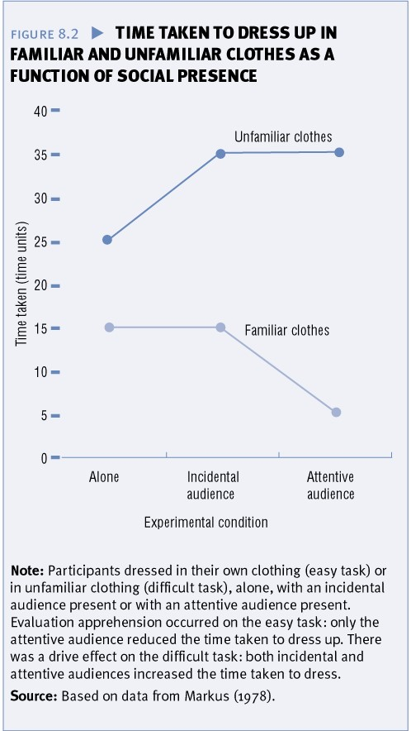
Supports
Evaluation
Apprehension
Theory
Supports
Drive
Theory
P
EOPLE
IN
G
ROUPS
The physical presence of members of the same species causes
drive because people are distracting and produces
conflict

between attending to the task and attending to the audience
Theories for Social Facilitation effect
D
ISTRACTION
-
C
ONFLICT
T
HEORY
Attentional
Conflict
Tendency
to
pay
attention
to
task
Tendency
to
pay
attention
to
audience
Increased
arousal
/
drive
Social
faciliation
Presence
of
audience
Individual
performing
a
task
Sanders, Baron and Moore (1978)
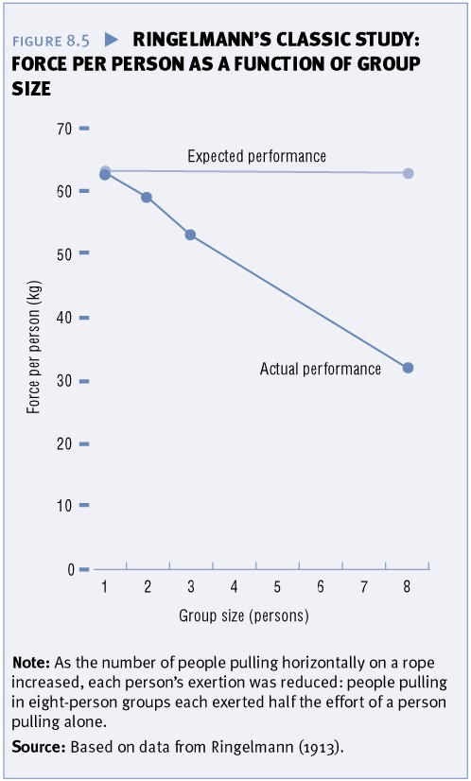
Does the size of the group impact on performance?
- Ringlemann (1913) found that the size of the group mattered
- The more people involved in a
task, the less effort each person contributed. Possible factors include:
P
EOPLE
IN
G
ROUPS
- Co-ordination loss (problems in coordinating behaviour)
- Motivation loss (less motivated and didn’t try as hard)
RINGELMANN EFFECT

Social Loafing is …

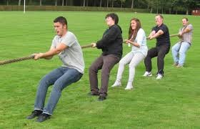


- a reduction in individual effort when working on a collective task, compared with working alone
P
EOPLE
IN
G
ROUPS
- working less hard when one believes others are also working on the task
- as the group size increases (only up to about
8 people), individual effort decreases
- Adding extra people to a large group only has minimal impact

Explanations for Social Loafing
Output equity - Belief that others will loaf and so loaf themselves to maintain equity (AKA: the Sucker Effect)
Evaluation apprehension - Group provides sense of anonymity and so unmotivated persons can remain unidentifiable
P
EOPLE
IN
G
ROUPS
- Working as an identifiable individual causes apprehension of evaluation so we work harder
Matching to standard – We loaf because either we have no clear performance standard, or someone sets a low standard and we match to it
- The presence of a high standard (personal, social or group) reduces loafing

Group Socialisation
- The dynamic relationship between the group and its members

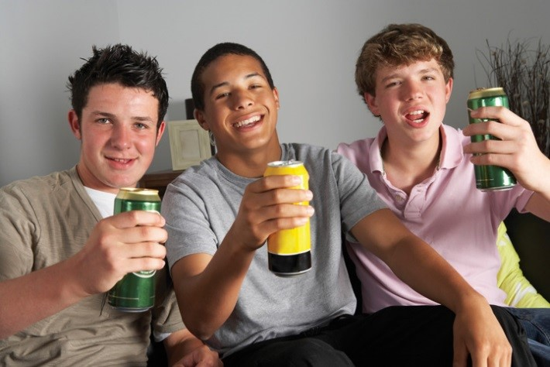


- Describes the passage of members through a group (joining, committing, leaving)
P
EOPLE
IN
G
ROUPS
- Describes entry, commitment and departure from groups (e.g., work groups, friendship groups, activity groups)
Stages of Group Membership
Tuckman (1965)
- FORMING = Orientation and familiarisation
- STORMING = Conflict stage when members know one another well enough to work through disagreements
P
EOPLE
IN
G
ROUPS
- NORMING = Consensus, cohesion and a sense of common identity and purpose begin to emerge
- PERFORMING = A period when the group works smoothly as a unit
- ADJOURNING = The group dissolves because it has accomplished its goals or members lose interest

Five phases of Group Socialisation
- Investigation: find out if you want to join or the group want you
- Socialisation: new members assimilated, learn how to be part of the group can be formal (induction) or informal.
P
EOPLE
IN
G
ROUPS
- Maintenance: role negotiation, dissatisfaction or transition (finish uni)
- Resocialisation: try to get back into the group (fit in again) or leave
- Rememberance: reminisce about the group – often fondly

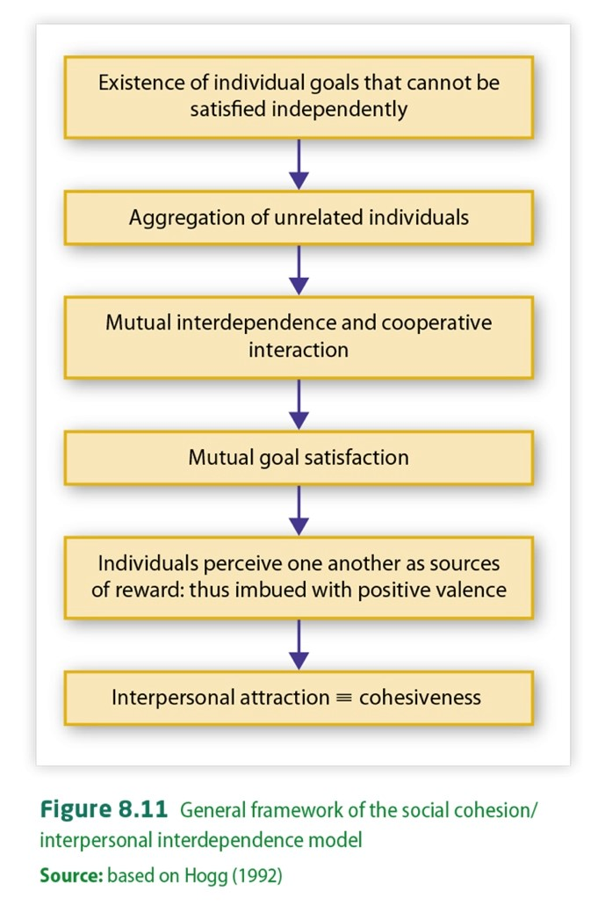
Group Cohesiveness
Cohesiveness is the property of a group that emotionally binds people (as members of the group) to one another and to the group as a whole.
- Essential property of a group that makes it act like a group
P
EOPLE
IN
G
ROUPS
- Gives the group a sense of solidarity and oneness
- Psychological process that transforms an aggregate into a group
- Increases a group’s productivity and Members of cohesive groups tend to feel efficiency, member satisfaction and more favourably inclined towards one interactions, and decision-making another as group members, and are _{quality} more likely to identify with the group
and conform to its norms
A high degree of COHESIVENESS was noted (in previous lecture) to enhance CONFORMITY

Group Norms and related concepts
Norms are attitudinal and behavioural uniformities that define group membership and differentiate between groups (e.g., customs, rituals, standards, values, fashions)
P
EOPLE
IN
G
ROUPS
R
EFERENCE
GROUP
is a group that is
psychologically significant
for one
’
s behaviour and
attitudes
M
EMBERSHIP
GROUP
is a group to which one
belongs by some objective
external criterion
- Shared beliefs about what is appropriate conduct for group members
- Can be both descriptive (what is) and prescriptive (what should be)
- Groups develop norms in order to regulate the behaviour of members, to define the group (defines what is acceptable), and to distinguish the group from other groups.

Group Structure
The division of a group into different roles is group structure. Structure includes one’s position (status) and prestige. People have different roles in groups. Roles:
- are patterns of behaviour that distinguish between different activities within the group (e.g., ideas, task or emotional)
P
EOPLE
IN
G
ROUPS
- are not people per se, but behavioural prescriptions. Can be formal
(e.g., flight crew) or informal (e.g., friends)
- inter-relate to one another for the greater good of the group and determine who does what (clarifies relationships)
- give individuals a sense of belonging and place in group
Roles can influence who we are, our identity and our self concept

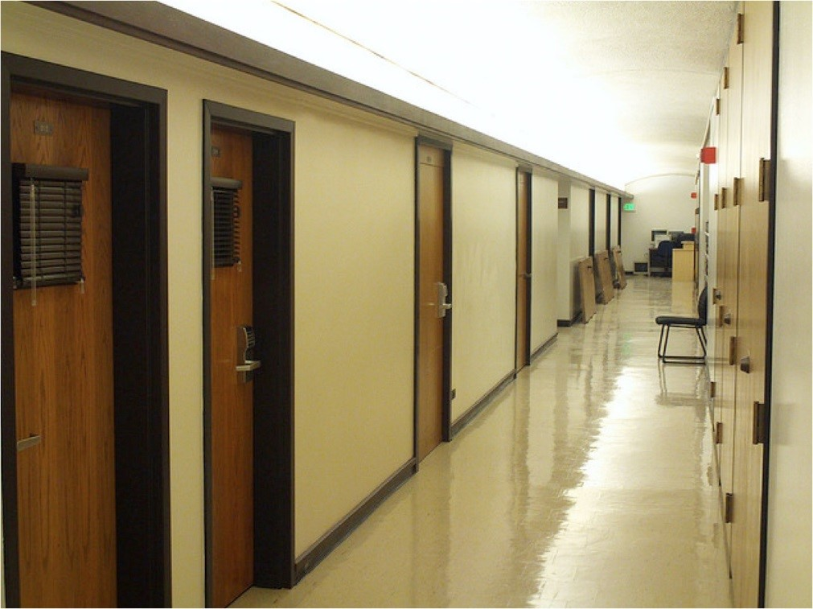

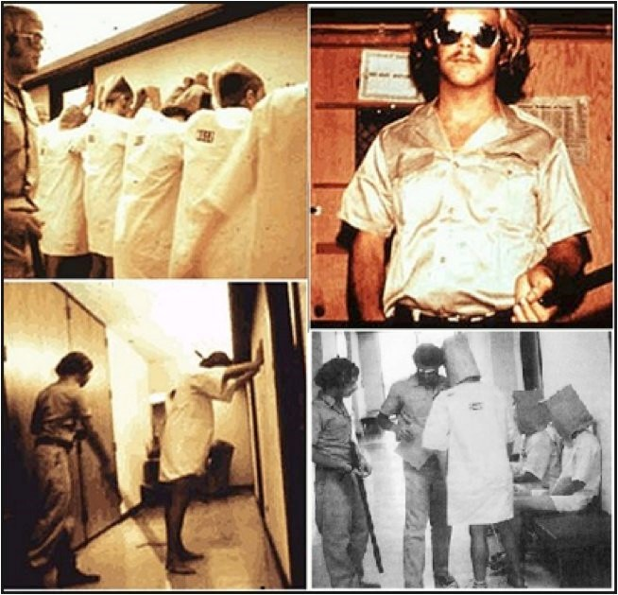
Zimbardo’s
http://www.youtube.com/watch?v=sZwfNs1pqG0&list=TLWAY51GBlIm
w
(1971) prison
experiments
P
EOPLE
IN
G
ROUPS
Recall from previous lecture on Social Influence: Milgram wanted to understand how Nazi SS Officers, on trial for war crimes, could say “I was just following orders”, when those orders led to such atrocities. This led to Milgram’s OBEDIENCE studies. He found that people would, indeed, subject others to painful shocks just for being told to do so by a perceived authority.
Zimbardo was a student of Milgram. He began to look at the ROLES that people occupy, as a possible influence on a person’s ability to do harmful things to others. Can you see how these two studies fit together?

Zimbardo’s Prison Experiment
Goal of the study: To examine whether the role—versus the personality of the persons in the role—governs behaviours
Research Design and Procedures:
- Converted basement of Stanford University into mock prison
- Advertised for volunteers to participate in study of ‘psychological effects of prison life’
P
EOPLE
IN
G
ROUPS
- Applicants were given diagnostic interviews and personality tests to ensure no one had any psychological problems, were antisocial, or had a history of drug abuse or crime
- 24 of the most ‘physically & mentally stable men’ (note: all white men) were chosen to participate and were paid $15 per day to participate (~$90 in today’s money)
- Participants were then randomly assigned role of prisoner or guard
Zimbardo’s Prison Experiment
Research Design and Procedures (cont.):
- Prisoners were ‘arrested’ and taken to police station to be ‘booked’

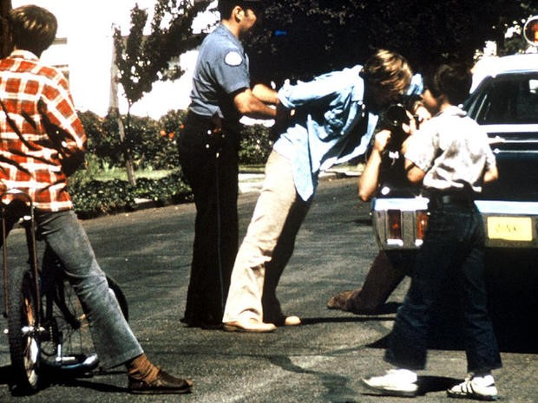
- At the prison they were stripped naked, deloused, had all their personal possessions removed and locked away, and were given prison clothes and bedding.
P
EOPLE
IN
G
ROUPS
- Prisoners were referred to by their ID number only, and they could only refer to themselves and other prisoners by their ID number
- Guards wore uniforms and special sunglasses, to make eye contact with prisoners impossible.
- Three guards worked shifts of eight hours each
- Zimbardo observed the behavior of the prisoners and guards (as the researcher),
- He also acted as the prison warden.
Zimbardo’s Prison Experiment
Results:
- Guards began harassing prisoners: awaking them from sleep for counts, taunting them with insults, giving them boring tasks. Pushups were given as punishment.

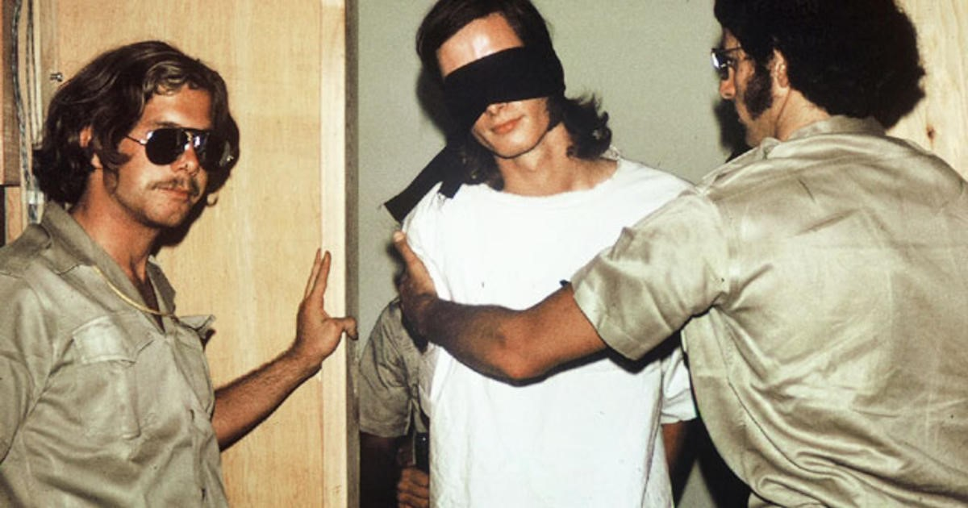
- Prisoners took rules seriously: would keep each other in line and talk guards off people who didn’t behave
P
EOPLE
IN
G
ROUPS
- On second day, prisoners rebelled: ripped off numbers and baricadded themselves in rooms. Guards broke in, took away beds and stripped prisoners naked, one prisoner was put in solitary confinement
- Prisoners became more submissive as guards became more aggressive
- One prisoner was released from experiment after 36 hours due to psychological distress (4 others also left early)
- The experiment was meant to run for 2 weeks. After 6 days, Zimbardo called off the study when Zimbardo’s girlfriend – a psychology PhD student objected to the abuse
Zimbardo’s Prison Experiment
Conclusions:
- In terms of his research question: Zimbardo saw behaviour as situational— not dispositional (based on one’s personality)
- Zimbardo concluded that people will readily conform to the social roles that they are expected to play, especially if the roles are as strongly stereotyped as those of the prison guards

- He saw deindivduation (on part of guards) and learned helplessness (as prisoners) to explain the participants’ behaviours
P
EOPLE
IN
G
ROUPS
Core Finding:
- Systemic and situational forces can operate to influence individual behaviour in negative or positive directions, often without our personal awareness.
- When people have power over others, they will abuse this power; people who are powerless will be driven to submission.
Zimbardo continued this line of research, including an investigation of the prisoner abuses at Abu Ghraib in 2003 by USA soldiers. This collective body of research strongly supports the idea that it is the power of the situation that influences us to behave so badly.


Intergroup
Intergroup behaviour
is also described
as any perception, cognition or
behaviour that is influenced by peoples’
recognition that they and others are
members of distinct social groups
Syrian refugees
Behaviour

Any behaviour that involves interaction between one or more representatives of two or more separate social groups
I
NTERGROUP
B
EHAVIOUR
The key here is interaction between groups
International and intranational conflicts, political confrontations, revolutions, interethnic relations, negotiations between unions and management, and even competitive team sports are all examples of intergroup behaviour.
Intergroup behaviour is usually competitive and ethnocentric, with people favouring their own group over outgroups. Sometimes it can become hostile and highly destructive.

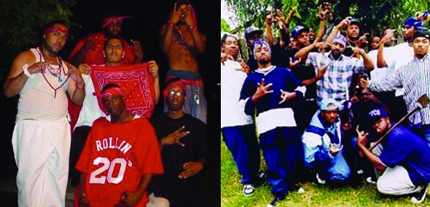
In understanding intergroup behaviour we are also trying to understand the conditions under which such behaviour can be shifted away from destructive hostility toward harmless competition or constructive cooperation.
I
NTERGROUP
B
EHAVIOUR
Remember Week 6’s discussion of
CONFORMITY
as a change in
behaviour in order to align with the
NORMS
of a socially significant
group. The Bloods and the Crips,
pictured here, are a great example of
not only
Intergroup Behaviour
, but
also
conformity to the group’s norms
.
We could also use them again when we learn about
PREJUDICE, DISCRIMINATION, and STEROTYPING.

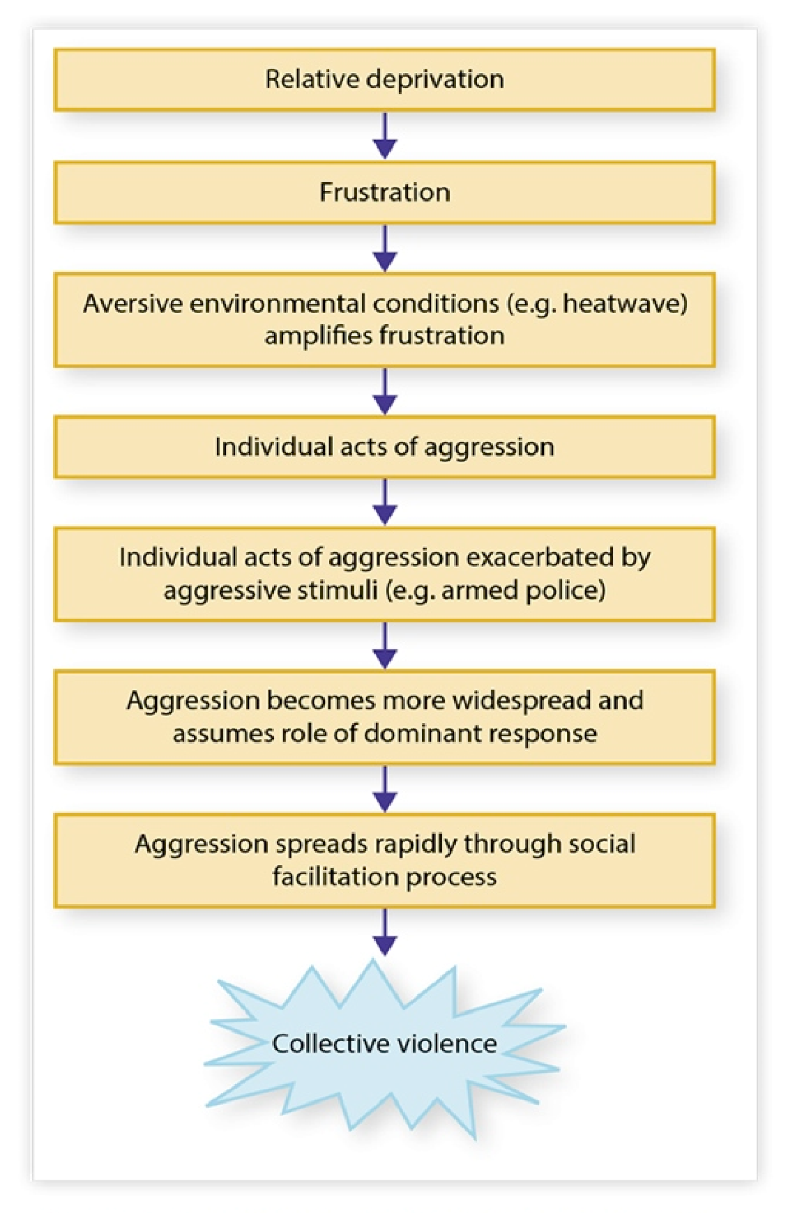
Intergroup Aggression
Relative deprevation is a sense of having less than one feels entitled to. This is a crucial precondition for intergroup aggression.
Berkowitz (1972) found relative deprivation can make people feel frustrated (hot summer, no air-con) and increase aggression*.
I
NTERGROUP
B
EHAVIOUR
It can become collective aggression
(riots) through social facilitation (presence of others) – something we just learned about in a previous slide.
*This idea of heat increasing aggression will come up in an upcoming lecture on Aggression & Pro-Social Behaviour.


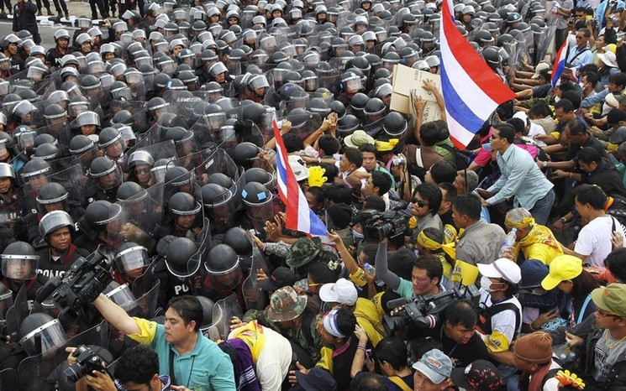

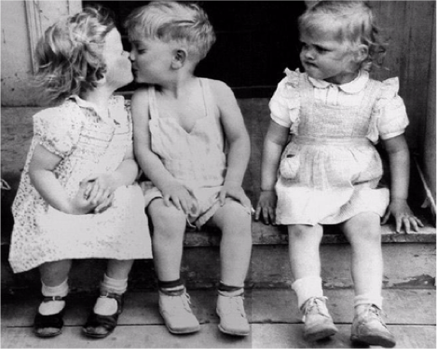
Two distinct forms of Relative Deprivation
I
NTERGROUP
B
EHAVIOUR
×
×
Egoistic relative deprivation: feeling like we personally have less than we feel entitled to (relative to our aspirations)


Fraternalistic relative deprivation: feeling that our group has less than entitled to when compared with others
In a study of unemployed workers, Walker and Mann (1987) found:
Those who reported the most fraternalistic deprivation were those prepared to contemplate militant protest, such as demonstrations, law breaking and destruction of private property.
Those who felt egoistically deprived reported symptoms of personal dsstress
(headaches, sleeplessness, etc)

Sherif's Realistic Conflict Theory
Sherif (1962) argued that where groups compete over scarce resources, intergroup relations become marked by conflict, and ethnocentrism arises.
Ethnocentrism:
- a view that one’s own group is the centre of everything
- all others are scaled and rated with reference to one’s group

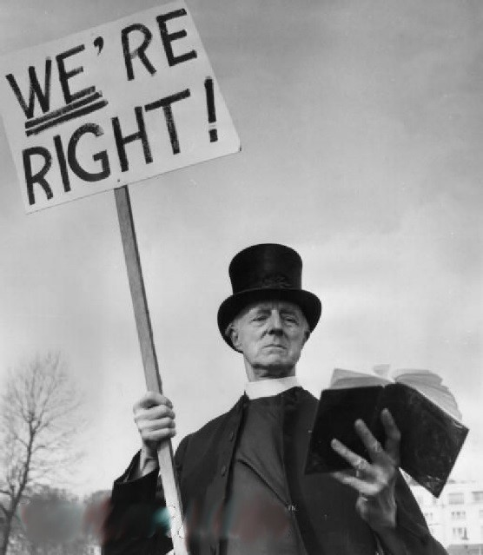
- each group thinks its own way is the only right way
Groups who share goals requiring Groups who have mutually interdependence for their achievement, exclusive goals (e.g., winning) tend to cooperate and form a group engage in inter-individual competition
I
NTERGROUP
B
EHAVIOUR
Where two groups have the same goal but the
goal can only be achieved by cooperative Inter-individual competition can interaction (a superordinate goal), the groups prevent group formation or cause cooperate and thus help each other, producing collapse of the group. more favourable intergroup attitudes.

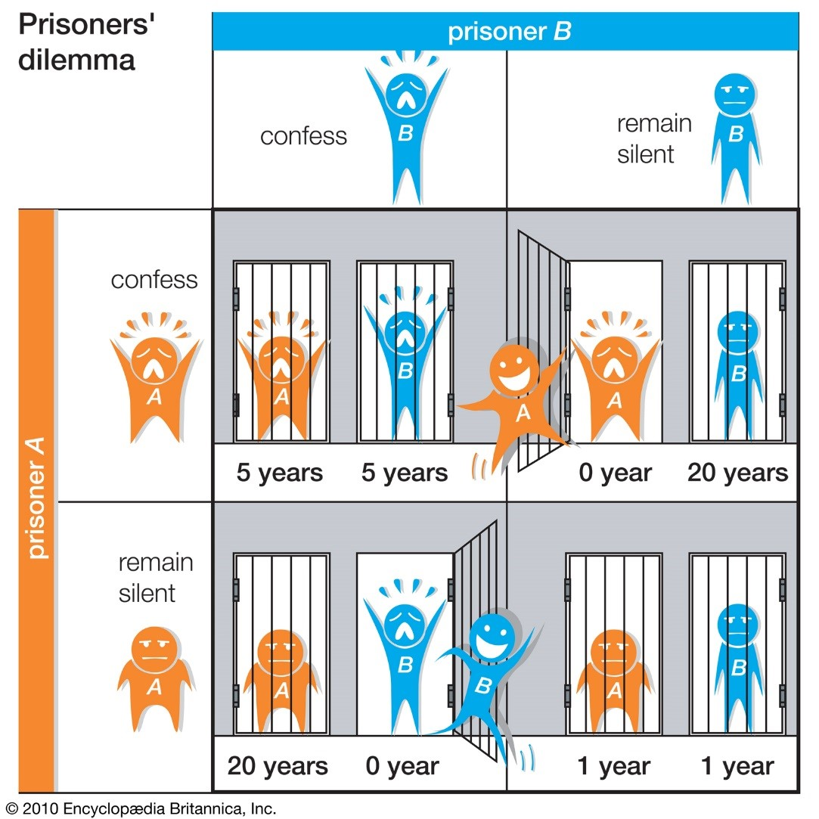
The prisoners dilemma is a two (2) person game in which both parties are torn between:
I
NTERGROUP
B
EHAVIOUR
- Competition
- Co-operation
Depending on mutual choices, both can win or both can lose
This is not unlike the game Split or Steal, sometimes played by DJs on NZ radio stations.
https://www.youtube.com/watch?v=YGyZX0VoRpI
Mutual non-confession is the best joint outcome but mutual suspicion and lack of trust almost always encourage both to confess, and both lose.

Decision-making in GROUPS
Areas of interest to Social Psychology
- Brainstorming = uninhibited generation of as many ideas as possible in a group in order to enhance group creativity

- Groupthink = a mode of thinking in highly cohesive groups in which the desire to reach unanimous agreement overrides the motivation to adopt proper rational decisionmaking procedures
G
ROUP
D
ECISION
-
M
AKING
- Group polarisation = the tendency for group discussion to produce more extreme group decisions than the mean of members pre-discussion opinions, in the direction favoured by the mean

Brainstorming
Coming up with a lot of ideas very quickly (and building on others’ ideas) without concern for their quality, in order to come up with creative and novel solutions.

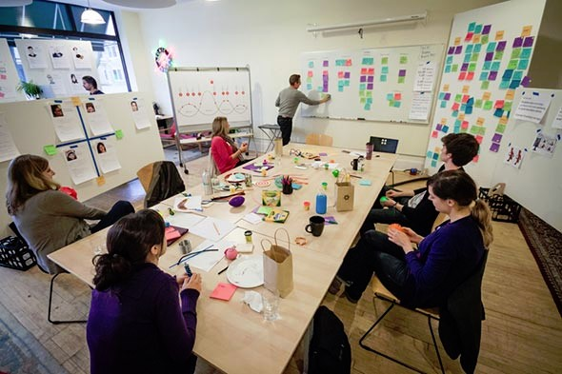
Used frequently and assumed to enhance individual creativity.
G
ROUP
D
ECISION
-
M
AKING
BUT research (Stroebe & Deihl, 1994) found that:
- Groups generate more ideas but the individuals are no more creative than if they worked alone
- Where people generate ideas by themselves (and do not interact with the group) they are twice as creative as when people actually interacted in a group
- Ideal is when individuals work alone and then pool their ideas as a group, making this a more productive strategy than Brainstorming, but probably less enjoyable.

Reduced Brainstorming (Paulus et al., 1993) performance attributed to
- Evaluation apprehension: Concern about making a good impression introduces self-censorship and a consequent reduction in productivity
- Social loafing/free riding: Loss of motivation due to the collective nature of the task
G
ROUP
D
ECISION
-
M
AKING
- Production-matching: Members guide their own ideas on the group performance mean or norm (regression to the mean)
- Production-blocking: Negative influence of interruptions and turn-taking (trying to generate your own ideas while hearing from others)
Groupthink THE DARKER SIDE OF
GROUP DECISION-MAKING


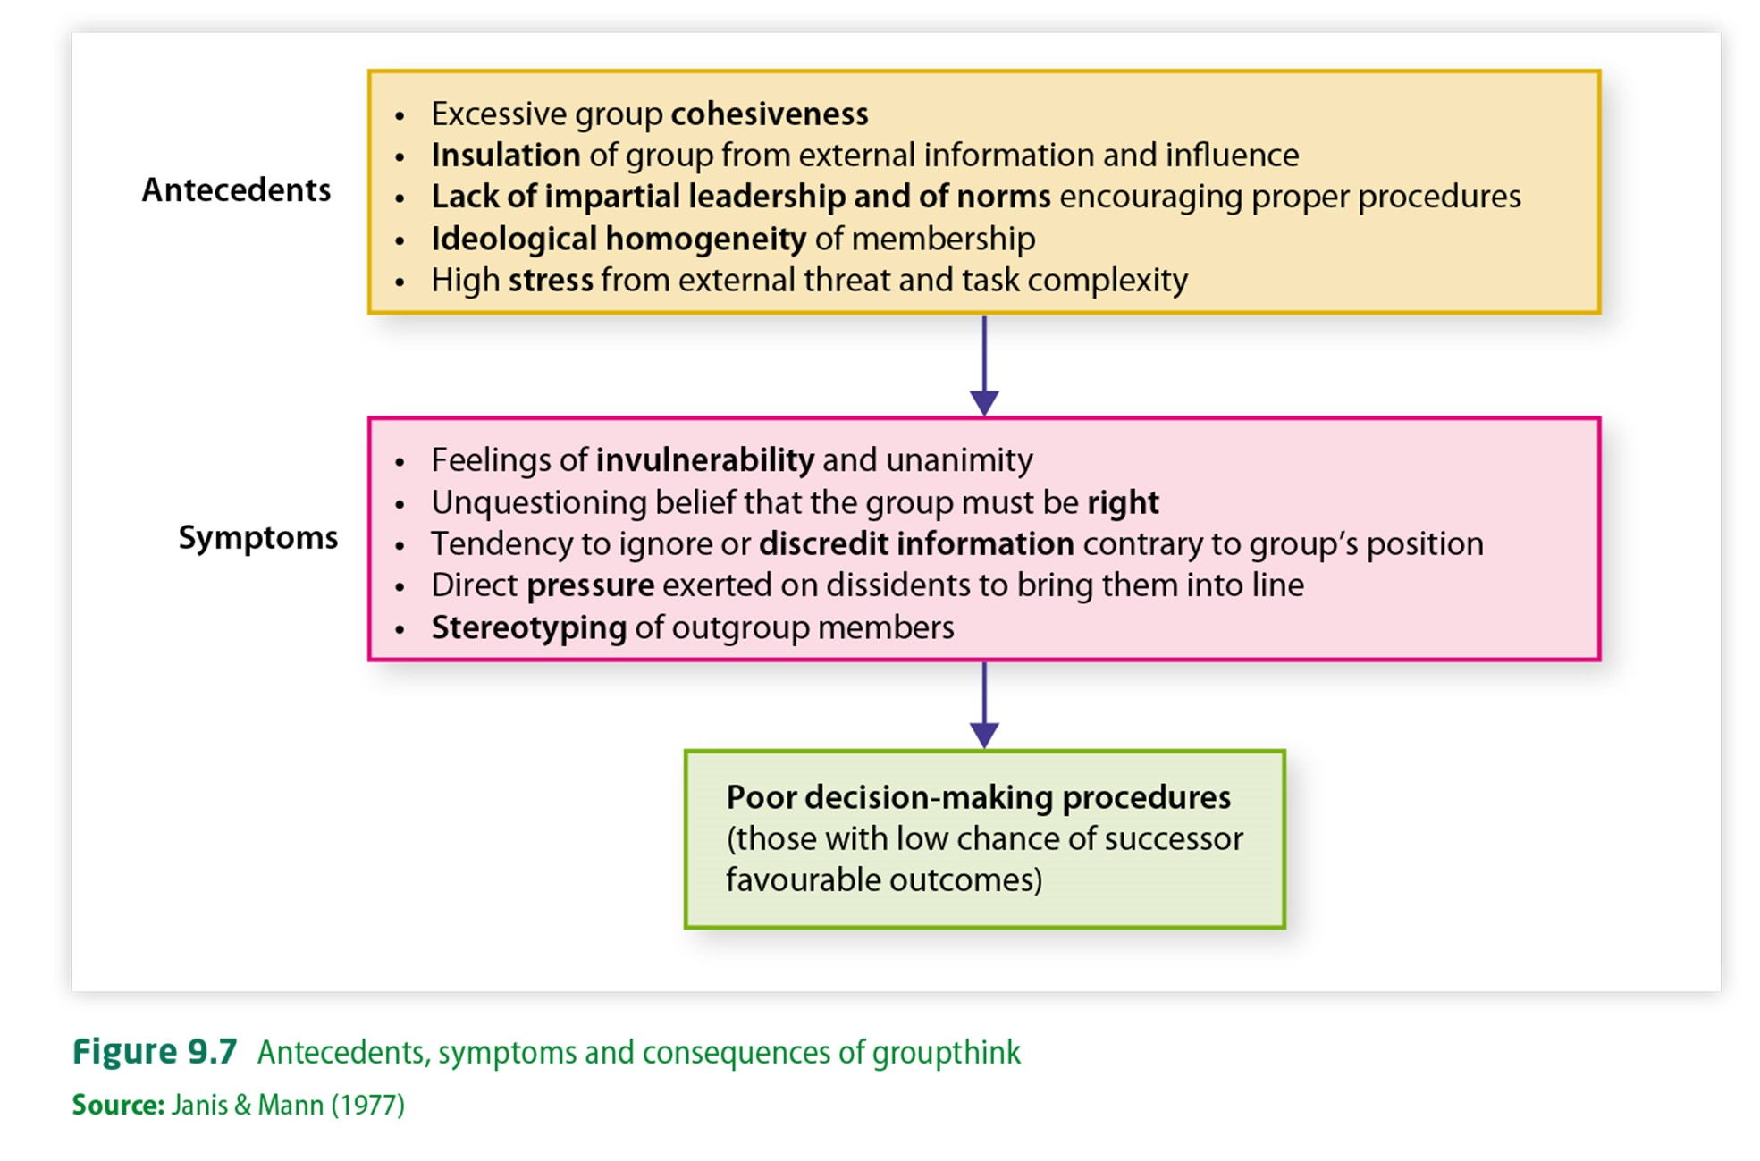
When the desire to reach a unanimous
G
ROUP
D
ECISION
-
M
AKING
agreement
overrides the
motivation to adopt
proper rational
decision
-
making
procedures
A counter
-
intuitive concept, as
most think groups would be more
conservative
Janis (1972) performed archival research (historical records & content analysis) that examined political decisions that had poor outcomes, and found above:
Space Shuttle Challenger
disaster is a perfect example https://www.youtube.com/watch?v=SBw0ased8Sw
Group
Polarisation

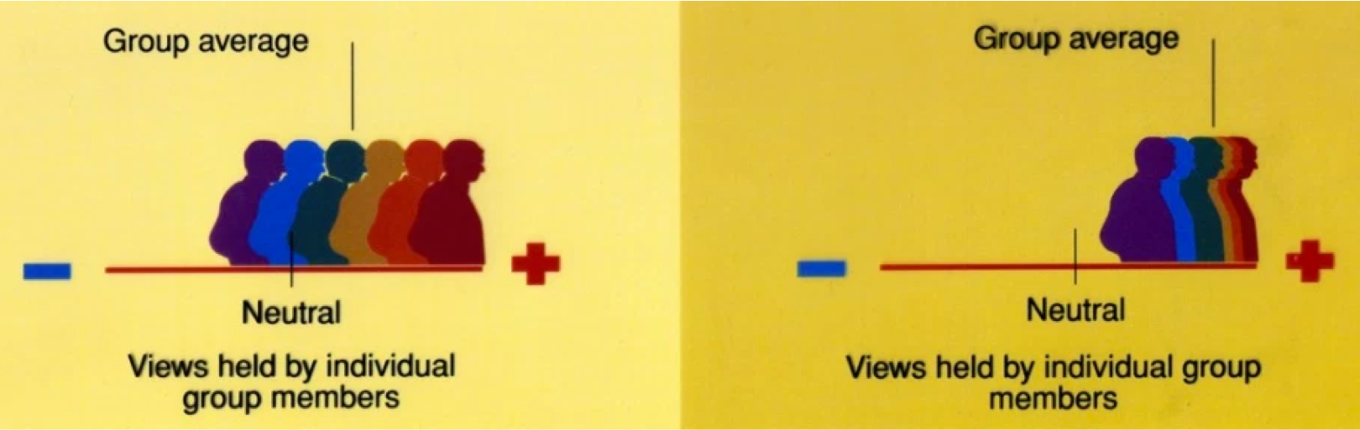
Groups that already tend towards an extreme position on a decision-making dimension often make even more extreme decisions when together, than the average of the members’ initial positions would suggest.
G
ROUP
D
ECISION
-
M
AKING
- Counter-intuitive phenomenon (folk wisdom = groups, committees and organisations are inherently more conservative in their decisions than the individuals who make up the groups).
- Similar process to “risky-shift” where a group that already tends towards risky decisions polarises through discussion to even more risky decisions (e.g., Stoner’s, 1961)
http://study.com/academy/lesson/group-polarization-in-group-decision-making.html

Explanations of Group Polarisation
Persuasive arguments theory: People in groups are persuaded by novel information that supports their initial
position, and thus become more extreme in their endorsement of their initial position
G
ROUP
D
ECISION
-
M
AKING
Social comparison theory: Process of comparing one’s behaviours and opinions with others in the group in order to establish the correct or socially approved way of thinking or behaving
Self-categorisation theory: Categorising oneself as a group member produces social identity, and group and intergroup behaviours. (Here is another place where a high degree of Group
Cohesiveness can enhance this effect)

Jury Examples
Jury decisions provide an ideal vehicle for examining group think and group polarisation. Juries contain individuals that have come together to make a decision, motivating them to come to a decision.




Factors specific to juries that influence decision-making:
G
ROUP
D
ECISION
-
M
AKING
- Characteristics of the defendant and/or victim
- Influence of laws and penalties
- Volumes of information
- Leadership of foreman
- Characteristics of jurors Interestingly, the film aspects of these concepts, but ultimately, it is 12 Angry Men shows minor Minority Influence that drives the movie’s outcome.

