Bringing Panera Bread to Norway

Executive Summary
Panera Bread, as of September 2020, was the tenth biggest fast food chain in the U.S in terms of sales and revenue (Ang, 2020). Pushing huge companies like KFC and Chipotle behind them. Considering the fast food category, they are in, Panera would be the second largest “sandwich” chain, behind Subway. Compared to Subway, Panera Bread have ten times less stores located in the U.S. Although Panera Bread is categorized under sandwiches together with Subway, I believe Panera has a broader operation and width in what they can offer compared to Subway. Panera built their reputation on sandwiches which might be the reason. Because of the bigger quality and potential of Panera Bread, I would see Panera exceed Subway eventually. We want to use that potential into expanding business internationally. We want to bring this ambitious chain to Norway, which after our analysis and studies would be the perfect fit.
Having analyzed the Norwegian market and looked at trends, there is no doubt that we realize a huge potential and opportunity in this idea. It would be a big success and improvement towards the Norwegian food market. The Norwegian people are already been introduced and very normalized to the American style and food, which simplify and normalize the introduction of a new franchise. Furthermore, we can see that Norway is very strong and stable when it comes to their economy and political situation. A very globalized society that is very including to international markets. The Norwegian government is very aware of international businesses coming to Norway and keeps an open mind, which enhances Panera’s transition into the Norwegian culture. Smart marketing such as social media and television will be essential in the beginning to make people aware and connect with the target market.
I believe Panera Bread has big chance in this food market, which will increase the knowledge and experience of Panera Bread trying something new. Norway’s strong economy can be an opportunity for Panera trying out different pricing strategies and compared to the U.S it can increase the prices looking at the long-term. Throughout this paper I will present and discuss how to bring Panera Bread to Norway at most optimal and best way.

Figure 1
Map that illustrates the U.S – Norway relation
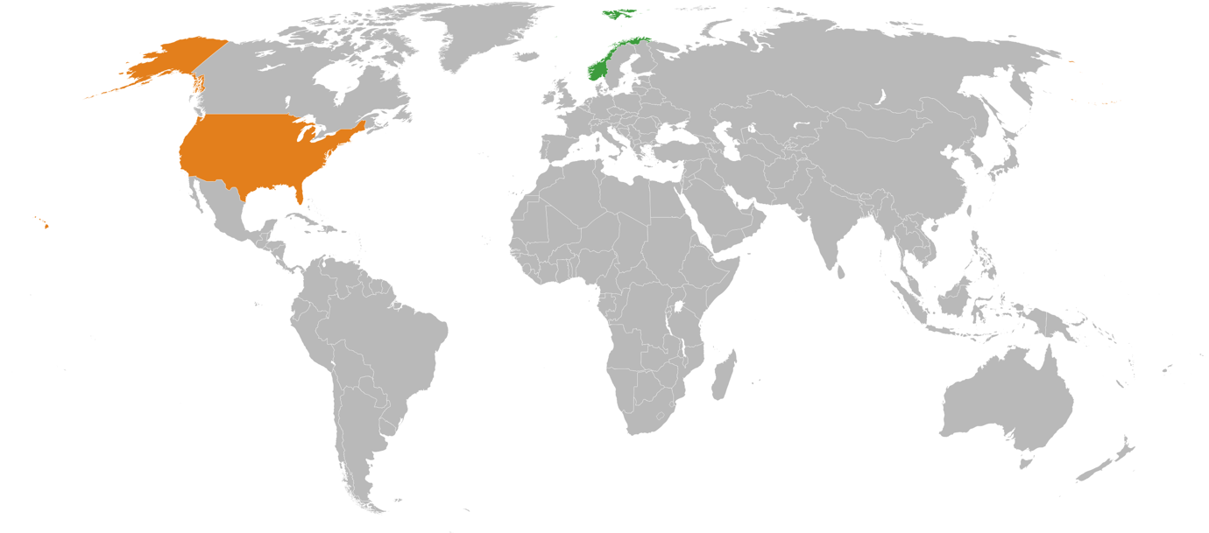
(Taken from Wikipedia Norway-United States relations, Last edited 25th July, 2020)

Table of Contents
Introduction 4
Company Background 5
Name of company and address 5
Type of industry 5
History of the company 5
Reason for expanding overseas 6
Description of product 7
General Market Screening 7
Basic needs potential for the product in the country selected 7
Climate of the country 7
Topography 8
Financial and Economic Screening 8
Economic indicators 8
Financial conditions 9
Economic data that highly correlates with the market demand 9
Political and Legal Screening 10
Type of Government 10
Entry Barriers 10
Profit transfer barriers 11
Political risk 12
Socio-cultural Screening 12
Demographic data 12
Religion 13
Social structure 13
Education and Language 14
Relevance of data to your product-market 14
Competitive Screening 14
Number, size and financial strength of competition 14
Market share distribution 15
Entry strategy by competitors 16
Quality of products 16
Pricing policies 17
After sales services 17
Distribution channels 17
Market coverage 18
Ethical Issues 18
Final Screening 19
Reason for the selection of country 19
Conduct further research 20
Conclusion and Recommendations 20
Work cited 22

Introduction
Panera Bread will soon be opening a new fast casual restaurant in Norway. This will be the first ever Panera Bread restaurant outside of North America. Panera Bread is the tenth largest fast food chain in the U.S, founded by Ronald M. Schaich in 1987. The current CEO of Panera Bread is Niren Chaudhary, and Shaich as the chairman. As of today, the business has over 2000 locations spread all over the U.S and some located in Canada. The purpose and ambition are to expand Panera’s daily operations and business from the United States to Norway. Panera Bread has only operated in the U.S and some in Canada, so expanding operations would be the next level for this successful business to take. Not to even mention the most fitting fast-food chain in the U.S for the Norwegian culture is Panera Bread.
As I have mentioned Panera Bread has no other experience of operating outside North America, but since the potential is at such a high level and the combination of the target market in Norway, we believe this could be the start of something big at Panera. Norway has a strong and wealthy economy which should be trustworthy and predictable for the business. Also, being owned by Panera will also give the Norwegian culture a taste of something of a healthier perception of the American cuisine, rather than the burger, pizza, donut view a lot of Europeans have of America.
We will be providing the same menu in Norway, as it is offered in the U.S because we have such faith in what Panera can offer. The commitment Norwegians have to a healthy lifestyle and support the local environment, our goal is to stay as locally as possible in terms of ingredients and produce. Norway is a country that is based towards agriculture and aquaculture, and supply of local grown produce would be beneficial for Panera and Norway. Obviously, we should only be importing products that are not found or grown in Norway, such as avocado. Furthermore, this would only be good for business to support this local view on ingredients, because importing everything would eventually exceed the costs and quality you can get from raising the resources locally. In fact, because of the healthy view from Panera makes it an even better match to the Norwegian market, because the healthy ingredients are what Norwegians are all about already. Looking at this we believe Norway would be a good start for Panera to increase sales and revenue, but also to break the ice of going global.

Company Background

Name of company and address
Panera Bread has its headquarters in Sunset Hills in Missouri, which is close to the big city of St. Louise. Panera is viewed as a “fast casual” restaurant, which is a mix between not being the real restaurant full-table service, but also higher quality than fast food restaurants. In other words, between the concept of casual dining and fast food. Which is also a good factor to bring to Norway, fast but casual.

Type of industry
The SIC code for this industry is 5812 and concludes as eating places, which relates to engagement in the retail sale of prepared food and drink for in-store or instant consumption.

History of the company
Panera started off as a single cookie shop nearby Boston area, during the beginning of 80s. Not long after Shaich, the shops founder, had started this “Cookie Jar” he merged with a French bakery called Au Bon Pain which had been struggling for some time. Later on, this merger resulted in a combination of operations that started selling soups, sandwiches and freshly baked baguettes. And this was the beginning of Panera Bread. Shaich idea of serving the working class that usually wanted their food fast, but at the same time conscious about their health. Shaich understood were the market and industry were going and predicted this fast-casual way of serving food was the new thing. By 1991 the company kept growing bigger and bigger which also resulted in them going public. Although this going very well for the company, Shaich decided to sell Au Bon Pain for the sole reason of maximize the potential of Panera Bread. Before you know it, at 1999 he sold Au Bon Pain and could entirely focus on growing his goals for Panera Bread. In general, that would be “restaurants that served food that customers could eat without guilt, in cozy cafés where they could hold meeting or Bible-study groups.” (Kolhatkar, 2018) Developing this ideology of his, by 2010, “Panera was opening a new store approximately every three days and had more than a billion in annual sales”. (Kolhatkar, 2018) Since then the company has kept growing and was also a major influence towards start implementing Wi-Fi hotspots for customers in their stores.

Reason for expanding overseas
Basically, in terms of growth opportunities and environmental changes Norway is a solid reason for expanding business. Technology and more globalized business have entered Norway, and even Norwegians are starting to adopt the characteristics of Americans by not always eating at home, cooking from their own ingredients. This is mostly closer to the big cities, but because of this, places like Panera has great potential to take advantage of this shift in Norway. In addition, this should also be a necessary benefit for Panera as they are competing against Subway and other fast casual chains that already are globally established. It’s a good opportunity for Panera to close that gap.

Description of product
The product that Panera will introduce to Norway is what they are known for, exactly the healthy fast casual food, bakery goods, flavored drinks, and a cozy place to gather during the meal. They will bring a relatively unknown industry to Norway, on very good terms.

General Market Screening

Basic needs potential for the product in the country selected
The most important thing for Panera when transition into the Norwegian market is to have a good reputation, which they already have. Also, instantly good marketing so that consumers realize what Panera Bread stands for and what they actually are. Norwegians are very careful and like their habits. They are very concerned about their decisions and does not like to be dragged into something. Therefore, I believe Panera has a good potential because of their in-store design and atmosphere. Additionally, it is vital that Panera’s future customers know that we use only high-quality food resources and locally grown ingredients, which is important for Norwegians. If we first get a good number of customers it will create a quick increase of demand, because of a chain reaction will happen. Norwegians often make choices based on family or friendly recommendation. Ultimately, the essential aspect for us is to be able to achieve repeat customers. With our values in Panera we believe this would definitely be within reach.

Climate of the country
Obviously, as many people know Norway is a country located in Northern-Europe and includes all four seasons. It can be compared towards the northern part of U.S. Although it is comparable Norway is something on its own. Usually holding a cold climate from late September, all the to late April. Which means that Norwegians are very used to working in harsh conditions. A result of this is that we really enjoy coming into a warm cozy atmosphere, which is very similar to what Panera Bread creates at their retail stores. There is no coincidence that the ideas of Panera come from the more northern part of U.S. What people eat is highly related to the climate you are in.

Topography
Norway is highly affected by huge areas of forest and agricultural areas. It is a hilly landscape with a good number of mountains spread all over the country. The country involves with lakes, rivers, and not mention a huge coastline of around 1650 miles long. If you consider the fjords and the so-called low-resolution coastline it grows up to 16,000 miles of coastline. (Coastline of Norway, 2020) Furthermore, Norway has a solid infrastructure and a society well established by high technological standards. You find most people in the capital area in Oslo with 1.03 million people (List of urban areas in Norway by population, 2020), which is not that much considering it’s the biggest city. This would naturally be the main point for Panera Bread to establish the first locations. As they increase their customers and reputation in Norway, there would be no issue of establish more locations all around the country even in some rural areas.

Financial and Economic Screening

Economic indicators
Considering the Norwegian economy in all this, there is nothing that should hold Panera back from turning their services into profit. Even though it is a small country, its known for its secure, sustainable and strong economy. It is very stable and compared to other economies it also has back up funds in case different scenarios starts happening. Norway is one of the richest economies in the world, showing a staggering $92,556 per capita (Trading Economics, 2020) see Table 1.
Table 1
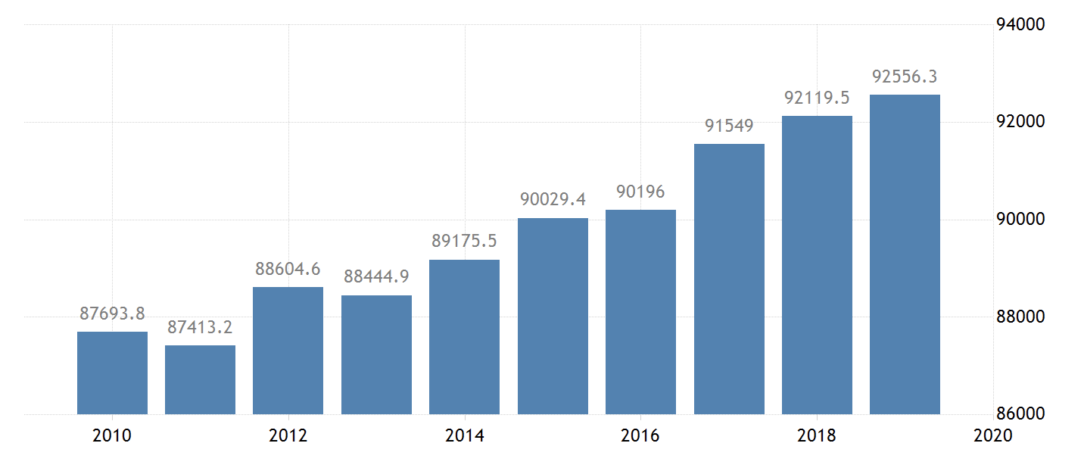
Norway’s GDP per capita
(Taken from Trading Economics Norway GDP per capita. Retrieved, Nov 13,2020)

Additionally, Norway has a total GDP of $403.34 billion as of 2019 (Trading Economics, 2020) see Table 2. Lately, it has obviously been declining a bit because of the global situation with the Coronavirus. Although that is the case, Norway should be a secure place to enter into considering some uncertainties that might occur.
Table 2
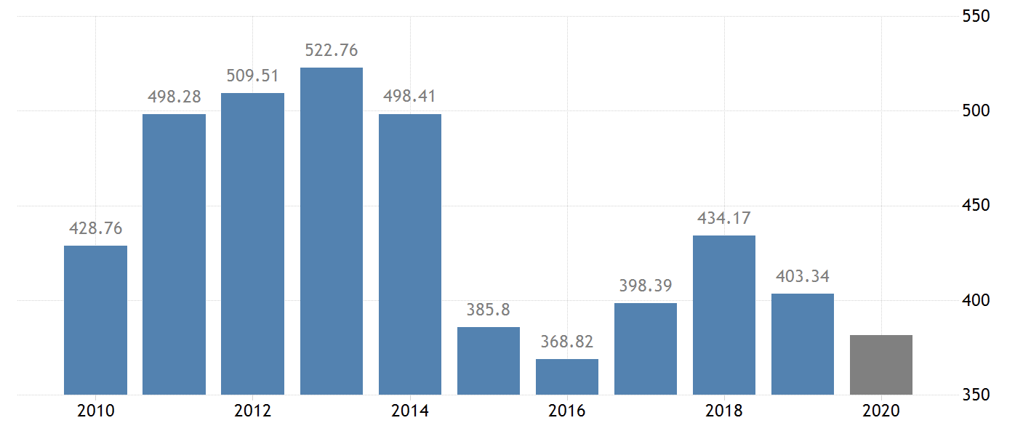
Norway’s GDP

(Taken from Trading Economics Norway GDP. Retrieved, Nov 13, 2020)
Also, the unemployment rate has been at a constant level all the way down to 3.7% as of January 2020 (Trading Economics, 2020) up until the recent periods were the COVID-19 pandemic has affected this massively. See Table 3. From January 2020 with 3.7%, the unemployment rate has increase to 5.3% measured again in August 2020. All in all, these numbers show confidently that the Norwegian economy is well developed and certainly competitive.
Table 3
Norway’s Unemployment Rate
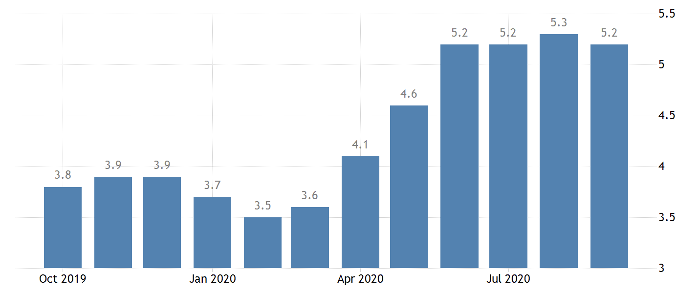
(Taken from Trading Economics Norway Unemployment Rate. Retrieved, Nov 14, 2020)

Financial conditions
The financial conditions and situation in Norway are very stable and very attractive. For any person that is struggling in any other country, Norway is the imaginable place to be or get a job. Not only is it good from a private person point of view, it’s also good conditions for business activity, no matter domestic or international. The company of Panera Bread will obviously invest their money into opening the first locations in Norway, even though bank loans and any other type of financing sources are trustworthy and safe. A big impact which also improves these conditions is the quality of life of Norwegians, which are documented to be one of the happiest people in the world. A big factor in this is the public social safety among the population and the standard income levels. This is to protect the welfare of the state and its people. This ensures Panera Bread to confidently enter a competitive food retail market, backed by financial safety nets to ensure sustainable start-up phase and establishment.

Economic data that highly correlates with the market demand
In Norway there has always been a relationship between the supplier of food retail stores, farmers, and the government. In Norway farming families have slightly been subsidized in some occasions. This is to keep Norway as self-sufficient as possible and use own suppliers as far as it goes. Bringing in a competitor such as Panera Bread, will most likely increase competition, prices and operations. An area in which Norway must improve is the responsiveness and handling large volume orders more efficiently. As I stated earlier, Norway is also growing towards more “convenience and alternative ways to buy food” (Dreyer et al., 2015). A result of this, Panera Bread can cooperate closely with suppliers to create cost-friendly deals and fast establish themselves in the Norwegian economy. Furthermore, Panera can introduce new jobs, showing Norwegians how operations and management are done effective and efficiently with the U.S guidelines. This is a major learning area for the Norwegian industry and market, where Americans are far ahead.

Political and Legal Screening

Type of Government
When it comes to how Norway is governed, the country is a parliamentary representative democratic constitutional monarchy. This is led through the prime minister and his/her party, chosen by the people. The power that comes with the monarchy is divided into three separate entities, with the purpose of divide the power and prevent power abuse. The King and Queen are the symbol of the monarchy but doesn’t really have a lot of power alone. All this is to ensure political stability, so nobody can make drastically decisions without informing the other governmental entities.

Entry Barriers
The political system in Norway is something that most Norwegians are very satisfied with. In terms of political stability, Norway is perfect for Panera Bread. It will simplify the way of entering the market and decrease the possibility of uncertainties. Considering Norway’s stable government and political status, there is very unreasonable to expect either an economic or political collapse. The only thing Panera Bread needs to enter the market is to “register the business with an organization number” (The Norwegian Tax Administration, 2020), so the government can track the activity. Making sure taxes, pension, and employment terms are being maintained and filled with the right legal procedures. Every organization are required and need this number, no matter if it is an international or national organization. Considering this is the main entry requirement, it will be easy and effective for Panera Bread to expand business to Norway as a franchise. The country doesn’t only have decent approaches to international businesses, but as we have seen it also have the proper economic and political sustainability for Panera to potentially succeed.

Profit transfer barriers
Even though it seems everything is perfect for Panera Bread to just enter the market, there are some barriers they also have to consider. Norway is also a heavy regulated country when it comes to the government’s role in the public sector. It is not like the U.S were complete competition can be compared, because many businesses here are protected and subsidized. This is mostly to protect national businesses and to actually protect what is Norwegian. This is not something Panera Bread should be very concerned about, but they need to be aware that the country is not complete capitalistic, but in a mix between a socialist- and non-socialist view. This view has been decreasing over the last years, but people are more open to higher competition and privately-owned companies than before. This is, in fact, on the country’s agenda at the moment. The reason for that is because Norway have for a long time been protected by the oil fund. Although this has been sort of a safety fund for our country, people understand that also Norway needs to become more competitive. Norway cannot rely on the oil fund forever, and business activity such as Panera Bread establish a franchising strategy into Norway can improve the competition and put the profit motive on Norway’s agenda.

Political risk
As we concluded with earlier there are minimal political risk and uncertainty by expanding business to Norway. It is a people with high values and a system you can trust. Corruption is almost non-existent with Norway as the “7th least corrupted country in the world” (Corruption Perception Index, 2020). Additionally, there are few loopholes and opportunities for illegal business activity to even happen. This is the positive aspect of having the government involved, because they can control and prevent illegal activity from happening.

Socio-cultural Screening

Demographic data
As stated in the beginning, Norway is located in Northern Europe, a small elongated country with a resourceful coastline. Norway has approximately 5.43 million people spread out over 19 states, and numerous small counties (Demographics of Norway, 2020). Furthermore, as of 2017 the life expectancy for the average Norwegian is 83 years which are a result of multiple factors. Some of the factors are the high standard of living, high educational levels, technological development, and focus on free universal healthcare. Norway is also a country that is constantly developing, and our oil fund makes us strong and stable within the international business. As of 2015, immigrants stand for approximately 13 percent of the Norwegian population. This gives Norway cultural diversity, which is an important factor for growth and better cultural understanding.

Religion
The main religion in Norway is Christianity which concludes to around 69.9 percent (Religion in Norway, 2020). Immigrants has also brought their native religion such as Islam when coming from their country of origin. This has helped Norway grow into a more diverse and multicultural society. Even though many states themselves as Christian, Norwegians are not a very practicing people when it comes to religion. Most people are baptized and confirmed in the Norwegian church, but other than that not really concerned about religion. Having immigrants coming into Norway improves cultural knowledge and peoples understanding of how different cultures work, which is important so people can learn early how to live and respect each other.

Social structure
Norway is a traditional country and proud of themselves and their flag. Our ancestors had to fight for our freedom during the second world war. This, together with the resource advantages Norway have, the average Norwegian belongs to the middle class. The social structure in Norway is that the living standard is relatively high and the gap is short between rich and poor. Compared to other countries and social structures, Norwegians are lucky to be protected with the socialistic aspects of our country, together with the opportunity to succeed (which has become much better than it was). With high income levels and legal and governmental protection it is rare for someone to fall through the system, although that happens too. It is not like Norway doesn’t have any issues but compared to others the social structure is very strong in Norway.

Education and Language
Education is mandatory up until high school and every Norwegian has a right for education. The government has set up a public entity so that every Norwegian that wants to strive for higher education can apply for loan and grant. All of this concludes to Norway having a high level of education. The mother tongue of Norwegians is naturally Norwegian, but everyone has to learn English and have one more elected language after middle school. This is very beneficial for us considering the world and business is becoming more globalized than ever.

Relevance of data to your product-market
Panera Bread is already established in a more socio-cultured country than Norway considering. Which gives them an easy approach when it comes to what they offer in terms of diversity in religion and culture. What is going to be new for them is that Panera Bread is going to be available to every Norwegian, no matter the prize. Since labor costs are higher, and generally Norway being one of the costliest countries to live in, Panera can charge higher prizes. Eventually, the standard of each store is going to be high considering the high standard of technology, infrastructure, and lastly because Norwegians are so picky Panera has to focus on how everything looks from the outside.

Competitive Screening

Number, size and financial strength of competition
As the Norwegian country is a well-developed country and highly industrialized, it is natural that Norway has already been exposed to the western ideology. In the way we do business, the way we live and the way we eat. Almost every Norwegian have access to social media, broadcast television, commercials etc. and this introduces the new innovations and new ways of living all the from the U.S. This has enabled Norwegians to experiment and try out new ways to eat, but also eating habits. People tend to be willing to pay “higher prices for good experiences when it comes to food” (AksjeInvest “Stock Invest”, 2020). Not as many Norwegians make their own dinner at home as it used to be which comes from multiple factors. Some of them is because the restaurant and fast food supply is increasing. Because when the supply wasn’t there, people couldn’t even though they wanted to. Another is that Norway is increasing in population and brings in different cultures with different eating habits. A study shows that number of restaurant and mobile food service have doubled over 10 years, from 2008 to 2018 (Lock, 2019). This means that competition and financial strength is stronger than ever in Norway, and it is also growing in number and size. This is a good thing for Panera Bread, considering they not being totally foreign as an international business entering another industry in another country.

Market share distribution
At a global level there is a “clear lead from McDonalds (21.4%) over the others within the fast food industry” (T4, 2020). Followed by Starbucks (7.52%), KFC (2.82%), Subway (2.8%), Domino’s Pizza (1.57%), Pizza Hut (1.24%), and Burger King (1.16). Except from KFC, all these have in common that they are already established in Norway. For Panera Bread to increase their market share it is time for them to expand business overseas. As we have studied above, they have a much higher potential to grow in Norway and even Europe for that matter. Compared to its competitors Panera is the European answer on fast food. The fast food market is also set to continuously grow in terms of revenue, reaching $691 billion in 2022. If you look at the global market share compared to the market in Norway, Burger King just surpassed McDonalds in locations. Considering McDonalds broke the ice of bringing fast food international, Norwegians doesn’t care what has been the longest or what is the biggest chain. They go for what they think tastes better and looks better, which is an enormous opportunity for Panera.

Entry strategy by competitors
The most common entry strategy among the competitors is franchising. It is a low-cost and fast entry model for international businesses. Especially effective in the fast food industry. This would also be the optimal solution for Panera Bread as well, getting fast access to a new market and low entry barriers. The they can use local labor, which will smoothen the cultural shift. Panera Bread will lose some brand control, but this will be more effective with local entrepreneurs or companies to expand Panera’s business. This will also be very helpful in terms of making supplier deals and distribution easier. As a franchise you give a lot of responsibility, but results have shown that this works in Norway, and should be trustworthy and profitable.

Quality of products
Source and quality of the product or service Panera Bread will offer, needs to be locally raised and prepared right. Going back in the study we know that Norwegians are pickier than others and therefore high quality is required. But Panera would have no issue with this. The market Panera can use for buying raw materials and ingredients are perfect for them. Norway is working towards short-distance food and fair manufactured resources. With Panera’s versatility in products that they offer, in addition to their in-store quality they will succeed.

Pricing policies
Pricing will be an important part of Panera’s marketing and vital to attract customers. As a fast-casual food store you can’t charge the highest prices, because that takes away some of the idea of the fast food experience. Panera Bread have excellent experiences with pricing in the U.S, but it might be a bit different in Norway. But in a sense, I feel Panera Bread doesn’t charge their prices very cheap in the U.S either. Anyway, in Norway people will definitely be more open to higher prices, if they feel it is worth it. The entry pricing strategy needs to be high enough to make profit, but also balanced so customer actually decides to try. If they see something, they want to try but the prices are too high, it results in a lot of customer lost. Compared to McDonalds, Panera Bread could definitely charge higher prices. The reason for that is because their menu and quality on the food is higher standard, and they have a more limited-edition atmosphere than McDonalds. Panera is going to bring something new to this market. If you don’t like what they offer at McDonalds, then you could just head over to Burger King. You can’t do that with Panera.

After sales services
Furthermore, Panera Bread is going to be well equipped with online, mobile and delivery solutions. They will have customer Wi-Fi, and self-order checkout systems. These are factors Norwegians love. They love to make things easy and effective. Additionally, because of the high standard of living this is not going to cut off a part of the customer pool or leave some of the target market out. This will only benefit Panera and the consumer.

Distribution channels
Distribution will happen through multiple channels, and it will happen chain wide. In-store menus will clearly label new food menu options and what Panera has to offer. Whereas digital and mobile marketing will additionally promote the availability of these new food menu options. We target a big market and looking to get as many new as we want repeat customers as well. Our goal is to optimize distribution so that most people can feel the simplicity of ordering from Panera, that they want to come back.

Market coverage
Market coverage is another important aspect of Panera Bread marketing and establishment phase. Panera should be looking at an undifferentiated approach which takes the broadest and most common approach towards what the consumer wants and should see. As Panera’s target market is very broad and their services would not change considering locations, this would be the direction to reach most people and to cover most of the applicable and selected target pools.

Ethical Issues
When you are running a fast food store or a fast-casual store which Panera Bread is categorized as, there are unfortunately some issue concerning the ethical standpoint. Although Panera Bread is one of the healthy and alternative ways of doing fast food, they still need to consider some ethical issues. Panera Bread, as a big, soon-to-be, international fast food organization has some social responsibilities and values they need to stand behind.
Among that, Panera bread has constantly been working hard to raise the food without Anti-Biotics, and that the chicken that produces the eggs are cage-free, vegetarian fed, and no antibiotics ever. They also established in 2010 a non-profit foundation called Panera Cares. This foundation used a “pay what you can” price tactic to welcome and broaden their customer base even further. These are all closed down now in 2020. Additionally, they also gave back to the community with their Day-End Dough-Nation program, which was set to give all unsold bread and baked goods to local charities and hunger shelters. Lastly, Panera states that their menu is 100 percent clean of genetically modified organisms and other artificial additives.
These are all aspects Panera Bread can bring into their business strategy in Norway too. The Norwegian people are very concerned with reputation of business and chose not only because they like their food but also because they stand for something. Norwegians believe they live in a better world than many other people, which is true, and therefore many has found an interest in supporting and doing what they can do on a daily business. Norway has lately been very concerned about environment and making green choices, and this is one part I believe Panera should engage in. Being environmentally friendly in daily operations, and production and transportation. If Panera doesn’t care about these things, they can fast get a bad reputation, which is not very hard in Norway because of the small population.

Final Screening

Reason for the selection of country
First and foremost, the biggest factor that steered me into choosing Norway as the country where Panera Bread should expand their business internationally, was primarily because that is my home country and I know how the culture, people, and economy is in this situation. If Panera bread was to expand business to Norway, this is the country I can have an idea of what to expect from and how it would be received. Taking that out of account, Norway or some other Northern European country would actually be an optimal place for Panera Bread to go global. It fits within every aspect of what the people would want, and also how the eating habits of also Europeans are changing. Furthermore, the reason I chose Panera Bread was because that is one of my favorite fast-casual restaurants in the U.S and I think it is a much better and healthier option than other fast food chains. I think it is a step up when it comes to doing fast restaurant business. I also had to think about what a good fit between the organization and the chosen country it should go international to, and as I have stated multiple times it is really potential in this idea. Additionally, I had to consider something that was different and not really established there before, because there are a lot of western/American based franchised chains in Europe already. Since Panera Bread only operates in the U.S and Canada, it would be exciting to see something that is only in North America going to Europe.

Conduct further research
I plan to conduct my further research by watching trends within the industry, and how the Norwegians keep their habits. It is mostly viewable in the biggest cities like Oslo that society is changing this way, if it is for the good or the worse, I don’t know yet. But it definitely will keep increasing competition in the country and maybe allow Norway to act more independently from the oil fund and economic safety nets. I also want to see how operations and growth goes for Panera Bread in the future, and how they plan to further develop and innovate their ideas to satisfy the consumer as times changes. This is especially exciting in times like this with a pandemic how restaurant and food business needs to adapt to huge changes in how people can access food and their usual schedules. Most people would probably take advantage of more distant suggestions like online food orders and pick-up options. This is obviously been around for a while, but maybe now it’s even more important to focus resources towards this area.

Conclusion and Recommendations
Taking all these viewpoints, studies, and facts into account, I am confident stating that Norway would be a sustainable and profitable country to start the U.S based company Panera Bread. The economic status of Norway and the political stability is a calming factor to show this is a good place to start a business. Norway is at the top when it comes to GDP, technology, distributive resources, income per person, and also growing within export and import. Additionally, Norway has a positive trade balance, which shows the healthy economy of this country. High educated people mean they make smarter and better decisions, and Panera Bread would be one of those smarter decisions for people going for fast food.
Norway is very safe from a political perspective. Panera can trust the system, without any concerns for instability and illegal activity. They can be certain of joining a sustainable and protected environment, with little to no corruption. Few entry barriers and Norway are experienced with international businesses, which shows that it is very including.
To sum up, Panera Bread should be excited to start the new business in Norway and the opportunities that comes with it. After this, Panera should be aware of what is required and what to expect. As long as the commitment is there, it should be nothing standing in their way of making a profitable business. Using the right marketing approaches and demographics analysis it should be a competitive startup phase, which will later on conclude to a stable and balanced business, with growing market share and growing customers. Uncertainties and obstacles will always be there, but at Panera that is what keeps them developing and getting better, improving the effectiveness and efficiency of the business.

Work cited
Ang, Carmen. (2020). Ranked: The 50 Most Popular Fast Food Chains in America. Visual Capitalist. Retrieved November 12, 2020, from https://www.visualcapitalist.com/top-50-fast-food-chains-ranked/

Kolhatkar, Sheelah. (2018). The Founder of Panera Bread Explains the Economic Forces that led to Trump. The New Yorker. Retrieved November 12, 2020, from https://www.newyorker.com/business/currency/the-founder-of-panera-bread-explains-the-economic-forces-that-led-to-trump

Coastline of Norway. (Last edited, 2020, March 4). Wikipedia. Retrieved November 12, 2020, from https://en.wikipedia.org/wiki/Coastline_of_Norway

List of urban areas in Norway by population. (Last edited, 2020, November 9). Wikipedia. Retrieved November 12, 2020, from https://en.wikipedia.org/wiki/List_of_urban_areas_in_Norway_by_population

Norway GDP per capita. (Last edited, 2020, November 13). Trading Economics. Retrieved November 13, 2020, from https://tradingeconomics.com/norway/gdp-per-capita

Norway GDP. (Last edited, 2020, November 13). Trading Economics. Retrieved November 13, 2020, from https://tradingeconomics.com/norway/gdp

Norway Unemployment Rate. Last edited, 2020, November 14). Trading Economics. Retrieved November 14, 2020, from https://tradingeconomics.com/norway/unemployment-rate

Dreyer, H. C., Swahn, N., Kiil, K., Strandhagen, O., & Romsdal, A. (2015). The Responsiveness of Food Retail Supply Chains: A Norwegian Case Study. Retrieved, November 14, 2020, from https://ntnuopen.ntnu.no/ntnu-xmlui/bitstream/handle/11250/2476132/APMS%2BDreyer_vfinal.pdf?sequence=2

Registration obligations for foreign limited companies in Norway. (Last edited, 2020, November 15). The Norwegian Tax Administration. Retrieved November 15, 2020, from https://www.skatteetaten.no/en/business-and-organisation/foreign/foreign-companies/registration-obligation/registration-obligations-for-foreign-businesses-in-norway/

Corruption Perception Index. (Last edited, 2020, November 15). Wikipedia. Retrieved November 15, 2020, from https://en.wikipedia.org/wiki/Corruption_Perceptions_Index

Demographics of Norway. (Last edited, 2020, November 15). Wikipedia. Retrieved November 15, 2020, from https://en.wikipedia.org/wiki/Demographics_of_Norway

Religion in Norway. (Last edited, 2020, October 16). Wikipedia. Retrieved November 15, 2020, from https://en.wikipedia.org/wiki/Religion_in_Norway

AksjeInvest. (2020). Fast food – fast profit “fixed profit”. AksjeInvest. Retrieved November 15, 2020, from http://www.aksjeinvest.no/fast-food-fast-profitt/

Lock, S. (2019). Number of enterprises in the restaurant and mobile food service industry in Norway from 2008 to 2018. Retrieved November 15, 2020, from https://www.statista.com/statistics/697728/number-of-restaurants-and-mobile-food-service-enterprises-in-norway/

Fast Food Market Share. (Last edited, 2020, August 16). T4. Retrieved November 15, 2020, from https://www.t4.ai/industry/fast-food-market-share

