Name:
Date:
Chosen Product: Pepsi Mini Cans, 7.5 Ounce, 10 Count
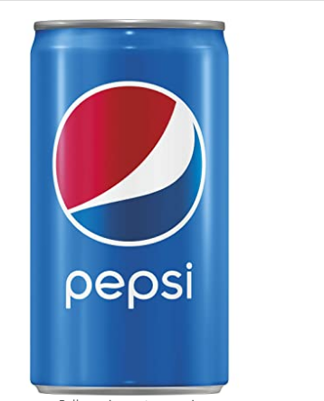
The labelled sugar composition is 41 grams
In 7.5 Ounce, 10 Count of Pepsi soda there are X ounces of sugar;
Where X= 11.25 (amount of sugar in 10 count)/7.5 (amount of sugar in a single can) X 41g
=7.5/11.25 X 41 g
=27 grams of sugar in a single can
Since 1 teaspoonful is equivalent to 4 grams of sugar, 1 can of Pepsi soda has
27/4 = 6.75 teaspoonful of sugar.
The sugar composition is slightly above the females’ daily recommended sugar composition amount (6 teaspoonful) but is within the range of males’ daily recommended sugar composition amount (9 teaspoonful).

