PhET Energy Skate Park
Student’s Name
Institutional Affiliation

- Kinetic Energy is energy possessed by an object in motion.
- Gravitational potential Energy is energy possessed by a body due to its position in a gravitational field.
- , 4, 5, & 6 were followed as instructions.
7.

Position of Skater | Pie Chart | Bar Graph
6 m |  | Kinetic = o  Potential = Max  Thermal = 0  Total = 0

9. (a) 
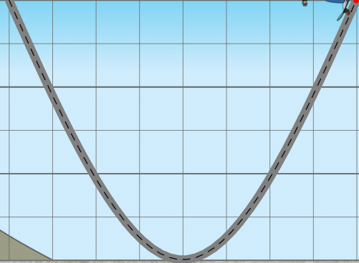

(b)
10. When the skater moves fast, Kinetic energy increases | 11. When the skater is above the ground, Potential energy is great. | 12. When Potential energy increases, Kinetic energy decreases. It is true that the total energy is always constant.

13. Initial gravitational energy is 1770.5 J
14. Gravitational Potential Energy at 3 meters is half the potential at 6 m.
15. The gravitation potential at 30 kg and at 60 kg is relatively same in magnitude.
16. The gravitational potential energy in Jupiter is 4,406 J and 1739 J on earth.
17. E = m g h = 60 × 9.8 × 6 = 3,528J
18. A the bottom of the track, all his energy is 1741 J.
19. Kinetic energy at the bottom of the track is 1741 J.
20. At m =50 kg and h = 5m, E = m g h = 50 × 5 × 9.8 = 2450 J
21. E = ¹/₂mv², 2450 = 0.5 × 50 × v²
v = 9.899 m/s
22. When the friction is turned up, the skater slows down to a gradual stop, and the energy gradually decreases to zero.
23. While using several loops, it’s notable that;
- In order for the skater not to fall off, he/she has to start from a position equal or lower to the lowest end of the path.
- The total energy is maintained provided that friction is minimum. When friction is applied, the energy gradually decreases to zero.

