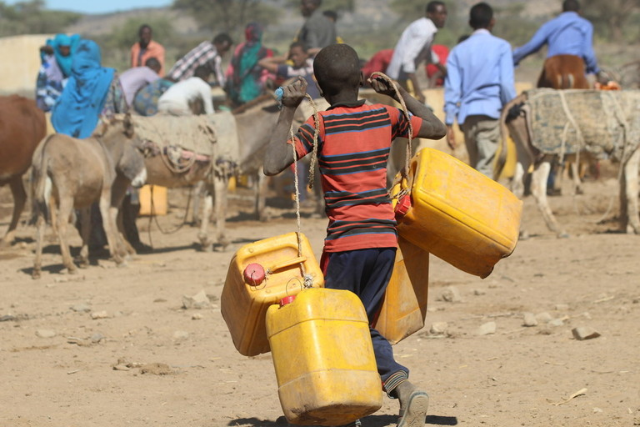
Photography analysis
Student name
Institution affiliation
Date

Every photograph is different. They contain small but important aspects that a normal person would not see. Effective analysis of any photograph involves the visualization of the different visible elements, performing technical analysis on the seen elements, narratively contextualizing the photo by using all the identified elements, and interpretation of the image based on the individual's feelings. Therefore, this paper focus on the analysis of the above photograph taken by the African leadership magazine. The photograph was taken by Katy Migiro, a writer of African leadership magazine to probably show the effects of the El Nino and drought. The photo shows a possible international program intervention that was developed to support the communities affected by drought. That is, the photograph shows people gathering at a motorized borehole to gather water since the temperatures are high leading to shortages of food, and water.
The photograph was taken at midday, probably between 11.30 am to 1.30 pm since the shadow of the boy is directly below them. The ground is dry and the donkey is thinner than it should be suggesting that the photo was taken during or immediately after the drought season. The climate of the area is dry with high temperatures due to a lack of vegetation. The landscape of the photograph suggests that the area is either arid, semi-arid, or a desert, in the areas around Somali, Somaliland, or Namibia in Africa.
Diversity in photography shows different features and characteristics of an individual. For instance, the photograph shows that the people are Africans. The women are covered in a hijab while some people are wearing normal modern clothes thus, showing the possibility of different religions in the area. That is, the religions may involve both Christians and Muslims. The people have gathered at one place, most of them carrying buckets and jerricans, suggesting that they are fetching water. The presence of donkeys also suggests that they are fetching something since donkeys are the major transportation medium in arid areas of Africa. This activity is carried out by people of different ages, and gender. The photo shows a young boy, youths, and middle-aged people. The photo also shows different aspects of poverty in that particular area because they have to fetch water using their hand and donkeys.
The major question that comes to mind when I look at this photo is whether the water, they were fetching was enough to keep everybody satisfied. This is because during droughts or in desert areas, a lot of water sources dry up including oases and temporary boreholes. My comprehension of climate, landscapes, and climatic change, its causes, its effects, and effective intervention methods helped me better interpret the photo. That is, my understanding that boreholes and dams are usually constructed in deserts to help aid in irrigation and water issues allowed me to understand that they were fetching water from either a dam or a borehole.
To improve the effectiveness of the photograph to the people, the photo should have included an aspect or element showing how domestic animals have been affected by drought. Moreover, since the photo shows the after-effects of drought, the photo should have included more malnourished people and animals to show the intensity of the drought.
In conclusion, the nations in the horn of Africa and hit by drought now and then, and approximately fifteen million people end u losing their lives, there are food shortages, and a lack of enough water due to the drying of rivers, lakes, oases, and rivers. Thus, an analysis of a photograph can help in a better understanding of physical geography and different economic activities.

Reference
Photo link: https://www.africanleadershipmagazine.co.uk/wp-content/uploads/2017/03/RS16044_Drought-affected-communities-gathered-at-a-motorized-shallow-well-constructed-by-CARE-during-the-El-nino-drought-in-2016_Photo_Cambe_Jan-2017.JPG_JPG-tw.jpg

