The Photography of Pierre Muckensturm
Name
Institution
Date

This essay discusses the photography of Pierre Muckensturm. Pierre is a French photographer who was born in Strasbourg in 1970. After training as a Geography teacher, Pierre met Jean Jerome, an art professor at the University of Strasbourg who greatly influenced Pierre to become an artist. Between, 1994 and 2004, Pierre had done a lot of artworks and he put them into one collection and now most of his arts are on display in the Lazarew Gallery in Paris-Bruzelles.
I have chosen three works of art from Pierre of which this essay will analyze. The three works of art are 191J24019, 191j24011, and 191j24017. I chose the three, among many, from Pierre’s photography because I believe they connect with this course’s themes of space and geometry. Pierre does well in manipulating space and arrangement objects so that he can challenge the perception of the viewer (Mactoux et al., 2019). Additionally, Pierre’s works are based on a visual language that is built around softly texture surfaces as well as a muted black and white palette and that makes his works have strong connections to this course.

Main Visual elements in each photo
191j24019
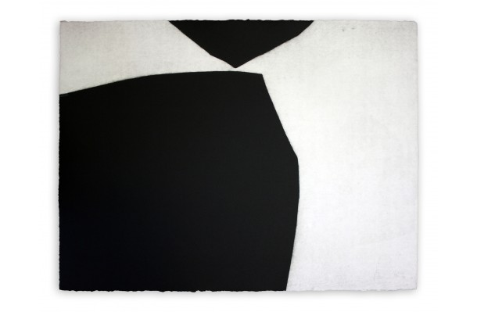
In this work of art, several visual elements can be discovered. For instance, the use of line in the artwork reveals two distant objects which are close to each other. The line also is used to show sharp edges and it is as if the two objects in the artworks will collide but most of Pierre’s artworks suggest calmness, the straight lines reveal calmness (Young, 2021). The shape in the artwork is also manifested by the angles which also express stability. Another important element in the artwork is tone. In the 191j24019 artwork, there are dark and bright colors which Pierre exploits to bring about contrast.

191j24011
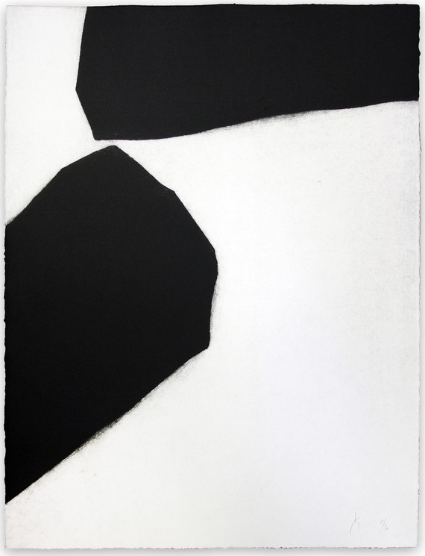

Pierre added 191j24011 to his oeuvre in 2010 and is on display and can be sold to the rest of the world. Several visual elements can be perceived from the artwork. First, there is the use of black and white colors to bring about distinction just like in any/all of his artworks. Texture in this artwork is experienced optically and it is smooth and the objects in this drawing are verisimilitude and two dark parks of the painting look antagonizing (Thelander & Cassinger, 2017). The idea of shape also comes into play in this painting which is visibly irregular and in 3D and therefore it is abstract and representational. The perspectives of the shapes in the drawing do not change concerning the position of viewing.
191j24017
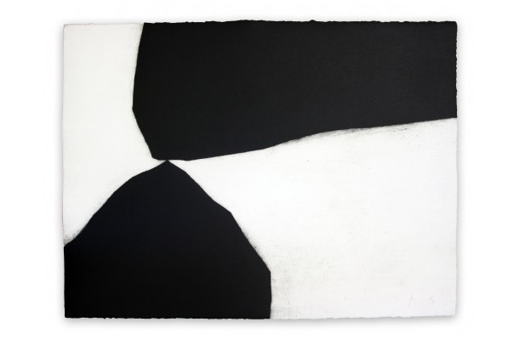
Unlike the other two artworks, 191j24017 is different because the two objects in the artwork are in contact. The tone in the drawing is dark and the darkness distinguishes the two shapes from the plane where they are painted. The use of lines also shows calmness since they are almost straight lines with angles at the tips of the two dark objects. The pattern in the artwork is also man-made which is simply useful for decorative purposes.
The main principles of Pierre’s Photography
The photography of Pierre more or less follows similar principles which why it is easier to relate his photographs amongst each other. Therefore, the engraving and printing process of his photography allows him to explore the aspects of time and perspective (Young, 2021). He is inspired by the photography concepts like calmness, constancy, and temporality whereby his works in all circumstances espouses the aspect of time. The beginnings of his works are gestural marks which, he examines in detail. He continues by transforming them gradually by altering important aspects like line, shape, depth, and orientation over time as well as magnitude.
Pierre’s Technique
Pierre started working with oil which he used to spread over large canvasses. One of his mercurial styles is the ability to separate gestural elements by enlarging them on his photographs to take advantage of the surrounding emptiness. Additionally, he works on the surface with the texture underneath it to achieve the balance of tranquility and intensity (Mactoux et al., 2019). While printing also, he begins with gestural marks, transforms them gradually while exploring how they communicate differently based on size, shape, depth, magnitude, and orientation. His works are inspired by senses of harmony and time and he discovered abstraction in 2004 while on his visit to Notre Dame du Haut. All of his artworks reveal how he felt of his Visit to Notre Dame du Haut, a feeling of tranquility and harmony.

References
Mactoux, M. M., Muckensturm-Poulle, C., Mackowiak, K., Piguet, É. Suarez, D. P., & Labarre, G. (2019). Actualities. Dialogues d'histoire ancienne, 45(1), 291-316.
Thelander, Å. & Cassinger, C. (2017). Brand new images? Implications of Instagram photography for place branding. Media and Communication, 5(4), 6-14.
Young, S. (2021). Citizens of photography: visual activism, social media, and rhetoric of collective action in Cambodia. Southeast Asia Research, 1-19.

