- By considering the equations of the form
u(x,t) = u₀e^{i(kx+wt)} and h(x,t) = h₀e^{i(kx+wt)}

Using the first differential equation we get
u₀wSin(kx+wt) + u₀wCos(kx+wt) + gh₀kSin(kx+wt) + gh₀kCos(kx+wt) = 0 (1)
Using the second differential equation we get
wh₀Sin(kx+wt) + wh₀Cos(kx+wt) + Hu₀kSin(kx+wt) + Hu₀kCos(kx+wt) = 0 (2)

This dispersal relation comes as from equation 1
w = -k(gh₀Sin(kx+wt) + gh₀Cos(kx+wt))/(u₀Sin(kx+wt) + u₀Cos(kx+wt))
w = -k(gh₀Sin(kx+wt) + gh₀Cos(kx+wt))/(u₀( Sin(kx+wt) + Cos(kx+wt)))
w = -kgh₀/u₀ (3)

From equation 2
We get it as w = -kHu₀/h₀ (4)

Using equation 3 and 4,
Hu₀² = gh₀²
u₀/h₀ = sqrt(h/H)

- If the problem is of the form
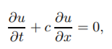 (1)
Then spatial derivative by central difference form is written as
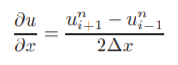 (2)
Now replacing the time derivative with a first order difference as
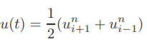 (3)
in the above equation, we get the eqn (1) as
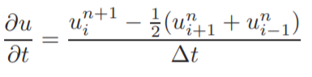 (4)
Substituting equations 2 and 4 in equation 1, we get
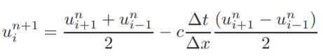
Now assuming the error of the form
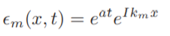, we get
Then the required condition culminates to
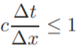
Here in our equations we have c = g and c = H in the respective two partial differential equations.
So, del(T) <= c*del(x)
Maximum value of del(t) is c*del(x)

