1)Define kinematics. What assumption must be true to use kinematics? Write down the most important kinematical equations
ANSWER: The branch of mechanics concerned with motion of object without reference to the force which cause the motion is called kinematics.
Assumptions are:
1)considering (g) as constant both in magnitude and direction
2)there is no resistance due to air
3)the earth is flat.
4)rotation motion of the earth is absent.
IMPORTANT kinematical equations are:
- V=U+at V is final velocity
- S=Ut+1/2at² S is displacement
- V²=U²+2aS t is time required
U is initial velocity.
2) Write down Newton’s 3 Laws of Motion. What assumptions must be made for Newton’s Laws to be valid?
answer: first law of motion: first law state that every object will remain at rest or in uniform motion in a straight line unless compelled to change its state by the action of an external force.
Second law of motion: second law state that acceleration of an object as produced by a net force is directly proportional to the magnitude of the net force, in the same direction as the net force, and inversely proportional to the mass of the object.
Third law of motion: third law state that for every action there is equal and opposite reaction.
1)considering (g) as constant both in magnitude and direction
2)newtons law is valid only in inertial frame.
3)surfaces are usually smooth.
3). What quantities have we learned about that are conserved? What must be true for each to be conserved?
Answer: In mechanics there are 3 fundamental quantities which are conserved.
1)energy (until there is no collision and friction is absent)
2)momentum (until there is no external force on the system)
3)angular momentum (until there is no external torque on the system)
4) A rifle is aimed horizontally at a target 50 m away. The bullet hits 1.25 m below the target. (a) What was the bullet’s flight time? (b) What was the bullet’s speed as it left the barrel?
Answer:
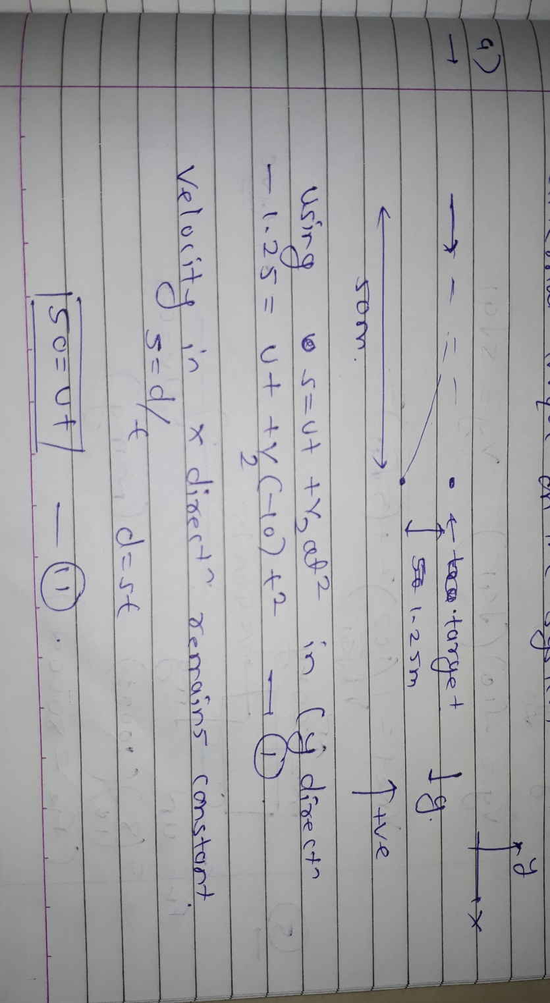
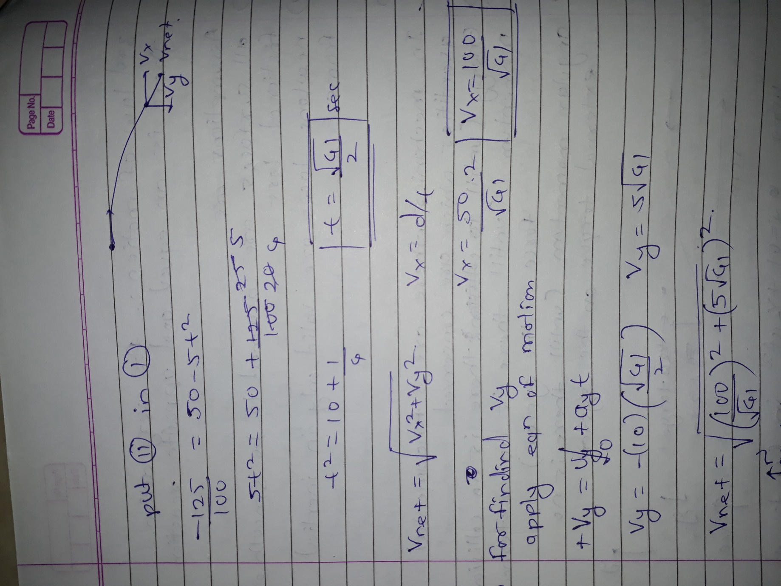
5. A 1000-kg car traveling at a speed of 40 m/s skids to a halt on wet concrete where µk = 0.8. How long are the skid marks?
Answer: 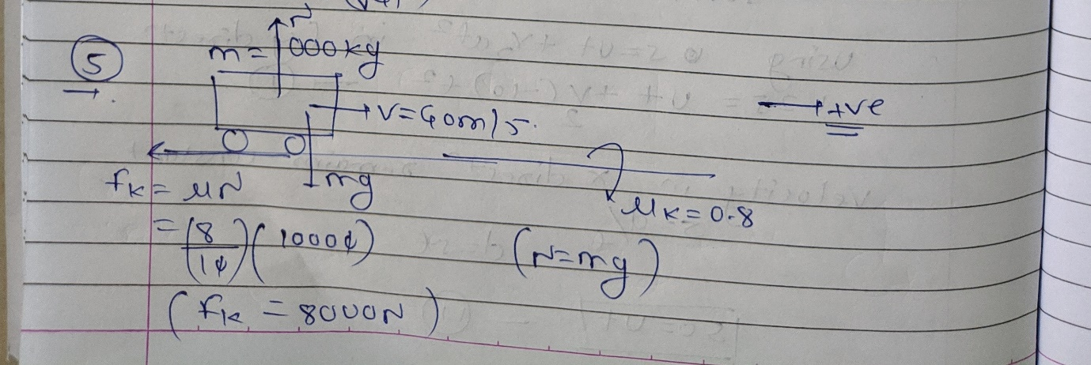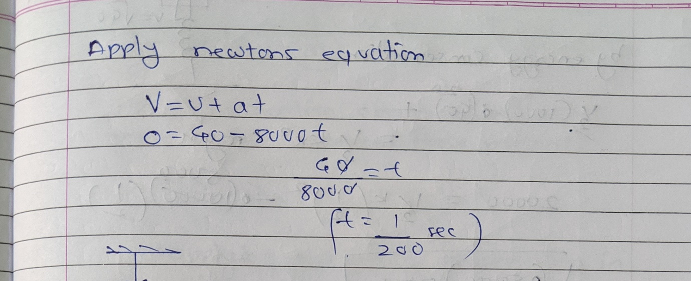
6)A 1000-kg safe is 2 m above a heavy-duty spring when the rope holding the safe breaks. The safe hits the spring and compresses it 50 cm. What is the spring constant of the spring?
Answer: 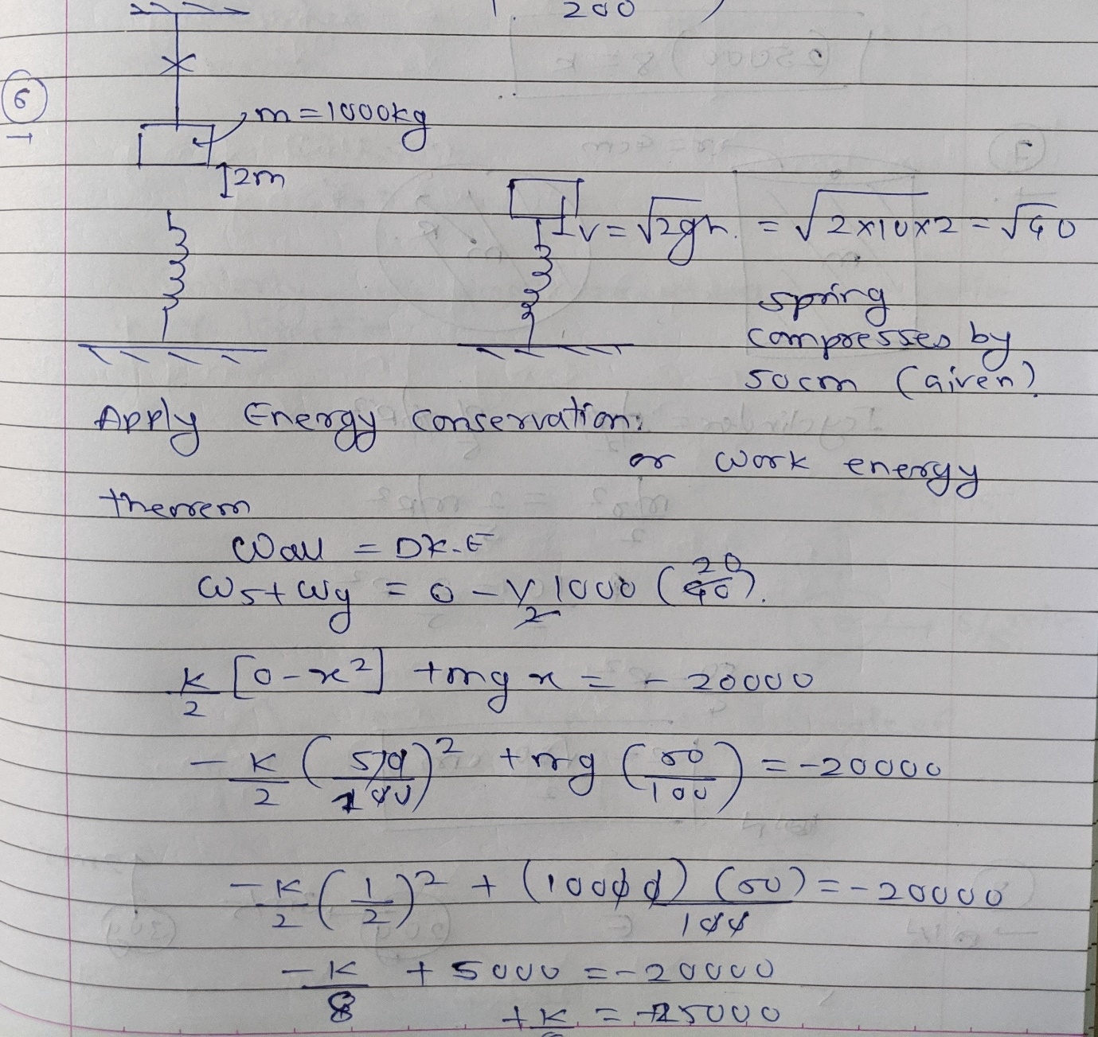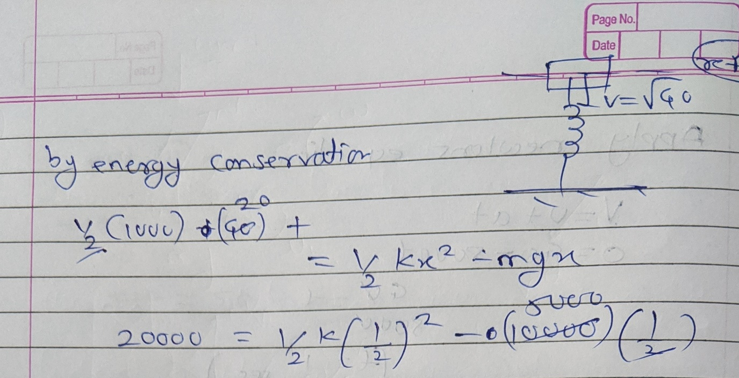
7) . A solid cylinder of radius 4 cm has the same mass as a solid sphere of radius R. If the cylinder and sphere have the same moment of inertia about their centers, what is the sphere’s radius?
Answer: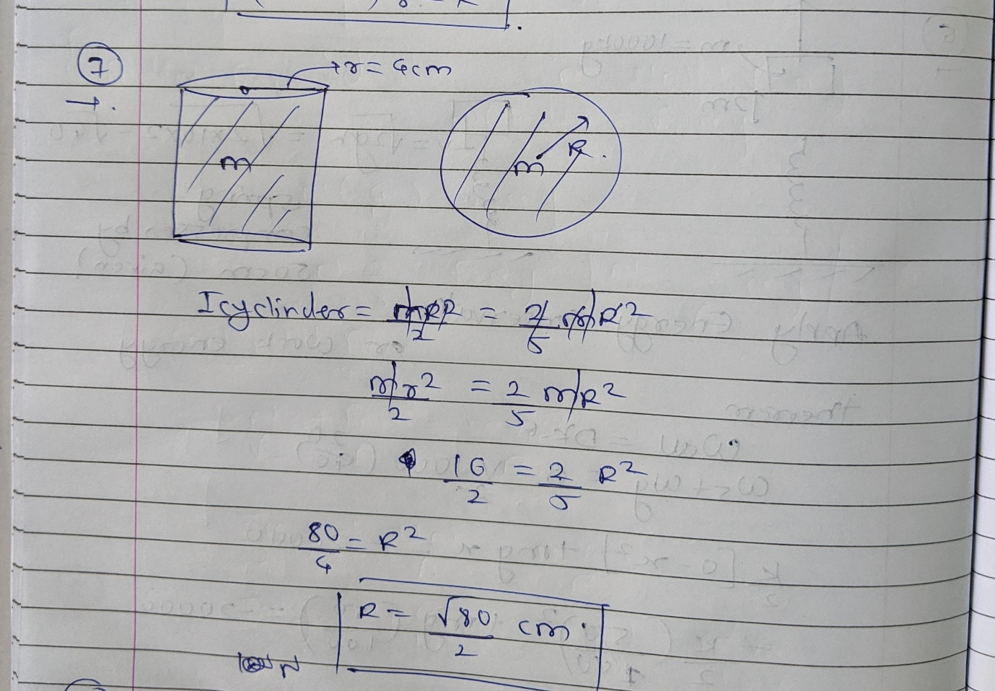
8) A 20-g ball of clay traveling east at 3 m/s collides with a 30-g ball of clay traveling north at 2 m/s. What are the speed and direction of the resulting 50-g blob of clay?
Answer: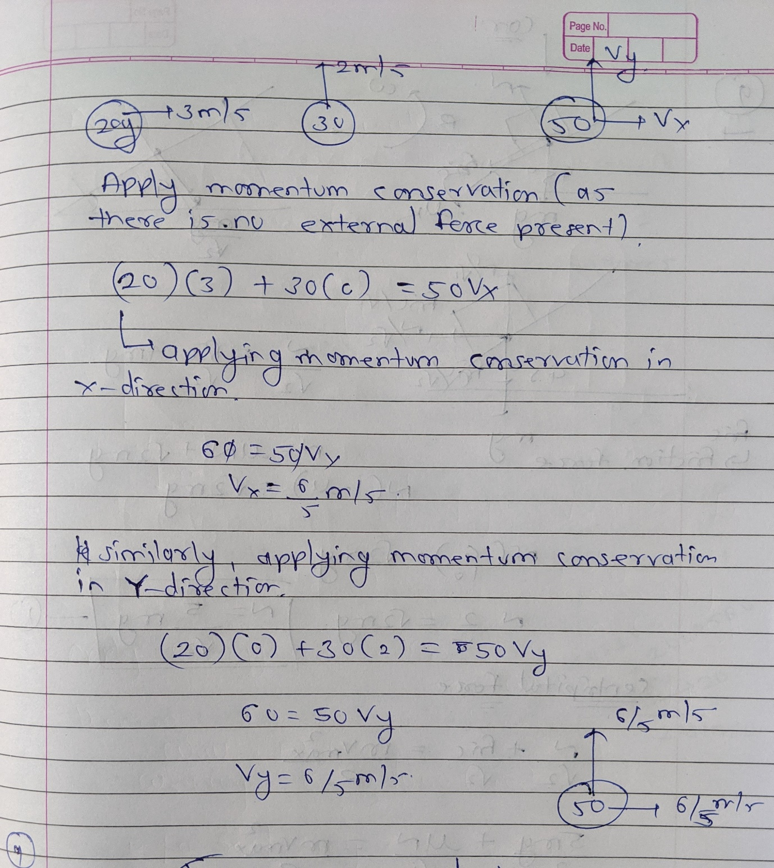
9) A curve at a racetrack has a radius of 100 m and is banked at an angle of 45 degrees. On a rainy day, the coefficient of static friction between the cars’ tires and the track is 0.6. What is the maximum speed at which a car could go around this curve without slipping?
Answer: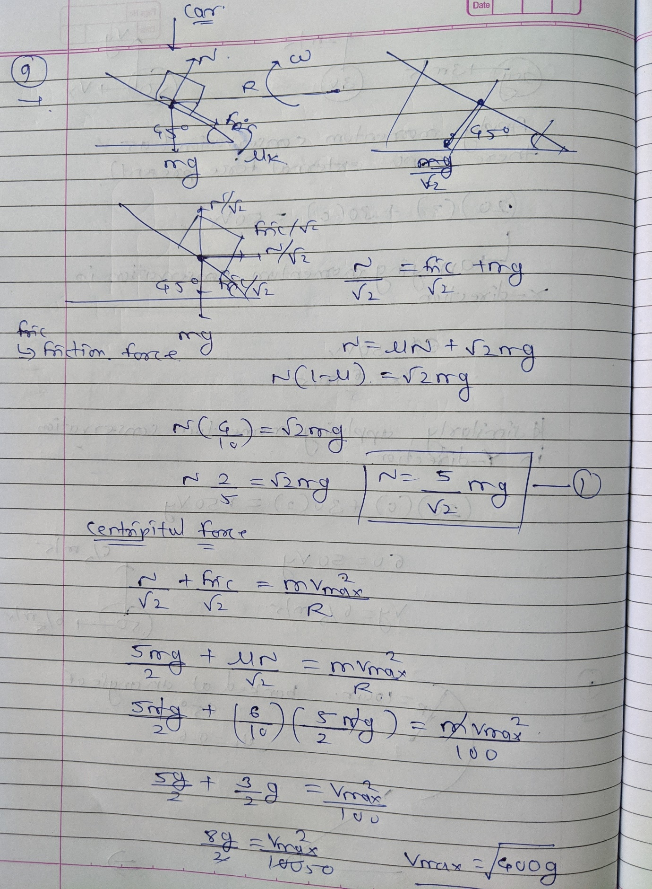
10) Ships A and B leave port together. For the next two hours, ship A travels at 30 mph in a direction 30 degrees west of north while ship B travels 60 degrees east of north at 20 mph. (a) What is the distance between the two ships two hours after they depart? (b) What is the speed of ship A as seen by ship B?
Answer: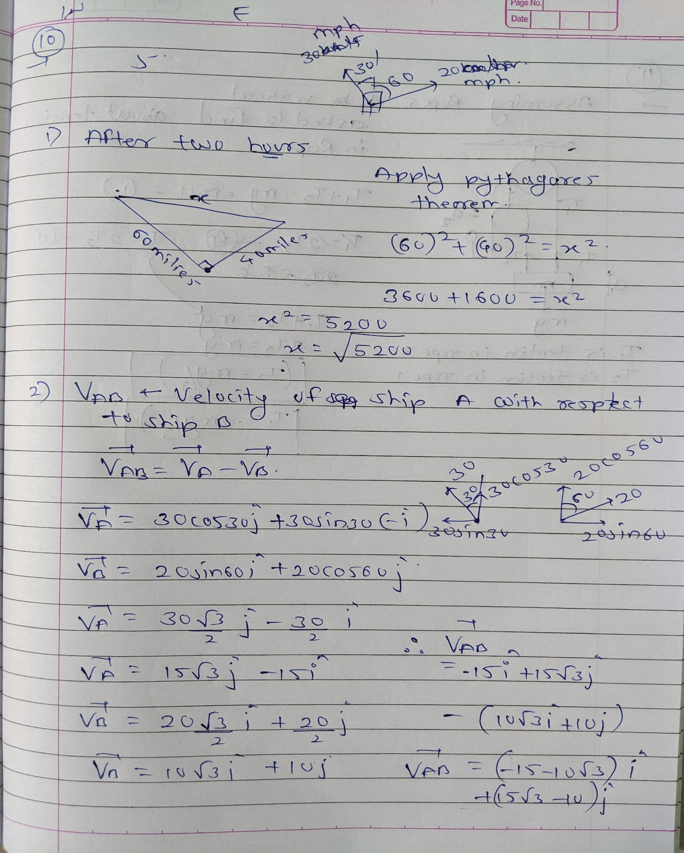
11) In rock climbing, various rope and pulley systems have been devised to help haul up heavy loads, including injured climbers. A rescuer is hauling up an injured climber who has a mass m using the rope and pulley system shown in Figure 1. (The ropes in this figure are drawn at various angles for clarity, but you can assume they’re all vertical). You may assume both pulleys are massless. Write your answers in terms of the mass m and g. (a) What is the tension in rope 1? (b) What is the tension in rope 2?
Answer:
