Physics assignment
1)
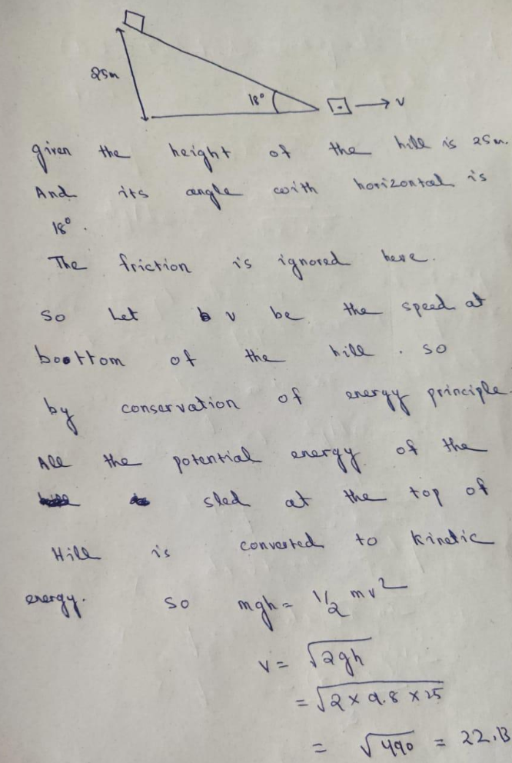
The speed of sled at the bottom of the hill is 22.13m/s .As no friction is acting in the body so the angle has no use in here. The only force here is gravity therefore; I have made the assumption that the bottom of the hill is the potential zero.

2) P1 = m × u
The final momentum
p₂ = m × v
The change in momentum can be expressed as
p₂ – p₁ = (m × v) – (m × u)
p₂ – p₁ = m (v – u)
But we know that the rate of change of momentum with respect to time is proportional to the applied force.
The applied force
F ∝ [m (v – u)]/t
F ∝ m × a
As acceleration (a) = rate of change of velocity with respect to time.
F = k × m × a
Since K is equal to one F=MA
M=4.23X10^3
F=1.8X 10^3+1.3X10^3
F=3.1X10^3
3100N=4230kg x a
.a=3100/4230
0.7329M/s^2
Therefore the acceleration is 0.7329M/s^2 (E 25°N)

