
Plate Log

Date / Time / # | Picture | Exercise
May 2nd 2020  Meal # 1 (Breakf)  Time: 06:35 |   2 Slices of bread (mix grain) = 138 cal (69each)  1 Hard-boiled egg = 78 cal  1 cup Milk low fat 1% = 102 cal  1 teaspoon of instant coffee = 20 cal  1/2 cup Pineapple Raw diced = 39 cal  Total Calories = 377 cal | Vigorous aerobics 30 mins (237 cal)  (15 mins aerobic dancing + 15 mins running)  Walking Fast 4mph 30 mins (161 cal)  Total calories burned in 60 mins = 398 cal
May 2nd 2020  Meal # 2 (Lunch)  Time: 12:28 | 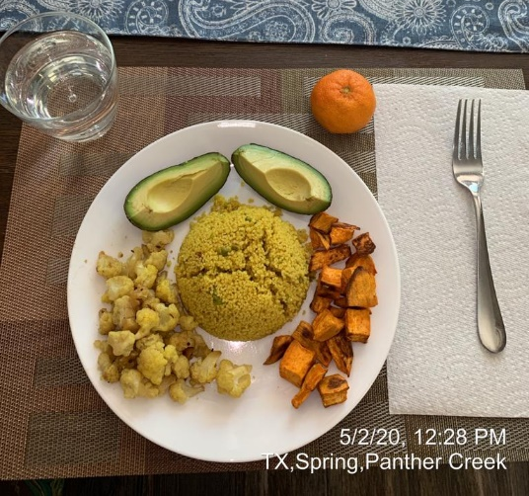  1 cup Couscous = 190 cal  1/2 cup Cauliflower boiled = 14 cal  1/2 cup Sweet Potatoes, baked, peeled = 90 cal  1/2 Avocado = 192 cal  1 Mandarin, Orange Raw = 62 cal  Total Calories = 548 cal | Stationary Cycling  (Vigorous 30 mins) = 331 cal +  Rowing (machine – moderate) = 223 cal  Total calories burned in 60 mins = 554 cal
May 2nd 2020  Meal # 3 (snack)  Time: 16:05 | 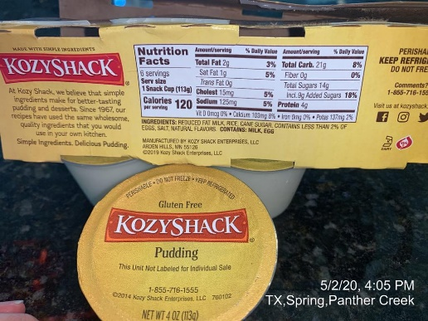  1 snack cup of Rice pudding = 120 cal  Total Calories = 120 cal | Walking (moderate – 3MPH – 129 cal)  Total calories burned in 30 mins = 129 cal
May 2nd 2020  Meal # 3 (dinner)  Time: 19:04 | 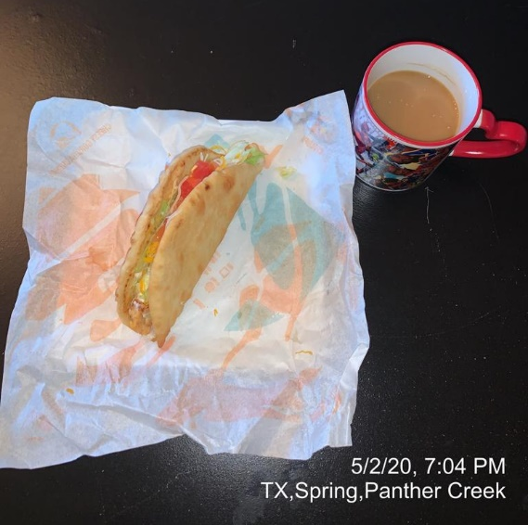  1 Chicken Chalupa Supreme = 360 cal  1 cup (8 F. oz) Instant prepared coffee = 5 cal  1 teaspoon Cream substitute powder = 11 cal  Total Calories = 376 cal | - Vigorous aerobics 30 mins (237 cal)  (15 mins step aerobics 120 steps / min +  15 mins jumping jacks) +  - Swimming fast freestyle 15 mind (152 cal)  Total calories burned in 45 mins = 389 cal

SECOND DAY BELOW…

Date / Time / # | Picture | Exercise
May 3RD 2020  Meal # 1 (Breakf)  Time: 06:48 |   1 Bagel Plain enriched toasted = 190 cal  1 Egg – Fried = 90 cal  1 cup Milk low fat 1% = 102 cal  1 teaspoon of instant coffee = 20 cal  1/2 cup Pineapple Raw diced = 39 cal  Total Calories = 441 cal | Cycling outdoor 9.4 mph 30 mins (205 cal) +  Vigorous aerobics 30 mins (237 cal):  (15 mins Jump the rope + 15 mins running)  Total calories burned in 60 mins = 442 cal
May 3rd 2020  Meal # 2 (snack)  Time: 14:57 |   2 slices – small, thin crust Pizza = 300 cal  Total Calories = 300 cal | Treadmill [12 min/mile] 30 mins (255 cal) +  Walking [slow – 2mph] – a (89 cal)  Total calories burned in 60 mins = 344 cal
May 3rd 2020  Meal # 3 (Lunch-Dinner)  Time: 16:46 | 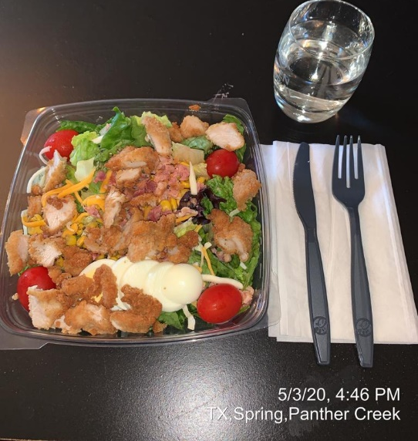  1 Chicken Cobb salad = 240 cal  Total Calories = 240 cal | Basketball 30 mins – Vigorous aerobics  Total calories burned in 30 mins = 250 cal

