Name
Tutor
Course name
Date
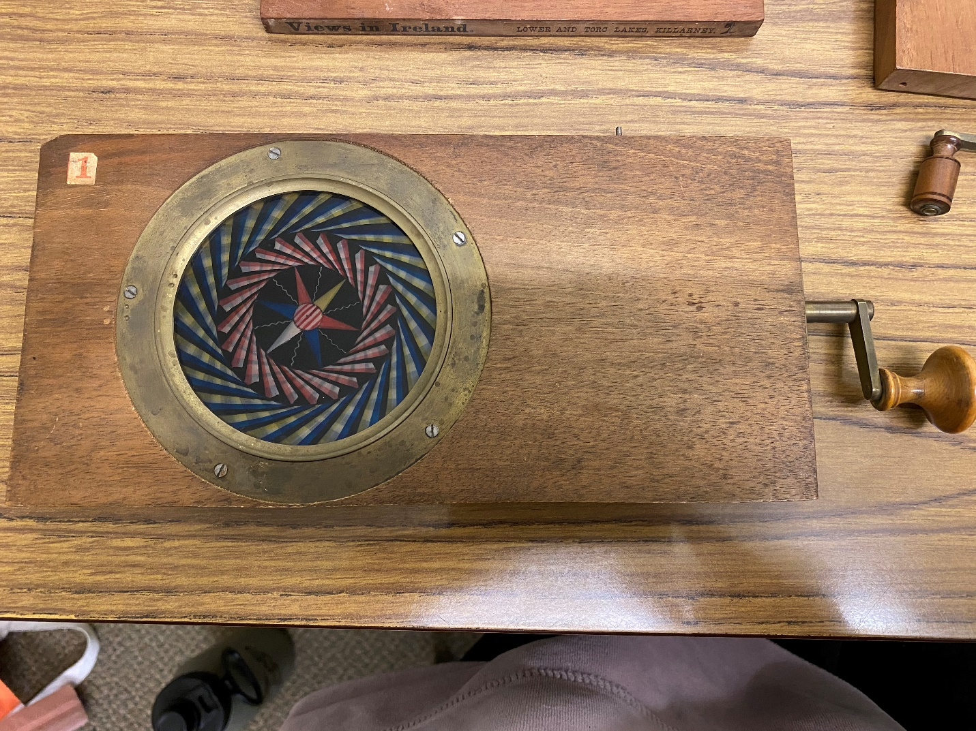
Plywood
The object I chose in the picture is that of the plywood material board, placed on top of the same are two objects also made of plywood material. The board and two objects are dark brown, they are designed in a rectangular shape. The plywood objects in context are made of hard materials. The plywood material sheets are thin in size, and in most cases, that is how they are designed.
Research findings
Plywood is a material produced from the thin layers of veneer wood, which are attached in layers adjacent. The wood is a type of manufactured board that is a mixture of chipboard and medium density fireboard. According to Moubarik and Amine, the Plywood is believed to have originated from the Greeks and the ancient Egyptians (Moubarik and Amine, 190). Plywood can be made from softwoods, hardwoods or the two combined. In the U.S., the popular softwood used to make this material is the Douglas fir; others are redwood, spruce, pine, and cedar. Plywood's, in general, bind wood fiber sheets and resin forming a composite object. Cross-graining a feature associated with Plywood which means changing of grain has various advantages that includes; reduces the shrinkage and expansion, lowers the habit of the wood to divide when placed at the edge and enables dimensional stability.
Plywood material has high stiffness and is perpendicular to the surface fold of the grain direction. As Birmingham and Donald in their book "Fibrous sheet covered plywood" notes, a standard quality plywood materials are designed with five plies arranged in forty-five degrees levels, and this makes it strong in various axes (Birmingham and Donald, 240). Plywood has gained a lot of popularity over the last one decade because of its low moisture content nature. It is used for different structural, exterior and interior applications, it is also used for construction. There are different types of Plywood, which include; hardwood, softwood, tropical, decorative, aircraft, marine, and flexible Plywood.

Works cited
Birmingham, Donald G. "Fibrous sheet covered plywood." U.S. Patent No. 2,343,740. 7 Mar. 1944.
Moubarik, Amine, et al. "Cornstarch and tannin in phenol-formaldehyde resins for plywood production." Industrial Crops and Products 30.2 (2009): 188-193.

