Policy Research Worksheet
Name: ____________________
1. Attach three newspaper articles that deal with policy issues that you are interested in. (3 points) Type the APA citation for each article below.
Millar, F. (2020). Some MPs Enjoyed a New Labour Education. Do they know how lucky they were? The Guardian Weekly. Retrieved from https://www.theguardian.com/education/2020/feb/04/mp-new-labour-education-lucky-blair-brown
Spencer, K. (2020). In College and Homeless. The New York Times. Retrieved from https://www.nytimes.com/2020/02/20/education/learning/college-homeless-students.html
The Learning Network (2019). Should College be Free? The New York Times. Retrieved from https://www.nytimes.com/2019/09/20/learning/should-college-be-free.html
2. Take those topics and begin your search for federal legislation dealing with two of these topics. Use http://thomas.loc.gov to find the information. Answer the following questions about two bills of your choice. (10 points)
Points Missed
Policy Topic #1
Name of Bill: Supporting the goal of increasing public school teacher pay and public education funding
1 points
Number of Bill: H.Res.58-116th Congress (2019-2020)
1 points
Sponsor(s) of Bill: Rep. O’Halleran, Tom
1 points
Committee: House-Education and Labor
Assignments
1 points
Latest status of Bill: Agreed to in House
1 points
Points Missed
Policy Topic #2
Name of Bill: School Safety Act of 2020
To reauthorize the matching grant program for school security in the Omnibus Crime Control and Safe Streets Act of 1968
1 point
Number of Bill: H.R.5765-116th Congress (2019-2020)
1 point
Sponsor(s) of Bill: Rep. Larsen, Rick
1 point
Committee: House-Judiciary
Assignments
1 point
Latest status of Bill: Referred to the House Committee on the Judiciary
1 point

3. Summarize in your own words one newly signed federal law that you are interested in. Use www.whitehouse.gov or www.thomas.loc.gov to find one. (5 points)
In the spirit of making the work environment and especially in the governmental offices a lot more efficient, a law was passed for the District of Columbia to help reduce the loads of paper work that was being done in this District’s government offices. The Bill was introduced into the House of Representatives on 23rd January, 2019 where it passed House, Senate, to the president where it became law. It entailed an amendment to the original Bill that proposed that the Congressional review of the newly passed District Laws be eliminated.
4. Take this piece of legislation (from #3) and put it into www.thomas.loc.gov to find the legislative history (All Congressional actions). Attach print out. (2 points)
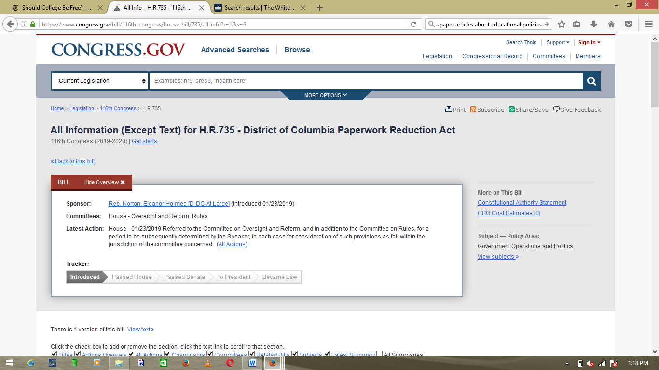
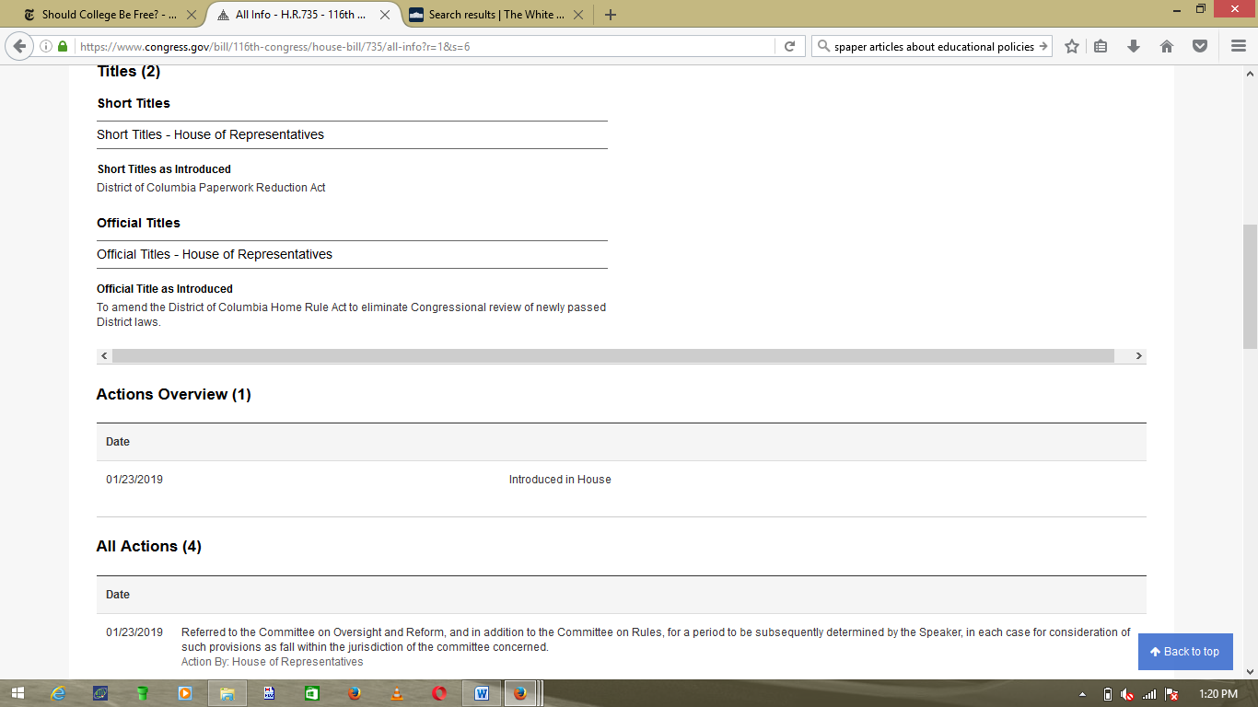
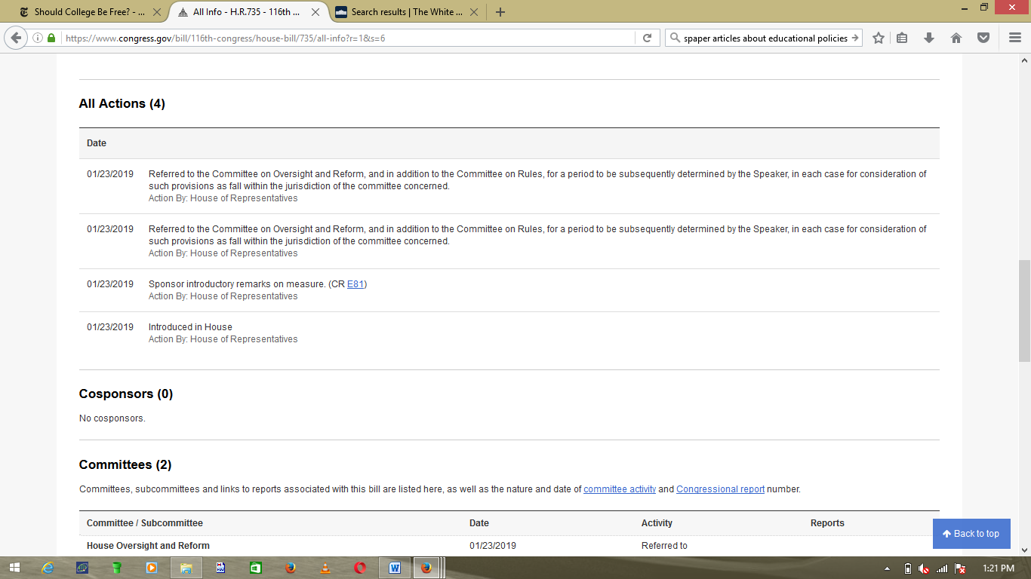
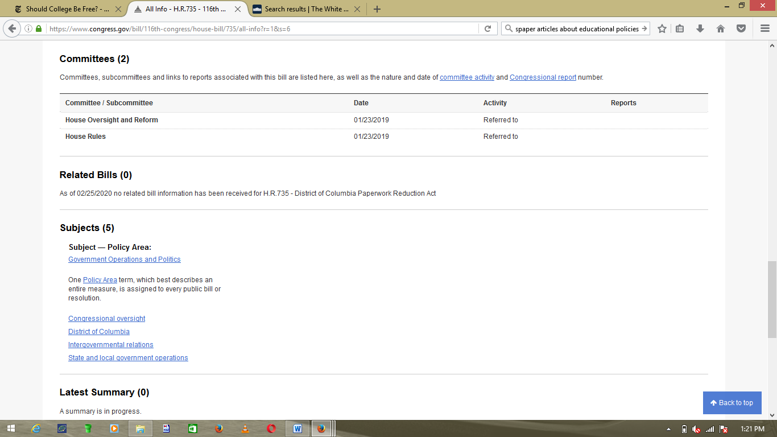
5. Find three newspaper articles on state policy issues. Attach articles to worksheet and type the complete APA citation for each article below. (3 points)
Keene, L. & Stockman, F. (2020). A Rare Legal Battle: Can a State Force a City to House Coronavirus Patients? The New York Times. Retrieved from https://www.nytimes.com/2020/02/24/us/costa-mesa-california-coronavirus.html
Schwartz, E. (2019). Good Nuclear Policy should combine Research, Innovation and Public Engagement. The Conversation. Retrieved from https://theconversation.com/good-nuclear-policy-should-combine-research-innovation-and-public-engagement-106666
Woods, M. (2018). There is extra funding for aged care in the budget, but not enough to meet demand. The Conversation. Retrieved from https://theconversation.com/there-is-extra-funding-for-aged-care-in-the-budget-but-not-enough-to-meet-demand-96403
6. Use the Florida Senate or House website: www.flsenate.gov and www.myfloridahouse.gov find a piece of legislation from the current session that is related to one of the topics from the newspaper articles in #5 above and fill in the table below with the answers to the following questions about the bill: (5 points)
Points Missed
Policy Topic
Name of Bill: Elder Abuse Fatality Review Teams
1 points
Number of Bill: SB 400
1 points
Sponsor(s) of Bill: Senator Audrey Gibson
1 points
Committee: Senate-Children, Families, and Elder Affairs
Senate-Judiciary
Assignments
1 points
Latest status of Bill: House-in messages
1 points
7. Find two non-profit, non-governmental policy advocacy (not service) agencies or organizations that advocate on behalf of your topic. Type names of organizations below and attach a print out of their home webpage. (5 points)
- AARP
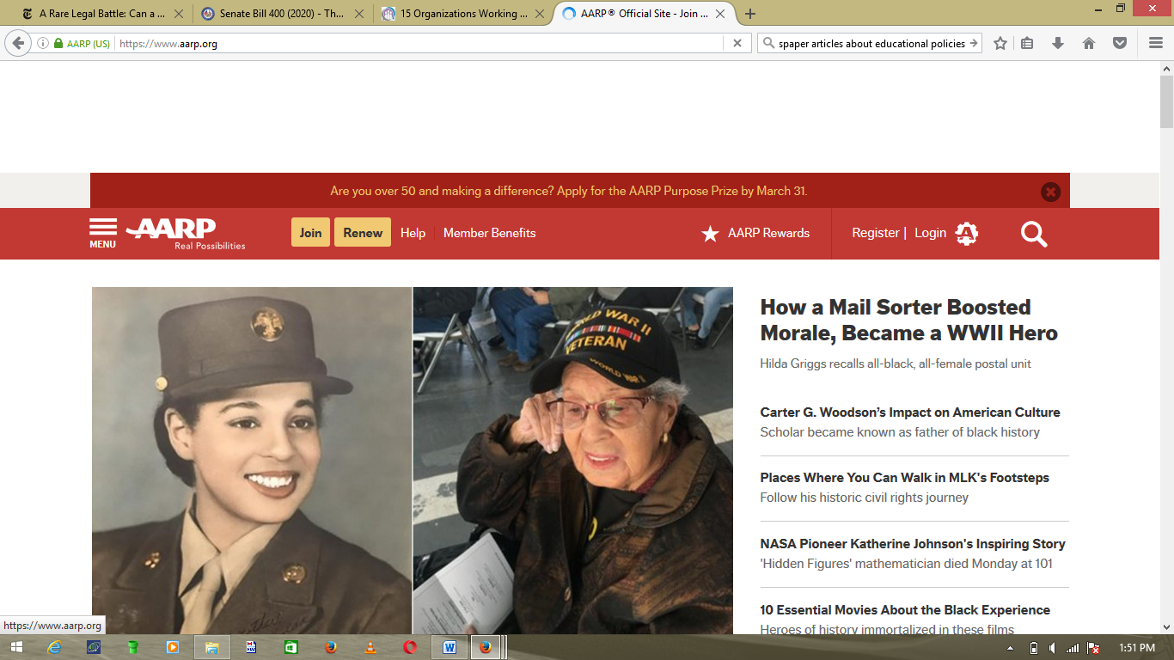
- Centre for Advocacy for the Rights and Interests of the Elderly (CARIE)
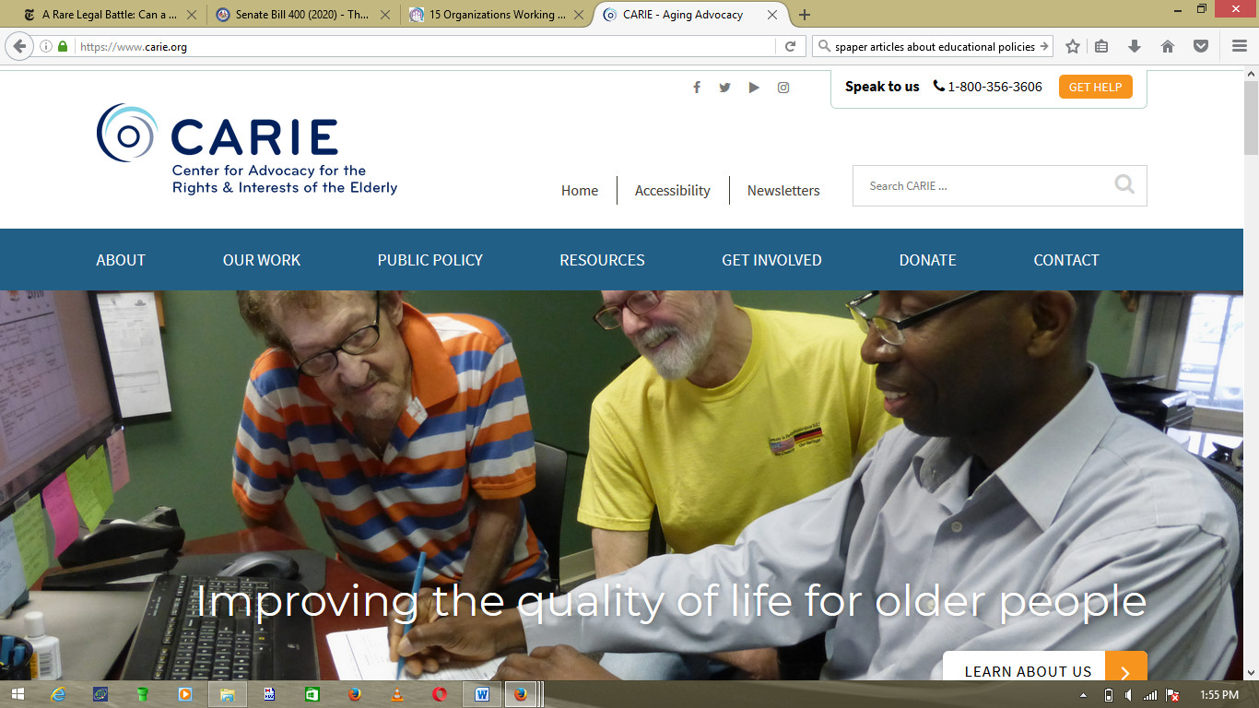
- Justice in Aging

8. Find a report or policy brief on the National Council of State Legislature’s (www.ncsl.org) website that is related to one of the policy topics you are interested in. Write the full citation below and attach the first page of the report to the worksheet. (2 points)

Morton, H. (2015). Financial Crimes against the Elderly 2015 Legislation. National Conference of State Legislatures. Retrieved from https://www.ncsl.org/research/financial-services-and-commerce/financial-crimes-against-the-elderly-2015-legislation.aspx
