Abortion in America
Students name
University
Date

Legislators Name
Topic –Pro-Life Sensitive Legislation
Abortion rates in America are devastatingly high due to different types of situations in people's lives. Abortion is one of the most controversial issues in American culture. There may be issues such as financial statements, stability, or the environment in which they live. There are many other reasons for abortion, but there is no excuse for using abortion to get off your free parenting card or any other circumstances that have happened in a traumatic way. There is a different view on abortion, the pros and cons, and the consequences of the trial. There will always be people out of your life who will criticize your decision to abort or maintain; there are some people who are totally in favor of abortion, and others are totally against it.
Pros and Cons of Abortion
To see the different points of view on this topic, you need to create a list of pros and cons to compare why people think your decision is the best answer for people thinking about having a baby. Here are just a few pros and cons I've written about my opinion on this topic and the research I've done on other people.:
Pros on Abortion | Cons on Abortion
Abortion may be appropriate for a woman too young to care for a baby. For example, if a young woman is raped and becomes pregnant, it could be an abortion. | Abortion is murder: The fetus never asked to be brought into the world, and now, with abortion, they do not choose to live or die. Abortion is not an alternative plan because you have not had protected sex.
Abortion is an excuse because women and men have been unable to pay for a baby due to work and school, or are in a financial situation. | In other cases, such as rape, if you are too young to care for a child, it is adopted to have a chance in life.

I'm pro-life. They are pro-life because babies and fetuses do not ask to be brought into this world under any circumstances or environment. If you can't afford to raise a child, there is a sure way to help these needy children: adoption. He deserves a chance in life. According to guttmacher.org, 18% of pregnancies, except for miscarriages, in 2017 ended in abortion. Approximately 862,320 abortions were performed in 2017, a decrease even compared to 926,190 in 2014. Most abortions performed in 2017 were for women between the ages of fifteen and forty-four.
(Courtesy of www.guttmacher.org)
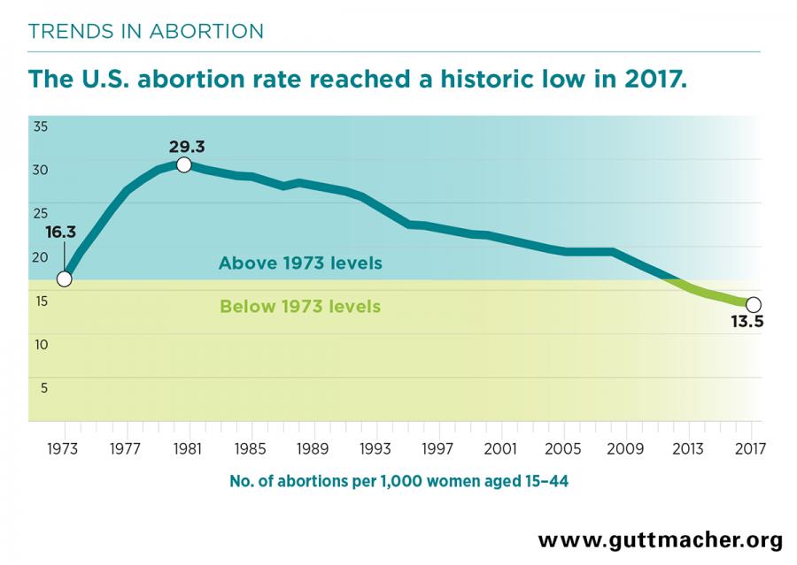
I understand that abortion is a better option in many circumstances, such as rape. Some children are raped at twelve, thirteen, fifteen, and so on, who can become pregnant, depending on their fertility due to monthly cycles. If they are so young and cannot take care of raising a child, not even with help, or if they cannot cope with the pain or just want to be a child, it is not their fault that they are pregnant to begin with, so I could see this argument as optional for abortion. In my opinion, any other reason for abortion is not optional.
Counter Argument
Abortion can be chosen because they do not have the money to raise a child or the mother is not ready for a child. It is her body, she can choose what she wants to do and what is best for her and the fetus. There are a few reasons why someone may be pro-choice and here are a few:
- Poor financial stability
- Raising a child alone
- I'm not ready to be a father
- Raped
There are items and medications designed to help prevent pregnancy and in fact some may malfunction if accidental pregnancies happen and this is how parents choose how they want to deal with the situation.
Name
Credentials

References
Induced Abortion in the United States. (2019, September 18). from https://www.guttmacher.org/fact-sheet/induced-abortion-united-states
Lipka, M., & Gramlich, J. (2019, August 30). 5 facts about the abortion debate in America. Retrieved from https://www.pewresearch.org/fact-tank/2019/08/30/facts-about-abortion-debate-in-america/
Gallup. (2019, November 10). Abortion. Retrieved from https://news.gallup.com/poll/1576/abortion.aspx
Holland, J. L. (n.d.). Abolishing Abortion: The History of the Pro-Life Movement in America. Retrieved from https://www.oah.org/tah/issues/2016/november/abolishing-abortion-the-history-of-the-pro-life-movement-in-america/

