Lab 8: Synthesis of acetaminophen
Name: Thamica Tertulien
School: Brooklyn College
Class: Chem 2500
Post lab Report

Observations:
The solid dissolved completely when heated on a hot plate.
After heating, the flask contents crystalizes when put on an ice bath.
The filtrate becomes darker with time.
The melting point of crude product is 173 °C-174 °C

Results :
Mass of p-aminophenol (MW= 109.1) used in the synthesis: 1.5g
Moles of p-aminophenol used in the synthesis: 0.014moles
Volume of acetic anhydride used in the synthesis: 1.7mL
Mass of acetic anhydride used in the synthesis: 1.59g
Moles of acetic anhydride used in the synthesis: 0.016moles
Melting point of crude product is 173 °C-174 °C
Mass of acetaminophen = 1.2g
Melting point of Acetaminophen = 170°C

Interpretation and explanation of results:
The synthesis of Acetaminophen occurs and per the structural equation below;
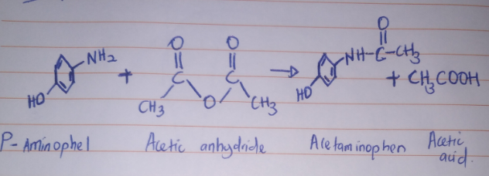

Post-lab Questions:
- Was the crystallized acetaminophen obtained pure? How do you know?

The crystallized acetaminophen is obtained pure, because it is purified by 50% by 50% mixture of water and ethanol. This is evident in the melting point of the product which is 170 °C which is close to the theoretical melting point of acetaminophen which is 169°C.

- Give two reasons why the crude product in most reactions is not pure.

Crude product in most reactions is not pure because most reaction materials do not go to completion leaving some starting materials present in the crude product. Secondly, side reactions may take place during initial reaction thus the completing reactions may have other products present.

- During the crystallization of acetaminophen, why was the mixture cooled in an ice bath?

During crystallization, a saturated solution is taken and crystallization is induced in the dissolved solute by lowering its solubility in the mixture. The ice bath treatment during the crystallization acetaminophen helps lower the solubility acetaminophen. The lower the temperatures the higher mount of crystallized acetaminophen since low temperatures promote acetaminophen crystallization.

- Why should you use a minimum amount of water to rinse the flask while transferring the purified acetaminophen to the Buchner funnel?

Acetaminophen is slightly soluble in cold water it is therefore important to use minimum amount of water to rinse the flask while transferring the purified acetaminophen to the Buchner funnel solution to reduce the amount of product (Acetaminophen) that gets dissolved in water.

