
Counseling Forum for People Dealing with Alcoholism
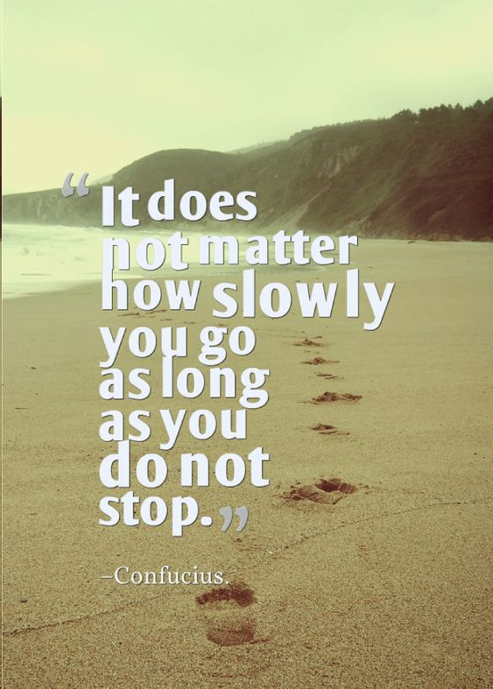
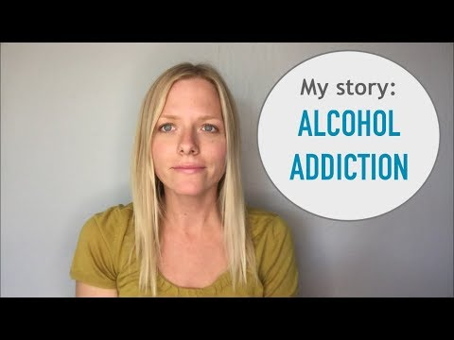
The Counselling sessions will be taking place in the public hall at the city square.
Are you struggling with Alcoholism? Life Savers is inviting you to a Counseling Group to Help you change
In only 4 weeks you will be able to abandon your drinking behavior that you have been struggling so much with.
It will make use of Behavioral therapies such as CBT and DBT with a final evaluation showing how you have progressed in the counselling therapy

