PROJECT HUMAN RESOURCE AND STAKEHOLDER ASSIGNMENT PROJECT REPORT



TEAM MEMBER NAMES:
COURSE CODE: HRM 4200
PROFESSOR’S NAME:
SECTION:
DATE:

Table of contents
Contents
INTRODUCTION 3
STAKEHOLDER ANALYSIS 3
STAKEHOLDERS REGISTER 4
STAKEHOLDER ENGAGEMENT PLAN 5
PROJECT ORGANIZATIONAL STRUCTURE WITH ROLES AND RESPONSIBILITIES 7
PROJECT TEAM MEMBER’S ROLE AND RESPONSIBILITIES, AND KEY SKILLS 7
CHALLENGES OF PROJECT 7

INTRODUCTION
This paper presents information about “Fill the Shelves” project. It was formed by various team members and stakeholders who anticipated to start the project on 2nd July 2019. The project was aimed to offer assistance to the College Food Cupboard Program by collecting funds for giving and buying the basic needs by College students who particularly experience scarcity of food so that they can also get access to nutritious food for their health. However, each member who was involved in the formation of the project was given duties and responsibility. Among the team members are stakeholders who are the great concern in the project. The whole part of this paper will focus on various stakeholders of Fill the Shelves project by providing their analysis, registration, and engagement plan. It will also present some information about project organizational structure with their roles and responsibilities as well as human resource management plan.

STAKEHOLDER ANALYSIS
Using power versus interest grid on a matrix model, the power of stakeholders’ increases when moving from bottom to top along the vertical axis where power is plotted. On the other side, the interest of stakeholders increases from left to right on the horizontal axis.

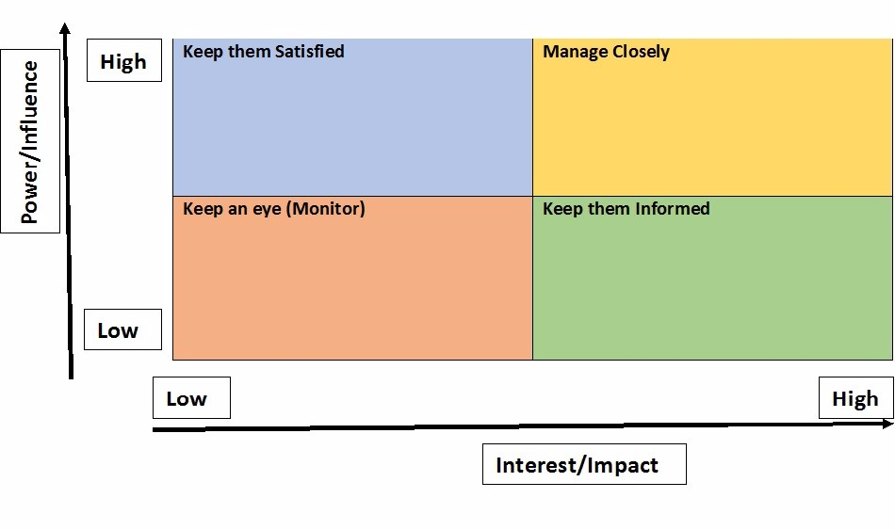
At the top left corner, Algonquin College Board is located that it should be kept satisfied. At the top right corner is the manager who manages the project carefully, who is Saeed Burham. At the bottom, left corner is the project monitors who keep an eye at the project operations. They include; Nicole Priatel, PMP, Professor, School of Business, Jessica Clark, Manager and Algonquin Food Cupboard. At the bottom left corner are the Algonquin students who have high interest and the beneficiaries of the project.
Basing on stakeholders identity and analysis, the Project Manager is then able to realize the interest intensities and decision-making competence and particular requirements of stakeholders, which stakeholder will approve a design or a change of a specific decision in the project.

STAKEHOLDERS REGISTER
FILL THE SHELVES
STAKEHOLDERS NAME | ROLE IN THE PROJECT | CONTACT INFORMATION | KEY EXPECTATIONS | POTENTIAL LEVEL OF INFLUENCE (H/M/L) | CLASSIFICATION (INTERNAL OR EXTERNAL) | NOTES
Nicole Priatel | Sponsor |  | Support the project financial and other critical assistance. | H | Internal
Jessica Clark | Sponsor |  | Support, including financial assistance. | H | Internal
Algonquin College Board | Silent  Executive | www.algonquincollege.com | Support and enabling a conducive environment for the operation of the project. | M | Internal
Algonquin Students | Beneficiaries |  | We are cooperating to ensure the effective running of the project without interferences. | L | Internal
Donor’s | Secondary Sponsors |  | Supporting and overlooking of the project operations. | H | External
Saeed Buryam | Project Manager | bura0012@algonquinlive.com | Oversee the general operation of the project. | H | Internal
Sandeep Kumar | Finance | kuma0142@algonquinlive.com | Dealing with all finance issues. | M | Internal
Geetanjali | Fundraiser | geet0002@algonquinlive.com | Collecting fund and organizing fundraising program. | M | Internal
Qiong lin | Fundraiser | lin00142@algonquinlive.com | Collecting funds and organizing fundraising program. | M | Internal
Arshdeep Singh | Procurement manager | Sing1127@algonquinlive.com | Purchase of equipment’s needed to run the project | M | Internal
Aithel Shibu | Finance | shib0017@algonquinlive.com | Dealing with all finance issues. | H | Internal

STAKEHOLDER ENGAGEMENT PLAN
STAKEHOLDERS NAME | ROLE IN THE PROJECT | LEVEL OF INFLUENCE (H/M/L) | INFLUENCE TYPE  SUPPORTER, RESISTER, NEUTRAL | LEVEL OF INTEREST (H/M/L) | CURRENT ENGAGEMENT LEVEL | ENGAGEMENT STRATEGY
Nicole Priatel | Sponsor | H | Supporter | H | Supportive | Invites more sponsors to support the project and attending meetings to oversee the project state. Building a relationship with other stakeholders of the project.
Jessica Clark | Sponsor | H | Supporter | H | Supportive | Invites more sponsors to support the project and attending meetings to oversee the project state. Building a relationship with other stakeholders of the project.
Algonquin College Board | A host of the general project | M | Neutral | M | Neutral | Distributing information to various stakeholders to make them aware of project operations.
Algonquin Students | Beneficiaries | L | Neutral | L | Unaware | Receiving and passing their suggestions through letters and posters.
Donor’s | Secondary Sponsors | H | Supporter | L | Supportive | Looking out for more donors who are interested in connecting them with the project work.
Saeed Buryam | Project Manager | H | Supporter | H | Supportive | To overlook the general operation of the project.
Sandeep Kumar | Finance | M | Neutral | H | Neutral | Recording and planning financial operations of the project.
Geetanjali | Fundraiser | L | Resister | L | Resistant | Passing updates about fundraising and arranging meetings.
Qiong lin | Fundraiser | H | Supporter | M | Supportive | Passing updates about fundraising and arranging meetings.
Arshdeep Singh | Procurement manager | M | Supporter | H | Leading | Making purchases of project equipment’s and supporting members.
Aithel Shibu | Finance | H | Supporter | H | Supportive | Recording and planning financial operations of the project.

PROJECT ORGANIZATIONAL STRUCTURE WITH ROLES AND RESPONSIBILITIES
Project Manager (Saeed Buryam)
To overlook the general operation of the project.

nnnnnnnnn
(

Project Sponsor (Jessica Clark)
Building a relationship with other stakeholders of the project.

Project Sponsor (Nicole Priatel)
Invites more sponsors to support the project and attending meetings to oversee the project state.
Aithel Shibu
Fundraiser
Arshdeep Singh
Procurement
Quiong Lin
Finance Manager
Sundeep Kumar
Finance Manager
Geetanjali Geet
Fundraiser

PROJECT TEAM MEMBER’S ROLE AND RESPONSIBILITIES, AND KEY SKILLS
Project manager (Saeed Buryam)
Develops a project plan, manage deliverables according to the program, recruit project staff, lead and manage the project team, determine the methodology used on the project.
Project sponsors (Nicole Priatel, Jessica Clark)
Makes the main project decisions and approval of the project budget. Ensures availability of resources, communicate the project’s goals throughout the organization.
Project team members (Aithel Shibu, Sandeep Kumar, Arshdeep Shingh, Geetanjali Geet, Qiong Lin)
They contribute to overall project objectives, completing individual deliverables, providing expertise and working with users to establish and meet business needs.

CHALLENGES OF THE PROJECT
Poor defined goals and objectives
This a challenge that can mislead the project not to achieve its objectives properly. To avoid this problem, managers should come up with appropriate and effective goals and objectives that can be met.
Unrealistic deadlines
In most cases is the date of project initiation and completion, which might not be realistic or met as expected. The proper time frame should be considered so that deadlines can be met adequately.
Insufficiently skilled team
Some of the team members may not be well-skilled to operate, thus leading to failure and delays that cause improper functioning of the project. Training and educating team members on how to take control and operate the project effectively.
Lack of accountability
The project may lack proper accountability that gives a clear indication of the operations going on in the project. Clear information should be presented to the full panel of whole members of the project s that transparent and open decisions can be made wherever there is a problem within the project.
Risk management
At first, implementing the project is taking a risk because most of the people are not even aware of the operation of the project. To reduce risk management, adequate financial support should be applied.
Miscommunication causing conflicts
Miscommunication can occur between members, thus causing misunderstanding of each other hence can cause conflict. Members should be taught how to communicate and relate to each other so that they can understand themselves better and avoid miscommunications.
Challenges of teamwork
Members of the project may not be in the same line of reasoning, thus causing conflicts and misunderstanding. Cooperation should be enforced as a slogan so that members can cooperate and perform better for the benefit of the maximum productivity of the project.

