Pre-Lab Assignment
Name:
Instructor’s Name:
Institutional Affiliation
Date:

Pre-Lab Assignment
Question 1:
Assume that the electric field between two charged parallel plates has a magnitude of 200 V/m.
Find the change in the electric potential from one point to another in the electric field, for the following
three cases:
- 20 cm in the direction of the electric field
$$E=\frac{v}{d}$$
= 200*0.2
= 40V
- 20 cm in a direction perpendicular to the electric field.
= 40-(0.2*40)
= 32V
- 3 cm in the direction of the electric field, then 4 cm perpendicular to the field, and then 5 cm back to the original position.
= 200*0.03-(0.04*6) + 200*0.05
=6-0.24+8
= 13.76V
Question 2:
a) Since the electric field component in a certain direction is proportional to the change in
potential, in that direction, what is the magnitude of the electric field component in the direction of an equipotential line? Explain.

The magnitude is potential energy multiplied by the distance of change. Since close to charges the energy is strong and away from charges its weaker.

b) Based on your answer to part (a), what is the direction of the electric field, relative to the equipotential lines? Explain.
Direction of E. field is from positive to negative charges. Since flow is from high to low energies.

Question 3:
What can you say about the electric field strength in a region where the equipotential lines are
close together, as opposed to a region where they are far apart? Explain your answer using the mathematical relation between the electric field and the electric potential, Ex = -dV/
dx.
When the lines are close together, the electric field is stronger. When they are far apart, the strength is weaker.
This is true considering the given equation
Question 4:
The figure to the left shows some equipotential lines in a region of space.
- Indicate the direction of the electric field at the four points A, B, C, and D in the figure by drawing the electric field vectors. Explain why you drew them that way.
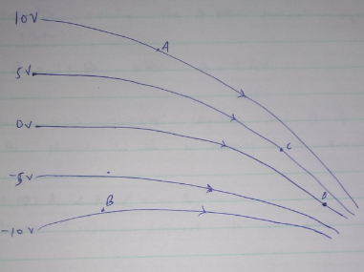

I drew them in that manner since where the lines are close together shows the field direction
- Is the magnitude of the electric field constant along each of the equipotential lines? Explain.

No. The magnitudes are same since the lines aren’t parallel
Question 5:
When you check the \Values" box, an arrow and its label is displayed in the bottom-right
corner. Based on the information provided in the simulation, what is the length of the edge of a large (thicker gridline) box in the grid?
= 0.5m
Question 6:
On the right side of the simulation screen, in the bottom square there is a potentiometer and
a meter tools. Use the meter tool to verify your answer to the previous question. What is the length of the edge of a small (thinner gridline) box in the grid?
= 10cm
Question 7:
Place a positive charge in the top left corner of the large grid located closest to the left top
corner of the screen, as shown in the diagram below. Will all the points on the simulation screen be at the same electric potential, or at different values? Explain your answer.
No. They won’t be at the same electric potential. This is because Electric potential is greater near a charge and reduces away from a charge
Question 8:
Knowing that the charge is +1.0 nC, calculate the distance from the positive charge to where
the potential is equal to 1.0 V.
Distance = 9m
Question 9:
Using the potentiometer in the applet, find the distance from the positive charge to where the potential is equal to 1.0 V. Use the grid or the meter tool to measure it. How does your answer to this question compare with the answer to the previous one?
= 9m
The Answers is the same
Question 10:
Place a positive and a negative charge 6.0 meters apart in a straight line, in the center of the screen, as shown in the diagram below. Knowing that the charges are equal to +1.0 nC and -1.0 nC respectively, calculate the distance from the positive charge (on the line connecting the two charges) where the net potential is equal to 0.0 V. Hint: use the corners of the large boxes in the center of the screen to place the charges.
= Distance is 3m
Question 11:
Using the potentiometer in the applet, find the distance from the positive charge (on the line connecting the two charges) where the net potential is equal to 0.0 V. How does your answer to this question compare with the answer to the previous one?
= Distance is 3m. It’s the same from the one above
Question 12:
Using the drawing option (pencil icon) in potentiometer in the applet to draw the equipotential
line for V= 0.0 V. Describe the shape of the line.
The shape is green in color

Question 13:
Using the potentiometer, find the value of the electric potential for the following distances from the positive charge on an axis perpendicular to the two plates connecting the two plates (in the region between the two plates): 0.1 m, 0.2 m, 0.3 m, 0.4 m, 0.5 m, 0.6 m, 0.7 m, 0.8 m, 0.9 m. Record your values in the table below. Make sure to note the value before moving to the next point (lines will be close together).

x | voltage
0.1 | 230
0.2 | 135
0.3 | 75
0.4 | 34
0.5 | 0
0.6 | -33.7
0.7 | -74
0.8 | -107
0.9 | -176

Question 14:
Based on your data, what is the direction of the electric _eld on a perpendicular line connecting
the two plates?
Electric field is from positive to negative charge
Question 15:
Check the Electric Field box in the applet. How does the electric field direction,
compare with your answer to the previous question?
The direction of the arrow is from positive to negative. Same as the answer above.
Question 16:
How do you find the direction of the electric field between the plates from your data for the potential?
It’s found by checking the values of voltage
Question 17:
Using Excel, enter your data to produce a plot of V vs. x and fit an equation to your graph.
What does the plot represent? Write down the equation for the fit. What is the magnitude of the electric field that you obtain from your fit?
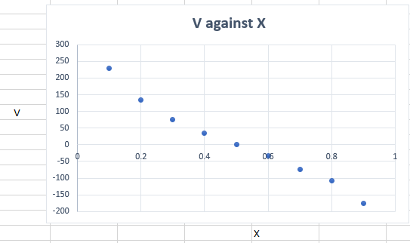

References
Bagotskii VS (2006). Fundamentals of electrochemistry. p. 22. ISBN 978-0-471-70058-6
Young, Hugh A.; Freedman, Roger D. (2012). Sears and Zemansky's University Physics with Modern Physics (13th ed.). Boston: Addison-Wesley. p. 754
Wangsness RK (1986). Electromagnetic Fields (2nd., Revised, illustrated ed.). Wiley. ISBN 978-0-471-81186-2.
Sen K, Murray JS (1996). Molecular Electrostatic Potentials: Concepts and Applications. Amsterdam: Elsevier. ISBN 978-0-444-82353-3.

