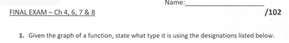

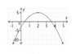 a) Quadratic
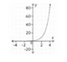b) Exponential
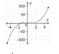c) Cubic
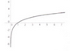d)Logarithmic
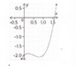e)Quadratic
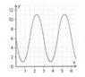f) Sinusoidal
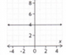g) Constant
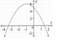h) Quadratic
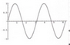i) Sinusoidal
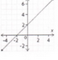j) Linear
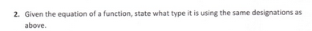
- Sinusoidal
- Constant
- Exponential
- Logarithmic
- Cubic
- Exponential
- Cubic
- Sinusoidal
- Linear
- Quadratic
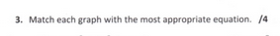
- III
- IV
- I
- II
a)
y-intercept
Substitute x=0, y = 0 – 0 -2
y = -2 or (0,-2)
end behaviour:
If x →∞, f(x)→∞
If x → -∞, f(x)→ -∞
Domain:
All real numbers (-∞,∞)
Range: y ≥ (-17/4)
[-17/4, ∞)
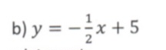
y-intercept: y = 5 or (0,5)
End Behaviour:
If x →∞, f(x)→ -∞
If x → -∞, f(x)→ ∞
Domain: (-∞,∞)
Range: (-∞,∞)
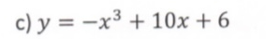
y-intercept: y = 6 or (0,6)
End Behaviour:
If x →∞, f(x)→ -∞
If x → -∞, f(x)→ ∞
Domain: (-∞,∞)
Range: (-∞,∞)
a)
Degree: 3
x-intercept: x = 1.5 or (1.5,0)
y-intercept: y=-2 or (0, -2)
End behaviour: If x →∞, f(x)→ ∞
If x → -∞, f(x)→ -∞
Domain: (-∞,∞)
Range: (-∞,∞)
Constant term: -2
Signof Leading coefficient: +ve
b)
Degree: 0
x-intercept: x = nil
y-intercept: y=4 or (0, 4)
End behaviour: It’s a constant function
Domain: (-∞,∞)
Range: y = 4
Constant term: 4
Signof Leading coefficient: +ve
c)
Degree: 2
x-intercept: x = -3.5 and x= 1.5 (-3.5,0),(1.5,0)
y-intercept: y=5 or (0, 5)
End behaviour: If x →∞, f(x)→ -∞
If x → -∞, f(x)→ -∞
Domain: (-∞,∞)
Range: (-∞,6]
Constant term: 5
Signof Leading coefficient: -ve
d)
Degree: 1
x-intercept: x = -2 or (-2,0)
y-intercept: y=2 or (0, 2)
End behaviour: If x →∞, f(x)→ ∞
If x → -∞, f(x)→ -∞
Domain: (-∞,∞)
Range: (-∞,∞)
Constant term: 2
Signof Leading coefficient: +ve
a)
Domain: [0, ∞)
Range: (-∞,∞)
Inc or Dec: Dec
b)
Domain: : (-∞,∞)
Range: [0, ∞)
Inc or Dec: Inc
c)
Domain: : (0,∞)
Range: (-∞,1.5)
Inc or Dec: Inc

d)
Domain: : (-∞,∞)
Range: [0, ∞)
Inc or Dec: Inc

