- a) The direction of fluctuations of unemployment and output is procyclical. Unemployment usually increases when the output decreases. A decrease in output means that institutions are not utilizing economic resources to their potential. The lack of exploitation limits the job opportunities available thus increased unemployment.

b) When the sign of m is positive, then the variables have a positive relationship. An increase in the independent variable results to an increase in the dependent variable and a decrease in the independent variable results in a decrease in the dependent variable when the cycle is procyclical. In a countercyclical cycle, the sign of m is negative. An increase in the independent variable makes the dependent variable to decrease and a decrease in the independent variable makes the independent variable to increase.

- A)

b)

c)

Y = mx+b
Y = Unemployment gap
X = output
b = constant
Y = -0.78X + 0.015
 | Coefficients
Intercept | -0.78316
Output Gap | 0.015233

d) The regression analysis supports Okun’s law. Okun states that unemployment and output are inversely related. Unemployment is high when output is low and low when output is high.

- Deriving the optimal rate rule
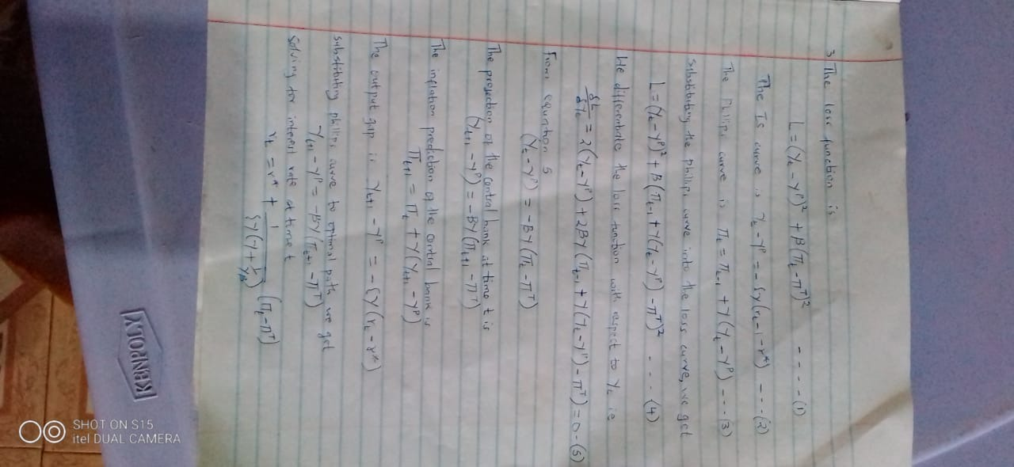

- 0.10% = 1/100
The bonds are worthy $65 million
The initial interest rate is 0.25%
25/100*65,000,000
= $16,250,000
1/100 interest rate = 1/100*$65000000
= $650,000
The bank will pay $(16250000-650000)
= $15.6 million

