Design and write a Monte Carlo simulation written in C/C++ of the four disk scheduling algorithms shown in Figure 11.7 using uniform random numbers. Seek time is to be measured in number of tracks crossed.
Simulation parameters: 1) Number of I/O requests (500-1000), 2) Track of each I/O request (track-sector combination) without duplicates within a simulation.
Run at least 1000 simulations for each Number of I/O requests. Calculate the average over all simulations of the average seek times for each algorithm (demonstrated in Table 11.2) using estimates of actual time for operations.
Using an external application such as Excel plot the average seek length of each algorithm for each simulation on the same chart. The chart should start with the smallest Number of I/O requests.
Submit your code and report. Your chart needs to be included and discussed in your report. Make a judgment as to which algorithm is best suited for these circumstances.
HDD details: 64KB sectors, 5,000 tracks, 12,000 sectors per track, 6Gb/s transfer rate, 10,000 RPM, Average seek time of 2 ms, a snapback feature which which will move the head back to track zero in 1.5 ms.

Table 11.2 following
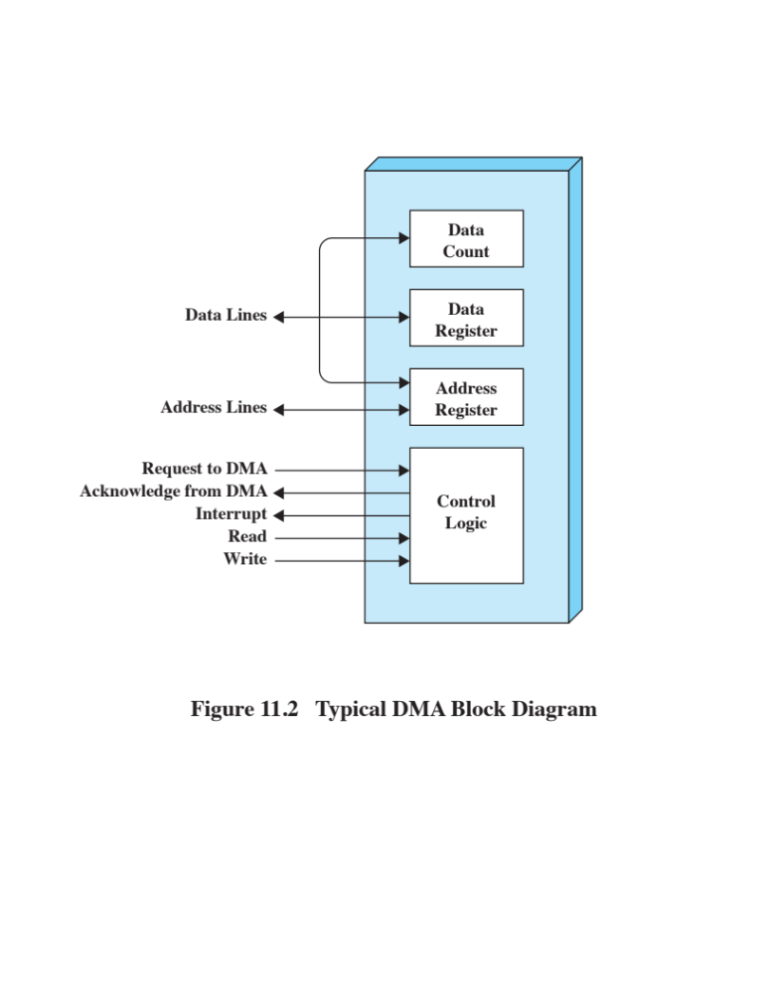
© 2017 Pearson Education, Inc., Hoboken, NJ. All rights reserved.
8
