

Research Project- MGT 675.
In partial Fulfillment for degree of
Master in Business Administration (MBA)

The Effects of Technology Advancement on Real estate in Saudi Arabia and Vision 2030

Prepared by:
- ID-
Supervised by- Dr.

July 7, 2019
Abstract

Technology is seemingly shaping the world we live today and almost all industries have been transformed for the last decade through technological advancement. The real estate industry has not been left behind in this transformation spree considering its importance to the public. Taking a good look at the effects of technology advancement on real estate in Saudi Arabia and vision 2030 will help us understand how transformed the industry is. Saudi Arabia is one of the countries in the world that have intentions to initiate a 2030 housing program in the country. The research will select a sample size of 603 Saudi Arabians to answer all questions in a provided questionnaire. This way, it will be possible to understand what consumers prioritize in the real estate industry.

Acknowledgement

First and foremost, praises and thanks to God the Almighty, for His showers of blessings throughout my research work to complete the research successfully.
I would like to express my deep and sincere gratitude to my research supervisor Doctor. Zahra Ghali.
I am extremely grateful to my parents for their love, prayers, caring and sacrifices for educating and preparing me for my future. I am very much thankful also to my Manager Turki Al-Dahmash in REDF (Real Estate Development Fund) for his support in my survey and other needed information.
I'm totally gratefulness to acknowledge my depth to all those who have helped me to put these ideas, well above the level of simplicity and into something concrete, despite their busy schedules, they gave me different ideas in making this project unique.

My heartfelt thanks.

Table of Contents
Cover page …………………………………....................................................1
Abstract ………………………………………………………………………2
Acknowledgement ……………………………………………………………3
Table of contents …………………………………………………………...…4
Introduction …………………………………………………………………...6
Problem statement …………………………………………………………….6
Purpose of study ………………………………………………………………7
Research question……………………………………………………….…….7
Chapter 1:
I. The real estate in KSA: characteristics, specificities and difficulties ……….9
I.1. Definitions of real estate …………………………………………………9
I.2. Types of real estate ………………………………………………………10
I.3. Characteristics & specificities of real estate in KSA…………………….17
II. Methods/ techniques & Difficulties of real estates in KSA ………………27
II.1. Traditional methods used to buy real estate……………………………..27
II.2. Difficulties faced by buyers in KSA…………….………………………30
Chapter 2:
Effect of technology advancement on financing in the real estate industry….37
i. Technology & real estate …………………………………………………..37
I.1. Impact of technology on transactions in real estate ……………….……..39
I.2. Impact of internet connection on commercial real estate…………………41
I.3. Current trends in technology and their impacts on real estate ……………47
ii. Effects of technology advancement in acquiring a house…………….….…50
iii. The innovations in real estate……………………………………………….55
iv. Tech laws in the real estate……………………………………………..…...61
Chapter 3:
Real Estate in Saudi Vision 2030……………….……………………….……..64
- Saudi industrial strategy to boost real estate demand …………….....67
- The 2030 housing program description……………………………...72
- Role of innovations towards the realization of the housing
program in the vision 2030…………………………………….…….78
- Great expectations for real estate investments in Saudi Arabia……...80
Bibliography…………………………………………………………………….88
List of keywords………………………………………………………………91

Introduction of the study
The influence of technology in the current world is undisputable considering its contribution to different industries. Today we live in a world that heavily depends on technological advancements to get things done. It is clear with the current trend that no industry can avoid the influence of technology and more importantly, the effects technological advancement has on those industries. The real estate industry is the latest industry to be greatly transformed by technological advancement considering the few innovations that have been introduced in the last decade (Al-Hathloul, 2015). It is not a matter of buying or selling a house anymore like it has been for thousands of years. The real estate industry has changed and so is the demand for more quality real estate products. Today internet connection is considered as a basic in many countries and this is just one of the many changes that have hit the industry.
In this research, we will discuss the effects of technology advancement on real estate in Saudi Arabia and vision 2030. The study will look into various changes that have been introduced in the sector and the overall effects of technology in the industry. Majorly, the study will focus on the effects of technology on transactions and priorities that consumers have in respect to technology advancement. The study sample will consist of 603 Saudi consumers. The study will use a descriptive and analytical approach in the search for access to the results (Dowall, 2014).
Problem statement
The recent wave of technological advancements has shaped the world, as we know today with various studies showing that over 75% of the world population heavily rely on technology on their day-to-day activities. Study shows that more than 85% of Saudi families appreciate the contributions of technological advancements in their lives. Most importantly, more than 73% of transactions in the real estate industry in the country are done electronically (Miles el at, 2016). In 2017 alone, more than 10 million housing units were connected to the internet and ever since that has come to be the trend across the country. Also, more house buyers consider internet connection as a basic and this is taking shape across the country.
The 2030 housing program is expected to provide quality and affordable housing to Saudi families irrespective of their social status. The quality of housing is expected to be determined by how the Saudi government intends to apply relevant technology in this program. Currently, only less than 60% of Saudi families own permanent housing. Out of this number, only 41% have an internet connection which is very low as compared to other countries in the same stature. By 2030, more than 85% of the country’s population is expected to own quality houses courtesy of the housing program that the government unveiled (Gerber & Rector, 2013).
The real estate market in the country is growing and has attracted foreign investors from Japan and the United States. To be able to accommodate the current market demand, there are more than 30 million housing units that should be delivered by 2030 and technology is expected to play a crucial role in this. A large percentage of Saudi families are connected to the internet and use various social media platforms (Tobey, 2016). This way, marketing is not a challenge in this industry and considering that the country’s banking system is also advanced, acquiring a house online is made easier than expected.
The concern is how technological advancement is expected to shape the real estate industry in Saudi Arabia. To what extent can technology transform the real estate in the country and how it can help in the realization of the vision 2030 housing program? There are significant effects of technology advancements on real estate and this is what the research intends to find out.
Purpose of the study
The effects on technology advancement in real estate in Saudi Arabia and vision 2030 is what will drive the country’s housing program to where it intends to be in the coming years. There are many concerns currently in the country on the nature of real estate products are appropriate for consumers (Dixon, 2015). Study shows that technology advancement has the power to transform the real estate industry to its best. Several innovations are currently in the market specifically meant to improve the real estate sector. This research intends to analyze the contribution(s) that technological advancements are making in the real estate industry and how those contributions will help in the realization of housing program, which is part of vision 2030. The research will conduct a survey, which will help understand the take of consumers in this industry and whether technology has made any notable contributions in the sector.

Research Question
The main question of our study is: What is the effect of technological advancement on real estate in Saudi Arabia and vision 2030?
This is the question that the research will dwell on and more particularly the changes that innovations have introduced in the industry. There are several innovations that have transformed the industry starting with its marketing strategy to final products. Considering that Saudi Arabia has announced its housing program as part of its vision 2030, the research will also focus on how technological advancement will help in the realization of this vision.
Research structure
This research paper is consist of five chapters each outlining a different topic related to the effects of technological advancements to the real estate in Saudi Arabia and vision 2030. The first chapter is the real estate in KSA and includes discussions related to the characteristics, specificities, and difficulties. The chapter also deals with definitions, types of real estate and the specific characteristics of the real estate in KSA. The second part of chapter one deals with traditional methods used to buy real estate in KSA and the difficulties buyers faced. The second chapter; effects of technology advancement on financing in the real estate industry. The chapter includes among others, the impact of technology in the real estate, impact of internet connection on commercial real estate, current trends in technology, effects of technology in acquiring a house, various innovations in real estate, and tech laws. Chapter three outlines the real estate in Saudi Vision 2030 and includes the industrial strategy to boost real estate demand, a detailed description of the 2030 housing program, and great expectations for the real estate investments in the country. Chapter five deals with research methodology while chapter five deals with data analysis including how the data was collected, sampling profile, discussion, implications , and recommendation.

CHAPTER 1
The real estate in KSA: characteristics, specificities and difficulties

Introduction
The real estate in KSA has been developing for the last four years since 2016 after the government announced its housing plan as part of the Saudi Araba vision 2030. Before 2016, the Kingdom solely relied on traditional budgeting for its real estate which many experts termed insufficient. The Saudi housing typology is very unique and traditionally its citizens have uphold the traditional architecture up to date. This involves a combination of the Arab architecture together with some elements of the Islamic culture. For decades now many Saudi families relied solely on traditional methods of buying real estate. This methods are no longer efficient and have either being neglected or advanced. The traditional methods posted different challenges to buyers and even made the industry unattractive.
- Definitions of real estate
Real estate is the property, buildings, air rights above the land, land itself, and underground rights below the land. The term real estate on its own means physical or real or property. ‘Real’ is a word of Latin origin originally referred to as ‘res’ or things (Tobey, 2016). There is also a section of scholars who believe that the actual word was ‘rex’ which means loyal, this discussion is because kings back in the days used to own all land in their kingdoms. Real estate can also be defined as property that is made up of land which has a building(s) on it as well as any other natural resources which are present in the land. Such natural resources include flora and fauna; livestock, mineral deposits, farmed crops, and water. Real estate is a very wide field of study and involves more than just buildings as many might think.
Real estate is basically a tangible asset and one of the big categories on real property. Real property is comprised of buildings, land, and any other relevant improvements including rights of use or develop that particular land. There is a big difference also between real property and personal property, personal property as used in real estate is used to refer to any intangible assets such as investments and this might go along with other tangible assets such as furniture and fixtures (Tiwari & White, 2014). Real estate is real and this is why it’s tangible and this is why it offers income and one of the most profitable investments in the world. Any improvements affixed to land is what is referred to as real estate and mainly this consist of houses, buildings, wells, landscaping, and fencing among many others.
- Types of real estate
There are four main types of real estate. Each of the four types serves a different purpose from the other, it’s not that each type is independent of the other but at times one type can serve more than one purpose (Kennedy, Jamison, & Kennedy, 2019). The most important thing to understand about the types of real estate is that some are considered as special than others. The four types include:
II.1. Residential real estate
This is the most common type of real estate with single family homes being the most common category. Under this category, construction is mainly done for resale homes and this includes high-volume homes, triple-decker, condominiums, townhouses, and co-ops. Vocational and multi-generational homes also make part of residential real estate. This is an area that has been developed for people to live on and mainly it should not be used for any other purpose such as commercial or industrial purposes. Different countries have different laws regarding the protection of residential areas including the number of buildings that are allowed to be in a particular block (Tuccillo, 2019). Residential real estate is very special and considered as such by municipal councils and this is why they receive different services from the municipal.
Real estate includes the land and the buildings on it or any other resource(s) that are on that land. Although there are different types of real estate, residential real estate dominate the market because of the number of units involved and also the population. Residential real estate is used for housing only, this includes a large section of the neighborhood including slums and wealthy suburb subdivision. A residential real estate does not mean a particular section of the dwelling but rather it’s used to define an area where people are living (Rascoff & Humphries, 2015). Mostly slums are not considered as residential areas but in actual sense they do. It is important to note that even when these sections are considered to be real estate, they actually are not and do not fit in the definition of real estate. Real estate is when an individual or a company purchase that particular piece of land and it turns it becomes real property.
There are in some areas or countries where residential real estate can be used for commercial purposes but there are strict laws that govern such operations. For example, a company might be allowed to carry on its commercial operations on an appointment-only schedule. The company should also ensure that there is very minimal automobile traffic and at the same time, very few workforces are involved. Many buyers in real estate use different financial means to source for financing including mortgages. When a house is purchased for a lot of money, then it means that it has gained a lot of equity.
Major categories under residential real estate include; apartment or flats which is the most common across the world. Apartments or flats are multi-unit buildings that accommodate individual units with each unit being defined by either a lockable door or a defined perimeter. Flats are common because they are cheap to lend and often they accommodate a large number of people hence making it more profitable to investors (Hassell, 2013). Other categories include; terraced houses, condominium, detached dwellings, portable dwellings, multi-family houses, and cooperatives among many others.
II. 2. Commercial real estate
Commercial real estate (CRE) is a property that is purposely made for business purposes, this means that the place or the property is meant to provide workspace and not for living. This is the most expensive of all spaces to lease, mostly CRE is meant for leasing to tenants who are looking for space to do business in or for a space to establish a working space in. There are different categories of CRE but the most common is single gas stations and huge shopping centers which hold a series of business or workstations at the same time. In general, real estate include all working stations, retailers irrespective of whatever kind, strip malls, convenience stores, office space, and restaurants (Rascoff & Humphries, 2015).
There are four different categories of CRE depending on the function of each category. These categories include; retail, office, multifamily, and industrial. Any individual space that is used for either office purposes or any other role is characterized as class A, B, or C (Miles, Netherton, & Schmitz, 2015). CRE can either be owned by the business that occupies that particular building while others lease the premise. Some building under CRE is owned by the business that occupies those building and this case the business might have acquired the property through direct purchase or it builds the premise for its intended use (Tobey, 2016).
There are four different types of commercial leases based on the level of involvement between the tenant and the landlord. These include; single-net lease which requires the tenant to pay the property’s taxes. The second type is the double-net lease, in this case, the tenant is required to pay for both the insurance and the taxes that involves the business. A triple-net lease is very involving and mostly considered as a tough condition by many tenants (Kennedy, Jamison, & Kennedy, 2019).
There are different types of commercial property which are divided into six different categories, these include; land which is an undeveloped or raw piece of land either in the rural or urban area (Dixon, 2015). The second category is a retail/restaurant, this includes single tenants in different retail buildings, OfficeMax, a small neighborhood that borders big shopping malls, PetSmart, and outlet malls. Other categories under commercial property include multifamily, land, and miscellaneous.
II.3. Industrial real estate
Industrial real estate is purely used for purposes of operating a business, this covers properties that are used by companies for their daily operations. Some of the examples covered under this category include; distribution centers, warehouses, garages, and offices. Mainly this is considered as industrial operational bases or industrial concentration centers. It is not easy to differentiate between an industrial real estate with commercial real estate. For the last decades industrial real estate has been growing and more so since the introduction of the industrial revolution. For the last ten years, this type of real estate has registered a 5.3% growth margin (Gerber & Rector, 2013). Industrial real estate is a very important sector considering that it accommodates both small and large business which require leasing space.
The importance of industrial real estate is to provide investors with excellent investment opportunities. Companies find it difficult to operate without warehouses which are very expensive to construct and maintain. The concern, in this case, is to ensure that business has the necessary storage facilities. The reason why the demand for industrial real estate has increased is that each company requires an office, a warehouse, or a distribution center (Miles, Netherton, & Schmitz, 2015). The demand is also driven by the success of e-commerce which has led to the industrial industry as the only member of the commercial real estate that has recorded huge demand.
There are several major property types under this category including; warehouse and distribution centers, these are characterized by the high ceiling and are usually very large storage facilities located strategically near consumers. There are different types of warehouses each depending on the nature of products that a particular company will be dealing with and also the location of the warehouse. There are also different special handling machines that are required in each warehouse such as loaders and off-loaders (Gerber & Rector, 2013). The second category is the manufacturing buildings, these are buildings that are designed specifically for the production of goods. This kind of real estate is usually equipped with large and specialized equipment although this is made for large settings only. Some small settings do not require this nature of handling materials since they are meant for light works.
The third category is the cold storage buildings and this is normally used as food distribution centers or just distribution of food products. In many cases such facilities are used for storage of frozen goods, the facilities are designed to handle a large number of goods at the same time. Telecom and data hosting centers is another category which is meant to host large computer systems which require much electricity. Showrooms are also part of the list and this offers retail space.
Industrial real estate is not just meant for manufacturing and storage of goods but also for research purposes. All research facilities lie under this category (Rascoff & Humphries, 2015). Industrial real estate is very important considering that it makes the global economy hum and is probably the most income-generating asset in this class. This category is mostly demand driven and this is why it’s ever recording an improvement each year.
II.4. Land
This is a type of real estate that is awaiting development or that which has not been developed for various reasons. Bare land is common and especially in rural areas or in outskirts of big cities and this is what many real estate investors go for. Value of land depends solely on its location and the nature of minerals that are available, these are the only two determinants of the value of the land. There are two different types of investors under this category, the first type of investor are those people who buy land specifically for personal use such as building a house (Tiwari & White, 2014). The second category and probably the most important in real estate are those who buy land for commercial purposes, that is, for construction of buildings specifically for rental purposes or for sale. There are three categories of land including; early development, undeveloped land, and subdivision or site assembly.

- Characteristics & specificities of real estate in KSA
III.1. The Real Estate market in Saudi Arabia
Real Estate properties in Saudi Arabia are declining in prices. The real estate in the country has to remain unpredictable for some time now and many investors are reconsidering their decision on whether to venture in the industry or not. Most importantly, the government is playing a crucial role to ensure that its 2030 housing program becomes a reality and so it’s encouraging investment in the industry. Before 2010, the Saudi kingdom solely relied on oil as the only drivers on their GDP. The country is focused on diversifying its revenue source and real estate is considered as one of the most potent and reliable boosters in the economy (Gerber & Rector, 2013). There is also an imbalance between demand and supply in this industry is also very high and this is what the government has been trying to address. There are several reforms that the government is introducing in the country to ensure that all citizens get affordable housing. This is unlike other countries such as Canada that has not witnessed such unfavorable imbalance in its history.
In 2017, the Saudi government introduced a 5% VAT in the real estate sector as a way of helping to revitalize its economic status. Several investors had raised their concern and most likely effects of this tax but the government has not changed its decisions. Many other countries across the world are already charging similar tax rate including Canada but investors in Saudi Arabia complain because prior to 2017 there were no such taxes. Canada, for example, charges over 15% of such tax and its citizens have been paying for decades now (Tobey, 2016). This new tax rate has reduced interest from investors to invest in the industry with many claiming that it’s affecting the industry negatively. This new tax rate has also reduced the purchasing power of consumers with many residents especially the middle class is unable to afford properties in the real estate market.
The government is taking several measures to ensure that the newly introduced tax does not badly affect the industry or even the purchasing power of the consumers. One of those measures is that the government has exempted residential rent and also public services from the list to be taxed. The VAT does also not apply when an individual is selling the property to a close relative or up to the fourth generation. There are many other measures in place all of which are meant to ensure that the industry is not overly affected by the new tax rate. There is also a move to ensure that no company or section has a monopoly in the industry, this is done by introducing a 2.5% or more for all those holding more than 10,000 square meters or more (Gerber & Rector, 2013).
Many Saudi families are largely affected by the new regulations and are unable to purchase houses such as villas but instead prefer to rent in apartments. There are very few locals who are interested in purchasing villas anymore considering that the cost involved is very high. This way of change in taste and preference in the country has led to an increase in demand for apartments. Many investors now than ever prefer to invest in apartments and not in villas which up to 2017 were considered to be profitable and highly demanded acr1oss the country. This wave of demand is expected to increase by over 45% by 2025 according to Saudi officials (Al-Saati, 2017).
III.2. Major real estate markets in Saudi Arabia
Riyadh is considered as the most valuable and most important real estate market in the country. The capital city is known to attract millions of locals and foreigners each year and the demand for real estate properties keeps on increasing. This is why there has been increasing imbalance between demand and supply and more specifically in areas where low-income earners are more concentrated. Low-income and middle-class earners are running short of supply of housing and this is expected to go on until a solution is found. According to Dixon (2015), the kingdom believes that supply will in future catch up with demand considering that many investors in the country are committed to urban development. The government also has a plan in place to do city expansion, there are also different housing programs which are believed to be very promising. A good example is the Sakani housing program which is one of the most successful housing programs in the country, the program is expected to provide over 38,000 real estate units not just in rentals but also in commercial real estate.
Other housing programs in Riyadh are expected to be launched soon some of which will be giving consumers subsidized loans, residential units, and residential lands. By 2020, the demand for real estate in the country is expected to rise by over 2.5% (Al-Tasan, 2018). This is the same situation in Jeddah and Eastern province where middle-class earners do not have much to enjoy. There are also housing programs in these areas which are under the ministry of housing and all are meant to reduce the imbalance which soon might turn into a crisis. The province of Makkah in 2017 received over 32,000 real estate units and more programs have been released to ease the ever-widening imbalance (Tiwari & White, 2014).
The problem with Saudi real estate is very unique and experts believe soon it might worsen. Take a good example where there is an imbalance between demand and supply and at the same time apartment rents are going done. The reason why apartment rents are falling is that the changes in taxation that were introduced are affecting the outflow of foreigners who are major consumers in this case. The population is expected to decline by more than 30% approximated to be 2.5 million. This population is expected to leave the country by 2020 and this is why apartment owners have advised their agents to voluntary reduce their apartment rents by up to 8% (Gerber & Rector, 2013). This is a move that is tailored to retain apartment occupants or to attract more occupants. There is a rise in vacancies and the situation is so worse such that landlords are approaching consumers to rent their apartments. Even those who were renting their apartments at high prices are considering the same move so as to avoid making losses. This is different from Canada where demand is ever increasing and rental fees are reasonable.
III.3. Real estate in KSA
Saudi Arabia is one of those few countries that have a specific taste of its architecture and remained to hold on it for decades. To start with, it is important to note that Saudi Arabia, like many other countries in the Middle East, uphold the Islamic culture and so its building topology is squarely based on that. Currently, the country is in the changing process and this is visible throughout the country as families try to balance between the past and the present. It is not just the building topology that many Saudi nationals are trying to change but rather the entire aspect of life. The country’s economy had tremendously grown and together with different government policies and the ever-increasing access to information is what is prompting a change in the country (Miles el at, 2016).
Saudi Arabia has its own factors, principles, and values and this is why earlier I stated that the country is trying to make changes based on its current needs. There are various designs that the country has tried to hold on even in its vision 2030 which was launched back in 2016. In order to understand the specific characteristics of the real estate in Saudi Arabia, there are some specific facts that one ought to understand the people. These are the facts that revolve around the housing circumstances in Saudi Arabia;
a. First, many large Arab families are interested in acquiring large houses since the tradition dictates that they stay together as a family. Large Arab families include extended family members such as uncles and cousins, this is why it is important to acquire large houses that accommodate the needs of the people. This is very different from many other settings including the western culture where only nuclear families live together.
b. The second important factor is that many affluent families are attracted to stay in large houses or large villas as referred by locals (Dowall, 2014).
c. The middle-class, which make a large percentage of the population prefer to live in large apartments or small villa, because they are considered to be affordable. This is the case across the world with middle-class being targeted by real estate investors.
d. The poor in the country live in small houses or smaller apartments which are cheap and affordable depending on their financial capacity. Their smaller houses and apartments are located in their shabbier neighborhoods characterized by poor living conditions and poorly maintained living conditions (Eilers, 2014). This is the case in many other countries across the world.
These facts are the greatest determinants of the country’s heritage. The country has a heritage or tradition that roots back to 20,000 years ago and many of the houses across the country hold to this tradition. Most importantly, there are historic monuments designed to suit the country’s tradition and built with a variety of materials. Many of the traditional buildings in Saudi Arabia are built with wood and mud, it is not just any wood but palm wood (Miles, Netherton, & Schmitz, 2015). This is not entire throughout the country to buy the southern and western part of the country uses stone as the main material because there are mountains.
The traditional use of wood and mud was sacrificed back in the 1970s but still, there are different buildings across the country that portray these traditional characteristics. No there are skyscrapers and air-conditioned concrete villas which the reason many traditional houses have been left unmanaged for a year now. Most of the traditional mud and wood houses across the country are in very poor condition or are deteriorated. Some parts of the country still rely on these traditional methods although they have proven to be unreliable with the current of climate change which has brought uncertainty across the globe. The country architecture is characterized by religious factors as well as the Wahhabi intolerance which are believed to have played a very crucial role in the deconstruction of the country’s heritage.
Many of the current building, however, do not strictly rely on those traditional dictations but they have blended different styles. The traditional aspects of the buildings have been maintained but not as strictly as it was back in the days. The current building techniques stick to international building guidelines and so they use concrete as their main building material. There are different parts of the country that has not embraced these changes and so they prefer not to upgrade their structures. The government is also dedicated to helping in preserving the country’s traditional architecture by either encouraging or funding the preservation of different loyal monuments and some villages (Kennedy, Jamison, & Kennedy, 2019).
a. Rooftop apartment complexes
It is important to note that all houses in Saudi Arabia irrespective of their style have great urban planning, this is one unique thing with Saudi Arabia real estate (Miles el at, 2016). This includes not just to residential but also to commercial and industrial real estate across the country. Another important factor is that all houses are located in well-planned neighborhoods with everything that the people need. Some of the most common basics provided in each and every neighborhood include; sports complex, market zones, public gardens, mosques, and government service buildings. Rooftop apartments are very common because they give an outdoor view and space, mostly they are attractive to foreigners. It also gives some space for privacy or what has come to be known as cultural privacy of the kingdom.
b. Penthouse Villas
This is for those locals who still want to live a comfortable life but still cannot afford it. In many cases, Saudi families who have a solid financial background prefer to live in villas and this is the reason villas are attractive across the country. Penthouse villas are more appropriate for families that are looking to stay in 3 bedrooms or more considering that they are very large in size (Tiwari & White, 2014). These type of houses mainly are located on rooftops of houses or buildings, it is not necessarily for sale but some nationals still hire them. This is one of the most comfortable, expensive, and attractive houses across the country.
c. Independent Villas
As indicated earlier, many Arab families prefer to stay in large numbers or with their extended families. This fact is very important and actually, it’s the driving notion behind this type of houses, these are houses meant to accommodate up to three generations. This kind of house can accommodate up to more than 30 family members and cover a very large area. The minimum space that an independent villa can cover is more than 2,000 square meter of land (Eilers, 2014). The house is usually designed to accommodate all manners of family members irrespective of their age and relationship. Saudi families greatly value togetherness and this why they prefer this nature of residential houses. In addition, they also respect and appreciate privacy and this is the reason each house is designed in a manner that different couples can stay together and each uphold its privacy.
The specific characteristics of each building are tailored to consider different traditions including both interior and exterior designs. The interior walls are very attractive and designed in a way to accommodate Islamic tradition and also promote privacy across different sections of the house (Dixon, 2015). This type of villas are very expensive and not just to foreigners but also to nationals. Almost all villas are constructed using the majlis style, this is one of the most common traditional styles of housing which many Saudi families still adore up to date. They also have very expensive gardens, portions with landscaping, and courtyards.
d. Detached Duplex
This is the newest architecture in Saudi Arabia and moderately a mixture of western culture combined with Islamic architecture. They are similar to villas but slightly smaller in size and area covered. This is one of the affordable houses in the kingdom and this is why they greatly gained popularity across the country (Tiwari & White, 2014). This housing typology consists of two units standing side by side and a deal-wall between them. The boundary wall is usually meant for privacy purposes, privacy is very important and has become part of the Arabic culture and so it’s considered in almost every decision. The duplex also use of the majlis style of building and this is why they have separate entrances for men and women.
- Palaces
This is for the top class ho prefer to spend their lives in the best and most expensive houses they can build. These lavished houses are common in the kingdom and look like actual palaces, almost 90% of all palaces are found in Riyadh with each covering more than 5000 square meters (Al-Hathloul, 2015). This is the most admired type of housing across the kingdom and is only owned by the few richest nationals in the country.
f. Compounds
Compound housing typology is mainly preferred by foreign workers considering the fact that there has been an influx of foreign workers in the country. They are the most comfortable and enjoyable for foreign workers. This type of typology features apartment-like design since they are built in a hurry, they also combine both western and local architect to ensure the safety of workers. They are available between one to four bedrooms and are designed for a shared purpose. These houses are shared by several occupants depending on how a foreigner would want to live (Al-Hathloul, 2015). These type of housing is meant to assimilate foreigners from locals since foreigners consider keeping so much in-house western facilities. Some of the facilities provided in these compound include; swimming pool, mini market, outdoor areas, a gym, and a community hall.
- Methods, techniques & Difficulties of real estates in KSA
IV.1. Traditional methods used to buy real estate
The real estate industry is one of the oldest industries in the world and probably among the few that have fully revolutionized. There are very many changes that have been introduced in this industry although there are still different traditional methods being practiced. The most interesting part is the traditional methods that were used to buy or finance real estate back in the days. This is a very complex problem that has taken decades to fix considering that many buyers were never satisfied with the entire process. Investing in real estate is not easy especially if a consumer wants to get value for their money. This is and has always being a process starting with property valuation to buying of the property. The traditional method of property valuation was the greatest.
Traditional methods of financing the purchase of real estate were determined by the type of investment that a buyer wanted to invest in. Each type of real estate was financed differently, for example, when intending to finance commercial real estate a person would be given a commercial loan. The good thing about a commercial loan is that they were not backed by a government entity. This is good because the buyer can negotiate with the financial institutions on terms that are favorable to them (Masi & Starkey, 2017). Commercial loans were also very unfavorable to many buyers because they charged higher interest rates as compared to home loans. Balloon loans were the most common type of loans that were available for investors seeking to invest in commercial real estate. The problem with these type of loans is that investors had to project their income(s) and determine whether their returns would be capable of repaying those loans.
There are three main traditional methods used to buy real estate property, these methods include;
i. Bank Financing
Bank financing is one of the oldest methods of purchasing a real estate property and it’s still in use and reliable up to date. Different buyers used bank financing because it was among the few reliable sources of financing. The difference between traditional bank financing and the current one is that traditional financing was very unreliable and unpredictable. For example, a case where a buyer is expected to pay for several charges even before they have applied for the loan. Banking systems were also very unreliable considering that it took too long for a bank to approve a loan. Mostly many banks would charge up to 25% interest on their loans which were accompanied by a series of tough conditions. In the traditional days, many buyers were required to hire a professional consultant or a lawyer to analyze the conditions that were given to them before signing any agreement with a bank. The process was long and tedious and many buyers would give up halfway.
ii. Private Lenders
Private lenders were also a very reliable method of buying or financing a real estate property. These include; co-workers, family, neighbors, and friends. Private lenders were reliable because there were no other readily available avenues where buyers would source for funding. There are also private professional lending institutions but these were not so common back then because there was no means of reaching to them (Al-Hathloul, 2015). Private professional lenders would only be available in urban areas and even then they were not so reliable considering that they were so cautious on who to lend their money to. Traditional private lenders did not give many conditions like it is the case with current private lenders. Other private lenders include; hard money loans commonly known as predatory loans but these were very expensive and only required during emergency times.
iii. Credit line agreement
This was only applicable to buyers who had at least one other property that would stand as security for the loan. It also applied in cases where the buyer had built the property half-way and only required financial aid to complete the financing of the remaining part of the property. This was not common as well because many buyers did not want to use their hard-earned properties as security for loans. This was a very lucrative method of buying real estate properties but very risky at the same time. A buyer had to have an assurance that the second property will generate enough income to repay the loan or otherwise he or she would risk losing the property used as security.
II.2. Difficulties faced by buyers in KSA
Buying a real estate property back in the days was like running a marathon, the problem was not locating a property to buy but rather getting the right property. Real estate at any given time presents different products at different prices and for different purposes. Many buyers are faced with the challenge of locating the best property that will suit their purposes. Traditionally, buyers did not get any advice on the nature of the property that suited their needs and would just go for any product that came on their way (Hassell, 2013). The big challenge that many buyers in the real estate have been facing for decades is investing in the right and safe property that gives them the value of their money. I have not touched on the question or issue of financing because it’s important to first understand the risks that buyers had to undertake for their hard-earned money. In this case, buyers are disadvantaged and end up making huge loses (Masi & Starkey, 2017).
The problem of information asymmetry dominated the market for quite some time before the introduction of the internet, buyers are now able to get all the information they need from the internet. Before the introduction of the internet, buyers approached the market blindly and invested in every property on their way without understanding the risks involved. Sellers, on the other hand, were favored by the condition and made huge profits (Dixon, 2015). For example, buyers would invest in properties that are blacklisted by banks or in areas which were once considered non-profitable.
The other challenge that many buyers faced was to identify a suitable property that bank inspectors would allow their banks to finance. There was bureaucracy in the banking system in Saudi Arabia and many banks demanded so much such that securing of loans became expensive for real estate buyers in the country (Eilers, 2014). The problem of getting a mortgage has also been an issue to many buyers for various reasons. To start with, mortgages are very reliable when purchasing a real estate property but the problem comes with the different conditions that financial institutions attach to them. The other problem is buying an uninspected property that is in bad condition. Traditionally buyers rarely had the privilege of inspecting a property before they buy and instead they just paid for those properties blindly (Al-Tasan, 2018).
The traditional method of property valuation is real estate was the greatest single challenge that many buyers faced for many decades. There are several methods that were used for land valuation all of which were very problematic and unreliable. Each of these traditional methods of land valuation was very problematic and a challenge to buyers in the industry. These methods include;
i. Comparable sales
This was at one point the most reliable method of land valuation that many buyers thought was designed to protect their interests. This was considered as a straightforward method of comparing sales of unimproved land. In this case, sellers or agents dealing with land issues preferred the use of comparable sales as a means of accounting for any differences in land-related issues such as features, size, and location of land (Al-Tasan, 2018). This method is, however, difficult to apply in urban areas which are densely populated. Buyers, therefore, ended up making huge loses. Mostly in urban areas, there is no vacant or idle or unimproved land which means that this method is only applicable in the rural areas.
ii. Income analysis
Under this method of land valuation, buyers were expected to pay for the land or any other real estate property based on the estimates of the income yielded by the developed property. First, the seller would locate a similar building in the same locality of a similar piece of land and then use it to calculate the prices of the intended property (Al-Saati, 2017). For example, if the buyer wanted to buy a three-bedroomed house, then the price would be determined by the income yielded by adjacent or neighborhood three bedroomed houses. Also, when relying on income yielded, it is very risky since there is no guarantee that in future the same house will cost the same or will record similar returns. For example, currently, in Saudi Arabia apartment owners are forced to reduce rent for their apartments for fear of losing customers (Al-Hathloul, 2015). The apartment owner is more likely to incur huge loses if he or she bought that property using this method not that its returns might reduce.
iii. Cost analysis
Similar problems confront a division of value according to the depreciated reproduction cost of the improvements. This means that the cost incurred in constructing a property does not mean that that is the cost of that particular structure too (Al-Saati, 2017). In fact, 40% is said to be the cost of land where the property is erected. This method has been in use for decades and many buyers have identified it as faulty. A good example is where a buyer wants to buy a property in a rural area, construction cost is the same both in rural and in urban areas but the value of land is not the same.
iv. Cost of development
A full-scale market appraisal of potential development alternatives provides another basis for estimating the sale price of unimproved land. This is different from other methods of land valuation and normally it affects investors in real estate more than buyers (Pritchard, 2015). This is one of the most reliable and accurate methods of valuation when dealing with a subdivision of land meant for residential purposes.
Conclusion
In conclusion, the traditional methods of buying real estate were never reliable and many buyers did not find them attractive at all. The introduction of the new method has been introduced to help in addressing the various challenges that many buyers faced as a result of using traditional methods. For example, the issue of delays in acquiring loans was very inconveniencing to buyers and resulted in huge loseses and also made buyers to lose the opportunity of acquiring prime properties. Each of the traditional methods was not reliable and none of them were favorable to buyers. It is this inconsistency and unreliability of traditional methods that necessitated the need for innovation of different ways of buying real estate.

CHAPTER 2
Effect of technology advancement on financing in the real estate industry

Introduction
The real estate sector is slowly being redefined by technology advancement and the ever-changing market conditions and shifts in consumer behavior. Most importantly, the real estate sector is so crowded such that there is a need for innovations to handle the current challenges that the industry is facing. In Saudi Arabia, the real estate industry is so fragile such that the kingdom has taken the initiative to oversee its progress. Technology, on the other hand, is doing great to ensure that the industry becomes of its best and that consumers get the best properties ever. One of the areas which have been transformed by technology in this sector is how transactions are done and the various ways through which consumers access real estate property (Wilkinson el at, 2018). The challenges that the real estate industry is facing cannot be replaced by a single technology but rather a series of innovations.
Traditional methods used in real estate have proven to be unreliable and made the industry unattractive to may potential buyers and sellers. There are many buyers who gave up their dream of owning a real estate property because of the inconsistencies and bureaucracies in the process of acquiring one. Each day developers think of the best way to improve their service delivery processes while consumers, on the other hand, want less complicated processes (Kennedy, Jamison & Kennedy, 2019). Technological advancements have been designed to suit consumers and developer’s needs. This change has been brought about by the involvement of computers in every aspect of the industry starting with establishing a relationship between sales prices and property characteristics.
- Technology & real estate
There are currently different innovations that are in the market and are doing great to elevate the industry to where it should be. Each innovation that is in the market is tailored to ensure that consumers get quality services and quality property as well. Those innovations are either meant to either improve service delivery to real estate buyers or to improve the quality of real estate property. Technological advancements are applied all over the world and are the same across the world and this means that these innovations are not specific to Saudi Arabia only but rather to every other part of the world. There are no specific challenges in real estate in Saudi Arabia that are not being experienced elsewhere in the world. The challenges are the same and this is why technological innovations are applicable everywhere in the world (Chao, 2015).
The solutions to the challenges in real estate will not be addressed by the acquisition of hardware but rather by innovate solutions that will largely be software solutions, applications, and platforms. The Saudi Arabia real estate continues to expand each year and more investors both local and foreign are showing interest because of the market potential (Edwards, 2017). The kingdom is also doing great in ensuring that investors and the industry at large are getting the necessary support through the ministry of housing. For this reason, change in the industry is inevitable especially now when the industry is becoming so competitive.
- New approaches in real estate
The new approaches are not as biased as the traditional ones and they consider both the consumer and the developer at equal measure. There might be a limitation in any of the innovations but these do not outweigh their contributions in various fields. Each innovation benefits all players in the real estate and most importantly the consumers. Technology has revolutionized the manner in which transactions were done and also introduced internet connection which has made life more enjoyable (Dixon, 2015).
II.1. Impact of technology on transactions in real estate
The transaction is the backbone of every industry; the case becomes much interesting when transactions are made much simpler or pretty simple. Traditionally, transactions in real estate were so complex and complicated such that many buyers found it unworthy to invest in the industry. The wave of technological advancement has brought with it new transaction platforms which are user-friendly, easy, and faster (International Conference on Technology and Management, & Kim, 2015). Transactions have played a crucial role in revolutionizing the real estate industry and it’s among the few key factors that have propelled the industry to where it is currently. Traditionally, people would be paid by either paper check or in cash but the new generations are not heavily relying on any of these. Cash transactions are still in use in real estate and especially where smaller amounts are involved. This was followed by credit cards which marked the first step to revolutionizing transactions.
Now there is a new transaction platform that is more efficient and reliable than the traditional ones. Some of the new platforms that can be used include PayPal and Bitcoins which are considered to be efficient when transacting large amounts. The concern, in this case, is not what new platforms have been introduced but rather the impact that those platforms have on real estate. The main objective of every innovation is to increase operational efficiency and this is the impact that technology has on transactions in the industry. Technology has not entirely changed the traditional modes of transactions but rather it has improved on each and at the same time came up with many and more reliable platforms (Tobey, 2016).
Internet is what has enabled all the changes in transactions possible considering that everything has shifted to online. Almost all transactions are being done online with more than 70% of consumers in real estate considering the use of online platforms rather than the use of cash and other traditional modes of transactions. Internet is running the world and it's becoming a basic need in almost every part of the world, the change is real and is like a wave. The influence of the internet is like a wave which users must either ride with it or fall. Every consumer in real estate understands what is at stake for not adopting online transactions is this is why there is no resistance in adopting these new modes of transactions. There are very many benefits of using online transactions including;
I.2. A variety of transaction platforms
Technology has availed a variety of transaction platforms which are very reliable and user-friendly. As indicated earlier, there were only two transaction modes back in the days which were never reliable at all. Now there are very many platforms available that buyers can use to do their transactions through. The good thing about having a variety of transaction platforms is that buyers are able to choose the best or that which suits their purpose (Rascoff & Humphries, 2015). Interestingly, having a variety of transactions also reduce the risks delays due to network or connection related issues. Not all platforms suit all purposes in real estate, there are some consumers who would want to transfer monies to different countries while others would want to a local transaction. Different platforms that suit each of the consumer’s need are available courtesy of technology advancement.

II. 3. Speedy transactions
Transaction delays are very common and are the worst experience any consumer would want to go through. Technology advancement has improved customer experience by enabling customers to do their transaction fast enough. Many of the online money transfer platforms are very fast and reliable and do not experience any delays as it was the case with traditional modes of payment. Online payment platforms have reduced transaction period by more than 99% which is a complete transformation in the transaction sector (Dixon, 2015). Another good thing about online payment is that there are very few changes of losing money as they are safe enough, unwarranted transactions can always be refunded when necessary.
III. Time-saving
Online transactions are very convenient and can be done anywhere and anytime. People are now able to transact from the comfort of their homes or offices and own a property in real estate. As mention earlier, the transaction period has been reduced by nearly 99% an indication that so much time is saved (Kennedy, Jamison & Kennedy, 2019). Most importantly, transactions can be done at any time and in a convenient way. People do not have to queue for hours so as to do simple transactions, now they can make payments by just pressing a button to confirm their payments.
IV. Impact of internet connection on commercial real estate
It is clear that internet connection is taking over commercial real estate by disrupting every single process of it. There are very many changes that have occurred in this sector each with the aim of improving the entire process of doing business (Edwards, 2017). Many of the processes in use are outdated and does not serve the interest of investors with other leading to huge loses. Innovations in real estate and especially commercial real estate are very many each with the intention of making a difference. This discussion will majorly look at the contribution(s) that IoT is making in commercial real estate and how those contributions are benefiting investors in return. It is important to note that technology advancement in this industry has defied the odds that real estate lacked the innovative spirit. Real estate is probably the only industry that has not undergone full disruption in the world (Wilkinson el at, 2018).
There are very many drastic changes that are occurring in real estate and most commercial real estate which is the driver in this industry. Many companies that are established in this industry have been forced to change their tactics and adjust to changes that suit their various business. Internet connection in commercial real estate is tailored to improve the production services as well as the quality of goods and services delivered by each enterprise Keeping outdated properties in business is dragging the growth of the business and at the same time blocking opportunities (Chao, 2015). The traditional methods of production are not viable at all and they cannot help a business to remain competitive in the current market setting. Competition is very high currently and businesses need to be operating at their best so as to reach the standards of their competitors.
The buildings that are currently available are specifically designed to accommodate a certain nature of business. This is what we have in the market now and all that has been made possible by the internet. These buildings are designed to accommodate the business, employees, and at the same time provide an environment that enables it to increase its revenue. This is what the 21st-century buildings bring on the table to different investors (Rascoff & Humphries, 2015). Internet connection is really helping in revolutionizing commercial real estate.
IoT is being applied to almost all commercial real estate buildings starting with its doors, elevators, office space, parking, and lobby. There is so much change in these areas and many more all of which are driven by internet connection (O'Kane, 2013). All this is made possible by the internet of things and also other innovations that have come to bring buildings to their level of glory. For example, many modern buildings do not require security guards because they are well equipped to prevent security breaches. Physical security is a thing of the past and now commercial buildings are equipped to man themselves.
Internet is enabling commercial buildings to generate enough data each day to address different challenges that certain business is facing. The data that is generated by different buildings courtesy of internet connection can help the business to improve its operational efficiency (Kennedy, Jamison & Kennedy, 2019). Internet connection has also made commercial buildings very secure not just to human instigated threats but also to a variety of threat. There are a variety of smart technologies available in commercial real estate all of which work with the internet connection. This is one way through which different companies have made buildings part of their corporate growth strategy (Rascoff & Humphries, 2015). The benefit of making a building part of a business corporate strategy is that it reduces operational cost.
Internet connection also creates a more collaborative workspace for employees and this enables a company to increase its productivity and at the same time improve its performance. The much focus, in this case, is to enable a business to achieve competitiveness in the market by providing the best working environment than ever. It is not possible to mention all the aspects or benefits that have been brought by building connecting to the internet (Tobey, 2016). In order to understand the connection between competition and internet connection in a commercial estate, it is important to first understand what gives a competitor a competitive advantage (International Conference on Technology and Management, & Kim, 2015). The role of technology in business is to help that particular business to improve its operational efficiency.
- Current trends in technology and their impacts on real estate
Technology is very predictable and it is possible to predict what new innovation will be raw in the market for the next decade or so. In each particular industry, there are challenges that necessitate for innovation or those trigger innovators to come up with a solution(s). The role of technology is to provide a solution to various challenges that exist. For the last decade or so there are some technological advancements that have been made in this industry and that have done great in revolutionizing this industry to what it is. Some of the current trends in technology that has in one way or another has impacted the real estate include;
V.1. The internet of things
Internet of things (IoT) is one of the newest products in the real estate industry and a key component of home automation and smart homes. This is currently the most demanded technology in every country because of the role that it plays. This technology allows homeowners to have some degree of control of their homes or items that are around their home. For example, some of the technologies in this category allow voice commands and even adjust curtains when necessary. This technology has changed the perception of many homeowners and is considered as the game charger in real estate. In Saudi Arabia, this technology is applied in almost all big houses and the market has responded well (Tobey, 2016). By 2020 this technology is estimated to be in use in over 3 million houses. The IoT is also being used for home searches and beefing security is homes an achievement that has excited many property owners.
The most important thing is that this technology has helped in beefing security is homes and also has given homeowners more control to their houses than before. The idea of home search also is very important as consumers are able to access and view different homes that are available at their locality. Different consumers now go online and search for their perfect homes without necessarily having to visit each home physically (Wilkinson el at, 2018). The good thing about being able to search for real estate property online is that consumers have a variety of homes to choose from and only get to visit the one he or she is attracted or interested in. Amazingly, IoT does this in a different way as consumers are allowed to use a voice-driven application embedded on their phones for their search. The voice-driven applications have the ability to respond nearly too all questions that a consumer wants to know about a particular property. This is helping to improve market access in this industry.
V.2. Building technology
The cost of construction is very high across the country and this is why the cost of houses has gone high as well making it difficult for different Saudi families to buy a home (Perrucci, 2018). Real estate properties I general are very expensive across the country and this has directly be attributed to the ever-increasing cost of construction. The effect of this is that the demand in the market has tremendously gown down and instead the demand for low-cost housing has parachuted. Currently, the market demand for affordable houses that have no impact on the environment has increased and this is what this technology seeks to address. In Saudi Arabia, builders and developers are left with no option than to innovate new cost-effective ways of constructing houses.
The most common technology that is trending is the modular construction that has proven to be very reliable and cost effective. This technology allows builders to construct different segments of the house in different areas and then bring them to the site for assembling. This is very cheap and the materials used are environmentally friendly. This technology is very common in China but it has taken root in different parts of the world including West African and the Middle East. Since the introduction of 3D printed houses back in 2014, it has been confirmed that the use of this method enables investors to save up to 80% of total construction cost and 60% labor. This technology is trending because of the attention that it has received across the world (Chao, 2015).
V.3. Augmented and virtual reality
Virtual Reality (VR) enables customers to tour predevelopment or ready house units from anywhere in the world. This technology is being used across the world as property developers and hoteliers including other business people consider using it to enable their potential customers to feel and experience their products virtually (O'Kane, 2013). This is one of the most advanced technologies in the market and a darling to many property developers. Using this technology, potential customers are able to view the progress of certain houses that are under development and also completed ones. Developers and business people are using this technology as a marketing tool and so far it has so much impact on the industry. This is a technology that has the potential to improve sales of real estate property. Currently, there are more than 12 million users of this particular technology across the world and many companies are stepping up to commercialize the potential that it has on the industry (International Conference on Technology and Management, & Kim, 2015). Virtual reality has the power to make great things happen, it has the power to allow prospective customers to walk through and experience the space of a real estate property even before that property has been constructed.
IV. Real estate operations automation
Automation is the innovation that has propelled the manufacturing and packaging industry to where it is now. Automation has been in use for many decades and no it has been introduced in the real estate industry (Tuccillo, 2019). The main reason for automation in the industry is to enable different companies in the industry to increase their operational efficiency and at the same time building customer loyalty. Real estate companies are now automating their customer relationship management, facility management, and portfolio management. This technology has impacted the real estate industry by enabling companies to become more cost efficient and also their communication with various stakeholder.
V. Effects of technology advancement in acquiring a house
Irrespective of whatever you think of technology, there have been various effects in every industry and it has changed the manner in which different business is done. The manner in which business is transacted in real estate has changed courtesy of technology advancement. To start with, there has been improved efficiencies (Perrucci, 2018). Later in the days, it would take a buyer for more than three months but currently, a buyer can buy a house in less than an hour. Everything is turning mobile and the various technologies such as virtual tours and e-signing are making life better for both investors and consumers. A good example of how things have changed is the idea of paperless transactions. A buyer and a seller can do transactions online without necessarily meeting each other and this is the world we live today and it has been made possible by technology advancement.
Technology advancement at the same time has also made it easy for real estate consumers to access financing for their real estate needs. It is not that traditionally there was no means of accessing financing but the problem is that those means were never reliable (Miles, Netherton, & Schmitz, 2015). Technology advancement has transformed those traditional financing means to become more reliable and effective. At the same time, technology advancement has enabled the introduction of many other forms of financing such as online loaning among other effective and reliable means of accessing loans. This has been a very big achievement in real estate and now consumers are able to access a variety of loan agents for their needs.
Buyers now have more access to information than before and above that, they understand the market well. Customers are able to communicate their expectations to developers with many companies in the industry relying on customers to give those expectations (O'Kane, 2013). The mobile technology is, by all means, the best thing that has happened to real estate consumers for many decades. Mobile searches for real estate information happens every minute across the world as customers tend to look for their dream houses through various platforms (Perrucci, 2018). This way, consumers are able to understand and personally make decisions on where or where not to acquire a house considering that they have all the information they need.
Lastly, technology has enabled buyers to receive professional services virtually and at the same time feel and experience the properties they would want to have prior to their construction. This is an important achievement in real estate considering that buyers had for decades been disappointed. A buyer does not need to wait for years or months for a developer to finalize on their property so as to experience it, at times developers would promise a masterpiece and instead of delivery very poor quality work (Eilers, 2014). Virtual reality and other relevant innovations have enabled consumers to get relevant information about their property of interest at any given time. This way, both developers and consumers are satisfied.
VI. The innovations in real estate
The real estate has been static for quite some time despite the fact that other industries or sectors have been revolutionized. This is what has enabled the industry to have so many challenges and obstacles that are not in any other industry. However, there are now different technological innovations that are available and that are helping to reshape this industry to what it should be. The real estate industry is now among the few industries in the world that are experiencing exemplary growth thanks to technological advancements (Eilers, 2014). There are different technologies that are very helpful in this industry and that has played a crucial role to make the industry what it is now. The following are some of the innovations that are largely celebrated across the world;
VI.1. Going digital
Technology rules the world that we live today and nothing can successfully and effectively be achieved without the involvement of technology. To start with, it is clear that the real estate industry cannot continue to operate in the dark and assume that technology has no meaning to it. Traditional methods that the industry has relied for decades on have proven unreliable and this is what calls for change (Masi & Starkey, 2017). The change that is expected in the real estate is to enable developers and investors in general to meet customer expectations and at the same time deliver quality products as per the millennium standards. This is being achieved by relocating their entire businesses to the digital world, this is a new development that buyers and sellers have shifted their attention from the traditional ways of doing business and relocated to transact online.
The internet has provided a platform for both buyers and sellers to do business, each on the platforms allows both parties to dispose of their needs. For example, buyers are able to inspect real estate project while buyers are able to provide to buyers all relevant information through the same platform. Internet is what has made this possible and now more than 60% of all transaction in this industry is done through various online platforms (Tiwari & White, 2014). Buying property in this digital era is easy and this is why the industry is growing by a 4% margin each year. The internet also enables consumers to search for real estate properties in their phones and also search for hotels, walking area, and employment opportunities through the same platforms. All these have been made possible by internet connection and the concept of going digital.
VI.2. Virtual showcasing
This is probably the most common technology in this industry considering that it’s the oldest but it has been advancing from time to time. Initially, this technology was used in the gaming industry alone and many people up to date associate it with gaming. However, innovators have advanced it and it's now being applied in other industries such as real estate (Masi & Starkey, 2017). Agents and brokers in real estate are finding this technology very helpful after it has found its way into the real estate, it seems to be doing well. There are very many benefits attached to the use of VR in showcasing properties in real estate. Currently, it’s a very popular trend that almost every company or agent is the industry is using. Virtual reality usually allows companies to display their property in a virtual simulation that is created by accurate property data. This is very unique and is currently the most reliable advertising tool in the market (Al-Saati, 2017).
This innovation has been very helpful as buyers and sellers are able to negotiate for real estate properties without necessarily having to schedule a meeting. There are many other benefits associated with the use of technology by companies in this industry all of which have enabled customers to experience a whole new level of service delivery. So much time and resources are been saved as now agents prefer to capitalize on this technology as their only advertising and promotion tool. It is understandable that a client would prefer to use this technology rather than taking a tour of some property (Hassell, 2013). The experience is the same irrespective of whether you tour to the property or you view it through your handset using VR. Another benefit of using this technology is that it can be used to showcase a single property to a number of potential buyers at the same time. This innovation has so far reached international markets and is acceptable at all levels and this means that agents can as well access international markets. There is no limitation to where the technology can be applied to since it can be used across borders.
III. Crowdfunding
This is an innovation that has become familiar to many business persons in the world because of its ability to transform businesses. Mostly, the innovation has been applied in real estate and is believed to have made an impact considering that it eliminates middlemen. All along many problems in the real estate have been associated with middlemen who entirely complicate the processes and also make properties more expensive by inflating prices (Tiwari & White, 2014). Crowdfunding is a means of investment that enables consumers to make their own choices without necessarily having to use middlemen. It also eliminated the risks associated with indirect investment by connecting consumers with managers that understand their needs.
This is one of the few technologies that have transformed real estate and completely reshaped it. Thanks to modern technology and online connections, contractors can easily obtain a construction bond to ensure investor’s interest, while guaranteeing that the project will be completed in accordance with regulations (Masi & Starkey, 2017). It is unfortunate that despite the potential that this innovation has, it has not been fully implemented in different countries and companies are also reluctant to adopt it. The good thing is that this technology is still in use and its popularity is still growing each year.
IV. Artificial Intelligence
The progress of AI technology has dominated almost every other industry, AI technology and machine learning are not new to any market including the real estate industry. This technology mostly benefits real estate agents who are overburdened by administrative tasks, responsibilities, and paperwork. The technology is satisfying all the needs of the agents as they expected and now managing their offices is more fun that it has ever been (Tuccillo, 2019). There are a wide variety of applications that AI can help but each depends on the task at hand and also the size of the business. AI can be expensive especially if an agency intends to computerize all its operations and can take too much time to learn and also excess funds.
AI is not revolutionizing the real estate industry but rather its technology that is meant to help a section of the industry. The role of AI in real estate is to enable agents to undertake their management tasks in an efficient and effective way. The technology presents so many opportunities for agents on how to undertake their roles and also simplifies them. This is achieved through reduced paperwork which was one of the biggest burdens to agents. Much of the data in the industry is handled by machines and agents only have to finalize on the information or just handle the implementation part. The shortening of these processes has made it simple to make key decisions based on reliable information (Hassell, 2013).
V. Smart homes
Smart homes are among the latest innovations in real estate and probably the most trending in the 21st century. This is a very exciting technology and a darling to many investors and homeowners because of the benefits that they rip. In this generation the benefits are technology and its contribution to the world are undebatable, this is the generation that has enjoyed the contributions of technology to its best. There are very many smart devices available for use and now comes the concept of smart homes. Other outstanding innovations in support of this new innovation include; internet of things, lighting, smart appliances, and many other smart devices that are applicable and enjoyable (International Conference on Technology and Management, & Kim, 2015). Many developers usually showcase very appealing properties to their clients but at the end of the day they end up proving unsatisfactory houses. This has been one of the biggest challenges in this industry and this is what this innovation seeks to address.
Smart homes are a technology that has satisfied the needs of consumers considering that it delivers exact products that are in line with market expectations. By 2020, this technology is estimated to grow up to $121.73 billion and may completely change the face of the industry (Al-Saati, 2017). The expectations from this industry are very high and demand is increasing as well as many people want to enjoy this outstanding technology.

VI. The blockchain
Real estate information that is held on a blockchain usually exists or appear as a network of nodes. This is a shared data which is normally a reconciled database, this database is usually hosted by millions of computers at the same time. This is among the very few innovations that are meant for real estate purposes and that are still catching up with market demand (Eilers, 2014). The information that is stored in these computers can be easily accessed by all consumers on the internet at any time without any restrictions. This is not entirely an evolved concept and innovators are still working on some elements of it to make it the best in the market. After the concept is fully evolved, it will change two main elements in the industry including transactions and access to information. It is expected that transactions in the industry will be done in a more efficient way and consumers will also be able to enter into smart contracts.
VII. Drones
Drones have by now enhanced human experience and they will be used in real estate for the same purpose (Tiwari & White, 2014). This actually part of AI but drones are more advanced to an extent their use has been extended to different industries. Drones are very useful in 3D imaging and videos mainly for office spaces hence helping buyers to narrow down on specific property options. So far drones are being in almost all countries in the world because of their popularity.
All the innovations stated in this case are very important in real estate and they are responsible for the achievements that are being witnessed in the industry. It is not possible to mention real estate in this generation without necessarily having to think about any of the above innovations. The good thing about this innovation is that they are diverse and consider every aspect of the market including key players (Hassell, 2013). For example, each player in the industry and their needs has been addressed and now the industry is almost running at its best. There are many other technologies and very exciting innovations in the market all of which are important but have not appeared in this list. There are more than 30 innovations in this industry but most of them lie under this category.
III. Tech laws in the real estate
Laws are there to guide and give directions to people so that there might be order in whatever they are doing. Technology is very important in this current world but it also has its limitation which might be very harmful if not well guided. By early 90s there were no tech laws because technology had not advanced this much and people could still do without tech laws back them. Now that technology has developed and is being used in almost every aspect of life and everywhere, laws are important to ensure that technology does not go beyond its limits (Tobey, 2016). There are various examples that can be used to explain how technology can be harmful to people, such examples are what calls for control. Many of the tech laws generally touch on the use of the internet and especially how information or data gathered can be used.
There are various categories of tech laws that so far are being implemented in almost every party of the world including Saudi Arabia and many other Middle East countries. The first tech law that is applicable in almost all countries includes the privacy of the client’s data. There is so much information that clients are asked to present when signing up for any of the platforms used in real estate. Personal information such as mobile phone numbers, personal email addresses, job description, monthly or annual earnings, and businesses among other very sensitive information (Miles, Netherton, & Schmitz, 2015). The law requires that at no particular point should client information be shared to a third party without the knowledge and consent of the client. This is very vital information and clients are left with no option than to share when asked.
Consumer data is the biggest focus of tech laws considering that many of the platforms solely rely on personal data to provide their services. The law requires that financial regulators as well as different financial institutions and platforms to report why they need so much personal data and what they do with it. Different countries have different tech laws but all are related because they are meant to address the same problem or to meet similar objectives. Consumer data has been the focus for many countries when drafting tech laws with over 67% of those laws meant to ensure that consumer privacy is promoted at all cost (Tuccillo, 2019).
Tech laws are also meant to control the manner in which different technologies are applied and at the limitations to the application of those technologies. In this case, drones have been the center of discussion and more so the manner in which they are applied. Drones have been considered as a very important piece of innovation not just in real estate but also in different industries. The problem is that drones can be misused such as being used to spy against people in their personal properties. Drones are very dangerous weapons and have recorded the highest number of cases on violation of people privacy than any other innovation.
Lastly, tech laws are also concerned with transaction and different loaning platforms that are available online. Such laws are meant to ensure that those platforms follow specific rules as per different countries existing laws. Different countries have different laws and each of those laws is meant to protect the interest of its citizens (Eilers, 2014). This is an area that is so much controlled and that every government has so many interests in. For example, an online platform that either provides loans or is used as a means of payment must be registered with the country’s central bank and given an operation license.

Conclusion
In conclusion, technology advancement has helped so much in transforming the real estate industry. There are different innovations that are doing great in helping the industry realize its full potential, each of these innovations are tailored to solve a specific problem or issue in the industry. Most importantly, these innovations were introduced because the traditional methods that consumers relied on were insufficient and did not serve to satisfy the interest of both consumers and developers. The new innovations in the market are very effective and are designed to suit their specific purposes. Technology has changed the entire perception of real estate and made it more attractive to different developers. There are several changes that have occurred in the industry including marketing and the entire transaction issue. Consumers are now able to inspect real estate properties from the comfort of their homes without necessarily having to travel to the site. In addition, they are also able to carry on all their transaction needs using various online platforms.

CHAPTER 3
Real Estate in Saudi Vision 2030

Introduction
Saudi Arabia vision 2030 aims at improving the lives of all Saudi nationals and at the same tie diversifying its economy. There is so much to discuss the program and what it aims to achieve in its many pillars. Most importantly, there are several issues that have been pressing and that require more attention from the kingdom than others. The real estate crisis that the country has been facing for decades is one of the few areas that require urgent or immediate support from both local and international investors (Al-Hathloul, 2015). It is for this reason that the country has included a housing program as part of its strategic goal towards the realization of the vision 2030. The plan that was announced by the crown prince back in 2016 identified housing as one of the priorities that the country intends to address.
The real estate in KSA is expected to boom sooner than later as foreign investors are already considering investment options. The government is also committed to ensuring that the industry grows to its best and has a significant impact on the economy. As stated earlier, Saudi Arabia is considering various options of diversifying its economy and real estate has been identified as one of those options (Alshiha, 2013). In many other countries, the industry is respected and highly protected for the contribution it has on the overall performance of the economy. This is exactly what KSA intends to achieve 2030. With such support from the government and the willingness of its close trade allies such as the United States and Japan, the real estate industry is likely to be transformed like in many other countries (Al-Yemeni, 2016).
- Vision 2030 housing program
The housing vision realization program aims at providing solutions that can enable Saudi families to own houses, benefit from the houses that they own, improve housing conditions in the entire kingdom, and also ensure that each family owns a house based on their needs or requirements, and financial capabilities. This is the main objectives that the housing program included in the vision 2030 aims at achieving (Kennedy, Jamison, & Kennedy, 2019). There are many factors to consider in the country before being considered to benefit from the ongoing government-sponsored housing program. The country has a plan that is tailored to ensure that all its citizens live as per their standards and at the same time benefit from its programs.
In this program, there is also the concept of guaranteed financial solutions in the future which has been a subject of debate in many national forums across the country. In addition, the main aim of the program is to ensure that all Saudi families are provided with affordable housing units and that the kingdom ensures that their continuous supply of affordable housing units. By affordable, this means that each housing unit will be charged a reasonable price within a first time frame. The main target of this program is the underprivileged members of the society who are living in pathetic and inhumane conditions. This is the population segment that is being targeted by the government and also is the same population that will benefit more from already existing or delivered housing programs (Gerber & Rector, 2013).
There is so much that the housing program under the vision 2030 has to offer. Taking a good look at the current housing typology in Saudi Arabia, it is clear there will be so much for that the program will offer to the real estate industry. The following is what vision 2030 has to offer to real estate;
a. Under the national transformation program and the vision 2030, housing has received the biggest share in both programs amounting to SR5 billion which is committed to the cause. The two are the most important programs that are expected to boost the real estate and amazingly they have not disappointed. With so much money waiting to be pumped to the industry, there is no doubt that the industry will rejuvenate to its best (Kennedy, Jamison, & Kennedy, 2019).
b. Ras Al Khair, Jubail, and Yanbu had by 2019 received very impressive support from the government. There is so much money that has so far been allocated to these areas to promote residential as well as community areas. This is expected to improve the real estate in each area and as well create real estate opportunities.
c. The ministry of housing in the kingdom is planning to allocate houses to its citizens and not just allocation gives full ownership as a way of improving the industry.
d. There are more than 46 notable projects that are currently underway and expected to provide to the kingdom more than 13,793 housing units across the state. Out of these projects, nine have successfully being delivered in different cities including Makkah, Jawf, Sharkiyah, Riyadh, and Qasim (Alshiha, 2013).
e. The government has projected that the real estate industry will witness increased investment for the last ten years and is likely to develop by more than 50%. Real estate market is expanding across the country and especially major cities such as Jeddah 43%, Makkah 43%, and Riyadh 50%. This is expected to be the trend for the next ten years until the kingdom realizes its housing vision.
Based on the above facts, it is now clear why the real estate industry is receiving so much attention from both international and local investors (Saudi Arabia, 2019). There are more international companies than the local ones in KSA that are interested in taking advantage of these great opportunities. Many of those companies are from Japan and the United States.
Saudi industrial strategy to boost real estate demand
The Saudi government has a plan in place that it intends to apply in its intent to boost demand in the real estate industry. There are several plans that the government so far has unveiled and that experts believe that they have what it takes to instigate demand in the industry. The Saudi government has a SAR 100-billion investment plan as part of its strategic plan that it intends to use to boost demand in the industry. The real estate industry in Saudi Arabia is not that big and such large amounts are likely to have a huge impact in real estate. The SAR 100-billion plan was recently announced by CBRE in its annual report (Eilers, 2014).
There are various objectives that the investment plan intends to achieve all of which are well outlined in its plan. First, this plan intends to attract over SAR 1.6 trillion in investments before 2030, this is not just in foreign investment but also involves the estimates in local investments. The Saudi real estate market is more attractive to foreign investors but the government is also considering expanding its local investments in a move to back its economic growth. The second objective that the plan intends to achieve is to create over 1.6 million jobs by 2030, mostly these jobs will be set for locals for the same reason of boosting economic growth (Kennedy, Jamison, & Kennedy, 2019).
The 1.6 billion investment that the country intends to attract and the 1.6 million jobs that are also expected to be created are expected to make the real estate industry more attractive. This is a transformative plan that is designed to make a difference and elevate not just the industry but also the country to a logistics hub. Talking of diversification of its economy, Saudi Arabia is not just concerned with real estate alone but also aims at making a difference in almost any other sector in the economy (Gerber & Rector, 2013). Some of the much-concentrated sectors that the governments want to focus on include; self-driven vehicles industry, different technologies, artificial intelligence, automation, and robotics. All these are very potential sectors and with the necessary back up from the government, they are likely to make a change in the economy.
Each local sector will be impacted in one way or another and they will be forced to expand their territories such as opening new offices or employing more staff to handle their excess demand. For example, a metal production company will be forced to increase its production so as to accommodate the new demand (Saudi Arabia, 2019).
The kingdom also intends to take advantage of its strategic location in the Middle East to make itself a logistics hub. Saudi Arabia has a key natural attribute that makes it attractive for business than any other country in the country in the region. Its central location is what it intends to use for optimal distribution of the GCC across all other countries in the region. This does not just apply to the Middle East but also to Europe and North Africa as well. The kingdom understands its importance in the region and is willing to make itself useful by taking advantage of this natural attribute (Saudi Arabia, 2019).
The government is also taking the initiative to facilitate exports and imports by ensuring that the necessary infrastructure is in place. The country will soon become a distribution center in the areas considering that it has all the necessary resources that it can use to make itself a logistics hub. This is one of the biggest and most talked about achievements in Saudi Arabia for the last decade. All along Saudi Arabia has been aiming at becoming a logistic hub but the government has never put the effort to achieve that dream. However, the kingdom now seems to have understood the benefit of working towards achieving such a goal and is focused to make it a reality (Tiwari & White, 2014).
II. The 2030 housing program description
There are several major agreements that have been signed by the Saudi government and other private as well as government agencies to facilitate the provision of housing services to Saudi families. The current real estate industry in Saudi Arabia is a mess and requires to be fixed with immediate effect. Currently, the country has the lowest house ownership rate as per countries in the same class (O'Donnell, 2017). There are different other challenges that the industry is facing all of which has contributed to the current state of the industry. However, the Saudi government is doing a lot to ensure that the industry is raised to its level and that each Saudi family benefits from the ongoing housing projects. Some of the main challenges that the industry is facing include; high prices for residential property, poorly managed neighborhood, and lack of access to mortgages and loans (Tiwari & White, 2014).
These are some of the challenges that the kingdom is committed is solving by 2030 in its current housing program. The main aim of the housing program is to provide affordable housing and at the same time increase home ownership from the current 40% to 70% by 2026 and later to 80% in 2030. The challenges that the real estate in the kingdom is facing currently threaten the realization of the housing program which many Saudi families have high expectations for (Eilers, 2014). Apart from just signing investment agreements with different stakeholders, the government is at the same time doing so much to boost demand and also make the industry attractive to both local and international investors.
Saudi Arabia housing program is expected to be top of the budget and a big pillar towards the realization of the vision 2030. The kingdom has announced that it intends to unveil a 120 billion riyals as part of its housing program towards the realization of the vision 2030. The main objective of the housing program is to boost home ownership in the Kingdom by providing affordable housing units to its citizens. Currently, home ownership is level is very low and the government intends to increase it from the current 40% to 70% by 2030 (Al-Yemeni, 2016). Experts have argued that this is a big ask by the government is unlikely to achieve but government experts and advisors argue that they have a plan in place to achieve it.
Increasing home ownership is a country is not easy and many countries have tried including the United States. The United States in its American dream had a similar objective and it has not worked as expected. The kingdom understands the limitations of this move including killing the rentals which make up to 60% in the current residential real estate (Rascoff & Humphries, 2015). The concern is what will happen to those rental residential considering that rental fee is already decreasing. The introduction of 5% VAT has already had a negative on the rental residential and investor are being forced to reduce their rental fee for fear of losings its tenants. This fee is further expected to reduce in the event the government achieves its 70% home ownership vision by 2030 considering the demand for rentals will greatly decline.
The government insists that its focus is on improving the lives of its citizens by striving to achieve its objective of providing affordable housing. There is so much that the government is doing in order to achieve this goal starting with inviting foreign investors to financing key real estate housing projects (O'Donnell, 2017). The current 120 billion Riyal program includes an 18 billion plan that is set aside for issuing of loans to people as a way of boosting the access of funds to the people. The 18 billion loan program is a guarantee to the people and the funds are already available for access. This is not the only plan that is available to the people but there is also 12.5 billion riyals set aside for helping home down payment. This 12.5 billion will be spent by 2030 and is expected to help over one million potential homeowners in this new program (American Real Estate & Urban Economics Association, 2013).
The reason why the kingdom is so concerned with enabling access to finance in the real estate industry is that there is no guarantee that the banking system will reciprocate the same. The banking system in the industry is not so established and this means that it cannot be over-relied in this case. The ministry of housing is also working on ensuring that all the funds allocated to help in acquiring of homes as well as those meant to boost home ownership are strictly used for that purpose (Rascoff & Humphries, 2015). Management and leadership have been identified as an important factor that can determine the success or failure of this program. It is for this reason the kingdom is going for qualified individuals who understand the country better and who believes in the government plan. The crown prince himself is working closely with the team saddled with the responsibility of overseeing the realization of the vision 2030 housing program.
This is not a government driven industry and the government can only do so little to help in the realization of the housing program. The government is concerned with all other sectors at an equal measure and so its divided attention can only do so little in the entire project. This is why it has chosen to work closely with the private sector to ensure that the industry gets the best it deserves. The main reason for having a different funding program such as the 12.5 billion and 18 billion finance plans is to make the industry attractive to the private sector (O'Donnell, 2017). The private sector participation in the housing program is what the government believes will make a huge difference and help in the actual realization of the housing program.
To make the real estate industry more attractive for private sector participation, the government has also assured that it will fund more than 65% of home loans that the people will need. The ministry of housing also indicated that there is a plan to expand the mortgage market by not less than 70% b 2020 which will now reach 502 billion riyals. There is so much money that the government is pumping to the real estate and not just money but other types of support. This is what is expected to make the market so attractive to the private sector. With this, the government has a very high chance of achieving its housing program (American Real Estate & Urban Economics Association, 2013).
The issue of affordable housing is the top priority for the kingdom and different government agencies have already affirmed its decision on the same. The kingdom has benchmarked from its close allies who have similar goals like Japan and the United States. These two countries have similar programs and understand what needed to make it a reality. The United States, for example, has increased its home ownership from 46% to 87% and is still aiming higher by 2035 (Tuccillo, 2019). Japan has not yet reached such greater heights but is in the process of doing the same. These two countries have pledged both financial and technical support to the kingdom to ensure that it achieves its housing plan. In 2018 the kingdom announced that it had sealed a historic agreement with Japan to help in delivering over 36,000 housing units by 2030.
The Saudi government is also working closely with different strategist in the banking sector to streamline the entire sector to accommodate the peoples’ needs. The banking sector in the country is not so reliable and this makes mortgages and other forms of loans very expensive for the locals. This is why the government is emphasizing on the issue of affordability and taking the initiative to provide over 65% of total funding in its home ownership program (Al-Saati, 2017). Many Saudi nationals cannot afford what is in the market. Another challenge with the current financial institutions in the country is that they are slow in adopting bank mortgages. The government is also engaging different players in the industry to ensure that bank mortgage grows to accommodate market needs.
There are at least 16 government agencies that are actively involved in the housing program and that is directly committed to ensuring that locals get affordable housings. Each of these 16 government agencies works in coordination with the rest to ensure that there is no interest clash (Gerber & Rector, 2013). The priority of any of these agencies is to help the kingdom in the realization of the 2030 housing program. The reason for engaging such a high number of players is to ensure that the industry provides a wide range of house units that will suit the interests of different segments of Saudi families. Note that all programs are different and each is designed to address a particular challenge and also serve a different segment of the population (Tiwari & White, 2014). There are families that need 4-bedroom houses while others suit in apartments and all these different segments need to benefit from the program. The Saudi held press indicated that different housing projects will be targeting different classes and this is how the government intends to achieve its home ownership plan.
There are several housing initiatives that are currently in progress under the watch of the ministry of housing and all of them are meant to address the housing issue. The Public investment fund (PIF) in 2017 states that it had set a plan to have much of the kingdom’s wealth directed to providing a long lasting solution to the housing issue (Chao, 2015). Above all, the government also indicated that it had set a real estate refinancing company that would ensure that it would pump liquidity into the real estate. This would increase the financing market in real estate and at the same time work towards achieving the increment of financing in the industry from 280 billion in 2016 to over 500 billion in 2026.
There are several companies that showed interest to partner with the ministry of housing and the Saudi central bank to undertake the liquidation process. However, only the Saudi Monetary Authority (SAMA) was allowed to sign the agreement because it has the resources to undertake the task (World Bank, 2013). SAMA is expected to pump in more than 75 billion riyals to the real estate industry by the end of 2020 and an additional 100billin by 2026. This is already a guaranteed investment plan which is different from the rest of the programs. This program or agreement is meant to increase the investment rate in the real estate industry for the next five years and further to 2016 (Tuccillo, 2019).
In 2018, SAMA introduced its first investment plan in real estate by revealing mortgage measures which will directly aim at providing the required funds in the industry. The main objective of involving SAMA is to ensure that there are enough funds to help in home purchasing by raising the maximum loan to value ratio for the home financing. This agreement is part of the large plan that the government has of increasing home ownership to 70% from the current level of 40% and later to 80% by 2030. Each of the program or project in the industry has its own objectives and this why the industry is experiencing such unimaginable growth (Al-Hathloul, 2015).
There are also bank financed programs that are available for mortgage issuance such as the Bidaya finance company which has also agreed to provide mortgages to its citizens. Bidaya is closely working with the ministry of finance, unlike many other stakeholders who are attached to the ministry of housing. The Bidaya agreement will be tailored to help the implementation of 2.5% white land tax that is meant to encourage investment in idle land. There are very large pieces of land in the kingdom that are idle and this is what the government wants to address. The government is using the 2.5% white land tax as a way of encouraging investment in idle land in the country (Dixon, 2015).
- Role of innovations towards the realization of the housing program in the vision 2030
The demand for more innovative products has increased and more than ever investors are more concerned with meeting customer expectations. For example, traditional methods of sale are no longer applicable and now sellers, as well as buyers, have to adapt to new methods of sale. Today much of the transactions are done online and so is advertising. The bottom line is that both buyers and sellers have been forced to adapt to changes not just to buying and selling of houses but also to designing among other changes (Dowall, 2014).
It is important to note that technological advancements have not come to replace the traditional setting but rather to make the sector better. Tuccillo (2019) States that technological innovations are meant to address the challenges that buyers and sellers face and also to make the industry more attractive in general. There are so many issues that traditional techniques have been able to handle and this is what technological advancement seeks to address. There are various sectors within the real estate industry that have been transformed by technology including transactions and the overall process of acquiring a house. The Saudi Arabia 2030 housing program is expected to transform the country’s housing sector and technology is expected to play a crucial role in achieving this vision. Mainly the focus will be what technological innovations will be helpful towards the realization of the country’s housing program.
Technological innovation is important and will be playing a crucial role in the realization of the housing program in the vision 2030 (Gerber & Rector, 2013). There are different innovations that are available in real estate and this expected to make a difference in this time of need. In order to fully understand the role that innovations will play towards the realization of the housing program, it is important to look at different innovations that are relevant to the cause and those that will be more likely to help in various areas. For example, an internet connection is an innovation that will greatly help in marketing in real estate.
Virtual reality will play a crucial role in marketing the house units by helping developers to showcase their properties to the public. It will not be necessary to have the entire public parade on construction sites to view different projects. Virtual reality will play this role and at the same time enhance the consumer experience in their expected dream homes. This is an innovation that is widely used across the world and that has proven to be reliable in the marketing of real estate property. This is what will make the real estate to look more attractive to consumers (American Real Estate & Urban Economics Association, 2013).
The use of the internet will also have a great impact on the realization of the housing program in vision 2030. Internet is everything in this era and without the internet very little can be achieved. There are many different roles that the internet will play towards the realization of the housing program. Much of the technological innovations in this industry rely on the internet and this means that without the internet very little can be achieved. Much of the work will be achieved through the use of internet services (Al-Saati, 2017).
Smart home innovation is likely to play an important role as well in ensuring that the vision of affordable housing is delivered. This is the innovation can help the government to fully deliver affordable housing to its citizens. Experts believe that smart home technology can cut construction cost to nearly 60%, with this, then the vision of affordable housing can become a reality. The innovation that will play a crucial role is the online transaction platforms (Gerber & Rector, 2013). This will facilitate the issuance of loans and mortgages to buyers effectively. Considering that the banking sector in the country is not so reliable, then online transaction platforms will play this important role.

IV. Great expectations for real estate investments in Saudi Arabia
Going through the Saudi 2030 housing program, you will get an idea of what the kingdom intends to offer both to residential and commercial real estate. The government’s housing plan is driven by the current market demand for affordable housing in the country. Many Saudi families are unable to afford to house because of the current market rate which is biased and only designed for the rich. Houses in Saudi Arabs are expensive considering that the industry is run by the private sector which entirely profits oriented. The private sector currently is running more than 78% of the real estate market in the country is this is why houses are so expensive.
In 2016, the real estate got a boost after the kingdom announced its vision 2030 housing plan as and also granted it’s the highest share in its budget allocation. The housing program has now become the hope of many Saudi families who has the hope of owning a house. Between 2016 and 2018, the Saudi government under various programs has delivered more than 19,000 housing units and is expected to deliver 36,000 more by 2020 (Tuccillo, 2019). This wave of real estate development across the country and the commitment that the government is showing in the realization of the housing program, many Saudi families have rekindled their hope of ever owning a home.
There are very great expectations that the people of Saudi Arabia has for the investments that are believed to be transforming the real estate. The transformational change is expected to transform the lives of people as well. To start with, people are expected to live in a different kind of environment apart from the one that has conditioned the kingdom for the last eight decades. The nature of change that people are expecting is entirely transformational and are meant to ensure that people get the best out of their lives (Miles, Netherton, & Schmitz, 2015). These investments are changing the overall Saudi life to modernity and expects to change the mindset of the locals. The mindset certainty needs to be changed so that people can be accommodated in the new environment which will be introduced by these investments.
There are expectations that the houses presented will have all state of the art facilities including swimming pools and also will have an internet connection. There are some basics that consumers expect developers to consider such as the provision of internet and also social amenities. All buildings or house units should be connected with the internet to suit the current market need (Chao, 2015).
The big change or expectation will be faced by developers who will have to understand that the old way of life which many terms as the Saudi way of life cannot entirely be accommodated in the new setting. Developers will have to work strictly with the new styles that are available and that will enable a large number of residents to be accommodated in one area (Gerber & Rector, 2013). Saudi families live in isolation for what many have come claim as privacy but this will not be the norm anymore. The new housing units are not considerate of such privacies and instead focus on delivering house units that are affordable.
The culture of big villas standing alone in large gated compounds might also be a thing of the past as the new housing program is more concerned with quantity rather than quality. Currently, villas are the most common house typology in Saudi Arabia and are preferred by many (Gerber & Rector, 2013). These houses are expensive and only affordable to the rich in the country. None of the already launched housing projects is dictated to deliver such houses despite the fact that many Saudi nationals are interested in acquiring them. Investors are expected to adapt to the changes in market nature not just in commercial real estate but also in residential real estate.
Another expectation is that there will be a mixed change in the quality of construction where mixed-use will be prioritized. Mixed-use developments are expected to be introduced in the country, this is very quality developments that are very common in Dubai and many other Arab countries (Dixon, 2015). Placemaking is another great expectation from developers and is going to be part of the Saudi real estate proportion. This is the provision of social amenities and some other important facilities within the same areas. Some of the facilities that are expected include; events spaces, restaurants, easy parking, fitness facilities, and cafes. All these facilities should be available in the context of both commercial and residential hub. This is more likely to develop more revenue for developers
Mixed-use is going to completely disorganize the Saudi way of life but at the same time, it’s going to improve community interactions which have been very poor among Saudi nationals. This is a new development that its likely to impact the lives of many and also introduce locals to the 21st way of life (Edwards, 2017). The current life in major cities in the country are literally boring as compared to other Arabic countries such as Dubai, with this new developments, there is a likelihood that the Saudi families will have a more exciting life than before.
Expectations are many from both developers, consumers, and the government from this new wave of investment in residential areas. There is an expectation that developers will be expected to adapt to several changes in the industry in their properties so as to remain relevant in the long run (Al-Tasan, 2018). Adopting to change will only be the beginning and will help developers to increase market relevance in the investments.
Another expectation in that these investments will also consider already existing houses or structures and instead work on improving their condition to suit intended purposes. Some of the existing structure is already old-fashioned and reasonably out of the market. For example, many of the commercial buildings are not connected to the internet and does not have parking areas which make it difficult to do business in such an era (World Bank, 2013). The expectation is that these buildings will also very improved to adapt to the current market needs. This does not just involve private developed or owned properties but also public areas which do not portray or depict the 21st way of life. Upgrading of existing buildings irrespective of which class of real estate they lie to will be a good move and will help to save a lot of money.
Real estate consumers are expecting real estate properties to reduce by 40% or more margin by 2026 after several of the ongoing projects are delivered to the public. This goes to both buyers and also those who have rented in apartments or in other types of rentals. The reason for this expectation and especially for those living in apartments is because an increase in prices of houses is likely to reduce occupants and significantly reduce demand in this sector. This is already happening and is likely worsen by 2026 when many of the ongoing projects are completed (Al-Saati, 2017).
Saudi families also expect that this is not going to be a 2030 project only and that all those ongoing and already delivered projects will continue to be maintained in the long run. It’s useless to deliver projects that have cost so much money to people and leave them unmaintained. Citizens expect that even after their houses are presented them, the government will continue to offer regular support to them in maintaining them. The expectation for a life cycle maintenance is what will give owners a value of their money (Miles, Netherton, & Schmitz, 2015).
In addition, the government has also put in place various strategies in order to boost demand in the industry and at the same time to make the industry more attractive to investors. There are great expectations from the Saudi public after this wave of development programs. The following are some of the great expectations that the Saudi public has from the investments that the government is doing in the real estate;
a. Optimal plot designs and home design
Different Saudi families understand the real estate market better and know which house models are attractive to different segments of the populations. To start with, detached villas are expected to be the highest in numbers in almost all projects that will be delivered (Edwards, 2017). This is one of the most attractive types of houses in the country but people have resisted from buying them because they are expensive. Considering that houses will be provided at reasonable and affordable prices, many Saudi families are expected to rush for this type of houses. Ready-made designs will be cheaper and attractive to a large segment of the population. This is also expected to be impacted by the fact that the government is issuing loans to facilitate the acquisition of homes. This is a home dream for almost 80% of the Saudi population and so given an opportunity, many would perfectly rush for it (Chao, 2015).
b. Accommodating the Saudi way of life
The Saudi public is very grateful for the changes that the government is introducing in the real estate sector and more so the involvement of foreign investors to get the work done. However, there is a great expectation that the Saudi way of life will be accommodated in the new wave of real estate projects. Saudi families still want to protect their way of life and so the new house designs should be accommodative in that sense. Some of the basics that need to be accommodated are privacy and equity, many Arab families value privacy and this is very important when designing a house. It should consider that many families prefer to stay with extended families and this includes several couples and kids as well (Dixon, 2015). All these factors should be considered to ensure that the housing program does not violate the Saudi way of life but rather promote it.
c. Comprehensive services
There are also expectations that the projects will be accommodated enough to offer quality services as per the standards of life. All services that a normal Saudi national or family require should be provided under each program as a way of improving the lives of the people. This include; retail centers, mosques, plazas, kindergartens, healthcare points, playgrounds, and public services where necessary. All these services will enable people to enjoy their lives as they would want to (Al-Tasan, 2018).
d. Pedestrian friendly environments and reliable infrastructure
The expectations from the public are high and everything should be designed to suit the consumer’s needs. This is one of the greatest expectations from the public as those, people want well-designed footpaths that will allow free circulation of people. Each area should be easily accessible and safe. Majorly, areas, where services will be offered or provided from, should be accessible from all different directions and by all residents. This expectation goes beyond just footpaths to accommodating easy traffic flow. There should be a well-developed infrastructure to ensure that there are no traffic issues in each of the developed areas. Traffic management should be a priority in all these programs (World Bank, 2013).
Conclusion
The Saudi Arabia real estate is undergoing a complete metamorphosis and the government intends to transform it to another level. The Saudi government announced its intentions to transform the industry back in 2016 and ever since several projects have been commissioned to market the beginning of the much-awaited change. There are over 16 government agencies that are involved in the transformation of the real estate industry. There are several big housing programs that the government intends to launch all of which are tailored to ensure that the government delivers quality and affordable housing to its citizens. Among other objectives, the government is planning to increase home ownership from the current 40% to 70% by 2026. The government intends to achieve this by making the real estate industry more attractive to the private sector. There are several ways through which the government intends to boost demand in this industry, this includes financing over 65% of the total financing required by locals to buy houses among other ways.

CHAPTER 4
Methodology

Introduction
Collection and analyzing of data is one of the most challenging in a research considering the accuracy standards and expectations that are set. Collecting data in this case was not a hard task considering that the nature of information sought in the questionnaire was not so personal. The respondents were also very corporative and willing to take part in the exercise which made it very easy for us to collect the data. We did not face any major challenges in collecting our data.
Research design
In this research, quantitative research design was the most appropriate for this study. This is because this method of research design is very objective and reliable, it is also very convenient to use considering that it generates findings and generalize them. This is why we found it sound to use it in our research considering that we were dealing with a large population. Under this method of research design, the sample was meant to represent the entire population. Although the method is less detailed and to some extend it might be reliable, we chose to work with it because of the many benefits that comes with using this method.
We used a questionnaire that consisted of 24 questions with two dimensions, questionnaires were found to be the most reliable data collection method in this case. This was based on considerations of various issues including time constraints, sample size, and nature of information required. All questionnaires were delivered to respondents directly and given enough time to participate in the study and later return the questionnaire. We gave each participant a period of four working days to go through the questionnaire and give their responses.
First part of the questionnaire consisted of the first four questions from A1 to A5 and this included more personal questions touching on personal life of the respondent. The questions sought to capture personal information such as gender, age, monthly income, and level of education or the respondent.
The second part of the questionnaire sought to know more about the respondents housing plans and their understanding of the real estate industry in the country. This consisted of 19 questions each seeking information either technological effects on real estate or the housing programs I vision 2030.
Sampling
We used a sample size of 603 respondents who filled the questionnaires. The sample only included Saudi nationals in different categories all of which were selected randomly. The choice of a respondent was based on their age with all respondents being 18 years and above and no maximum limit. The research focused on both male and female respondents and were only required to answer general questions that did not touch more on personal lives. The respondents had the choice to skip a question that they felt were personal or inappropriate to answer. This was important considering that forcing respondents to answer all questions would lead to biasness.
Conclusion
In conclusion, data collection and analysis is very important in research and plays a crucial part in understanding the whole idea behind the research. This is the fact check and requires to be handled very seriously. In our research, we sought to use the best and most reliable data collection method so that we could get all the information we required. We also sought to provide respondents with questions that are general and that does not infringe their privacy.

CHAPTER 5
Data Analysis

Introduction
We amassed 603 responses. The responses came from both male and female respondents all of which are Saudi nationals. The reason for performing statistical analysis is to translate data into numeric values in order to make some statistical analyzes that will assist in insuring the validity of the research hypotheses and answering the research questions. The results will enable us to make accurate conclusions about the data.

Frequency Tables
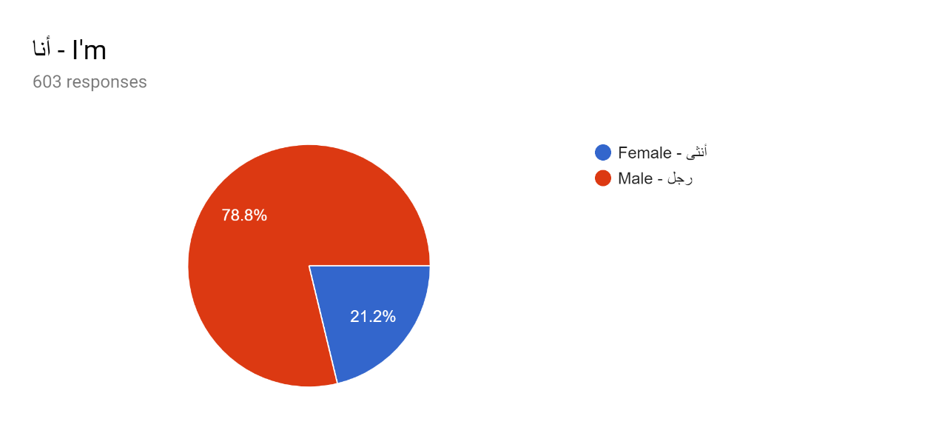
Table A1: Respondent’s Gender
Answer Option | Respond percent | Respond  count
Female  Male | 21.2%  78.8% | 128  475
Answered questions |  | 603
Skipped questions |  | 0

Form table A1, it can be seen that out of the 603 respondents, 78.8% of those respondents were male while the remaining 21.2% were female. This is an indication that male represent a large percentage that is actively engaged in real estate.

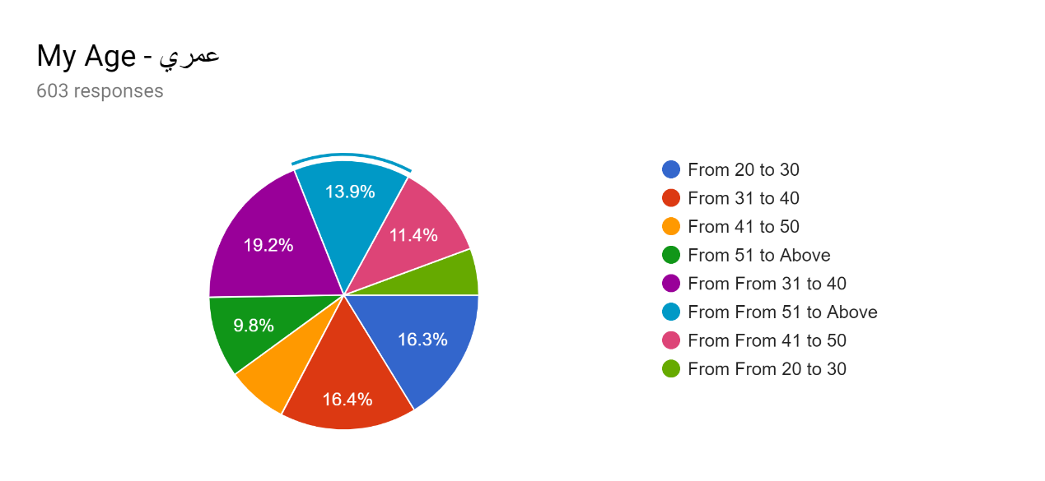
Table A2: Respondent’s age
Answer Option | Respond percent | Respond  count
From 20 to 30  From 31 to 40  From 41 to 50  From 51 and Above  From From 20 to 30  From From 31 to 40  From From 41 to 50  From From 51 to Above | 16.3%  14.4%  8%  9.8%  7%  19.2%  11.4%  13.9% | 98  87  48  59  42  116  69  84
Answered questions |  | 603
Skipped questions |  | 0

From Table A2 it can be seen that 16.3% of those who participated in the study were from 20 to 30 year of age, 14.4% were between 31 and 40 years while only 8% were between 41 to 50 years. A large number of the respondents were from from 31 to 40 years of age which is 19.2%, this is followed by those from from 41 to 50 years which totaled to 11.4%. The remaining respondents accounting for 13.9% of the respondents were from from 51 to above categogy.

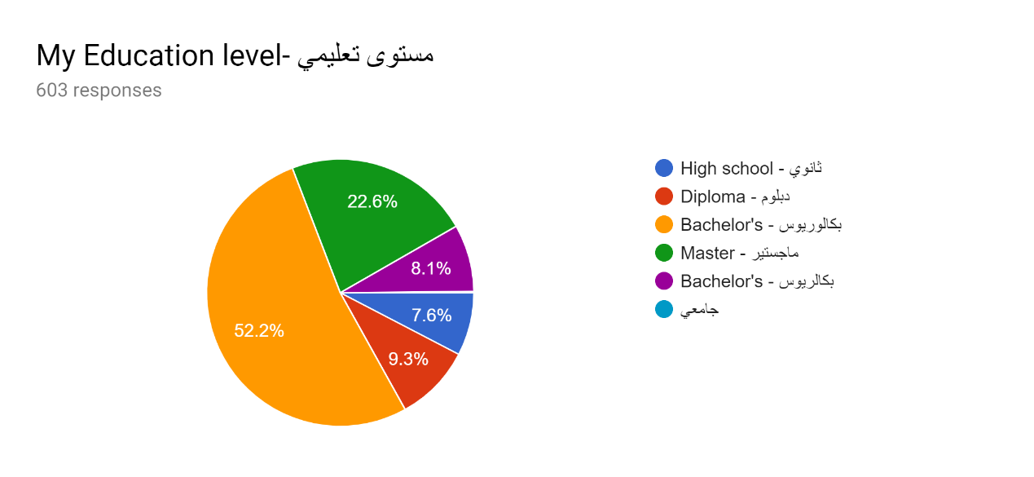
Table A3: Respondent’s level of education
Answer Option | Respond percent | Respond  count
High school  Diploma  Bachelor’s  Masters  Bachelor’s  others | 7.6%  9.3%  52.2%  22.6%  8.1%  7.6% | 46  56  315  136  49  46
Answered questions |  | 603
Skipped questions |  | 0

Table A3 represents the respondent’s level of education with a higher number of those who participated in study having attained a masters and Bachelors’ degree. 22.6% of the respondents have attained a masters’ degree and 52.2% have attained a Bachelors’ degree. 9.3% have diploma, 7.6% have schooled as far as high school and the remaining respondents lie in the others category. This, therefore, means that a large percentage of the Saudi population have attained higher education.
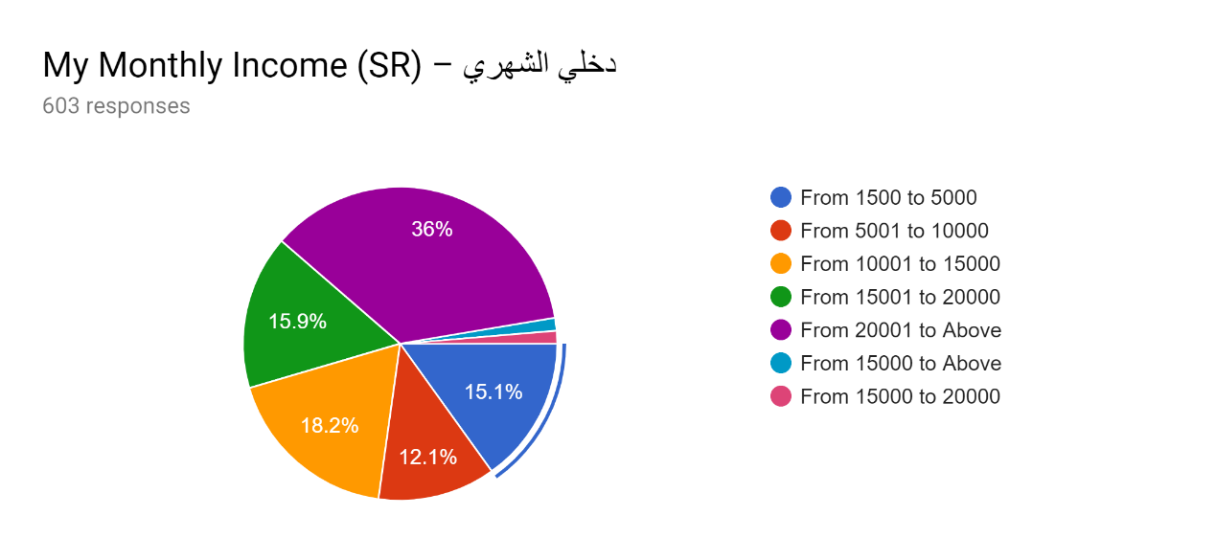
Table A4; Respondents monthly income
Answer Option | Respond percent | Respond  count
From 1500 to 5000  From 5001 to 10,000  From 10,001 to 15,000  From 15,001 to 20,000  From 20,001 and Above  From 15,000 to Above  From 15,000 to 20,000 | 15.1%  12.1%  15.9  18.2%  36%  1%  1% | 91  73  96  110  217  6  6
Answered questions |  | 603
Skipped questions |  | 0

It can be seen from Table A4 that a big percentage of the respondents earns a monthly salary of above 20,000 SR, this category accounted for 36%. This is mostly the working category that either has rentals or own an apartment or own their own residential house. 15.1% earns between 1,500 to 5,000 while 12.1% of the respondents earns 5,001 and 10,000. Majority of the remaining respondents earn between 15,000 to above 20,000. On overall, 18.2% of the total respondents earn between 15,001 and 20,000. 15.9% earn between 10,000 and 15,000. This data is very important as it gives a true picture of the financial position of the entire Saudi population. From this data, it is possible to understand how the population investment in real estate is likely to be.
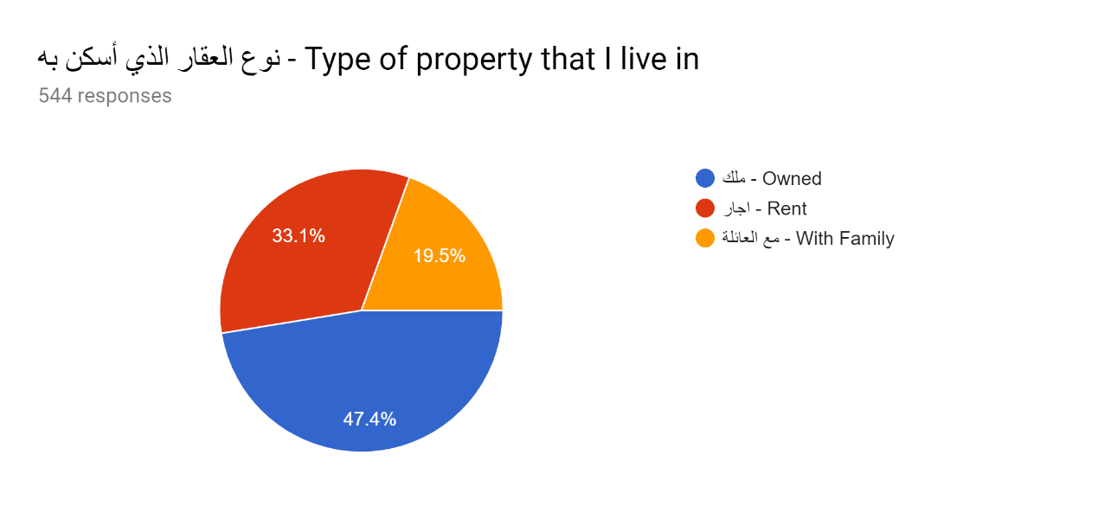
Table A5: Type of property that the respondent lives in
Answer Option | Respond percent | Respond  count
Owned  Rent  With Family | 47.4%  33.1%  19.5% | 257  180  106
Answered questions |  | 544
Skipped questions |  | 59

It can be seen from Table A5 that the highest percentage of respondents own their own houses. Out of the 544respondents who sought to disclose the type of house that they live in, 47.4% live in their own houses, 33.1% lives in rentals while the remaining 19.5% stay with their family. This is an indication that a large percentage of the population live in their own houses which is a big achievement in this generation. It is also a big boost to the Saudi 2030 housing program which seeks to increase house ownership from the current 47% to 75% by 2030.

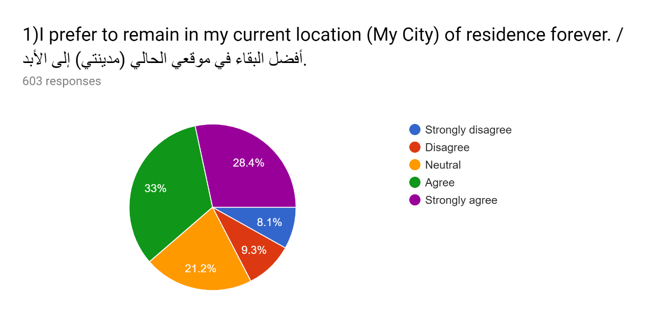
Table 1; consumer’s decision on whether they are comfortable in their current location of residence or they would prefer to move in future.
Answer Option | Respond percent | Respond  count
Strongly Disagree  Disagree  Neutral  Agree  Strongly Agree | 8.1%  9.3%  21.2%  33%  28.4% | 49  56  127  199  172
Answered questions |  | 603
Skipped questions |  | 0

From Table 1, it is very clear that a large percentage of the Saudi population would prefer to remain in their location of residence. The over 55% of the respondents are very okay with where they stay and would not prefer moving to any other location. Out of the total respondents, 33% agree that they would prefer to remain in their current location and 28.4% strongly agree on the same. A large number of the respondents are also undecided on whether they would prefer to stay or move, 21.2% were neutral on this question. 15.4% of the total respondents prefer to move from their current location in the future. 8.1% strongly disagree that they would prefer to remain in their current location and 9.3% disagree on the same. This leads to the conclusion that the government housing programs that are currently ongoing might only serve less than 40% of the population, this includes those who disagreed with the statement and those who lie under the neutral category.
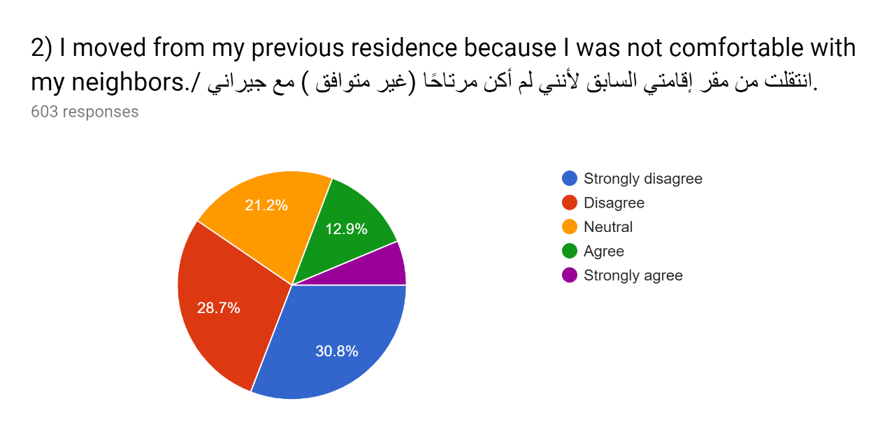
Table 2; percentage of families that moved from their previous residence because they were unconformable with their neighbors.
Answer Option | Respond percent | Respond  count
Strongly Disagree  Disagree  Neutral  Agree  Strongly Agree | 30.8%  28.7%  21.1%  12.9%  6.5% | 186  173  127  78  39
Answered questions |  | 603
Skipped questions |  | 0

From table 2, it is clear that Saudi families and neighbors are very friendly to each other. This question sought to understand the number of residents who moved from their previous residents because they were made unconformable by their neighbors. Over 58% of the total respondents disagree with this issue and only 19% of respondents associated their movement with being uncomfortable with their neighbors. On overall, 30.8% strongly disagreed with the idea, 28.7% disagreed, 6.5% strongly agreed, and 12.9% agreed. 21.1% of the respondents sought to remain neutral and could not in any way associate it with their neighbors. This leads to the conclusion that a large number Saudi nationals are friendly to each other and stay in peace with their neighbors.
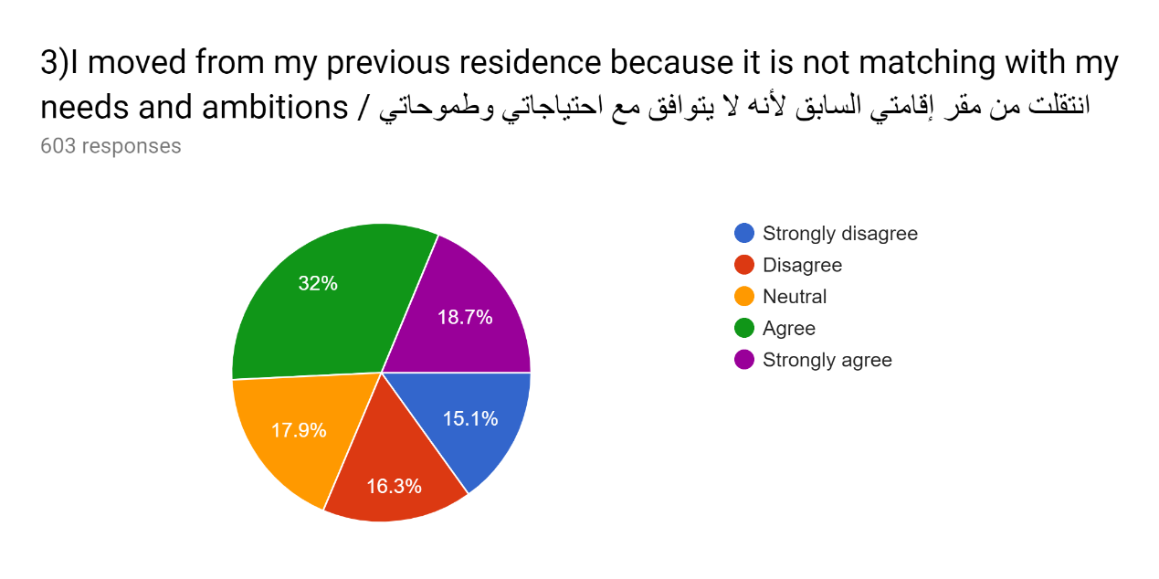
Table 3; percentage of residents who moved from their previous location because they wanted to get a better place that suits their needs and ambitions.
Answer Option | Respond percent | Respond  count
Strongly Disagree  Disagree  Neutral  Agree  Strongly Agree | 15.1%  16.3%  17.9%  32%  18.7% | 91  98  108  193  113
Answered questions |  | 603
Skipped questions |  | 0

From table 3, it’s clear that a large number of Saudi national are motivated by their needs and ambitions and have no problem moving to a place that suits them. 32% of the respondents agreed with the statement that they moved for their previous residence because it was not matching with their needs and ambitions. 18.7% strongly agreed with the same statement and only 31.4% disagreed or strongly disagreed with this statement. An overwhelming 17.9% sought to remain neutral on the same issue. This is an indication that Saudi families are flexible and given a chance would move to better houses that suit their needs and ambitions.
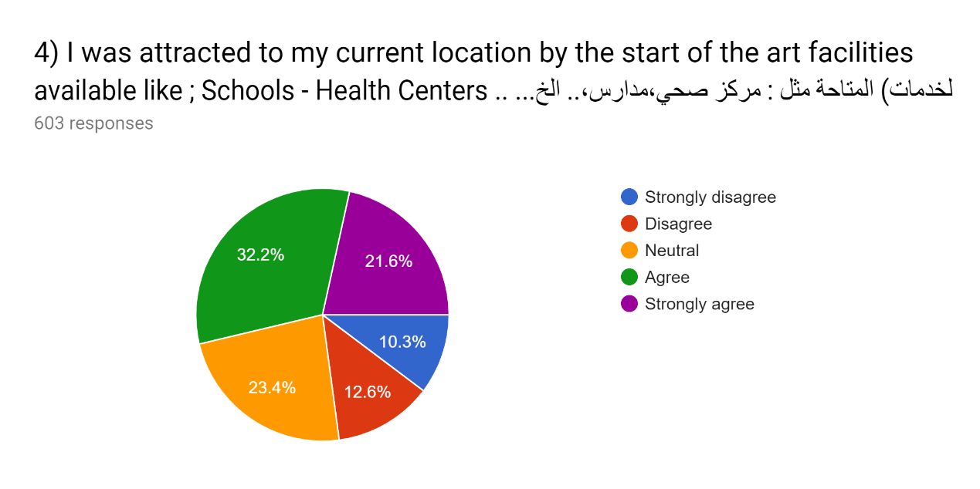
Table 4; percentage of residences who are influenced by state of the art facilities that are avaible in a certain location.
Answer Option | Respond percent | Respond  count
Strongly Disagree  Disagree  Neutral  Agree  Strongly Agree | 10.3%  12.6%  23.4%  32.2%  21.6% | 62  76  141  194  130
Answered questions |  | 603
Skipped questions |  | 0

It can be seen from Table 4 that many Saudi families appreciate the availability of social amenities or state of the art facilities such as schools and health centers. A large number agreed with the statement that they moved from their current location because it has such facilities. 32.3% agreed with this statement while over 21.6% strongly agreed with the same statement. Only 22.9% disagreed with this statement while 23.4% remained neutral with the statement. This means that Saudi families value the presence of state of the art facilities and can be a determining factor for their choice of stay in certain location.
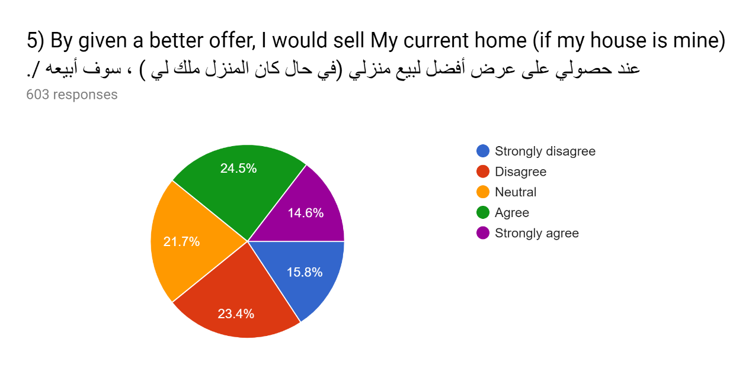
Table 5; value of money over the choice of residence
Answer Option | Respond percent | Respond  count
Strongly Disagree  Disagree  Neutral  Agree  Strongly Agree | 15.8%  23.4%  21.7%  24.5%  14.6% | 95  141  131  148  88
Answered questions |  | 603
Skipped questions |  | 0

Table 5 gives the percentage of Saudi nationals who would be motivated by a better offer to sell their current home. On overall, many Saudi nationals are comfortable with their current home and would not be prompted to sell it by any offer. 15.8% strongly disagreed with the statement that they would be motivated to sell their current home given a better and 23.4% disagreed with the same statement. 21.7% did not seem to be decided on the same. On overall, only 31.1% would sell their house in the event they are given a better offer. This leads to the conclusion that a large number of Saudi nationals would not move from their current home.
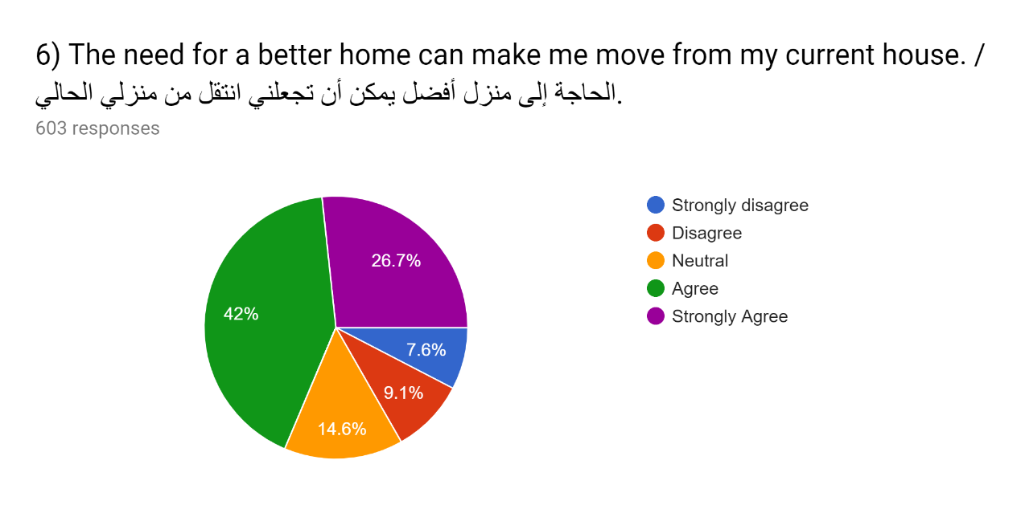
Table 6; the value of a better home
Answer Option | Respond percent | Respond  count
Strongly Disagree  Disagree  Neutral  Agree  Strongly Agree | 7.6%  9.1%  14.6%  42%  26.7% | 46  55  88  253  161
Answered questions |  | 603
Skipped questions |  | 0

Table 6 presents the percentage of the number of Saudi nationals who would be motivated by a better home to move from their current home. 68.7% are in need of a better home as they are ready to move from their current home. 42% of the respondents agree while 26.7% strongly agree with the statement that they can move from their current home to look for a better home. Only 16.7% of the total respondents o overall disagree with this statement meaning that they are comfortable with their current home. This leads to the conclusion that many Saudi nationals are still in need of better housing.
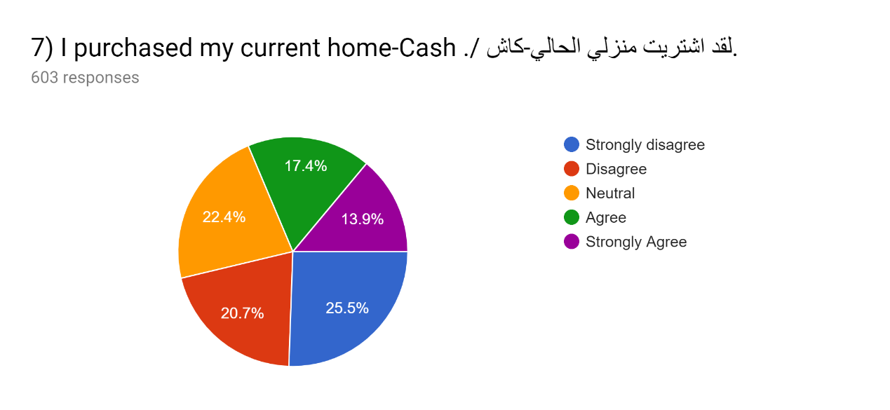
Table 7; purchasing real estate
Answer Option | Respond percent | Respond  count
Strongly Disagree  Disagree  Neutral  Agree  Strongly Agree | 25.5%  20.7%  22.4%  17.4%  13.9% | 154  125  135  105  84
Answered questions |  | 603
Skipped questions |  | 0

Table 7 gives the statistics of Saudi nationals who purchased their home in cash. 25.5% of the respondents strongly disagree with the statement that they bought their current home in cash while 20.7% disagree with the same statement. This means that they bought their house in other payment terms but not in cash. 22.4% sought to remain neutral with this statement. Only 17.4% agreed with the statement that they bought their current home in cash while 13.9% strongly agreed. This leads to the conclusion that many home owners either sourced for loans or mortgages to buy their current home.
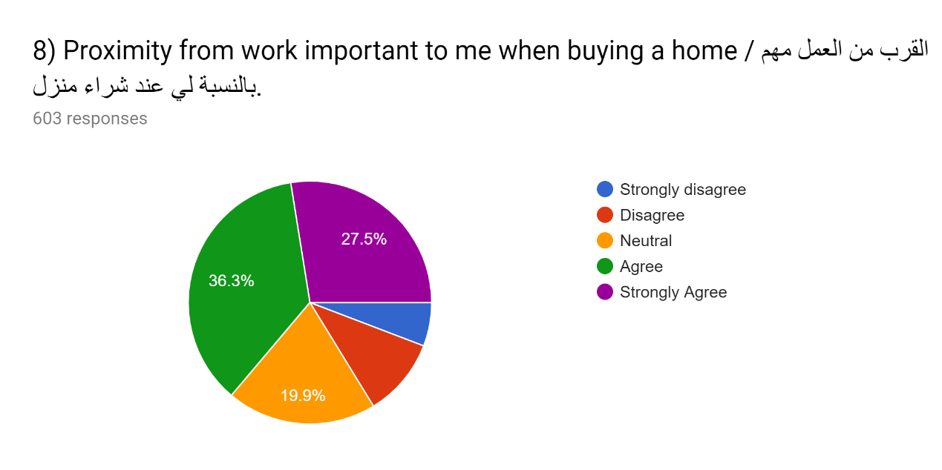
Table 8; work proximity when considering to buy a home
Answer Option | Respond percent | Respond  count
Strongly Disagree  Disagree  Neutral  Agree  Strongly Agree | 5.4%  10.9%  19.9%  36.3%  27.5% | 32  66  120  219  166
Answered questions |  | 603
Skipped questions |  | 0

Table 8 gives the percentage of Saudi nationals who consider work proximity as an important factor when purchasing a home. 36.3% agreed with the statement that proximity from work is very important when buying a home. 27.5% strongly agreed with same statement while only 16.3% did not seem to have an issue with work proximity when making a purchase decision. 19.9% sought to remain neutral with the statement. This is an indication that many Saudi nationals are likely to be tied to their current location because of work proximity.

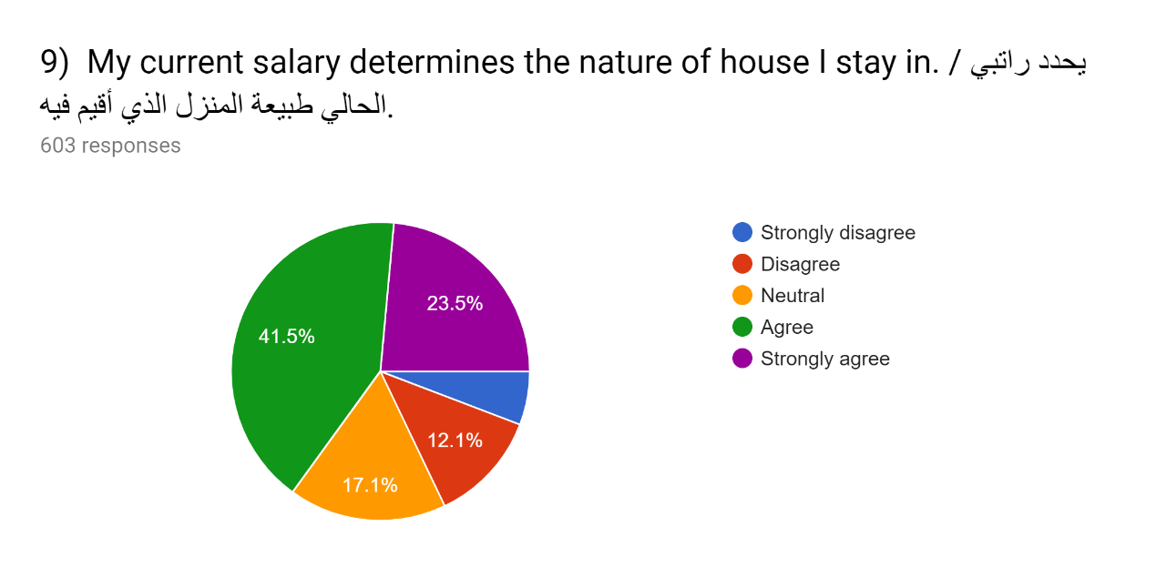
Table 9; living standards based on income
Answer Option | Respond percent | Respond  count
Strongly Disagree  Disagree  Neutral  Agree  Strongly Agree | 5.8%  12.1%  17.1%  41.5%  23.5% | 35  73  103  250  142
Answered questions |  | 603
Skipped questions |  | 0

Table 9 gives the percentage of Saudi nationals whose choice of home is determined by their income. 41.5% agreed with the statement that their current house in which they stay is determined by their income while 23.5% strongly agreed with the same statement. 17.1% remained neutral to this statement. 5.8% of the respondents feel that are not dictated by their income in their choice for the kind of house they stay. 12.8% strongly disagree with the statement as well. This concludes that salary or income is a very important determinant of the nature of houses that Saudi families live in.

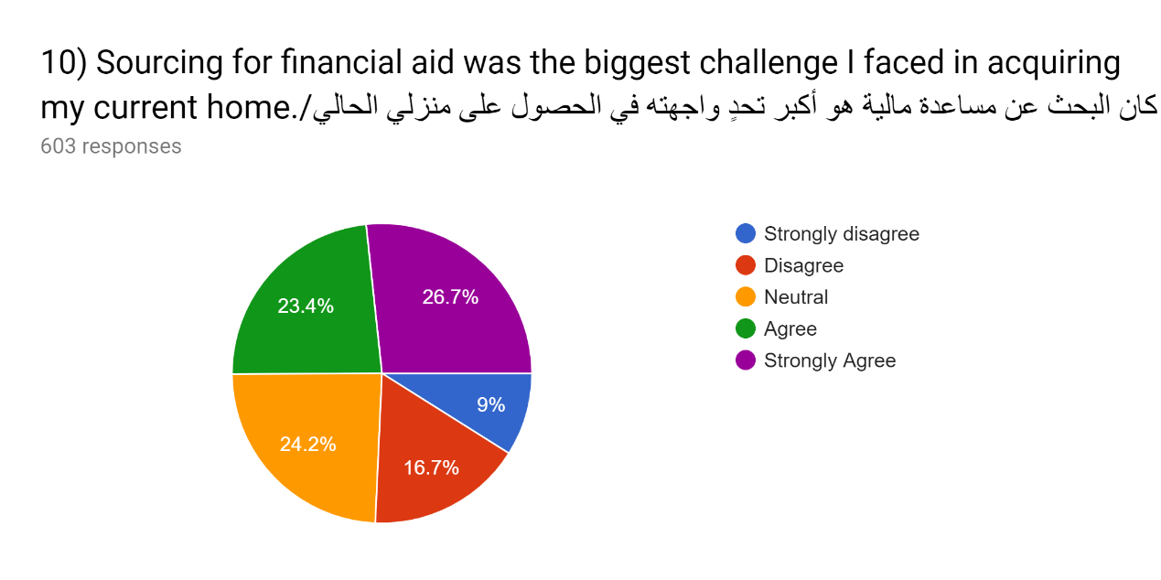
Table 10; biggest challenge in acquiring a home
Answer Option | Respond percent | Respond  count
Strongly Disagree  Disagree  Neutral  Agree  Strongly Agree | 9%  16.7%  24.2%  23.4%  26.7% | 54  101  146  141  161
Answered questions |  | 603
Skipped questions |  | 0

It can be seen from Table 10 that a large number of the respondents faced challenges in sourcing for finances when buying a home. 26.7% strongly agreed with the statement that sourcing for financial aid was the biggest challenge they faced when buying their current home. 23.4% also agree with the statement. 24.2% sought to remain neutral to this statement while 9% sought to strongly disagree that sourcing for financial aid was the biggest challenge. 16.7% did not agree with the same statement. This leads to the conclusion that financial institutions are not effective enough hence making sourcing for financial aid in real estate a huge or serious challenge among many Saudi nationals.

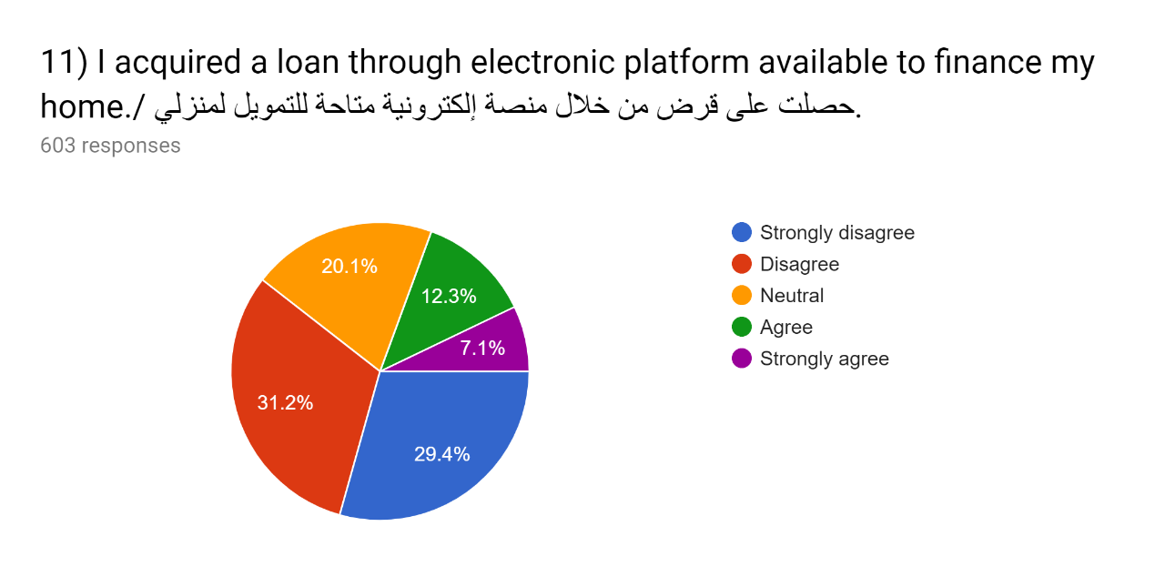
Table 11; impact of electronic platforms in acquiring home loans
Answer Option | Respond percent | Respond  count
Strongly Disagree  Disagree  Neutral  Agree  Strongly Agree | 29.4%  31.2%  20.1%  12.3%  7.1% | 177  188  121  74  43
Answered questions |  | 603
Skipped questions |  | 0

Table 11 shows the impact that electronic platforms of sourcing for loans have in real estate. From the results presented in the table, it is clear that a large number of Saudi nationals did not use any of the available electronic platforms to source for loans when buying their home. 29.4% strongly disagree with the statement that they used electronic platforms in acquiring a home loan, 31.3% also disagree with the same statement. 20.1% sought to remain neutral with this statement. 12.3% agreed to have used electronic platforms in acquiring their home loan, 7.1% also strongly agreed to have benefited for same platforms. This is an indication that electronic platforms have not gained the popularity they deserve when it comes to acquiring home loans.
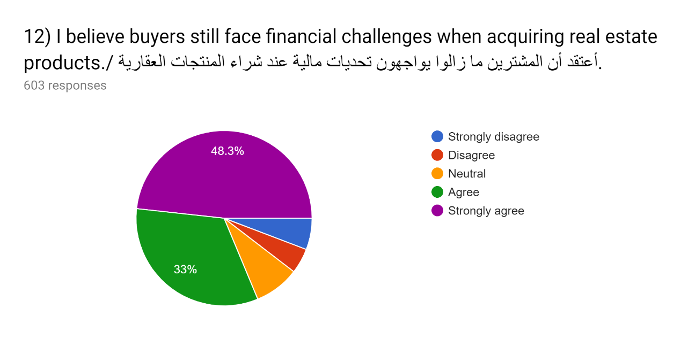
Table 12; financial challenges in acquiring a real estate product
Answer Option | Respond percent | Respond  count
Strongly Disagree  Disagree  Neutral  Agree  Strongly Agree | 7.5%  4.7%  6.5%  33%  48.3% | 45  28  39  199  291
Answered questions |  | 603
Skipped questions |  | 0

It can be seen from Table 12 that over 81% of Saudi nationals face financial challenges when acquiring a home. 48.3% of the respondents strongly agreed with the statement that buyers face financial challenges when acquiring a home. 33% also agreed that financial challenges was a big issue in acquiring real estate products. 6.5% sought to remain neutral while 7.5% strongly disagreed with this statement. This leads to the conclusion that financial challenge in a serious issue in acquiring real estate products.

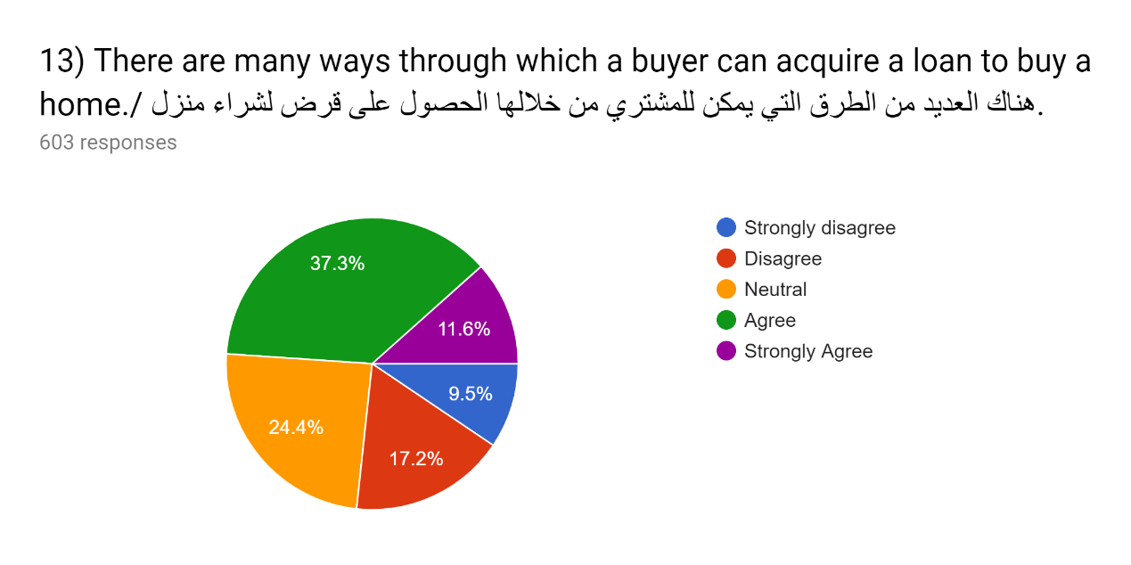
Table 13; acquiring a home loan
Answer Option | Respond percent | Respond  count
Strongly Disagree  Disagree  Neutral  Agree  Strongly Agree | 9.5%  17.2%  24.4%  37.3%  11.6% | 57  104  147  225  70
Answered questions |  | 603
Skipped questions |  | 0

From Table 13, it can be seen that a 37.3% of the respondents believe that there are many platforms that an individual can source for a home loan. 11.6% strongly agree with the statement while 24.4% sought to remain neutral in relation to this question. 17.2% disagree that there are many ways through which an individual can acquire a home loan, 9.5% strongly disagree with the same statement. This is an indication that Saudi nationals are in a position to acquire home loans easily.

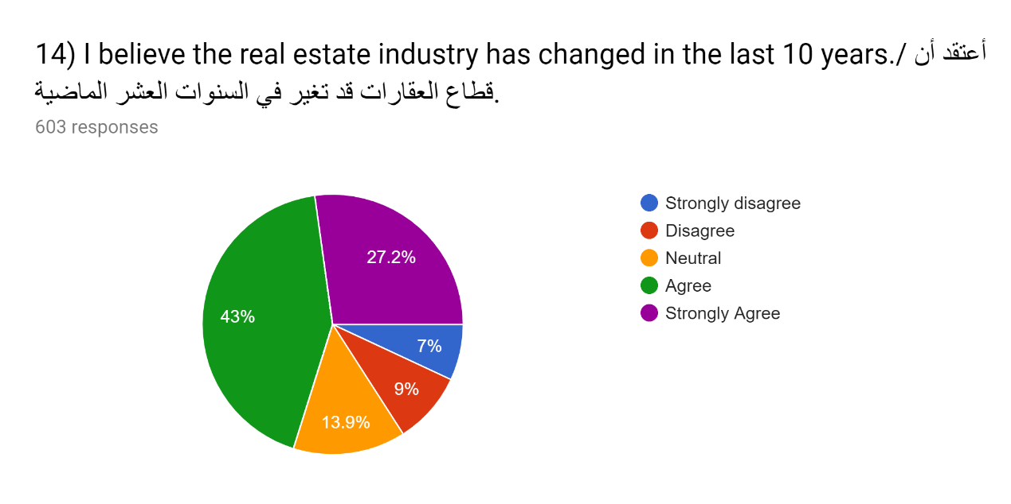
Table 14; change in real estate industry in the past 10 years
Answer Option | Respond percent | Respond  count
Strongly Disagree  Disagree  Neutral  Agree  Strongly Agree | 7%  9%  13.9%  43%  27.2% | 42  54  84  259  164
Answered questions |  | 603
Skipped questions |  | 0

It is clear from Table 14 that a large number of respondents believe that there has been great change in real estate for the last 10 years. 43% agreed with the statement that they believe the real estate industry has changed for the last 10 year, 27.2% strongly agree with the statement. On overall, only 15% of the respondents do not believe that there is visible change in real estate for the last 10 years. 13.9% sought to remain neutral with this statement. This leads to the conclusion that the real estate industry in Saudi Arabia has changed for the last 10 years.

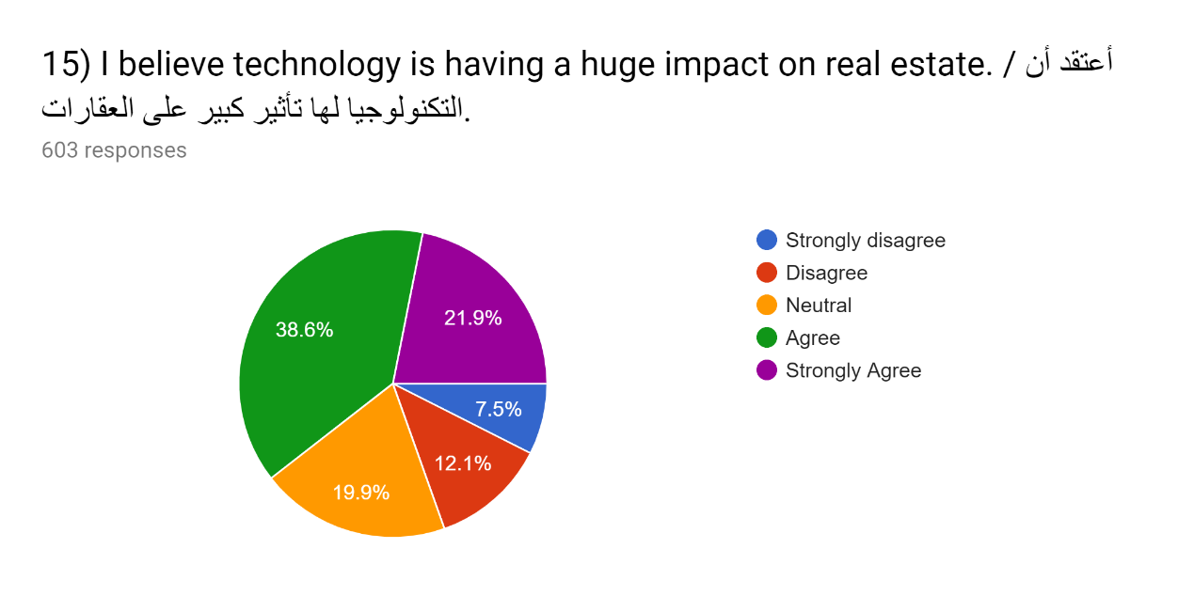

Table 15; impact of technology on real estate
Answer Option | Respond percent | Respond  count
Strongly Disagree  Disagree  Neutral  Agree  Strongly Agree | 7.5%  12.1%  19.9%  38.6%  21.9% | 45  73  120  233  132
Answered questions |  | 603
Skipped questions |  | 0

From Table 15, it’s clear that technology has had a huge impact on real estate. 38.6% agree with the statement that technology has a huge impact on real estate while 21.9% strongly agree with the same statement. 19.9% sought to remain neutral with this statement. 7.5% strongly disagreed this statement. This leads to the conclusion that technology has a huge impact on real estate.
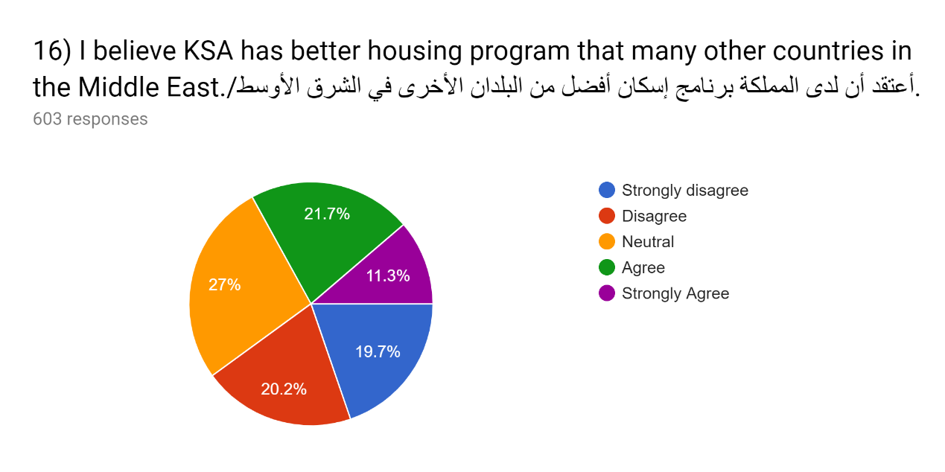
Table 16; housing program in KSA as compared to other countries in Middle East
Answer Option | Respond percent | Respond  count
Strongly Disagree  Disagree  Neutral  Agree  Strongly Agree | 19.7%  20.2%  27%  21.7%  11.3% | 119  122  163  131  68
Answered questions |  | 603
Skipped questions |  | 0

It can be seen from table 16 that many respondents disagree with the statement that the housing programs in KSA are better than those in other Middle East countries. 19.7% of the respondents strongly disagree with this statement, 20.2% disagree with the statement, 27% sought to remain neutral with this statement. Out of the respondents, only 11.3% strongly agree with this statement while the remaining 21.7% agree with the same statement. This leads to the conclusion that many Saudi nationals believe that there is room for improvement in the real estate industry in the country. There is so much to be done in order to become an icon in real estate in the region.
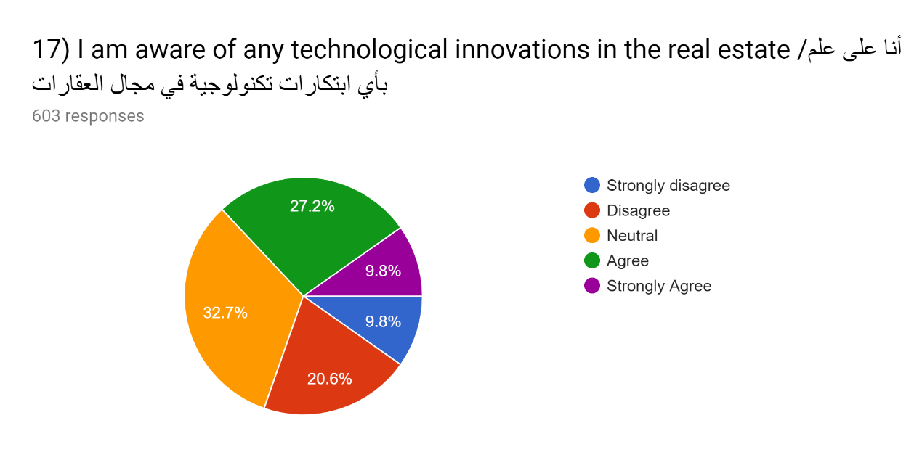
Table 17; technological innovation awareness
Answer Option | Respond percent | Respond  count
Strongly Disagree  Disagree  Neutral  Agree  Strongly Agree | 9.8%  20.6%  32.7%  27.2%  9.8% | 59  124  197  164  59
Answered questions |  | 603
Skipped questions |  | 0

Table 17 shows the results of the level of awareness in technological advancement among Saudi nationals. An equal percentage of 9.8% strongly disagree and strongly agree that they are aware on technological innovations in real estate. 20.65 disagree with the statement they are aware of technological innovations in real estate, 27.2% agree with this statement while 32.7% are neutral. This leads to the conclusion that a large number of Saudi nationals are unaware of technological innovations in real estate.
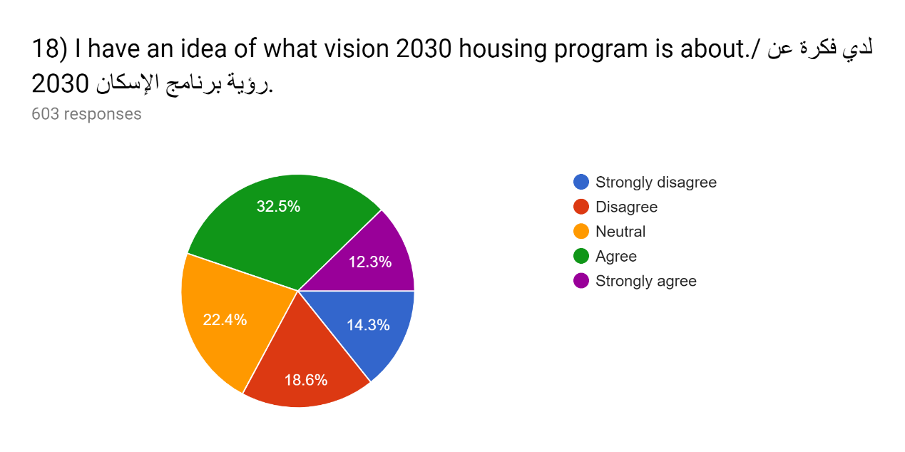
Table 18; vision 2030 housing program popularity
Answer Option | Respond percent | Respond  count
Strongly Disagree  Disagree  Neutral  Agree  Strongly Agree | 14.3%  18.6%  22.4%  32.5%  12.3% | 86  112  135  196  74
Answered questions |  | 603
Skipped questions |  | 0

It can be seen from Table 18 that 14.3% of the respondents did not have an idea of what vision 2030 housing program is and disagree with the statement that they have an idea of what it is, 18.6% also disagreed it the statement. 32.5% agree that they know what vision 2030 housing program is, 12.3% strongly agree with the statement while the remaining 22.3% sought to remain neutral on this statement. This leads to the conclusion that the Saudi government has not done intense campaigns relating to the vision 2030 housing program well.
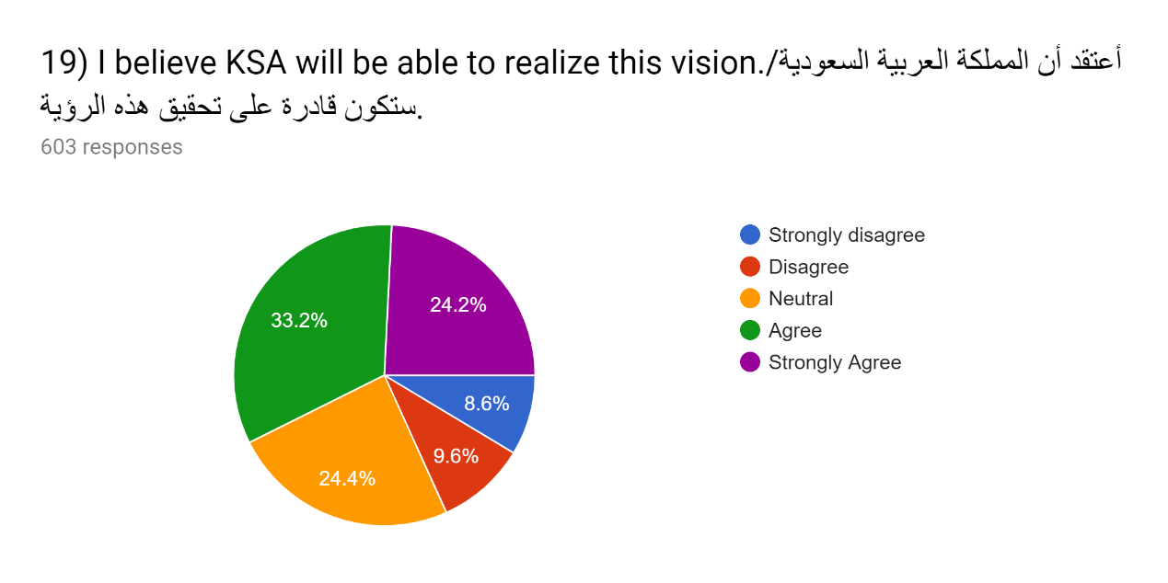
Table 19; KSA vision 2030 realization
Answer Option | Respond percent | Respond  count
Strongly Disagree  Disagree  Neutral  Agree  Strongly Agree | 8.6%  9.6%  24.4%  33.2%  24.2% | 52  58  147  200  146
Answered questions |  | 603
Skipped questions |  | 0

From Table 19, it is clear that a large number of the respondents believe that the vision 2030 housing program will be achieved. 24.2% of the respondents strongly agreed with the statement that they believe the vision will be realized, 33.2% also agreed with the statement. 8.6% do not believe that the vision will be realized, 9.6% disagree with the statement while the remaining 24.4% sought to remain neutral with this statement .This leads to the conclusion that a large number of Saudi national have trust in their leadership and believe that vision 2030 housing program will be realized.

Discussion of the results
All the results that has been presented in the frequency table are important and this is why we will discuss them in this section considering their importance in our research. There are a total of 24 frequency tables which carry very important results from the research. There are many things that can be discussed from the results in the frequency tables considering that each question had a certain intended role but this section will summarize the various facts that has been represented by the results. To start with, it is clear that a large number of Saudi nationals are comfortable with their current residence or home and would not prefer to leave to another place. Earlier in the research we indicated that 45% of the Saudi population own a home and this would explain why such a high number would be comfortable and unwilling to leave their current residence.
The second fact is that a large number of Saudi nationals are flexible and given a better home they would take it. A large section of the population does not own a home and are flexible to shift given a chance of better housing. There are very many people who are living in rentals and others with their families who still have a hope of living in their own homes. Therefore, this section represents the target population towards the realization of the vision 2030 housing program. Majority of Saudi families believe that financing or sourcing for financing is a real challenge in real estate and a big determinant in buying of real estate products.
Third, Saudi people live according to their standards and agree that there current houses are based on their income. Almost all Saudis would prefer to own a home but they have been handicapped by their financial position. The results indicate that many of Saudis live based on their income and this is the biggest determinant of the nature of houses they live in. The results further suggest that many of the Saudis who own a home earn over 25, 000 and above.
Fourth, the results shows that many Saudis are not aware of the vision 2030 housing program and does not understand what it intends to achieve. According to the results, only a handful of Saudi really understand what vision 2030 plans to achieve and the government’s plan about it. This is not different from the technological innovations that are available in real estate. Very few Saudis are aware of those innovations and what they do in real estate.
Lastly, a large number of Saudis believe that the government has the ability to achieve vision 2030 housing program. This means that the public has trust in the government and believe that it will achieve its agenda with the housing program. A similar percentage believe that technology does not have much impact in real estate. This is a clear indication that a large percentage of Saudi nationals does not appreciate technological contribution in real estate.
Recommendations
Recommendation for the government to do more public participation and sensitization of the vision 2030 housing program. This would improve the public’s understanding and knowledge on the housing program which is a vital part or role towards the realization of the program. This will also make it easier for the government to roll out the plan and get the required support from the public.
Second, the government should ensure that there is enough platforms that can offer loans to people who would want to buy houses. The result identified financing and sourcing for financing as one of the biggest challenges many home buyers face. This should not be the case in this generation and considering the various efforts that the government is putting to increase home ownership in the country. There should be various government sponsored platforms that can help people in acquiring home loans.
Third, the various government housing programs should be tailored to accommodate the less income earners who are not in a position to finance house-buying on their own. The houses should not be so expensive for low income earners. Those who earn over 25,000 and above constitute the large number of home owners while those who earn below 15,000 either live in rentals or with their families. This should the priority for the government in its housing program.
Forth, it is recommended that housing programs should not be concentrated in small towns but rather near major cities where housing pressure is high. A large number of people consider work proximity when choosing where to buy a house, many people work in major cities and this is where those programs should be concentrated in. It might be less helpful to have many housing programs which are far from major cities since people will not buy them.
Conclusion
The real estate industry in Saudi Arabia has changed for the last 10 years and is undisputable that that change has come with many other changes not just to the people but also to other sectors that rely on it. While many Saudis many not be aware of the role and impact of technology in real estate, it is clear that technology has played a crucial role to achieve the change that is visible in this sector.
The research sought to understand the effects of technology advancement in real estate in Saudi Arabia and vision 2030. We first investigated the effects of technology in buying real estate property which is major boost that has been impacted by technology in the industry. There are many other major areas of concern that should have been investigated but due to the nature of research, we had to narrow down to various aspects of technology. Under this category, we first did research on traditional methods of buying real estate property and the new methods that has been introduced in the industry.
We researched on the effects of technological advancement in acquiring real estate and more so the various online platforms that are available and helpful in acquiring a home. Mostly, the research focused on the various platforms that can offer loans to consumers and how they have impacted buying of real estate property. The research further focused on the popularity of the vision 2030 housing program and how it’s likely to impact the entire real estate industry. We used question with 23 questions which were analyzed quantitatively.

Bibliography
Al-Hathloul, S. A. (2015). Urban land utilization, case study: Riyadh, Saudi Arabia. Cambridge: Education/Research Program, Urban Settlement Design in Developing Countries, School of Architecture and Planning, Massachusetts Institute of Technology.
Al-Saati, A. J. (2017). Residents' satisfaction in subsidized housing: An evaluation study of the real estate development fund program in Saudi Arabia. Washington, D.C.: International Monetary Fund, ©2017.
Alshiha, A. A. (2013). The role of Saudi Real Estate Development Fund in solving the housing problem in Saudi Arabia. Boca Raton, FL: Taylor and Francis, an imprint of CRC Press, © [2017].
Al-Tasan, H. S. A. (2018). An evaluation of housing finance in Saudi Arabia: The Real Estate Development Fund's policies and alternative options. University of Durham.
Al-Yemeni, M. S. (2016). Urban land development policies: The case of Saudi Arabia.
American Real Estate & Urban Economics Association (Bloomington). (20013). Real estate economics. Oxford: Blackwell.
Chao, S. J. (2015). Internet resources and services for international real estate information. Westport, CT: Oryx Press.
Dixon, T. J. (2015). Technology and real estate. Bradford, England: Emerald Group Pub.
Dowall, D. E. (2014). Riyadh land market study final report: Prepared for the Ministry of Municipal and Rural Affairs, Deputy Ministry of Town Planning, Kingdom of Saudi Arabia. Riadh, Saudi Arabia: The Ministry.
Edwards, K. W. (2017). Your successful real estate career. New York: American Management Association.
Eilers, T. (2014). Real estate millions in any market. Hoboken, N.J: J. Wiley.
Gerber, M. E., & Rector, R. A. (2013). The e-myth: Real estate brokerage: why most real estate brokerage firms don't work and what to do about it. Escondido: Prodigy Business Books.
Hassell, S. (2013). Building better homes: Government strategies for promoting innovation in housing. Santa Monica, CA: RAND.
In Wilkinson, S., In Dixon, T. J., In Miller, N. G., & In Sayce, S. (2018). Routledge handbook of sustainable real estate. Washington, D.C.: Paul H. Nitze School of Advanced International Studies, Johns Hopkins University.
International Conference on Technology and Management, & Kim, H. (2015). Advances in technology and management: Proceedings of the 2015 International Conference on Technology and Management (ICTAM 2015), International Convention Center Jeju, Jeju-Island, Korea. Berlin: Springer.
Kennedy, D., Jamison, W., & Kennedy, D. (2019). How to list and sell real estate in the 21st century. Upper Saddle River, NJ: Prentice Hall.
Masi, M., & Starkey, L. B. (2017). Real estate career starter. New York: Learning Express.
Miles, M. E., Berens, G., Weiss, M. A., & Urban Land Institute. (2016). Real estate development: Principles and process. Washington, D.C: Urban Land Institute.
Miles, M. E., Netherton, L. M., & Schmitz, A. (2015). Real estate development: Principles and process. Publisher: [Washington, D.C.]: Urban Land Institute, [2015] ©2015
O'Donnell, K. (2017). Connected real estate: Essays from innovators in real estate, design, and construction. Walmer: Torworth Publications.
O'Kane, M. (2013). Saudi real estate law and practice. Chicago, IL: Andalus Publishing.
O'Mara, M. A. (2019). Strategy and place: Managing corporate real estate and facilities for competitive advantage. New York, NY: Free Press.
Perrucci, S. (2018). Mortgage and real estate finance: Latest innovations and opportunities. London: Risk Books.
Pritchard, S. B. (2015). Confluence: The nature of technology and the remaking of the Rhône. Cambridge, Mass: Harvard University Press.
Rascoff, S., & Humphries, S. (2015). Zillow talk: The new rules of real estate. Cambridge, Mass.: Harvard University Press, 2011.
Saudi Arabia. (2019). Regulations for ownership of real estate in the Hijaz. Dhahran: Arabian American Oil Company, Relations Dept., Arabic Research and Translation Section.
Tiwari, P., & White, M. (2014). Real estate finance in the new economy. Chichester, West Sussex, United Kingdom: John Wiley & Sons Inc., 2014.
Tobey, R. C. (2016). Technology as freedom: The New Deal and the electrical modernization of the American home. Berkeley: University of California Press.
Tuccillo, J. A. (2019). The eight new rules of real estate: Doing business in a consumer-centric, techno-savvy world. Chicago, Ill.: Real Estate Education Co.
World Bank. (2013). Financial Sector Assessment Program: Saudi Arabia - CPSS Core Principles for Systematically Important Payment Systems. Washington, DC: World Bank

Appendix B
BAYES ANOVA VAR00001 BY VAR00002
/CRITERIA CILEVEL=95 TOL=0.000001 MAXITER=2000
/INFERENCE ANALYSIS=BAYESFACTOR
/ESTBF COMPUTATION=JZS.

Bayesian ANOVA

Notes
Output Created |  | 19-JUL-2019 16:28:59
Comments
Input | Active Dataset | DataSet0
Input | Filter | <none>
Input | Weight | <none>
Input | Split File | <none>
Input | N of Rows in Working Data File | 16
Missing Value Handling | Definition of Missing | User-defined missing values are treated as missing.
Missing Value Handling | Cases Used | Only cases with valid data for all analysis variables are used in computing any statistics.
Weight Handling |  | not applicable
Syntax |  | BAYES ANOVA VAR00001 BY VAR00002  /CRITERIA CILEVEL=95 TOL=0.000001 MAXITER=2000  /INFERENCE ANALYSIS=BAYESFACTOR  /ESTBF COMPUTATION=JZS.
Resources | Processor Time | 00:00:00.06
Resources | Elapsed Time | 00:00:00.24

[DataSet0]

The requested model has a perfect fit. R squared=1.

ANOVA
VAR00001 | Sum of Squares | df | Mean Square | F | Sig. | Bayes Factorª
Between Groups | 120806.000 | 2 | 60403.000 | . | . | .
Within Groups | .000 | 0 | .
Total | 120806.000 | 2

a. Bayes factor: JZS

List of keywords
- Real estate- Real estate is real and tangible asset including buildings, fences, houses, and wells among other fixes in a piece of land.
- Residential real estate- this is a type of real estate that is meant for construction and resale homes.
- Commercial real estate- A type of real estate that include strip malls, shopping centers, offices, and hotels among other commercial purposes.
- Industrial real estate- this is a type of real estate that is meant for manufacturing buildings or property, this also includes warehouses.
- Real property- this include land and buildings in it and any other improvements that have been made in that land as well.
- Personal property- property that is entitled to an individual or that has a personal claim such as a house.
- Real estate categories- Various types of real estate.
- Warehouse- a large building with high ceiling that is used to store goods.

